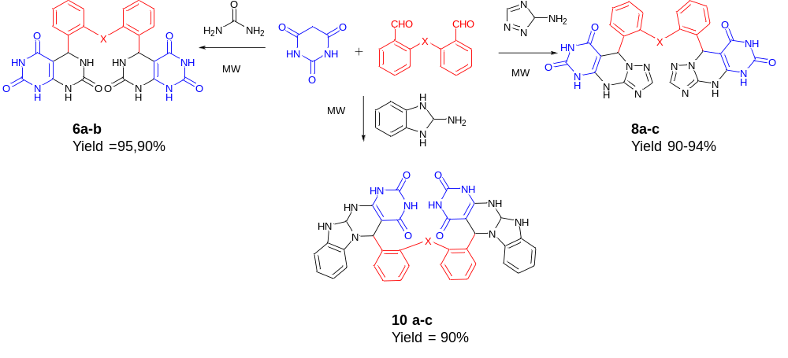
Scheme 1. Green sustainable Hantzch one-pot reaction synthesis of Bis(heterocycles)

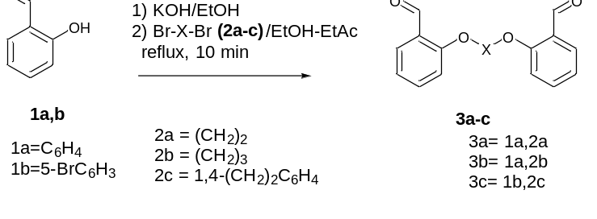

Scheme 2. Synthesis of bis aldehydes 3a-c

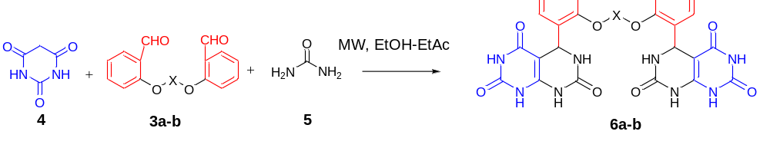
Scheme 3. Synthesis of fused bicyclic compounds 6a-b
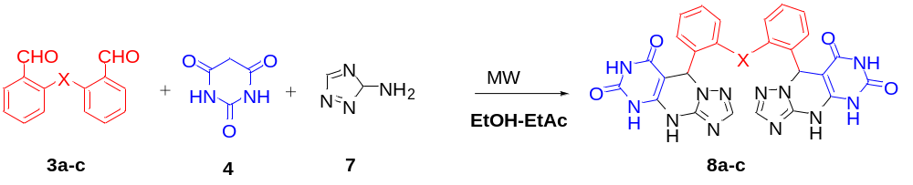
Scheme 4 Synthesis of fused tricyclic compounds 8a-c
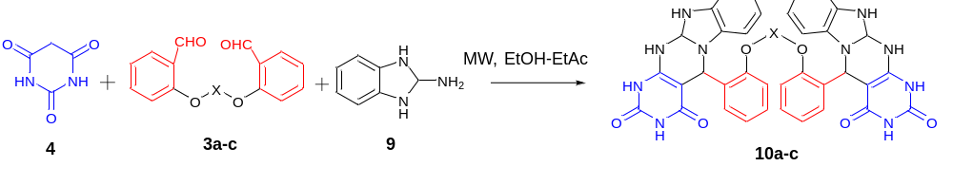
Scheme 5. Synthesis of tetracyclic 5,11,11a,12-tetrahydrobenzo[4,5]imidazo[1,2-a]pyrimido[4,5-d]pyrimidine-2,4(1H,3H)-dione (10)

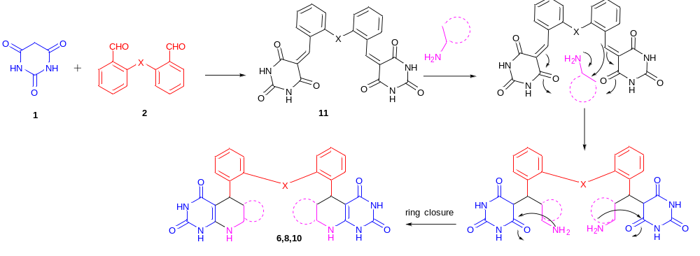
Scheme 5. Propose mechanism for the synthesis of fused pyrimidine-barbituric acid rings

