Supplementary Figures
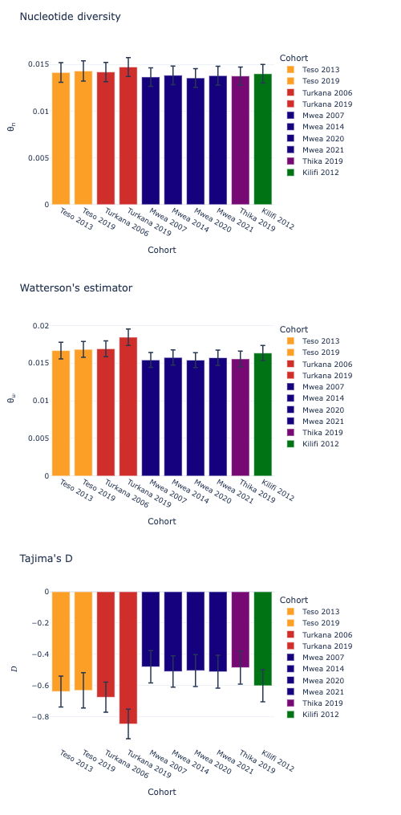
Supplementary Figure 1. Bar plots of genetic diversity statistics for population cohorts, including nucleotide diversity (π), Watterson’s Theta (θ) and Tajima’s D.

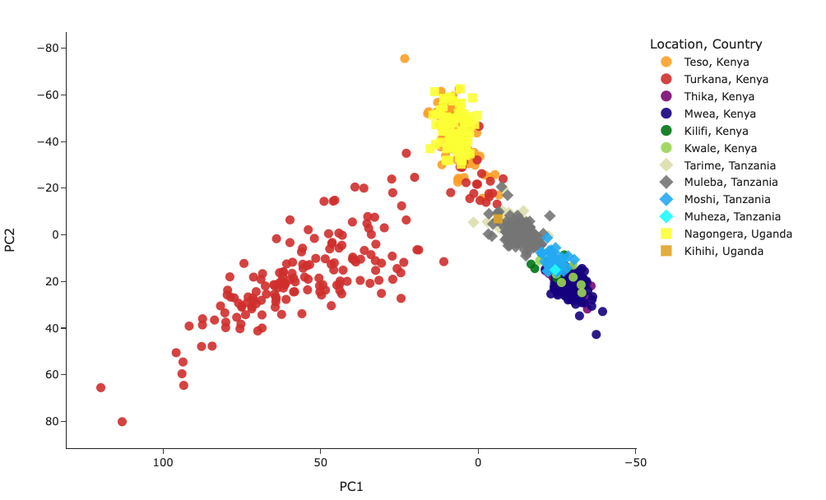

Supplementary Figure 2. PCA to investigate the population structure of An. arabiensis from Kenya in relation to the neighbouring countries of Uganda and Tanzania.
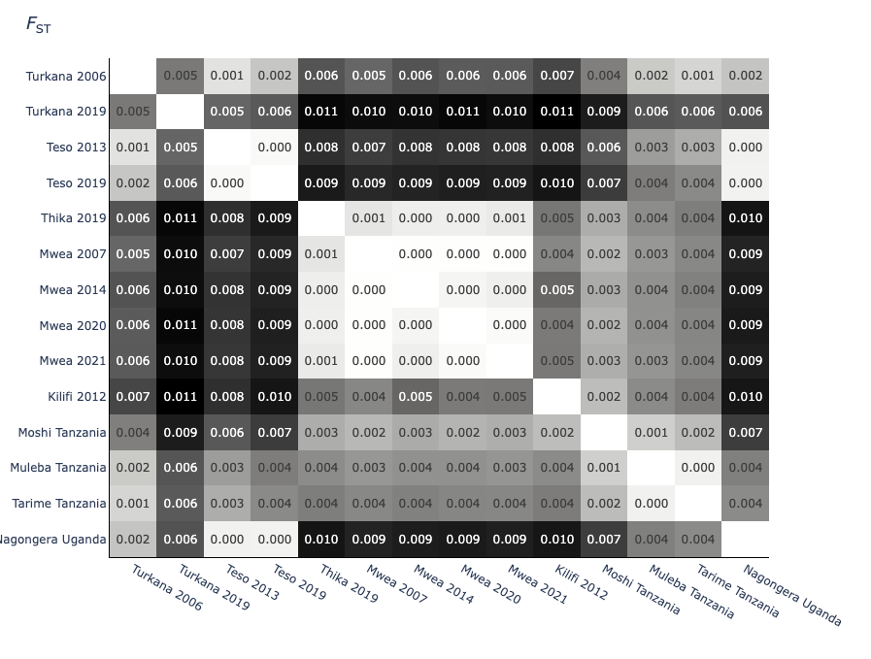
Supplementary Figure 3. Investigation of the genetic differentiation of population cohorts with Hudson’s pairwise FST.
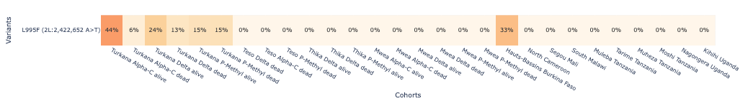
Supplementary Figure 4. Investigation of the frequencies of the voltage-gated sodium channel substitution L995F in African An. coluzzii.

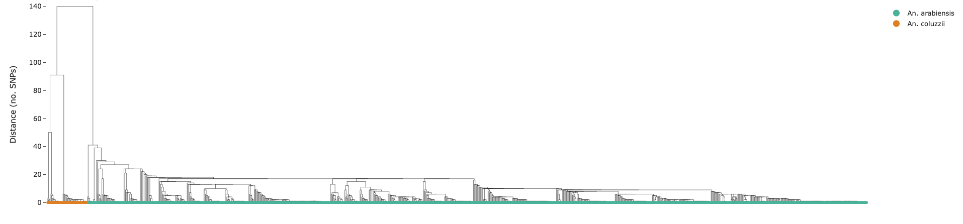
Supplementary Figure 5. Investigation of haplotype sharing with hierarchical clustering of the voltage-gated sodium channel gene.

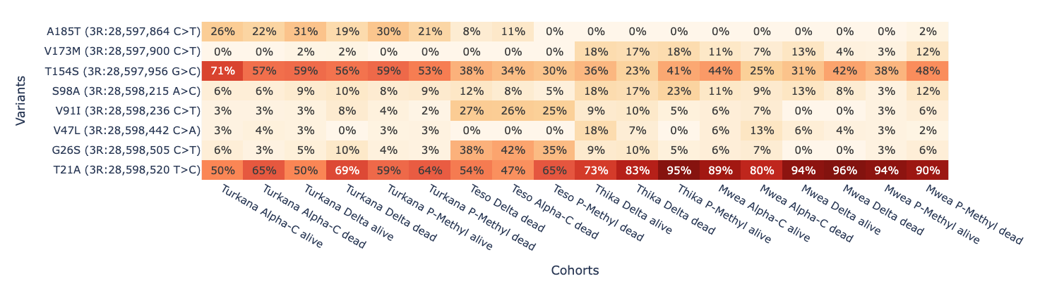
Supplementary Figure 6. Investigation of amino acid substitutions at the ACE-1 locus.
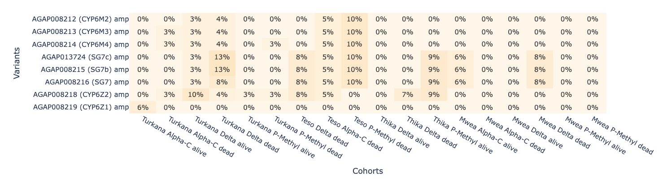
Supplementary Figure 7. Investigation of CNV frequencies in the Cyp6z/m gene cluster.

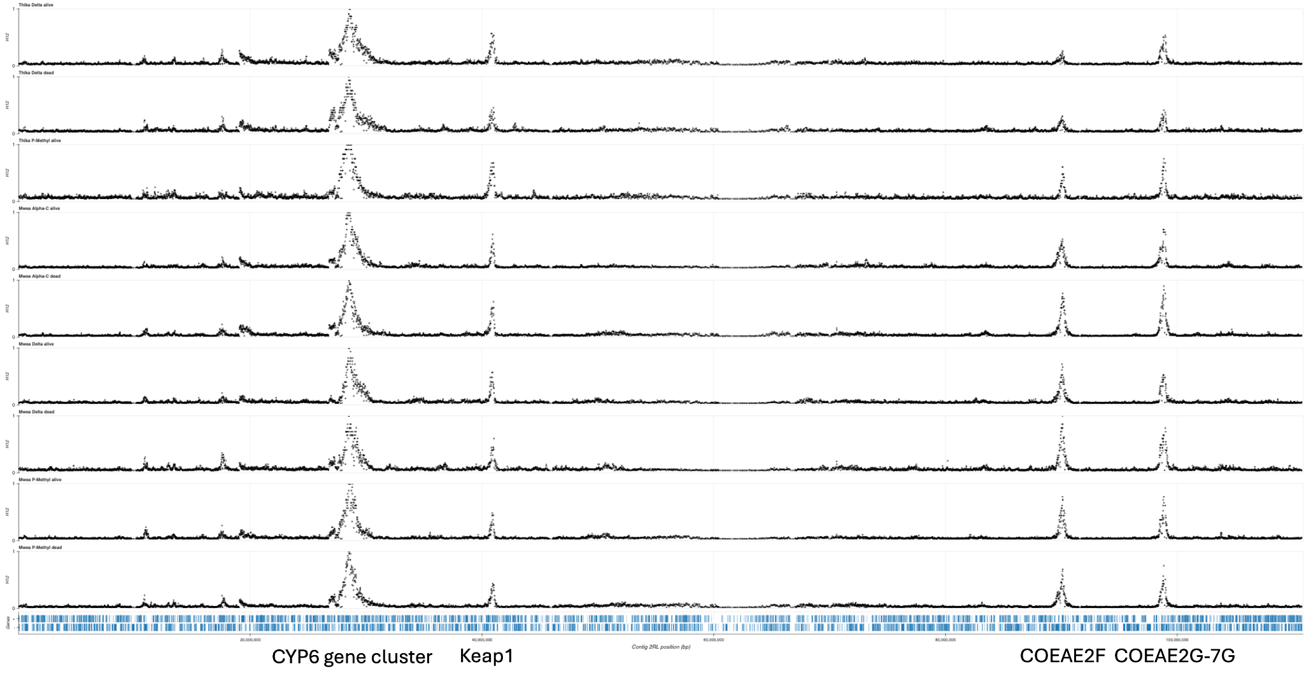
Supplementary Figure 8. Investigation of signals of selection with the H12 statistic calculated across windows of chromosome 2 for population cohorts from Central Kenya. Peaks in H12 values are observed at the Cyp6aa/p gene cluster (2R:28,460,000-28,580,000), Keap1 (2R:40,926,195-40,945,169), Coeae2f (2 L:28,548,433-28,550,748) and Coeae2G-7G (2 L:37,282,152-37,298,223).

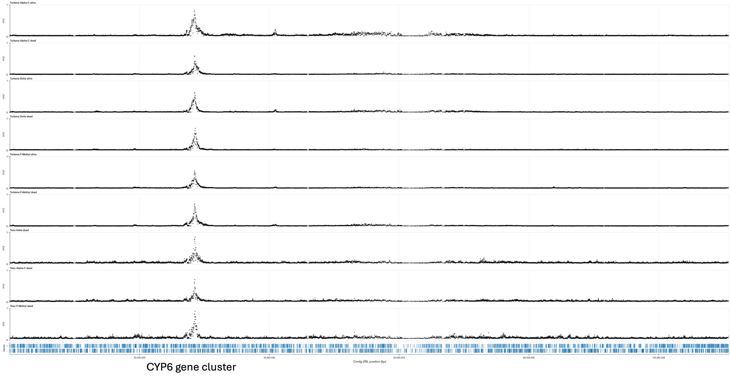

Supplementary Figure 9. Investigation of signals of selection with the H12 statistic calculated across windows of chromosome 2 for population cohorts from northwestern Kenya. A peak in H12 values was observed for the Cyp6aa/p gene cluster (2R:28,460,000-28,580,000).

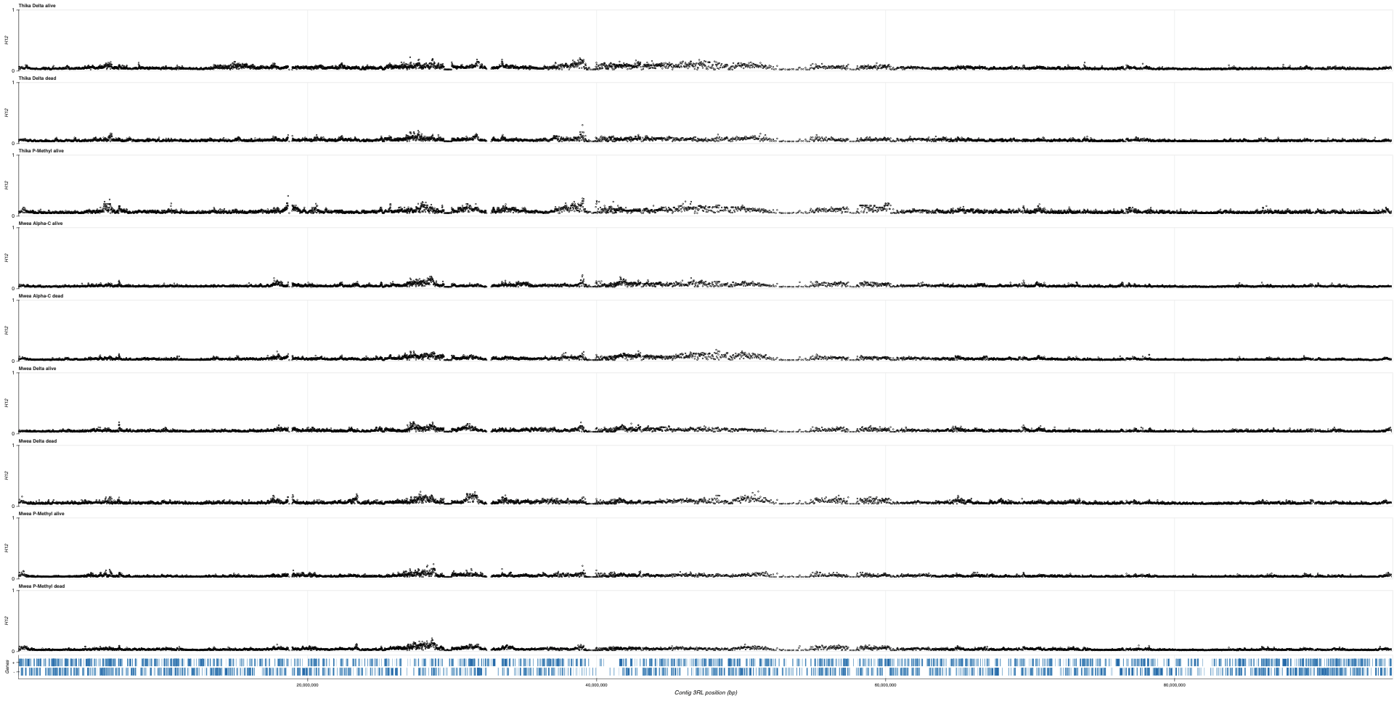

Supplementary Figure 10. Investigation of signals of selection with the H12 statistic calculated across windows of chromosome 3 for population cohorts from Central Kenya. No clear peaks in H12 values are observed.

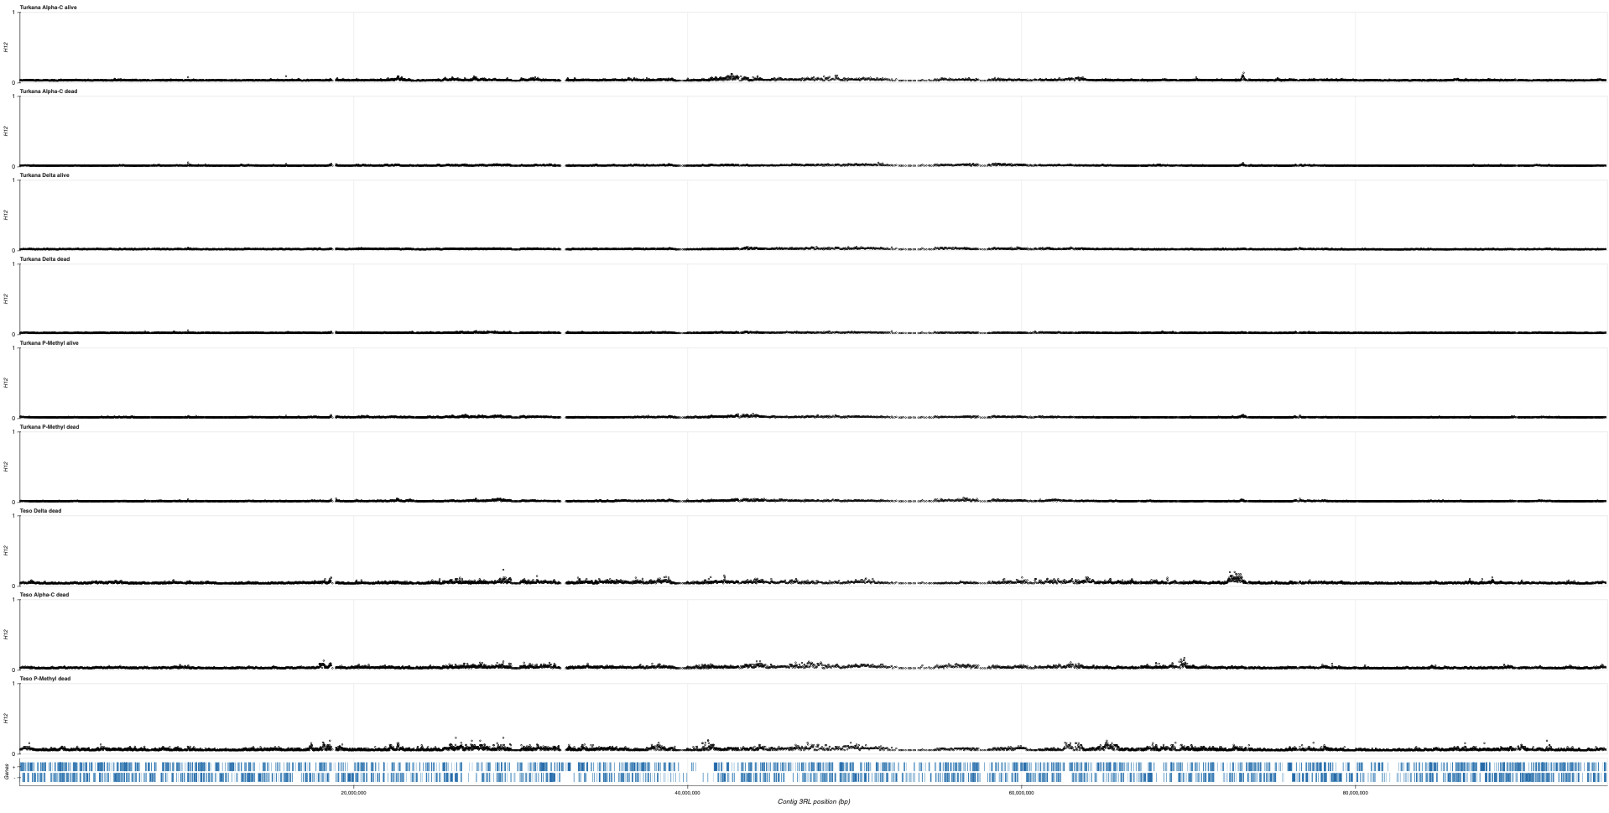

Supplementary Figure 11. Investigation of signals of selection with the H12 statistic calculated across windows of chromosome 3 for population cohorts from northwestern Kenya. No clear peaks in H12 values are observed.

