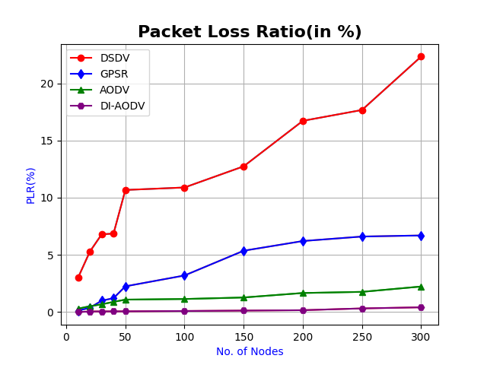
Graph 1. Comparison of Various VANET Protocols with the proposed DI-AODV protocol model using Packet Loss Ratio (in percentage)
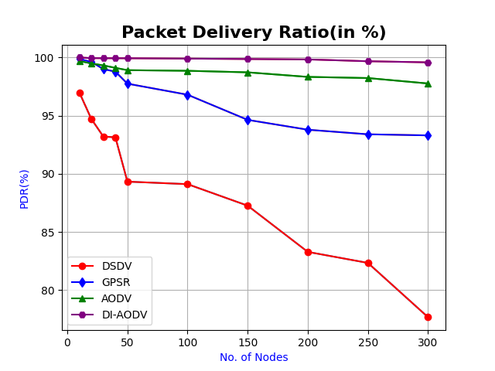
Graph 2. Comparison of Various VANET Protocols with the proposed DI-AODV protocol model using Packet Delivery Ratio (in percentage)

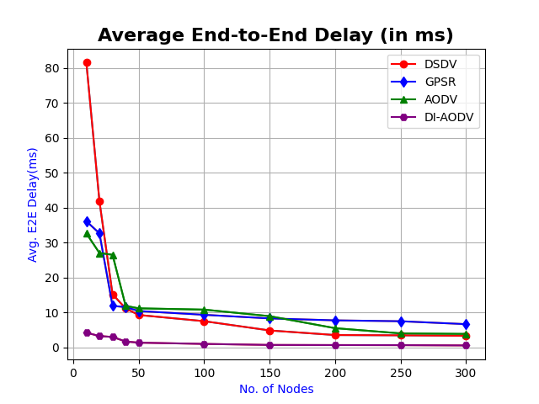
Graph 3. Comparison of Various VANET Protocols with the proposed DI-AODV protocol model using Average End-to-End Delay (in ms)

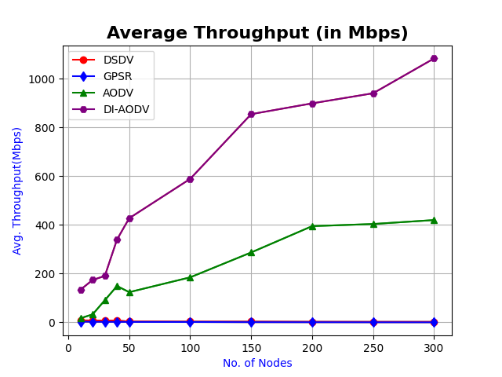
Graph 4. Comparison of Various VANET Protocols with the proposed DI-AODV protocol model using Average Throughput (in Mbps)

