Supplementary Information

Evolution of cyclic clusters in SiO₂ hollow particle shells during heat treatment.
Tatiana N. Fursova*, Nadezhda S. Sukhinina, Vladimir M. Masalov,
Irina I. Zverkova, Gennadi A. Emel’chenko*
Osipyan Institute of Solid State Physics, Russian Academy of Sciences, 142432 Chernogolovka, Russia
* Corresponding authors.
E-mail addresses: fursova@issp.ac.ru (T.N. Fursova), emelch@issp.ac.ru (G.A. Emel’chenko).

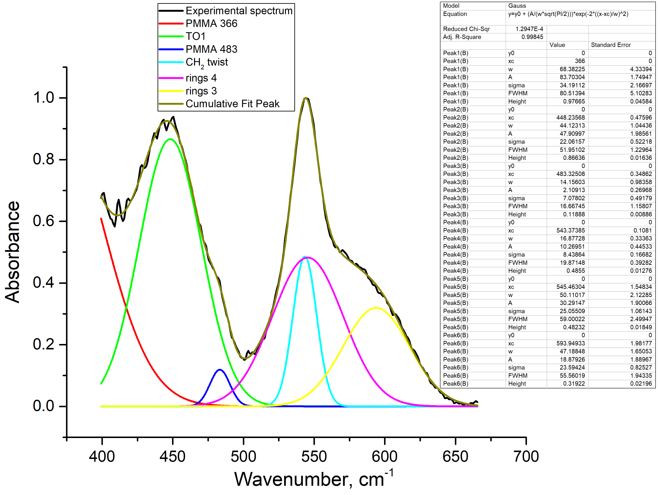
Fig. S1. Deconvolution of the spectrum of the initial PMMA–SiO₂ core-shell particles.

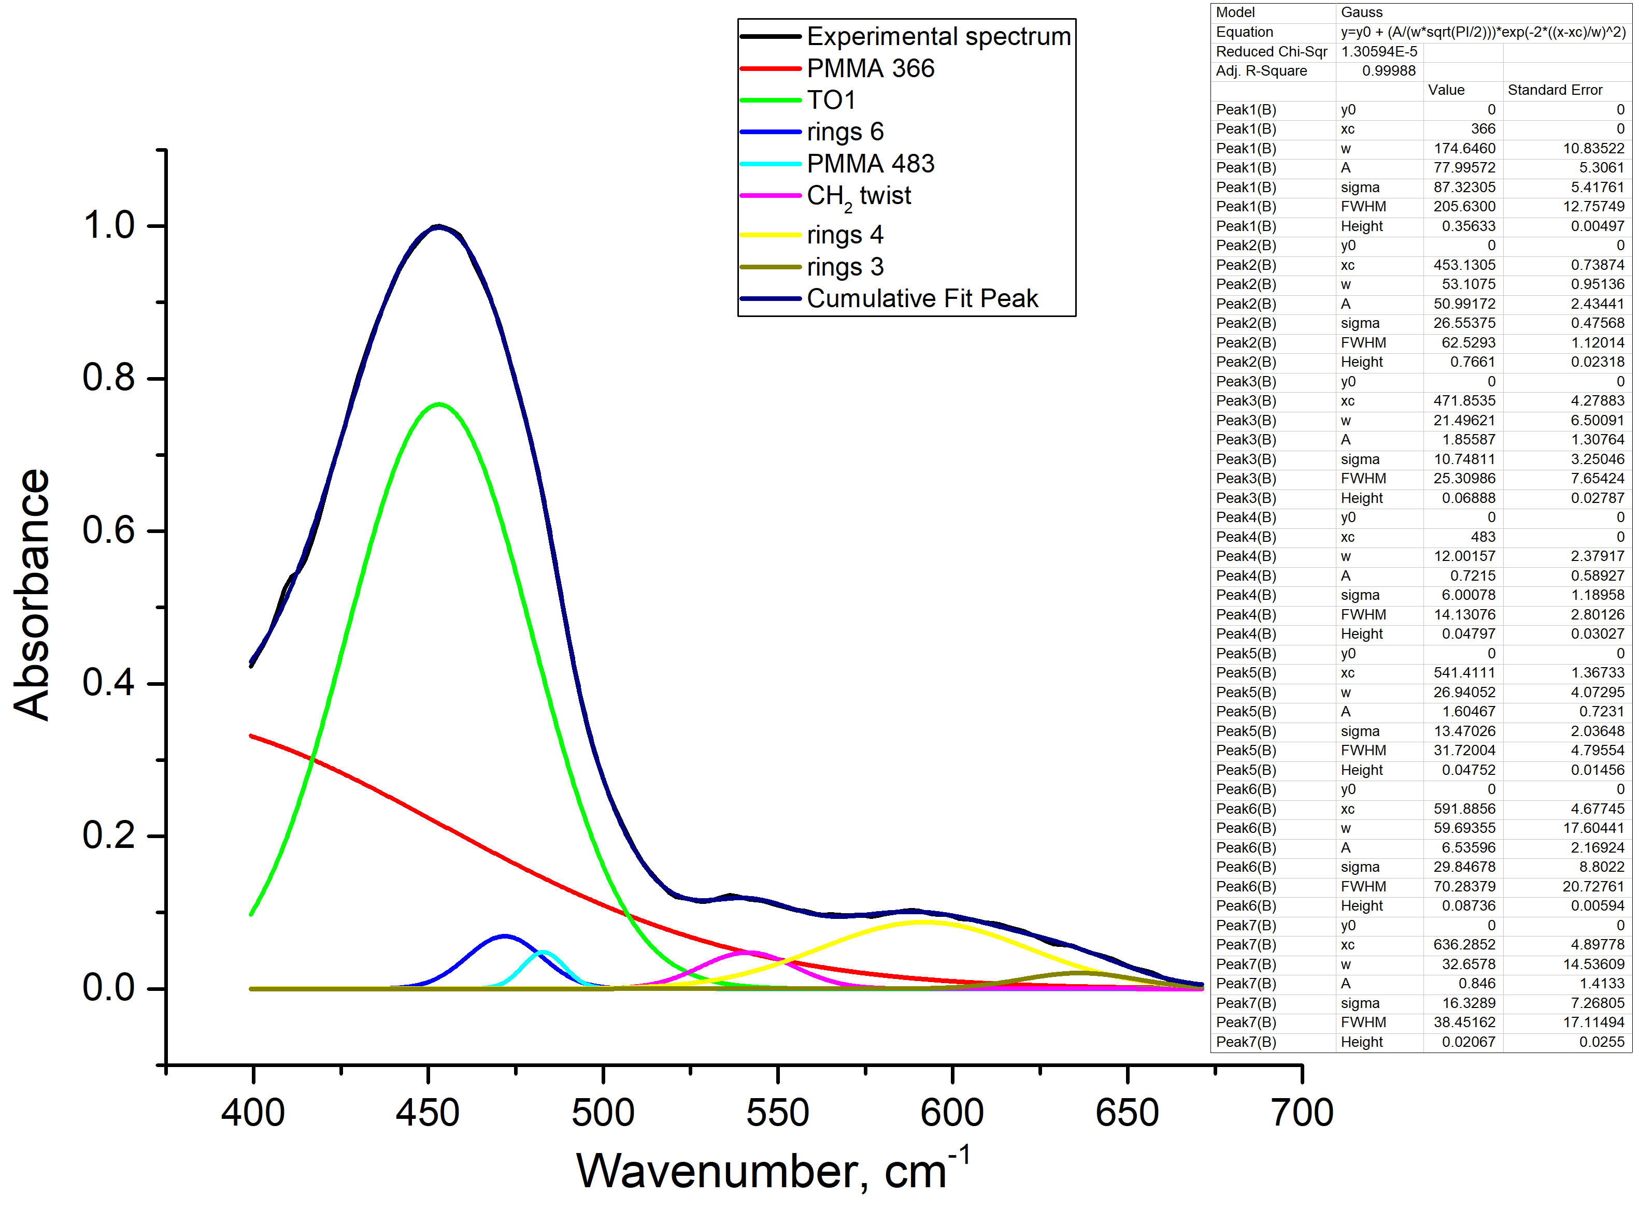
Fig. S2. Deconvolution of the spectrum of the sample annealed at T = 150 °C.

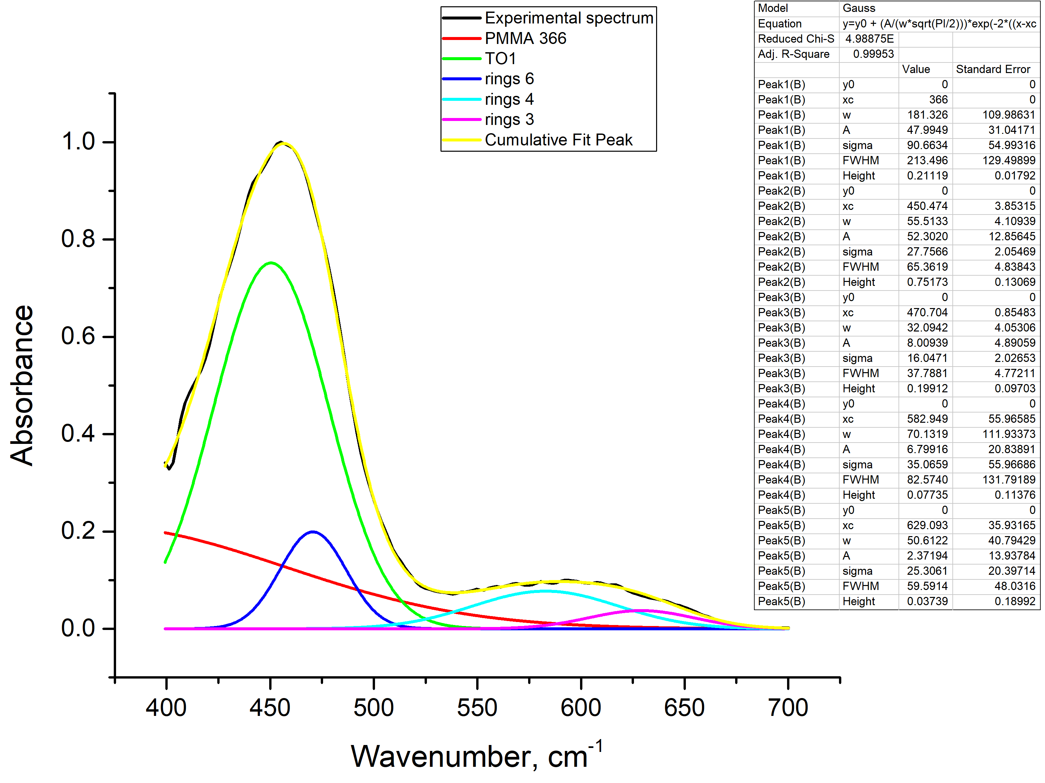
Fig. S3. Deconvolution of the spectrum of the sample annealed at T = 200 °C.

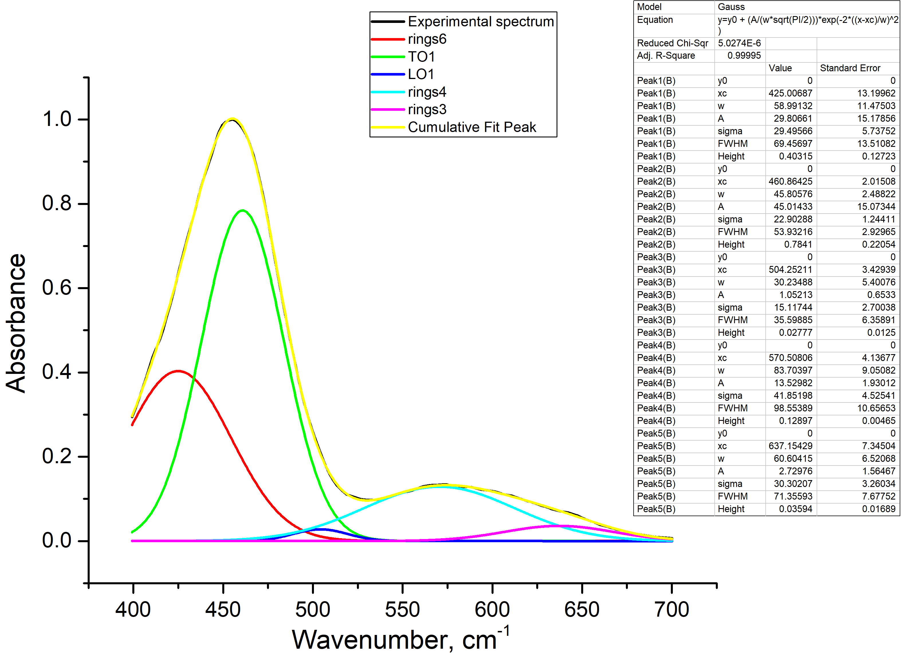
Fig. S4. Deconvolution of the spectrum of the sample annealed at T = 300 °C.

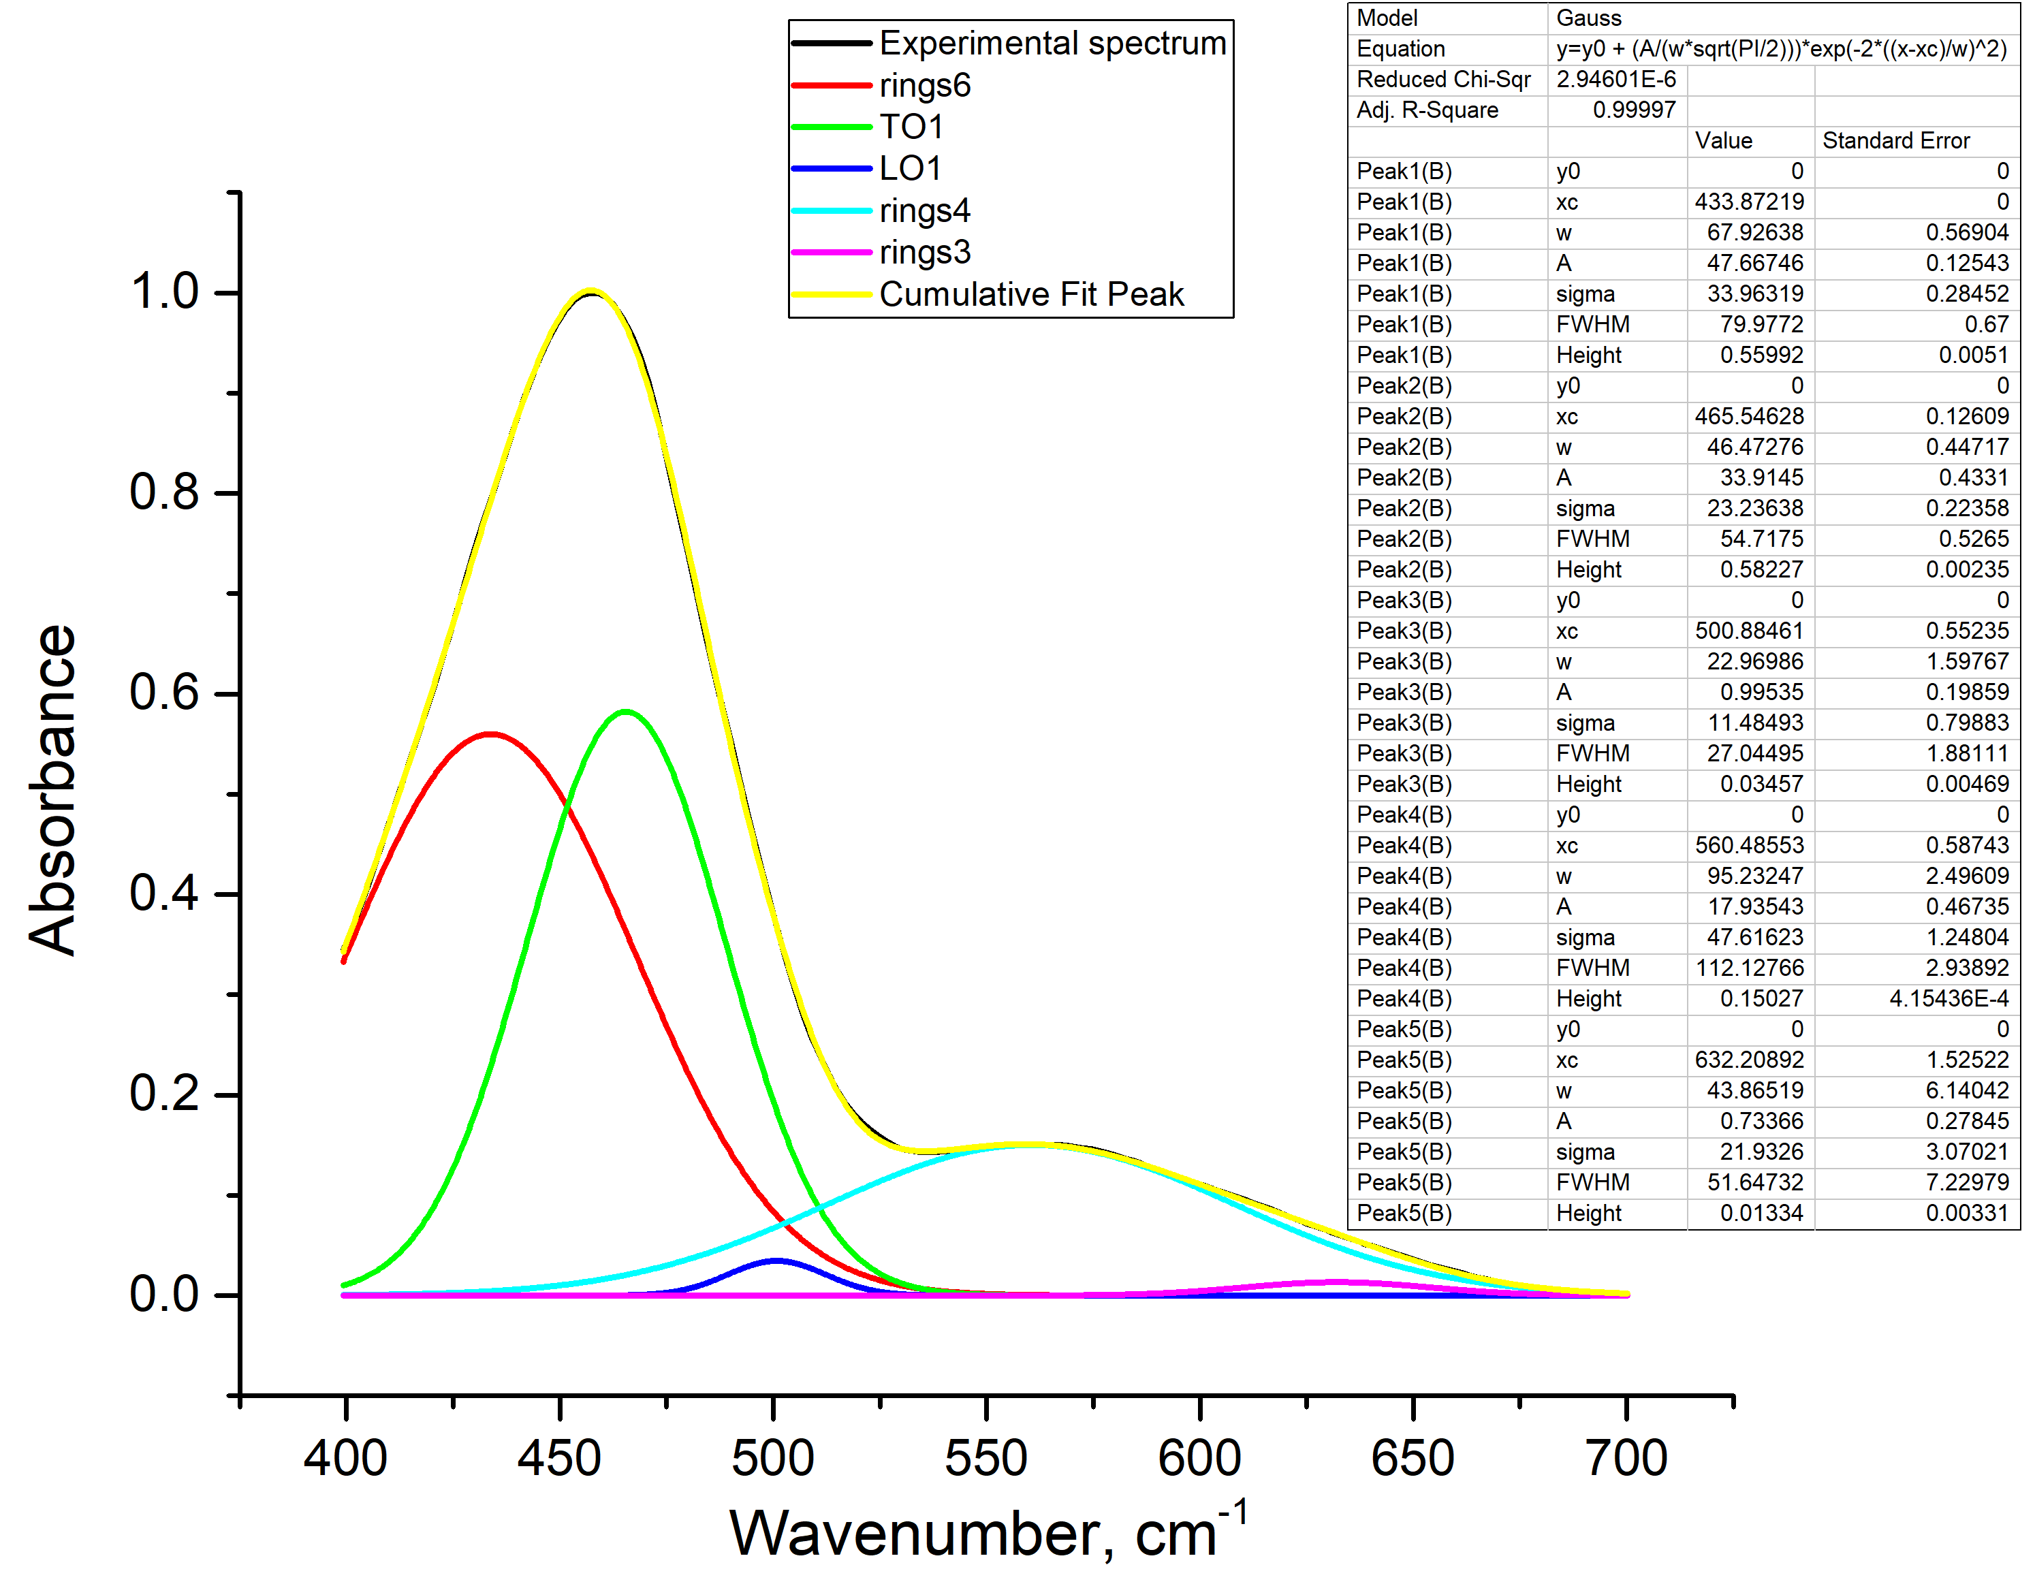
Fig. S5. Deconvolution of the spectrum of the sample annealed at T = 400 °C.

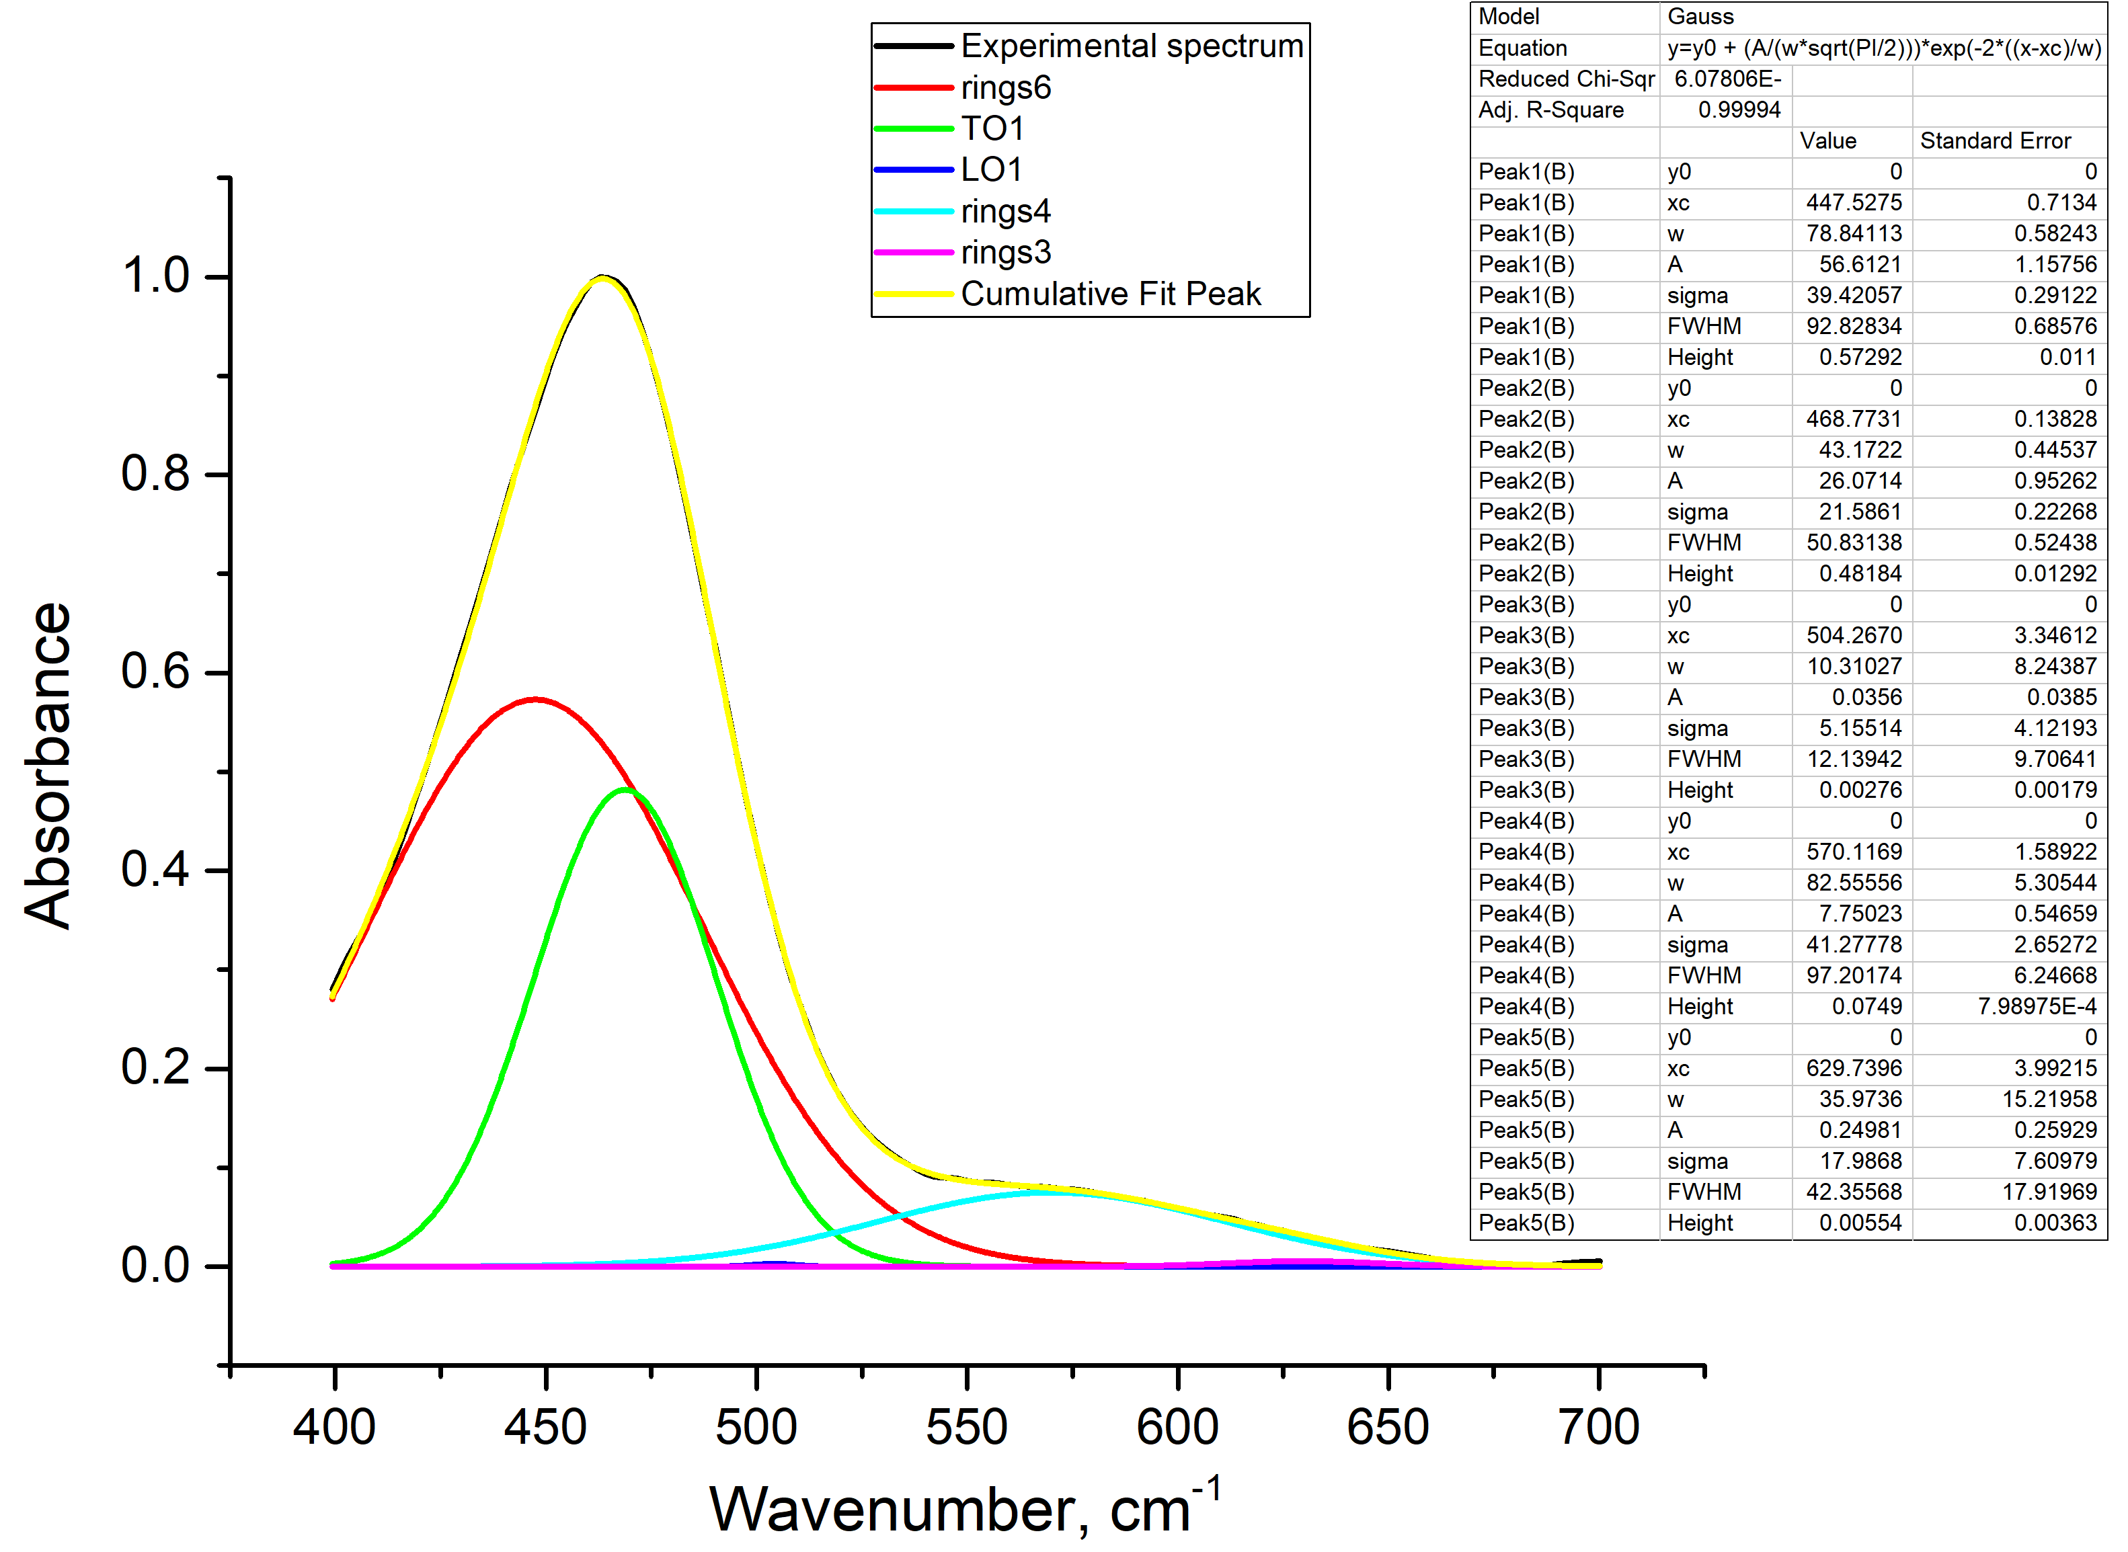
Fig. S6. Deconvolution of the spectrum of the sample annealed at T = 500 °C.

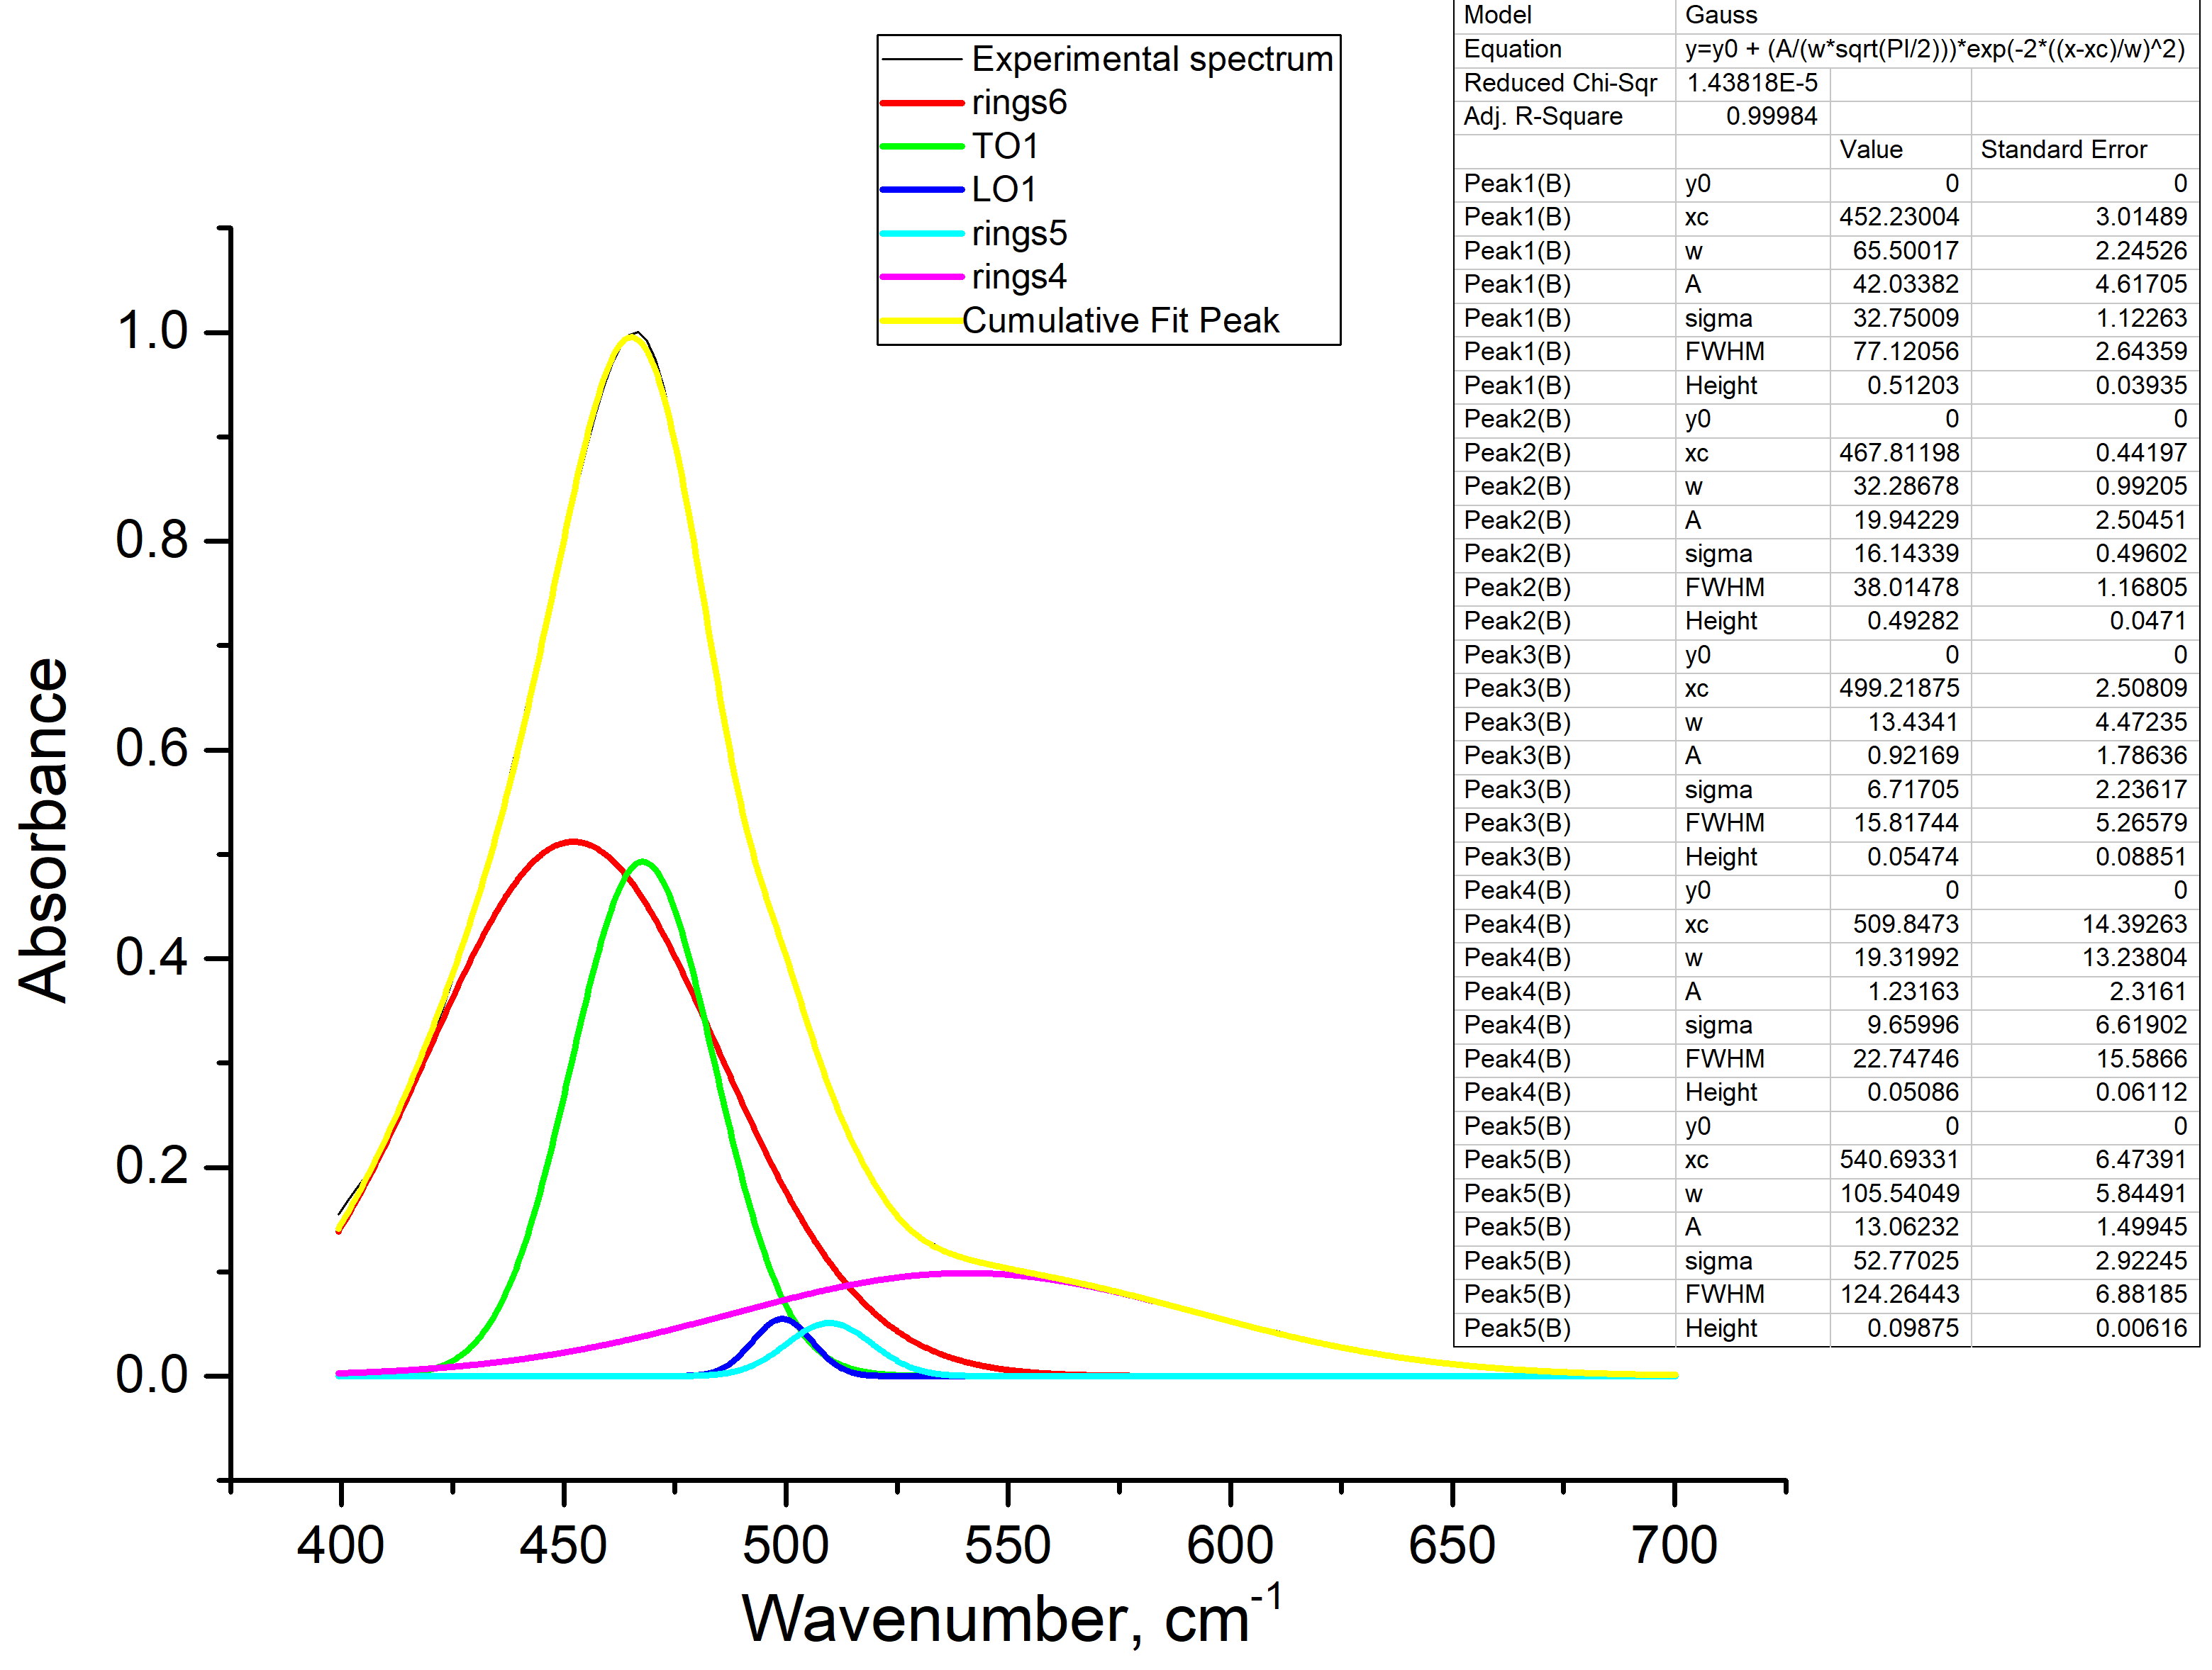
Fig. S7. Deconvolution of the spectrum of the sample annealed at T = 600 °C.

Fig. S8. Deconvolution of the spectrum of the sample annealed at T = 800 °C.

Fig. S9. Deconvolution of the spectrum of the sample annealed at T = 900 °C.

Fig. S10. Deconvolution of the spectrum of the sample annealed at T = 950 °C.

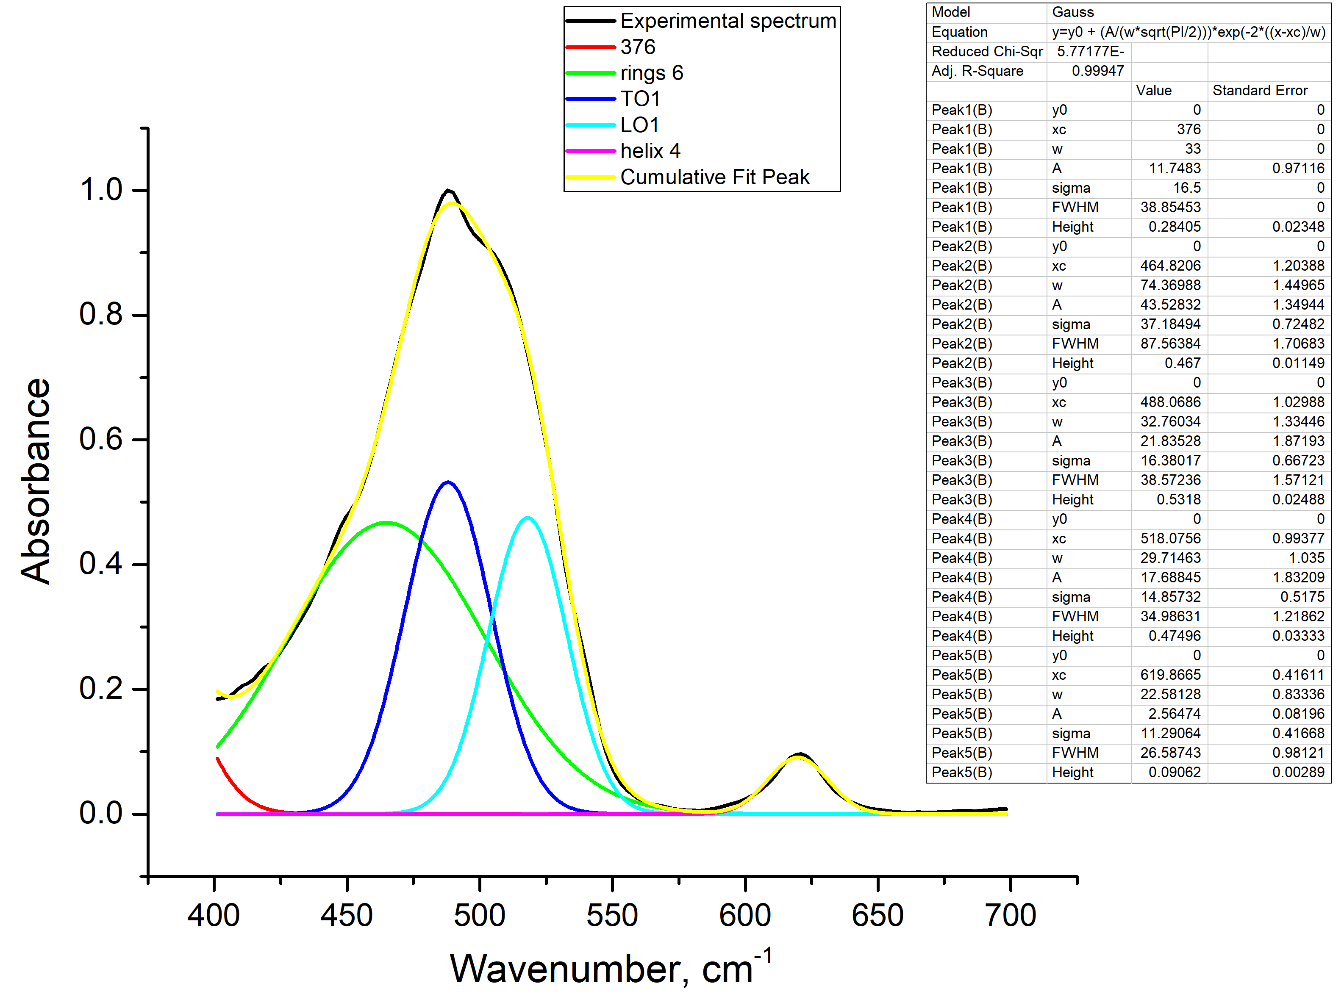
Fig. S11. Deconvolution of the spectrum of the sample annealed at T = 1000 °C.

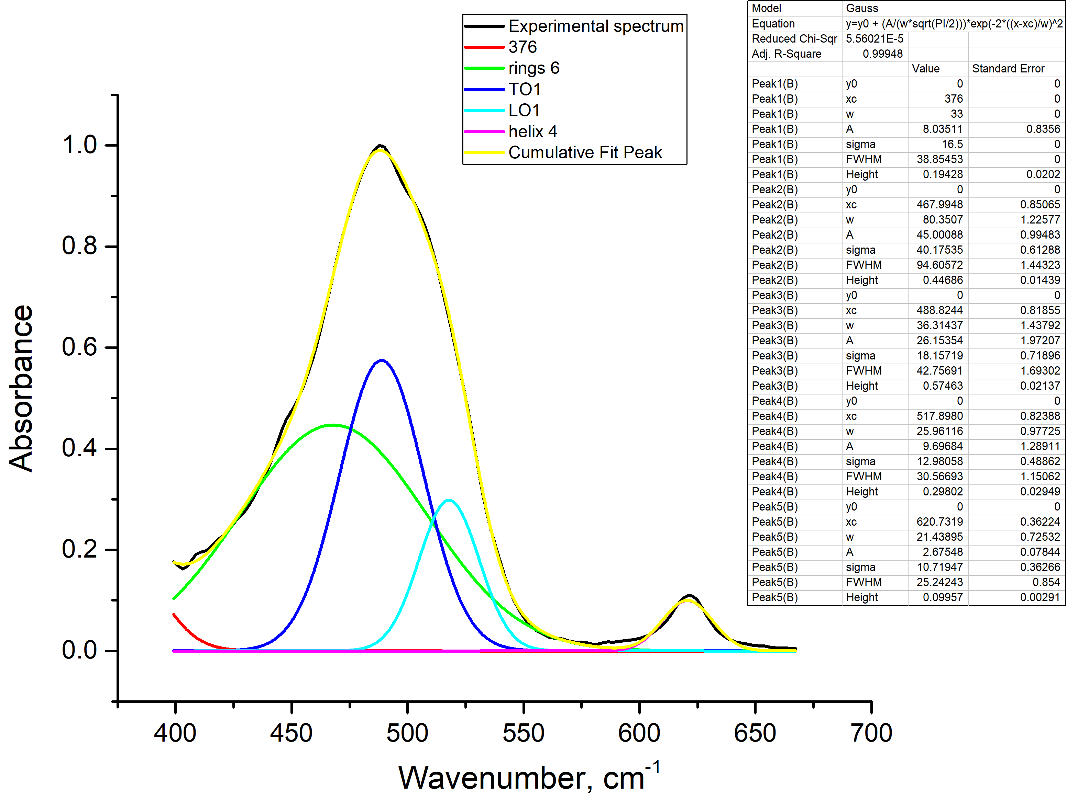
Fig. S12. Deconvolution of the spectrum of the sample annealed at T = 1100 °C.

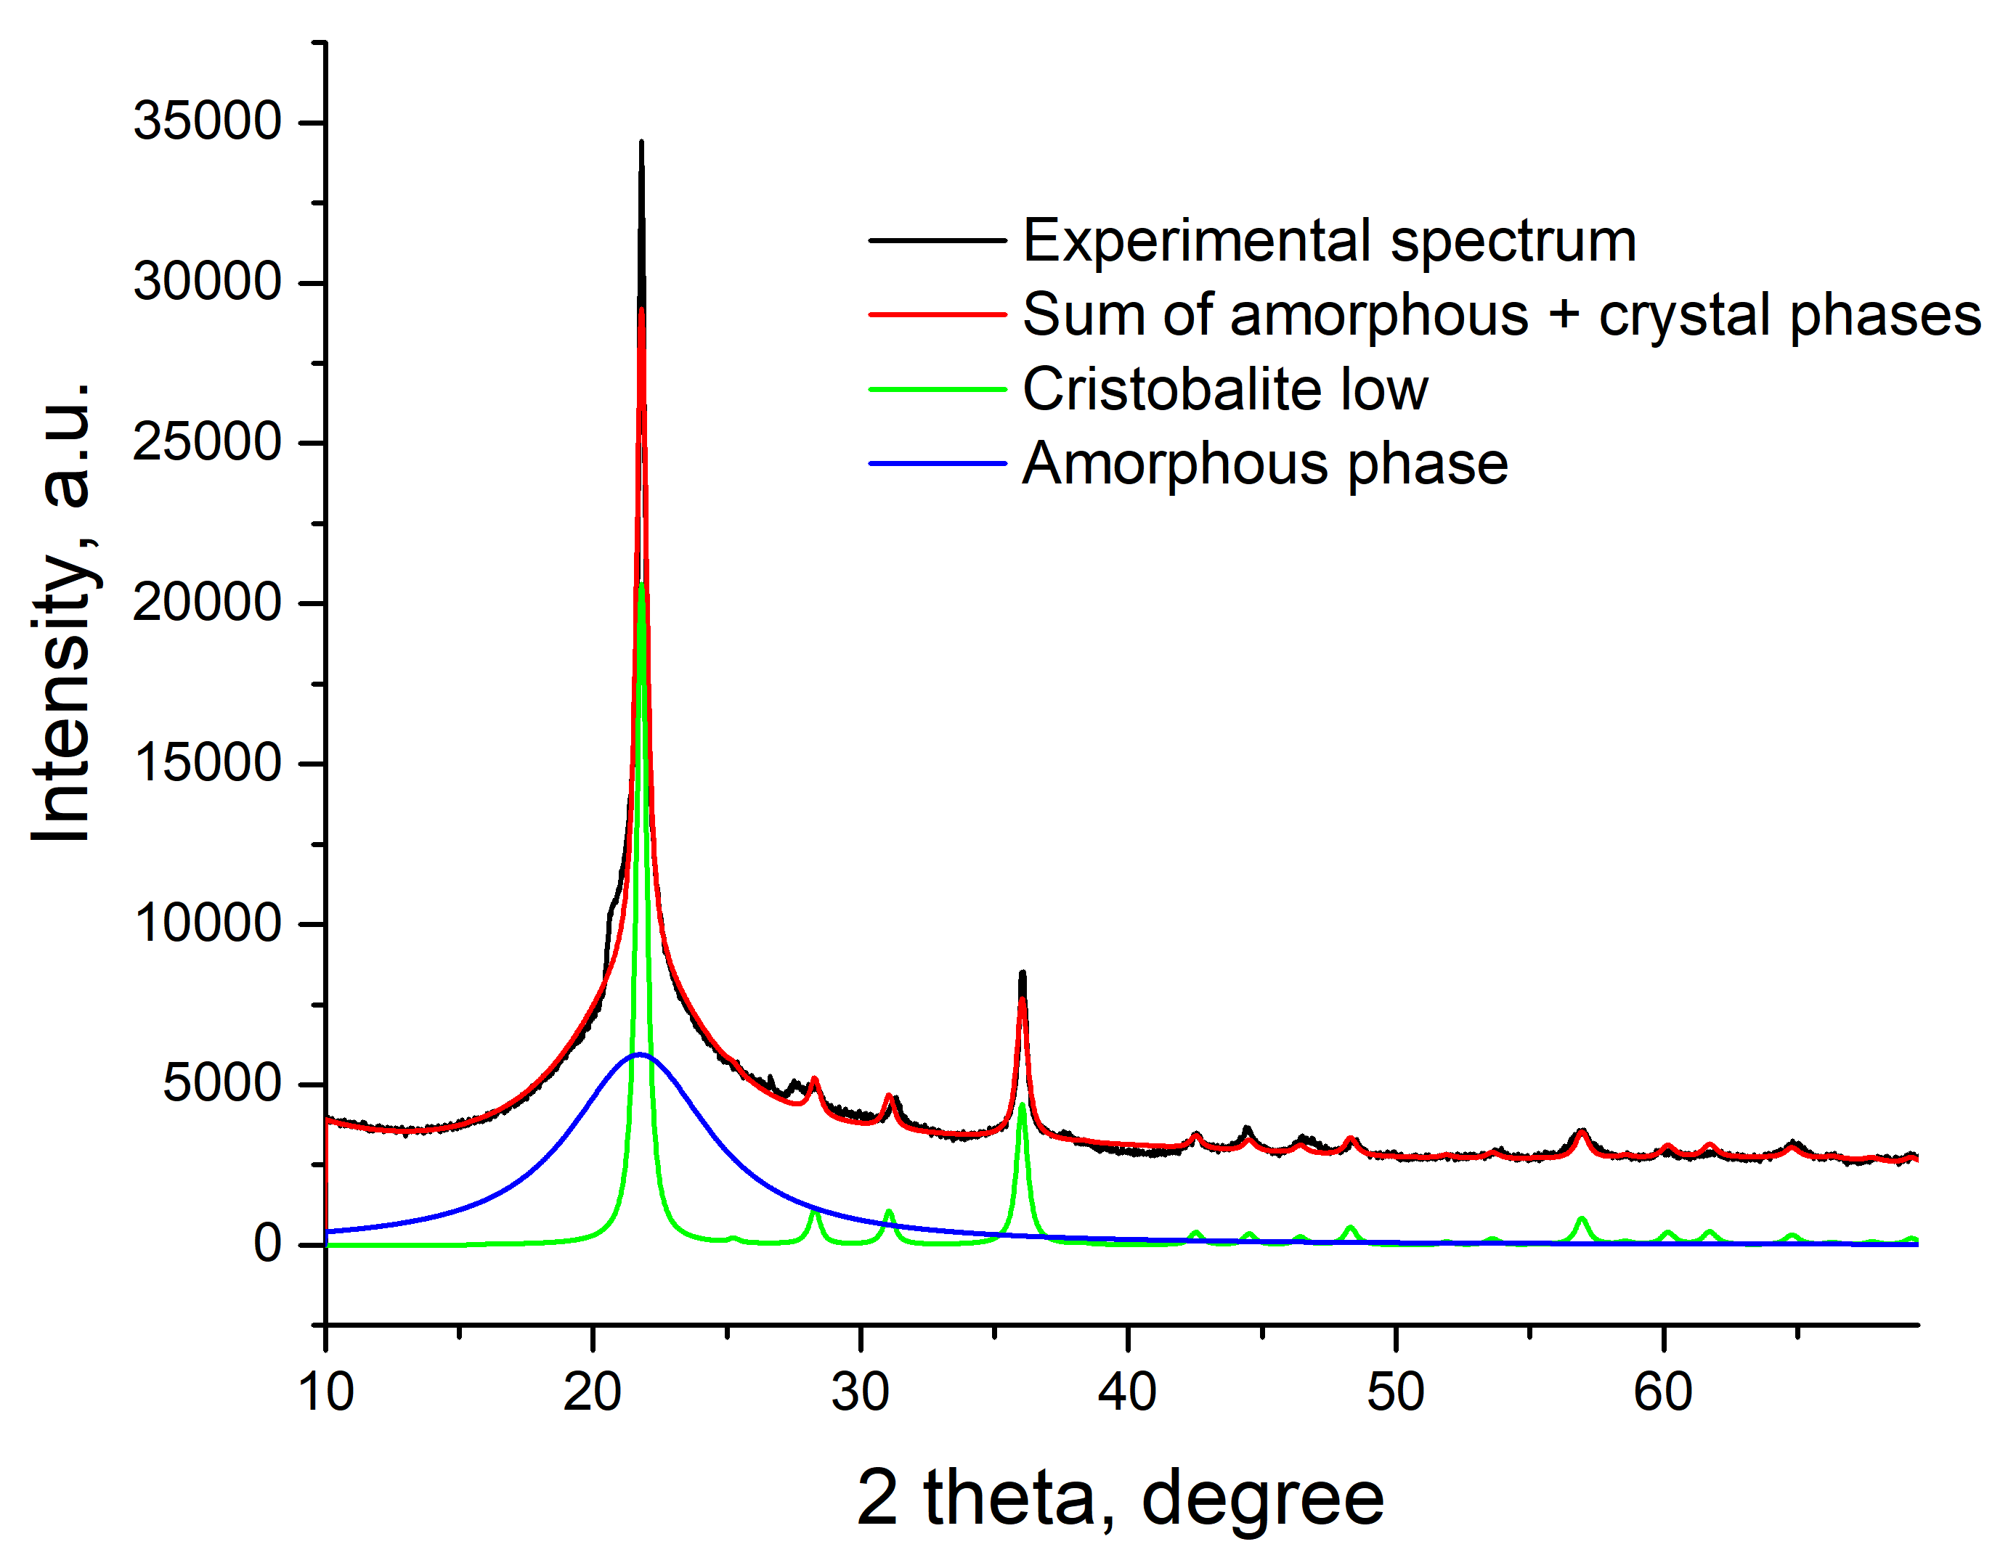
Fig. S13. Decomposition of the experimental X-ray diffraction pattern of the SiO₂ sample (annealing at 1000 °C, 24 hours) into amorphous and crystalline components.

