Excel S1. The clinical characteristics table of 117 patients in TCGA-LSCC.

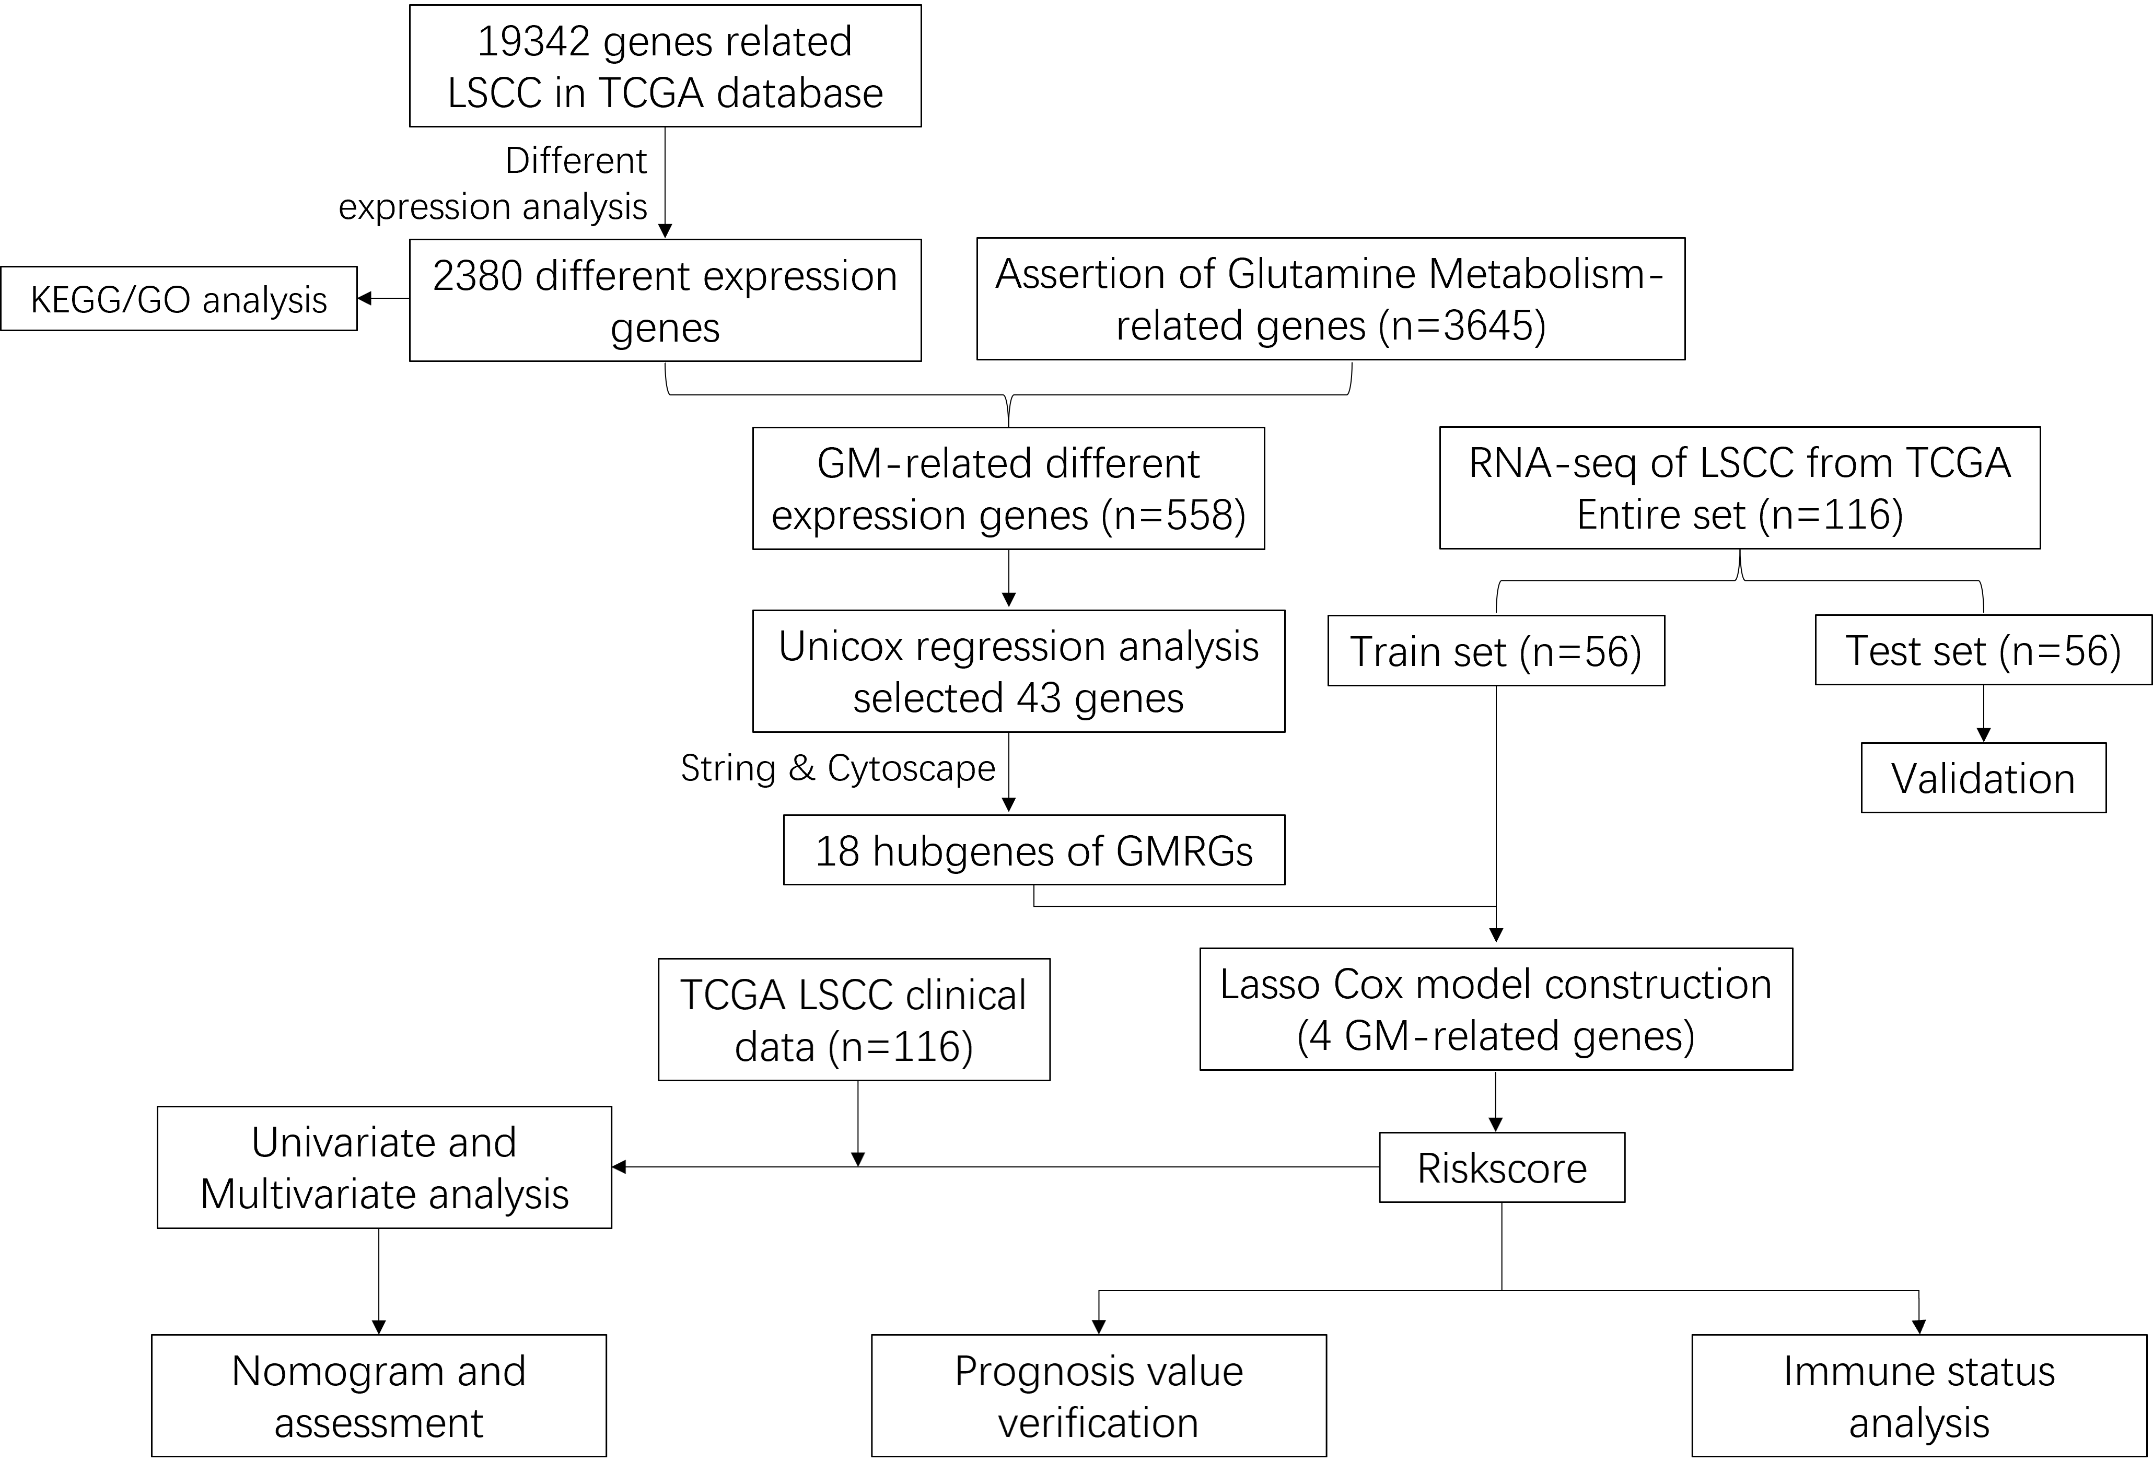
Figure S1. Analysis workflow of the study.

