Interplay between C-reactive protein responses and antibiotic prescribing in suspected bloodstream infections

Supplementary Tables
Table S1. Prescribing decisions in the 24h following different categories of CRP centile changes over the preceding two days.
Characteristic | Recovering faster than expected, N = 4,314¹ | Recovering as expected, N = 22,186¹ | Sub-optimal recovery, N = 5,092¹ | Overall, N = 31,592¹ | p-value²
Prescribing Decision |  |  |  |  | <0.001
Escalation | 395 (9.2%) | 2,381 (10.7%) | 838 (16.5%) | 3,614 (11.4%)
Unchanged | 2,609 (60.5%) | 13,823 (62.3%) | 3,107 (61.0%) | 19,539 (61.8%)
De-escalation | 1,016 (23.6%) | 3,806 (17.2%) | 801 (15.7%) | 5,623 (17.8%)
Stop | 294 (6.8%) | 2,176 (9.8%) | 346 (6.8%) | 2,816 (8.9%)
¹n (%)
²Pearson's Chi-squared test
Note: Centile changes were calculated from CRP measurements over two consecutive days and compared with prescribing decisions made in the 24h following the second CRP measurement. Centile changes of <−15, −15 to 15 and >15 were considered as recovering faster than expected, recovering as expected and sub-optimal recovery, respectively. Presented pictorially in Figure 2A.

Table S2. Factors independently associated with different prescribing decisions following CRP centile changes.
 | Escalation |  |  | De-escalation |  |  | Stop
Characteristic | RRR¹ | 95% CI¹ | p-value | RRR¹ | 95% CI¹ | p-value | RRR¹ | 95% CI¹ | p-value
Centile change | See Figure 2B | — |  | See Figure 2B | — |  | See Figure 2B | —
Prescribing day | See Figure S12 | — |  | See Figure S12 | — |  | See Figure S12 | —
Age at admission (10 years) | 0.98 | 0.96, 1.00 | 0.072 | 0.99 | 0.97, 1.01 | 0.208 | 1.05 | 1.03, 1.08 | <0.001
Sex (male vs female) | 1.04 | 0.96, 1.11 | 0.344 | 1.06 | 0.99, 1.12 | 0.078 | 0.90 | 0.83, 0.98 | 0.013
Charlson score | 1.03 | 0.99, 1.08 | 0.152 | 1.03 | 0.99, 1.07 | 0.175 | 1.03 | 0.98, 1.08 | 0.208
Elixhauser score | 0.96 | 0.93, 0.98 | 0.001 | 0.94 | 0.92, 0.96 | <0.001 | 0.99 | 0.96, 1.02 | 0.365
Renal dialysis | 0.88 | 0.72, 1.07 | 0.193 | 0.79 | 0.66, 0.93 | 0.006 | 0.63 | 0.50, 0.79 | <0.001
Diabetes mellitus | 0.95 | 0.86, 1.05 | 0.330 | 0.97 | 0.89, 1.06 | 0.527 | 0.99 | 0.88, 1.10 | 0.798
NEWS score (baseline) | 1.01 | 0.99, 1.02 | 0.271 | 1.01 | 1.00, 1.02 | 0.085 | 0.99 | 0.97, 1.00 | 0.162
Immunosuppression | 1.02 | 0.93, 1.13 | 0.672 | 1.09 | 1.00, 1.18 | 0.039 | 0.79 | 0.70, 0.88 | <0.001
Palliative care | 1.07 | 0.94, 1.22 | 0.313 | 0.60 | 0.52, 0.69 | <0.001 | 1.08 | 0.93, 1.26 | 0.323
Community-onset | 1.28 | 1.18, 1.39 | <0.001 | 1.80 | 1.66, 1.94 | <0.001 | 0.87 | 0.80, 0.95 | 0.002
Blood culture results
E. coli | — | — |  | — | — |  | — | —
Klebsiella sp. | 0.98 | 0.72, 1.32 | 0.879 | 1.32 | 1.02, 1.71 | 0.035 | 0.79 | 0.45, 1.39 | 0.418
Other Enterobacterales | 0.96 | 0.67, 1.38 | 0.826 | 1.01 | 0.72, 1.40 | 0.963 | 0.48 | 0.21, 1.14 | 0.095
Pseudomonas aeruginosa | 1.05 | 0.73, 1.50 | 0.795 | 0.67 | 0.46, 0.98 | 0.039 | 0.19 | 0.06, 0.61 | 0.005
Enterobacter sp. | 0.73 | 0.40, 1.34 | 0.312 | 0.83 | 0.49, 1.40 | 0.477 | 0.61 | 0.24, 1.55 | 0.295
Staphylococcus aureus | 0.70 | 0.53, 0.93 | 0.014 | 0.83 | 0.65, 1.06 | 0.134 | 0.22 | 0.10, 0.48 | <0.001
Beta-Hemolytic Streptococci | 0.61 | 0.39, 0.96 | 0.032 | 1.47 | 1.07, 2.01 | 0.016 | 1.09 | 0.49, 2.44 | 0.837
Enterococcus sp. | 1.46 | 1.03, 2.05 | 0.032 | 1.26 | 0.90, 1.76 | 0.183 | 1.17 | 0.68, 2.01 | 0.566
Streptococcus pneumoniae | 0.69 | 0.42, 1.11 | 0.127 | 1.40 | 0.98, 1.98 | 0.061 | 0.39 | 0.09, 1.60 | 0.189
Other Pathogenic Streptococcus | 0.37 | 0.17, 0.82 | 0.014 | 0.77 | 0.42, 1.40 | 0.393 | 0.21 | 0.03, 1.51 | 0.120
Other | 1.23 | 0.88, 1.71 | 0.222 | 1.10 | 0.80, 1.52 | 0.546 | 0.65 | 0.33, 1.29 | 0.217
Polymicrobial | 1.46 | 1.07, 2.00 | 0.017 | 1.15 | 0.84, 1.58 | 0.379 | 0.55 | 0.29, 1.04 | 0.067
Anaerobes | 0.77 | 0.48, 1.24 | 0.290 | 1.24 | 0.86, 1.80 | 0.247 | 0.88 | 0.39, 1.98 | 0.759
Culture-negative | 0.66 | 0.57, 0.77 | <0.001 | 0.89 | 0.78, 1.01 | 0.075 | 2.76 | 2.16, 3.53 | <0.001
CoNS (contaminant) | 0.90 | 0.73, 1.11 | 0.309 | 0.88 | 0.73, 1.07 | 0.215 | 2.84 | 2.12, 3.82 | <0.001
Other Suspected Contaminants | 1.03 | 0.63, 1.67 | 0.907 | 1.07 | 0.69, 1.66 | 0.758 | 2.74 | 1.53, 4.92 | <0.001
Viridans and Other Streptococcus | 0.86 | 0.54, 1.36 | 0.512 | 1.38 | 0.96, 1.99 | 0.079 | 1.13 | 0.58, 2.21 | 0.724
Source of infection
Urinary | — | — |  | — | — |  | — | —
Unspecific | 0.67 | 0.57, 0.79 | <0.001 | 0.73 | 0.65, 0.82 | <0.001 | 1.38 | 1.18, 1.61 | <0.001
Respiratory | 1.26 | 1.10, 1.45 | <0.001 | 0.83 | 0.75, 0.93 | <0.001 | 0.90 | 0.77, 1.04 | 0.163
Multiple sources | 1.87 | 1.63, 2.13 | <0.001 | 1.05 | 0.95, 1.17 | 0.351 | 0.71 | 0.60, 0.83 | <0.001
Abdominal | 1.37 | 1.18, 1.59 | <0.001 | 0.80 | 0.71, 0.90 | <0.001 | 1.17 | 0.99, 1.37 | 0.062
Skin, soft tissue, orthopaedic | 1.07 | 0.89, 1.29 | 0.483 | 0.89 | 0.78, 1.02 | 0.098 | 0.59 | 0.47, 0.73 | <0.001
CNS | 0.86 | 0.59, 1.28 | 0.463 | 0.55 | 0.39, 0.77 | <0.001 | 1.10 | 0.77, 1.57 | 0.600
Other | 1.06 | 0.82, 1.38 | 0.668 | 0.84 | 0.68, 1.04 | 0.116 | 0.78 | 0.56, 1.08 | 0.132
¹RRR = Relative-Risk Ratio vs. Unchanged, CI = Confidence Interval

Table S3. Factors independently associated with all-cause mortality over 5-30 days following index blood culture..
 | Covariates Only |  |  | Covariates + CRP centile change |  |  | Change in log(OR) (%)
Characteristic | OR¹ | 95% CI¹ | p-value | OR¹ | 95% CI¹ | p-value | Change in log(OR) (%)
Age at admission (10 years) | 1.59 | 1.51, 1.68 | <0.001 | 1.58 | 1.50, 1.67 | <0.001 | 0.0
Sex (male vs female) | 1.13 | 0.99, 1.29 | 0.074 | 1.12 | 0.98, 1.28 | 0.10 | -8.3
Charlson score | 1.15 | 1.07, 1.23 | <0.001 | 1.16 | 1.08, 1.25 | <0.001 | 7.1
Elixhauser score | 1.08 | 1.03, 1.12 | 0.001 | 1.06 | 1.02, 1.11 | 0.008 | -14.3
Renal dialysis | 0.78 | 0.49, 1.21 | 0.29 | 0.77 | 0.48, 1.18 | 0.25 | 12.5
Diabetes mellitus | 0.78 | 0.65, 0.92 | 0.005 | 0.77 | 0.65, 0.92 | 0.004 | 4.0
NEWS score (baseline) | 1.11 | 1.08, 1.13 | <0.001 | 1.13 | 1.10, 1.15 | <0.001 | 20.0
Immunosuppression | 1.36 | 1.15, 1.61 | <0.001 | 1.32 | 1.11, 1.57 | 0.001 | -9.7
Palliative care | 13.6 | 11.5, 16.0 | <0.001 | 12.7 | 10.7, 15.0 | <0.001 | -3.8
Community-onset | 0.98 | 0.85, 1.14 | 0.83 | 1.01 | 0.87, 1.18 | 0.89 | -150.0
Blood culture result
E. coli | — | — |  | — | —
Klebsiella sp. | 1.26 | 0.61, 2.46 | 0.51 | 1.18 | 0.56, 2.31 | 0.65 | -30.4
Other Enterobacterales | 2.01 | 0.99, 3.95 | 0.047 | 1.95 | 0.95, 3.85 | 0.060 | -4.3
Pseudomonas aeruginosa | 0.73 | 0.28, 1.69 | 0.48 | 0.80 | 0.30, 1.88 | 0.62 | -28.1
Enterobacter sp. | 1.07 | 0.23, 3.53 | 0.92 | 1.21 | 0.26, 3.95 | 0.78 | 171.4
Staphylococcus aureus | 1.54 | 0.86, 2.70 | 0.14 | 1.53 | 0.86, 2.68 | 0.14 | 0.0
Beta-Hemolytic Streptococci | 0.77 | 0.25, 1.90 | 0.60 | 0.75 | 0.25, 1.85 | 0.57 | 11.5
Enterococcus sp. | 1.64 | 0.78, 3.29 | 0.18 | 1.43 | 0.67, 2.89 | 0.33 | -28.0
Streptococcus pneumoniae | 0.57 | 0.20, 1.42 | 0.27 | 0.60 | 0.20, 1.52 | 0.32 | -9.1
Other Pathogenic Streptococcus | 1.10 | 0.33, 3.38 | 0.87 | 0.92 | 0.27, 2.82 | 0.89 | -180.0
Other | 2.51 | 1.26, 4.79 | 0.007 | 2.17 | 1.09, 4.13 | 0.022 | -15.2
Polymicrobial | 2.69 | 1.33, 5.27 | 0.005 | 2.44 | 1.20, 4.79 | 0.011 | -10.1
Anaerobes | 1.71 | 0.61, 4.24 | 0.28 | 1.58 | 0.56, 3.97 | 0.36 | -13.2
Culture-negative | 1.35 | 0.99, 1.87 | 0.067 | 1.18 | 0.86, 1.63 | 0.32 | -46.7
CoNS (contaminant) | 1.30 | 0.85, 2.00 | 0.23 | 1.13 | 0.73, 1.74 | 0.58 | -53.8
Other Suspected Contaminants | 0.92 | 0.21, 2.83 | 0.89 | 0.84 | 0.18, 2.67 | 0.80 | 88.9
Viridans and Other Streptococcus | 0.70 | 0.18, 2.04 | 0.56 | 0.55 | 0.14, 1.63 | 0.34 | 66.7
Source of infection
Urinary | — | — |  | — | —
Unspecific | 1.27 | 0.96, 1.70 | 0.10 | 1.27 | 0.95, 1.69 | 0.11 | 0.0
Respiratory | 2.30 | 1.80, 2.95 | <0.001 | 2.26 | 1.77, 2.91 | <0.001 | -1.2
Multiple sources | 1.75 | 1.36, 2.26 | <0.001 | 1.72 | 1.33, 2.24 | <0.001 | -3.6
Abdominal | 1.13 | 0.83, 1.54 | 0.43 | 1.16 | 0.85, 1.59 | 0.34 | 25.0
Skin, soft tissue, orthopedic | 0.67 | 0.43, 1.03 | 0.073 | 0.68 | 0.43, 1.05 | 0.087 | -2.5
CNS | 2.65 | 1.23, 5.20 | 0.008 | 2.93 | 1.36, 5.77 | 0.003 | 13.4
Other | 1.29 | 0.71, 2.24 | 0.38 | 1.26 | 0.70, 2.18 | 0.43 | -11.5
¹OR = Odds Ratio, CI = Confidence Interval
Note: Mean CRP centile change was calculated for each individual patient using ordinary least squares regression on values from day 1 to day 4, see Methods. Change in log(OR)% = ((log(OR) with CRP centile change- log(OR) covariates only) / log(OR) covariates only) × 100, used to quantify the percentage change in the association of a covariate with the outcome after adjusting for CRP centile change.
Table S4. Ranking list of antibiotics.
1 |  | 2 | 3 | 4 | 5
Narrow Spectrum | Additions to any (or "narrow spectrum" if used as monotherapy) | Broad spectrum | Extended spectrum | Antipseudomonal | Protected
First/Second generation cephalosporins¹ | Aminoglycosides² | Fluoroquinolones³ | Third generation cephalosporins⁴ | Antipseudomonal penicillin⁵ | Antipseudomonal carbapenem⁶
Amoxicillin | Clarithromycin | Co-amoxiclav |  | Ceftazidime | Linezolid
Metronidazole | Clindamycin | Co-trimoxazole |  | Aztreonam | Daptomycin
Flucloxacillin | Azithromycin |  |  |  | Colistin
Doxycycline | Erythromycin |  |  |  | Tigecycline
Nitrofurantoin | Rifampicin |  |  |  | Ceftazidime/avibactam
Benzylpenicillin | Vancomycin |  |  |  | Ceftolozane/tazobactam
Phenoxymethylpenicillin | Teicoplanin |  |  |  | Ertapenem
Trimethoprim
Fosfomycin
Pivmecillinam
¹ First/Second generation cephalosporins: cefalexin, cefazolin, cefradine, cefuroxime
² Aminoglycosides: amikacin, gentamicin, streptomycin, tobramycin
³ Fluoroquinolones: ciprofloxacin, ofloxacin, levofloxacin, moxifloxacin
⁴ Third generation cephalosporins: cefixime, cefotaxime, cefoxitin, ceftriaxone
⁵ Antipseudomonal penicillin: piperacillin/tazobactam, temocillin, piperacillin
⁶ Antipseudomonal carbapenem: imipenem, meropenem, imipenem/cilastatin
Note: Antibiotic agents used for suspected BSI were ranked on a five-tiered scale, which considered the agents’ spectrum of activity against bacterial pathogens as well as the priority for stewardship.

Supplementary Figures
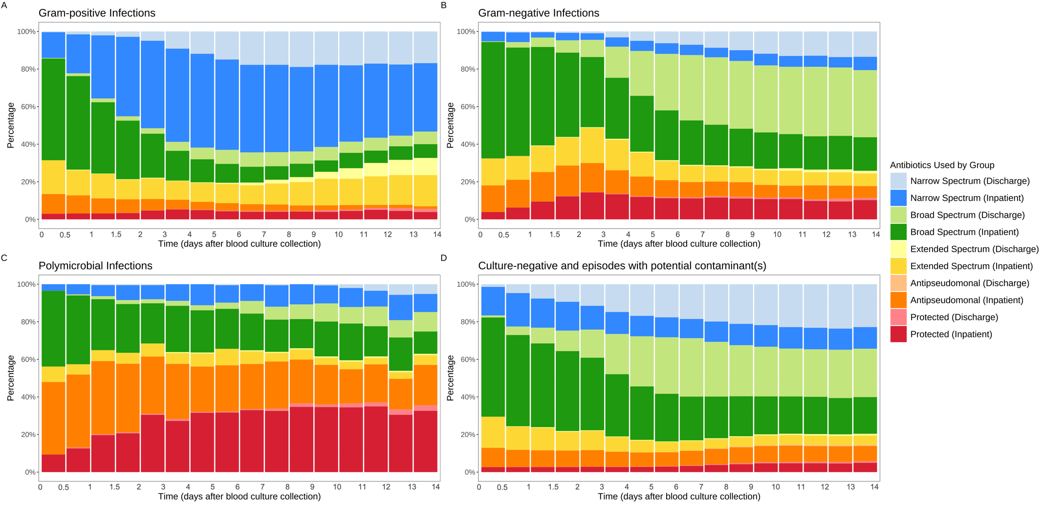
Figure S1. Trends in combined inpatient and discharge antibiotic use for suspected BSI episodes where the patient was still on antibiotics, within 14 days following index blood culture collection.
Gram-positive pathogens in panel A, Gram-negative pathogens in panel B, polymicrobial infections in panel C, and potential contaminants or culture-negative results in panel D. Discharge antibiotic orders were in light colour, while inpatient orders were in dark colour.

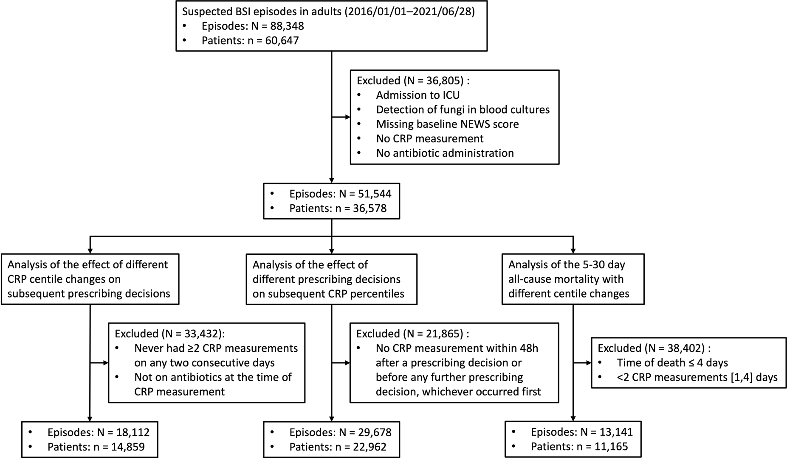
Figure S2. Flowchart to identify study population for different analyses.

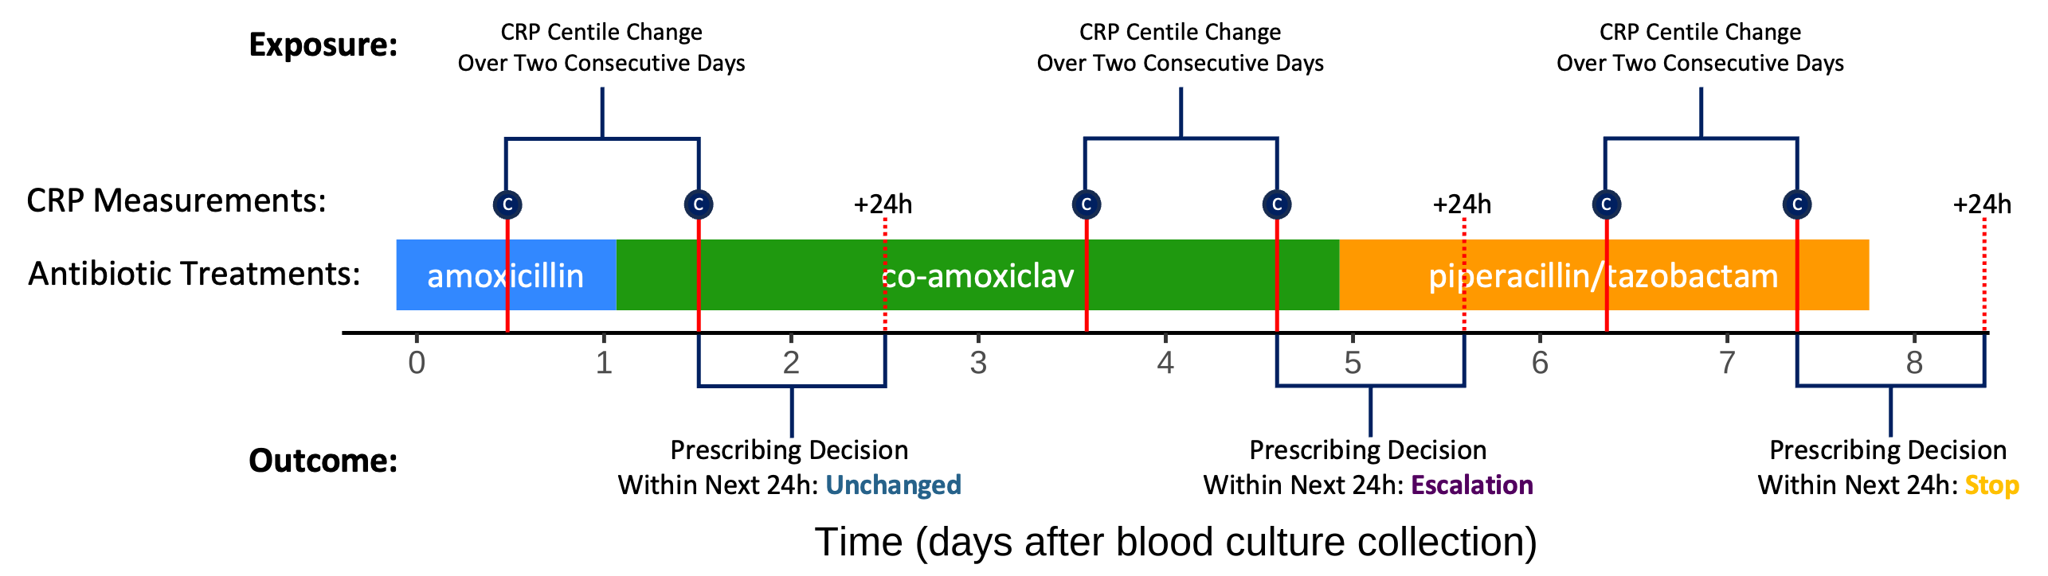
Figure S3. Illustrative diagram of analysis of impact of changes in CRP centiles on prescribing decisions.

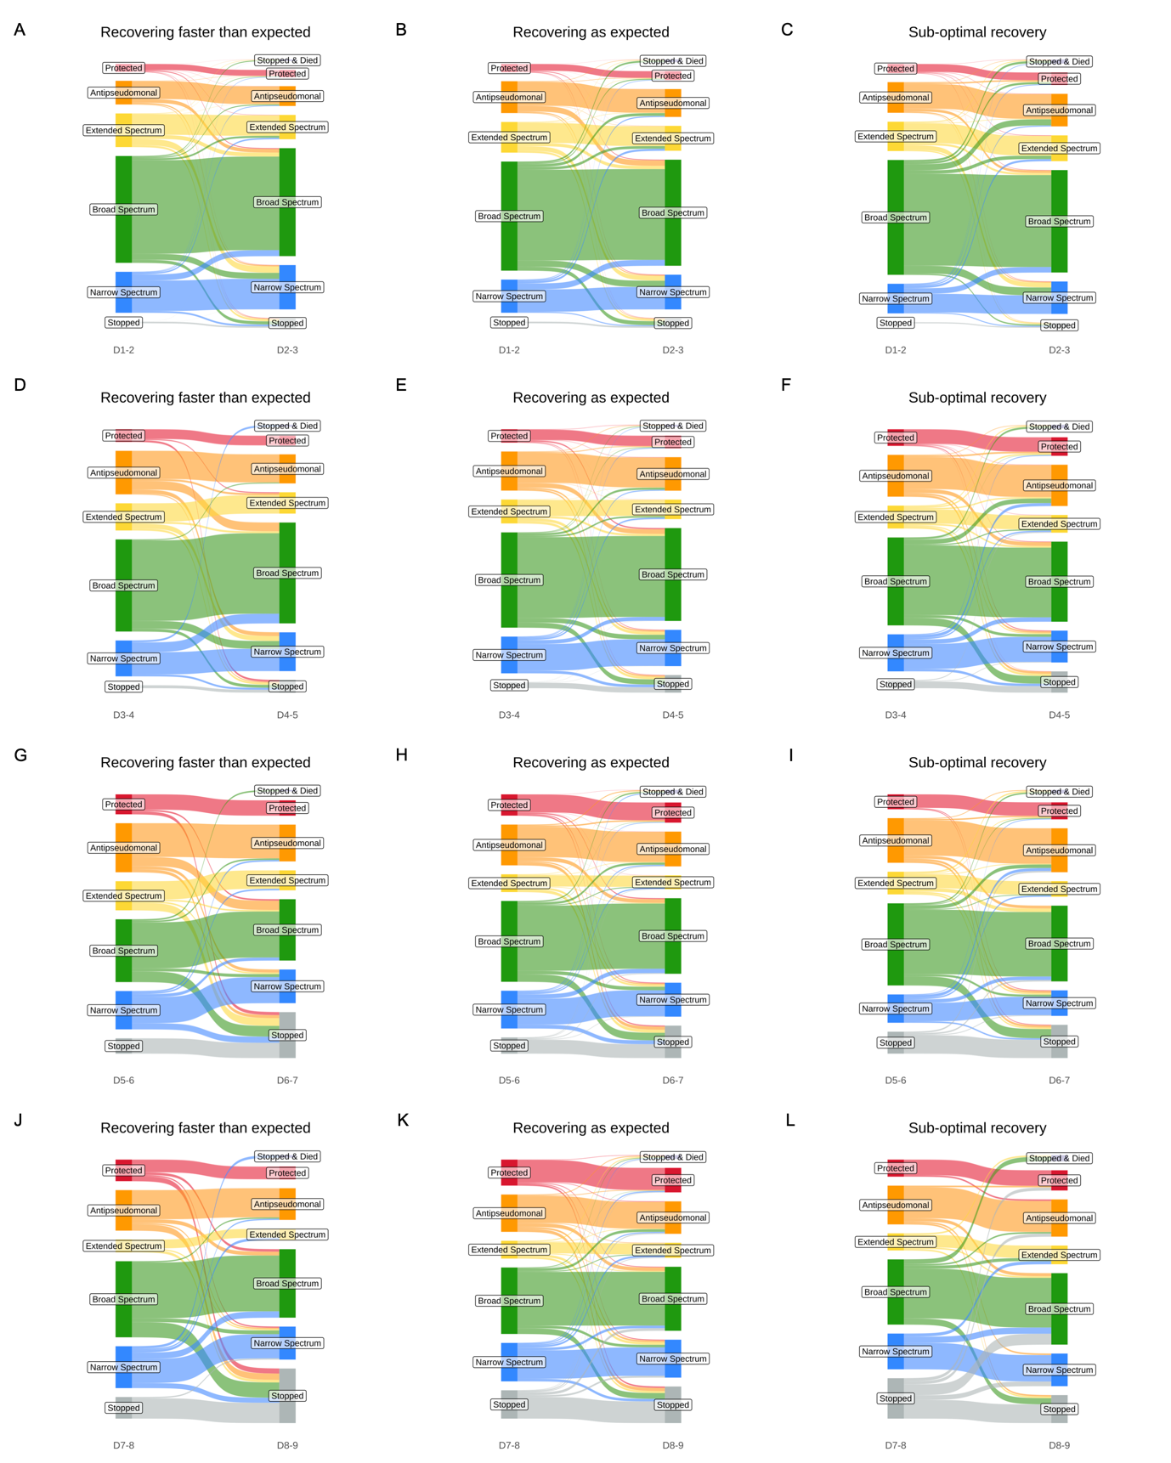
Figure S4. Distribution of change in antibiotic groups from day 1 to day 2, day 3 to day 4, day 5 to day 6, and day 7 to day 8 following different CRP centile changes over two consecutive days.
Centile changes of <−15, −15 to 15 and >15 were arbitrarily defined as recovering faster than expected, recovering as expected and sub-optimal recovery, respectively.

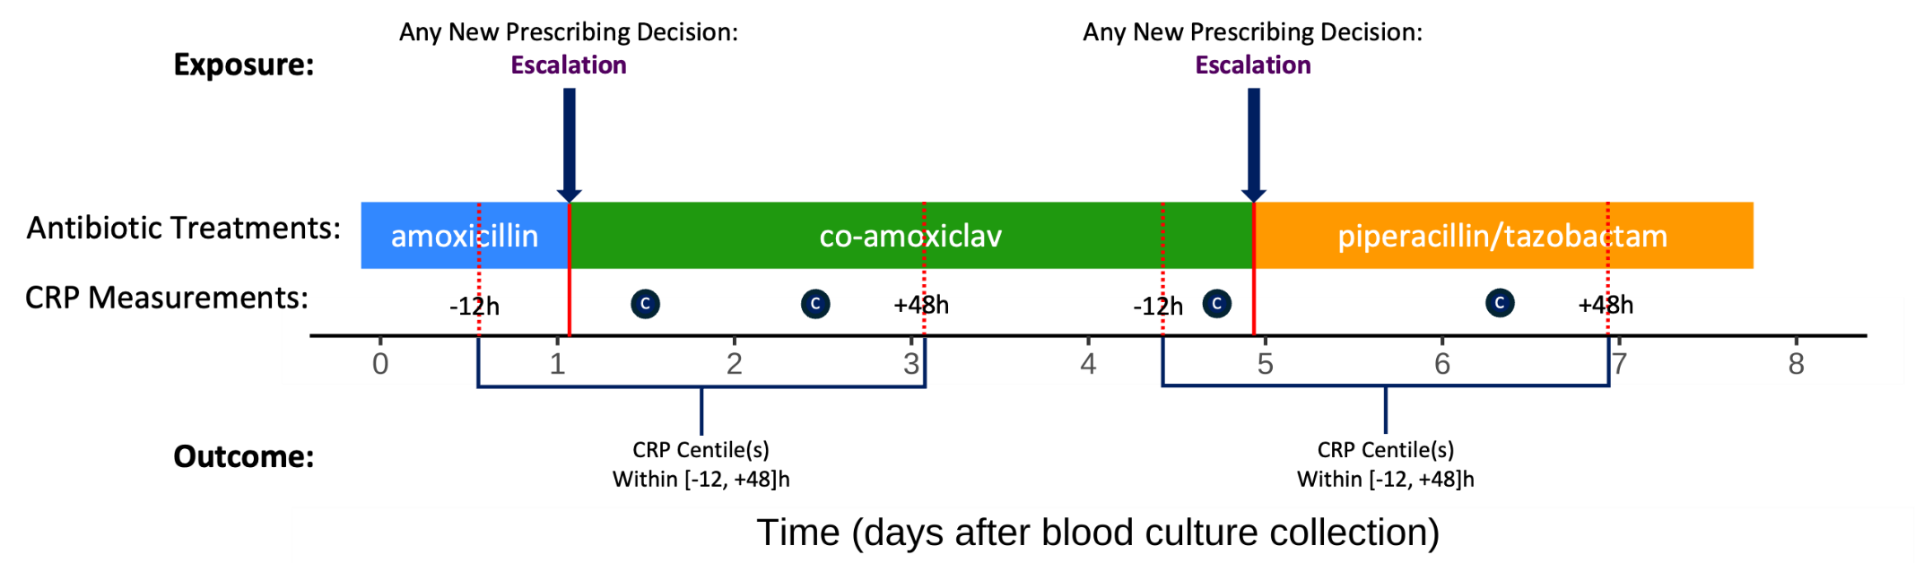
Figure S5. Illustrative diagram of analysis of impact of prescribing decision on CRP centile changes.

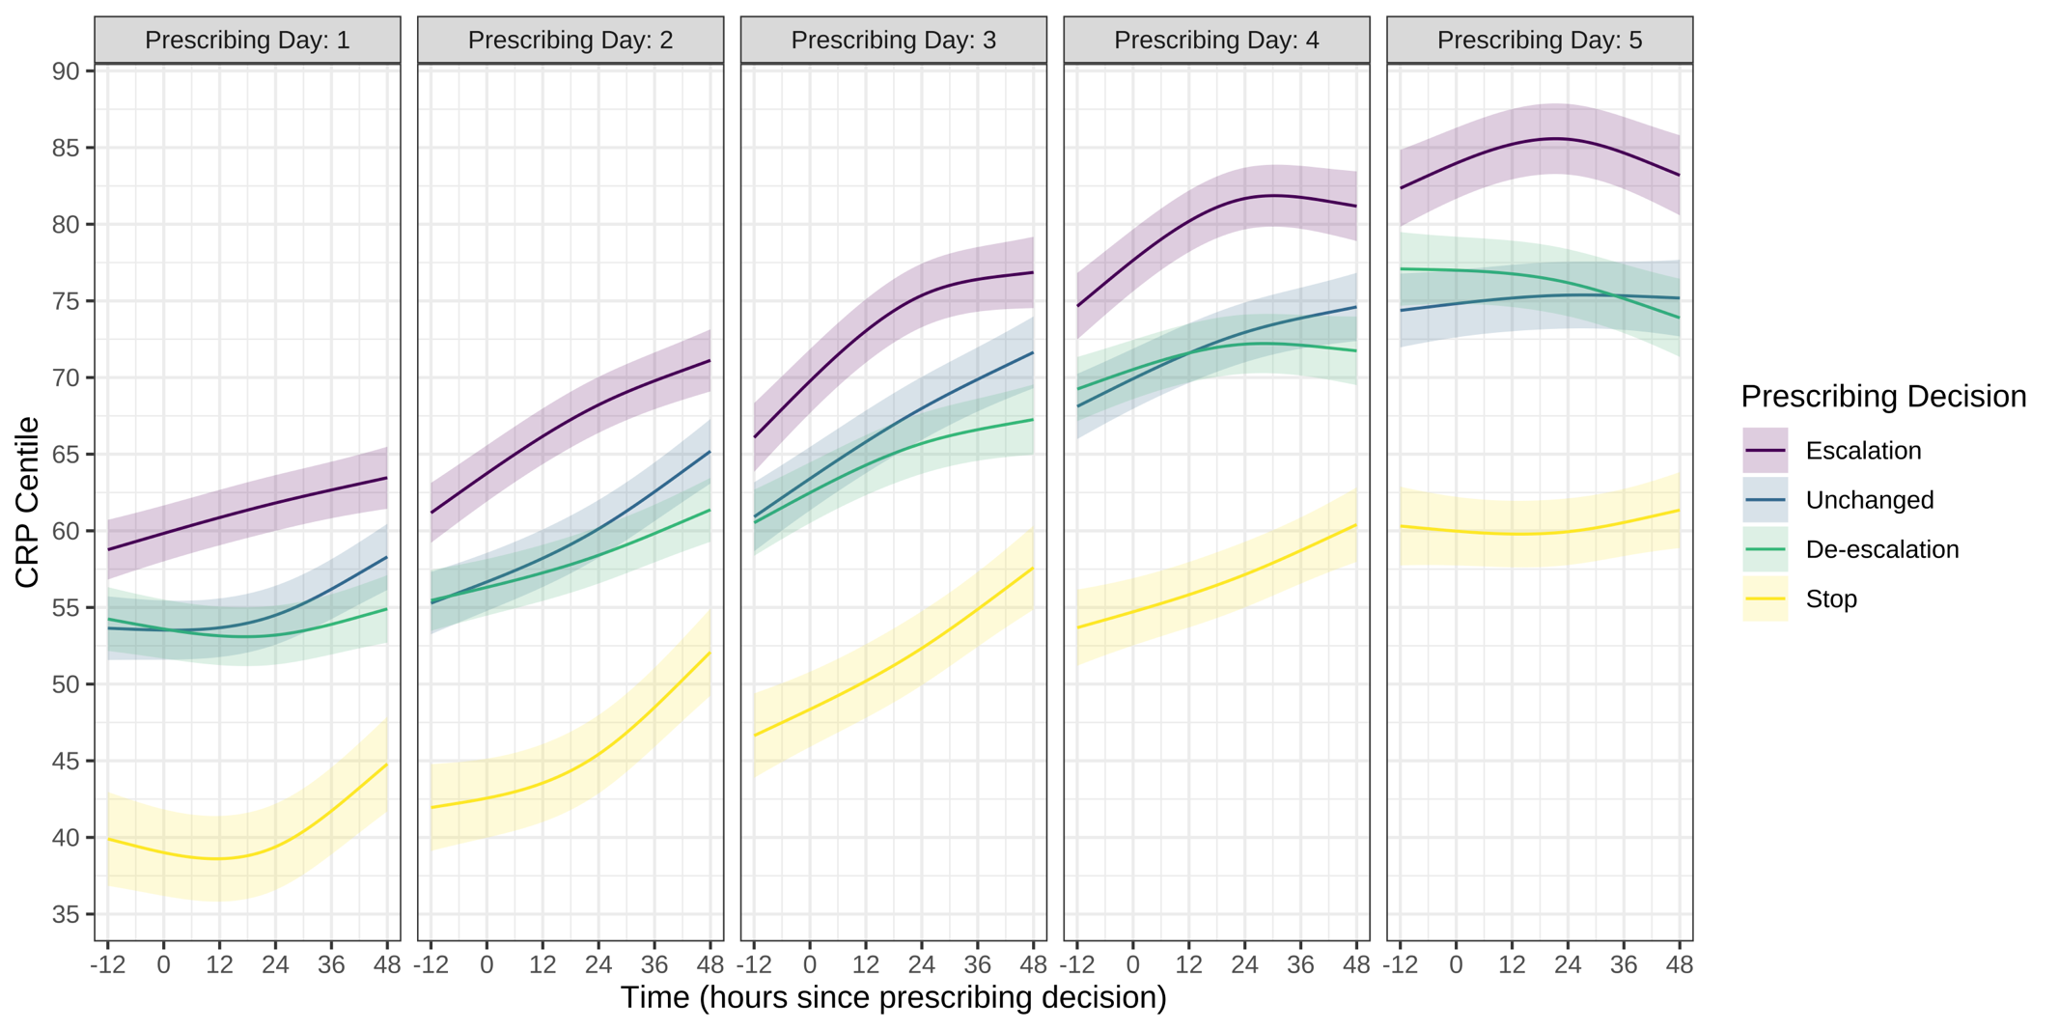
Figure S6. Predicted CRP centile trajectories over the next 48 hours following different prescribing decisions on days 1, 2, 3, 4 and 5 since blood culture collection (prescribing day).
Predictions are plotted using the reference values for other variables adjusted for in a multivariable model: age = 67 years, male, Charlson score = 2, Elixhauser score = 3, no renal dialysis, no diabetes, baseline NEWS = 3, absence of immunosuppression, no palliative care, community-onset, urinary source, and E. coli infection.

