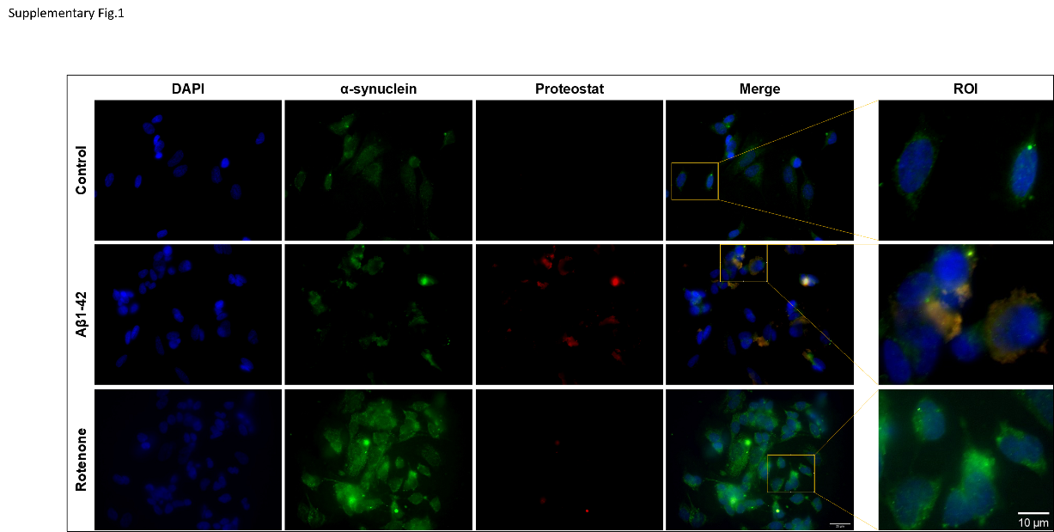
Supplementary Fig. 1
α-synuclein aggregation is promoted by Aβ peptide in SH-SY5Y cells.
Cells treated with Aβ-42 and RT were fixed and stained with α-synuclein (green) and proteostat dye (red). Images were acquired using Zeiss fluorescence microscope. Scale bar is 25 µm.

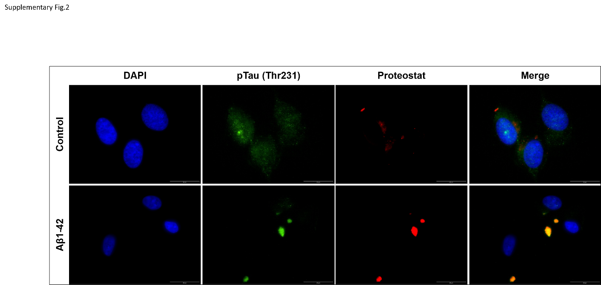
Supplementary Fig. 2
pTau (Thr231) aggregation is promoted by Aβ peptide in SH-SY5Y cells.
Cells treated with Aβ-42 were fixed and stained with pTau (Thr231) (green) and proteostat dye (red) and images were acquired using Olympus IX81 fluorescence microscope. Scales bar is 20 µm.

