Supporting Information

Size Effect-based Improved Antioxidant Activity of Selenium Nanoparticles Regulating Anti-PI3K-mTOR and Ras-MEK Pathways for Treating Spinal Cord Injury to Avoid Hormone Shock-induced Immunosuppression

Figure S1. The surface zeta potential of LNT-SeNPs over time in different solutions.

Figure S2. Effects of different concentrations of LNT-SeNPs and LNT-UsSeNPs on the viability of PC-12 cells (24 hours).

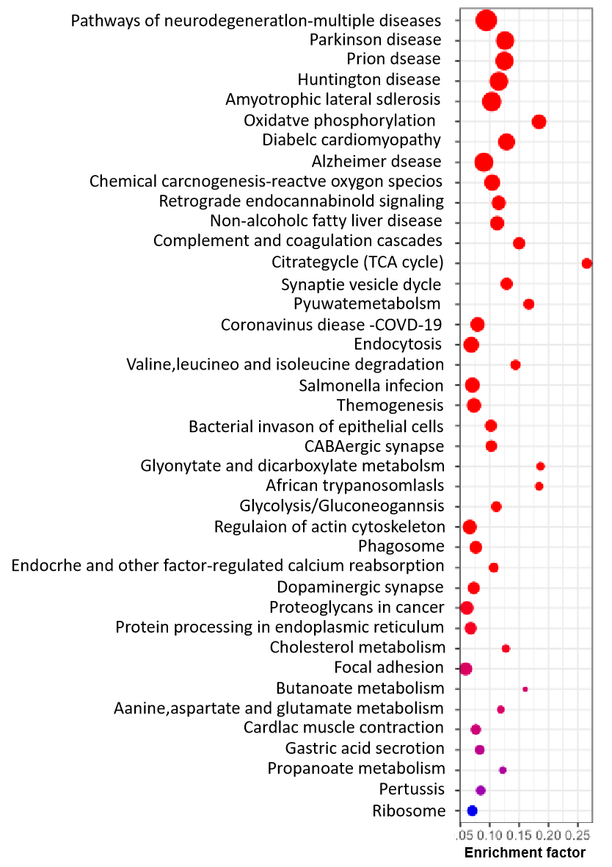
Figure S3. The histogram indicates the analysis of subcellular localization of differential proteins in the comparison of LNT-UsSeNPs group, injury group and control group in the data, the statistical analysis of human cell markers and the enrichment analysis of KEGG pathway of multiple groups of overlapping genes.

Figure S4. The proportion of NK cells in spleen of each group.

Figure S5. The proportion of CD4+/CD8+cells in the spleen of SCI mice in different groups. Values were represented as means ± SD of triplicate. Bars with different characteristics are statisically different at the P<0.05 level.

 | RBC ×10¹²/L |  | HGB g/L |  | WBC ×10⁹/L |  | PLT ×10⁹/L
 | Mean | SD | Mean | SD | Mean | SD | Mean | SD
Sham | 10.14 | 0.95 | 119.4 | 166.56 | 7.03 | 1.91 | 539.6 | 152.42
SCI | 8.44 | 1.41 | 122.2 | 19.99 | 3.74 | 0.92 | 621.8 | 167.15
SCI+MPSS | 10.90 | 0.71 | 156.2 | 13.46 | 4.40 | 1.21 | 797.8 | 165.71
SCI+LNT-UsSeNPs | 8.41 | 1.00 | 118.4 | 13.35 | 3.79 | 0.54 | 669 | 140.47

Table S1. Blood routine analyzer was used to analyze the blood routine results of SCI mice in each group.

