Supporting Information

Pressure-Induced Phase Transitions in Bilayer La₃Ni₂O₇

Mingyu Xu^{1#}, Greeshma C. Jose ^{2#}, Aya Rutherford³, Haozhe Wang¹, Stephen Zhang⁴, Robert J. Cava⁴, Haidong Zhou³, Wenli Bi^{2*}, Weiwei Xie^{1*}

¹Department of Chemistry, Michigan State University, East Lansing, MI, 48824, USA
²Department of Physics, University of Alabama at Birmingham, Birmingham, AL, 35294, USA
³Department of Physics and Astronomy, University of Tennessee, Knoxville, TN, 37996, USA
⁴Department of Chemistry, Princeton University, Princeton, NJ, 08540, USA

#contributed equally

Table SI. Crystal structure refinement data……………………………………………………...S2
Table SII. Atomic coordinates and isotropic displacement parameters…….................................S3
Fig. S1. Criterion of T_{DW} and T’ based on the plots of dR/dT at different pressures……..… S4
Fig. S2. Normalized resistance (R(T)/R(150 K)) of La₃Ni₂O₇-2222………………………...S5

Table SI. The crystal structure and refinement of La₃Ni₂O₇ at room temperature K (Mo Kα radiation). Values in parentheses are estimated standard deviation from refinement.

Chemical Formula | La₃Ni₂O₇
Formula Weight | 646.15 g/mol
Space Group | Cmcm
Unit Cell dimensions | a = 20.5510(13) Å  b = 5.4508(4) Å  c = 5.3975(4) Å
Volume | 604.62(7) Å³
Z | 4
Density (calculated) | 7.098 g/cm³
Absorption coefficient | 26.849 mm⁻¹
F (000) | 1132
2θ range | 7.734 to 81.316°
Reflections collected | 4856
Independent reflections | 1047 [R_{int} = 0.0701]
Refinement method | Full-matrix least-squares on F²
Data/restraints/parameters | 1047/0/37
Final R indices | R₁ (I>2σ(I)) = 0.0460; wR₂ (I > 2 σ(I)) = 0.1067  R₁ (all) = 0.0862; wR₂ (all) = 0.1261
Largest diff. peak and hole | +7.82 e⁻/Å³ and -2.74 e⁻/Å³
R. M. S. deviation from mean | 0.769 e⁻/Å³
Goodness-of-fit on F² | 0.997

Table SII. Atomic coordinates and equivalent isotropic atomic displacement parameters (Å²) of La₃Ni₂O₇. (U_{eq} is defined as one-third of the trace of the orthogonalized U_{ij} tensor.) Values in parentheses are estimated standard deviations from refinement.

Atoms | Wyck. | x | y | z | Occ. | U_{eq}
La1 | 4c | 0 | 0.75046(11) | 1/4 | 1 | 0.008(14)
La2 | 8g | 0.32020(2) | 0.25758(7) | 1/4 | 1 | 0.007(13)
Ni | 8g | 0.09594(5) | 0.25201(16) | 1/4 | 1 | 0.005(19)
O1 | 4c | 0 | 0.29120(15) | 1/4 | 1 | 0.008(15)
O2 | 8g | 0.20360(3) | 0.21760(12) | 1/4 | 1 | 0.012(13)
O3 | 8e | 0.39500(4) | 0 | 0 | 1 | 0.013(13)
O4 | 8e | 0.08990(3) | 0 | 0 | 1 | 0.012(14)

Tables SI and SII show the results of the single-crystal XRD. The structure was solved and refined using the Bruker SHELXTL Software Package with the space group Cmcm, La₃Ni₂O₇. The final anisotropic full-matrix least-squares refinement on F² with 37 variables converged at R₁ = 8.62%, for the observed data and wR₂ = 12.61% for all data. The goodness-of-fit was 0.997. The largest peak in the final difference electron density synthesis was 7.82 e⁻/Å³, and the largest hole was -2.74 e⁻/Å³ with an RMS deviation of 0.769 e⁻/Å³. Based on the final model, the calculated density was 7.098 g/cm³ and F (000), 1132 e⁻.

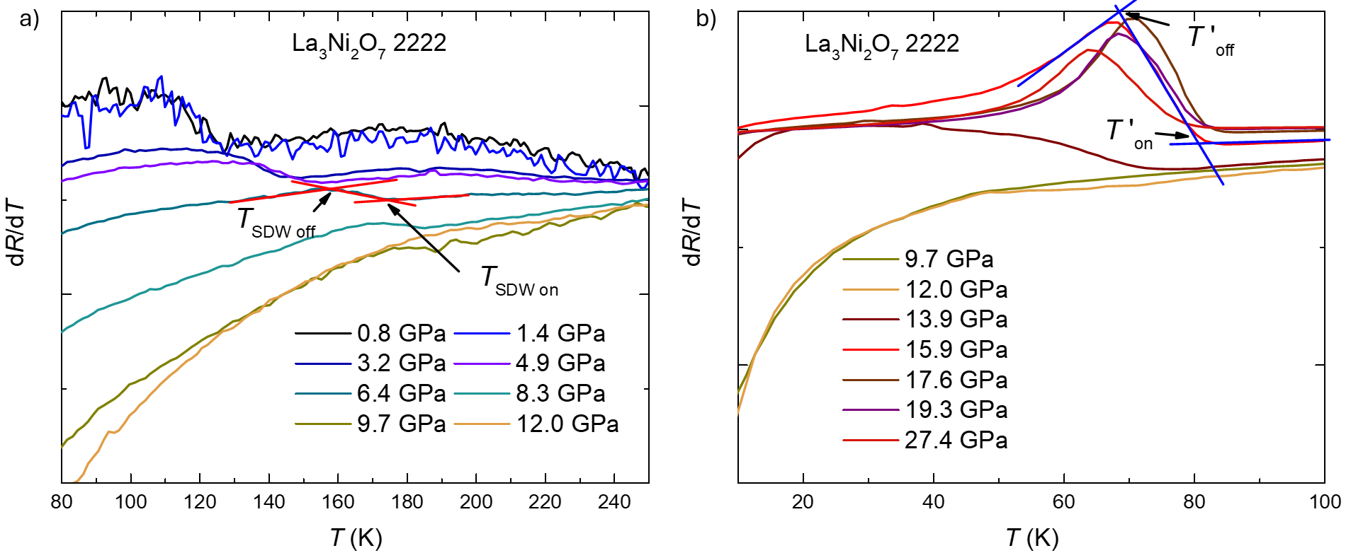 Fig. S1. Criterion of T_{DW} and T’ based on the plots of dR/dT at different pressures. Fig. S1a shows the criterion (onset and offset value) of T_{SDW} using dR/dT in the temperature range from 80 K to 150 K. Fig. S1b gives the criterion of T’ based on dR/dT in the temperature range from 10 K to 100 K.

Fig. S1 shows the criteria for the determination of T_{SDW} and T’. The values of T_{SDW} and T’ are given by the mean values of onset and offset, and the transition width is given by the half value of the difference of onset and offset.

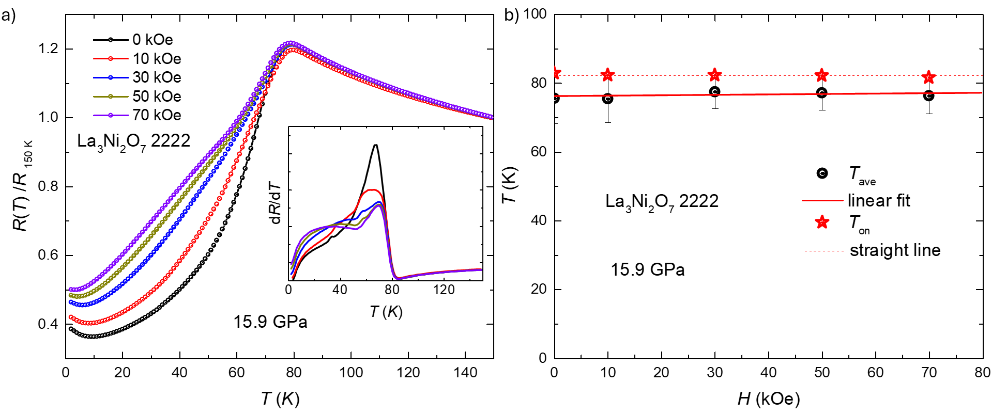
Fig. S2. Normalized resistance (R(T)/R(150 K)) of La₃Ni₂O₇-2222 under the different magnetic fields (Fig. S2a) and T’-H phase diagram (Fig. S2b) at 15.9 GPa. Fig. S2a shows the normalized resistance as a function of temperature under the different magnetic fields at 15.9 GPa. (Inset) The derivative of resistance as a function of temperature. Fig. S2b shows the temperature-magnetic field (T-H) phase diagram. The black symbols show the T’ values, and the red star symbols present the onset values. The red solid line gives the linear fit of T’, and the red dashed line presents the straight line across the onset values.

