PfAMA1 | N | Y | M | G | N | P | W | T | E | - | - | - | - | - | - | Y | M | A | K | Y | D | I | E | E | V | H | G | S | G | I | R | V | D | L | G | E | D | A | E | V | A | G | T | Q | Y | R | L | P | S | G | [147]
TgAMA1 | - | - | - | G | N | P | F | Q | A | N | V | E | M | K | T | F | M | E | R | F | N | L | T | H | H | H | Q | S | G | I | Y | V | D | L | G | Q | D | K | E | V | D | G | T | L | Y | R | E | P | A | G | [115]
PfAMA1 | K | C | P | V | F | G | K | G | I | I | I | E | N | S | N | - | - | - | - | - | T | T | F | L | T | P | V | A | T | G | Q | Y | L | K | D | - | - | - | - | - | - | G | G | F | A | F | - | - | - | P | [184]
TgAMA1 | L | C | P | I | W | G | K | H | I | E | L | Q | Q | P | D | R | P | P | Y | R | N | N | F | L | E | D | V | P | T | E | K | E | Y | K | Q | S | G | N | P | L | P | G | G | F | N | L | N | F | V | T | [165]
PfAMA1 | P | T | E | P | L | M | S | P | M | T | L | D | E | M | R | H | F | Y | K | D | N | K | Y | V | K | N | L | D | E | L | T | L | C | S | R | H | A | G | N | M | I | P | - | - | D | N | D | K | N | S | [223]
TgAMA1 | P | S | G | Q | R | I | S | P | F | P | M | E | L | L | - | - | - | - | - | E | N | S | N | I | K | A | S | T | D | L | G | R | C | A | E | F | A | F | K | T | V | A | M | D | K | N | N | K | A | T | [211]
PfAMA1 | N | Y | K | Y | P | A | V | Y | D | D | K | D | K | K | C | H | I | L | Y | I | A | A | Q | E | N | N | G | P | R | Y | C | M | - | - | - | - | - | - | - | - | - | - | F | C | F | R | P | A | K | D | [281]
TgAMA1 | K | Y | R | Y | P | F | V | Y | D | S | K | K | R | L | C | H | I | L | Y | V | S | M | Q | L | M | E | G | K | K | Y | C | S | V | K | G | E | P | P | D | L | T | W | Y | C | F | K | P | R | K | S | [261]
PfAMA1 | I | S | F | Q | N | Y | - | - | - | - | - | T | Y | L | S | K | N | V | V | D | N | W | E | K | V | C | P | R | K | N | L | Q | N | A | K | F | G | L | W | V | D | G | N | C | E | D | I | P | H | V | [325]
TgAMA1 | V | T | E | N | H | H | L | I | Y | G | S | A | Y | V | G | E | N | - | P | D | A | F | I | S | K | C | P | N | Q | A | L | R | G | Y | R | F | G | V | W | K | K | G | R | C | L | D | Y | T | E | L | [310]
PfAMA1 | N | E | F | P | A | I | D | L | F | E | - | - | - | - | C | N | K | L | V | F | E | L | S | - | - | A | S | D | Q | P | K | Q | Y | E | Q | H | L | T | D | Y | E | K | I | K | E | G | F | K | N | K | [370]
TgAMA1 | T | D | - | T | V | I | E | R | V | E | S | K | A | Q | C | W | V | K | T | F | E | N | D | G | V | A | S | D | Q | P | H | T | Y | P | - | - | L | T | S | Q | A | S | W | N | D | W | W | P | - | - | [355]
PfAMA1 | N | A | S | M | I | K | S | A | F | L | P | T | A | D | R | Y | K | S | H | G | K | G | Y | N | W | G | N | Y | N | T | E | T | Q | - | - | - | K | C | E | I | F | N | V | K | P | T | C | L | I | N | [421]
TgAMA1 | - | - | - | - | - | - | - | - | - | L | H | Q | S | D | Q | P | H | S | G | G | V | G | R | N | Y | G | F | Y | Y | V | D | T | T | G | E | G | K | C | A | L | S | D | Q | V | P | D | C | L | V | S | [395]
PfAMA1 | N | S | - | - | - | S | Y | I | A | T | T | A | L | S | - | - | - | - | - | - | - | - | - | - | - | - | - | - | - | - | - | - | - | - | - | - | - | - | - | - | H | P | - | - | - | - | - | I | E | V | [437]
TgAMA1 | D | S | A | A | V | S | Y | T | A | A | G | S | L | S | E | E | T | P | N | F | I | I | P | S | N | T | P | P | T | P | E | T | A | L | Q | C | T | A | D | K | F | P | D | S | F | G | A | C | D | V | [449]
PfAMA1 | E | - | - | - | - | - | - | - | - | - | - | - | - | - | - | - | - | - | - | - | - | - | - | - | - | - | - | - | - | - | [438]
TgAMA1 | Q | A | C | K | R | Q | K | T | S | C | V | G | G | Q | I | Q | S | T | S | V | D | C | T | A | D | E | Q | N | E | C | [479]
SUPPLEMENTARY DATA

Supp. Table 1: Linear alignment of the PfAMA1 and TgAMA1 antigens with their respective predicted B epitopes

The amino-acid linear sequence of PfAMA1 PDB ref 4R19 (104 to 438) is aligned with TgAMA1 PDB ref 2X2Z (69 to 479). The PDB alignment algorithm displays 32% of identity with conserved sites, as shown in yellow. Regions with predicted discontinuous epitopes are indicated in red for PfAMA1 and in orange for TgAMA1.

Supp. Table 2: Univariate linear regression analysis of the combined malaria and toxoplasmosis serological status in relation to specific IgG responses against P. falciparum and T. gondii antigens

 | IgG anti-PfAMA1 |  |  | IgG anti-TgAMA1 |  |  | IgG anti-TgSAG1 IgG |  |  | IgG anti-TgGRA7 |  |  | IgG anti-Pfs48/45 ^{d}
Variables (n=148) ª | coef^{b} | 95% CI | pval | coef^{b} | 95% CI | pval | coef^{b} | 95% CI | pval | coef^{b} | 95% CI | pval | coef^{b} | 95% CI | pval
Serological Status ^{c}
Malaria (+) and toxoplasmosis (-) | 1.23 | 0.11 2.34 | 0.031 | 0.07 | -0.31 0.45 | 0.706 | -0.44 | -0.75 -0.13 | 0.005 | 0.22 | -0.17 0.60 | 0.269 | 1.22 | 0.74 1.70 | <0,001
Malaria (+) and toxoplasmosis (+) | 2.14 | 1.04 3.25 | <0,001 | 1.98 | 1.60 2.36 | <0,001 | 2.53 | 2.22 2.83 | <0,001 | 1.41 | 1.03 1.80 | <0,001 | 1.01 | 0.54 1.49 | <0,001
Malaria (-) and toxoplasmosis (+) | 0.34 | -1.07 1.75 | 0.631 | 1.42 | 0 .93 1.90 | <0,001 | 2.01 | 1.62 2.40 | <0,001 | 1.14 | 0.66 1.63 | <0,001 | 0.1 | -0.50 0.70 | 0.743

ª: n=148 including PDC (n=29), COA (n=95) and TXD (n=24); ^{b}: coef = a positive coefficient indicates an increase of both independent and dependant variables. A negative coefficient indicates an increase of the independent while the dependent variable tends to decrease; ^{C}: the combined status “malaria and toxoplasmosis negative serology” is the reference; ^{d}: n = 119, the evaluation of antibody response against Pfs48/45 was only performed in COA (n=95) and TXD groups (n=24).

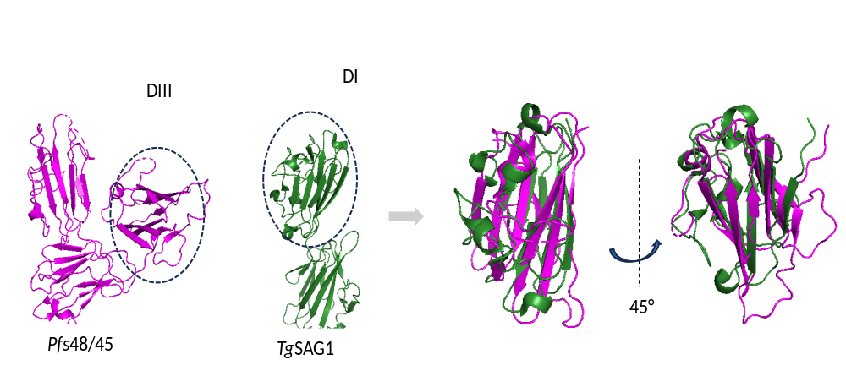
Supp. Figure 1: Structural alignment of Pfs48/45 and TgSAG1

The domain DIII of Pfs48/45 (7ZXG_D) is aligned with the domain DI of TgSAG1 structure (1KZQ_A). RMSD=3.0, TM score=0.38, identity=19%.

Supp. Figure 2: Quantitative analysis of the IgG responses directed to T. gondii and P. falciparum antigens according to the toxoplasmosis serology from the pregnant women under study
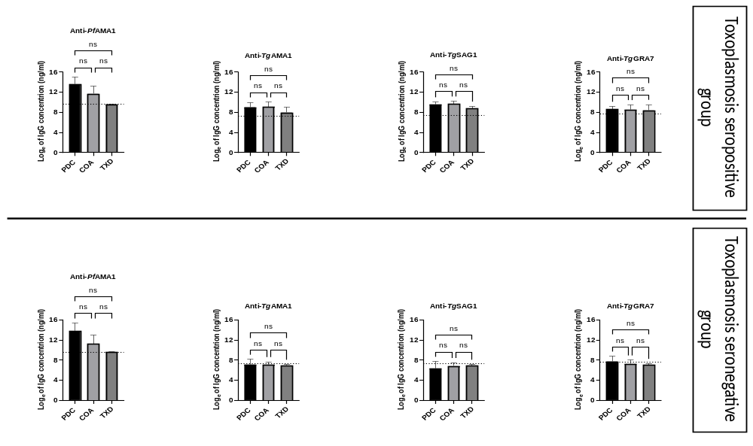
Toxoplasmosis seropositive group: PDC n=16; COA n=45; TXD n=11. Toxoplasmosis seronegative group: PDC n=13; COA n=50; TXD n=13. The cut-off for every specific antibody response is represent by a dotted line.

