Supplementary Material
Table S1. Study Participants
Process | Participation |  | No | Type of Institutions | Positions | Specialty | Age  (yrs) | Gender | Experience  (yrs)
Process | Session 1 | Session 2
Expert- Focus Group Interview | Yes | No | 1 | University | Professor | Preventive Medicine | 58 | Male | 33.7
Expert- Focus Group Interview | Yes | No | 2 | University | Professor | Preventive Medicine | 53 | Male | 28.2
Expert- Focus Group Interview | Yes | No | 3 | University | Professor | Urban planning | 46 | Male | 18.3
Expert- Focus Group Interview | Yes | No | 4 | University | Professor | Urban planning | 58 | Male | 33.5
Expert- Focus Group Interview | Yes | No | 5 | University | Professor | Urban Planning | 46 | Female | 19.2
Expert- Focus Group Interview | Yes | No | 6 | University | Professor | Health Promotion | 52 | Female | 26.4
Expert- Focus Group Interview | Yes | No | 7 | University | Professor | A Healthy City | 51 | Female | 19.7
Expert- Focus Group Interview | Yes | No | 8 | University | Professor | Management Information Systems | 43 | Female | 20.3
Expert- Focus Group Interview | No | Yes | 9 | University | Professor | Governance | 55 | Male | 19.2
Expert- Focus Group Interview | No | Yes | 10 | University | Professor | Science and Technology Policy | 58 | Male | 28.0
Expert- Focus Group Interview | No | Yes | 11 | University | Professor | Urban planning | 57 | Male | 33.3
Expert- Focus Group Interview | No | Yes | 12 | University | Researcher | Urban planning | 35 | Male | 8.1
Expert- Focus Group Interview | No | Yes | 13 | University | Professor | Medical Informatics | 46 | Female | 21.3
Expert- Focus Group Interview | No | Yes | 14 | University | Professor | Occupational therapy | 40 | Female | 17.4
Expert- Focus Group Interview | Yes | No | 15 | Research Institute | Researcher | Atmospheric science | 45 | Male | 16.2
Expert- Focus Group Interview | Yes | No | 16 | Research Institute | Researcher | Health Promotion | 43 | Male | 25.1
Expert- Focus Group Interview | Yes | No | 17 | Research Institute | Researcher | Health Promotion | 54 | Male | 30.3
Expert- Focus Group Interview | Yes | No | 18 | Research Institute | Researcher | Occupational Therapy | 41 | Male | 14.2
Expert- Focus Group Interview | Yes | No | 19 | Research Institute | Researcher | Occupational Therapy | 37 | Male | 10.3
Expert- Focus Group Interview | Yes | No | 20 | Research Institute | Researcher | Occupational therapy | 50 | Female | 28.5
Expert- Focus Group Interview | No | Yes | 21 | Research Institute | Researcher | Living Lab | 62 | Male | 24.0
Expert- Focus Group Interview | No | Yes | 22 | Research Institute | Researcher | Motor Learning and Control | 46 | Male | 21.0
Expert- Focus Group Interview | No | Yes | 23 | Research Institute | Researcher | Urban Planning | 42 | Female | 15.1
Expert- Focus Group Interview | Yes | No | 24 | Research Institute | Researcher | Health Promotion | 38 | Female | 12.2
Expert- Focus Group Interview | Yes | No | 25 | Research Institute | Researcher | Endocrinology and Digital health | 45 | Female | 20.0
Expert- Focus Group Interview | Yes | No | 26 | Software Company | CEO | Digital Healthcare | 54 | Male | 31.3
Expert- Focus Group Interview | Yes | No | 27 | Software Company | CEO | Digital Healthcare | 41 | Male | 13.5
Expert- Focus Group Interview | Yes | No | 28 | Design Company | CEO | Urban Planning | 44 | Male | 19.6
Expert- Focus Group Interview | Yes | No | 29 | Design Company | CEO | Urban Planning | 52 | Male | 26.8
Expert- Focus Group Interview | No | Yes | 30 | Municipal Office | Public Officer | Internet of Things | 59 | Male | 22.7
Expert- Focus Group Interview | No | Yes | 31 | Research Institute | Researcher | Living Lab | 51 | Female | 27.4
Expert- Focus Group Interview | No | Yes | 32 | Patient Support Group | Advisor | Living Lab | 46 | Female | 21.3
Expert- Focus Group Interview | No | Yes | 33 | Public Institution | Public Officer | Preventive Medicine | 62 | Female | 37.5
Expert- Focus Group Interview | No | Yes | 34 | Public Institution | Public Officer | Health Promotion | 54 | Female | 27.6
Expert- Focus Group Interview | No | Yes | 35 | Public Institution | Public Officer | Health Promotion | 55 | Female | 31.1
Expert- Focus Group Interview |  |  | Mean |  |  |  | 49.11 | 0.57¹ | 22.92
Expert- Focus Group Interview |  |  | S.D. |  |  |  | 7.33 | 0.50¹ | 7.26
Group Concept Mapping | Yes | Yes | 1 | University | Professor | Preventive dentistry | 42 | Male | 6.6
Group Concept Mapping | Yes | Yes | 2 | University | Professor | Health promotion | 59 | Male | 25.3
Group Concept Mapping | Yes | Yes | 3 | University | Professor | Urban planning | 47 | Male | 7.3
Group Concept Mapping | Yes | Yes | 4 | University | Professor | Urban planning | 58 | Male | 7.1
Group Concept Mapping | Yes | Yes | 5 | University | Professor | Architecture and urban planning | 36 | Male | 0.8
Group Concept Mapping | Yes | Yes | 6 | University | Professor | Politics | 56 | Male | 6.0
Group Concept Mapping | Yes | Yes | 7 | University | Professor | Occupational therapy | 53 | Male | 10.8
Group Concept Mapping | Yes | Yes | 8 | University | Professor | Urban planning | 47 | Female | 5.3
Group Concept Mapping | Yes | Yes | 9 | University | Professor | Urban planning | 47 | Female | 8.3
Group Concept Mapping | Yes | Yes | 10 | University | Professor | Health policy and administration | 52 | Female | 12.8
Group Concept Mapping | Yes | Yes | 11 | Education Center | Director | Social welfare | 44 | Male | 5.4
Group Concept Mapping | Yes | Yes | 12 | Research Institute | Director | Geography Education | 47 | Male | 5.7
Group Concept Mapping | Yes | Yes | 13 | Meteorological Institute | Director | Atmospheric science | 46 | Male | 13.3
Group Concept Mapping | Yes | Yes | 14 | Research Institute | Researcher | Urban planning and design | 43 | Female | 5.5
Group Concept Mapping | Yes | No | 15 | Research Institute | Researcher | Public administration | 63 | Male | 25.0
Group Concept Mapping | Yes | No | 16 | University | Professor | Mechanical engineering | 44 | Male | 4.7
Group Concept Mapping |  |  | Mean |  |  |  | 49.00 | 0.71¹ | 9.00
Group Concept Mapping |  |  | S.D. |  |  |  | 7.21 | 0.47¹ | 6.89
1 Proportion of male participants calculated as the number of male participants divided by the total number of participants.
Table S2. Clusters and Statements Defining the Concept of a Smart Healthy City
Cluster (Number of Stmts) | Statements
Cluster (Number of Stmts) | No. | Content | Mean | S.D
Healthy Environment Cities (7) | 3 | A smart healthy city is a city that encompasses the concepts of a smart city and a healthy city. | 4.14 | 0.86
Healthy Environment Cities (7) | 5 | A smart healthy city is a city that is well equipped with basic infrastructure. | 3.86 | 0.77
Healthy Environment Cities (7) | 10 | A smart healthy city is a city with easy access to healthcare. | 4.21 | 0.58
Healthy Environment Cities (7) | 23 | A smart healthy city is a city that is highly efficient in improving the health of individuals and the city as a whole. | 4.15 | 0.90
Healthy Environment Cities (7) | 42 | A smart healthy city is a city that aims to promote physical activity using smart mobility. | 4.00 | 0.88
Healthy Environment Cities (7) | 53 | A smart healthy city is a city that improves human psychology. | 3.71 | 0.91
Healthy Environment Cities (7) | 55 | A smart healthy city is a city with urban environment elements for health. | 4.29 | 0.83
Smart Networking Cities (13) | 20 | A smart healthy city is a city where data is shared between organizations. | 3.79 | 1.05
Smart Networking Cities (13) | 21 | A smart healthy city is a city that enables inter-agency communication. | 3.93 | 0.83
Smart Networking Cities (13) | 22 | A smart healthy city is a city where inter-agency data can be used collaboratively. | 3.93 | 0.92
Smart Networking Cities (13) | 25 | A smart healthy city is a city that enables residents to communicate with each other. | 3.86 | 0.95
Smart Networking Cities (13) | 31 | A smart healthy city is a city where there are no barriers to utilizing smart technologies. | 4.14 | 0.86
Smart Networking Cities (13) | 32 | A smart health city is a city that uses digital technology to reorient healthcare. | 4.21 | 1.12
Smart Networking Cities (13) | 33 | A smart health city is a city where the application of bio and industrial technologies is felt by its citizens. | 4.07 | 0.92
Smart Networking Cities (13) | 35 | A smart health city is a city that smartens the needs of its citizens. | 3.93 | 1.07
Smart Networking Cities (13) | 43 | A smart health city is a city that engages its citizens in community activities through digital connectivity. | 3.79 | 1.05
Smart Networking Cities (13) | 44 | A smart health city is a city that engages citizens in services through digital connectivity. | 3.79 | 0.89
Smart Networking Cities (13) | 46 | A smart healthy city is a city that promotes opportunities for participation through networking. | 3.79 | 0.89
Smart Networking Cities (13) | 47 | A smart healthy city is a city with a circular structure where networking enhances capabilities. | 3.86 | 0.95
Smart Networking Cities (13) | 56 | Smart health cities are cities that go beyond the traditional healthcare system through smart technologies. | 4.50 | 1.09
Socially Sustainable Cities (17) | 4 | A smart healthy city is a city that supports the lives of its citizens and communities in a social environment. | 3.71 | 0.91
Socially Sustainable Cities (17) | 6 | A Smart Healthy City is socially sustainable. | 3.86 | 0.77
Socially Sustainable Cities (17) | 7 | A smart healthy city is financially sustainable. | 3.86 | 1.03
Socially Sustainable Cities (17) | 8 | A smart healthy city is a city that promotes inclusive policies. | 4.00 | 0.55
Socially Sustainable Cities (17) | 13 | A smart healthy city is a city that adapts unhealthy parts of the city to the needs of its citizens. | 3.07 | 0.92
Socially Sustainable Cities (17) | 16 | A smart healthy city is a city that sets standards for marginalized groups. | 3.86 | 0.53
Socially Sustainable Cities (17) | 17 | A smart healthy city is a city where the spatial environment is built for the socially vulnerable. | 4.00 | 0.55
Socially Sustainable Cities (17) | 27 | A smart healthy city is a city that allows universal dignity to be maintained. | 3.79 | 0.70
Socially Sustainable Cities (17) | 34 | A smart healthy city is a city that targets the health of the entire community. | 4.50 | 0.65
Socially Sustainable Cities (17) | 39 | A smart healthy city is a city that offers solutions to the problem of an aging population. | 4.00 | 0.68
Socially Sustainable Cities (17) | 40 | A smart healthy city is a city that offers solutions to address issues of inequality | 3.93 | 0.83
Socially Sustainable Cities (17) | 48 | A smart healthy city is a city that focuses on problem-solving methods. | 3.64 | 0.84
Socially Sustainable Cities (17) | 49 | A smart healthy city is a city that sets incremental goals to achieve and ideal system | 3.43 | 0.85
Socially Sustainable Cities (17) | 50 | A smart healthy city is a city that can address social challenges. | 3.64 | 1.01
Socially Sustainable Cities (17) | 51 | A smart healthy city is a city that can enhance the quality of life for people with disabilities. | 4.07 | 0.73
Socially Sustainable Cities (17) | 52 | A smart healthy city is a city that can improve the quality of life for the elderly. | 4.07 | 0.73
Socially Sustainable Cities (17) | 57 | A smart healthy city is a city where people all generations can live together harmoniously in their daily lives. | 4.00 | 0.88
Health Empowering Cities (20) | 1 | In a smart health city, health is defined as the restoration of capabilities. | 3.71 | 0.83
Health Empowering Cities (20) | 2 | A smart healthy city is a city that provides personalized and customized services. | 4.07 | 1.07
Health Empowering Cities (20) | 9 | A smart healthy city is a city with a clear definition of health. | 3.43 | 1.09
Health Empowering Cities (20) | 11 | A smart healthy city is a city where the psychology of health is embedded in everyday life. | 3.57 | 0.85
Health Empowering Cities (20) | 12 | A smart healthy city is a city where healthy behaviors are part of everyday life. | 3.50 | 1.02
Health Empowering Cities (20) | 14 | A smart healthy city is a city that enlightens the thinking system of citizens through education. | 3.00 | 0.55
Health Empowering Cities (20) | 15 | A smart healthy city is a city that promotes basic health. | 3.79 | 0.80
Health Empowering Cities (20) | 18 | A smart healthy city is a social model that scales healthy living behaviors. | 4.14 | 0.86
Health Empowering Cities (20) | 19 | A smart healthy city is a model for disease prevention. | 4.29 | 0.73
Health Empowering Cities (20) | 24 | A smart healthy city is a city that values mental health. | 3.79 | 0.97
Health Empowering Cities (20) | 26 | A smart healthy city is a city where personal quality of life is maintained. | 4.07 | 0.73
Health Empowering Cities (20) | 28 | A smart healthy city is a city that enables people to form healthy habits in their daily lives. | 3.93 | 0.83
Health Empowering Cities (20) | 29 | A smart healthy city is a city that promotes everyday convenience. | 3.79 | 0.80
Health Empowering Cities (20) | 30 | A smart healthy city is a city without health literacy challenges. | 3.64 | 0.93
Health Empowering Cities (20) | 36 | A smart healthy city is a public health city that is safe from infectious diseases. | 4.29 | 0.73
Health Empowering Cities (20) | 37 | A smart healthy city is a city that provides solutions to the carbon problem. | 3.29 | 0.91
Health Empowering Cities (20) | 38 | A smart healthy city is a city that provides solutions to energy problems. | 3.43 | 0.85
Health Empowering Cities (20) | 41 | A smart healthy city is a city that promotes human security in everyday life. | 3.43 | 0.94
Health Empowering Cities (20) | 45 | A smart healthy city is a city that aims to strengthen capabilities. | 3.64 | 0.84
Health Empowering Cities (20) | 54 | A smart healthy city is a city that improves people’s behavior | 3.79 | 0.80

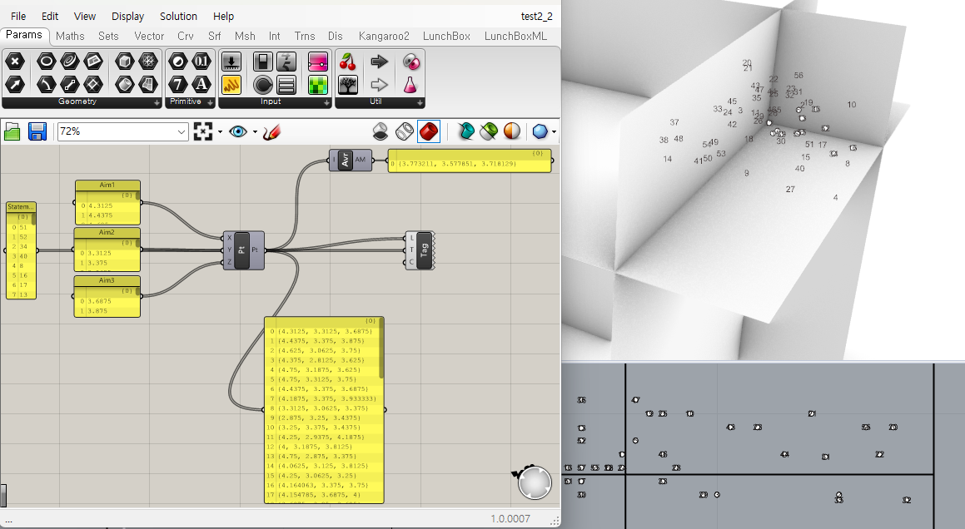
Figure S1. Results Verified Using Rhino7-Grasshopper 1.0.0007 (bottom)

