Title: Melatonin delayed leaf senescence induced by WRKY75 in Arabidopsis thaliana
Journal: Journal of Plant Research
Author’s Name: Ke-yu Wang¹, Jing-jing Mao¹, Wen-hui Chen, De-qiang Li, Zi-zhong Tang, Yang-er Chen, Shu Yuan, Gong-hong Li, Ming Yuan*
Corresponding author: Ming Yuan
Address: College of Life Science, Sichuan Agricultural University, Xinkang Road 46#, Ya’an, Sichuan Province, China
E-mail address: yuanming@sicau.edu.cn

Supplementary material:

Table S1. Primers for mutant identification.
Gene | Category | Sequence
 | LBb1.3 | 5’-ATTTTGCCGATTTCGGAAC-3’
SNAT | LP | 5’-TTTTGACCACAAAATTGCAG-3’
 | RP | 5’-ATTCGAAGATTTGGGTCTTCG-3’
SID2 | LP | 5’-TTGAGGTGGAGGGTAAAAAGG-3’
 | RP | 5’-CAGGTACGAGCTTTTGTCCAG-3’
WRKY75 | LP | 5’-CGTTGAGATGGTTCGAAGAAG-3’
 | RP | 5’-ACATGGGCCTATTTTTATGCC-3’

Table S2. PCR procedure.
Temperature | Time | Cycle
94°C | 5 min | 1
94°C | 30 s | 30
60°C | 1 min | 30
72°C | 1 min | 30
72°C | 5 min | 1
20°C | ∞

Table S3. qPCR procedure.
Procedure | Temperature | Time | Cycle
Pre-denaturation | 95°C | 3 min | 1
Denaturation | 95°C | 5 s | 40
Annealing and elongation | 60°C | 30 s | 40
Final elongation | 95°C | 10 s | 1
Melting curve run | 65°C (0.5°C 5s⁻¹ slope) | 10 s | 1
Melting curve run | 95°C | 5 s | 1

Table S4. Primers for qPCR detection.
Gene | Category | Sequence
ACT2 | Forward | 5’-TATGAATTACCCGATGGGCAAG-3’
 | Reverse | 5’-TGGAACAAGACTTCTGGGCAT-3’
SNAT | Forward | 5’-ATGCTACTAATCCCAATTTC-3’
 | Reverse | 5’-CTTTGGGTACCAAAACATGCC-3’
SID2 | Forward | 5’-AATCTGGTTAGCGTTGCTGGTA-3’
 | Reverse | 5’-CAACAGCGATCTTGCCATTAGG-3’
WRKY75 | Forward | 5’-CCGTCAAGAACAACAAGTTCCC-3’
 | Reverse | 5’-TATGCTCGAAGTTTTCGGTGGA-3’
SAG13 | Forward | 5’-TGTCCTTGGTATATCACAACT-3’
 | Reverse | 5’-TCATAGATTATGGATGCGG-3’

Fig. S1 Identification of T-DNA insertion mutant of wrky75 by PCR. M: DL2000 marker; C: Col; 1-4: the wrky75 to be identified; -1 lane: the primer is LP+RP, -2 lane: the primer is LP+ LBb1.3

Fig. S2 Gene relative expression. (a) SNAT gene relative expression of Col-0 and snat-2 (b) WRKY75 gene relative expression of Col-0, wrky75 and WOE-3 “+MT” indicates the application of exogenous melatonin, “-MT” as the control. Each value represents the mean ± SD. Diferent letters denote signifcant differences (student’s t-test. **, p < 0.01; ***, p < 0.001).

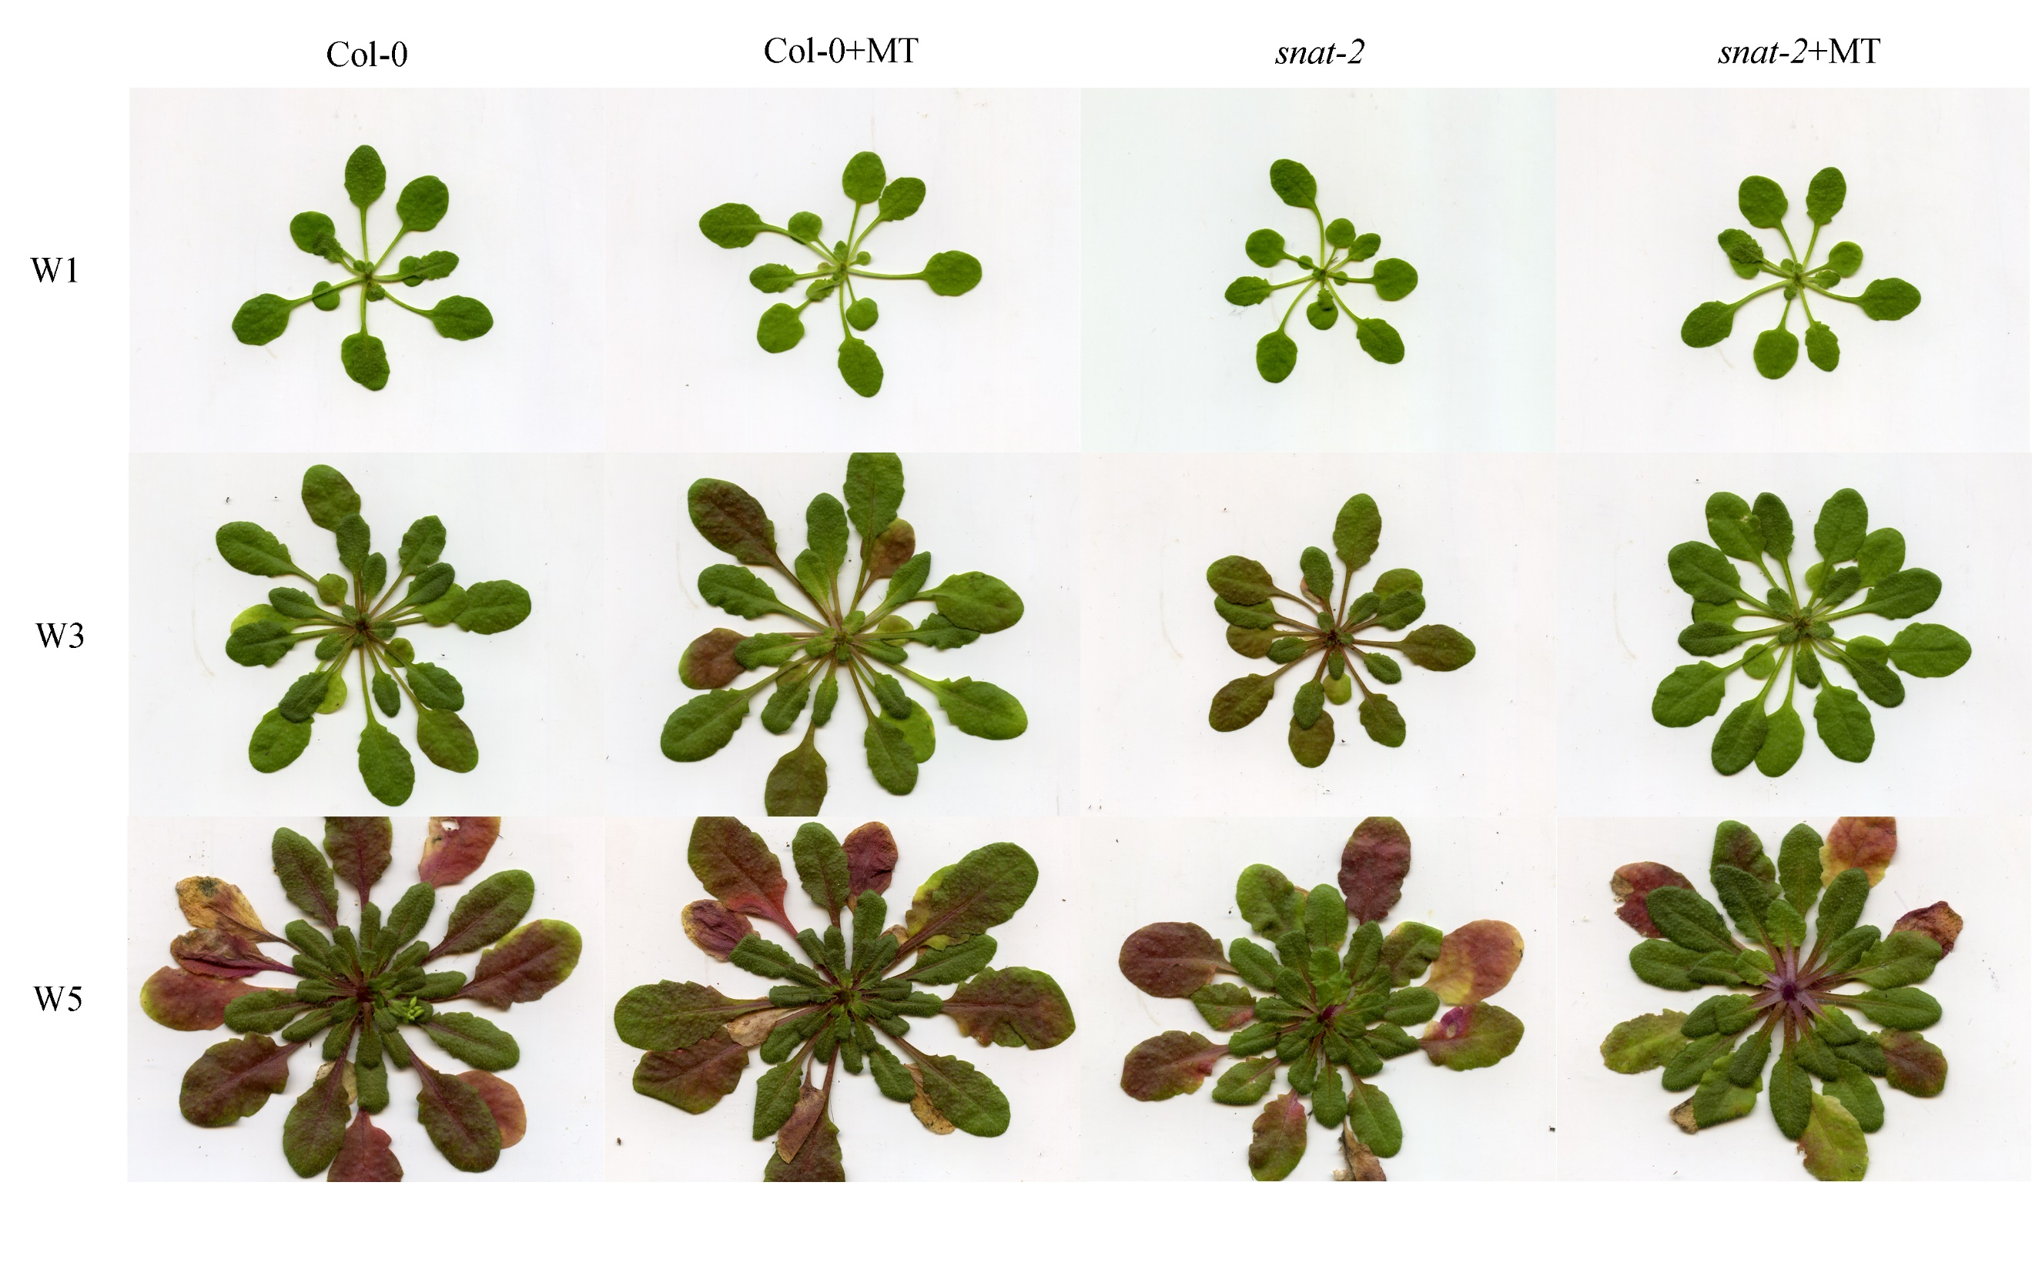
Fig. S3 Plant phenotype of Col-0 and snat-2 in phases W1, W3 and W5 phase. " +MT" indicates the application of exogenous melatonin.

Fig. S4 NBT staining for Col-0 and snat-2 in W2 and W3 phase. "+MT" indicates the application of exogenous melatonin.

