"Streamlined Protoplast Transfection System for In-vivo Validation and Transgene-free Genome Editing in Banana"

Journal- Transgenic Research-Generation, analysis and application of genetically altered plants and animals

Hiralben Lakhani^{1,2}, Naveen Kumar^{1,2}, Alka Jangra³, Sanjana Negi¹, Thobhanbhai Dholariya⁴ and Siddharth Tiwari¹*

¹Plant Tissue Culture and Genetic Engineering Lab, National Agri-Food Biotechnology Institute (NABI), Department of Biotechnology, Ministry of Science and Technology (Government of India), Sector‑81, S.A.S. Nagar, Mohali 140306, Punjab, India
²Department of Biotechnology, Panjab University, Chandigarh 160014, India
³Department of Agricultural Biotechnology, College of Biotechnology, Chaudhary Charan Singh Haryana Agricultural University, Hisar, Haryana 125004, India
⁴Solar Agrotech Pvt Ltd, Rajkot, Gujarat 360005, India

*Corresponding author:
Dr. Siddharth Tiwari
Scientist F
Plant Tissue Culture and Genetic Engineering Lab
National Agri-Food Biotechnology Institute (NABI)
Department of Biotechnology, Ministry of Science and Technology, Govt. of India
Sector 81, Knowledge City, Mohali, Punjab, India - 140306
Phone (Office) 91-172-5221138
Email: siddharth@nabi.res.in; siddharthdna@gmail.com
ORCID ID: https://orcid.org/0000-0003-3958-8465
Table S1. Flanking primers of BCH gene target site
Primer for sequencing (5’ to 3’)
BCH_F | ATGGCGGCCGGGATCTCCGCTG
BCH_R | TCAGATACGCCCGTCGCTCC

Supplementary figures
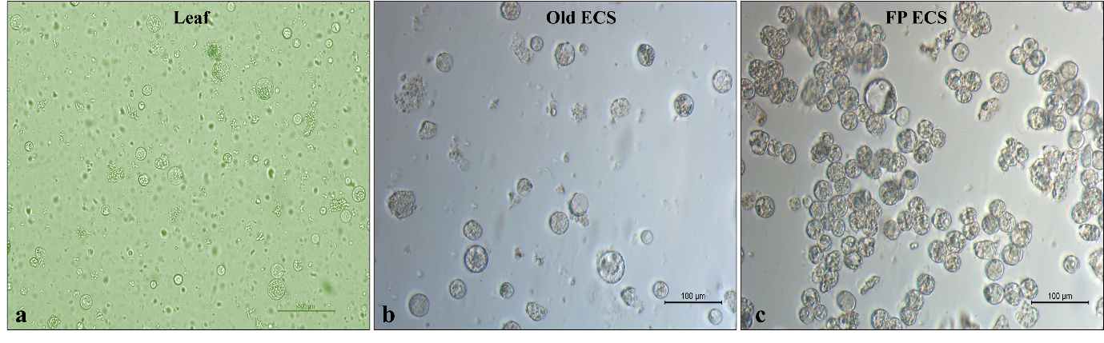
Fig. S1 Protoplasts isolated from (a) Tissue cultured raised banana leaf. (b) Old (nine months) banana ECS. (c) Freshly prepared banana ECS

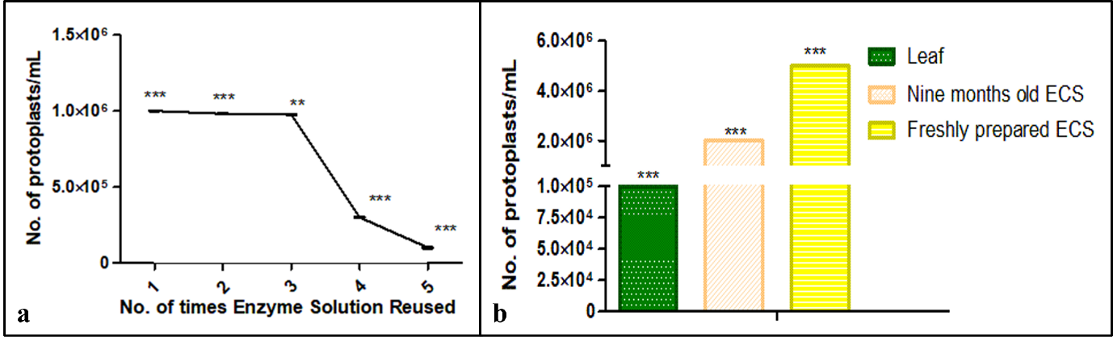
Fig. S2 (a) Re-usability of enzyme solution to isolate protoplasts (b) no. of isolated protoplasts from different source material. ** and *** represent statistically significant differences among treatments (one-way ANOVA with Tukey’s post hoc test, p < 0.05)

