Supplementary figures

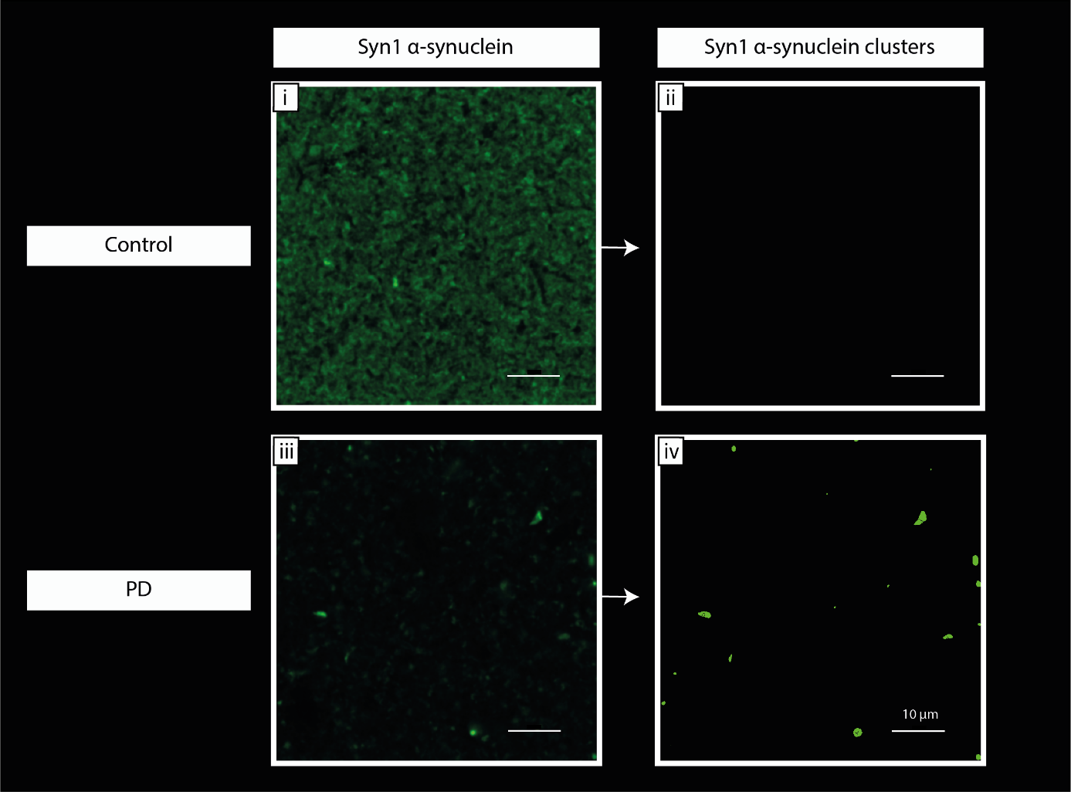
Figure S1. Definition of Syn1 α-synuclein and Syn1 α-synuclein clusters. The Syn1 α-synuclein staining showed two types of immunoreactivity: 1) total immunoreactivity that was termed Syn1 α-synuclein, which was clearly visible in controls (i) and reduced in PD cases (iii); 2) a clustered immunoreactivity that was termed Syn1 α-synuclein clusters, which was rarely in controls (ii), and often visualized in PD (iv),and was therefore thought to be most likely a pathological clustering of α-synuclein. In order to separately investigate these two patterns, we performed two different analyses on the Syn1 α-synuclein images. Syn1 α-synuclein was defined based on the raw Syn1 signal, and synaptic positivity analysis was performed similarly to how it is described in Fig. S2. On the other hand, Syn1 α-synuclein clusters were defined when based on high-intensity and high-contrast immunoreactivity, which was quantified with the ‘bright spots’ function, and synaptic positivity analysis was performed by colocalization analysis between Syn1 clusters and synaptic puncta (for details on criteria for positivity, see Table S4). The images in (i) and (iii) have the same intensity measures. Legend: PD: Parkinson’s disease.

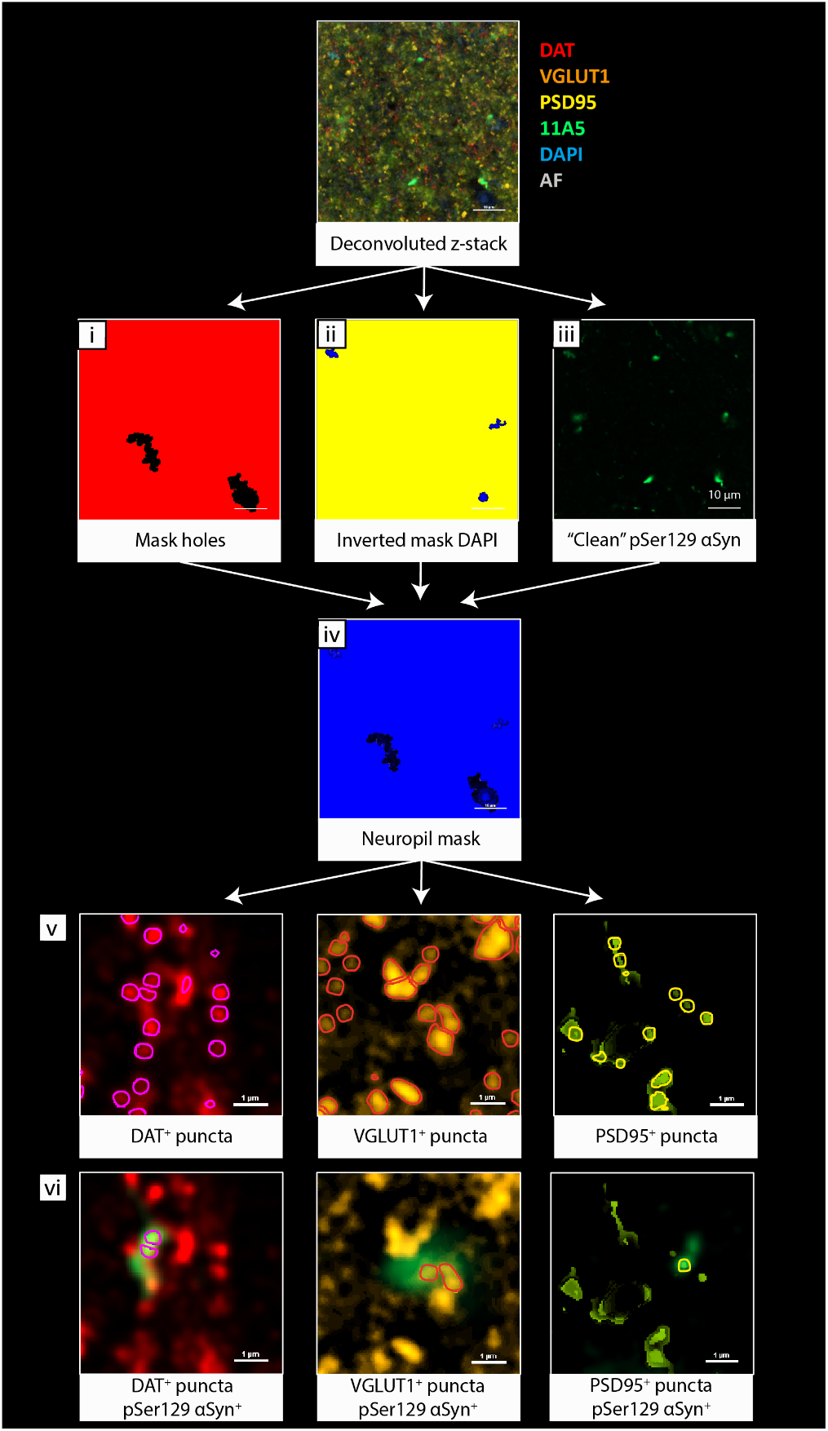
Figure S2. 3D analysis of DAT, VGLUT1, and PSD95 synaptic puncta positive to α-synuclein (example with pSer129 α-synuclein). Deconvolution was performed in Huygens Professional, and then 3D image analysis was performed in NIS-elements AR analysis 5.42.03. Deconvoluted images were masked for holes in tissue on the VGLUT1 channel (i) since it showed consistent staining pattern across cases, and then for nuclei on the DAPI channel (ii) or somas on the PSD95 channel, since PSD95 showed unspecific staining in neuronal somas, as described by the manufacturer’s page (#3450S, Cell Signaling Technology). The masks were combined and the neuropil volume was established (iv). DAT+, VGLUT1+ and PSD95+ synaptic puncta were identified with the ‘bright spots’ function within the neuropil volume, based on intensity and average size (0.6 µm for DAT, 0.5μm for VGLUT1, and 0.4μm for PSD95) (v). Synapses were allowed to grow following the immunoreactivity pattern for size analyses. An extra pre-processing step was applied on the PSD95 channel (Fig. S3 for details). Before identifying synaptic puncta positive to α-synuclein, the pSer129 α-synuclein channel (iii) was pre-processed to get rid of unspecific signal. Specifically, the DAPI and autofluorescence channels were subtracted from the pSer129 α-synuclein channel using the ‘clip’ function. (vi) Next, DAT+, VGLUT1+ and PSD95+ puncta positive to pSer129 α-synuclein was identified. A similar analysis was performed to identify synaptic puncta positive to Syn1 and CTT122, while Syn1 clusters were analyzed with the ‘bright spots’ function (see Fig. S1) (for details on criteria for positivity, see Table S4). Legend: α-syn: α-synuclein; AF: autofluorescence; DAT: dopaminergic transporter; PSD95: post-synaptic density 95; VGLUT1: vesicular glutamatergic transporter 1.

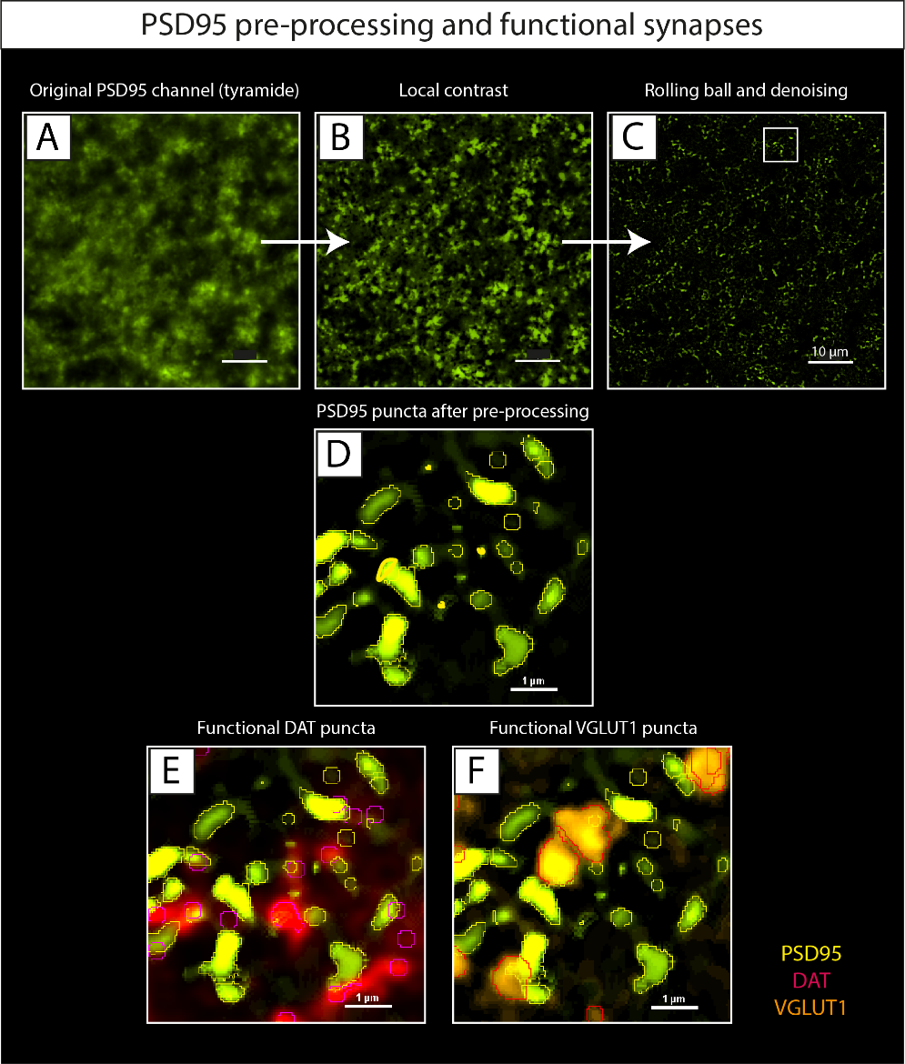
Figure S3. Pre-processing of the PSD95 channel, and 3D analysis of functional DAT and VGLUT1 synapses. A) The PSD95 immunoreactivity was visualized with Alexa Fluor® 555 Tyramide (since also the DAT antibody was anti-rabbit), giving a precipitate which looked like a cloud-like pattern. To decrease noise and measure only the brightest spots (real signal), B) local contrast was applied first, C) followed by the ‘rolling ball’ function (0.35 μm) and denoising. Since we set the size of PSD95 synapses artificially, synapse size analyses were not performed on PSD95+ puncta. D) After these pre-processing steps, PSD95 synapses were clearly visible, and E, F) were located next to DAT and VGLUT1 pre-synaptic puncta. In this way, DAT and VGLUT1 functional synapses (defined when a post-synaptic density is within 1 µm of the pre-synaptic puncta) were quantified. Legend: DAT: dopaminergic transporter; PSD95: post-synaptic density 95; VGLUT1: vesicular glutamatergic transporter 1.

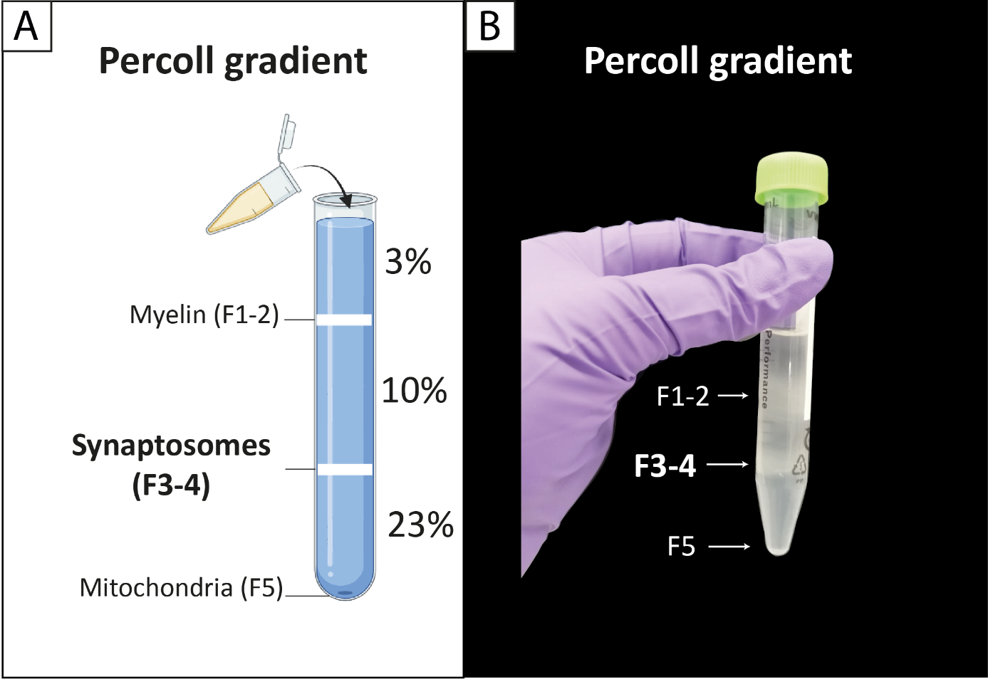
Figure S4. Percoll gradient and synaptosomal fraction isolation. A) Percoll gradient defined 3 fractions: myelin and membranes (F1-2), synaptosomes (F3-4), and mitochondria (F5). B) The interfaces could be clearly visualized against light sources or black background as white opaque lines (arrows). According to Dunkley et al [1], striatal Fractions 3 and 4 (F3-4) contain different populations of synaptosomes, with Fraction 4 harboring larger and denser synaptosomes than Fraction 3, with peaks of 1.4 µm of synaptic diameter (mean synaptic diameter of 0.59 µm and 0.91 µm for F3 and F4, respectively). Fractions 3 and 4 (F3-4) can be pulled together to increase synaptosomal yield [1], as performed in this study.

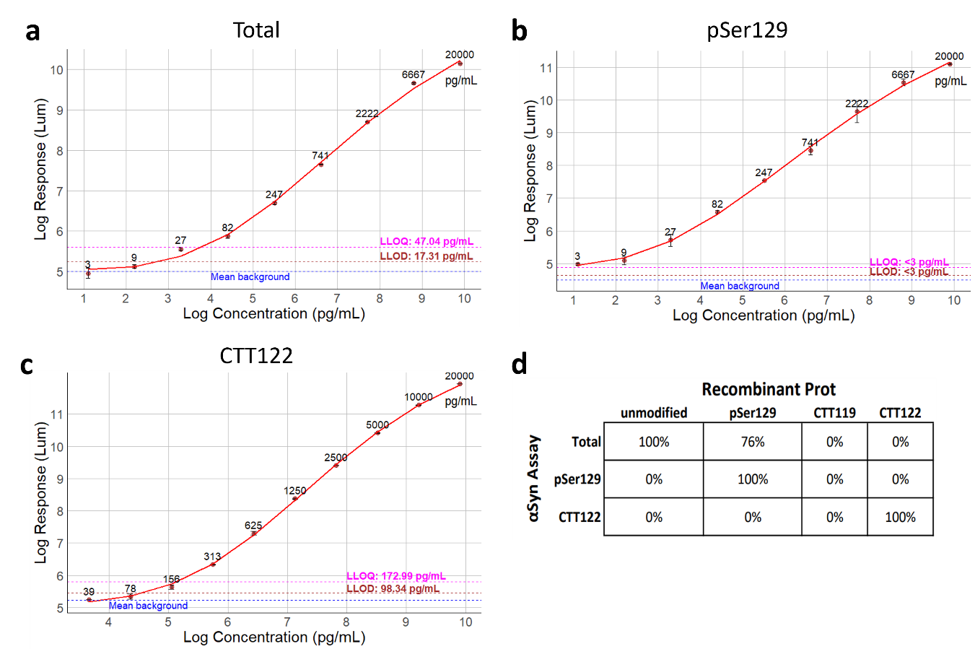
Figure S5. Standard curves of the AlphaLISA assays for α-synuclein proteoforms quantification. (a-c): Standard curves made with recombinant α-synuclein protein used for quantification in the total (a), pSer129 (b) and CTT122 αSyn (c) AlphaLISA assays. Mean values and Standard Deviations are presented. (d): Cross-reactivity of each α-synuclein AlphaLISA assay (α-synuclein Assay) with unmodified, pSer129, aa119-truncated (CTT119), aa122-truncated (CTT122) recombinant protein. Mean value of measurements at 20000, 2000 and 200 pg/mL compared to the corresponding recombinant protein standard. Legend: LLOD = Lower Limit of Detection; LLOF = Lower Limit of Quantification.
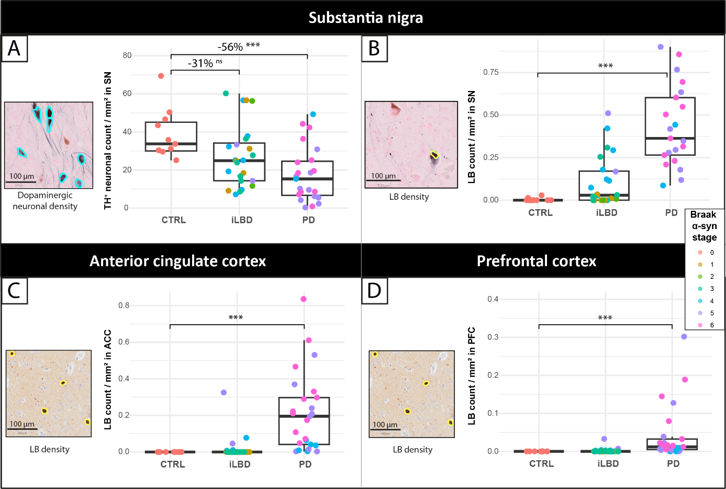
Figure S6. TH neuronal density and SN density in the substantia nigra, and LB density in anterior cingulate and pre-frontal cortex. Dopaminergic neuronal density was lower (A) and LB density higher (B) in the substantia nigra of PD cases compared to controls. iLBD cases showed a phenotype between controls and PD. LB density was higher in the anterior cingulate (C) and prefrontal cortex (D) in PD cases compared to controls. Data points are color-coded per Braak α-synuclein stage per case. In each insert, a representative image of each outcome measure is shown (A: TH staining visualized with Vector SG, highlighting dopaminergic neurons in light blue; B: pSer129 α-synuclein staining visualized with Vector SG, highlighting LBs in yellow; C and D: KM51 α-synuclein staining visualized with DAB, highlighting LBs in yellow). Legend: ACC: anterior cingulate cortex; CTRL: control; DAT: dopaminergic transporter; iLBD: incidental Lewy body disease; LB: Lewy body; PD: Parkinson’s disease; PFC: prefrontal cortex; SN: substantia nigra; TH: tyrosine hydroxylase.

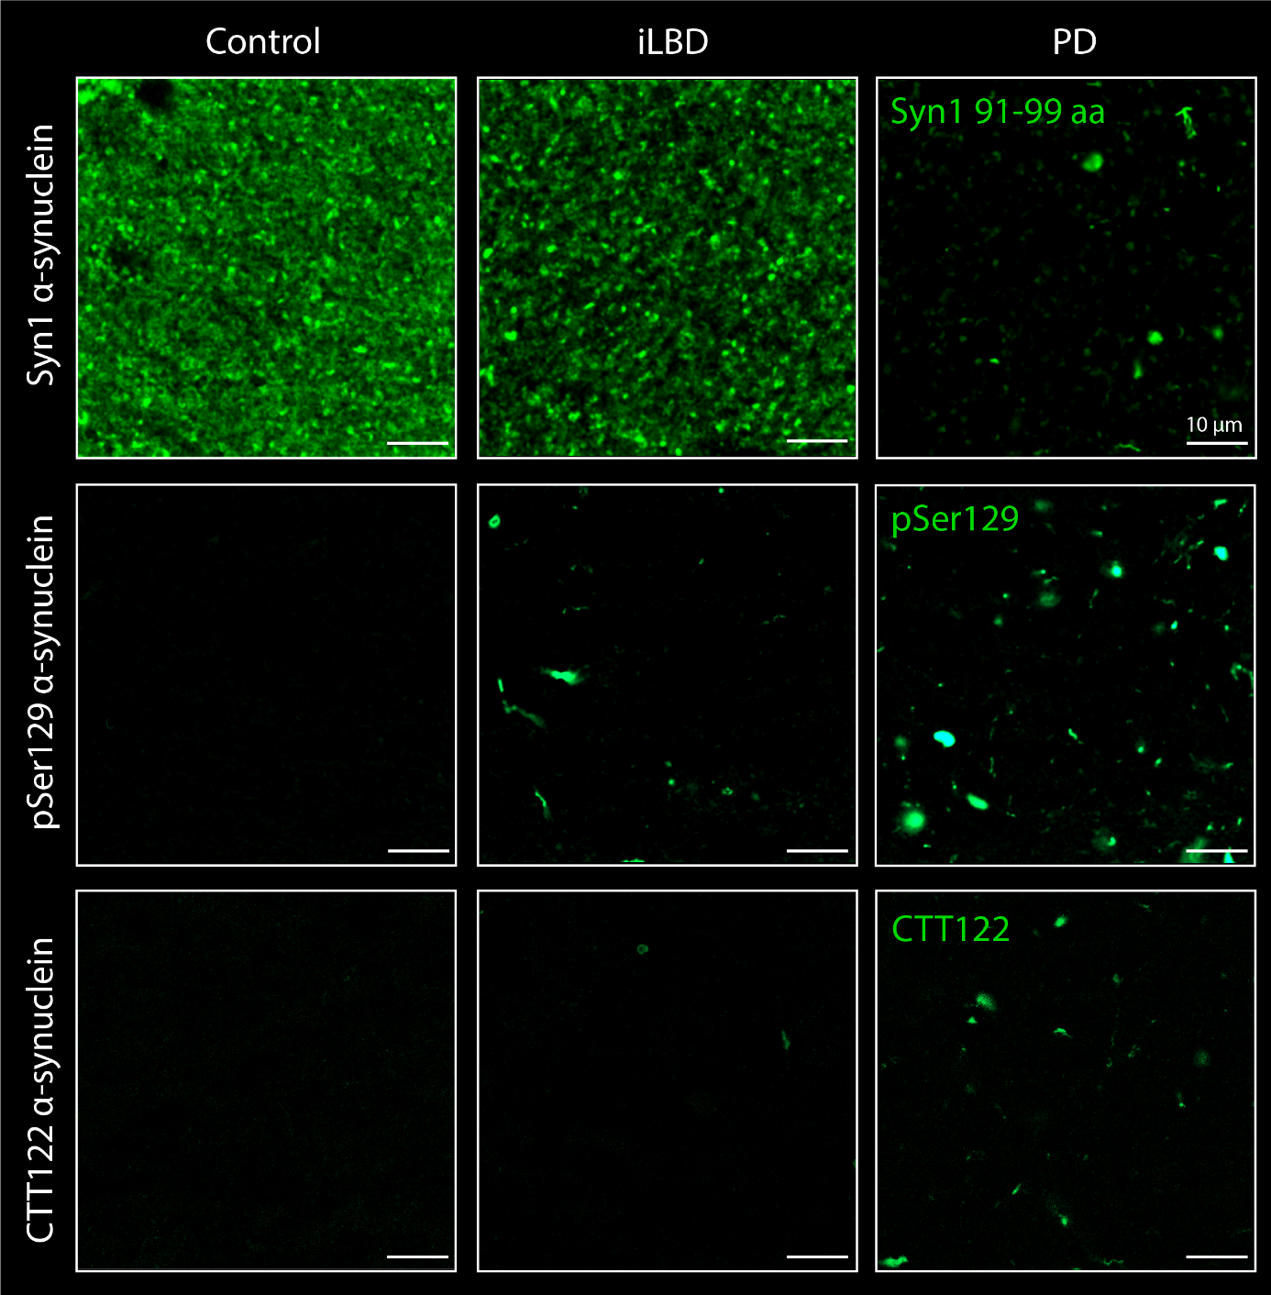
Figure S7. Immunoreactivity of Syn1, pSer129 and CTT122 α-synuclein in control, iLBD and PD putamen. Images of stainings of Syn1 (aa 91-99, BD Transduction Labs), pSer129 (clone 11A5, Prothena), and CTT122 (clone A15127A, Biolegend) α-synuclein in the putamen (ACC innervation area) of a control (case nr 1 in Table S1), iLBD (at Braak α-synuclein stage 3, case nr 26 in Table S1), and PD case (at Braak α-synuclein stage 6, case nr 68 in Table S1). For information on primary antibodies see Table S2. Staining of alpha-synuclein proteoforms were not performed in the same section (for this, check Figure S6). Scale bar is 10 µm for all images. Legend: aa: amino acid; CTT122: α-synuclein truncated at aa 122; pSer129: α-synuclein phosphorylated at serine 129; Syn1: α-synuclein antibody from BD Transduction Labs, targeting amino acids 91-99.

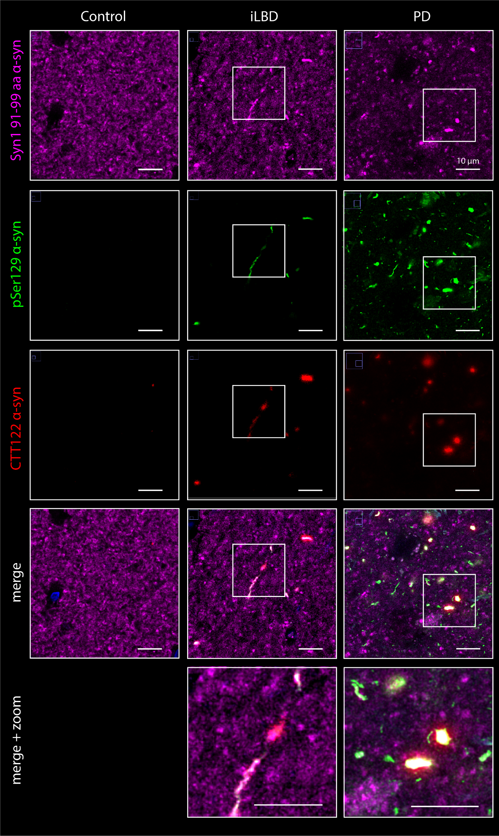
Figure S8. Co-localized immunoreactivity of Syn1, pSer129 and CTT122 α-synuclein in control, iLBD and PD putamen within the same section. Images of stainings of Syn1 (aa 91-99, BD Transduction Labs; magenta), pSer129 (clone 11A5, Prothena; green), and CTT122 (clone A15127A, Biolegend; red) α-synuclein in the putamen (ACC innervation area) of a control (case nr 1 in Table S1), iLBD (at Braak α-synuclein stage 3, case nr 26 in Table S1), and PD case (at Braak α-synuclein stage 6, case nr 68 in Table S1). For information on primary antibodies see Table S2. Staining protocol is in supplementary methods. Briefly, mouse anti-Syn1 α-synuclein was visualized with goat anti-mouse Alexa Fluor® 680 PLUS, mouse anti-pSer129 α-synuclein was already labelled with Alexa Fluor® 488, and mouse anti-CTT122 α-synuclein was visualized with tyramide and Alexa Fluor® 555. From the figure, it is clear that while all pSer129 and CTT122 positive structures are also positive to Syn1 α-synuclein, not all pSer129 and CTT122 colocalize. Specifically, pSer129 positive structures were more abundant than CTT122 positive structures. Scale bar is 10 µm for all images. Legend: aa: amino acid; CTT122: α-synuclein truncated at aa 122; pSer129: α-synuclein phosphorylated at serine 129; Syn1: α-synuclein antibody from BD Transduction Labs, targeting amino acids 91-99. Methods: six-µm thick sections from tissue blocks of caudate-putamen were cut and mounted on superfrost+ glass slides (Thermo Scientific, USA). All sections were stained for mouse anti-Syn1 α-synuclein (SYN1, aa 91-99, BD Biosciences), mouse anti-pSer129 α-synuclein (clone 11A5, Prothena) and mouse anti-α-synuclein C-terminally truncated at residues 122 (CTT122, clone A15127A, Biolegend). Briefly, the sections were deparaffinised, immersed in Tris-EDTA pH 9.0, heated to 100°C in a steam cooker for 30 minutes, immersed in 80% formic acid for 5 minutes, and washed under warm running tap water for antigen retrieval. The sections were blocked for endogenous peroxidase using 1% hydrogen peroxide in tris buffered saline (TBS; pH 7.4), and consequently in 3% normal goat serum in TBS for 30 minutes. CTT122 α-synuclein primary antibody was diluted in 1% normal goat serum in TBS, and the sections incubated overnight at 4°C. On the second day, CTT122 α-synuclein primary antibody was detected using EnVision (Dako, Glostrup, Denmark) and Alexa Fluor® 555 Tyramide with 0.005% hydrogen peroxide in Tris-HCl buffer. The sections were then immersed in Tris-EDTA pH 9.0, and heated to 100°C in a steam cooker for 15 minutes for antibody removal, and blocked in 3% normal goat serum in TBS for 30 minutes. Syn1 α-synuclein primary antibody was then diluted in 1% normal goat serum in TBS, and incubated overnight at 4 °C. On the third day, sections were incubated for 2 hours with the secondary antibodies labelled to goat anti-mouse Alexa Fluor® 680 PLUS. After 3 washes in TBS and 30 minutes incubation with 5% normal mouse serum, primary antibodies against pSer129 α-synuclein directly labelled with Alexa Fluor® 488 were added, and the sections incubated at room temperature for 2 hours in 1% normal mouse serum in TBS. TBS was used to wash the sections between steps. The sections were counterstained with DAPI and mounted with Mowiol (Sigma-Aldrich, St. Louis, United States) plus anti-fading agent DABCO.

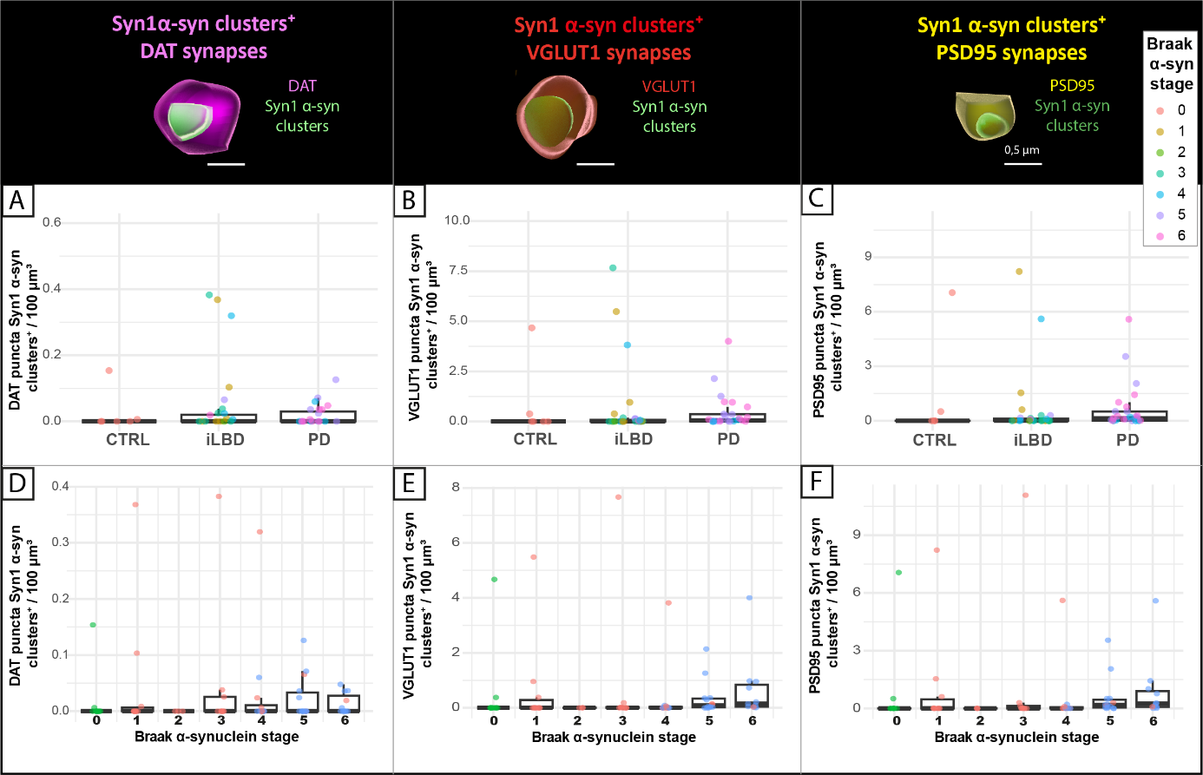
Figure S9. Enrichment of Syn1 α-synuclein clusters in dopaminergic, glutamatergic and post-synapses per group and across Braak α-synuclein stages. The density of Syn1 α-synuclein clusters positive DAT, VGLUT1 and PSD95 synapses did not differ between groups (all p>0.05). One control case (case number 3 in Table S1) showed clustered positivity, and iLBD and PD groups showed several extreme outliers. Data points are average per case, and are color-coded per Braak α-synuclein stage in A-C) and per group in D-F). On top, a representative 3D surface-rendering image of DAT (magenta), VGLUT1 (red), and PSD95 (yellow) synapses positive to Syn1 α-synuclein clusters (green) are shown (scale bar 0.5 µm). Legend: α-syn: α-synuclein; CTRL: control; DAT: dopaminergic transporter; iLBD: incidental Lewy body disease; PD: Parkinson’s disease; PSD95: post-synaptic density 95; VGLUT1: vesicular glutamatergic transporter 1.

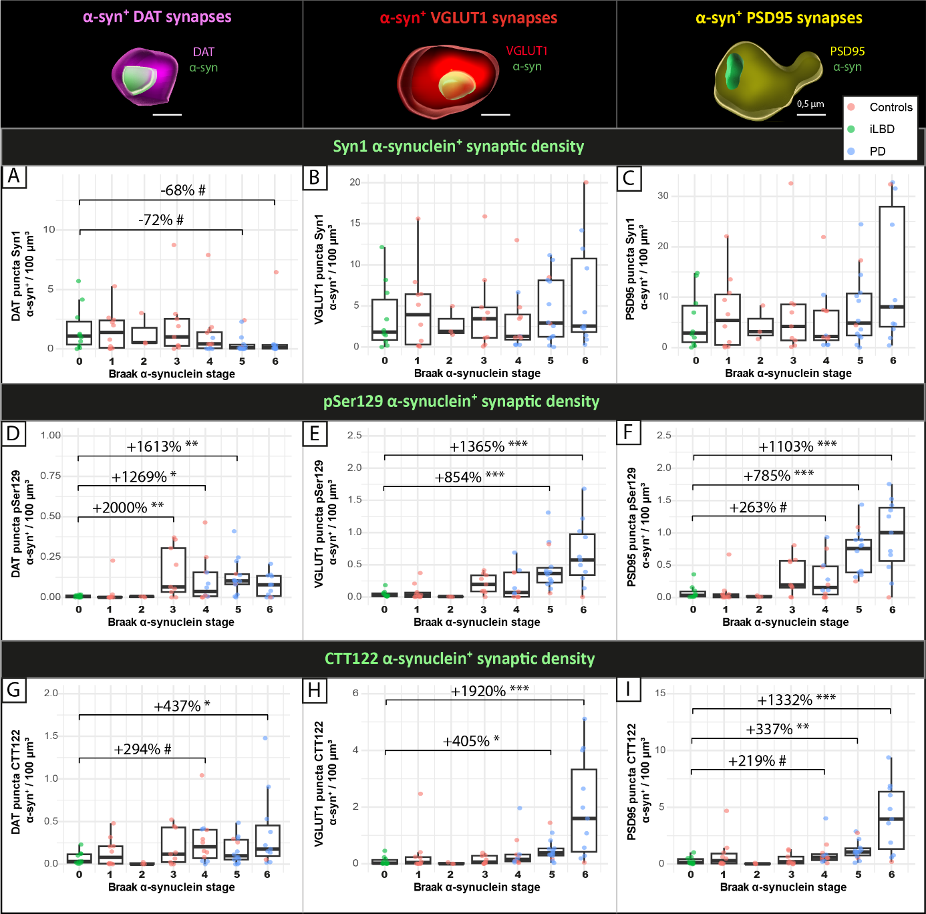
Figure S10. Enrichment of α-synuclein proteoforms in DAT, VGLUT1 and PSD95 across Braak α-synuclein stages. A) Syn1 α-synuclein+ DAT synaptic density tended to be lower at Braak stage 5 and 6 compared to control, while Syn1 α-synuclein+ B) VGLUT1 and C) PSD95 synaptic density did not change across Braak α-synuclein stages. D) pSer129 α-synuclein+ DAT synaptic density was higher from Braak α-synuclein 3 compared to controls; pSer129 α-synuclein+ E) VGLUT1, and F) PSD95 synaptic density was higher in PD about from Braak α-synuclein 5 compared to controls. G) CTT122 α-synuclein+ DAT synaptic density was higher at Braak α-synuclein stage 6 compared to controls; CTT122 α-synuclein+ H) VGLUT1 and I) PSD95 synaptic density was higher from Braak α-synuclein stage 5 compared to controls. Data points are average per case, and are color-coded per Braak α-synuclein stage. Data points are average per case, and are color-coded per group. On top, a representative 3D surface-rendering image of DAT (magenta), VGLUT1 (red), and PSD95 (yellow) synapses positive to α-synuclein proteoforms (green) are shown (scale bar 0.5 µm). Legend: α-syn: α-synuclein; DAT: dopaminergic transporter; PSD95: post-synaptic density 95; VGLUT1: vesicular glutamatergic transporter 1. 0.10< p ≤0.05#, p<0.05*, p<0.01**, p<0.001***
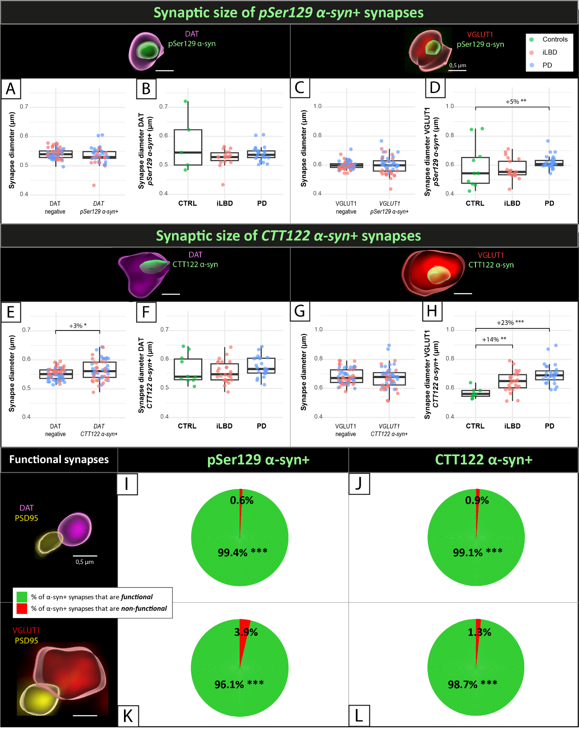
Figure S11. Synaptic size and functionality of Syn1 α-synuclein clusters+ DAT and VGLUT1 synapses. A-H) Synaptic size: DAT and VGLUT1 synapses positive to A-D) pSer129 and E-H) CTT122 α-synuclein. Mean synaptic diameter of DAT and VGLUT1 synapses negative to α-synuclein was about 545 nm and 635 nm, respectively. The diameter of pSer129 α-synuclein+ DAT and VGLUT1 synapses did not differ from pSer129 α-synuclein-negative synapses (DAT: p=0.075; VGLUT1: p=0.808). While the size of pSer129 α-synuclein+ DAT synapses did not differ between controls, iLBD and PD (all p>0.05), pSer129 α-synuclein+ VGLUT1 synapses were significantly larger (swollen) in PD compared to the same synapses in controls (+5%, d= 0.34, p=0.001). CTT122 α-synuclein+ DAT synapses were significantly swollen compared to DAT synapses negative to CTT122 α-synuclein (+3%, d= 0.52, p=0.022), while the size of CTT122 α-synuclein+ synapses did not differ from VGLUT1 synapses negative to CTT122 α-synuclein (p=0.456). While the size CTT122 α-synuclein+ DAT synapses did not differ between controls, iLBD and PD (all p>0.05), CTT122 α-synuclein+ VGLUT1 synapses were significantly larger (swollen) in iLBD (+14%, d= 1.00, p=0.008) and PD (+23%, d= 1.65, p<0.001) compared to the same synapses in controls. Interestingly, in controls CTT122 α-synuclein+ VGLUT1 synapses were smaller compared to VGLUT1 synapses negative to CTT122 α-synuclein (-18%, d= 0.38, p<0.001). I-L) Synaptic functionality: DAT and VGLUT1 synapses positive to I-J) pSer129 and K-L) CTT122 α-synuclein were almost exclusively functional synapses, i.e. in close proximity (≤1µm) of a post-synaptic density. In total, 77% of DAT synapses and 75% of VGLUT1 synapses were functional (see Figure S10, I-L; for results of Syn1 α-synuclein clusters, see Figure S11). The percentage of functional DAT synapses did not differ between iLBD, PD and controls (all p<0.05), nor across Braak α-synuclein stages (all p<0.05). The percentage of functional VGLUT1 synapses was slightly lower in PD compared to iLBD (-6%, d= 0.55, p=0.027), and did not differ between the other groups (all p<0.05), nor across Braak α-synuclein stages (all p<0.05). pSer129 (p>0.001) and CTT122 α-synuclein (p>0.001) were significantly enriched more often in functional compared to non-functional DAT and VGLUT1 synapses, even when correcting for percentage of functional DAT and VGLUT1 synapses. Representative 3D surface-rendering image of DAT (magenta), VGLUT1 (red), and PSD95 (yellow) synapses positive to α-synuclein proteoforms (green) are shown (scale bar 0.5 µm). Legend: α-syn: α-synuclein; CTRL: control; DAT: dopaminergic transporter; iLBD: incidental Lewy body disease; PD: Parkinson’s disease; PSD95: post-synaptic density 95; VGLUT1: vesicular glutamatergic transporter 1. 0.10< p ≤0.05#, p<0.05*, p<0.01**, p<0.001***

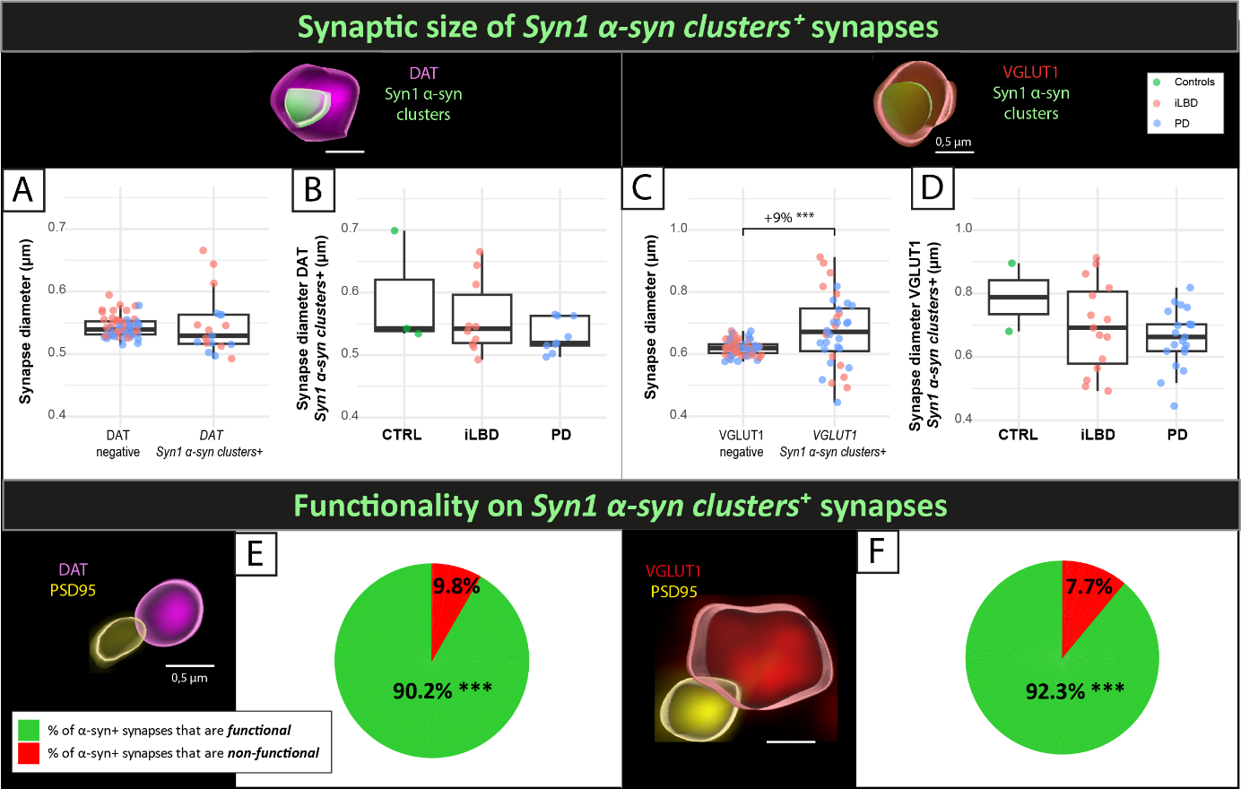
Figure S12. Synaptic size and functionality of Syn1 α-synuclein clusters+ DAT and VGLUT1 synapses. C) VGLUT1 synapses positive to Syn1 α-synuclein clusters were swollen compared to VGLUT1 synapses negative to Syn1 α-synuclein clusters (+9%, d= 0.72, p<0.001), while A) size of DAT synapses positive to Syn1 α-synuclein clusters did not differ from DAT synapses negative to Syn1 α-synuclein clusters (p=0.265). B, D) The size of DAT and VGLUT1 synapses positive to Syn1 α-synuclein clusters did not differ between controls, iLBD and PD (all p>0.05), indicating that enrichment of Syn1 α-synuclein clusters has a swelling effect on VGLUT1 synapses specifically, independently of disease state. Syn1 α-synuclein clusters were significantly enriched more often in functional compared to non-functional DAT and VGLUT1 synapses (both p>0.001), even when correcting for percentage of functional DAT and VGLUT1 synapses. Briefly, 90.2% and 92.3% of Syn1 α-synuclein cluster positive DAT and VGLUT1 synapses were functional, respectively (DAT: d= 1.68, p<0.001; VGLUT1: d= 1.44, p<0.001). Data points are average per case, and are color-coded per Braak α-synuclein stage per case. On top, a representative 3D surface-rendering image of DAT (magenta) and VGLUT1 (red) synapses positive to Syn1 α-synuclein clusters (green) are shown (scale bar 0.5 µm). On bottom, a representative 3D surface-rendering image functional DAT (DAT: magenta; PSD95: yellow) and VGLUT1 functional synapses (VGLUT1: red; PSD95: yellow) are shown (scale bar 0.5 µm). Legend: α-syn: α-synuclein; DAT: dopaminergic transporter; PSD95: post-synaptic density 95; VGLUT1: vesicular glutamatergic transporter 1. p<0.001***

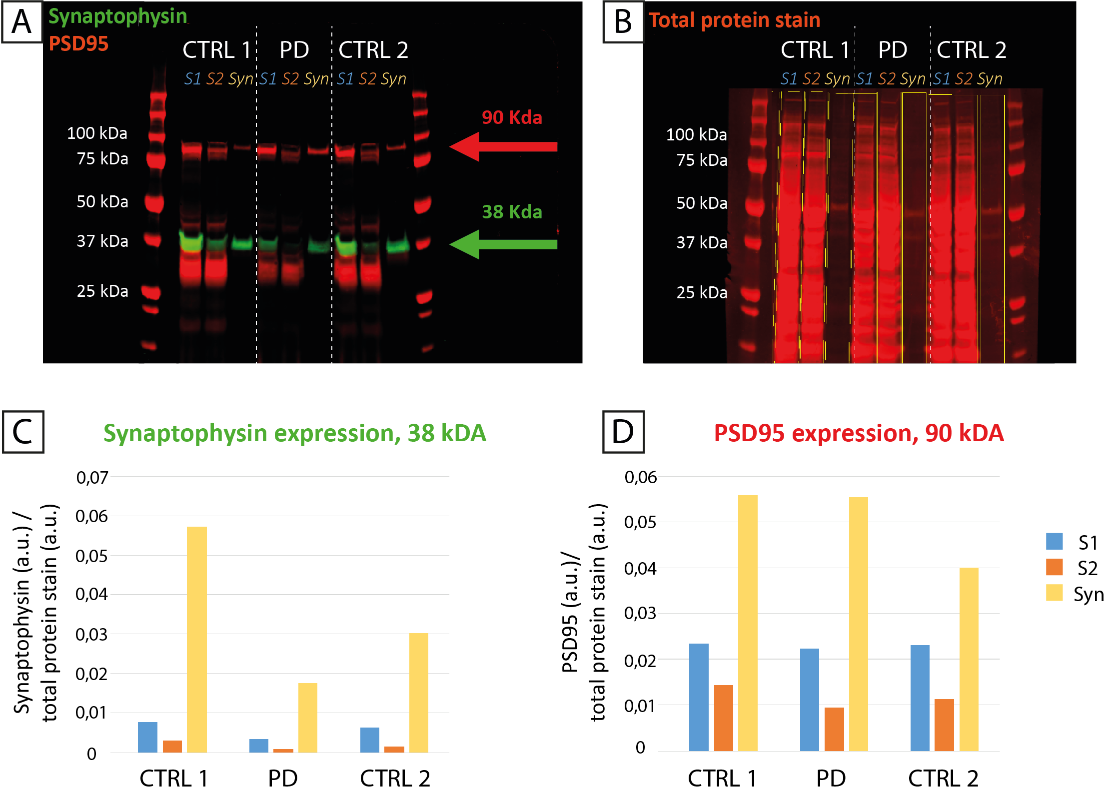
Figure S13. Pre- and post-synaptic protein enrichment in synaptosomal fraction (Western blot analysis). A) Western blot of mouse anti-synaptophysin (green, 38 kDa), and rabbit anti-PSD95 (red, 90 kDa) in total homogenate (S1), cytosolic (S2) and synaptosomal fraction (Syn) of putamen in two controls and one PD case. B) Shows total protein stain for S1, S2, and Syn fractions. C) Synaptophysin (pre-synaptic marker) and D) PSD95 (post-synaptic marker) protein expression was quantified and normalized over total protein stain of each fraction. Both synaptic markers were enriched in all three cases. Legend: a.u.: arbitrary unit; CTRL: control; PD: Parkinson’s disease; Syn: synaptosomal fraction.

References

1. Dunkley, P.R., P.E. Jarvie, and P.J. Robinson, A rapid Percoll gradient procedure for preparation of synaptosomes. Nature protocols, 2008. 3(11): p. 1718-1728.

