Supplementary Material of the paper

Spectral evidence for recent/ongoing activity in Mercury’s Praxiteles basin

Anna Galiano¹, Giovanni Munaretto², Deborah Domingue³, Cristian Carli¹, Gianrico Filacchione¹, Valentina Galluzzi¹, Salvatore Buoninfante^{1,4}, David Rothery⁵, Fabrizio Capaccioni¹, Mario D’Amore⁶, Alessandro Maturilli⁶, Sebastien Besse⁷, Océane Barraud⁶, Lauren Jozwiak⁸, Ariel N. Deutsch^{9,10}, Antti Penttilä¹¹, Oleg Abramov³.

¹ Institute of Space Astrophysics and Planetology (INAF), Rome, Italy. ²Astronomical Observatory of Padova (INAF), Italy. ³Planetary Science Institute, Arizona, USA. ⁴University of Naples Federico II, Italy. ⁵School of Physical Sciences, The Open University, UK. ⁶Deutsches Zentrum für Luft- und Raumfahrt (DLR), Institute of Planetary Research, Berlin, Germany. ⁷European Space Astronomy Centre (ESAC), Spain. ⁸Johns Hopkins Applied Physics Laboratory, Maryland, USA. ⁹NASA Ames Research Center, California, USA. ¹⁰Bay Area Environmental Research Institute, California, USA. ¹¹University of Helsinki, Finland.
Section 1
We mosaicked the Fassett et al. (2016) DEMs of Orm faculae and the USGS global DEM of Mercury and resampled the result at 665 m/px spatial resolution. The Fassett et al. (2016) DEMs were shifted vertically to match the average elevation of the USGS DEM. A 665 m/px grid was defined, with each grid-point matching with a pixel within the DEM. All rasters were co-registered and resampled to this resolution and the local incidence, emission, phase and azimuth angles were computed with the ISIS phocube routine. For each grid-point, the flux and photometric angles were collected for each observation and this data was fitted with a basic Hapke model. Wavelength-dependent Hapke parameters for the Orm faculae pyroclastic deposits were estimated by averaging 3 regions of interest (ROIs) showing uniform, flat terrain within the faculae (Fig. S7). Although the full analysis of the photometric properties of the Orm faculae as implied by the photometric modelling results is being prepared in a future work, we report the Hapke parameters used for the photometric correction in Table S2. These Hapke parameter values were used to perform the photometric normalization of the spectral cube (i.e., ratio of the I/F predicted by the Hapke model at the photometric angles of the observation and multiplication to the I/F predicted by the Hapke model at the standard angles, incidence=30°, emission=0°, phase=30°).

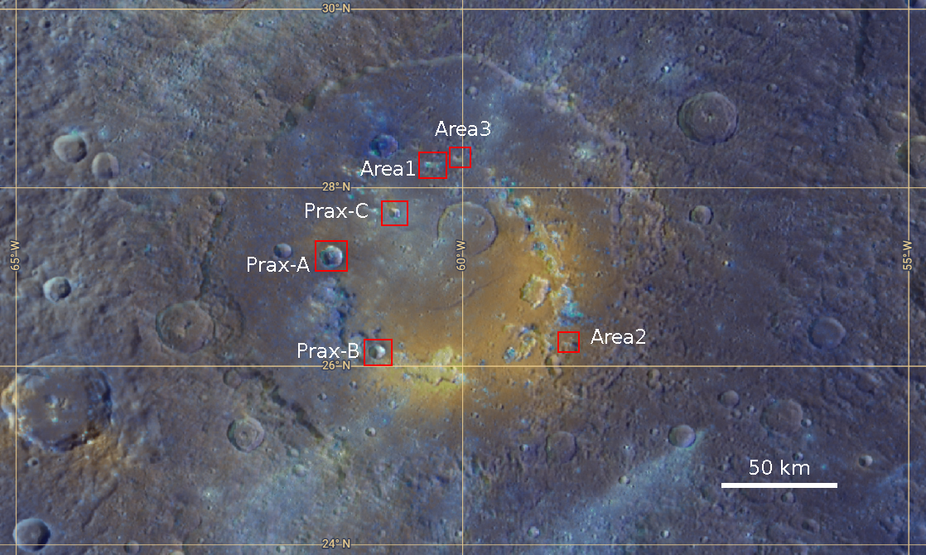
Fig. S1. The Praxiteles basin. Enhanced color image of Praxiteles basin studied in this work. The areas whose spectra show the 830 nm spectral features are enclosed in red rectangles.

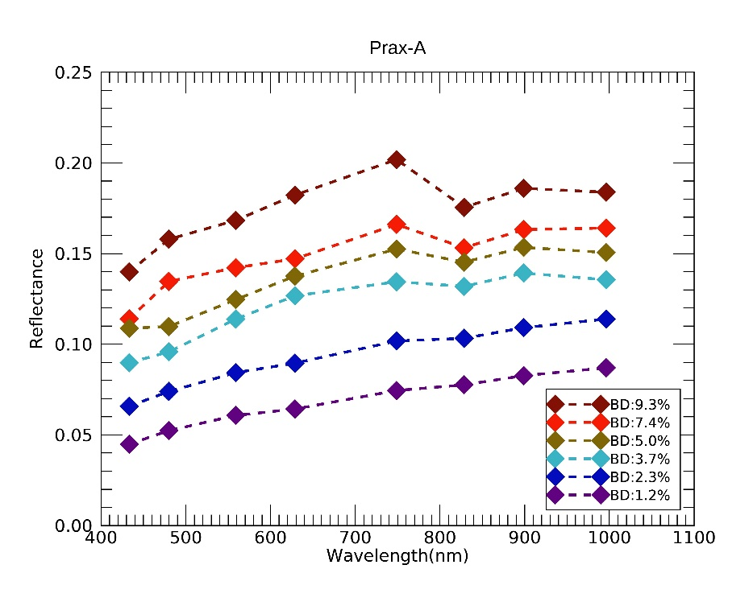
Fig. S2. MDIS WAC spectra with the band at 830 nm. MDIS single spectra from within Prax-A with increasing intensity of the band at 830 nm. The spectral feature is absent or undetectable for spectra with a BD lower than 3%. The spectra shown in the figure can be found at the following samples and lines in the MDIS cube: 160, 436 (dark red spectrum); 164, 434 (light red spectrum); 158, 439 (yellow spectrum); 160, 435 (cyan spectrum); 160, 439 (blue spectrum); 164, 432 (violet spectrum).

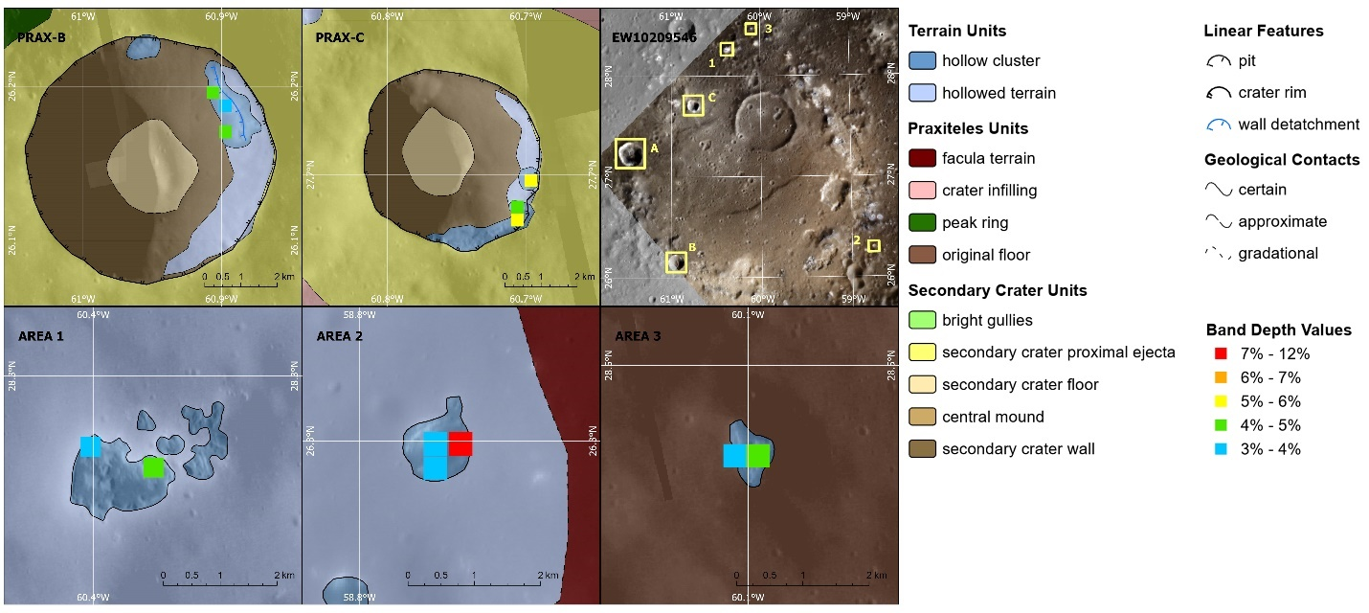
Fig. S3. High-resolution geological map of the studied areas. The location of pixels displaying spectra with a 830 nm band depth greater than 3% are superposed on the geological map of the study areas.

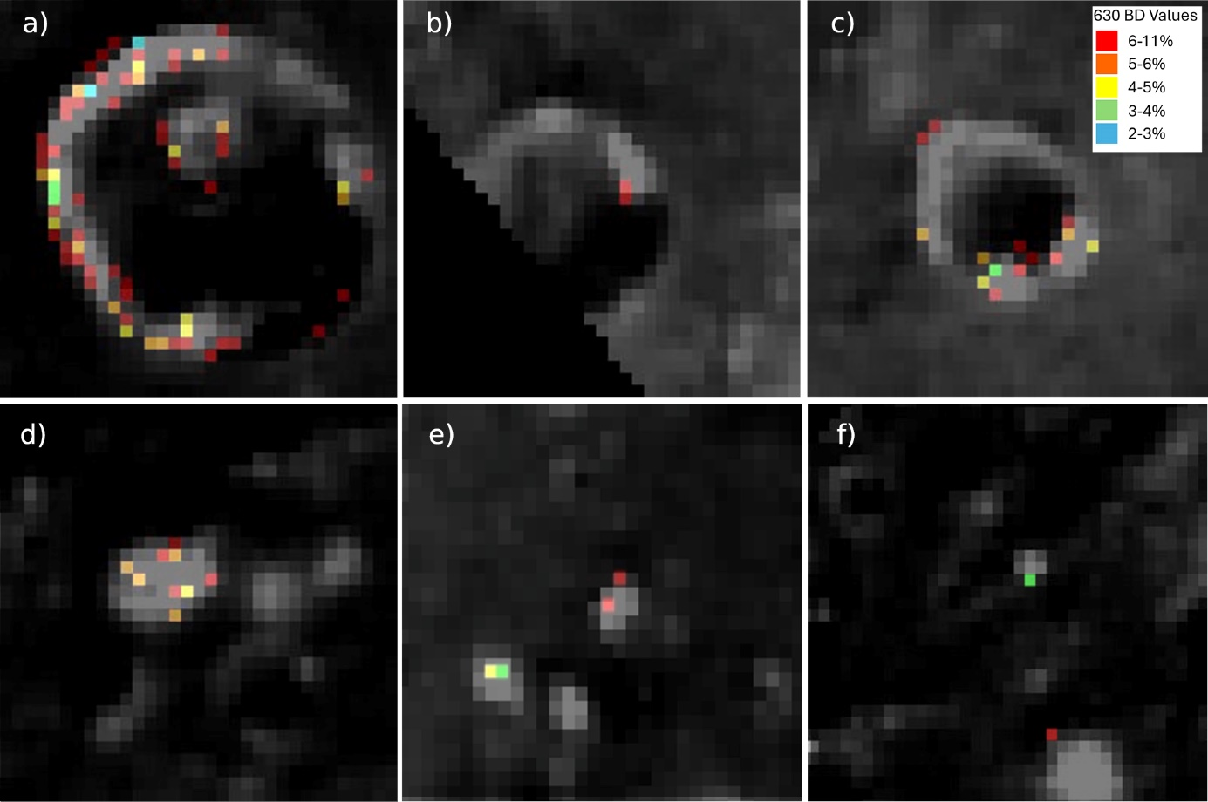Fig. S4. Geospatial location of the 630 nm feature in the studied regions. MDIS colour image EW10209546 (spatial resolution of 365 m/px) of Prax-A (a), Prax-B (b), Prax-C (c), Area1 (d), Area2 (e) and Area (f). The colored pixels correspond to the spectra with the 630 nm band and the color code indicates band depth (BD) values (%).

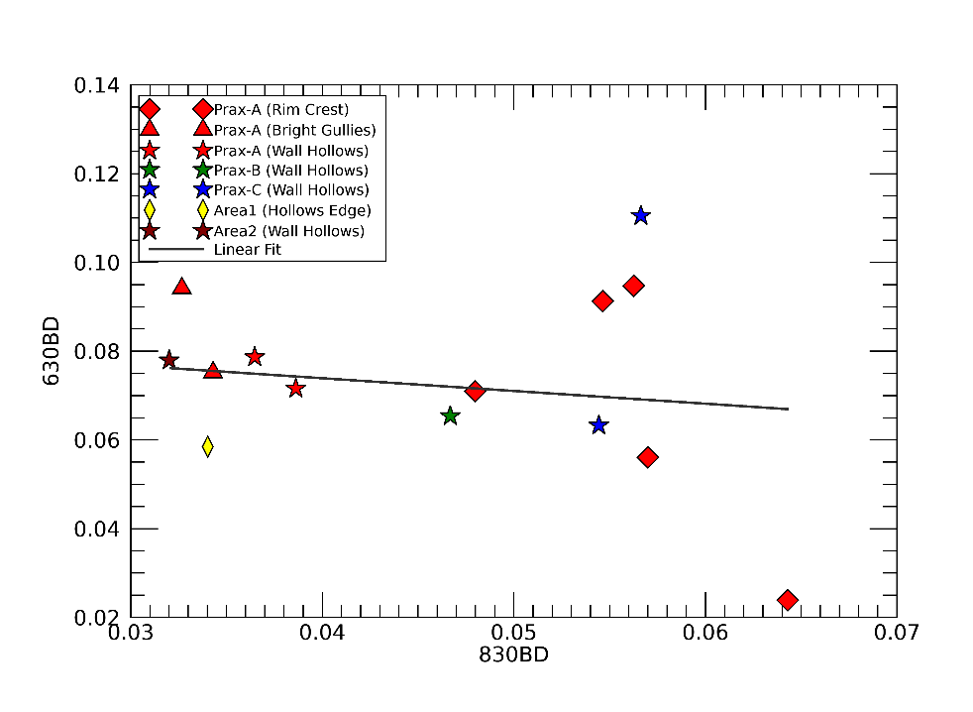
Fig.S5. Scatterplot of the 630 nm Band Depth vs. the 830 nm Band Depth. A weak anti-correlation (Pearson coefficient of -0.2) is found between the spectral features, when fitted to a linear relationship represented by the black line.
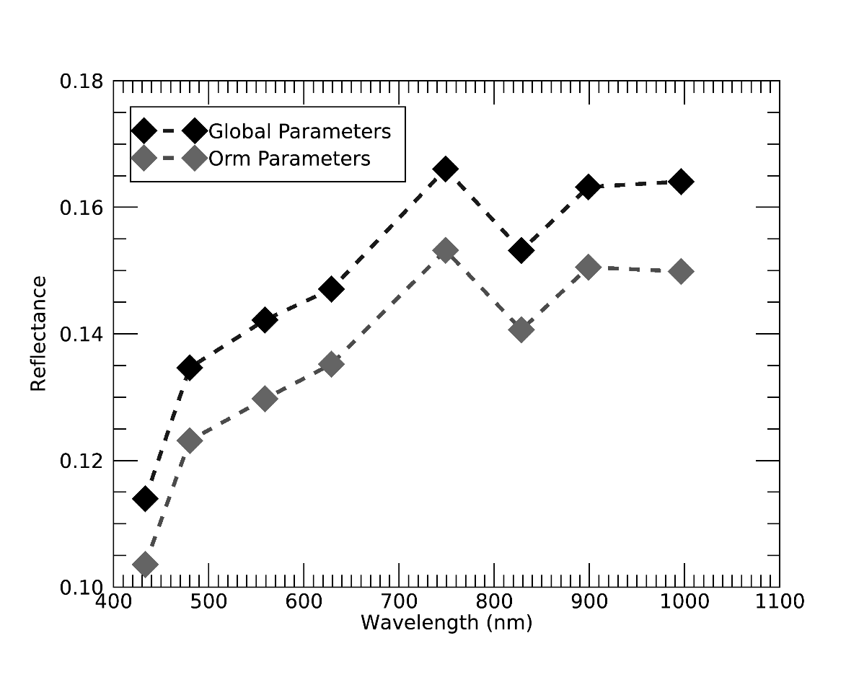
Fig. S6. Photometrical correction on MDIS spectra. A representative MDIS spectrum of Prax-A (164, 434) corrected for global parameters (grey spectrum) and for Orm parameters (black spectrum). The 830 nm spectral feature is present in both spectra. The different photometrical corrections introduce a shift in reflectance level.
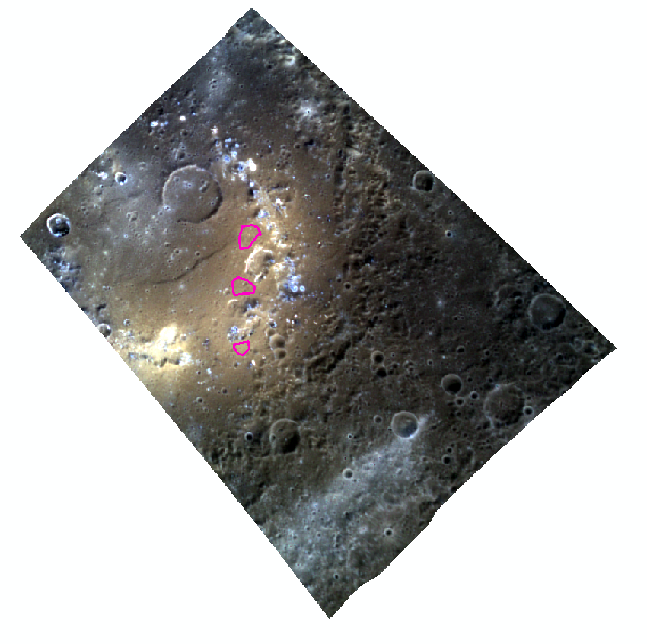
Fig. S7. ROIs in the RGB colour image of the EW10209546. RGB colour composite of bands I (Red), G (Green), and F (Blue) of MDIS spectral cube EW10209546 showing the location of the 3 ROIs used for deriving the Hapke parameters for pyroclastic deposits.
Lat (°N) | Lon (°E) | BD830 (%) | Location | Geological Setting | Description | BD630 (%)
27.32 | -61.54 | 3.2 | Prax-A | Bright Gullies | Bright gullies and fresh wall detachments | n.d.
27.33 | -61.52 | 3.3 | Prax-A | Bright Gullies | Bright gullies and fresh wall detachments | 9.4
27.18 | -61.56 | 3.4 | Prax-A | Shadow | NAC frame is in shadow. | n.d.
27.31 | -61.53 | 3.4 | Prax-A | Bright Gullies | Bright gullies and fresh wall detachments | 7.5
27.16 | -61.55 | 3.5 | Prax-A | Shadow | NAC frame is in shadow. | n.d.
27.12 | -61.44 | 3.6 | Prax-A | Wall Hollows | Hollow cluster along southern wall | 7.9
27.33 | -61.53 | 3.7 | Prax-A | Bright Gullies | Bright gullies and fresh wall detachments | n.d.
27.12 | -61.48 | 3.9 | Prax-A | Wall Hollows | Hollow cluster along southern wall | 7.2
27.30 | -61.54 | 4.0 | Prax-A | Bright Gullies | Bright gullies and fresh wall detachments | n.d.
27.32 | -61.50 | 4.1 | Prax-A | High Wall | Top of crater wall, next to fresh gullies. | n.d.
27.31 | -61.54 | 4.7 | Prax-A | High Wall | Top of crater wall, next to fresh gullies. | n.d.
27.22 | -61.58 | 4.8 | Prax-A | Rim Crest | NAC in shadow but the point is located on high rim crest. | 7.1
27.29 | -61.55 | 5.0 | Prax-A | High Wall | Top of crater wall, next to fresh gullies. | n.d.
27.31 | -61.56 | 5.1 | Prax-A | Rim Crest | On top of rim crest, behind wall detachments. | n.d.
27.33 | -61.50 | 5.4 | Prax-A | Bright Gullies | Bright gullies and fresh wall detachments | n.d.
27.29 | -61.57 | 5.5 | Prax-A | Rim Crest | On top of rim crest. behind wall detachments | 9.1
27.14 | -61.53 | 5.6 | Prax-A | Rim Crest | NAC in shadow but the point is located on high rim crest | 9.5
27.30 | -61.56 | 5.7 | Prax-A | Rim Crest | On top of rim crest, behind wall detachments. | 5.6
27.27 | -61.58 | 6.1 | Prax-A | Rim Crest | NAC in shadow but the point is located on high rim crest. | n.d.
27.34 | -61.47 | 6.4 | Prax-A | Bright Gullies | Bright gullies and fresh wall detachments | n.d.
27.34 | -61.52 | 6.4 | Prax-A | Rim Crest | On top of rim crest, behind wall detachments | 2.4
27.34 | -61.46 | 7.4 | Prax-A | Bright Gullies | Bright gullies and fresh wall detachments | n.d.
27.34 | -61.49 | 7.4 | Prax-A | Bright Gullies | Bright gullies and fresh wall detachments | n.d.
27.32 | -61.53 | 9.3 | Prax-A | Bright Gullies | Bright gullies and fresh wall detachments | n.d.
27.29 | -61.58 | 9.8 | Prax-A | Rim Crest | On top of rim crest. behind wall detachments. | n.d.
27.30 | -61.57 | 11.4 | Prax-A | Rim Crest | On top of rim crest. behind wall detachments | n.d.
26.19 | 60.91 | 4.2 | Prax-B | Wall Hollows | Feature located below incipient hollow cluster forming along a fresh crater wall | n.d.
26.19 | 60.90 | 3.1 | Prax-B | Wall Hollows | Feature located below incipient hollow cluster forming along a fresh crater wall | n.d.
26.17 | 60.90 | 4.7 | Prax-B | Wall Hollows | Feature located below incipient hollow cluster forming along a fresh crater wall | 6.5
27.70 | 60.70 | 5.7 | Prax-C | Wall Hollows | Hollow cluster along south-eastern wall. High incidence angles | 11.0
27.68 | 60.71 | 4.5 | Prax-C | Wall Hollows | Hollow cluster along south-eastern wall. High incidence angles | n.d.
27.67 | 60.71 | 5.4 | Prax-C | Wall Hollows | Hollow cluster along south-eastern wall. High incidence angles | 6.3
28.27 | 60.40 | 3.4 | Area1 | Hollows edge | Feature located at the edge of the largest hollow of a wider hollow cluster | 5.8
28.26 | 60.37 | 4.2 | Area1 | Hollows edge | Feature located at the edge of the largest hollow of a wider hollow cluster | n.d.
26.30 | 58.77 | 3.2 | Area2 | Wall Hollows | Feature located at the edge or within a hollow cluster that likely follows the edges of a subdued secondary crater | 7.8
26.25 | 58.72 | 8.8 | Area2 | Wall Hollows | Feature located at the edge or within a hollow cluster that likely follows the edges of a subdued secondary crater | n.d.
26.30 | 58.76 | 3.2 | Area2 | Wall Hollows | Feature located at the edge or within a hollow cluster that likely follows the edges of a subdued secondary crater | n.d.
28.47 | 60.11 | 3.7 | Area3 | Isolated Hollows | Feature within a small isolated hollow cluster found on Praxiteles floor | n.d.
28.47 | 60.10 | 4.7 | Area3 | Isolated Hollows | Feature within a small isolated hollow cluster found on Praxiteles floor | n.d.

Table S1. Coordinates of the pixels whose spectra show the 830 nm band. The columns describe, from left to right for each pixel: the latitude and longitude, the intensity of the band at 830 nm (BD830), the corresponding region and geologic setting, descriptive notes and the intensity of the band at 630 nm (BD630) when present (n.d. indicates a 630 nm band not detected).
Filter | λ | w | b | c | θ
F | 433.20 | 0.1966 | 0.1357 | 0.7096 | 21.9560
C | 479.90 | 0.2304 | 0.1375 | 0.7159 | 20.5020
D | 558.90 | 0.2709 | 0.1243 | 0.7254 | 20.5177
E | 628.80 | 0.2980 | 0.1232 | 0.7270 | 19.4303
G | 748.70 | 0.3385 | 0.1038 | 0.7986 | 20.3064
L | 828.40 | 0.3769 | 0.1099 | 0.7423 | 19.2851
J | 898.80 | 0.3936 | 0.1056 | 0.7480 | 20.8316
I | 996.20 | 0.4126 | 0.1005 | 0.7463 | 20.8469
Table S2. Average Hapke parameters from the 3 ROIs in Fig. S4. λ represents the center wavelength of the filter, w is the single scattering albedo, b is the anisotropy parameter in the single particle scattering function, c is the forward vs. backward scattering parameter in the single particle scattering function, and θ is the topographic roughness

