Supplementary information
Enhancing lettuce resilience to cadmium stress: Insights from raw vs. cystamine-modified biochar
Rongqi Chen ¹, Xi Duan ¹, RuoXuan Xu ^{2, 3} and Tao Zhao ^{2, 3*}

¹ School of Agriculture Science and Technology, Shandong Agriculture and Engineering University, Ji’nan, 250100, China; echo_chenrq@126.com (R.C.); z2017020@sdaeu.edu.cn (X.D.).
² School of Food Science and Engineering, Qilu University of Technology (Shandong Academy of Sciences), Ji’nan, 250353, China; zhaotao1989@qlu.edu.cn (T.Z.).
³ Shandong Key Laboratory of Healthy Food Resources Exploration and Creation, Ji’nan, 250353, China.
* Correspondence: zhaotao1989@qlu.edu.cn (T.Z.); Tel.: +86-0531-8963-1932

Biochar treatment design
The soil samples were subjected to a cadmium concentration of 5 mg kg⁻¹, followed by the addition of raw biochars at concentrations of 0.3%, 0.6%, 1.2%, and 1.8% to evaluate the effects of different biochars additions on vegetable growth after 35 days of establishment.
Table S1 Effect of biochar addition on Lettuce biomass
Treatment | Plant height  (cm) | Stem diameter  (mm) | Leaf number | Leaf width  (cm) | Leaf length  (cm) | Fresh weight  (g·plant⁻¹)
CK | 23.80±0.24a | 9.85±0.24A | 13.40±0.80a | 9.80±0.22A | 12.70±0.28a | 143.28±1.04A
C₀₋₅ | 15.78±0.10e | 5.09±0.17E | 10.40±0.49c | 5.85±0.30E | 7.07±0.24d | 69.93±1.41E
C_{0.3-5} | 18.00±0.19d | 7.04±0.34D | 11.20±0.75bc | 6.31±0.29E | 7.33±0.39d | 74.97±1.22D
C_{0.6-5} | 19.40±0.42c | 8.03±0.42C | 11.40±0.49bc | 7.68±0.08D | 8.90±0.24c | 78.62±1.05C
C_{1.2-5} | 21.65±0.50ab | 9.06±0.56B | 12.80±0.40a | 8.53±0.27C | 10.97±0.33b | 83.21±1.61B
C_{1.8-5} | 22.83±0.25bc | 8.24±0.40C | 12.20±0.75ab | 9.06±0.24B | 11.16±0.14b | 83.97±1.14B
CK：Blank soil treatment group, C_{a-b}：a- the amounts of raw biochar (0、0.3%、0.6%、1.2%、1.8%)，b- the amount of cadmium (5 mg kg⁻¹)
The results presented in Table 1 demonstrate a significant difference between the C₀₋₅ and CK groups, with an impressive increase of 73.35 g plant⁻¹ fresh weight compared to CK group. Biochar addition had a substantial positive effect on lettuce growth indicators, with a noteworthy increase of 7.21-20.08% in the fresh weight of single plants. These findings suggest that biochar incorporation can effectively mitigate the toxic effect of cadmium. Interestingly, the difference between lettuce plants treated with 1.2% and 1.8% biochar was not significant, suggesting that the optimal conditions for subsequent studies were achieved with 1.2% biochars addition.
Table S2 Soil treatment design
Groups | Soil treatment design
CK | Blank soil | Blank soil | Blank soil
T₀ | Cd 1 mg kg⁻¹ | Cd 3 mg kg⁻¹ | Cd 5 mg kg⁻¹
T₁ | Cd 1 mg kg⁻¹+0.3%C* | Cd 3 mg kg⁻¹+0.3%C* | Cd 5 mg kg⁻¹+0.3%C*
T2 | Cd 1 mg kg⁻¹+0.6%C* | Cd 3 mg kg⁻¹+0.6%C* | Cd 5 mg kg⁻¹+0.6%C*
T₃ | Cd 1 mg kg⁻¹+1.2%C* | Cd 3 mg kg⁻¹+1.2%C* | Cd 5 mg kg⁻¹+1.2%C*
C₁ | Cd 1 mg kg⁻¹+0.3%C | Cd 3 mg kg⁻¹+0.3%C | Cd 5 mg kg⁻¹+0.3%C
C₂ | Cd 1 mg kg⁻¹+0.6%C | Cd 3 mg kg⁻¹+0.6%C | Cd 5 mg kg⁻¹+0.6%C
C₃ | Cd 1 mg kg⁻¹+1.2%C | Cd 3 mg kg⁻¹+1.2%C | Cd 5 mg kg⁻¹+1.2%C
Note: C*-Cystamine modified biochar C-raw rice husk biochar
Effects of various biochar treatments on root morphology
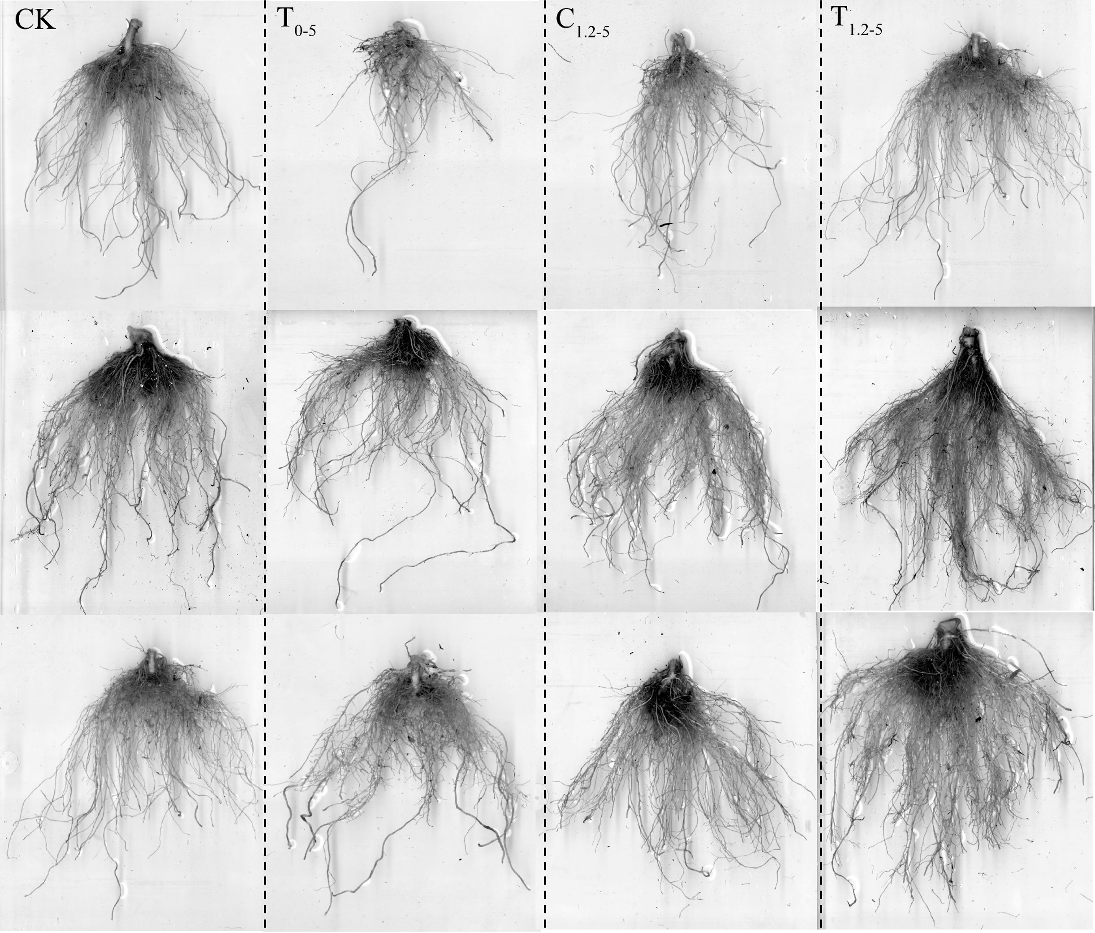

Fig. S1 Effects of different biochar treatments on morphology of lettuce roots, Cd addition level of 5 mg kg⁻¹and growth period from 14 to 28 days (from top to bottom).

Effect of various biochar on lecture’s photosynthetic parameters

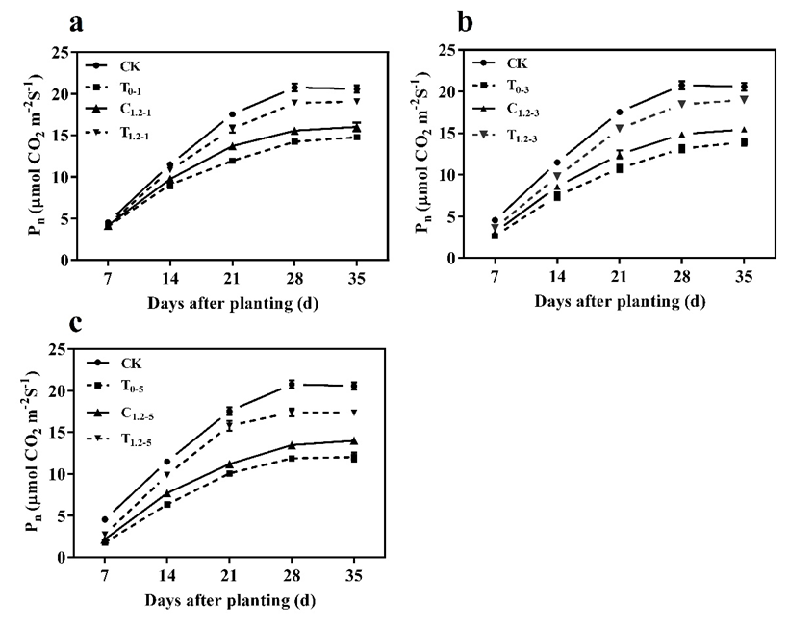

Fig. S2 Variation trend curves of net photosynthetic rate of lettuce leaves under different Cd level: (a) 1 mg kg⁻¹, (b) 3 mg kg⁻¹, and (c) 5 mg kg⁻¹.

Figure S2 shows the temporal trend in the net photosynthetic rate (Pn) of lettuce, which consistently increased, stabilizing 28 days after planting. In the T_{0-b} treatment group, a notable decrease in Pn was observed, with reductions of 25.37%, 29.63%, and 34.45% at Cd concentrations of 1, 3, and 5 mg kg⁻¹, respectively, compared to the CK. Conversely, the application of raw biochar (C_{1.2-b}) and Cys-BC (T_{1.2-b}) led to improvements in Pn, with increases ranging from 1.38% to 11.97% for C_{1.2-b} and from 1.91% to 37.93% for T_{1.2-b}, relative to the T_{0-b} group.
Fig. S3 Effects of different biochar treatments on photosynthetic parameters: (a) intercellular CO₂ concentration, (b) stomatal conductance, and (c) transpiration rate.
Figure S3 a illustrates the response of intercellular CO₂ concentration (Ci) to varying levels of Cd stress. Ci increased across all treatments (T₀, C_{1.2}, and T_{1.2}) as Cd concentrations rose, with the most significant elevation observed in the T₀₋₅ treatment. However, in the C_{1.2-b} and T_{1.2-b} treatments, Ci decreased by 5.86% and 4.20% for C_{1.2-b}, and by 11.93% and 15.57% for T_{1.2-b} at Cd levels of 3 and 5 mg kg⁻¹, respectively, compared to T_{0-b}.
Figure S3 b shows that stomatal conductance (Gs) in lettuce decreased substantially with increasing Cd concentrations. The T₀ treatments exhibited Gs reductions of 37.37%, 52.43%, and 66.47% at Cd levels of 1, 3, and 5 mg kg⁻¹, respectively, compared to the CK group. While raw and modified biochar treatments did not significantly alter Gs at lower Cd levels, they enhanced Gs at higher concentrations relative to T₀. Notably, the T_{1.2-b} treatment was more effective, increasing Gs by 12.74% to 44.93% and 9.67% to 71.27% at Cd concentrations of 1 and 5 mg kg⁻¹, respectively.
Figure S3 c details the transpiration rate (Tr) data, indicating that the T₀ treatment had a significantly reduced Tr compared to the CK group. Both C_{1.2} and T_{1.2} treatments significantly increased Tr at all Cd levels relative to T₀. Specifically, at a Cd concentration of 1 mg kg⁻¹, Tr increased by 14.43% and 29.68% for C_{1.2} and T_{1.2} treatments, respectively. At 3 mg kg⁻¹, the increases were 13.87% and 34.77%, and at 5 mg kg⁻¹, they were 17.20% and 13.69%, respectively, compared to T₀₋₅.

