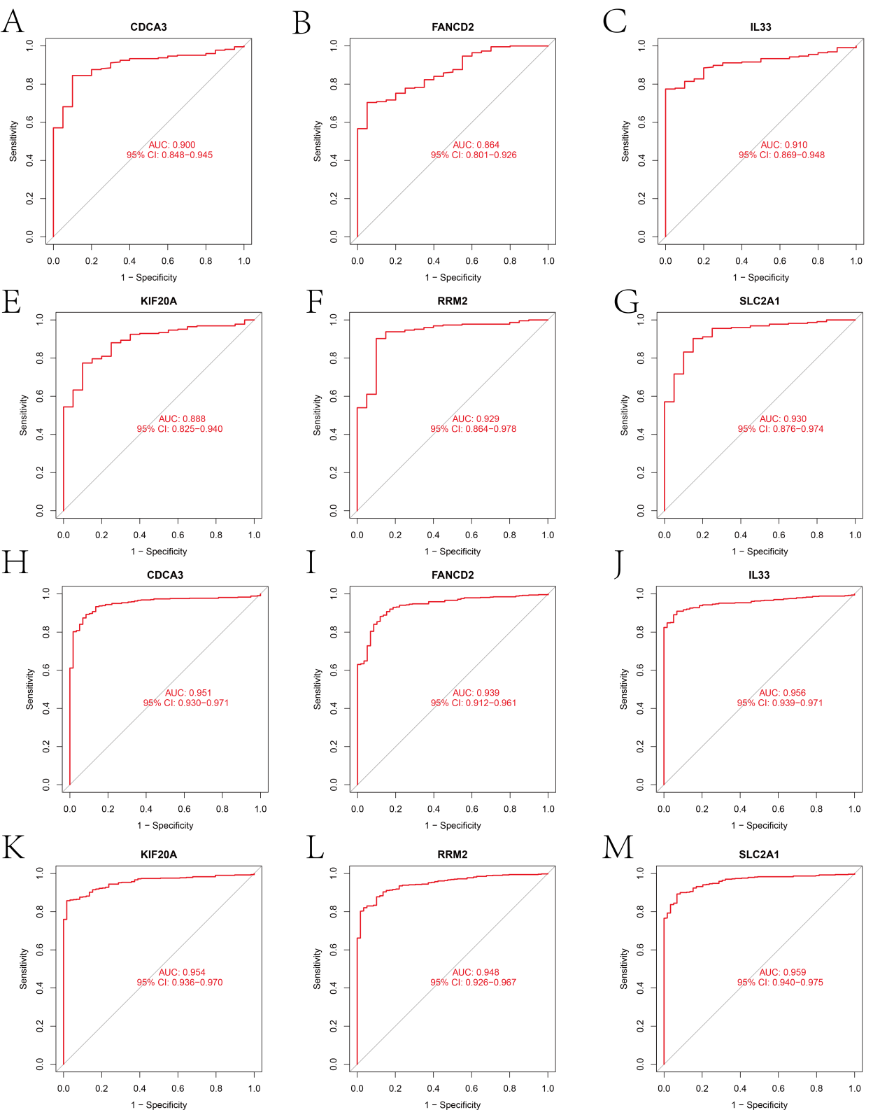
Supplementary Figure 1. ROC values of 6 DRF genes in (A-G) GSEA cohort; (H-M) TCGA cohort
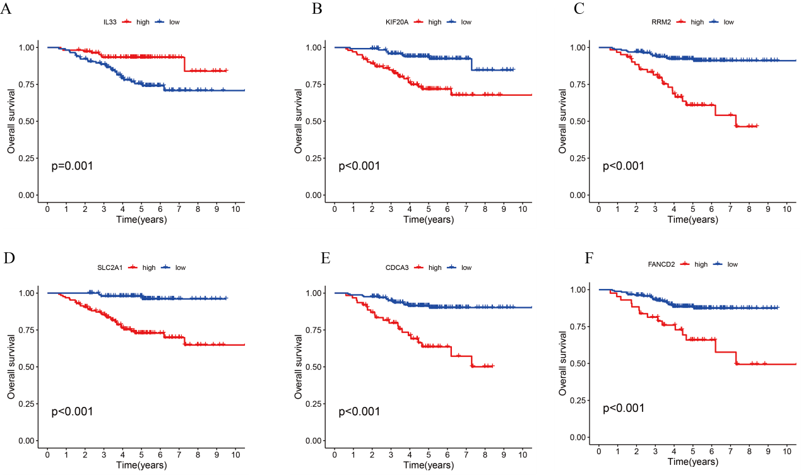
Supplementary Figure 2. Survival analysis of different DRF gene expression levels in the GSEA cohort.
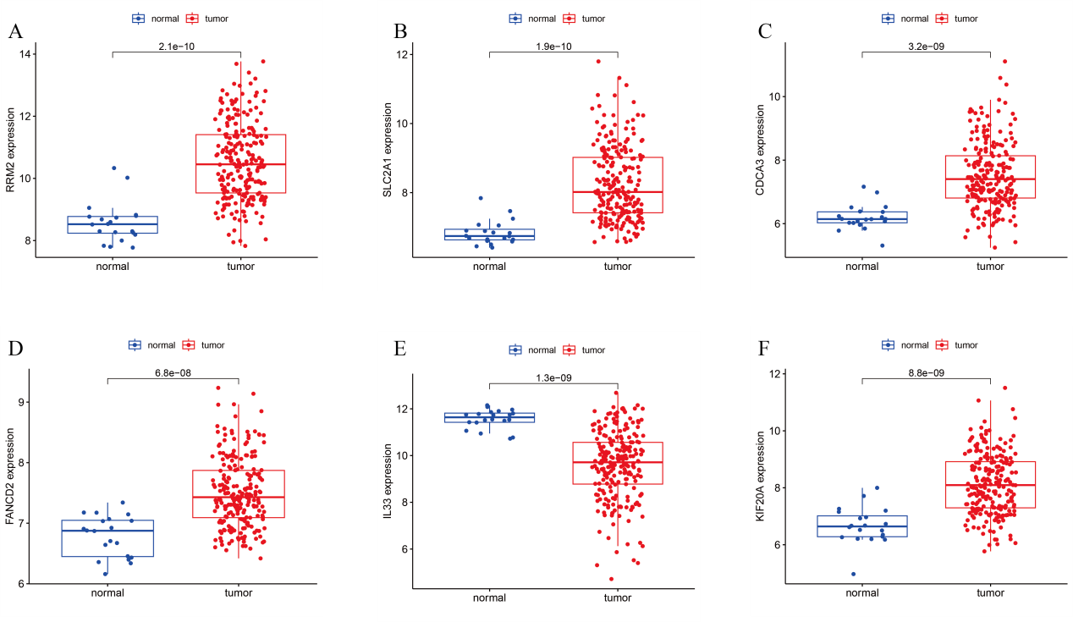
Supplementary Figure 3. Analysis of the expression of DRF gene in tumor group and adjacent tissues in GSEA cohort

Supplementary Table 1
id | HR | HR.95L | HR.95H | pvalue | km
RRM2 | 1.214732 | 1.0932 | 1.349775 | 0.000298 | 8.48E-06
SLC2A1 | 1.169465 | 1.07081 | 1.27721 | 0.000499 | 3.31E-07
KIF20A | 1.250856 | 1.098375 | 1.424505 | 0.000739 | 4.82E-05
CIRBP | 0.716706 | 0.58628 | 0.876148 | 0.001154 | 0.000912
AURKA | 1.191447 | 1.057566 | 1.342276 | 0.003973 | 0.00267
CDCA3 | 1.252426 | 1.070278 | 1.465574 | 0.005001 | 3.24E-05
CDC25A | 1.318739 | 1.085256 | 1.602454 | 0.005388 | 0.00375
SLC7A5 | 1.121591 | 1.015365 | 1.23893 | 0.023801 | 0.000131
IL33 | 0.896897 | 0.809725 | 0.993453 | 0.036991 | 0.000883
FANCD2 | 1.272485 | 1.008006 | 1.606357 | 0.042658 | 0.003171

Supplementary Table 2
id | HR | HR.95L | HR.95H | pvalue | km
IL33 | 0.999444 | 0.998965 | 0.999924 | 0.023142 | 0.0014
SLC2A1 | 1.0009 | 1.000398 | 1.001403 | 0.000444 | 3.37E-06
CDCA3 | 1.000848 | 1.000128 | 1.001567 | 0.020925 | 6.47E-07
KIF20A | 1.000617 | 1.000063 | 1.001171 | 0.029125 | 8.07E-05
FANCD2 | 1.00458 | 1.001714 | 1.007453 | 0.001716 | 0.000109
RRM2 | 1.000118 | 1.000013 | 1.000223 | 0.027975 | 6.42E-08

Supplementary Table 3
Gene | The amount of gene expression in the tumor is positively correlated with survival time | The amount of gene expression in the tumor is inversely correlated with survival time
CDCA3 | THYM | ACC/KIRC/KIRP/LGG/LIHC/LUAD/MESO/PAAD/SKCM
FANCD2 | DLBC/READ/THYM/ | ACC/KICH/KIRC/KIRP/LGG/LIHC/LUAD/MESO/PCPG/SARC/UCEC
IL33 | LAML/LGG/LIHC/LUAD/SARC/SKCM | BLCA/KIRP
KIF20A | THYM | ACC/KIRC/KIRP/LGG/LIHC/LUAD/MESO/PAAD/SARC/SKCM/UCEC/UVM
RRM2 | THYM | ACC/KICH/KIRC/KIRP/LGG/LIHC/LUAD/MESO/PAAD/PRAD/SARC/UVM
SLC2A1 |  | ACC/KIRP/LIHC/LUAD/MESO/PAAD/SARC/SKCM
In UCEC, RRM2 gene expression was negatively correlated with survival time in the first 9 years and positively correlated with survival time after 9 years

