Supporting Information for
Estimating Regional Terrestrial Ecosystem Carbon Sinks on Multi-Model Coupling Approach
Qingzhou Lv¹, Hui Yang¹*, Jia Wang² Gefei Feng³, Wanzeng Liu^{4,5}, Yunhui Zhang⁶, Wenfeng Wang^{7,8}, Cheng Wang⁹, Guoqing Zhang¹⁰, Lei Liu¹¹, Xinfeng Huang¹, Liu Cui¹, Yina Qiao¹, Huaiwei Fan¹, Yuejing Yao¹, Yin Qin¹, Wenkai Zhang¹², Yang Han¹

Affiliations:
¹School of Resources and Geosciences, China University of Mining and Technology, Xuzhou 221116, China.
²School of Computing and Mathematical Sciences, University of Greenwich, London, United Kingdom
³School of Linguistic Sciences and Arts, Jiangsu Normal University, Xuzhou 221009, China.
⁴National Geomatics Center of China, Beijing 100830, China
⁵Key Laboratory of Spatio-Temporal Information and Intelligent Services, Ministry of Natural Resources of China, Beijing 100830, China
⁶Xinjiang Uygur Autonomous Region Meteorological Observatory, Ürümqi 830002, China
⁷Key Laboratory of Coalbed Methane Resource and Reservoir Formation Process, Ministry of Education, School of Resources and Geosci ences, China University of Mining and Technology, Xuzhou 221116, China
⁸College of Geology and Mining Engineering, Xinjiang University, Ürümqi 830017, China
⁹National 305 Project Office, The People’s Government of Xinjiang Uygur Autonomous Region, Ürümqi 830000, China
¹⁰Geological Bureau of Xinjiang Uygur Autonomous Region, Ürümqi 830000, China
¹¹Ecological Environment Monitoring Station of Xinjiang Uygur Autonomous Region, Ürümqi 830011, China
¹²Key Laboratory of Investigation,Monitoring and Protection of Natural Resources in Mining Cities,MNR，Jinzhong 030600.China
e-mail: TB23010015A41@cumt.edu.cn

Carbon Density Classification Results
Using the CatBoost model, the underground, aboveground, and soil carbon density in Xinjiang were classified into three categories: low, medium, and high. This classification helps to differentiate spatial heterogeneity, thereby improving the accuracy of the assessment.
Supplementary Fig. 1 Carbon density classification results of Catboost model. Panel a Soil Carbon Density Classification Results. Panel b Belowground Carbon Density Classification Results. Panels c aboveground Carbon Density Classification Results. Deeper color intensities indicate higher levels of carbon density.

study area
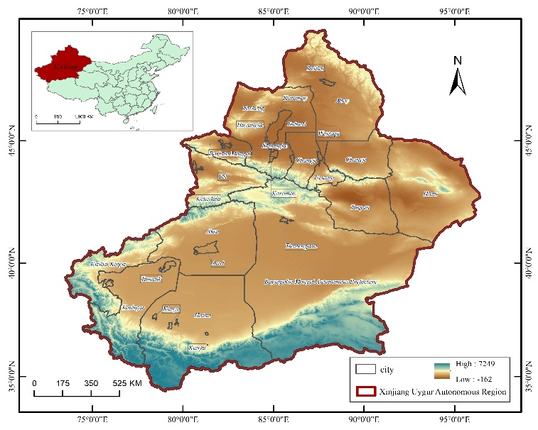
Supplementary Fig. 2 research zoning of the Xinjiang Tianshan Mountains
Xinjiang's terrain and landscape exhibit the characteristic "three mountains and two basins" pattern, with distinct vertical natural zones encompassing glaciers, frozen tundra, forests, grasslands, deserts, and mountains. This composition forms unique natural ecosystems and geographical features, making it one of the 36 global biodiversity hotspots. However, over the past two decades, urban expansion and ecosystem degradation have exacerbated ecological issues such as desertification, salinization, and shrinking lakes in Xinjiang. These changes have significantly altered the carbon storage in terrestrial ecosystems, necessitating detailed research for timely management. Moreover, climatically, Xinjiang experiences a typical temperate continental arid climate characterized by strong continental influence, large annual temperature variations, concentrated precipitation, and distinct seasons. This climate context facilitates analysis of factors like temperature and precipitation, contributing to understanding the carbon sequestration capacity of terrestrial ecosystems, attributing changes, and forecasting trends.

Data Acquisition and Processing

Influencing Factor Data
Influencing factor data includes eight categories: annual average precipitation^{[1]}, annual average temperature^{[2]}, annual average soil moisture^{[3]}, normalized difference vegetation index (https://www.resdc.cn/data.aspx?DATAID=343), net primary productivity (NPP)^{[4]}, land use intensity (LUI), population density, per capita GDP^{[5]}, and land cover data (https://www.resdc.cn/DOI/DOI.aspx?DOIID=54).
PRE, TEM, and SM data are from the China Environmental Data Platform, with a spatial resolution of 1 km, presented as monthly averages. PRE data is generated using the Delta spatial downscaling scheme based on CRU’s global climate dataset and WorldClim’s high-resolution dataset. TEM data is derived from AMSR-E/AMSR2 inversion algorithms and geographically weighted regression, integrating multi-source data. SM data is generated using a random forest model, incorporating leaf area index, land cover type, terrain, and soil properties as covariates.
NDVI, POP, GDP, and Land Cover Data are from the Resource and Environment Data Platform of the Chinese Academy of Sciences, with a spatial resolution of 1 km. NDVI data is obtained from SPOT/VEGETATION PROBA-V through stitching and projection transformation. POP data is generated based on national county-level GDP statistics, combined with land use types, nighttime light brightness, and residential density data through spatial interpolation. GDP data is distributed from administrative units to spatial grids using a multi-factor weight allocation method. Land Cover Data is constructed using Landsat imagery through manual interpretation. LUI is derived from Land Cover Data using land use intensity formulas.
NPP data comes from the China National Ecosystem Science Data Center, with a spatial resolution of 0.072°×0.072°, generated using the BEPS ecological model driven by vegetation parameters, remote sensing data, and meteorological data.

Carbon Density Data
Carbon density data includes aboveground biomass carbon density, belowground biomass carbon density^{[6]}, soil carbon density and dead organic matter carbon density. (http://www.ncdc.ac.cn/portal/metadata/2064ef7f-1cb8-4f05-9ca3-3395f52617dd)
Aboveground and belowground carbon density data are sourced from NASA, with a spatial resolution of 300 meters, measured in Mg C/ha, estimated through models trained on remote sensing and ground survey data.
Soil carbon density data is sourced from the National Glacier, Frozen Soil, and Desert Science Data Center of China, with a spatial resolution of 30 meters, measured in kg C m⁻², estimated using the Extreme Gradient Boosting algorithm based on multiple environmental covariates.
Dead organic matter carbon density data for the Xinjiang Autonomous Region in 2010 is estimated using a coefficient method based on the above datasets^{[7]}.

Statistical Data
Statistical data is sourced from the Chinese Academy of Sciences, covering aboveground, belowground, soil, and dead organic matter carbon density from 2000 to 2014(http://www.sciencedb.cn/dataSet/handle/603). The dataset contains 15,610 entries, with 3,921 entries specific to Xinjiang and nearby regions.
Supplementary Table 1 Information on Basic Data
 | Data Type | Data Source | Coverage Period | Units | Spatial Resolution
Impact Factor | PRE | Big Earth Data Platform | 1901-2021 | mm | 1km
Impact Factor | TEM | Big Earth Data Platform | 1901-2021 | ℃ | 1km
Impact Factor | SM | Big Earth Data Platform | 2000-2020 | m³/m³ | 1km
Impact Factor | NDVI | Resource and Environment Science | 2000-2020 | —— | 1km
Impact Factor | NPP | National Environmental Science | 2000-2020 | KgC/m²/y | 0.072°×0.072°
Impact Factor | LUI | Resource and Environment Science | 2000-2020 | —— | 1km
Impact Factor | POP | Resource and Environment Science | 2000-2020 | p/km² | 1km
Impact Factor | GDP | Resource and Environment Science | 2000-2020 | 10k¥/km² | 1km
Impact Factor | Land Cover Data | Resource and Environment Science | 2000、2005、2010、2015、2020 | —— | 1km
Carbon density | Aboveground | NASA | 2010 | Mg C/ha | 300M
Carbon density | Belowground | NASA | 2010 | Mg C/ha | 300M
Carbon density | Soil Carbon | National Glacier Permafrost | 2010 | kg C/ m² | 30M
Carbon density | Dead Organic Carbon | National Glacier Permafrost | 2010 | kg C/m² | 1km
Statistics | Carbon density statistics | Paper Database | 2000-2014 | kg C/m² | ——
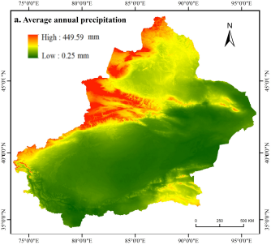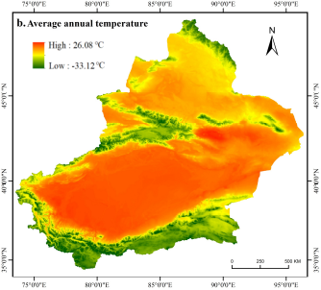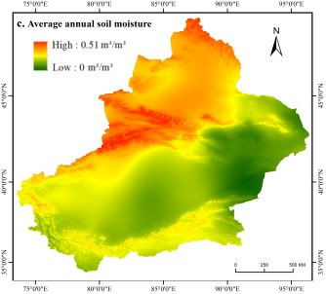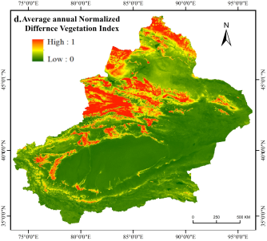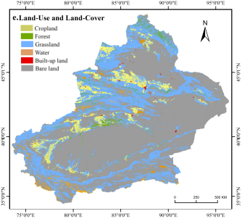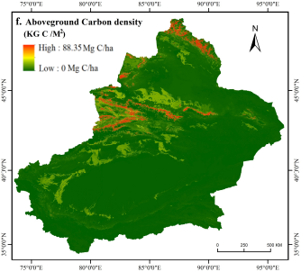
Supplementary Fig. 3 Impact factor and validation data preprocessing. Panels a to i represent various distribution maps: annual average precipitation (Panel a), temperature (Panel b), soil moisture (Panel c), NDVI (Panel d), land use type (Panel e), and the distributions of annual average aboveground carbon density (Panel f), belowground carbon density (Panel g), soil carbon density (Panel h), and dead organic matter carbon density (Panel i).

Data Preprocessing
Annual averages were calculated from daily and monthly data using MATLAB. ArcGIS was used for projection, resampling, and clipping to unify the data coordinate system to WGS1984 and spatial resolution to 1KM. To enhance model training efficiency, reduce tuning complexity, and prevent overfitting, data normalization, extraction, filtering, and partitioning were essential. The main preprocessing steps were as follows:
Data Extraction: ArcGIS software masked raster data to extract information within the study area. The fishnet tool converted all raster data into vector points, totaling 1,635,396 points. Each point included a sequence number, annual average precipitation, annual average temperature, NDVI, soil carbon density, and aboveground biomass carbon density.
Data Normalization: The Min-Max Normalization method was applied to scale data to a 0-1 range, standardizing values to facilitate model training. Figure 9 illustrates preprocessing results for a subset of raster data.
Training and Validation Dataset Construction: Carbon density data, ranging from 0 to 1, was divided into 100 intervals with a step size of 0.01. For each interval, 1000 data points were sampled from the dataset to form training and validation datasets. A total of 100,000 randomly selected data points from the study area were split 7:3 into training and validation sets, stored in CSV format. For the aboveground carbon density training set, the first column listed the raster unit sequence number, followed by annual average temperature, annual average precipitation, annual average soil moisture, NDVI, etc., as shown in Table 3. Separate training and validation datasets were prepared for aboveground, belowground, and soil carbon density to support the training of distinct RNN models.
Supplementary Table 2. Training and validation dataset
OBJECTID | TEM_2010 | PRE_2010 | SM_2010 | NDVI_2010 | Above_CD_2010
305045 | 0.545694 | 0.380544 | 0.515774 | 0.452055 | 0.144192
209543 | 0.470923 | 0.853057 | 0.528571 | 0.691781 | 0.261682
257973 | 0.533014 | 0.549923 | 0.536607 | 0.582192 | 0.158879
596503 | 0.328379 | 0.177428 | 0.587054 | 0.59589 | 0.165554
336671 | 0.588108 | 0.736085 | 0.582589 | 0.616438 | 0.64486
288221 | 0.574552 | 0.444254 | 0.711012 | 0.849315 | 0.496662
528716 | 0.208572 | 0.08683 | 0.414583 | 0.636986 | 0.447263
305186 | 0.419328 | 0.486728 | 0.502976 | 0.486301 | 0.46996
… | … | … | … | … | …
409351 | 0.55575 | 0.517212 | 0.680952 | 0.767123 | 0.46729
301066 | 0.533887 | 0.554033 | 0.553125 | 0.582192 | 0.245661
78188 | 0.420638 | 0.393903 | 0.408631 | 0.794521 | 0.497997
327006 | 0.517709 | 0.299708 | 0.564732 | 0.561644 | 0.283044
306561 | 0.444689 | 0.455386 | 0.318155 | 0.493151 | 0.236315
216664 | 0.504593 | 0.788319 | 0.601637 | 0.636986 | 0.261682
239719 | 0.645824 | 0.586402 | 0.545982 | 0.424658 | 0.134846

Coupled Carbon Density Estimation Model
The study utilizes the ARIMA model to forecast the mean carbon density from 2015 to 2020 based on carbon density statistical data from 2000 to 2014. Additionally, the CatBoost model spatially partitions carbon density levels in the study area using various influencing factors. The ARIMA model's carbon density predictions provide temporal constraints for the carbon density values estimated by the RNN model. Meanwhile, the spatial classification results from the CatBoost model impose spatial constraints on the carbon density values estimated by the RNN model, thereby achieving high-precision carbon density estimation.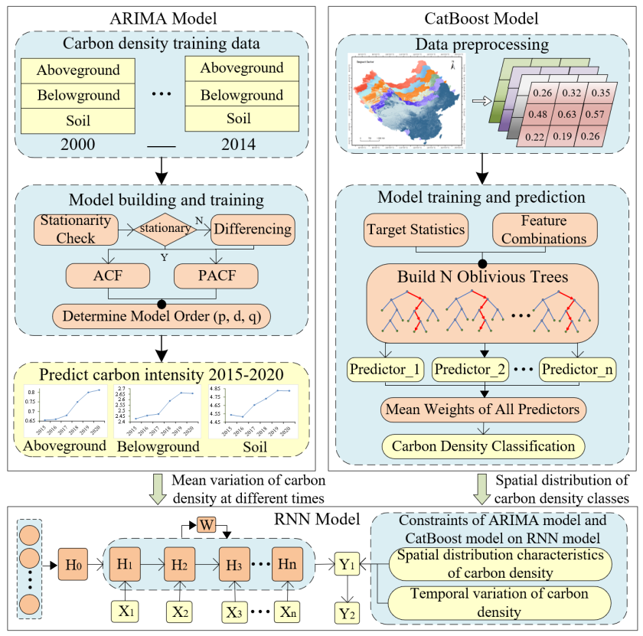
Supplementary Fig. 4 Multi-model coupling structure diagram

Building the ARIMA Model
The parameter determination process of the ARIMA model begins with data differencing to smooth the input data and ascertain the value of parameter 𝑑. Subsequently, values for 𝑝 and 𝑞 are determined based on minimizing the Akaike Information Criterion (AIC) and Bayesian Information Criterion(BIC).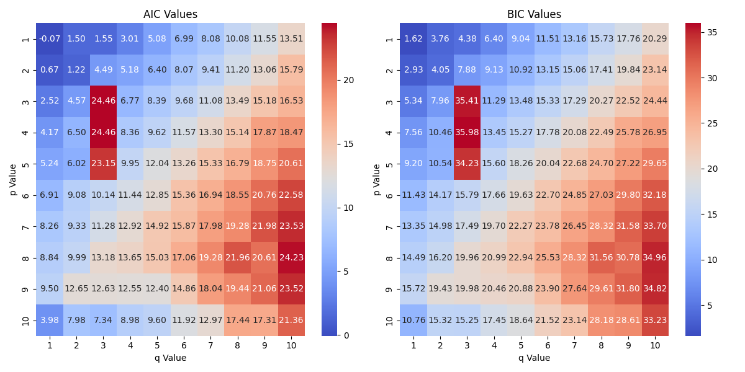
Supplementary Fig. 5. ARIMA Model Parameter Selection

CatBoost Model Accuracy Validation
Supplementary Fig. 5 shows the validation process for the aboveground carbon density classification results: the left figure represents the validation data for aboveground carbon density, while the right figure represents the carbon density levels predicted by the CatBoost model. The model's prediction results were validated at different spatial scales. As shown in the figure, the CatBoost model's prediction results at large and regional scales were highly consistent with the actual situation. Although the prediction error at the finer scale was slightly larger, it could still basically depict the true distribution of carbon density levels. The classification accuracy of each category was evaluated using the F1 score, which comprehensively considers precision and recall, while the overall accuracy of the model was assessed using the accuracy metric.
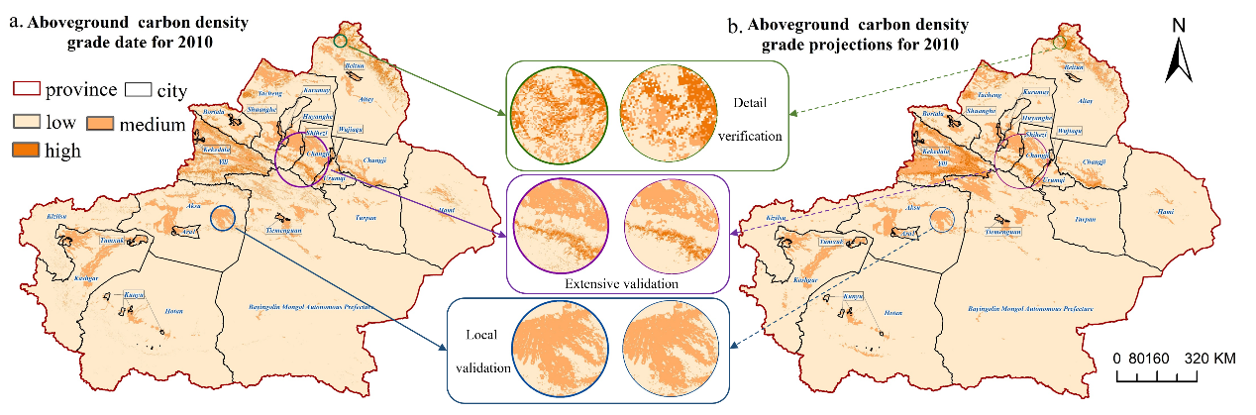
Supplementary Fig. 6. Verification of aboveground carbon density grading results. Panel a shows the soil carbon density classification results using CatBoost in 2010. Panel b displays the carbon density distribution of the soil validation dataset in Xinjiang for the year 2010.
Precision is the ratio of correctly predicted instances of a category to the total predicted instances of that category; recall is the ratio of correctly predicted instances to the total instances of that category in the validation data; the F1 score is the harmonic mean of precision and recall; accuracy is the ratio of correctly predicted instances to the total instances. The F1 score indicates that the carbon density classification models for soil, underground, and aboveground have high recognition accuracy for low carbon density cells, moderate accuracy for high carbon density, and low accuracy for medium carbon density. This is because low and high carbon density data have distinct characteristics, while medium density data are influenced by both, making differentiation difficult. The accuracy metrics for soil, aboveground, and underground carbon density models are 0.92, 0.86, and 0.85, respectively, with a mean of 0.876, indicating the CatBoost model accurately distinguishes carbon density levels across grid cells.
Supplementary Table 3. CatBoost Model Training Accuracy Evaluation
Carbon Density Grade | Soil |  |  | Aboveground |  |  | Underground
Carbon Density Grade | precision | recall | f1-score | precision | recall | f1-score | precision | recall | f1-score
1（Low Density） | 0.94 | 0.97 | 0.95 | 0.91 | 0.92 | 0.91 | 0.94 | 0.95 | 0.95
2（Medium Density） | 0.82 | 0.79 | 0.81 | 0.76 | 0.78 | 0.77 | 0.78 | 0.8 | 0.79
3（High Density） | 0.94 | 0.88 | 0.91 | 0.89 | 0.86 | 0.87 | 0.85 | 0.86 | 0.85
accuracy | 0.92 |  |  | 0.86 |  |  | 0.85

Supplementary References
[1]. Peng, S. (2020). 1-km monthly precipitation dataset for China (1901-2021). A Big Earth Data Platform for Three Poles, DOI: 10.5281/zenodo.3185722.
[2]. Peng, S. (2019). 1-km monthly mean temperature dataset for china (1901-2021). A Big Earth Data Platform for Three Poles, DOI: 10.11888/Meteoro.tpdc.270961. CSTR: 18406.11.Meteoro.tpdc.270961.
[3]. Shangguan, W., Li, Q., Shi, G. (2022). China Soil Moisture Dataset (2000-2020). A Big Earth Data Platform for Three Poles, DOI: 10.11888/Terre.tpdc.272415. CSTR: 18406.11.Terre.tpdc.272415.
[4]. He Q, Ju W, Dai S, et al. Drought risk of global terrestrial gross primary productivity over the last 40 years detected by a remote sensing‐driven process model[J]. Journal of Geophysical Research: Biogeosciences, 2021, 126(6):1-15.
5]. Yi L, Xiong L, Yang X. Method of pixelizing GDP data based on the GIS[J]. J. Gansu Sci, 2006, 18: 54-58.
[6]. Spawn, S.A., and H.K. Gibbs. 2020. Global Aboveground and Belowground Biomass Carbon Density Maps for the Year 2010. ORNL DAAC,Oak Ridge, Tennessee, USA. https://doi.org/10.3334/ORNLDAAC/1763
[7]. Liu S, Bian Z, An T, et al. Carbon pools of biomass and dead organic matter in typical forest ecosystems of Tibet: A new estimation based on the first forestry carbon sequestration monitoring undertaken in China[J]. Land Degradation & Development, 2021, 32(10): 2877-2891.

