Coffee husks activated carbon supported cobalt oxide-Zinc oxide nanocomposites for enhanced adsorption-photocatalytic degradation of methylene blue dye in water
Waktola Fite Dinka¹, Melkamu Biyana Regasa²
^{1,2}Department of Chemistry, College of Natural and Computational Sciences, Wollega University, Nekemte, Ethiopia
¹Department of Chemistry, College of Natural and Computational Sciences, Dambi Dollo University, Dambi Dollo, Ethiopia

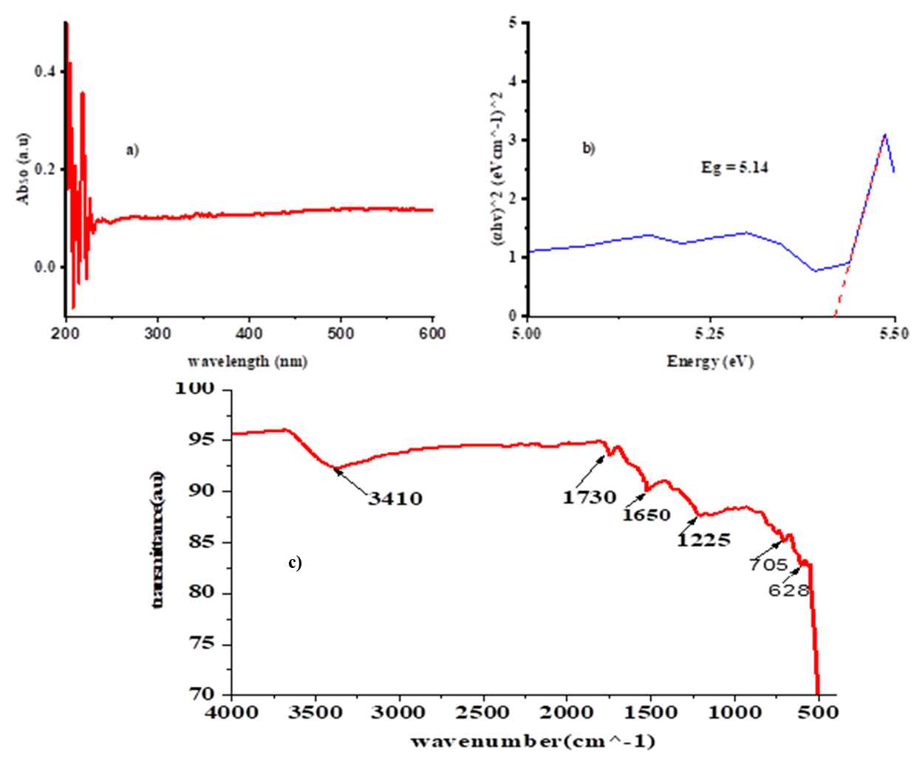

Figure 1 a) UV-Vis spectra and b) Energy band gap c) FT-IR spectra of AC prepared from coffee husk.

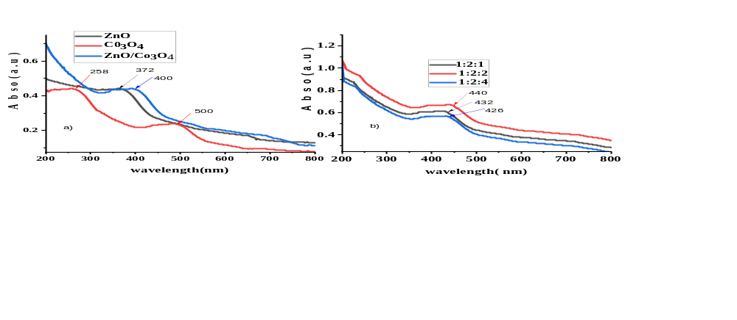Figure 2. UV-Vis absorbance spectra of a) nanoparticle and binary nanocomposite and b) supported nanocomposite.

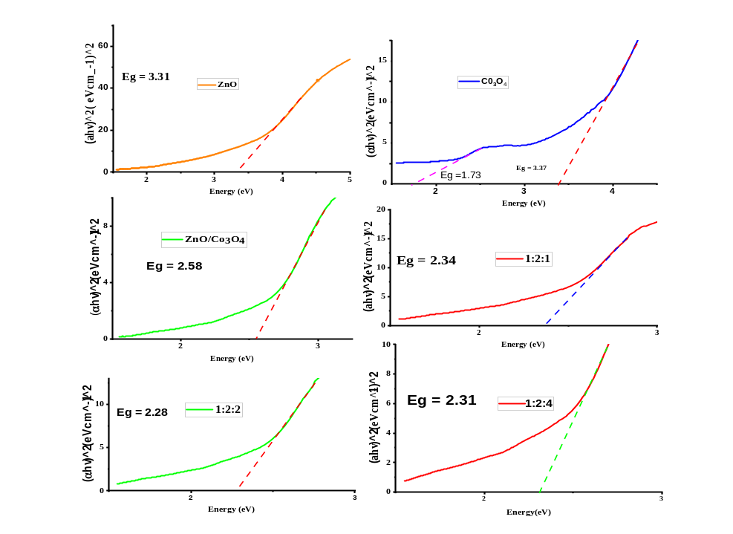
Figure 3. Tauc’s plot for optical band gap estimation for nanoparticle, binary nanocomposite and supported nanocomposite.

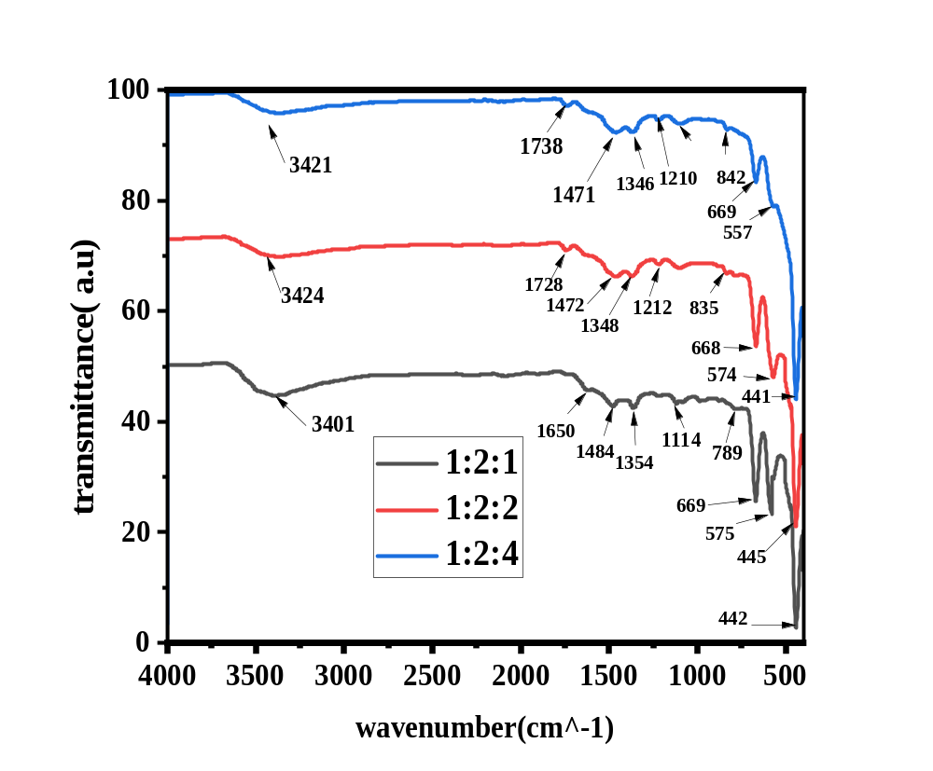
Figure 4. The FT-IR spectrum of ZnO/Co₃O₄/AC nanocomposite with three different atios (1:2:1, 1:2:2 and 1:2:4) were recorded to investigate their bonding properties.

Table 1 Optimization of different experimental parameters to prepare stable and efficient ZnO/Co₃O₄/AC photocatalyst.
Parameter | Values | Maximum absorbance point
Precursor mass ratio | ZnO:Co₃O₄:AC | 1:1:2
Precursor mass ratio | 1:2:4 | 1:1:2
Precursor mass ratio | 1:2:1 | 1:1:2
Precursor mass ratio | 1:2:2 | 1:1:2
Solution pH | 6 | 10
Solution pH | 8 | 10
Solution pH | 10 | 10
Solution pH | 12 | 10
Reaction temperature (ºC) | 60 | 75
Reaction temperature (ºC) | 75 | 75
Reaction temperature (ºC) | 90 | 75
Reaction time (hour) | 2 | 4

