SUPPLEMENTARY MATERIALS

Nethavhani et al. Multimarker genetic analyses of Gonimbrasia belina, the most harvested wild edible insect of mopane woodlands in southern Africa supports concerns over the sustainability of the species

Supplementary table 1. Collection data of Gonimbrasia belina (n = 160) collected in north central Namibia and the Limpopo River Basin (South Africa and Botswana).
Country | Specimen | Collection site (area) | Collection date | Latitude | Longitude | Haplotype | Barcode | Fragment A | Fragment C | mtDNA | ddRAD
Botswana | D1 | Dikabeya (Bot2) | 01-Apr-21 | -22.4907 | 27.2093 | H13 | PP886282 | PP905920 | PP905760 | Yes | No
Botswana | D2 | Dikabeya (Bot2) | 01-Apr-21 | -22.4907 | 27.2093 | H13 | PP886283 | PP905921 | PP905761 | Yes | No
Botswana | D3 | Dikabeya (Bot2) | 01-Apr-21 | -22.4907 | 27.2093 | H14 | PP886284 | PP905922 | PP905762 | Yes | No
Botswana | D6 | Dikabeya (Bot2) | 01-Apr-21 | -22.4907 | 27.2093 | H13 | PP886285 | PP905923 | PP905763 | Yes | No
Botswana | D7 | Dikabeya (Bot2) | 01-Apr-21 | -22.4907 | 27.2093 | H13 | PP886286 | PP905924 | PP905764 | Yes | No
Botswana | L05 | Letlapeng (Bot4) | 01-Apr-21 | -22.0164 | 27.2462 | H13 | PP886287 | PP905925 | PP905765 | Yes | No
Botswana | L06 | Letlapeng (Bot4) | 01-Apr-21 | -22.0164 | 27.2462 | H15 | PP886288 | PP905926 | PP905766 | Yes | No
Botswana | L08 | Letlapeng (Bot4) | 01-Apr-21 | -22.0164 | 27.2462 | H16 | PP886289 | PP905927 | PP905767 | Yes | No
Botswana | L09 | Letlapeng (Bot4) | 01-Apr-21 | -22.0164 | 27.2462 | H17 | PP886290 | PP905928 | PP905768 | Yes | No
Botswana | L12 | Letlapeng (Bot4) | 01-Apr-21 | -22.0164 | 27.2462 | H13 | PP886291 | PP905929 | PP905769 | Yes | No
Botswana | L13 | Letlapeng (Bot4) | 01-Apr-21 | -22.0164 | 27.2462 | H18 | PP886292 | PP905930 | PP905770 | Yes | No
Botswana | L14 | Letlapeng (Bot4) | 01-Apr-21 | -22.0164 | 27.2462 | H13 | PP886293 | PP905931 | PP905771 | Yes | No
Botswana | L17 | Letlapeng (Bot4) | 01-Apr-21 | -22.0164 | 27.2462 | H13 | PP886294 | PP905932 | PP905772 | Yes | No
Botswana | L18 | Letlapeng (Bot4) | 01-Apr-21 | -22.0164 | 27.2462 | H13 | PP886295 | PP905933 | PP905773 | Yes | No
Botswana | L20 | Letlapeng (Bot4) | 01-Apr-21 | -22.0164 | 27.2462 | H13 | PP886296 | PP905934 | PP905774 | Yes | Yes
Botswana | L21 | Letlapeng (Bot4) | 01-Apr-21 | -22.0164 | 27.2462 | H19 | PP886297 | PP905935 | PP905775 | Yes | Yes
Botswana | L22 | Letlapeng (Bot4) | 01-Apr-21 | -22.0164 | 27.2462 | H13 | PP886298 | PP905936 | PP905776 | Yes | No
Botswana | L24 | Letlapeng (Bot4) | 01-Apr-21 | -22.0164 | 27.2462 | H13 | PP886299 | PP905937 | PP905777 | Yes | No
Botswana | L27 | Letlapeng (Bot4) | 01-Apr-21 | -22.0164 | 27.2462 | H13 | PP886300 | PP905938 | PP905778 | Yes | Yes
Botswana | L29 | Letlapeng (Bot4) | 01-Apr-21 | -22.0164 | 27.2462 | H13 | PP886301 | PP905939 | PP905779 | Yes | No
Botswana | L36 | Letlapeng (Bot4) | 01-Apr-21 | -22.0164 | 27.2462 | H13 | PP886302 | PP905940 | PP905780 | Yes | No
Botswana | L40 | Letlapeng (Bot4) | 01-Apr-21 | -22.0164 | 27.2462 | H13 | PP886303 | PP905941 | PP905781 | Yes | Yes
Botswana | L41 | Letlapeng (Bot4) | 01-Apr-21 | -22.0164 | 27.2462 | H13 | PP886304 | PP905942 | PP905782 | Yes | No
Botswana | L46 | Letlapeng (Bot4) | 01-Apr-21 | -22.0164 | 27.2462 | H13 | PP886305 | PP905943 | PP905783 | Yes | No
Botswana | L48 | Letlapeng (Bot4) | 01-Apr-21 | -22.0164 | 27.2462 | H13 | PP886306 | PP905944 | PP905784 | Yes | Yes
Botswana | MJ03 | Majojo (Bot4) | 01-Apr-21 | -21.9914 | 27.2888 | H13 | PP886307 | PP905945 | PP905785 | Yes | No
Botswana | MJ04 | Majojo (Bot4) | 01-Apr-21 | -21.9914 | 27.2888 | H13 | PP886308 | PP905946 | PP905786 | Yes | No
Botswana | MJ05 | Majojo (Bot4) | 01-Apr-21 | -21.9914 | 27.2888 | H13 | PP886309 | PP905947 | PP905787 | Yes | No
Botswana | MJ11 | Majojo (Bot4) | 01-Apr-21 | -21.9914 | 27.2888 | H20 | PP886310 | PP905948 | PP905788 | Yes | Yes
Botswana | MJ13 | Majojo (Bot4) | 01-Apr-21 | -21.9914 | 27.2888 | H13 | PP886311 | PP905949 | PP905789 | Yes | Yes
Botswana | MJ14 | Majojo (Bot4) | 01-Apr-21 | -21.9914 | 27.2888 | H13 | PP886312 | PP905950 | PP905790 | Yes | No
Botswana | MJ16 | Majojo (Bot4) | 01-Apr-21 | -21.9914 | 27.2888 | H13 | PP886313 | PP905951 | PP905791 | Yes | No
Botswana | MJ17 | Majojo (Bot4) | 01-Apr-21 | -21.9914 | 27.2888 | H13 | PP886314 | PP905952 | PP905792 | Yes | No
Botswana | MJ18 | Majojo (Bot4) | 01-Apr-21 | -21.9914 | 27.2888 | H21 | PP886315 | PP905953 | PP905793 | Yes | Yes
Botswana | MJ25 | Majojo (Bot4) | 01-Apr-21 | -21.9914 | 27.2888 | H13 | PP886316 | PP905954 | PP905794 | Yes | No
Botswana | MJ27 | Majojo (Bot4) | 01-Apr-21 | -21.9914 | 27.2888 | H13 | PP886317 | PP905955 | PP905795 | Yes | No
Botswana | MJ43 | Majojo (Bot4) | 01-Apr-21 | -21.9914 | 27.2888 | H13 | PP886318 | PP905956 | PP905796 | Yes | No
Botswana | MO1 | Moremi (Bot1) | 01-Apr-21 | -22.5642 | 27.4389 | H13 | PP886319 | PP905957 | PP905797 | Yes | No
Botswana | MO2 | Moremi (Bot1) | 01-Apr-21 | -22.5642 | 27.4389 | H13 | PP886320 | PP905958 | PP905798 | Yes | No
Botswana | P03 | Palapye (Bot2) | 01-Apr-21 | -22.4936 | 27.1413 | H13 | PP886321 | PP905959 | PP905799 | Yes | No
Botswana | P06 | Palapye (Bot2) | 01-Apr-21 | -22.4936 | 27.1413 | H13 | PP886322 | PP905960 | PP905800 | Yes | Yes
Botswana | P08 | Palapye (Bot2) | 01-Apr-21 | -22.4936 | 27.1413 | H13 | PP886323 | PP905961 | PP905801 | Yes | Yes
Botswana | P09 | Palapye (Bot2) | 01-Apr-21 | -22.4936 | 27.1413 | H13 | PP886324 | PP905962 | PP905802 | Yes | Yes
Botswana | P10 | Palapye (Bot2) | 01-Apr-21 | -22.4936 | 27.1413 | H13 | PP886325 | PP905963 | PP905803 | Yes | Yes
Botswana | S1 | Serule (Bot5) | 01-Apr-21 | -21.9236 | 27.3220 | H13 | PP886326 | PP905964 | PP905804 | Yes | No
Botswana | S2 | Serule (Bot5) | 01-Apr-21 | -21.9236 | 27.3220 | H22 | PP886327 | PP905965 | PP905805 | Yes | Yes
Botswana | S5 | Serule (Bot5) | 01-Apr-21 | -21.9236 | 27.3220 | H13 | PP886328 | PP905966 | PP905806 | Yes | Yes
Botswana | S7 | Serule (Bot5) | 01-Apr-21 | -21.9236 | 27.3220 | H13 | PP886329 | PP905967 | PP905807 | Yes | Yes
Botswana | T03 | Topisi (Bot3) | 01-Apr-21 | -22.2763 | 27.2464 | H13 | PP886330 | PP905968 | PP905808 | Yes | Yes
Botswana | T05 | Topisi (Bot3) | 01-Apr-21 | -22.2763 | 27.2464 | H13 | PP886331 | PP905969 | PP905809 | Yes | No
Botswana | T06 | Topisi (Bot3) | 01-Apr-21 | -22.2763 | 27.2464 | H13 | PP886332 | PP905970 | PP905810 | Yes | Yes
Botswana | T08 | Topisi (Bot3) | 01-Apr-21 | -22.2763 | 27.2464 | H13 | PP886333 | PP905971 | PP905811 | Yes | Yes
Botswana | T09 | Topisi (Bot3) | 01-Apr-21 | -22.2763 | 27.2464 | H13 | PP886334 | PP905972 | PP905812 | Yes | No
Botswana | T12 | Topisi (Bot3) | 01-Apr-21 | -22.2763 | 27.2464 | H13 | PP886335 | PP905973 | PP905813 | Yes | No
Botswana | UK02 | Gojwana (Bot5) | 01-Apr-21 | -21.8389 | 27.3419 | H13 | PP886336 | PP905974 | PP905814 | Yes | No
Botswana | UK04 | Gojwana (Bot5) | 01-Apr-21 | -21.8389 | 27.3419 | H13 | PP886337 | PP905975 | PP905815 | Yes | No
Botswana | UK13 | Gojwana (Bot5) | 01-Apr-21 | -21.8389 | 27.3419 | H13 | PP886338 | PP905976 | PP905816 | Yes | Yes
Botswana | UK15 | Gojwana (Bot5) | 01-Apr-21 | -21.8389 | 27.3419 | H13 | PP886339 | PP905977 | PP905817 | Yes | No
Botswana | UK16 | Gojwana (Bot5) | 01-Apr-21 | -21.8389 | 27.3419 | H13 | PP886340 | PP905978 | PP905818 | Yes | No
Botswana | UK23 | Gojwana (Bot5) | 01-Apr-21 | -21.8389 | 27.3419 | H13 | PP886341 | PP905979 | PP905819 | Yes | No
Botswana | UK33 | Gojwana (Bot5) | 01-Apr-21 | -21.8389 | 27.3419 | H13 | PP886342 | PP905980 | PP905820 | Yes | Yes
Namibia | EP1 | Ongava Nature Reserve (Nam2) | 20-Feb-19 | -19.3311 | 15.9401 | H01 | PP886343 | PP905981 | PP905821 | Yes | No
Namibia | GM4.2 | Blyerus Farm (Nam5) | 09-Mar-19 | -19.4677 | 14.6035 | H02 | PP886344 | PP905982 | PP905822 | Yes | No
Namibia | J11 | Windpoort Farm (Nam4) | 14-Mar-17 | -19.3414 | 15.4538 | H03 | PP886345 | PP905983 | PP905823 | Yes | No
Namibia | J05 | Windpoort Farm (Nam4) | 14-Mar-17 | -19.3414 | 15.4538 | H03 | PP886346 | PP905984 | PP905824 | Yes | No
Namibia | J06 | Windpoort Farm (Nam4) | 14-Mar-17 | -19.3414 | 15.4538 | H04 | PP886347 | PP905985 | PP905825 | Yes | No
Namibia | J09 | Windpoort Farm (Nam4) | 14-Mar-17 | -19.3414 | 15.4538 | H03 | PP886348 | PP905986 | PP905826 | Yes | No
Namibia | MH2 | Blyerus Farm (Nam5) | 22-Dec-19 | -19.4751 | 14.5946 | H04 | PP886349 | PP905987 | PP905827 | Yes | No
Namibia | MH6 | Blyerus Farm (Nam5) | 23-Jan-20 | -19.4751 | 14.5946 | H02 | PP886350 | PP905988 | PP905828 | Yes | No
Namibia | NG01 | Farm Schenau (Nam3) | 01-Apr-22 | -20.1178 | 15.2782 | H05 | PP886351 | PP905989 | PP905829 | Yes | No
Namibia | NG02 | Farm Schenau (Nam3) | 01-Apr-22 | -20.1178 | 15.2782 | H04 | PP886352 | PP905990 | PP905830 | Yes | No
Namibia | NG03 | Farm Schenau (Nam3) | 01-Apr-22 | -20.1178 | 15.2782 | H04 | PP886353 | PP905991 | PP905831 | Yes | No
Namibia | NG09 | Farm Schenau (Nam3) | 01-Apr-22 | -20.1178 | 15.2782 | H06 | PP886354 | PP905992 | PP905832 | Yes | No
Namibia | NG11 | Main road past Munsterland (Nam1) | 03-Apr-22 | -20.2038 | 15.8655 | H04 | PP886355 | PP905993 | PP905833 | Yes | No
Namibia | NG12 | Main road past Munsterland (Nam1) | 03-Apr-22 | -20.2038 | 15.8655 | H04 | PP886356 | PP905994 | PP905834 | Yes | No
Namibia | NG13 | Main road past Munsterland (Nam1) | 03-Apr-22 | -20.2038 | 15.8655 | H04 | PP886357 | PP905995 | PP905835 | Yes | No
Namibia | NG19 | Main road past Munsterland (Nam1) | 03-Apr-22 | -20.2038 | 15.8655 | H07 | PP886358 | PP05996 | PP905836 | Yes | No
Namibia | NG21 | Munsterland main road (Nam1) | 03-Apr-22 | -20.1955 | 15.8924 | H08 | PP886359 | PP905997 | PP905837 | Yes | No
Namibia | NG22 | Munsterland main road (Nam1) | 03-Apr-22 | -20.1955 | 15.8924 | H04 | PP886360 | PP905998 | PP905838 | Yes | No
Namibia | NG23 | Munsterland main road (Nam1) | 03-Apr-22 | -20.1955 | 15.8924 | H04 | PP886361 | PP905999 | PP905839 | Yes | No
Namibia | NG29 | Munsterland main road (Nam1) | 03-Apr-22 | -20.1955 | 15.8924 | H04 | PP886362 | PP906000 | PP905840 | Yes | No
Namibia | NG31 | Munsterland Farm main road (Nam1) | 03-Apr-22 | -20.1908 | 15.9201 | H04 | PP886363 | PP906001 | PP905841 | Yes | No
Namibia | NG32 | Munsterland Farm main road (Nam1) | 03-Apr-22 | -20.1908 | 15.9201 | H04 | PP886364 | PP906002 | PP905842 | Yes | No
Namibia | NG33 | Munsterland Farm main road (Nam1) | 03-Apr-22 | -20.1908 | 15.9201 | H04 | PP886365 | PP906003 | PP905843 | Yes | No
Namibia | NG39 | Munsterland Farm main road (Nam1) | 03-Apr-22 | -20.1908 | 15.9201 | H09 | PP886366 | PP906004 | PP905844 | Yes | No
Namibia | NG41 | Munsterland Farm main road (Nam1) | 03-Apr-22 | -20.1893 | 15.9297 | H04 | PP886367 | PP906005 | PP905845 | Yes | No
Namibia | NG42 | Munsterland Farm main road (Nam1) | 03-Apr-22 | -20.1893 | 15.9297 | H10 | PP886368 | PP906006 | PP905846 | Yes | No
Namibia | NG43 | Munsterland Farm main road (Nam1) | 03-Apr-22 | -20.1893 | 15.9297 | H04 | PP886369 | PP906007 | PP905847 | Yes | No
Namibia | NG49 | Munsterland Farm main road (Nam1) | 03-Apr-22 | -20.1893 | 15.9297 | H04 | PP886370 | PP906008 | PP905848 | Yes | No
Namibia | NG51 | Sophienhof Farm (Nam1) | 03-Apr-22 | -20.1763 | 15.9531 | H04 | PP886371 | PP906009 | PP905849 | Yes | No
Namibia | NG52 | Sophienhof Farm (Nam1) | 03-Apr-22 | -20.1763 | 15.9531 | H11 | PP886372 | PP906010 | PP905850 | Yes | No
Namibia | NG53 | Sophienhof Farm (Nam1) | 03-Apr-22 | -20.1763 | 15.9531 | H04 | PP886373 | PP906011 | PP905851 | Yes | No
Namibia | NG59 | Sophienhof Farm (Nam1) | 03-Apr-22 | -20.1763 | 15.9531 | H12 | PP886374 | PP906012 | PP905852 | Yes | No
South Africa | A01 | Platjan Border Post (SA6) | 21-Mar-18 | -22.4870 | 28.8089 | H13 | PP886375 | PP906013 | PP905853 | Yes | No
South Africa | A02 | Platjan Border Post (SA6) | 21-Mar-18 | -22.4870 | 28.8089 | H13 | PP886376 | PP906014 | PP905854 | Yes | No
South Africa | A03 | Platjan Border Post (SA6) | 21-Mar-18 | -22.4870 | 28.8089 | H13 | PP886377 | PP906015 | PP905855 | Yes | No
South Africa | A04 | Platjan Border Post (SA6) | 21-Mar-18 | -22.4870 | 28.8089 | H13 | PP886378 | PP906016 | PP905856 | Yes | No
South Africa | A05 | Platjan Border Post (SA6) | 21-Mar-18 | -22.4870 | 28.8089 | H13 | PP886379 | PP906017 | PP905857 | Yes | No
South Africa | A06 | Platjan Border Post (SA6) | 21-Mar-18 | -22.4870 | 28.8089 | H23 | PP886380 | PP906018 | PP905858 | Yes | Yes
South Africa | A07 | Platjan Border Post (SA6) | 22-Mar-18 | -22.4870 | 28.8089 | H13 | PP886381 | PP906019 | PP905859 | Yes | No
South Africa | A08 | Platjan Border Post (SA6) | 22-Mar-18 | -22.4870 | 28.8089 | H24 | PP886382 | PP906020 | PP905860 | Yes | No
South Africa | A09 | Platjan Border Post (SA6) | 22-Mar-18 | -22.4870 | 28.8089 | H23 | PP886383 | PP906021 | PP905861 | Yes | No
South Africa | A10 | Platjan Border Post (SA6) | 22-Mar-18 | -22.4870 | 28.8089 | H13 | PP886384 | PP906022 | PP905862 | Yes | No
South Africa | A11 | Platjan Border Post (SA6) | 22-Mar-18 | -22.4870 | 28.8089 | H13 | PP886385 | PP906023 | PP905863 | Yes | No
South Africa | A12 | Platjan Border Post (SA6) | 22-Mar-18 | -22.4870 | 28.8089 | H24 | PP886386 | PP906024 | PP905864 | Yes | No
South Africa | A13 | Platjan Border Post (SA6) | 22-Mar-18 | -22.4870 | 28.8089 | H25 | PP886387 | PP906025 | PP905865 | Yes | No
South Africa | A14 | Platjan Border Post (SA6) | 22-Mar-18 | -22.4870 | 28.8089 | H13 | PP886388 | PP906026 | PP905866 | Yes | No
South Africa | A15 | Platjan Border Post (SA6) | 22-Mar-18 | -22.4870 | 28.8089 | H13 | PP886389 | PP906027 | PP905867 | Yes | No
South Africa | A16 | Platjan Border Post (SA6) | 22-Mar-18 | -22.4870 | 28.8089 | H13 | PP886390 | PP906028 | PP905868 | Yes | Yes
South Africa | A17 | Platjan Border Post (SA6) | 22-Mar-18 | -22.4870 | 28.8089 | H23 | PP886391 | PP906029 | PP905869 | Yes | No
South Africa | A18 | Platjan Border Post (SA6) | 22-Mar-18 | -22.4870 | 28.8089 | H13 | PP886392 | PP906030 | PP905870 | Yes | No
South Africa | B1 | Platjan Border Post (SA6) | 22-Mar-18 | -22.4870 | 28.8089 | H24 | PP886393 | PP906031 | PP905871 | Yes | No
South Africa | C1 | Platjan Border Post (SA6) | 21-Mar-18 | -22.4870 | 28.8089 | H23 | PP886394 | PP906032 | PP905872 | Yes | Yes
South Africa | C4 | Platjan Border Post (SA6) | 22-Mar-18 | -22.4870 | 28.8089 | H13 | PP886395 | PP906033 | PP905873 | Yes | No
South Africa | E1 | Platjan Border Post (SA6) | 22-Mar-18 | -22.4870 | 28.8089 | H23 | PP886396 | PP906034 | PP905874 | Yes | No
South Africa | F1Y | Platjan Border Post (SA6) | 21-Mar-18 | -22.4870 | 28.8089 | H13 | PP886397 | PP906035 | PP905875 | Yes | No
South Africa | G2 | Platjan Border Post (SA6) | 22-Mar-18 | -22.4870 | 28.8089 | H13 | PP886398 | PP906036 | PP905876 | Yes | No
South Africa | G3 | Platjan Border Post (SA6) | 22-Mar-18 | -22.4870 | 28.8089 | H26 | PP886399 | PP906037 | PP905877 | Yes | No
South Africa | GB01 | Venetia Limpopo Nature Reserve (SA5) | 26-Nov-20 | -22.3537 | 29.3007 | H26 | PP886400 | PP906038 | PP905878 | Yes | Yes
South Africa | GB02 | Venetia Limpopo Nature Reserve (SA5) | 26-Nov-20 | -22.3537 | 29.3007 | H26 | PP886401 | PP906039 | PP905879 | Yes | Yes
South Africa | GB03 | Venetia Limpopo Nature Reserve (SA5) | 26-Nov-20 | -22.3537 | 29.3007 | H26 | PP886402 | PP906040 | PP905880 | Yes | Yes
South Africa | GB04 | Venetia Limpopo Nature Reserve (SA5) | 26-Nov-20 | -22.3537 | 29.3007 | H26 | PP886403 | PP906041 | PP905881 | Yes | Yes
South Africa | GB15 | Ka-Mushiyani (SA1) | 31-Dec-20 | -23.5962 | 30.8985 | H29 | PP886404 | PP906042 | PP905882 | Yes | Yes
South Africa | GB19 | Ka-Mushiyani (SA1) | 31-Dec-20 | -23.5962 | 30.8985 | H28 | PP886405 | PP906043 | PP905883 | Yes | Yes
South Africa | GB22 | Ka-Mushiyani (SA1) | 31-Dec-20 | -23.5962 | 30.8985 | H29 | PP886406 | PP906044 | PP905884 | Yes | Yes
South Africa | GB24 | Ka-Mushiyani (SA1) | 31-Dec-20 | -23.5962 | 30.8985 | H27 | PP886407 | PP906045 | PP905885 | Yes | Yes
South Africa | GB28 | Gumbu (SA3) | 21-Nov-20 | -22.3639 | 30.8255 | H30 | PP886408 | PP906046 | PP905886 | Yes | Yes
South Africa | GB35 | Gumbu (SA3) | 21-Nov-20 | -22.3639 | 30.8255 | H30 | PP886409 | PP906047 | PP905887 | Yes | Yes
South Africa | GB40 | Gumbu (SA3) | 21-Nov-20 | -22.3639 | 30.8255 | H30 | PP886410 | PP906048 | PP905888 | Yes | Yes
South Africa | GB45 | Gumbu (SA3) | 21-Nov-20 | -22.3639 | 30.8255 | H30 | PP886411 | PP906049 | PP905889 | Yes | No
South Africa | GI01 | Nkomo village A (SA2) | 29-Dec-18 | -23.4072 | 30.7844 | H31 | PP886412 | PP906050 | PP905890 | Yes | No
South Africa | GI02 | Nkomo village A (SA2) | 29-Dec-18 | -23.4072 | 30.7844 | H26 | PP886413 | PP906051 | PP905891 | Yes | No
South Africa | GI03 | Nkomo village A (SA2) | 29-Dec-18 | -23.4072 | 30.7844 | H26 | PP886414 | PP906052 | PP905892 | Yes | No
South Africa | GI04 | Nkomo village A (SA2) | 29-Dec-18 | -23.4072 | 30.7844 | H26 | PP886415 | PP906053 | PP905893 | Yes | Yes
South Africa | GI05 | Nkomo village A (SA2) | 29-Dec-18 | -23.4072 | 30.7844 | H32 | PP886416 | PP906054 | PP905894 | Yes | Yes
South Africa | GI06 | Nkomo village A (SA2) | 29-Dec-18 | -23.4072 | 30.7844 | H26 | PP886417 | PP906055 | PP905895 | Yes | No
South Africa | GI07 | Nkomo village A (SA2) | 29-Dec-18 | -23.4072 | 30.7844 | H29 | PP886418 | PP906056 | PP905896 | Yes | Yes
South Africa | GI08 | Nkomo village A (SA2) | 29-Dec-18 | -23.4072 | 30.7844 | H26 | PP886419 | PP906057 | PP905897 | Yes | No
South Africa | GI09 | Nkomo village A (SA2) | 29-Dec-18 | -23.4072 | 30.7844 | H33 | PP886420 | PP906058 | PP905898 | Yes | No
South Africa | GI10 | Nkomo village A (SA2) | 29-Dec-18 | -23.4072 | 30.7844 | H26 | PP886421 | PP906059 | PP905899 | Yes | No
South Africa | GI11 | Nkomo village A (SA2) | 29-Dec-18 | -23.4072 | 30.7844 | H26 | PP886422 | PP906060 | PP905900 | Yes | No
South Africa | GI12 | Nkomo village A (SA2) | 29-Dec-18 | -23.4072 | 30.7844 | H29 | PP886423 | PP906061 | PP905901 | Yes | No
South Africa | GI13 | Nkomo village A (SA2) | 29-Dec-18 | -23.4072 | 30.7844 | H26 | PP886424 | PP906062 | PP905902 | Yes | Yes
South Africa | GI14 | Nkomo village A (SA2) | 29-Dec-18 | -23.4072 | 30.7844 | H26 | PP886425 | PP906063 | PP905903 | Yes | No
South Africa | GI20 | Nkomo village A (SA2) | 29-Dec-18 | -23.4072 | 30.7844 | H31 | PP886426 | PP906064 | PP905904 | Yes | No
South Africa | H1 | Platjan Border Post (SA6) | 22-Mar-18 | -22.4870 | 28.8089 | H13 | PP886427 | PP906065 | PP905905 | Yes | No
South Africa | H2 | Platjan Border Post (SA6) | 22-Mar-18 | -22.4870 | 28.8089 | H23 | PP886428 | PP906066 | PP905906 | Yes | No
South Africa | H3 | Platjan Border Post (SA6) | 22-Mar-18 | -22.4870 | 28.8089 | H13 | PP886429 | PP906067 | PP905907 | Yes | Yes
South Africa | H6 | Platjan Border Post (SA6) | 22-Mar-18 | -22.4870 | 28.8089 | H13 | PP886430 | PP906068 | PP905908 | Yes | No
South Africa | H8 | Platjan Border Post (SA6) | 22-Mar-18 | -22.4870 | 28.8089 | H26 | PP886431 | PP906069 | PP905909 | Yes | Yes
South Africa | I2 | Platjan Border Post (SA6) | 22-Mar-18 | -22.4870 | 28.8089 | H13 | PP886432 | PP906070 | PP905910 | Yes | No
South Africa | MA1 | Mapesu Nature reserve (SA4) | 31-Dec-18 | -22.2492 | 29.4675 | H26 | PP886433 | PP906071 | PP905911 | Yes | Yes
South Africa | MA2 | Mapesu Nature reserve (SA4) | 31-Dec-18 | -22.2492 | 29.4675 | H26 | PP886434 | PP906072 | PP905912 | Yes | Yes
South Africa | MA3 | Mapesu Nature reserve (SA4) | 31-Dec-18 | -22.2492 | 29.4675 | H26 | PP886435 | PP906073 | PP905913 | Yes | Yes
South Africa | MA5 | Mapesu Nature reserve (SA4) | 31-Dec-18 | -22.2492 | 29.4675 | H26 | PP886436 | PP906074 | PP905914 | Yes | Yes
South Africa | MP01 | Mapungubwe R572 (SA4) | 30-Dec-18 | -22.2431 | 29.3903 | H26 | PP886437 | PP906075 | PP905915 | Yes | No
South Africa | MP06 | Mapungubwe R572 (SA4) | 30-Dec-18 | -22.2431 | 29.3903 | H26 | PP886438 | PP906076 | PP905916 | Yes | No
South Africa | MP11 | Mapungubwe R572 (SA4) | 30-Dec-18 | -22.2431 | 29.3903 | H26 | PP886439 | PP906077 | PP905917 | Yes | Yes
South Africa | MP14 | Mapungubwe R572 (SA4) | 30-Dec-18 | -22.2431 | 29.3903 | H26 | PP886440 | PP906078 | PP905918 | Yes | No
South Africa | MP17 | Mapungubwe R572 (SA4) | 30-Dec-18 | -22.2431 | 29.3903 | H26 | PP886441 | PP906079 | PP905919 | Yes | Yes

Supplementary table 2. Distance between sampling areas of Gonimbrasia belina in South Africa, Botswana, and Namibia. The codes of the individual sampling sites included in each sampling area are given in parenthesis.
Sampling areas | Number of sampling sites per area | Distance between sampling sites (km)
South Africa |  | SA1 | SA2 | SA3 | SA4 | SA5 | SA6
SA1 (KM) | 1 | 0
SA2 (NV) | 1 | 25 | 0
SA3 (GM) | 1 | 138 | 117 | 0
SA4 (MP, MA) | 2 | 212 | 188 | 142 | 0
SA5 (VN) | 1 | 215 | 192 | 157 | 20 | 0
SA6 (PL) | 1 | 248 | 227 | 209 | 73 | 54 | 0
Botswana |  | Bot1 | Bot2 | Bot3 | Bot4 | Bot5
Bot1 (MO) | 1 | 0
Bot2 (DK, PP) | 2 | 28 | 0
Bot3 (TP) | 1 | 38 | 25 | 0
Bot4 (LT, MJ) | 2 | 65 | 54 | 29 | 0
Bot5 (SR, UK) | 2 | 78 | 71 | 46 | 19 | 0
Namibia |  | Nam1 | Nam2 | Nam3 | Nam4 | Nam5
Nam1 (PM, MR, MF, SM, SF) | 5 | 0
Nam2 (ET) | 1 | 95 | 0
Nam3 (FS) | 1 | 67 | 110 | 0
Nam4 (WF) | 1 | 105 | 51 | 88 | 0
Nam5 (BF) | 1 | 160 | 142 | 99 | 93 | 0

Supplementary table 3. Primers used for PCR amplification and Sanger sequencing of three polymorphic mitochondrial regions of Gonimbrasia belina (n = 160) collected in South Africa, Botswana, and Namibia. *Sequencing primers.
Polymorphic region | Gene | Primer | Sequence (5' - 3') | Amplicon size (bp) | Reference
DNA barcode | COX1 | BAR-BEL-F | ATTCTACTAATCATAAAGATATTGG | 709 | Nethavhani et al. 2022
DNA barcode | COX1 | BAR-BEL-R* | ACTTCTGGGTGTCCAAAAAATC | 709 | Nethavhani et al. 2022
DNA barcode | COX1 | LEP-F | ATTCAACCAATCATAAAGATATTGG | 709 | Hebert et al. 2004
DNA barcode | COX1 | LEP-R* | TAAACTTCTGGATGTCCAAAAAATCA | 709 | Hebert et al. 2004
Fragment A | ATP6-COX3 | GB-A3-F* | GATTATTTCCTTATATTTTCACTAG | 653 | This study
Fragment A | ATP6-COX3 | GB-A3-R | AACCTTTAATAACATAAATTGTATG | 653 | This study
Fragment C | ND6-CYTB | GB-C1-F | GTAGCAAGAATTGCCTCTAATG | 961 | This study
Fragment C | ND6-CYTB | GB-C1-R* | AGCCTGTTTGATGAAGGAAAAG | 961 | This study

Supplementary table 4. Information on individual specimens of Gonimbrasia belina used in library preparation for ddRADseq, showing library in which each individual specimen was sequenced, and its barcode within libraries.
Name | Barcode sequence | Pool 1 | Pool 2 | Pool 3
RadMan001 | ATGCAG | P9 | H8 | MJ18
RadMan002 | CCGTCT | GB24 | MJ13 | MA1
RadMan003 | TGTAGC | GI13 | MA5 | S5
RadMan004 | CGCACG | T6 | MP11 | S4
RadMan005 | GACGTA | GB1 | L21 | P6
RadMan006 | TCATGG | GB2 | GI4 | S3
RadMan007 | GGTTAA | GB3 | UK33 | P10
RadMan008 | GTGACC | T8 | UK13 | MA3
RadMan009 | GCCTCC | GB28 | GB22 | T3
RadMan010 | TCCGTT | GB40 | MP17 | L48
RadMan011 | AGAGCA | A6 | L20 | GB19
RadMan012 | ACTCGT | GB15 | S2 | A16
RadMan013 | CACCGT | GI5 | P8 | C1
RadMan014 | ACTATA | H3 | MA2 | L40
RadMan015 | GTCAGA | L27 | GB4 | MJ11
RadMan016 | GAAGGC | GI7 | GB35 | S7

Supplementary table 5. Genetic diversity measures, and Tajima’s D and Fu’s F_{S} tests based on mitochondrial sequences of Gonimbrasia belina (n = 160) collected in South Africa, Botswana, and Namibia. n – number of individuals; Nh – number of haplotypes; S – number of variable sites; Hd – haplotype diversity; π – nucleotide diversity and k – mean number of pairwise differences. Standard deviation value is given in parenthesis.
Sampling area | n | Nh | S | Hd | π | k
Bot1 | 2 | 1 | 0 | 0.00 (0.00) | 0.00 (0.00) | 0.00 (0.00)
Bot2 | 10 | 2 | 1 | 0.18 (0.14) | 0.00 (0.00) | 0.18 (0.25)
Bot3 | 6 | 1 | 0 | 0.00 (0.00) | 0.00 (0.00) | 0.00 (0.00)
Bot4 | 32 | 8 | 7 | 0.39 (0.11) | 0.00 (0.01) | 0.50 (0.44)
Bot5 | 11 | 2 | 1 | 0.20 (0.15) | 0.00 (0.00) | 0.20 (0.27)
Nam1 | 20 | 7 | 8 | 0.52 (0.13) | 0.01 (0.01) | 0.81 (0.61)
Nam2 | 1 | 1 | n. a | n. a | n. a | n. a
Nam3 | 4 | 3 | 4 | 0.83 (0.22) | 0.13 (0.11) | 2.00 (1.41)
Nam4 | 4 | 2 | 1 | 0.50 (0.27) | 0.03 (0.04) | 0.50 (0.52)
Nam5 | 3 | 2 | 1 | 0.67 (0.31) | 0.04 (0.06) | 0.67 (0.67)
SA1 | 4 | 3 | 4 | 0.83 (0.22) | 0.07 (0.06) | 2.00 (1.41)
SA2 | 15 | 5 | 5 | 0.64 (0.13) | 0.05 (0.03) | 1.22 (0.82)
SA3 | 4 | 1 | 0 | 0.00 (0.00) | 0.00 (0.00) | 0.00 (0.00)
SA4 | 9 | 1 | 0 | 0.00 (0.00) | 0.00 (0.00) | 0.00 (0.00)
SA5 | 4 | 1 | 0 | 0.00 (0.00) | 0.00 (0.00) | 0.00 (0.00)
SA6 | 31 | 5 | 18 | 0.59 (0.09) | 0.13 (0.08) | 3.51 (1.84)

Supplementary table 6. Pairwise F_{ST} values (below the diagonal, in italics) and gene flow values (above the diagonal) between sampling areas of Gonimbrasia belina based on mitochondrial sequences (n = 160). * Statistically significant (P < 0.05); n. a. – Gene flow could not be computed because population consist of only one sequence; (-) – Gene flow could not be computed because population lacks polymorphic sites.
South Africa - sampling area | SA1 | SA2 | SA3 | SA4 | SA5 | SA6
SA1 | 0.00 | 0.92 | 0.20 | 0.20 | 0.27 | 0.56
SA2 | 0.57* | 0.00 | 0.29 | 7.76 | 13.82 | 0.25
SA3 | 0.78* | 0.48 | 0.00 | 0.00 | 0.00 | 0.56
SA4 | 0.83* | 0.04 | 1.00* | 0.00 | - | 0.31
SA5 | 0.71* | 0.00 | 1.00* | 0.00 | 0.00 | 0.61
SA6 | 0.81* | 0.81* | 0.80* | 0.81* | 0.79* | 0.00
Botswana - sampling area | Bot1 | Bot2 | Bot3 | Bot4 | Bot5
Bot1 | 0.00 | 27.00 | - | 209.10 | 32.50
Bot2 | 0.00 | 0.00 | 12.00 | 28.51 | 9.45
Bot3 | 0.00 | 0.00 | 0.00 | 77.90 | 14.17
Bot4 | 0.00 | 0.00 | 0.00 | 0.00 | 29.12
Bot5 | 0.00 | 0.00 | 0.00 | 0.00 | 0.00
Namibia - sampling area | Nam1 | Nam2 | Nam3 | Nam4 | Nam5
Nam1 | 0.00 | NA | 5.89 | 2.15 | 3.41
Nam2 | 0.43 | 0.00 | n. a | n. a | n. a
Nam3 | 0.12 | 0.00 | 0.00 | 1.15 | 1.54
Nam4 | 0.38* | 0.71 | 0.29 | 0.00 | 0.41
Nam5 | 0.28 | 0.60 | 0.15 | 0.60 | 0.00

Supplementary table 7. AMOVA results based on mitochondrial sequences of Gonimbrasia belina (n = 160) collected in South Africa, Botswana, and Namibia. df – degrees of freedom.
All regions | df | Sum of squares | Variance components | Percentage of variation
Among populations | 3 | 905.65 | 8.82 | 81.75
Within populations | 158 | 308.90 | 1.97 | 18.25
Total | 160 | 1214.55 | 10.78 | Fixation index F_{ST} = 0.8753
South Africa | df | Sum of squares | Variance components | Percentage of variation
Among populations | 6 | 217.80 | 4.49 | 81.02
Within populations | 61 | 64.11 | 1.05 | 18.98
Total | 67 | 281.91 | 5.54 | Fixation index F_{ST} = 0.81020
Botswana | df | Sum of squares | Variance components | Percentage of variation
Among populations | 4 | 0.31 | 0.01 | 5.81
Within populations | 56 | 9.50 | 0.17 | 94.19
Total | 60 | 9.80 | 0.18 | Fixation index F_{ST} = 0.05806
Namibia | df | Sum of squares | Variance components | Percentage of variation
Among populations | 5 | 5.17 | 0.19 | 29.52
Within populations | 27 | 12.02 | 0.45 | 70.48
Total | 32 | 17.19 | 0.63 | Fixation index F_{ST} = 0.29521

Supplementary table 8. Statistics summary of RADseq libraries constructed in this study. n – number of individual specimens of Gonimbrasia belina per library. n – number of individuals.
Library ID | n | Median read length (bp) | Total number of reads | Number of retained reads | Retained reads (%)
Pool 1 | 16 | 217 | 138,870,876 | 100,174,561 | 72.1
Pool 2 | 16 | 220 | 132,739,494 | 96,199,798 | 72.5
Pool 3 | 16 | 216 | 122,508,368 | 76,136,309 | 62.1

Supplementary table 9. Pairwise F_{ST} values (below the diagonal, in italics) and gene flow values (above the diagonal) between sampling areas of Gonimbrasia belina in South Africa and Botswana.
 | SA6 | SA5 | SA4 | Bot5 | Bot4
SA6 | 0.00 | 0.21 | 0.42 | 0.36 | 0.24
SA5 | 0.52* | 0.00 | 0.21 | 0.17 | 0.15
SA4 | 0.34* | 0.53* | 0.00 | 0.37 | 0.24
Bot5 | 0.38* | 0.58* | 0.38* | 0.00 | 0.24
Bot4 | 0.48* | 0.61* | 0.49* | 0.49* | 0.00
*Statistically significant (P < 0.05).

Supplementary table 10. Summary of genetic diversity measures of Gonimbrasia belina (n = 29) based on 778 nuclear SNPs determined by ddRADseq. n – number of individuals; N_{a} - mean number of alleles; H_{e} - mean expected heterozygosity; H_{o} - mean observed heterozygosity; F_{is} - mean fixation index. Standard error value is given in parenthesis.
Sampling area | Code | n | N_{a} | H_{o} | H_{e} | F_{is}
Mapesu Nature reserve, Mapungubwe R572 | SA4 | 6 | 1.506 (0.026) | 0.205 (0.008) | 0.209 (0.006) | -0.011 (0.015)
Venetia Limpopo Nature Reserve | SA5 | 4 | 1.045 (0.033) | 0.155 (0.008) | 0.149 (0.007) | -0.058 (0.017)
Platjan Border Post | SA6 | 5 | 1.449 (0.026) | 0.203 (0.008) | 0.202 (0.007) | -0.022 (0.016)
Total South Africa |  | 15 | 1.333 (0.028) | 0.188 (0.008) | 0.187 (0.007) | -0.030 (0.015)
Majojo | Bot4 | 8 | 1.239 (0.033) | 0.163 (0.007) | 0.177 (0.007) | 0.070 (0.015)
Serule, Gojwana | Bot5 | 6 | 1.410 (0.029) | 0.216 (0.008) | 0.201 (0.007) | -0.075 (0.014)
Total Botswana |  | 14 | 1.325 (0.031) | 0.189 (0.008) | 0.189 (0.007) | -0.003 (0.015)
Total South Africa + Botswana |  | 29 | 1.330 (0.014) | 0.188 (0.004) | 0.188 (0.003) | -0.016 (0.007)

Supplementary table 11. Contemporary effective population size (N_{e}) estimates of Gonimbrasia belina (n = 29) based on the linkage disequilibrium (LD) and heterozygosity excess (HE) methods, and the heterozygosity excess (HE) test as an indicator for population contraction or expansion based on heterozygosity deficiency/excess under the infinite alleles model (IAM) (Wilcoxon-sign rank test) and mode shifts.
Group | n | N_{e}LD (95% CI) | N_{e}HE (95% CI) | HE deficit | HE excess | Mode shift
South Africa | 15 | 10.3 (9.8 - 10.8) | ∞ | 0.982 | 0.018 | Shifted mode
Botswana | 14 | ∞ (11.9 - ∞) | ∞ | 0.983 | 0.017 | Shifted mode
Total | 29 | 28.5 (27.2 - 30) | ∞ | 0.994 | 0.006 | Shifted mode

Suplemmentary figures

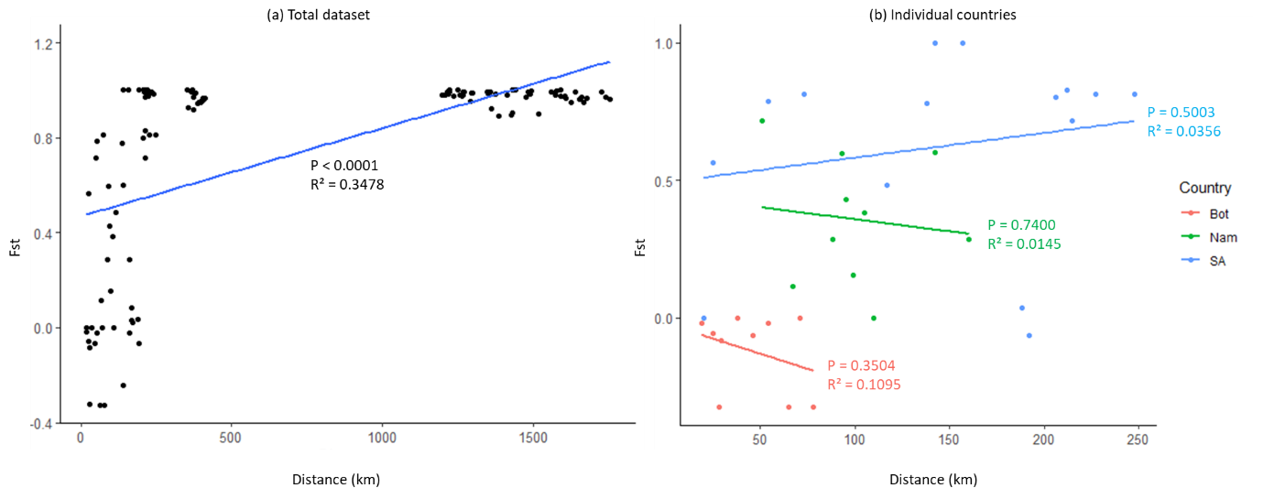

Supplementary figure 1. Isolation-by-distance by regression of genetic divergence (F_{ST}) vs. geographic distance (km) of Gonimbrasia belina (a) between South Africa, Botswana, and Namibia and (b) within each country.

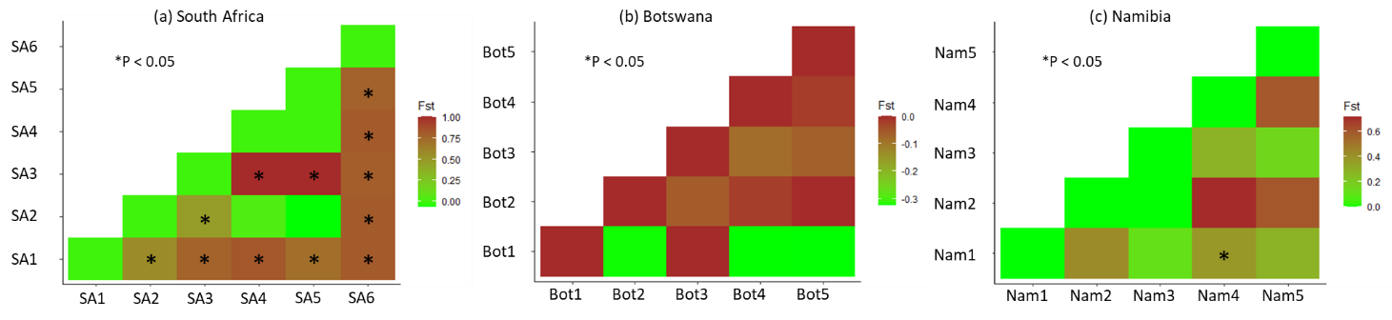

Supplementary figure 2. Pairwise F_{ST} values between sampling areas of Gonimbrasia belina in (a) South Africa, (b) Botswana, and (c) Namibia. * Statistically significant (P < 0.05).

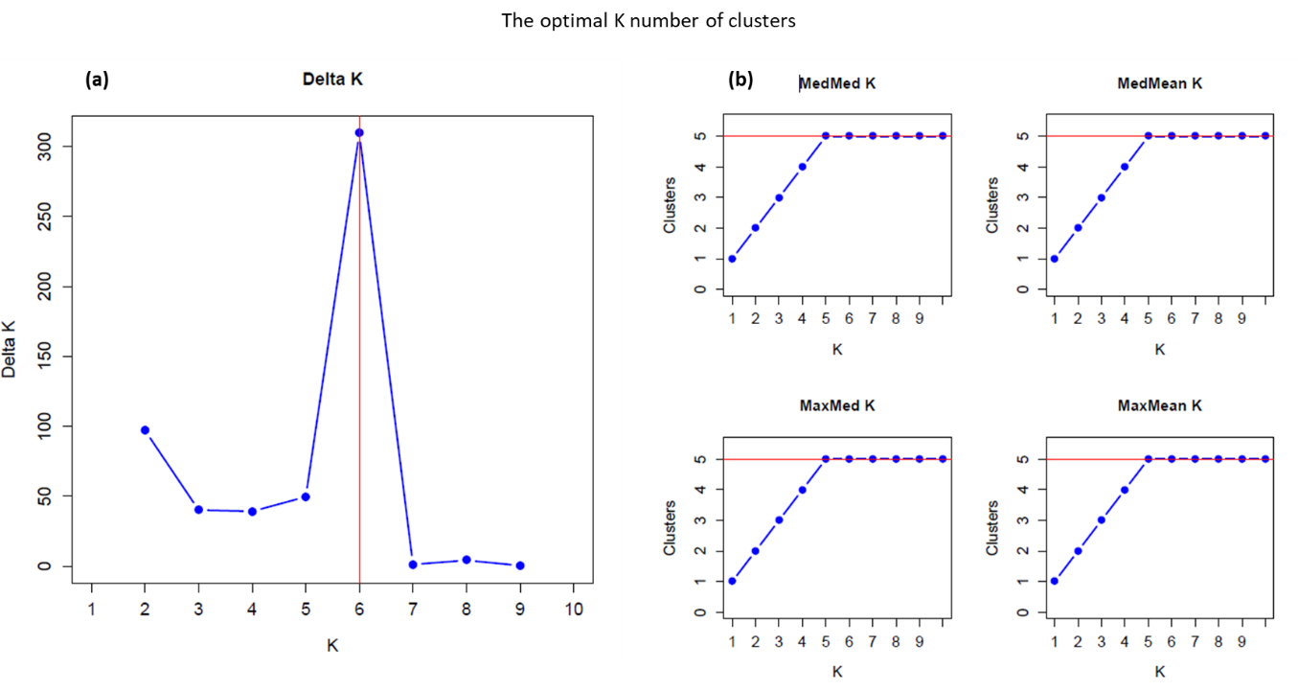
Supplementary figure 3. Optimal K based on (a) ΔK and (b) MedMed K, MedMean K, MaxMed K, and MaxMean K.

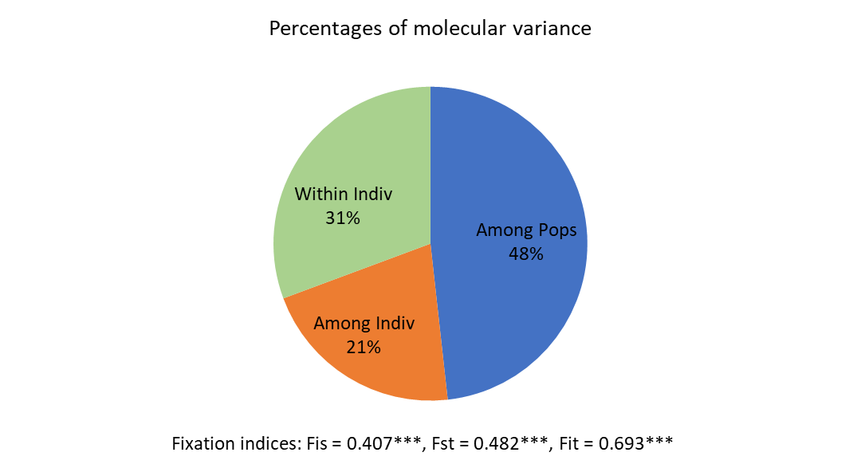

Supplementary figure 4. Analysis of Molecular Variance (AMOVA) of Gonimbrasia belina (n = 29) collected in South Africa and Botswana.

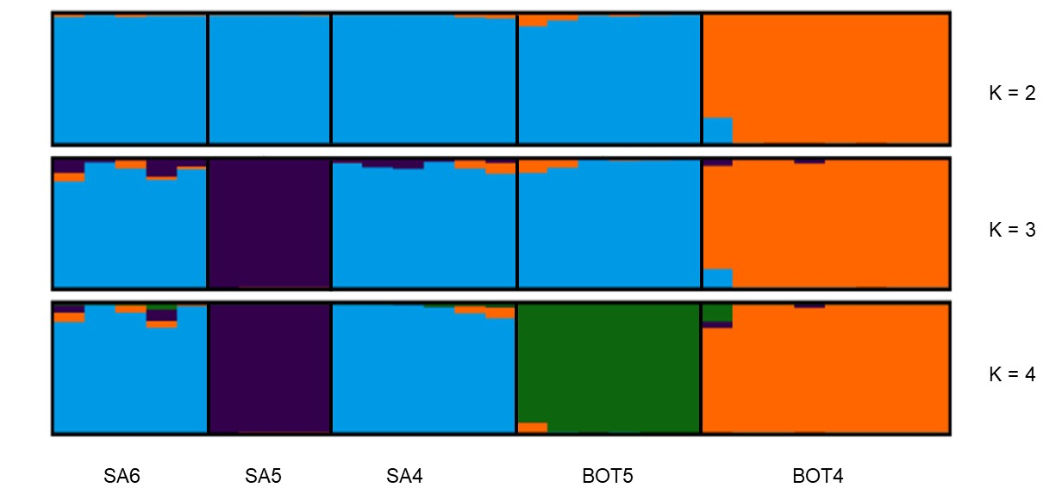
Supplementary figure 5. STRUCTURE bar plots of low K (K = 2 to K = 4) for Gonimbrasia belina (n = 29) collected at five sampling areas in South Africa and Botswana.

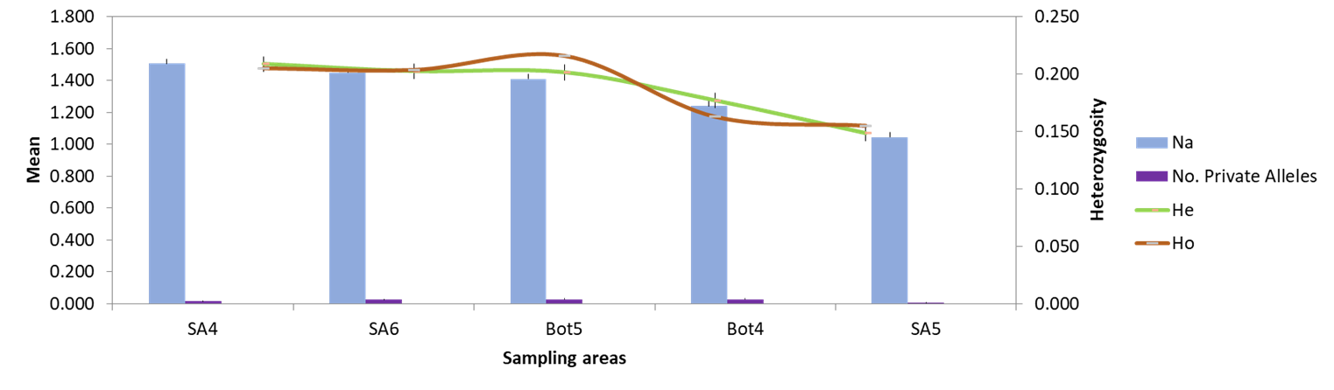
Supplementary figure 6. Genetic diversity measures of Gonimbrasia belina (n = 29) collected in South Africa and Botswana. N_{a} - mean number of alleles, H_{e} – mean expected heterozygosity and H_{o} – mean observed heterozygosity.

