Mitochondrial pathogenic variants in Whole Exome Sequencing data: from screening to diagnosis and follow-up
Supplemental Material
The main phenotype by HP number was divided into 7 main phenotype groups:
- Neurological Disorders:
  - Autism
  - Seizure
  - Ataxia
  - Microcephaly
  - Hypotonia
  - Generalized hypotonia
  - Cerebellar atrophy
  - Dysarthria
  - Polyneuropathy
  - Generalized seizures
  - Febrile seizures
  - Migraine
  - Muscle wasting
- Developmental and Intellectual Disabilities:
  - Delayed development
  - Delayed speech
  - Intellectual disability
  - Global developmental delay
  - Absent speech and language development
  - Neurodevelopmental disorders
- Behavioral and Emotional Disorders:
  - Aggressive behavior
  - Hyperactivity
- Sensory Disorders:
  - Hearing loss
- Cardiovascular and Metabolic Disorders:
  - Obesity
  - Hyperlipidemia
  - Myocardial infarction
  - Stroke
  - Diabetes
- Renal Disorders:
  - Hematuria
  - Renal failure
  - Renal cysts
- Other Physical Disorders:
  - Delayed growth
  - Growth abnormalities
  - Skin abnormalities
Neurological disorders (n=164), developmental and intellectual disabilities (n=80), behavioral disorders (n=15), sensory disorders (n=11), cardiovascular and metabolic disorders (n=30), renal disorder disorders (n=93) and other disorders (n=25)

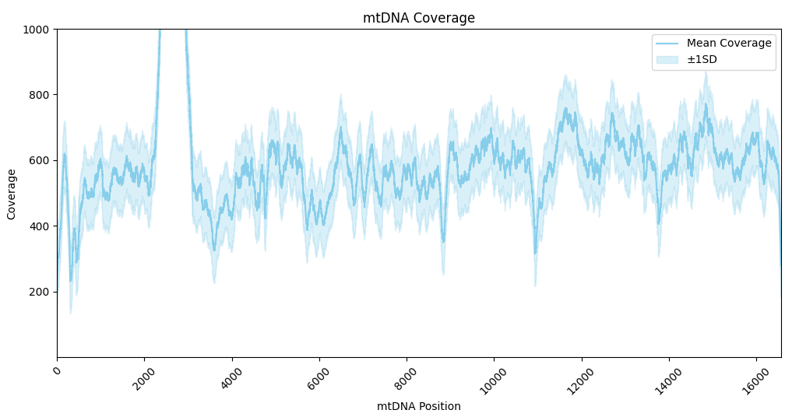
Figure 1. Mean coverage of mtDNA.

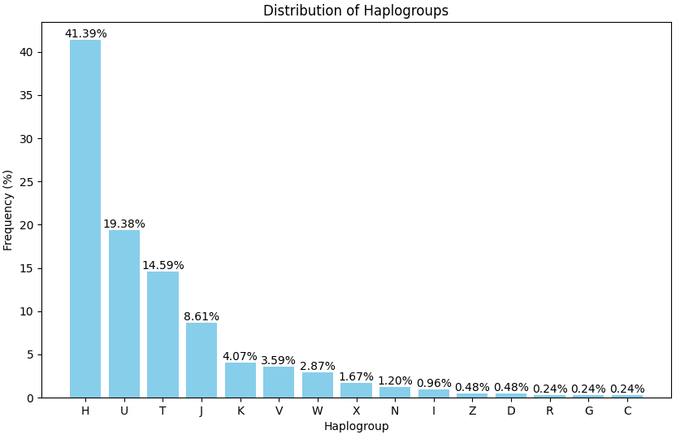
Figure 2. Haplogroup frequency.

