Label-free morphology-based phenotypic analysis of spinal and bulbar muscular atrophy muscle cell models

Kenji Sakakibara1, Kenjiro Tanaka2, Yuta Imai2, Mai Okada2, Madoka Iida1, Kentaro Sahashi1, Tomoki Hirunagi1, Kentaro Maeda1, Ryuji Kato2,3,4**, Masahisa Katsuno1,5*

Affiliations
¹Department of Neurology, Nagoya University Graduate School of Medicine, Tokai National Higher Education and Research System, 65 Tsurumai-cho, Showa-ku, Nagoya, Aichi 466-8550, Japan
²Department of Basic Medicinal Sciences, Graduate School of Pharmaceutical Sciences, Nagoya University, Tokai National Higher Education and Research System, Furocho, Chikusa-ku, Nagoya, Aichi 464-8601, Japan
³Institute of Nano-Life-Systems, Institutes of Innovation for Future Society, Nagoya University, Tokai National Higher Education and Research System, Furocho, Chikusa-ku, Nagoya, Aichi 464-8601, Japan
⁴Institute for Glyco-core Research (iGCORE), Tokai National Higher Education and Research System, Furocho, Chikusa-ku, Nagoya, Aichi 464-8601, Japan
⁵Department of Clinical Research Education, Nagoya University Graduate School of Medicine, Tokai National Higher Education and Research System, 65 Tsurumai-cho, Showa-ku, Nagoya, Aichi 466-8550, Japan

*Correspondence to:
(Biological part)
Masahisa Katsuno, Department of Neurology, Nagoya University Graduate School of Medicine, Tokai National Higher Education and Research System, 65 Tsurumai-cho, Showa-ku, Nagoya, Aichi 466-8550, Japan
Tel.: +81-52-744-2389
Fax: +81-52-744-2384
E-mail: katsuno.masahisa.i1@f.mail.nagoya-u.ac.jp

(Analysis part)
Ryuji Kato, Department of Basic Medicinal Sciences, Graduate School of Pharmaceutical Sciences, Nagoya University, Tokai National Higher Education and Research System, Furocho, Chikusa-ku, Nagoya, Aichi 464-8601, Japan
Fax: 81-52-747-6813
E-mail: kato-r@ps.nagoya-u.ac.jp

Lead contact: Masahisa Katsuno
E-mail: katsuno.masahisa.i1@f.mail.nagoya-u.ac.jp

Supplementary Figures S1-4
Supplementary Tables S1-4
Supplementary Figure S1. Schematic diagram of the image processing pipeline
Supplementary Figure S2. The pipeline for creating the training and test dataset for the drug effect prediction model

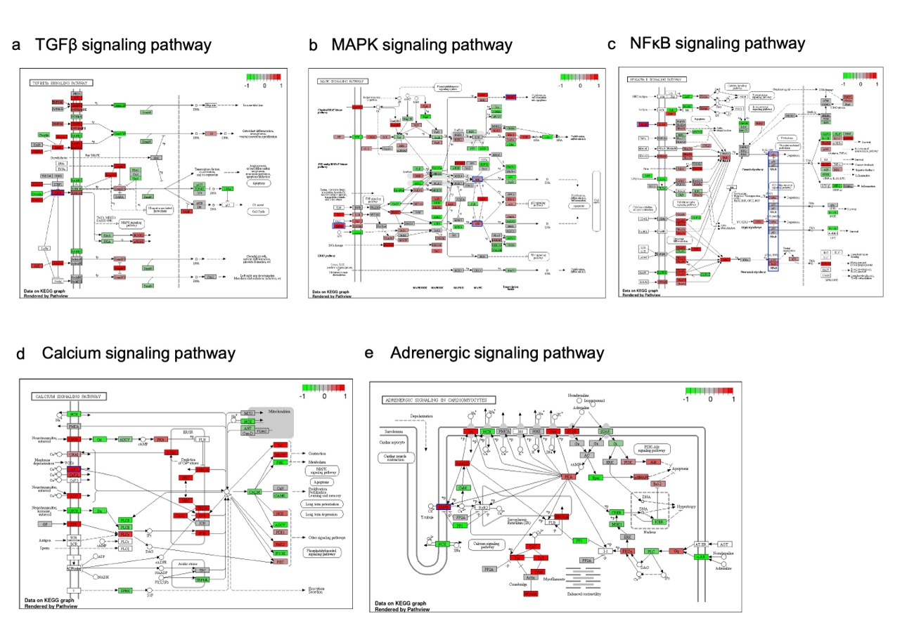 Supplementary Figure S3. Significantly enriched pathways identified via KEGG pathway enrichment analysis of DEGs
a–e. The upregulated genes in AR-97Q cells are colored red, and the downregulated genes in AR-97Q cells are colored green for the TGFβ signaling pathway (a), the MAPK signaling pathway (b), the NFκB pathway (c), the calcium signaling pathway (d), and the adrenergic signaling pathway (e). The cutoff criteria were set at an FDR < 0.1 and a fold change (log2) < 2. The areas with blue box indicate molecules of interest.

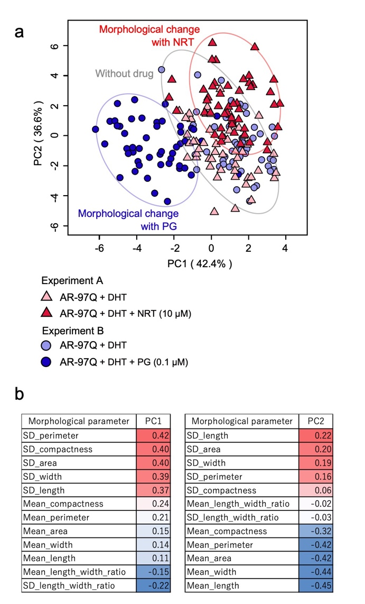
Supplementary Figure S4. Differences in morphology induced by NRT or PG in SBMA Model C2C12 cells
a. Principal component analysis (PCA) visualization depicting the morphological profiles of AR-97Q cells (treated with DHT) under three conditions: untreated, naratriptan (NRT)-treated, and pioglitazone (PG)-treated. The data from the independent experiments, experiment A and B, were merged. b. Analysis of weighted morphological parameters contributing to PC1 and PC2 in the PCA in Fig. 2a.
Parameter number | Statistics | Parameter name | Definition
1 | Mean | Mean_area | Total pixels in the recognized cell region.
2 | Mean | Mean_perimeter | The arc length of recognized cell region.
3 | Mean | Mean_length | Long axis of bounding rectangle covering cell.
4 | Mean | Mean_width | Short axis of bounding rectangle covering cell.
5 | Mean | Mean_length_width_ratio | Length/Width
6 | Mean | Mean_compactness | (Perimeter)^2/Area
7 | Standard deviation  (SD) | SD_area | Total pixels in the recognized cell region.
8 | Standard deviation  (SD) | SD_perimeter | The arc length of recognized cell region.
9 | Standard deviation  (SD) | SD_length | Long axis of bounding rectangle covering cell.
10 | Standard deviation  (SD) | SD_width | Short axis of bounding rectangle covering cell.
11 | Standard deviation  (SD) | SD_length_width_ratio | Length/Width
12 | Standard deviation  (SD) | SD_compactness | (Perimeter)^2/Area
Supplementary Table S1. Morphological parameters used in the morphology-based phenotypic analysis

Supplementary Table S2. Top 20 genes upregulated in AR-97Q cells compared to AR-24Q cells

Gene Symbol | Ensembl ID | log2 Fold Change* | Adj. p-val
Gm6213 | ENSMUSG00000109827 | 7.06 | 4.29E-10
Cd24a | ENSMUSG00000047139 | 6.90 | 1.64E-09
Grem2 | ENSMUSG00000050069 | 6.57 | 2.82E-08
Tmem130 | ENSMUSG00000043388 | 6.37 | 1.23E-07
Rbm24 | ENSMUSG00000038132 | 6.36 | 2.09E-51
Itih1 | ENSMUSG00000006529 | 6.26 | 1.06E-07
Gm6831 | ENSMUSG00000110639 | 5.99 | 1.80E-14
Lrtm1 | ENSMUSG00000045776 | 5.94 | 3.41E-07
Gm49808 | ENSMUSG00000117110 | 5.80 | 8.47E-07
Ces2c | ENSMUSG00000061825 | 5.69 | 6.81E-06
Egflam | ENSMUSG00000042961 | 5.68 | 4.13E-06
Serpinb9e | ENSMUSG00000062342 | 5.66 | 5.70E-07
Lrrc2 | ENSMUSG00000032495 | 5.47 | 1.55E-05
Zfp521 | ENSMUSG00000024420 | 5.37 | 8.04E-06
Il23r | ENSMUSG00000049093 | 5.33 | 2.99E-05
Shisa2 | ENSMUSG00000044461 | 5.30 | 1.81E-05
Sfrp2 | ENSMUSG00000027996 | 5.30 | 1.73E-69
Lama1 | ENSMUSG00000032796 | 5.27 | 1.31E-05
Gm5479 | ENSMUSG00000044697 | 4.94 | 2.51E-04
Igha | ENSMUSG00000095079 | 4.88 | 8.81E-05
* The log2 fold change is calculated as log2(AR-24Q) - log2(AR-97Q).
Supplementary Table S3. Top 20 genes downregulated in AR-97Q cells compared to AR-24Q cells

Gene Symbol | Ensembl ID | log2 Fold Change* | Adj. p-val
Cyp3a44 | ENSMUSG00000054417 | -6.65 | 7.43E-09
Xlr4a | ENSMUSG00000079845 | -5.98 | 2.15E-07
Cyp3a41a | ENSMUSG00000075551 | -5.66 | 6.26E-06
Ceacam10 | ENSMUSG00000054169 | -5.41 | 5.90E-09
Rtl1 | ENSMUSG00000085925 | -5.36 | 1.81E-46
Olfr330 | ENSMUSG00000050818 | -5.21 | 1.91E-05
Fa2h | ENSMUSG00000033579 | -5.07 | 4.59E-05
Slurp1 | ENSMUSG00000022596 | -5.04 | 4.32E-16
Olfr224 | ENSMUSG00000059279 | -4.83 | 4.63E-07
Vldlr | ENSMUSG00000024924 | -4.83 | 8.37E-70
Gramd1c | ENSMUSG00000036292 | -4.72 | 1.33E-10
Klk7 | ENSMUSG00000030713 | -4.68 | 1.33E-03
Gm13932 | ENSMUSG00000083915 | -4.65 | 7.26E-04
Rian | ENSMUSG00000097451 | -4.62 | 1.77E-04
Greb1 | ENSMUSG00000036523 | -4.58 | 6.79E-06
Hunk | ENSMUSG00000053414 | -4.57 | 1.47E-03
Slitrk6 | ENSMUSG00000045871 | -4.54 | 5.44E-04
Odf3l2 | ENSMUSG00000035963 | -4.53 | 5.09E-06
Mc4r | ENSMUSG00000047259 | -4.48 | 2.06E-03
5033406O09Rik | ENSMUSG00000113769 | -4.45 | 6.76E-04
* The log2 fold change is calculated as log2(AR-24Q) - log2(AR-97Q).
Supplementary Table S4. Representative pathways of the DEGs identified by KEGG pathway enrichment analysis
Pathways | Adjusted p value | Number of genes | Upregulated genes
Amoebiasis | 9.06E-03 | 12 | Serpinb9c, Lamb3, Il1b, Il12a, Cd1d1, Col4a6, Lama1, Tgfb2, Serpinb6b, Serpinb9d, Serpinb9g, Serpinb9e
Cytokine‒cytokine receptor interaction | 1.11E-03 | 18 | Il27ra, Amhr2, Il1rl1, Il1b, Il12a, Cntfr, Il21r, Il2rg, Ccl17, Inha, Gdf5, Tgfb2, Inhba, Ctf1, Il23r, Tnfsf15, Tnfrsf19, Il2rb
Dilated cardiomyopathy | 8.03E-07 | 18 | Sgca, Myl2, Atp2a3, Cacnb1, Itga7, Cacna1s, Tnnt2, Itgb6, Itga11, Tpm1, Lama1, Adrb1, Sgcg, Tgfb2, Dmd, Ttn, Cacng7, Tnnc1
Hypertrophic cardiomyopathy | 3.02E-07 | 19 | Sgca, Prkag3, Myl2, Atp2a3, Cacnb1, Edn1, Itga7, Cacna1s, Tnnt2, Itgb6, Itga11, Tpm1, Lama1, Sgcg, Tgfb2, Dmd, Ttn, Cacng7, Tnnc1
Arrhythmogenic right ventricular cardiomyopathy | 2.84E-05 | 14 | Sgca, Actn3, Atp2a3, Cacnb1, Cdh2, Itga7, Cacna1s, Itgb6, Lef1, Itga11, Lama1, Sgcg, Dmd, Cacng7
Adrenergic signaling in cardiomyocytes | 8.37E-03 | 15 | Myl2, Atp2a3, Cacnb1, Camk2a, Cacna1s, Tnnt2, Atp1b1, Creb3l1, Tpm1, Scn5a, Atp1a1, Adrb1, Myl4, Cacng7, Tnnc1
Cardiac muscle contraction | 6.56E-06 | 16 | Myl2, Trdn, Atp2a3, Cacnb1, Cox8b, Cacna1s, Tnnt2, Atp1b1, Casq2, Cox6a2, Tpm1, Atp1a1, Hrc, Myl4, Cacng7, Tnnc1
Calcium signaling pathway | 1.40E-03 | 20 | Pdgfb, Casq1, Erbb3, Trdn, Atp2a3, Mylk, Camk2a, Htr2b, Cacna1s, Mylk2, Casq2, Ryr1, Fgf21, Stim1, Adrb1, Hrc, Mylk4, Fgfr3, Ryr3, Tnnc1
Cell adhesion molecules | 5.91E-03 | 12 | Cdh1, Ocln, Cdh2, Cd6, Sdc3, Cd28, Cadm1, Ptprf, F11r, Ncam1, Cldn2, Nrxn3

