Supporting Information

High-energy and long-life O3-type layered cathode material for sodium-ion batteries

Xinghui Liang^{1,4}, Xiaosheng Song^{1,4}, H. Hohyun Sun², Hun Kim¹, Myoung-Chan Kim¹ & Yang-Kook Sun^{1,3*}

¹Department of Energy Engineering, Hanyang University, Seoul, South Korea.
²Department of Chemical and Biological Engineering, University of Alabama, Alabama, USA
³Department of Battery Engineering, Hanyang University, Seoul, South Korea.
⁴These authors contributed equally: Xinghui Liang, Xiaosheng Song.
*Corresponding authors: yksun@hanyang.ac.kr

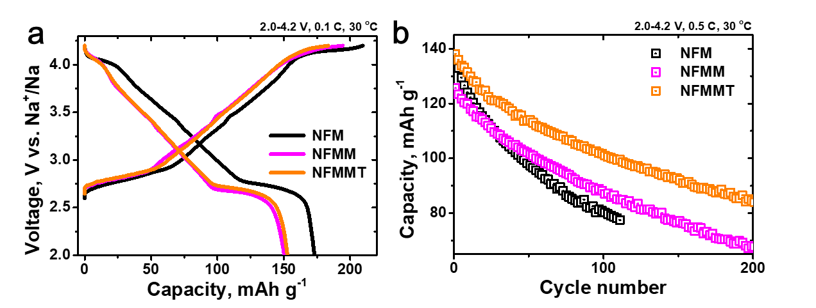
Supplementary Fig. 1 | (a) Initial charge/discharge profiles at 0.1 C, (b) cycling stability at 0.5 C of Na half cells featuring NFM, NFMM, and NFMMT.

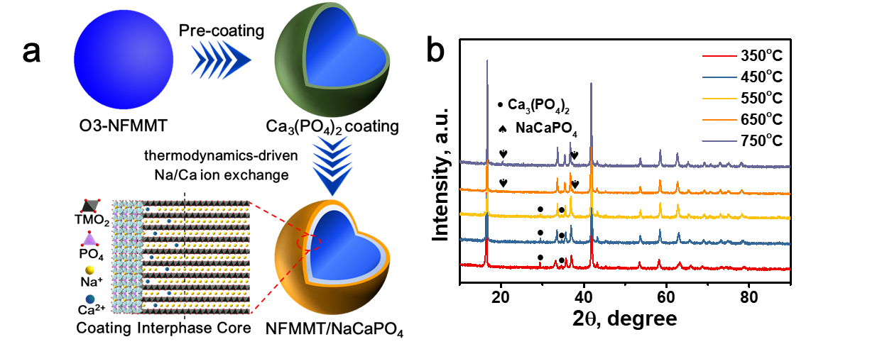
Supplementary Fig. 2 | (a) Schematic diagram of the synthesis process of NMFMT/NaCaPO₄. (b) XRD patterns of 1 wt% NaCaPO₄-coated NFMMT, calculated at various temperatures.

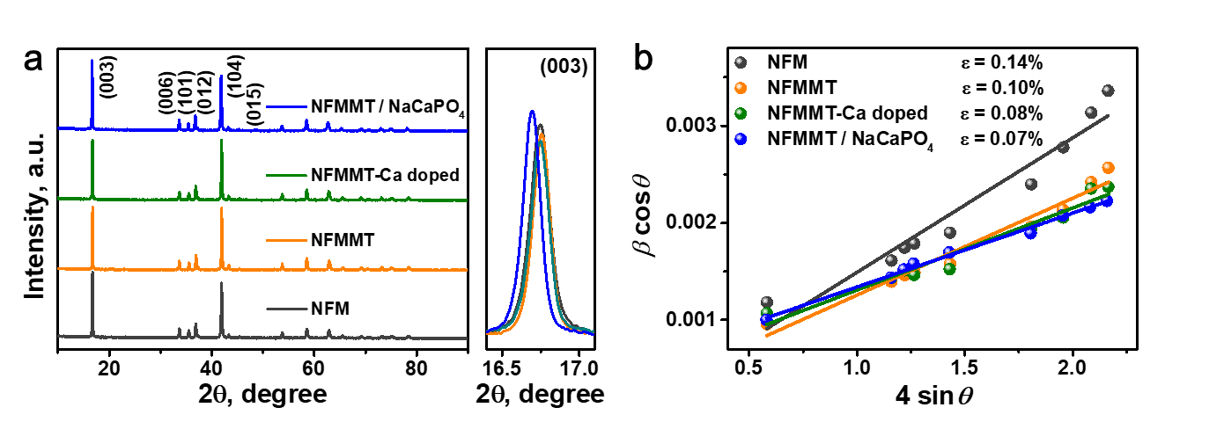
Supplementary Fig. 3 | (a) Powder XRD patterns of NFM, NFMMT, NFMMT-Ca doped, and NFMMT/NaCaPO₄. (b) ε calculated using Williamson–Hall analysis.

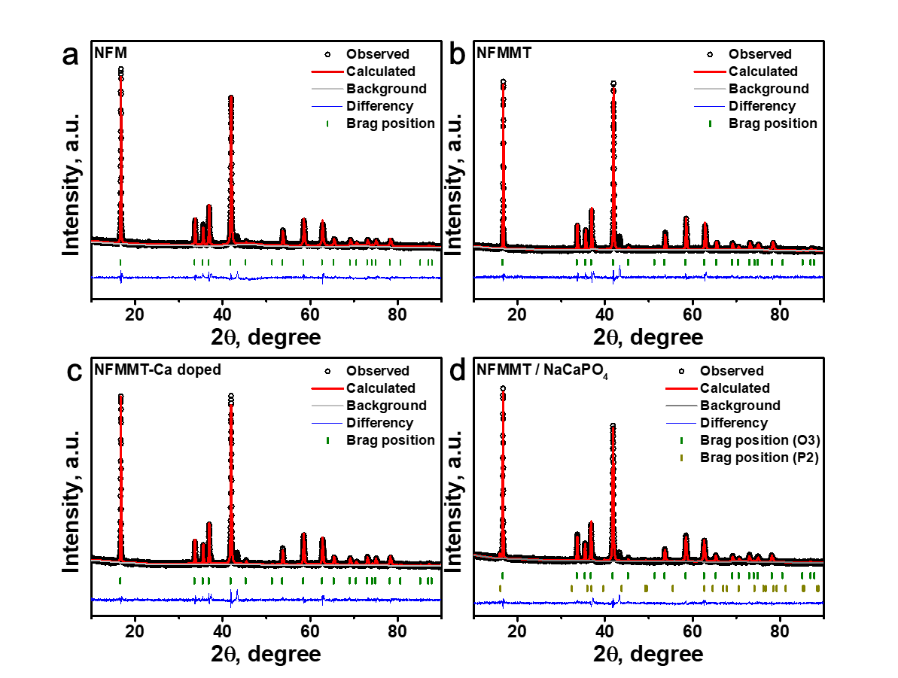
Supplementary Fig. 4 | Powder XRD and corresponding Rietveld refinement patterns of (a) NFM, (b) NFMMT, (c) NFMMT-Ca doped, and (d) NFMMT/NaCaPO₄.

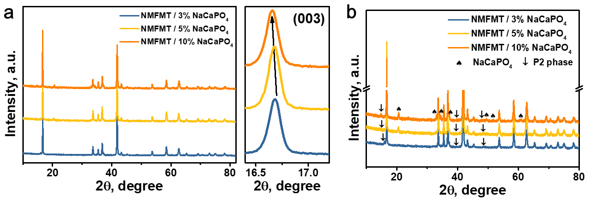
Supplementary Fig. 5 | XRD patterns of NFMMT coated with varying amounts of NaCaPO₄.

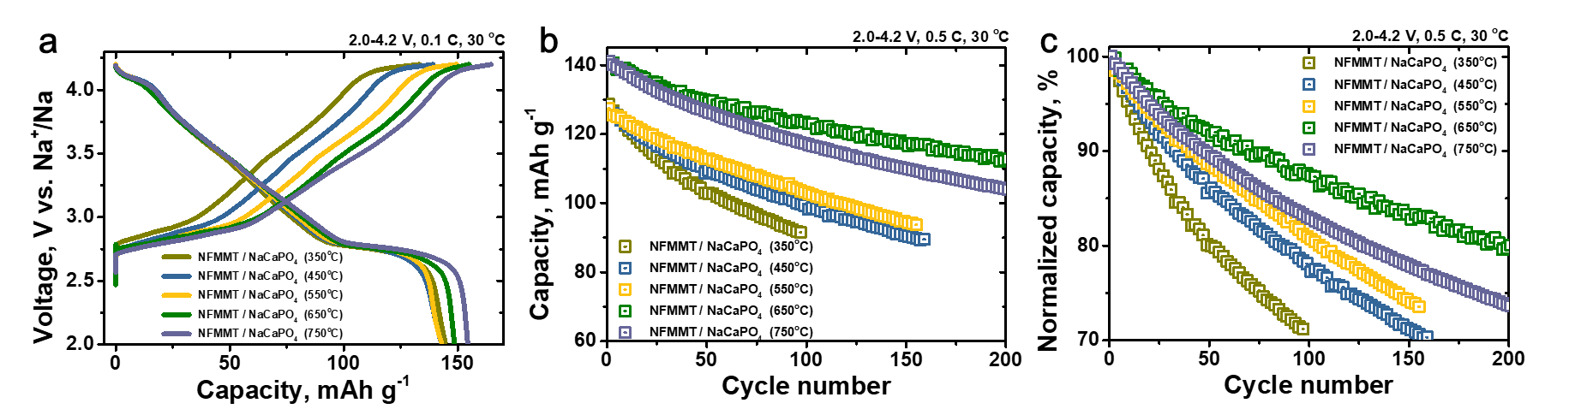
Supplementary Fig. 6 | (a) Initial charge/discharge profiles at 0.1 C, (b) cycling stability at 0.5 C, and (c) capacity retention of Na half cells with 1 wt% NaCaPO₄-coated NFMMT, calculated at different temperatures.

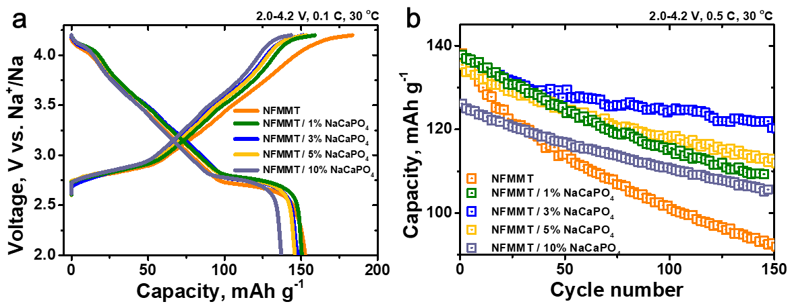
Supplementary Fig. 7 | (a) Initial charge/discharge profiles at 0.1 C, (b) cycling stability at 0.5 C of Na half cells featuring NFMMT coated with varying amounts of NaCaPO₄.

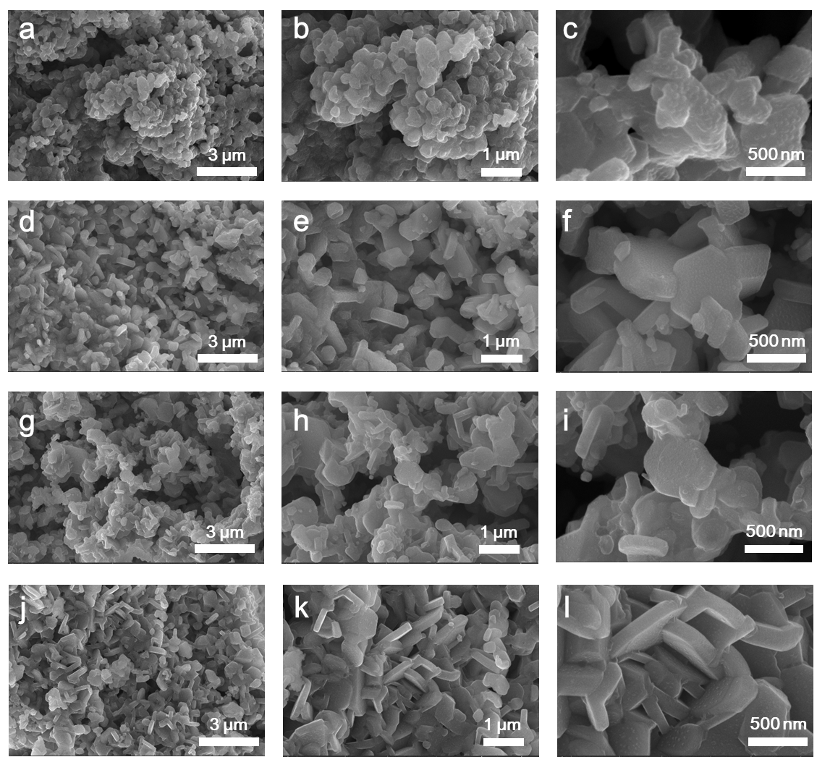
Supplementary Fig. 8 | SEM images of (a-c) NFM, (d-f) NFMMT, (g-i) NFMMT-Ca doped, and (j-l) NFMMT/NaCaPO₄.

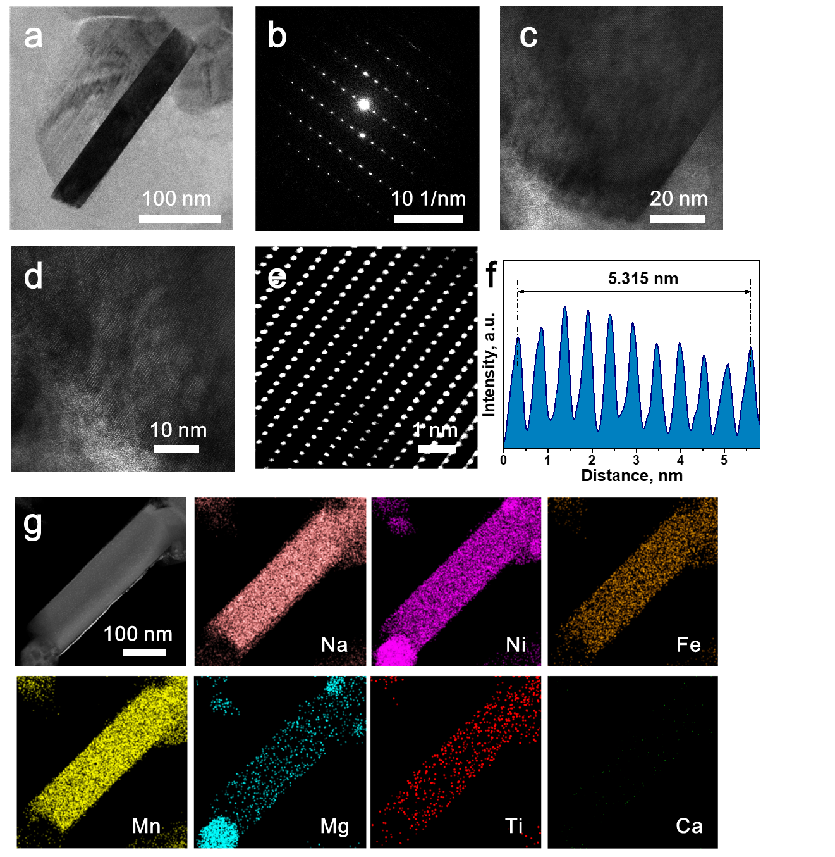
Supplementary Fig. 9 | (a) Low-magnification TEM image and (b) corresponding SAED pattern of pure NFMMT. (d,e) High-resolution TEM images of NFMMT. (f) Intensity line profile of NFMMT. (g) TEM-EDS mapping of NFMMT.

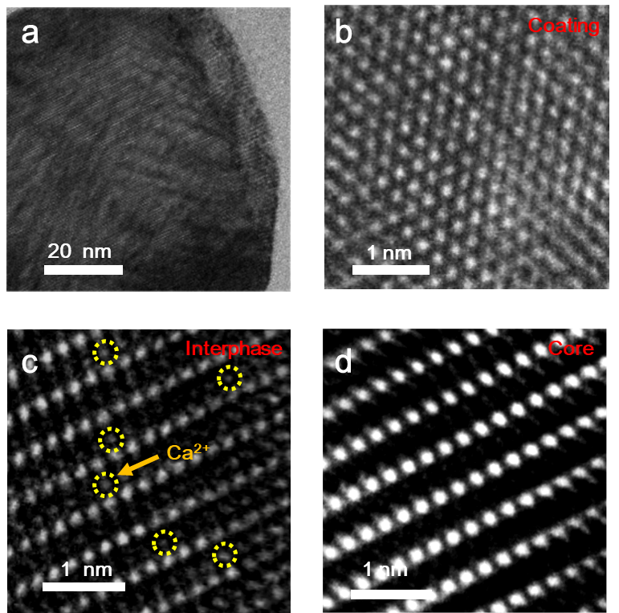
Supplementary Fig. 10 | (a) Low-magnification TEM image of NFMMT/NaCaPO₄. High-resolution TEM images of NFMMT/NaCaPO₄ showing the (b) surface region, (c) interphase region, and (d) core region.

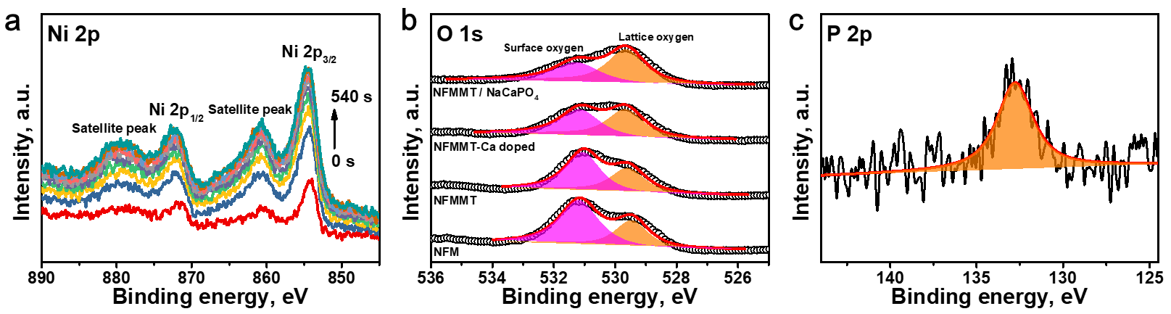
Supplementary Fig. 11 | (a) Depth profiling of Ni 2p XPS spectra for NFMMT/NaCaPO₄. (b) O 1s XPS spectra of NFM, NFMMT, NFMMT-Ca doped, and NFMMT/NaCaPO₄. (c) Core-level P 2p XPS spectra of NFMMT/NaCaPO₄.

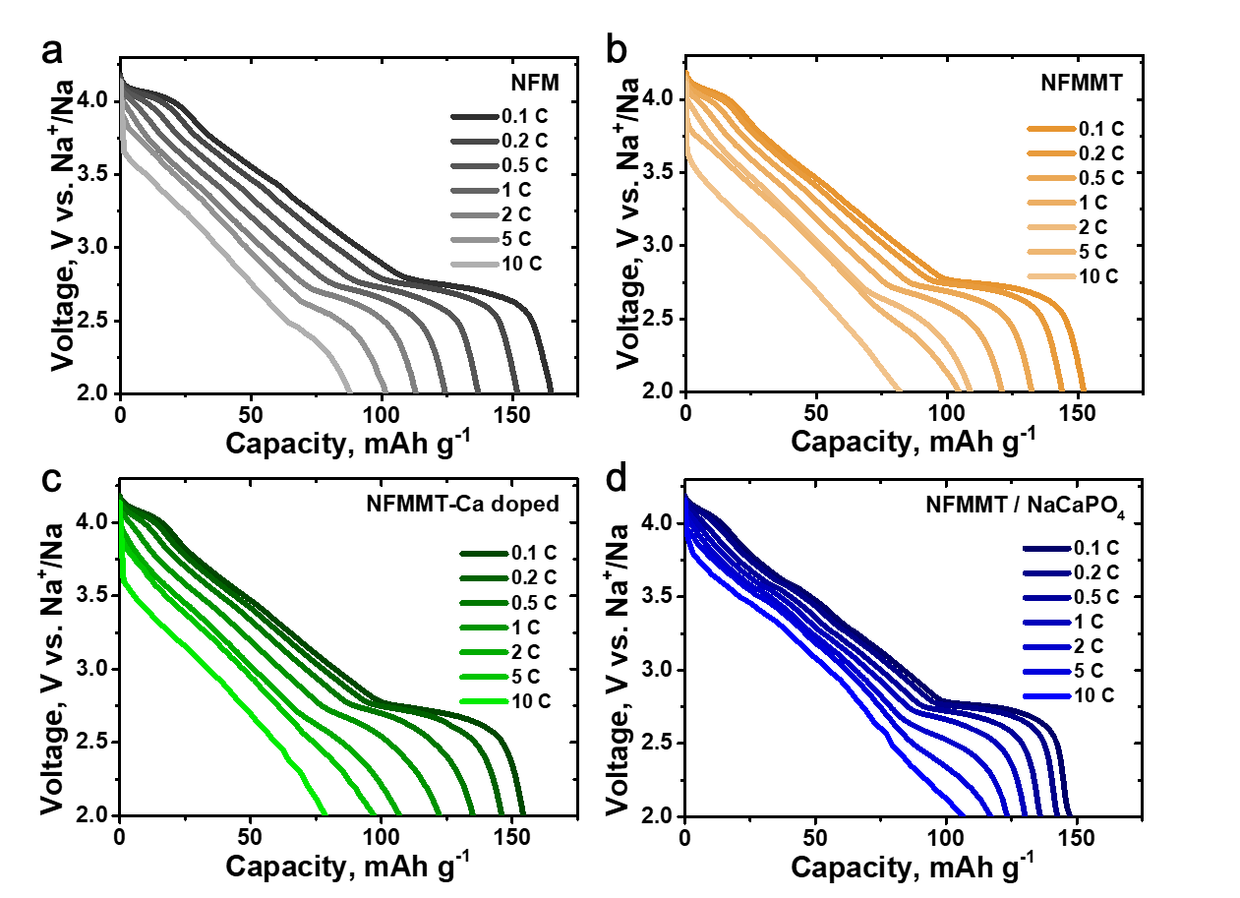
Supplementary Fig. 12 | Rate capability of Na half cells featuring (a) NFM, (b) NFMMT, (c) NFMMT-Ca doped, and (d) NFMMT/NaCaPO₄.

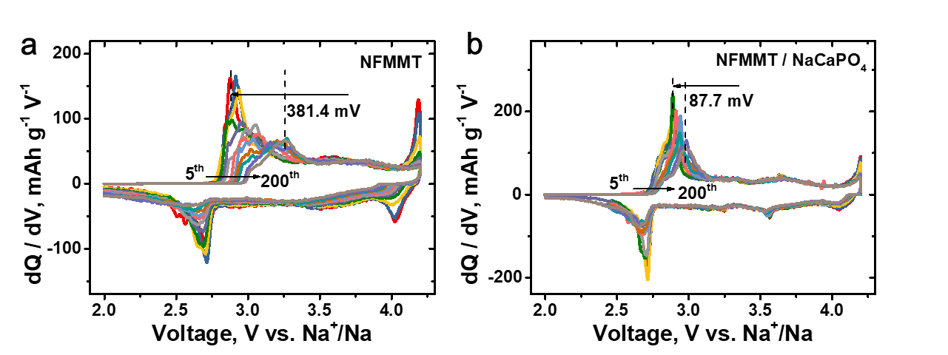
Supplementary Fig. 13 | Differential capacity curves of (a) NFMMT and (b) NFMMT/NaCaPO₄ at various cycles under a 1 C rate.
The differential capacity (dQ/dV) profiles for different cycles contain two redox peaks, which correspond to the plateaus in the charge/discharge curves, indicating the occurrence of a phase transition process (Supplementary Fig. 13). During subsequent cycles, NFMMT exhibits significant electrochemical polarization (0.381 V) and a decrease in the peak current intensity. However, for NFMMT/NaCaPO₄, the peak position shifts more slowly (0.088 mV polarization) and overlapping peak profiles appear within the same cycle, suggesting that the introduction of the protective coating mitigates irreversible structural damage.

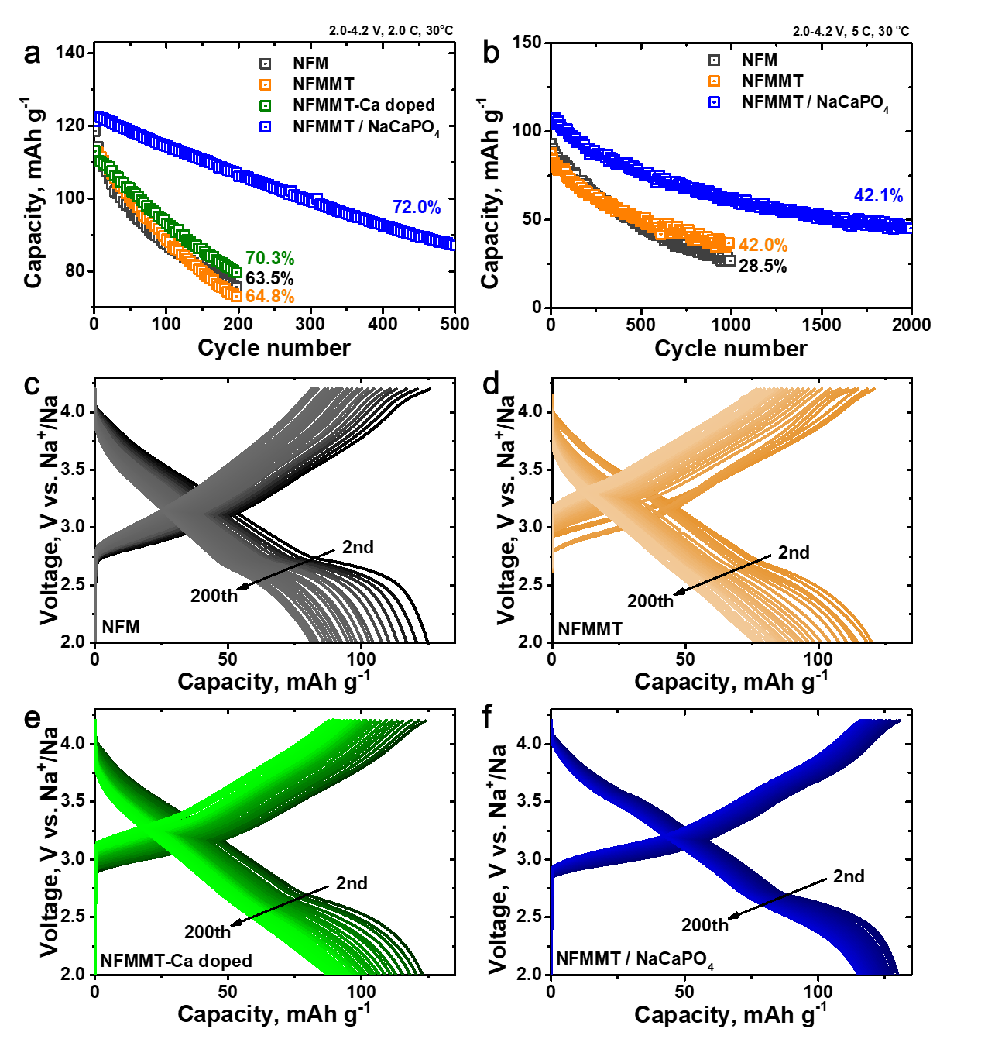
Supplementary Fig. 14 | (a,b) cycling stability of Na half cells featuring NFM, NFMMT, NFMMT-Ca doped, and NFMMT/NaCaPO₄. Charge/discharge profiles of (c) NFM, (d) NFMMT, (e) NFMMT-Ca doped, and (f) NFMMT/NaCaPO₄ cathodes cycled at 1 C.

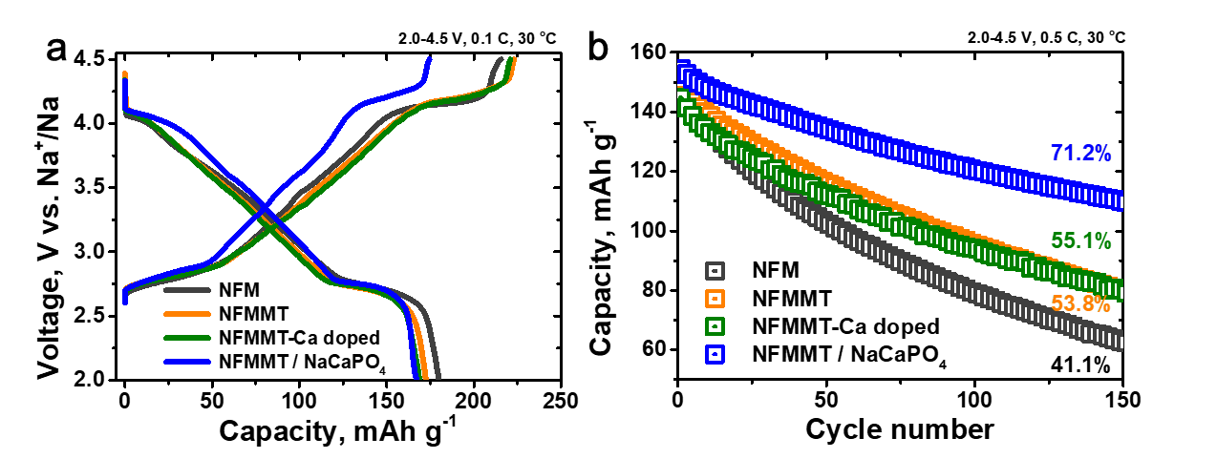
Supplementary Fig. 15 | (a) Initial charge/discharge profiles at 0.1 C and (b) cycling stability (0.5 C) of Na half cells with NFM, NFMMT, NFMMT-Ca doped, and NFMMT/NaCaPO₄ cathodes under high cut off voltage (2.0–4.5 V).

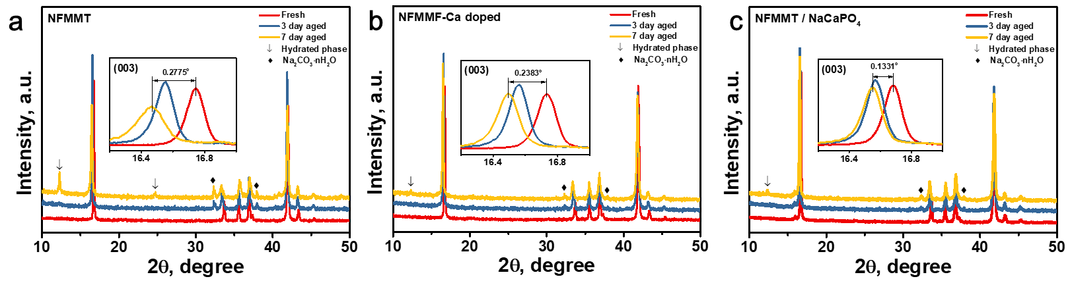
Supplementary Fig. 16 | XRD patterns of (a) NFMMT, (b) NFMMT-Ca doped, and (c) NFMMT/NaCaPO₄ of as-prepared and corresponding air-exposed samples (with a relative humidity of 55%).
After exposing NFMMT to moisture (70% relative humidity), the (003) peak in the XRD pattern shifts toward a lower angle (0.278°), and a characteristic Na₂CO₃·nH₂O peak appears, indicating the intercalation of water molecules and a reaction between Na ions released from the lattice and CO₂ in air. Upon increasing the exposure time (up to 7 days), the intensity of the O3 peak decreases significantly, and a new diffraction peak attributed to the hydrated phase appears, suggesting an unfavorable structural transformation. Ca-ion doping enhanced the air stability of the layered cathode by strengthening interlayer bonding between the TMO₂ slabs and promoting the formation of Na-deficient structures.

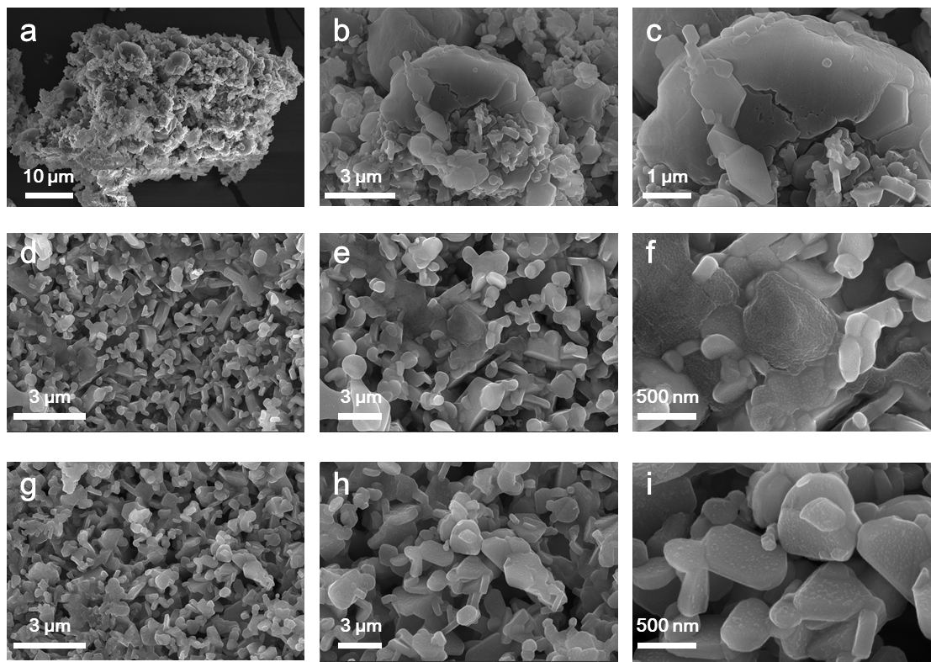
Supplementary Fig. 17 | SEM images of samples exposed to air with 70% relative humidity for 7 days: (a–c) NFMMT, (d–f) NFMMT-Ca doped, and (g–i) NFMMT/NaCaPO₄.

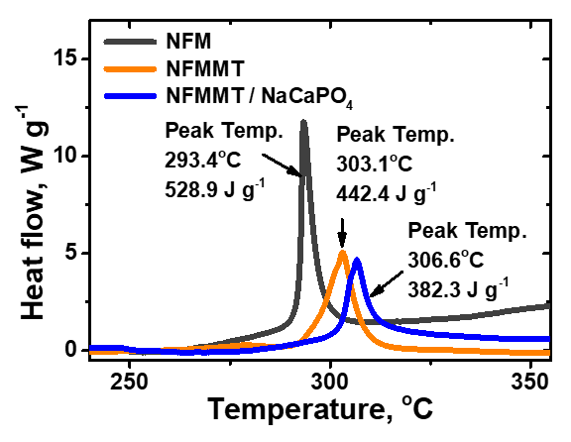
Supplementary Fig. 18 | DSC curves of NFM, NFMMT, and NFMMT/NaCaPO₄ cathodes in fully charged states (4.2 V).
The thermal and air stabilities of the prepared cathodes were further analyzed using differential scanning calorimetry (DSC) and atmospheric aging tests. As shown in Supplementary Fig. 25, NFMMT exhibits a strong exothermic peak at 303.1 °C with relatively high heat generation of 442.4 J g⁻¹ in the fully desodiated state, which is related to the decomposition of the active material (lattice oxygen release) and organic electrolyte. In contrast, NFMMT/NaCaPO₄ has a higher exothermic peak at 306.6 °C but lower overall heat release (382.3 J g⁻¹), demonstrating that the reconstruction layer effectively mitigates the risk of thermal runaway.

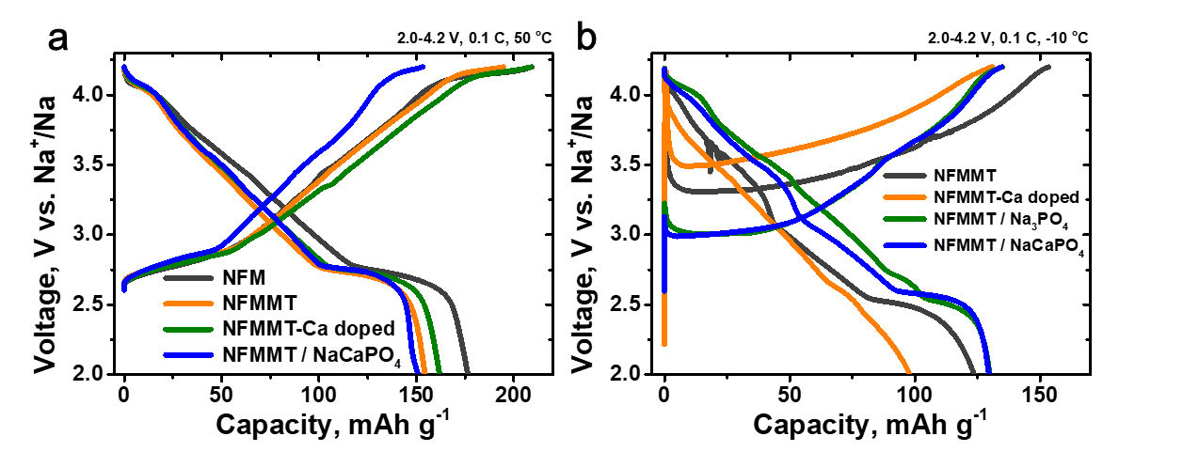
Supplementary Fig. 19 | Initial charge/discharge profiles of Na half cells with NFM, NFMMT, NFMMT-Ca doped, and NFMMT/NaCaPO₄ cathodes under (a) high temperature (50 °C) and (b) low temperature (−10 °C) at 0.1 C.

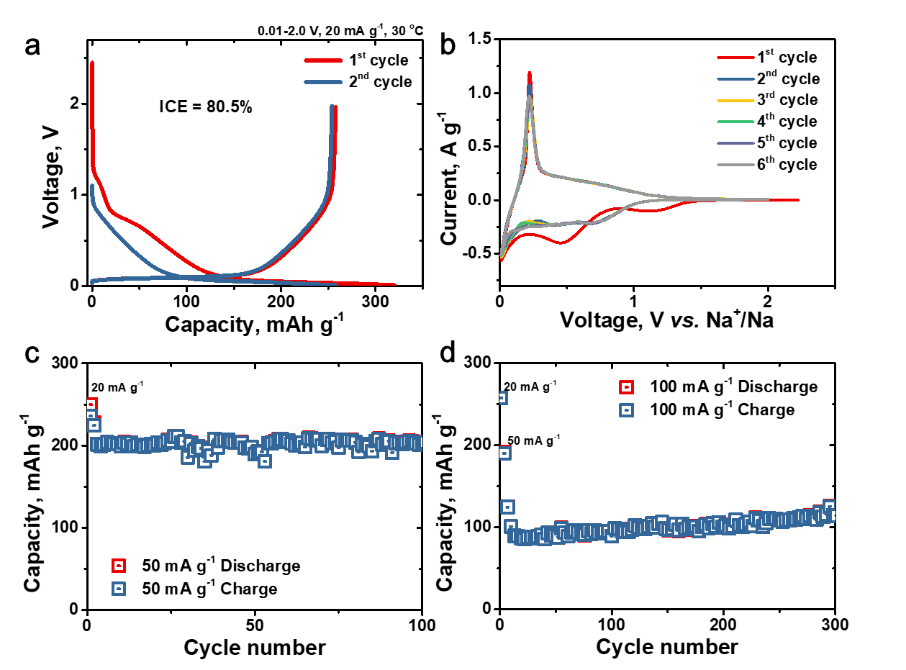
Supplementary Fig. 20 | (a) Initial charge/discharge profiles of a half cell featuring an HC anode at 20 mA g ⁻¹ in the voltage range of 0.01–2.0 V. (b) CV curves of HC anode for the first 6 cycles (0.1 mV s⁻¹ ) in the Na half-cell. (c,d) Cycling stability (50 and 100 mA g⁻¹) of Na half cells featuring the HC anodes.

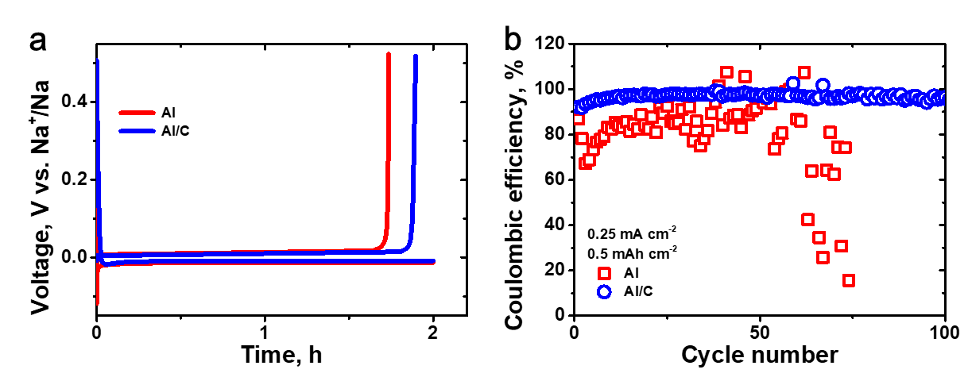
Supplementary Fig. 21 | (a) The first plating/stripping curves and the CEs of Na||Al and Na||Al-C cells.

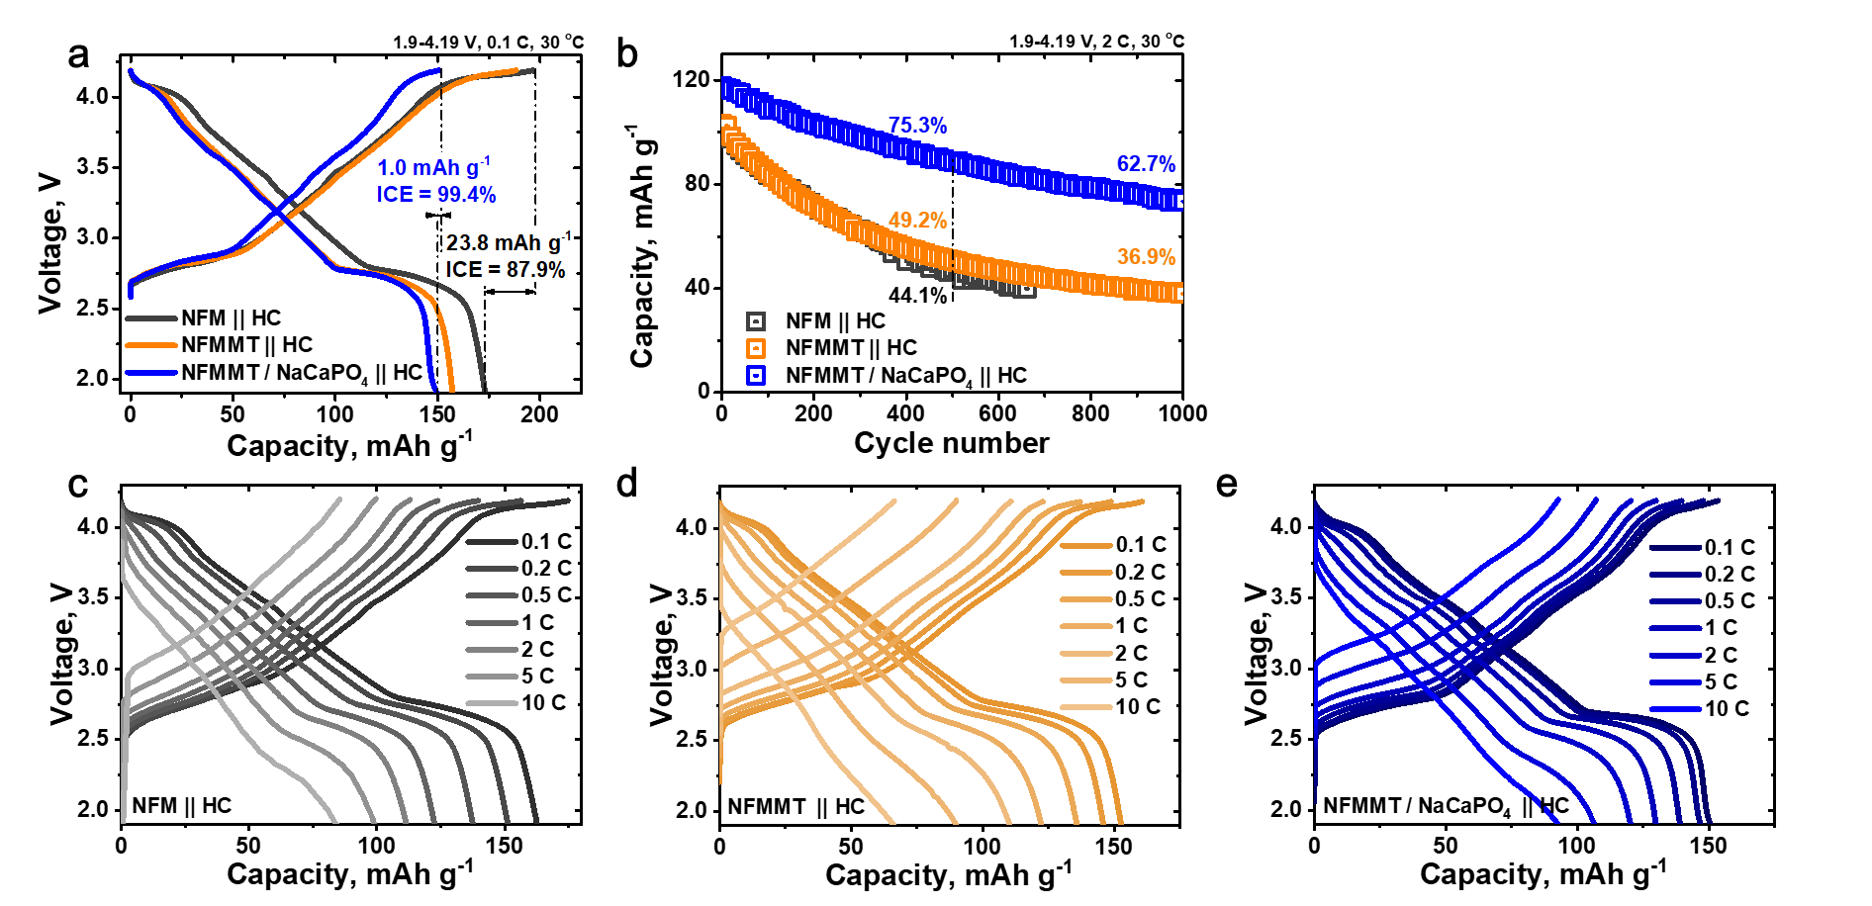
Supplementary Fig. 22 | (a) Initial charge/discharge profiles of the coin-type full cell. (b) Cycling stability of Na-ion full cells with NFM||HC, NFMMT||HC, and NFMMT/NaCaPO₄||HC at 2 C rate. Rate capability of (c) NFM||HC, (d) NFMMT||HC, and (e) NFMMT/NaCaPO₄||HC.
The rate performance of NFMMT/NaCaPO₄ in the Na-ion full-cell system (63.1% capacity retention from 0.1 C to 10 C) is slightly lower than that in the half-cell system (71.0% capacity retention), which is attributed to the poor rate performance of the HC anode (Supplementary Fig. 20d).

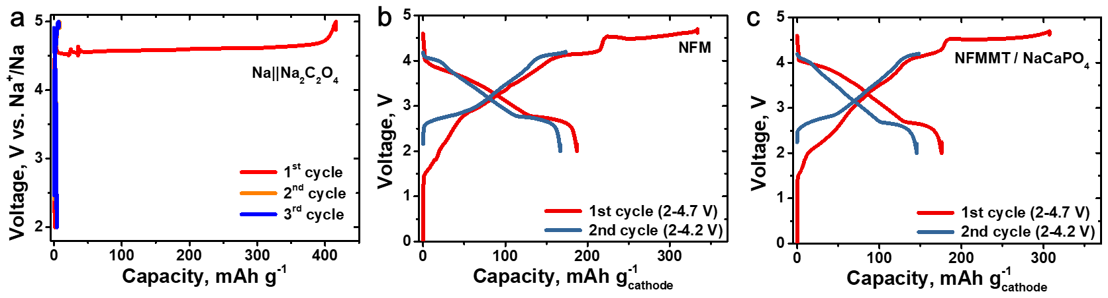
Supplementary Fig. 23 | (a) Electrochemical characteristics of Na₂C₂O₄ at 0.1 C with a potential window of 2–4.7 V. Charge/discharge profiles of half-cells with a 17 wt% Na₂C₂O₄ additive using (a) MFMMT and (b) NFMMT/NaCaPO₄ cathodes.
In anode-free Na batteries, the active Na ions are supplied by the cathode. However, the behavior of the Na/Al-C half cell indicates that solid electrolyte interphase formation and subsequent Na plating/stripping inevitably lead to the consumption of active Na (Supplementary Fig. 21), potentially causing initial capacity loss and rapid capacity degradation in the anode-free battery. To mitigate this issue and thus extend the cycle life of the anode-free Na battery, 17 wt.% Na₂C₂O₄ was introduced as a Na compensation material. During the initial charge, Na₂C₂O₄ decomposes into Na metal and CO₂, yielding an irreversible charging capacity of approximately 416 mAh g⁻¹. Consequently, NFMMT/NaCaPO₄//Al-C is activated within the voltage range of 2.0–4.7 V to deposit sufficient Na metal onto the Al-C anode current collector.
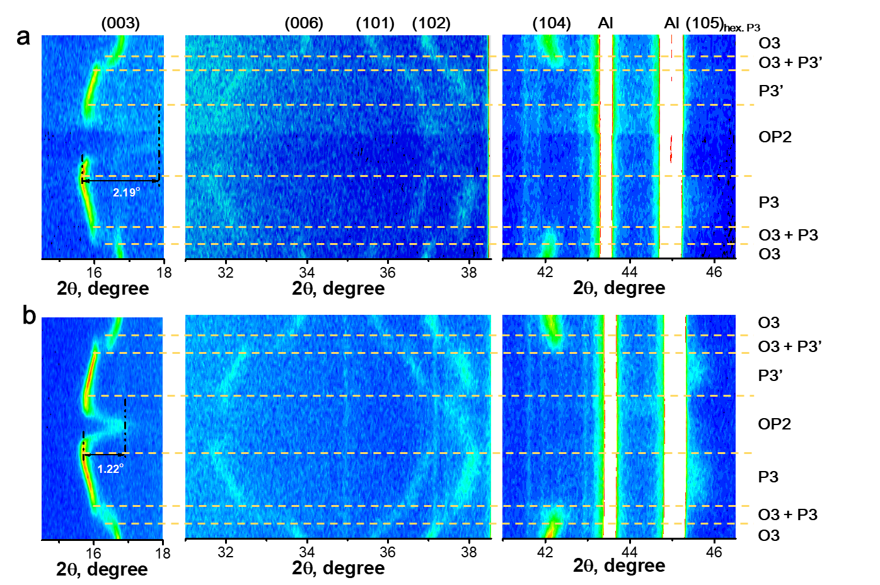
Supplementary Fig. 24 | In situ XRD of (a) NFMMT and (b) NFMMT/NaCaPO₄.
Supplementary Fig. 24 shows the phase evolution of the O3-type cathode during Na extraction, with a transition from hexagonal O3 to hexagonal P3 and subsequently to the OP2 phase, driven by TMO₂ layer slip and stacking faults. This process is reversible, with the cathode returning to the O3 phase upon discharging to 2.0 V. The (101) and (102) diffraction peaks shift gradually toward higher diffraction angles during the charging process, reflecting the contraction of the ab plane owing to the oxidation of TM ions.

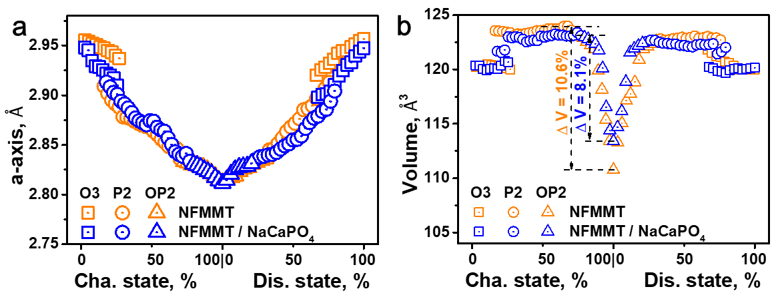
Supplementary Fig. 25 | The change in (a) a and (b) V parameter during charge/discharge of NFMMT and NFMMT/NaCaPO₄.

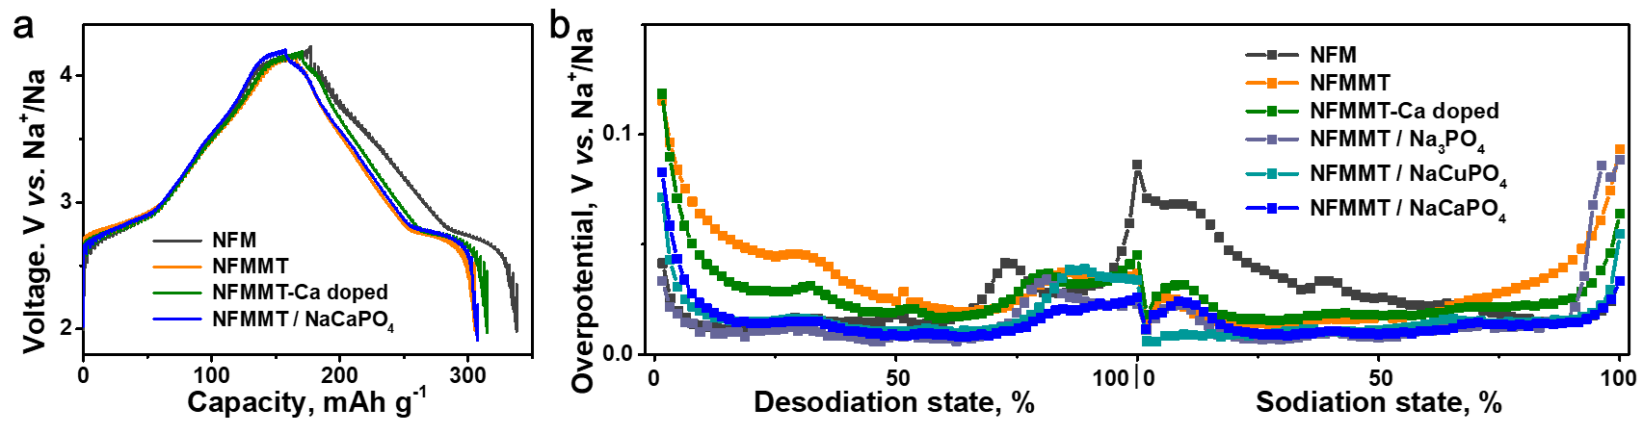
Supplementary Fig. 26 | (a) GITT curves of NFM, NFMMT, NFMMT-Ca doped, and NFMMT/NaCaPO₄. (b) Overpotential of prepared cathodes during charge/discharge.

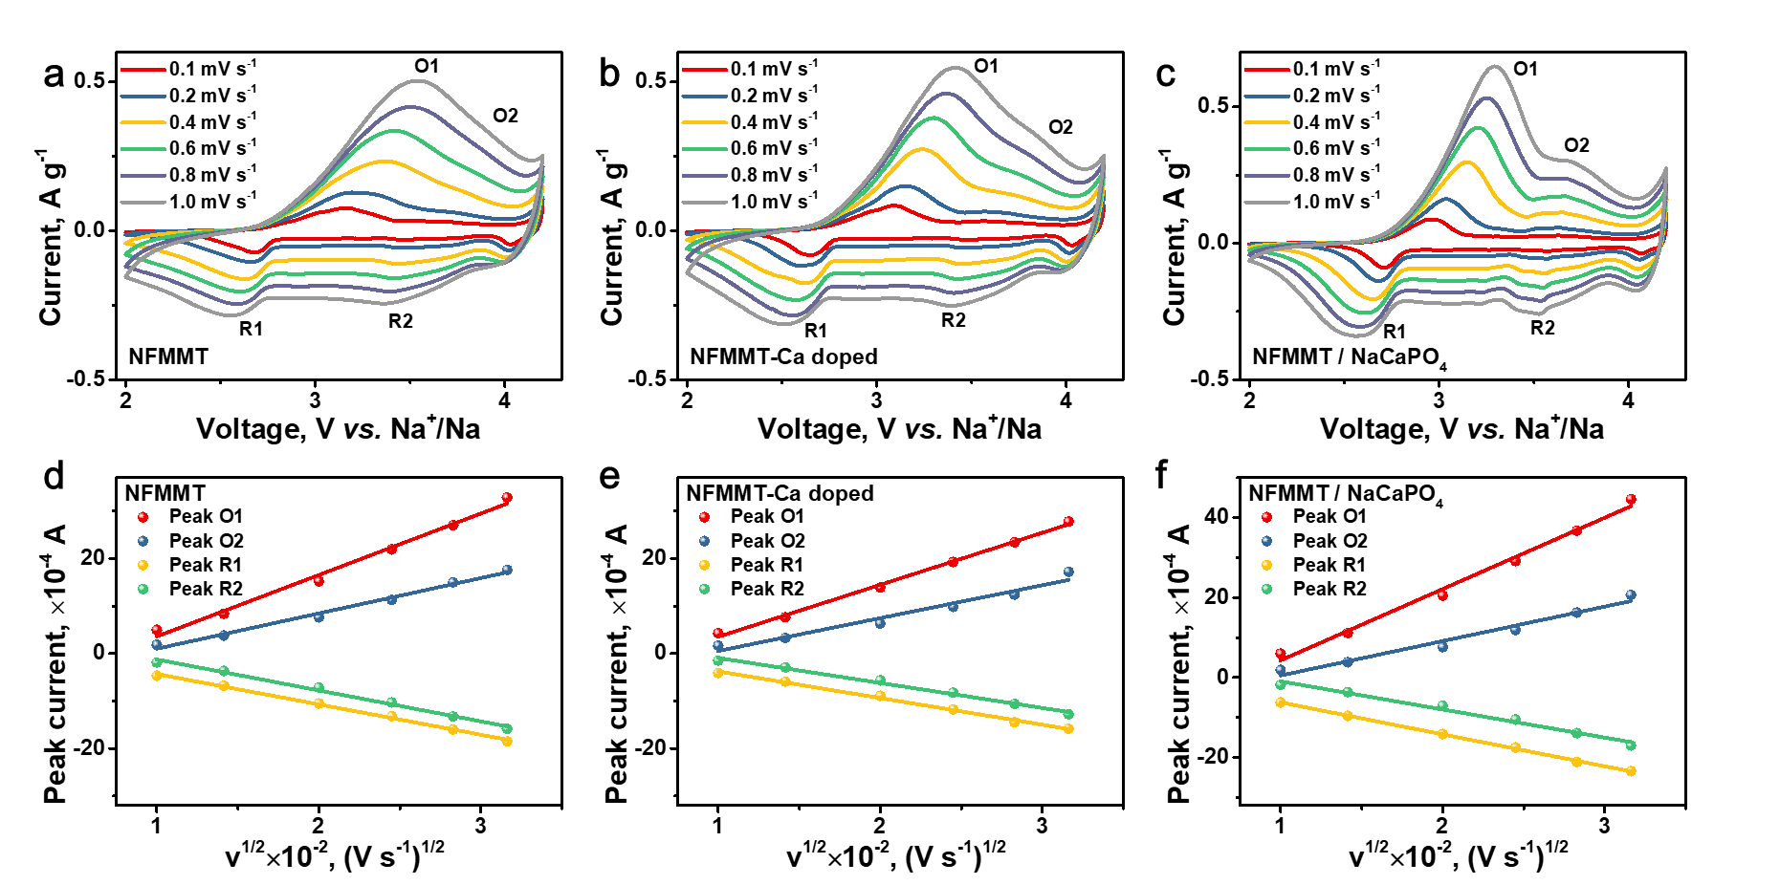
Supplementary Fig. 27 | CV profiles of Na half cells featuring (a) NFMMT, (b) NFMMT-Ca doped, and (c) NFMMT/NaCaPO₄ cathodes at different scan rates. Corresponding linear fittings of peak current versus the square root of the sweep rate for (d) NFMMT, (e) NFMMT-Ca doped, and (f) NFMMT/NaCaPO₄.

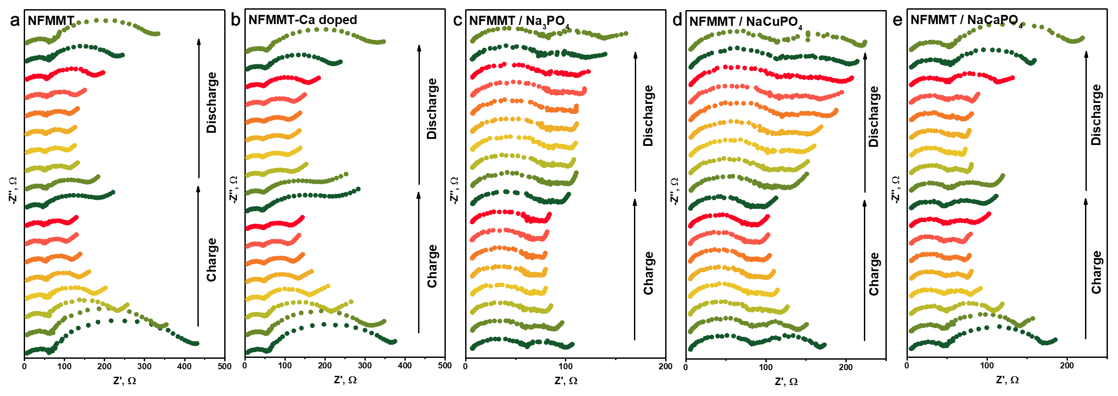
Supplementary Fig. 28 | Nyquist plots of (a) NFMNT, (b) NFMMT-Ca doped, (c) NFMMT/Na₃PO₄, (d) NFMMT/NaCuPO₄, and (e) NFMMT/NaCaPO₄ at different states of charge during the first cycle.

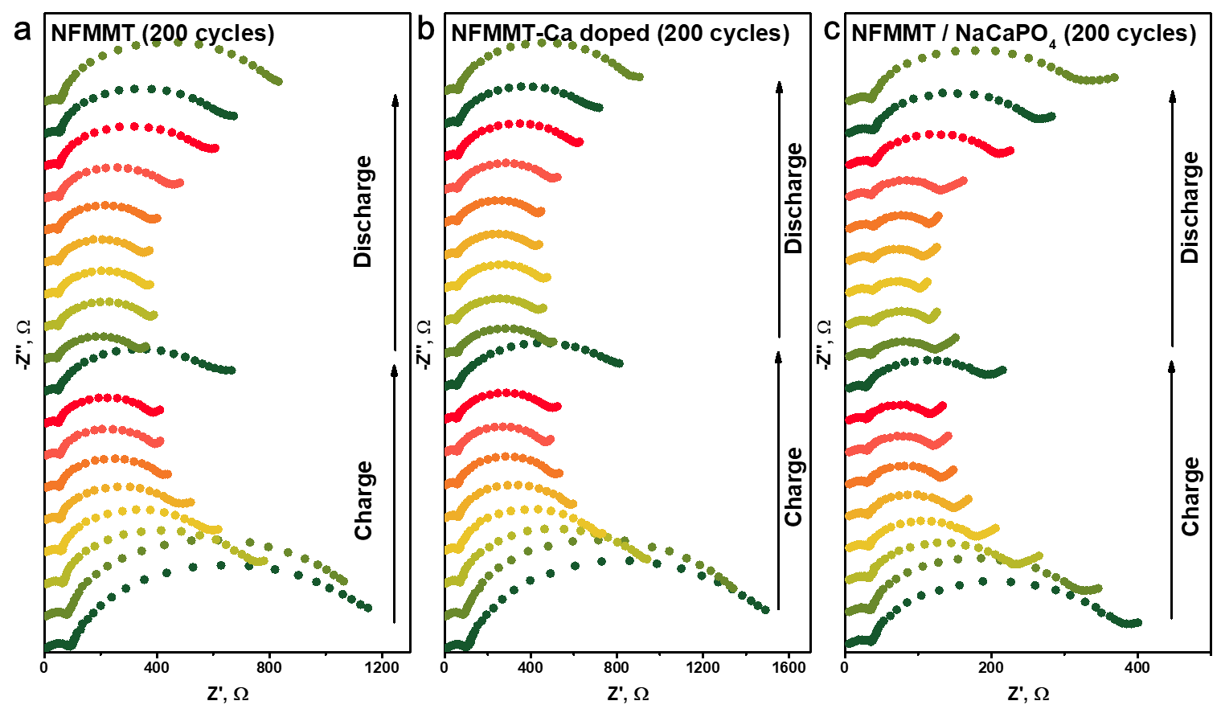
Supplementary Fig. 29 | Nyquist plots of (a) NFMNT, (b) NFMMT-Ca doped, and (c) NFMMT/NaCaPO₄ at different states of charge after 200 cycles.

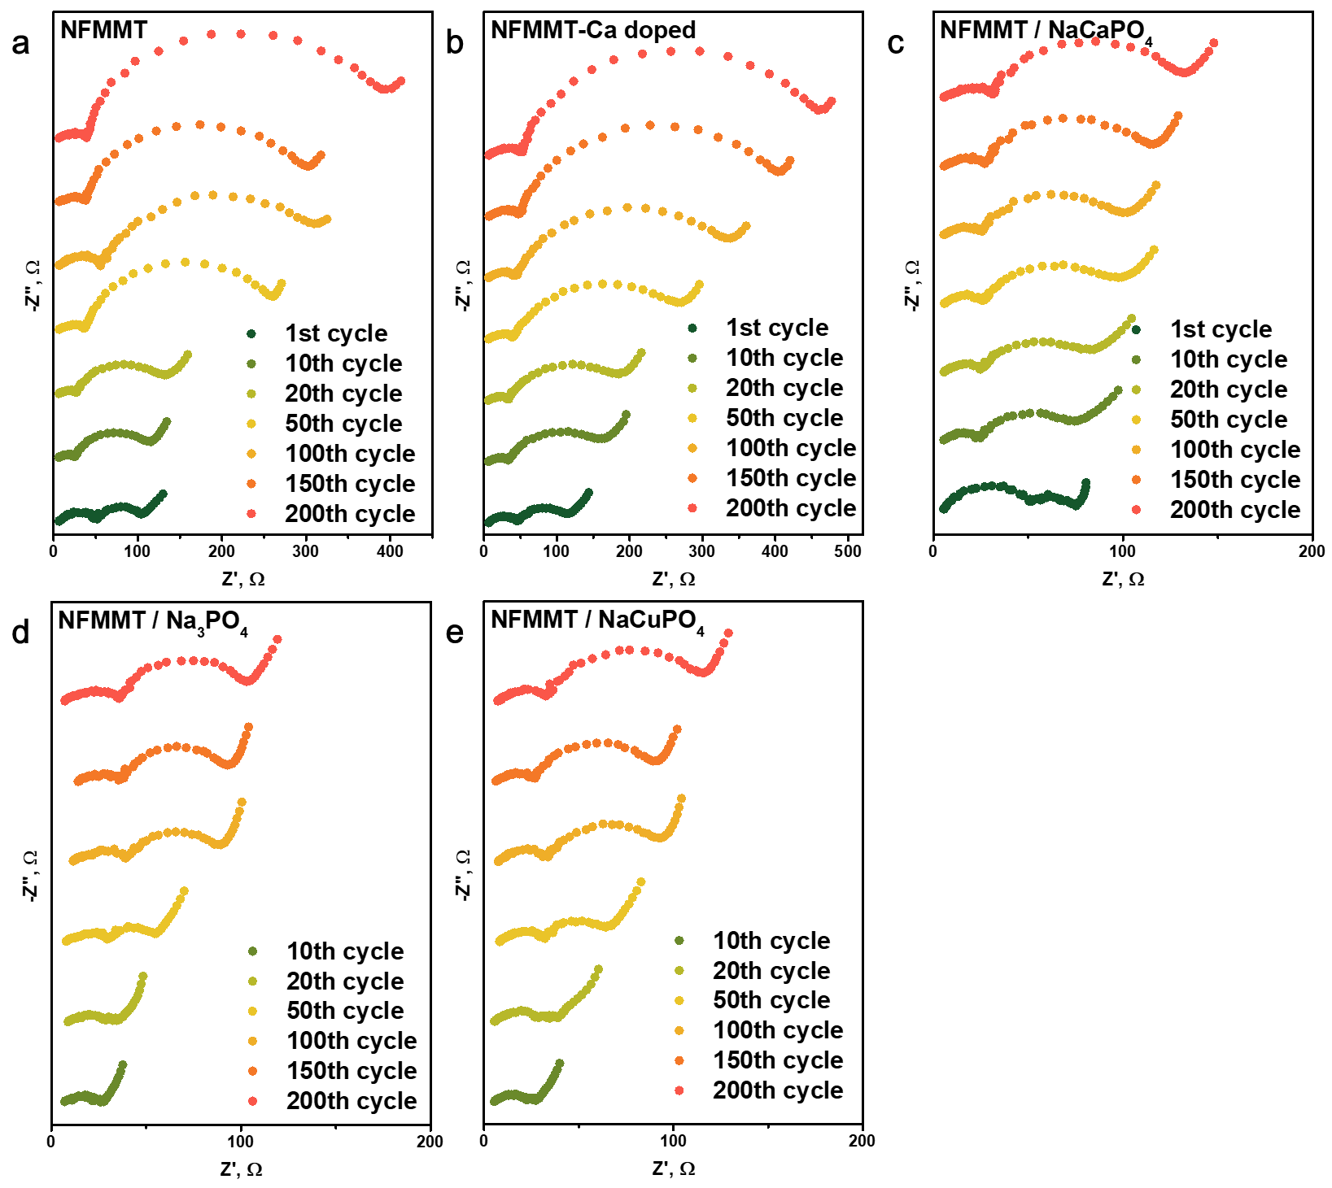
Supplementary Fig. 30 | Nyquist plots of (a) NFMNT, (b) NFMMT-Ca doped, (c) NFMMT/NaCaPO₄, (d) NFMMT/Na₃PO₄, and (e) NFMMT/NaCuPO₄ after different cycles.

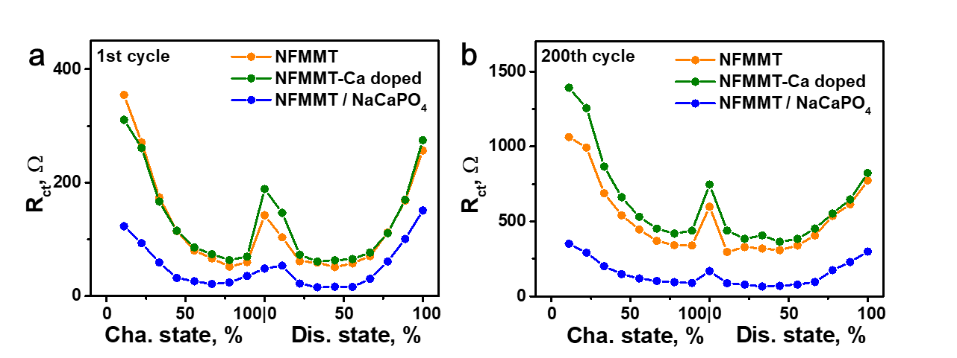
Supplementary Fig. 31 | EIS spectra of NFMMT, NFMMT-Ca doped, and NFMMT/NaCaPO₄ at different voltages during the (a) 1st cycle and (b) 200th cycle.

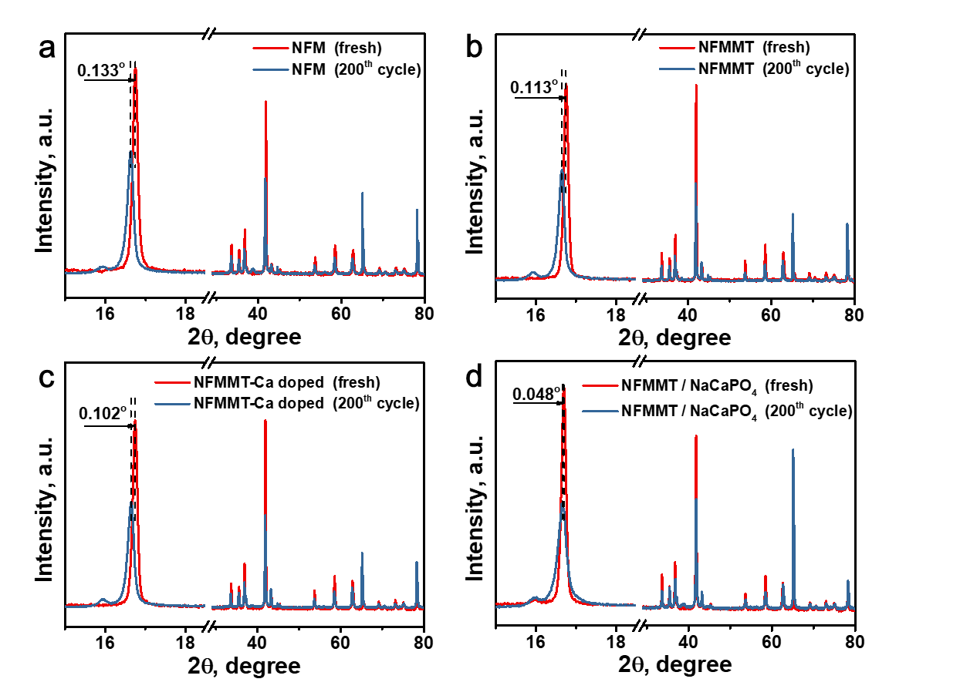
Supplementary Fig. 32 | XPD patterns of (a) NFM, (b) NFMMT, (c) NFMMT-Ca doped, and (d) NFMMT/NaCaPO₄ before and after 200 cycles.

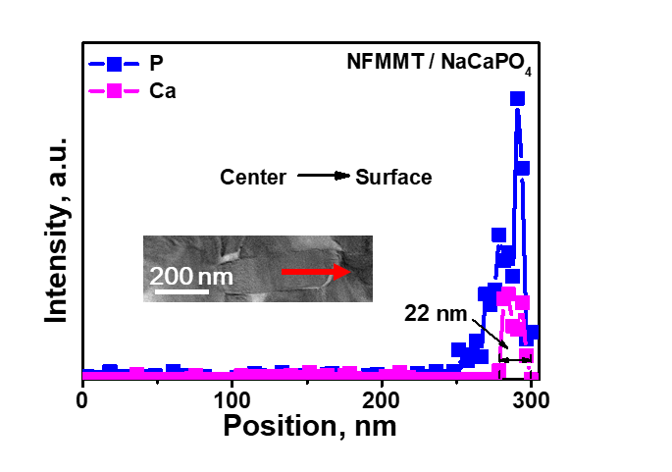
Supplementary Fig. 33 | STEM images (inset) and corresponding EDS line scan results for P and Ca elements in cycled NFMMT/NaCaPO₄.

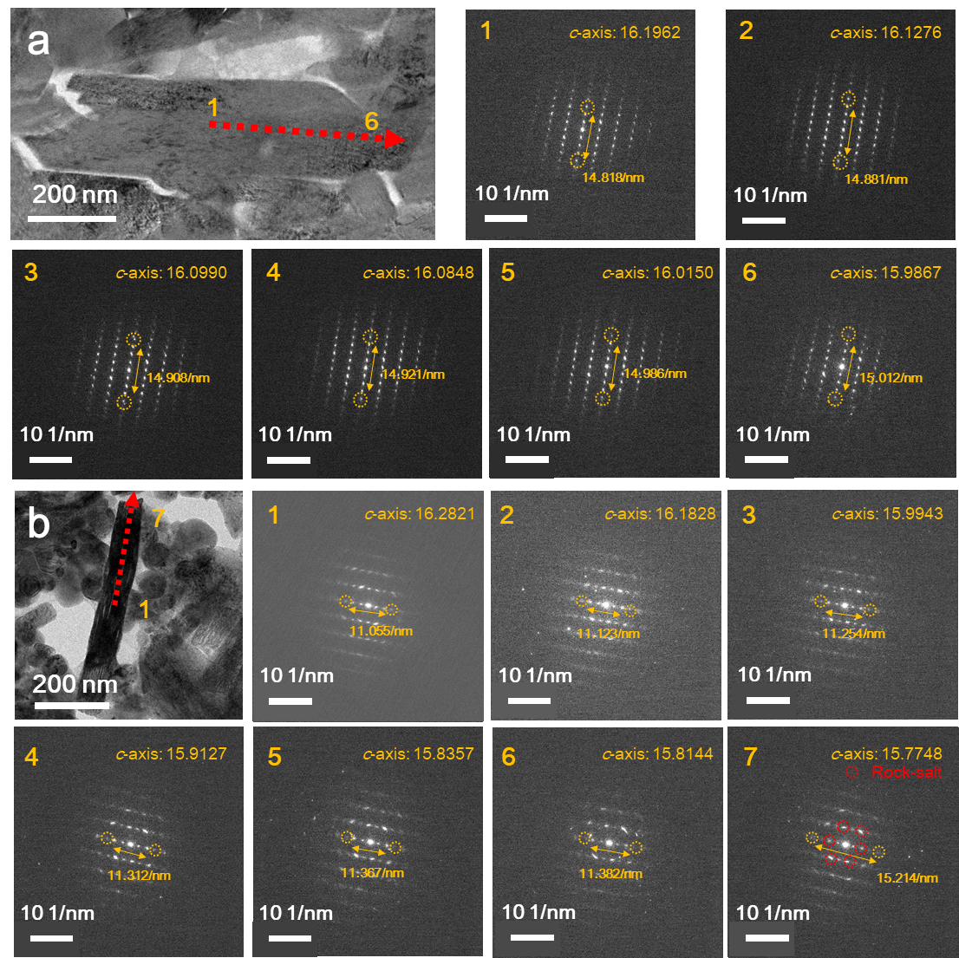
Supplementary Fig. 34 | TEM images of (a) NFMMT and (b) NFMMT/NaCaPO₄ cathode particle charged to 4.2 V after 200 cycles, along with the corresponding electron diffraction patterns measured from core to surface.

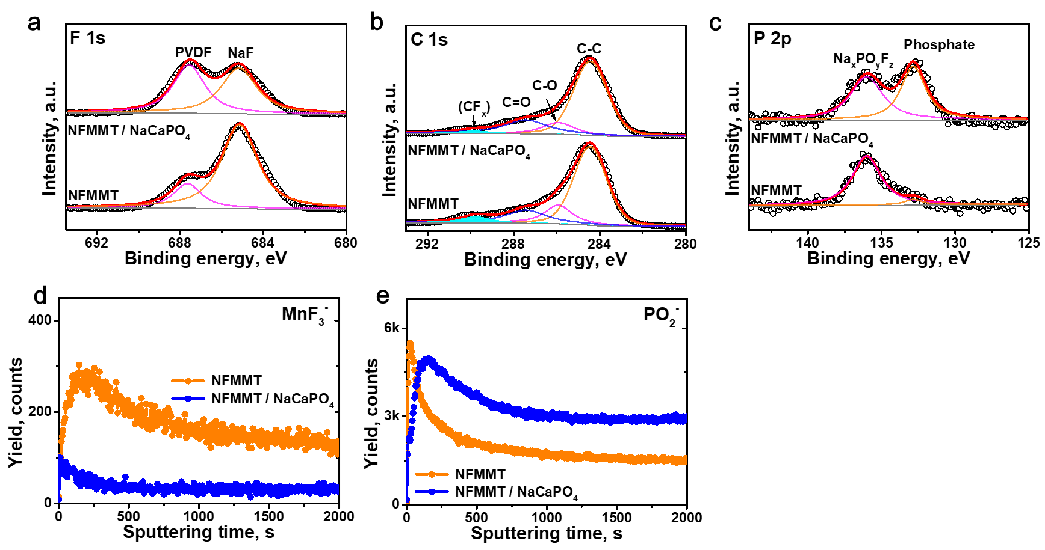
Supplementary Fig. 35 | (a) F 1s, (b) C 1s, and (c) P 2p XPS spectra of cycled NFMMT and NFMMT/NaCaPO₄. Normalized TOF-SIMS depth profiles of (d) MnF₃⁻ and (e) PO₂⁻ in NFMMT and NFMMT/NaCaPO₄.

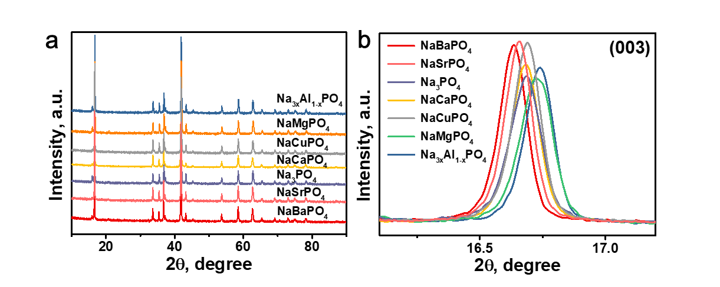
Supplementary Fig. 36 | XPD patterns of NFMMT with different coating layers.
XRD analysis confirmed that the synthesized cathodes retain the primary O3 phase structure with a small amount of the P2 phase formed by ion exchange, similar to the characteristics of NFMMT/NaCaPO₄. Additionally, the enlarged view of the (003) plane reveals peak shifts corresponding to the ionic radii of the X ions, indicating that some X ions were successfully doped in the interlayer, resulting in lattice parameter expansion/contraction along the c-axis.

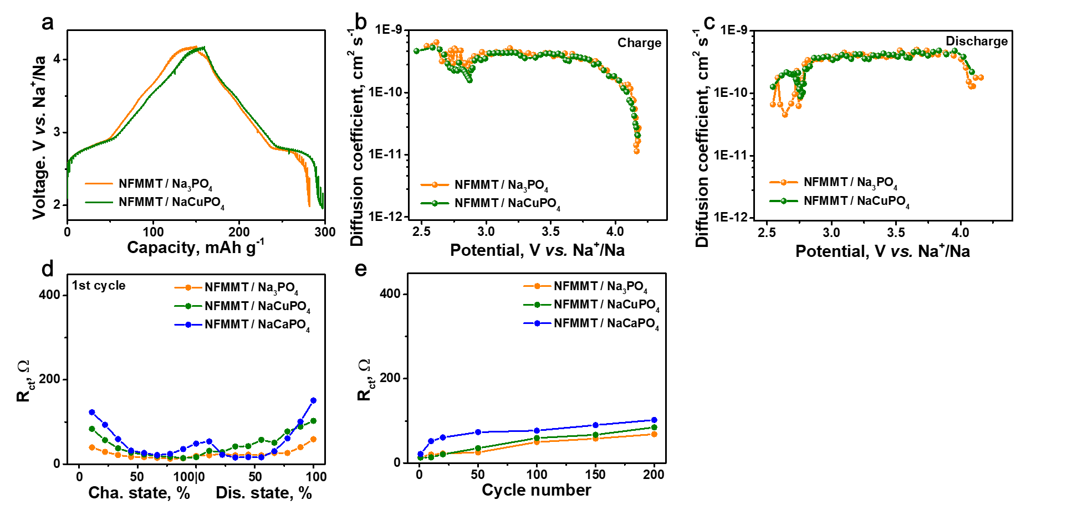
Supplementary Fig. 37 | (a) GITT curves and (b,c) the corresponding diffusion coefficient of NFMMT/Na₃PO₄ and NFMMT/NaCuPO₄. EIS spectra of NFMMT/Na₃PO₄, NFMMT/NaCuPO₄ and NFMMT/NaCaPO₄ at (d) different states of charge during the first cycle and (e) after different cycles.

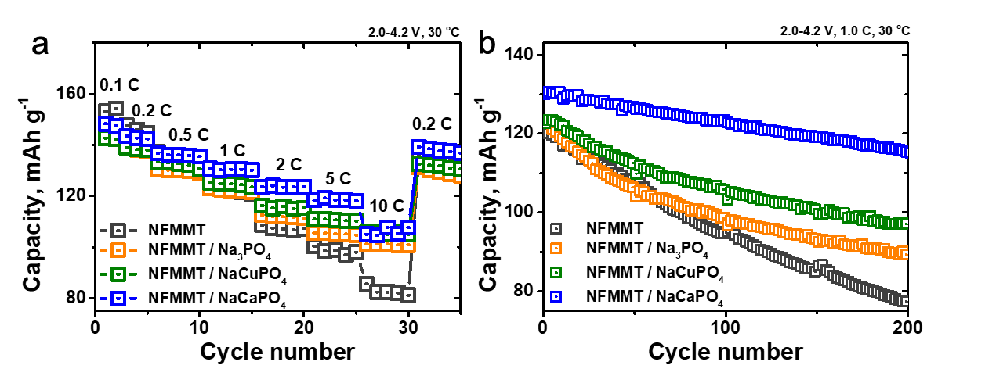
Supplementary Fig. 38 | (a) Rate capability and (b) cycling stability of Na half cells featuring NFMMT, NFMMT/Na₃PO₄, NFMMT/NaCuPO₄, and NFMMT/NaCaPO₄ cathodes.

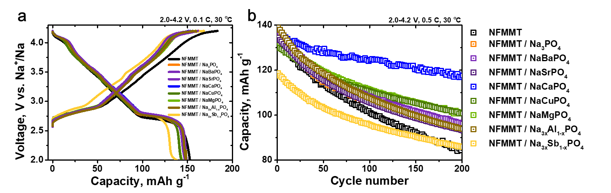
Supplementary Fig. 39 | (a) Initial charge/discharge profiles at 0.1 C, (b) cycling stability at 0.5 C of Na half cells featuring NFMMT with different coating layers.

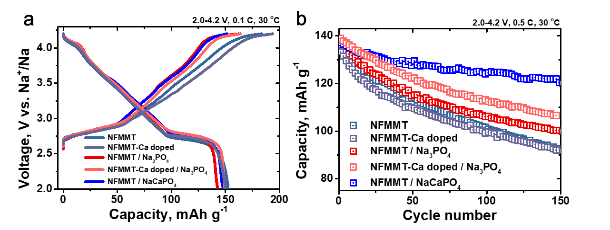
Supplementary Fig. 40 | (a) Initial charge/discharge profiles at 0.1 C, (b) cycling stability at 0.5 C of Na half cells featuring NFMM, NFMMT-Ca doped, NFMMT/Na₃PO₄, NFMMT-Ca doped/Na₃PO₄ and NFMMT/NaCaPO₄.

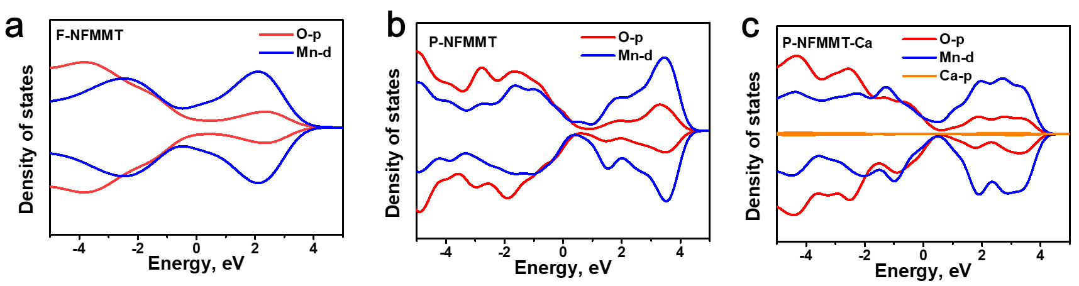
Supplementary Fig. 41 | DOS of (a) F-NFMMT, (b) P-NFMMT, and (c) P-NFMMT-Ca.

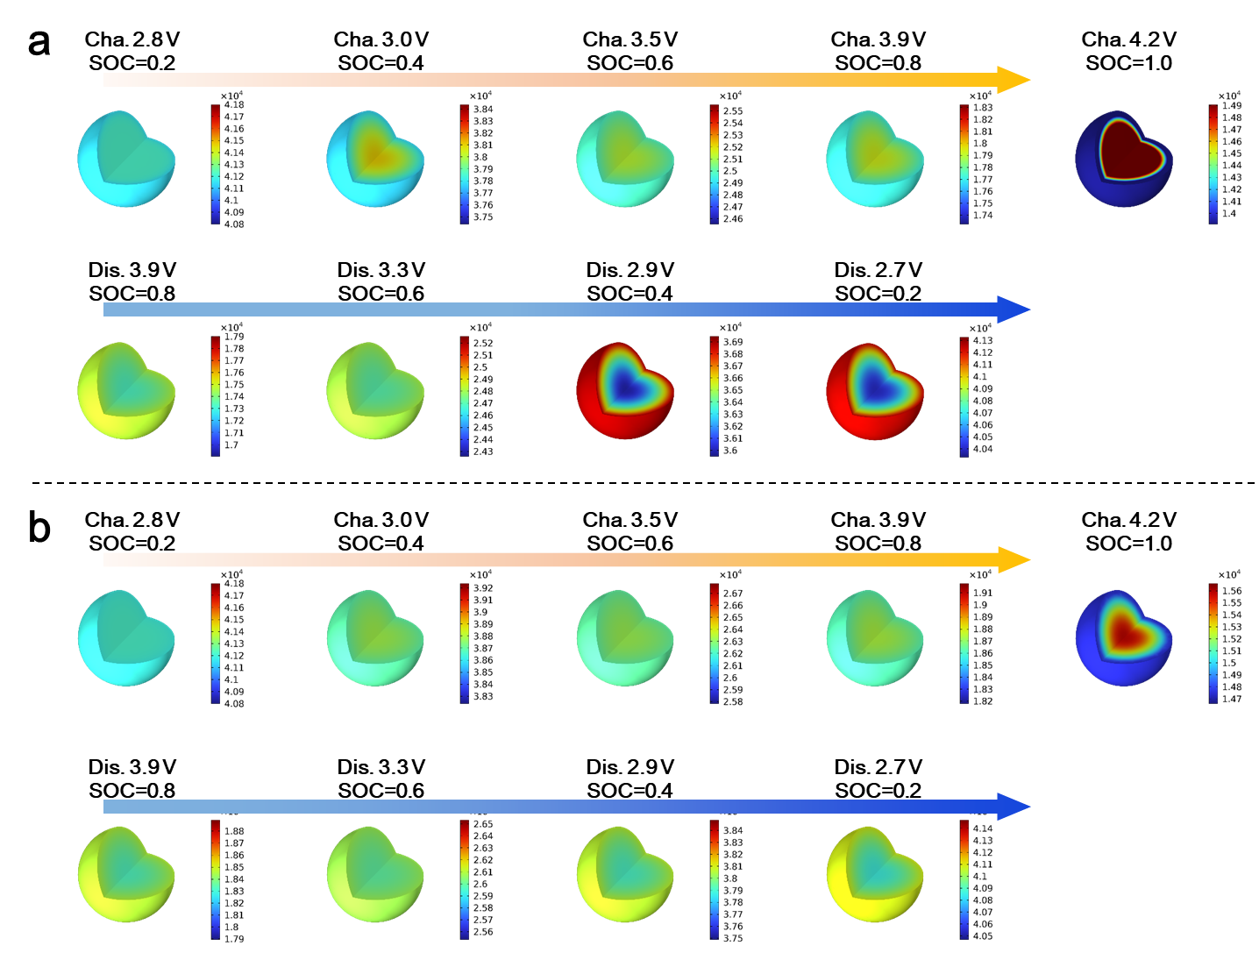
Supplementary Fig. 42 | COMSOL simulations of internal Na⁺ concentration distribution for (a) NFMMT and (b) NFMMT/NaCaPO₄ at different states of charge.
The concentration plot reflects the uniformity of Na-ion distribution in the cathode at different voltage states. During charging and discharging, both NFMMT and NFMMT/NaCaPO₄ exhibit opposing Na⁺ concentration gradients between the interior and exterior of the particles. Overall, NFMMT/NaCaPO₄ demonstrates a more uniform Na⁺ distribution throughout the entire process, with a particularly notable improvement in uniformity near the phase transition region. Moreover, the introduction of the interface reconstruction layer ensures stable Na-ion transport, effectively alleviating the hindrance to further Na insertion when surface Na concentration is relatively high at the end of discharge. As a result, simulations show that Na distribution in NFMMT/NaCaPO₄ remains uniform through the electrochemical process.

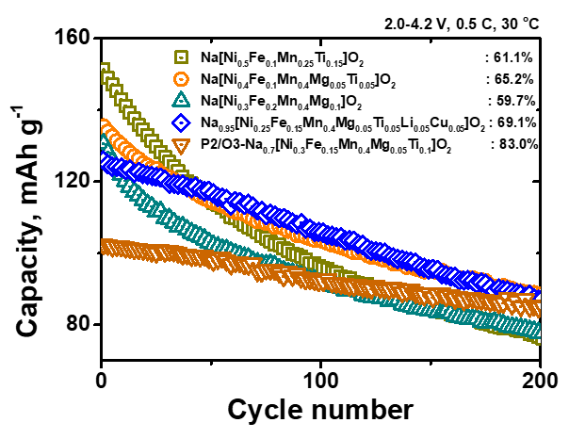
Supplementary Fig. 43 | Cycle performance of other Ni/Fe/Mn-based materials.

Supplementary Table 1 | The composition of NFM, NFMMT, NFMMT-Ca doped, and NFMMT/NaCaPO₄ determined by ICP optical emission spectroscopy.
Sample | Na | Ni | Fe | Mn | Mg | Ti | Ca | P | chemical formula
NFM | 0.98888 | 0.43410 | 0.14559 | 0.42032 | - | - | - | - | Na_{0.99}[Ni_{0.43}Fe_{0.15}Mn_{0.42}]O₂
NFMMT | 0.98406 | 0.41410 | 0.09092 | 0.40020 | 0.04509 | 0.04969 | - | - | Na_{0.98}[Ni_{0.41}Fe_{0.09}Mn_{0.40}Mg_{0.05}Ti_{0.05}]O₂
NFMMT-Ca doped | 0.95446 | 0.39932 | 0.09421 | 0.41418 | 0.04589 | 0.04640 | 0.00862 | - | [Na_{0.95}Ca_{0.01}][Ni_{0.41}Fe_{0.09}Mn_{0.40}Mg_{0.05}Ti_{0.05}]O₂
NFMMT/NaCaPO₄ | 0.96435 | 0.40643 | 0.09421 | 0.41003 | 0.04547 | 0.04387 | 0.03108 | 0.03245 | Na_{0.93}[Ni_{0.41}Fe_{0.09}Mn_{0.41}Mg_{0.05}Ti_{0.04}]O₂ / 3.2 mol% NaCaPO₄

Supplementary Table 2 | Lattice parameters of the prepared cathodes (NFM, NFMMT, NFMMT-Ca doped, and NFMMT/NaCaPO₄).
Sample |  | a, Å | c, Å | V, Å³ | R_{p}, % | R_{wp}, %
NFM |  | 2.96057 | 15.97073 | 121.229 | 1.96 | 2.61
NFMMT |  | 2.95915 | 15.98203 | 121.198 | 2.13 | 2.13
MFMMT-Ca doped |  | 2.96403 | 15.95496 | 121.392 | 2.04 | 2.85
NFMMT/NaCaPO₄ | O3 (98.6%) | 2.96721 | 16.00949 | 122.069 | 2.08 | 2.87
NFMMT/NaCaPO₄ | P2 (1.4%) | 2.86102 | 11.14674 | 79.017 | 2.15 | 2.96

Supplementary Table 3 | Comparison of electrochemical performance between NFMMT/NaCaPO₄ and other layered oxides.
Sample (voltage window) | Rate capability Capacity/current (mA h g^{–1}/mA g^{–1}) | Cycling stability Capacity/current/retention/cycles (mA h g^{–1}/mA g^{–1}/%/n) | Reference
Na[Ni_{0.5}Mn_{0.5}]O₂ (2–4 V) | 147.5/15 | 144.5/75/75.5/100 | ¹
Na[Ni_{0.4}Mn_{0.4}Co_{0.2}]O₂ (2–3.8 V) | - | 120/14.4/38.7/100 | ²
Na[Li_{1/9}Ni_{2/9}Fe_{2/9}Mn_{4/9}]O₂ (2–4.3 V) | 160/25  120/250  84.9/500 | 130/250/82.8/200 | ³
Na[(Ni_{1/3}Fe_{1/3}Mn_{1/3})_{0.99}Sc_{0.01}]O₂ (1.5–4.2 V) | 156.1/13  105/650  82.5/1300 | 130/130/91/50 | ⁴
Na[Mn_{1/3}Fe_{1/3-0.01}Ni_{1/3}Ho_{0.01}]O2 (1.5–4.3 V) | 170/18  140/90  110/360  80/900  55/1440 | 140/180/67.9/100 | ⁵
Na_{0.95}[Ni_{0.94}Mg_{0.051}]O₂ (1.8–4.2 V) | 146/7.5  123/15  95/75  82/150  68/300 | 95/75/76/100 | ⁶
Na_{0.9}[Mn_{0.5}Ni_{0.5}Cu_{0.1}]O_{2+x} (2–4 V) | 115/12  90/600  67/1200 | 112/120/82.5/280 | ⁷
Na_{0.9}Li_{0.1}Ni_{0.4}Fe_{0.2}Mn_{0.44}Ti_{0.04}Mg_{0.02}O_{1.9}F_{0.1} (2–4 V) | 110/9  100/30  83/300  80/450 | 95/75/90/200  110/75/70/130 | ⁸
Na[Cu_{1/9}Ni_{2/9}F_{1/3}Mn_{1/3}]O₂ (2–4 V) | - | 125/75/82/200 | ⁹
Na[Ni_{0.4}Fe_{0.2}Mn_{0.4}]O₂@Na_{3–3x}Al_{x}PO₄ (2–4 V) | 147/14  125.2/140  120.1/280  112.5/700 | 140/140/80/200 | ¹⁰
Na[Ni_{1/3}Fe_{1/3}Mn_{1/3}]O₂@Ni_{2.44}Ti_{0.77}O₄ (2–4.1 V) | 135/12  128/60  120/120  115/240  100/600 | 124/120/84.7/100 | ¹¹
Na[Mn_{1/3}Fe_{1/3}Ni_{1/3}]O₂@ZrO₂ (1.5–4.3 V) | 150/7.5  120/150  80/750  50/1500 | 130/150/81.9/100 | ¹²
Na[Ni_{1/3}Fe_{1/3}Mn_{1/3}]O₂@Co_{x}B (2–4 V) | 158.6/13  123/65  112/260  99.6/650 | 120/130/79.6/300 | ¹³
Na[Ni_{0.4}Cu_{0.1}Mn_{0.4}Ti_{0.1}]O₂@NaMgPO₄ (2.4–4.3 V) | 156/37.5  112/187.5  81/375  49/1875 | 145/120/70/300 | ¹⁴
Na[Ni_{0.5}Mn_{0.5}]O₂@Na_{2/3}MnO₂ (2–4 V) | 141.4/12.5  120/625  103.7/1875 | 139.9/125/85.3/150 | ¹⁵
Na_{0.8}[Ni_{0.3}Fe_{0.2}Mn_{0.3}Li_{0.1}Mg_{0.02}Ca_{0.05}Sb_{0.03}]O₂ (2–4.2 V) | 130/28  121/70  110/140  102/280  92/700 | 110/140/85/250 | ¹⁶
Na_{7/9}[Ni_{2/9}Mn_{4/9}Fe_{1/9}Mg_{1/9}Li_{1/9}]O₂ (2–4.4 V) | 1705/12.5  140/62.5  110/625  106.6/1250 | 145.3/62.5/84.4/120  139.8/125/80/100 | ¹⁷
Na_{0.76}[Ni_{0.33}Mn_{0.5}Fe_{0.1}Ti_{0.07}]O₂ (2.2–4.3 V) | 145/21  120/420  105/1050 | 140/42/81.5/100  105/1050/75.4/500 | ¹⁸
Na_{0.76}[Cu_{0.1}Co_{0.1}Ni_{0.25}Mn_{0.4}Ti_{0.15}]O₂ (2–4.5 V) | 142.9/12  122.5/120  114.4/240  99.2/600 | 101.1/120/85.6/200 | ¹⁹
Na_{0.75}[Ni_{0.33}Mn_{0.4}Cu_{0.1}Ti_{0.13}Sn_{0.05}]O₂ (2–4.5 V) | 150/10  100/150  88.7/750 | 108/100/71.6/300 | ²⁰
[Na_{0.75}Ca_{0.04}][Li_{0.1}Ni_{0.2}Mn_{0.67}]O₂ (2–4.3 V) | 133/10.7  102/214  80/1070  68.8/2140 | 136.9/10.7/94.2/50 | ²¹
Na_{0.72}[Ni_{0.20}Co_{0.21}Mn_{0.55}Mg_{0.036}]O₂ (2–4.3 V) | 107/36  90/540  80/900 | 100/36/89/150 | ²²
Na_{0.7}[Ni_{0.2}Fe_{0.25}Mn_{0.5}Zn_{0.05}]O₂ (2.4–4.5 V) | 122.8/12  114.5/60  110.7/120  97.6/600  86.5/1200 | 117.5/120/83.7/100 | ²³
Na_{2/3}[Fe_{2/9}Ni_{2/9}Mn_{5/9}]O₂ (2.6–4.3 V) | 141/16  105/160  63/800 | 130.9/80/78/100 | ²⁴
Na_{2/3}[Ni_{0.25}Mg_{0.083}Mn_{0.55}Ti_{0.117}]O₂ (3–4.4 V) | 95.9/170  84/340 | 103/170/87/200 | ²⁵
Na_{0.56}[Ni_{0.1}Mn_{0.81}□_{0.09}]O₂ (2.2–4.5 V) | 134.8/26  122.1/650 | 120/260/80.8/100 | ²⁶
Na_{0.7}[Fe_{0.1}Mn_{0.75}□_{0.15}]O₂ (2–4.5 V) | 125/20  90/100  70/500 | 115/100/76/200 | ²⁷
Na[MnTi_{0.1}Ni_{0.1}]O₂ (1.5–4.5 V) | 180/20  139/200  118/1000 | 145/100/85/100 | ²⁸
NFMMT/NaCaPO₄ (2–4 V) | 143.8/15  136.2/75  130.5/150  124.0/300  119.2/750  105.3/1500 | 137.3/75/81/300  130.1/150/73.3/500  107.5/750/42.1/2000 | This work

Supplementary References
1. Yu, T.-Y., Ryu, H.-H., Han, G. & Sun, Y.-K. Understanding the capacity fading nechanisms of O3-type Na[Ni_{0.5}Mn_{0.5}]O₂ cathode for sodium-ion batteries. Adv. Energy Mater. 10, 2001609 (2020).
2. Xu, G. L. et al. Native lattice strain induced structural earthquake in sodium layered oxide cathodes. Nat. Commun. 13, 436 (2022).
3. Guo, Y.-J. et al. Boron-doped sodium layered oxide for reversible oxygen redox reaction in Na-ion battery cathodes. Nat. Commun. 12, 5267 (2021).
4. Hong, N. et al. Regulating phase transition and restraining Fe distortion at high potential window via rare earth metal incorporation on O3‐type layered cathodes. Adv. Funct. Mater. 34, 2402398 (2024).
5. Yu, Y. et al. Triggering reversible anion redox chemistry in O3-type cathode through tuning Na/Mn anti-site defects. Energy Environ. Sci. 16, 584-597 (2023).
6. Sada, K., Kmiec, S. & Manthiram, A. Mitigating sodium ordering for enhanced solid solution behavior in layered NaNiO₂ cathodes. Angew. Chem., Int. Ed. 136, e202403865 (2024).
7. Li, M. et al. Tailoring Cu-rich surface spinel phase for high-performance O3-type layered cathode naterials for sodium-ion batteries. Nano Energy 123, 109375 (2024).
8. Joshi, A. et al. High-entropy Co-free O3-type layered oxyfluoride: A promising air-stable cathode for sodium-ion batteries. Adv. Mater. 35, 2304440 (2023).
9. Li, Y. et al. Interfacial engineering to achieve an energy density of over 200 Wh kg⁻¹ in sodium batteries. Nat. Energy 7, 511-519 (2022).
10. Wang, H. et al. In situ plastic-crystal-coated cathode toward high-performance Na-ion batteries. ACS Energy Lett. 8, 1434-1444 (2023).
11. Gao, X. et al. Post-substitution modulated robust sodium layered oxides. Small Methods 7, 2300635 (2023).
12. Yu, Y. et al. Revealing the anionic redox chemistry in O3-type layered oxide cathode for sodium-ion batteries. Energy Storage Mater. 38, 130-140 (2021).
13. Feng, S. et al. Surface engineering through in situ construction of Co_{x}B-spinel dual coating layers for high-voltage stable sodium-ion batteries. Adv. Energy Mater. 14, 2303773 (2024).
14. Xu, W. et al. Conversion of surface residual alkali to solid electrolyte to enable Na-ion full cells with robust interfaces. Adv. Mater. 35, 2301314 (2023).
15. Liang, X., Yu, T.-Y., Ryu, H.-H. & Sun, Y.-K. Hierarchical O3/P2 heterostructured cathode materials for advanced sodium-ion batteries. Energy Storage Mater. 47, 515-525 (2022).
16. Zhang, K. et al. Regulating phase transition and oxygen redox to achieve stable high-voltage O3-type cathode materials for sodium-ion batteries. Adv. Energy Mater. 13, 2302793 (2023).
17. Liang, X. & Sun, Y.-K. A novel pentanary metal oxide cathode with P2/O3 biphasic structure for high-performance sodium-ion batteries. Adv. Funct. Mater. 32, 2206154 (2022).
18. Cheng, Z. et al. A rational biphasic tailoring strategy enabling high-eerformance layered cathodes for sodium-ion batteries. Angew. Chem., Int. Ed. 61, 202117728 (2022).
19. Liu, R. et al. Revealing the nature of binary-phase on structural stability of sodium layered oxide cathodes. Adv. Mater. 36, 2401048 (2024).
20. Li, R. et al. High-entropy and multiphase cathode materials for sodium-ion batteries. Adv. Energy Mater. 14, 2400127 (2024).
21. Jin, J. et al. Unveiling the complementary manganese and oxygen redox chemistry for stabilizing the sodium‐ion storage behaviors of layered oxide cathodes. Adv. Funct. Mater. 32, 2203424 (2022).
22. Jiang, N. et al. Surface gradient desodiation chemistry in layered oxide cathode materials. Angew. Chem., Int. Ed. 63, e202410080 (2024).
23. Wang, H. et al. Manipulating local chemistry and coherent structures for high-rate and long-life sodium-ion battery cathodes. ACS Nano 18, 13150–13163 (2024).
24. Zhang, Y. et al. Revisiting the Na_{2/3}Ni_{1/3}Mn_{2/3}O₂ cathode: oxygen redox chemistry and oxygen release suppression. ACS Cent. Sci. 6, 232-240 (2020).
25. Huang, Y. et al. Vitalization of P2–Na_{2/3}Ni_{1/3}Mn_{2/3}O₂ at high-voltage cyclability via combined structural modulation for sodium-ion batteries. Energy Storage Mater. 29, 182-189 (2020).
26. Lee, S. Y. et al. Enhanced fast-discharging performance and cyclability in oxygen-redox-based P3-type Na-layered cathode via vacancies in TM layers. Adv. Energy Mater., 2402412 (2024).
27. Tang, Y. et al. Sustainable layered cathode with suppressed phase transition for long-life sodium-ion batteries. Nat. Sustain. 7, 348-359 (2024).
28. Guo, S., Li, Q., Liu, P., Chen, M. & Zhou, H. Environmentally stable interface of layered oxide cathodes for sodium-ion batteries. Nat. Commun. 8, 135 (2017).

