Supplementary

Recombinant human collagen hydrogels with different stem cell-derived exosomes encapsulation for wound treatment
Xiaoman Zeng^{1,2}, Jingjing Gan², Danqing Huang², Yuanjin Zhao*^{2,3}, Lingyun Sun*^{1,2}

1 School of Medicine, Southeast University, Nanjing, China
2 Department of Rheumatology and Immunology, Institute of Translational Medicine, Nanjing Drum Tower Hospital, Medical School, Nanjing University, Nanjing, 210002, China
3 State Key Laboratory of Bioelectronics, School of Biological Science and Medical Engineering, Southeast University, Nanjing 210096,China
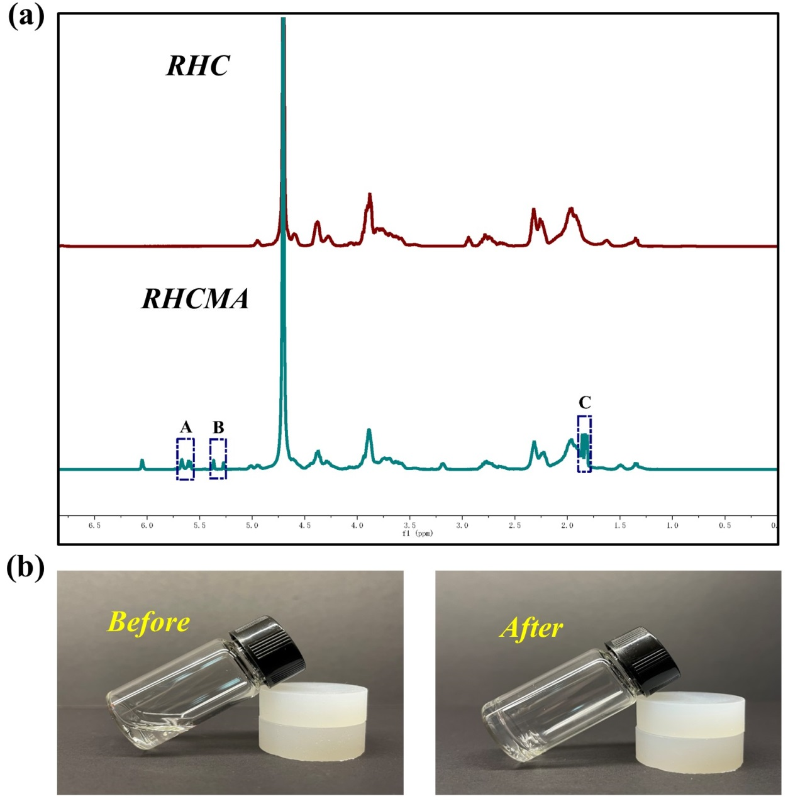
Figure S1. (a) ¹H-NMR spectra of recombinant human collagen (RHC) and methacrylate anhydrate modified RHC (RHCMA). The methyl signal of methacrylate at (C) 1.8 ppm and signals of olefinic protons from methacrylate at (B) 5.4 and (A) 5.6 ppm demonstrated the synthesis of RHCMA. (b) The macroscopic images of the RHCMA before and after gelation.

Figure S2. The CCK-8 assay demonstrated the cell viability of 3T3 cells cultured on the RHCMA hydrogel surface for 48 h.

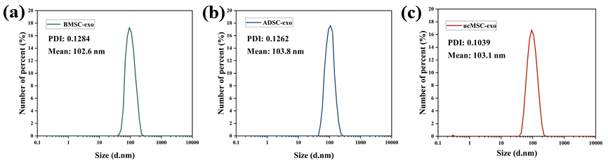
Figure S3. The particle size distribution of BMSC-exo, ADSC-exo and ucMSC-exo detected by the DLS.

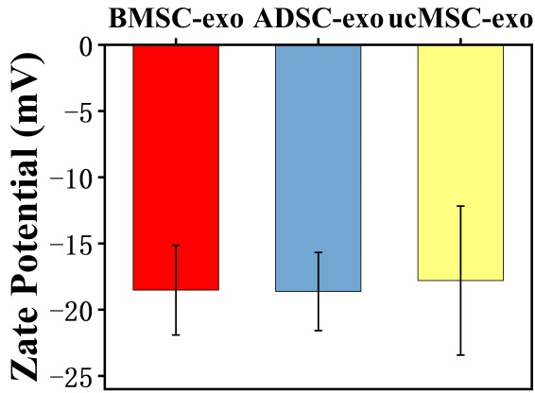
Figure S4. The zeta potential of BMSC-exo, ADSC-exo and ucMSC-exo measured by the DLS.
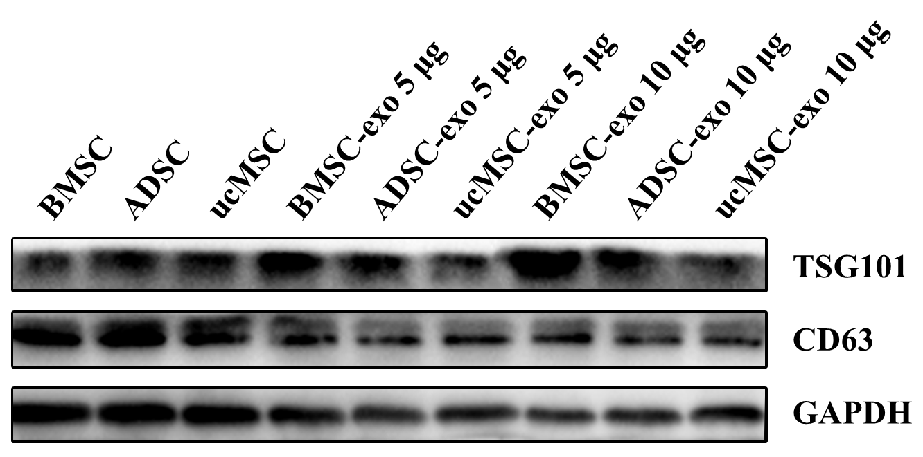
Figure S5. Analysis of the presence of TSG101 and CD63 in BMSC-exo, ADSC-exo and ucMSC-exo using Western blotting.

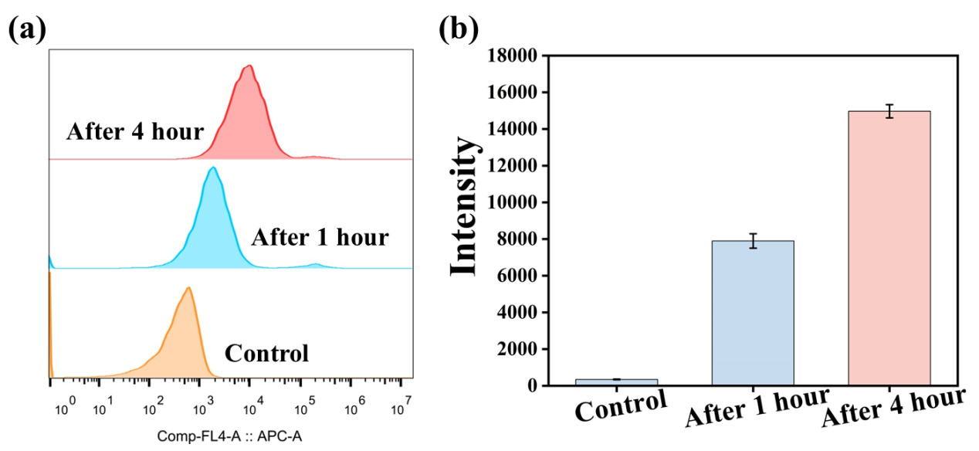 Figure S6. (a) HUVECs were incubated with 20μg/mL DID&MSC-exos or untreated (PBS) for 1 h and 4h. (b) Cellular uptake result was measured Flow cytometry.

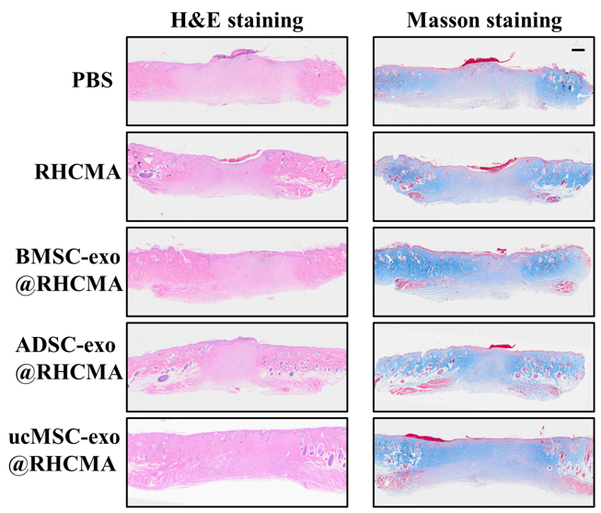
Figure S7. Representative images of H&E staining and Masson staining were presented at low (×5) magnification. Scale bar: 200 μm.

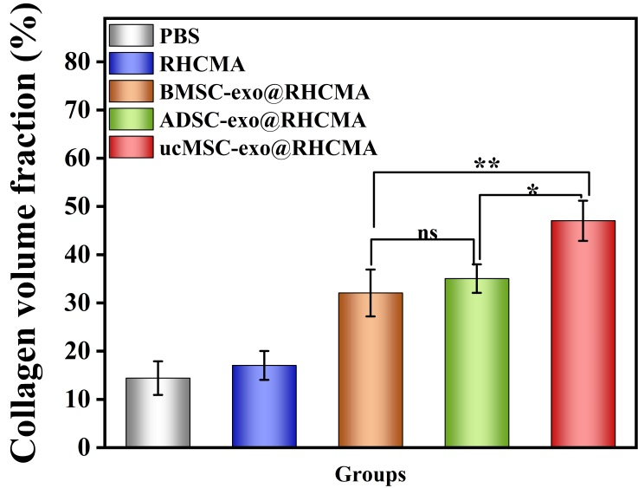
Figure S8. Quantitative analysis of collagen volume fraction in wounds with different treatments.

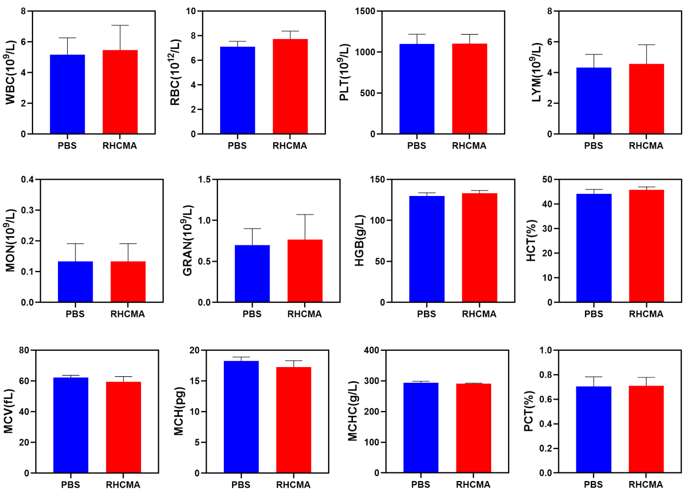
Figure S9. Blood biochemistry analysis of rats after treatment with or without RHCMA for 9 days with examined parameters including white blood cell (WBC) count, red blood cell (RBC) count, platelets (PLT), lymphocyte (LYM), monocyte (MON), neutrophile granulocyte (GRAN), hemoglobin (HGB), hematocrit (HCT), mean corpuscular volume (MCV), mean corpuscular hemoglobin (MCH), mean corpuscular hemoglobin concentration (MCHC), and plateletcrit (PCT).

Figure S10. H&E staining results of major organs including heart, liver, spleen, lung, and kidney .Scale bar: 200 μm.

