Table 1. Main scanning sequences and corresponding parameters
Abbreviations: IVIM, intravoxel incoherent motion; TR, repetition time; TE, echo time; T2w SSFSE, T2-weighted half-Fourier acquisition single-shot turbo/fast spin-echo.

Table 2. Demographic and clinical characteristics
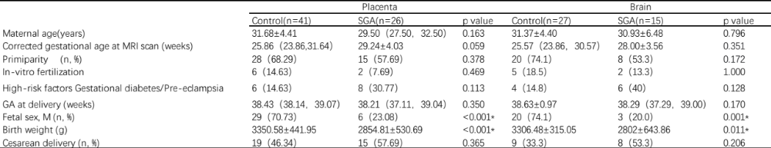

Table 3. Inter- and intra-observer ICC values for measurements of IVIM and T2* parameters
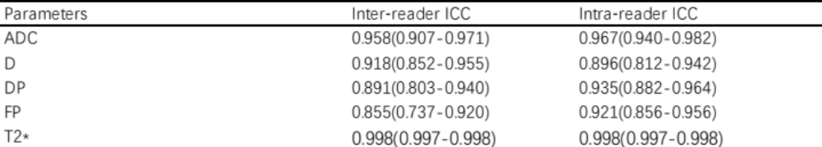
Abbreviations: ADC, apparent diffusion coefficient; D, tissue diffusivity; DP, perfusion diffusivity; FP, perfusion fraction; ICC, intra-class correlation coefficient.
Values in parentheses are 95% confidence intervals.

Table 4. Comparison of placental functional parameters between control and SGA groups
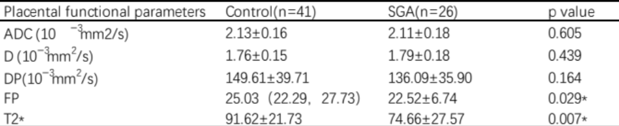

Table 5. Cortical thicknesses of various brain regions in control and SGA groups
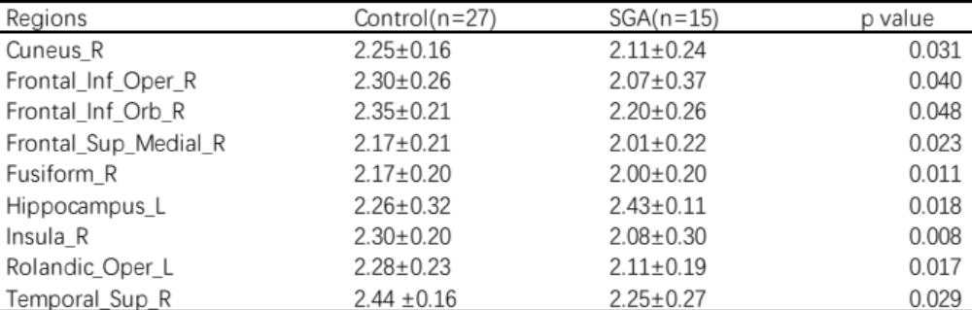
Abbreviations: Frontal_Inf_Oper, inferior frontal gyrus, opercular part; Frontal_Inf_Orb, inferior frontal gyrus, orbital part; Frontal_Sup_Medial, superior frontal gyrus, medial; Rolandic_Oper, Rolandic operculum; Temporal_Sup, superior temporal gyrus.

