Supplementary information
Fig S1: Net CO2 forest flux in 2050 under a baseline scenario
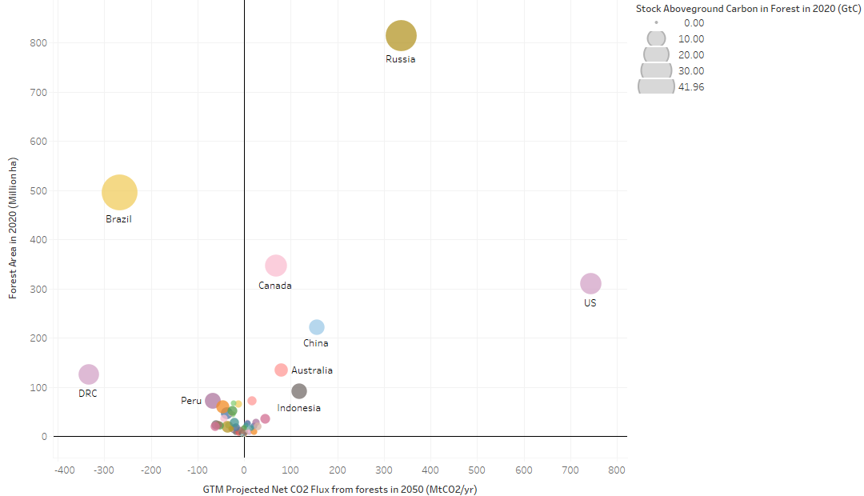
Notes: Negative values = Net CO₂ emissions from forests in 2050; Positive values = Net CO₂ sequestration from forests in 2050

Fig S2. Forest CO2 net mitigation by (A) dominant forest type and (B) activity
- (B)
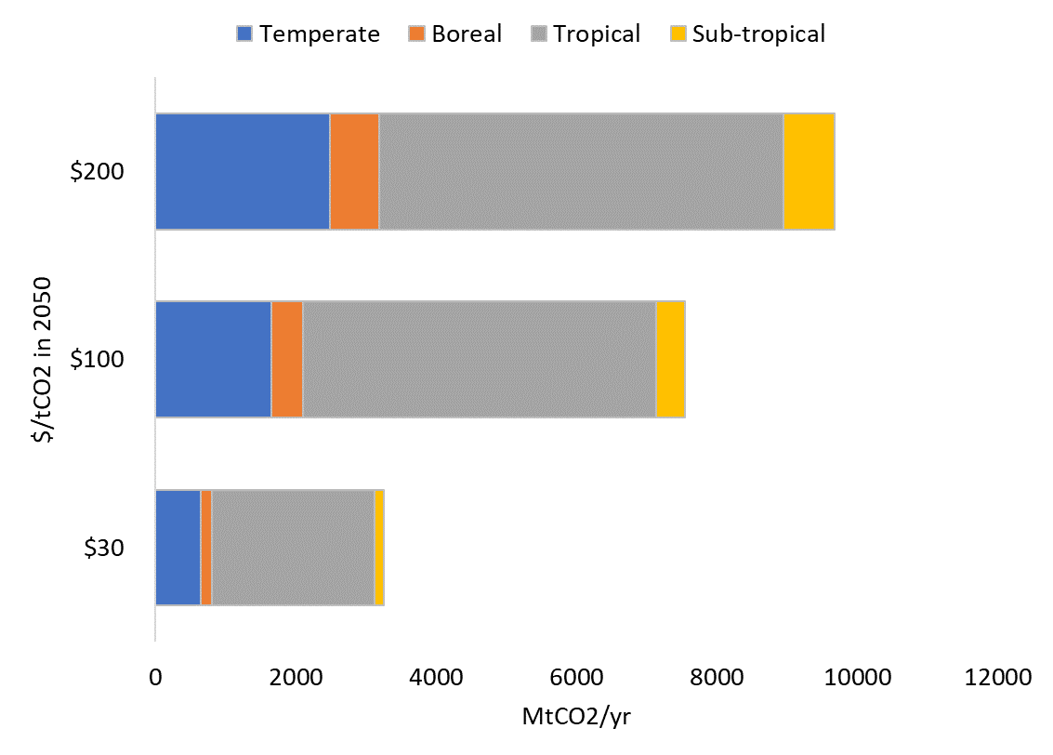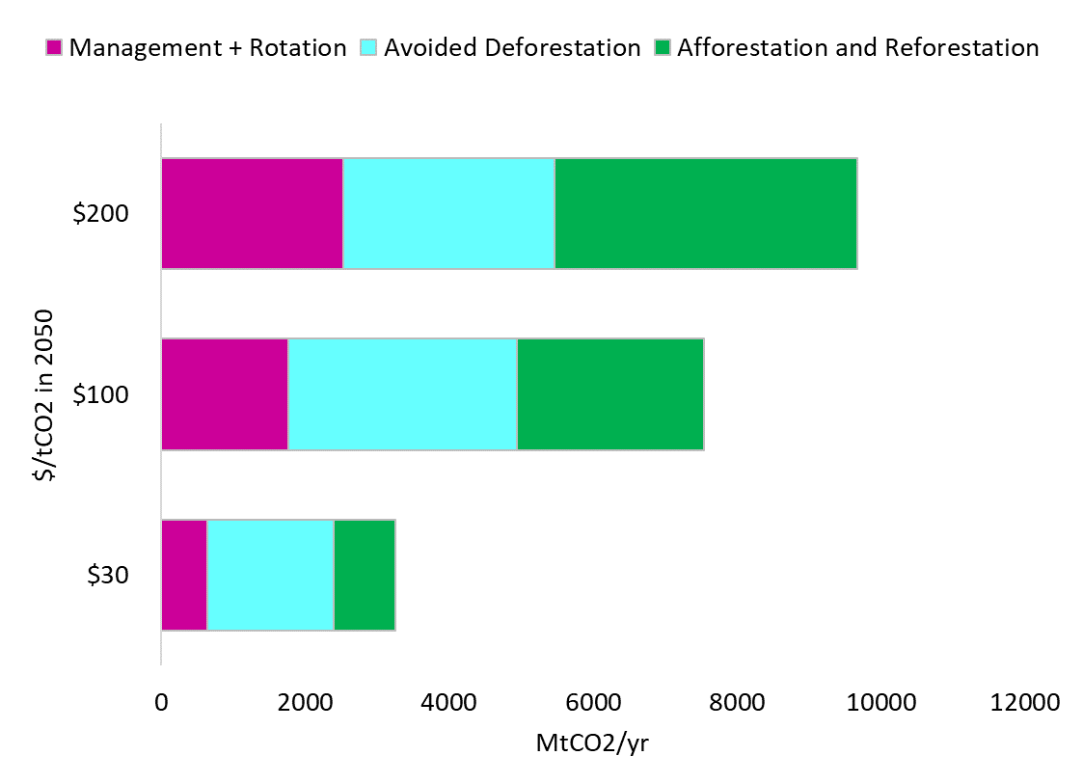

Fig S3: 2050 Global Forest MACCs under two land scenarios
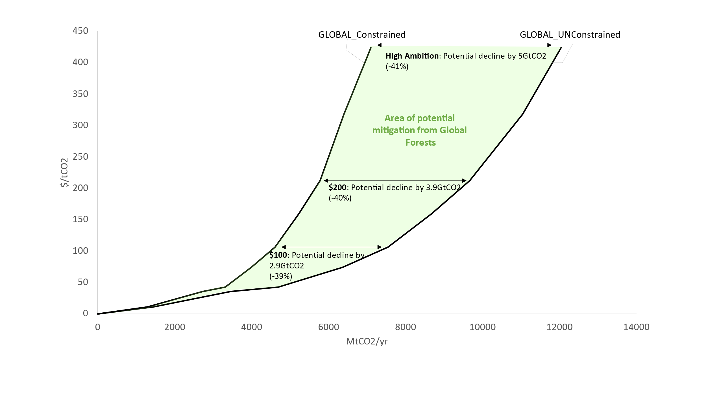 Table S1: Key assumptions and projections for forest land and forest net flux under the Constrained Scenario

