Supplementary Data

Mechanism and prevention of ginseng fibrous root biomass-induced soil fungal deterioration
Si-Heng Zhu ^{1, 2, #}, Yu-Ting Li ^{3, #}, Bate Baoyin⁴, Ming-Xiao Zhang^{1, 2}, Lianxue Zhang ², Yu Li ^{1,} *, and Shengyuan Xiao ^{1,2,} *

Supplementary method information

1. Cultivation media preparation
Komada agar medium: Sodium tetraborate (Na₂B₄O₇) 1g, K₂HPO₄ 1g, KCl 0.5g, MgSO₄ 0.5g, EDTA iron (III) sodium salt (C₁₀H₁₂FeN₂NaO₈) 0.01g, D-galactose 20g, L-asparagine 2.0g, pentachloronitrobenzene 1.0g, and bile salt 0.5g was dissolved in 1 L pure water; then 15.0g agar was added into the water and melt the agar in a 90 ℃ water bath. The pH value of the suspension was adjusted to 4.0 with 10% hydrogen chloride after cooling to 50 ℃. Then, 0.3g streptomycin sulfate was added into the suspension and well dissolved. Finally, each 20 mL suspension was dispensed in a 9-cm plate. This medium was selective for Fusarium, Trichoderma, Aspergillus, Rhizopus, and Penicillium ⁵⁸.
CMC agar medium: MgSO₄ 0.5g, NH₄NO₃ 1.0g, KH₂PO₄ 1.0g, Yeast powder 1.0g, carboxymethylcellulose 1.0g, and 15.0g agar; all these ingredients were suspended in 1L pure water and sterilized at 121 ℃ for 20 min. Each 20 mL aliquot of the suspension was dispensed in a 9-cm plate after being cooled to 50 ℃. This medium is productive for F. oxysporum microconidia.
VBC agar medium: KNO₃ 1.0g, KH₂PO₄ 1.0g, sucrose 0.5g, vitamin C 0.1g, and one table of Compound Vitamin B table (Containing VB₁ 0.3mg, VB₂ 1.5 mg, VB₆ 0.2 mg, nicotinamide 10 mg, and calcium pantothenate 1 mg) and 20.0 g agar were added into 1 L pure water. The suspension was sterilized at 121 ℃ for 20 min. Finally, each 20 mL suspension was dispensed in a 9-cm plate after being cooled to 50 ℃. This medium is productive for F. oxysporum macroconidia.
PDA agar medium: Take 200g of potato and wash to remove the foreign matter. Then, peel off the skin and dice them. Add all the pieces into 1L of pure water and boil the water for 30 min. The extract was collected through a muslin cloth. The mixture was sterilized at 121 ℃ for 20 min after the extract volume was adjusted to 1L with pure water. Then, the medium was cooled to 50 ℃ in a water bath, and 0.3g streptomycin sulfate was added into the medium and well dissolved. Finally, each 20 mL suspension was dispensed in a 9-cm plate and cooled under ambient temperature.
2. Mobile phase for ginsenosides Ro, Re, Rb1, and Rb3 preparation
Semi-preparing chromatography isolation was performed via a C18 column (Agilent, US, 10 × 250 mm id). The chromatographic equipment (1100 series, Agilent, US) consists of a quaternary pump, a manual sampler, and a variable wave length detector. The mobile phase consists of pure water (A) and acetonitrile (B). The flow rate was 3 mL/min; and the injection volume was 500 μL. the detection wave length is 210 nm.
Gradient for Ro and Re isolation
The initial mobile phase was 5% B; then a linear gradient of 5%–18% B for 0–2 min, 18%–22% B for 2–8 min, and 22%–25% B for 8–17 min, 25-95% B for 17-25 min; this ratio was kept for 10 min for column recycle and then returned to the initial condition for 10 min.
Gradient for Rb1 and Rb3 isolation
The initial mobile phase was 5% B; then a linear gradient of 5%–28% B for 0–2 min, 28%–30% B for 2–10 min, and 30%–60% B for 10–18 min, 25-95% B for 18-25 min; this composition was maintained for 10 min and then returned to the initial condition for 10 min.

Fig. S1. Ginseng seedlings growing in fibrous ginseng root biomass (GFR) added soils
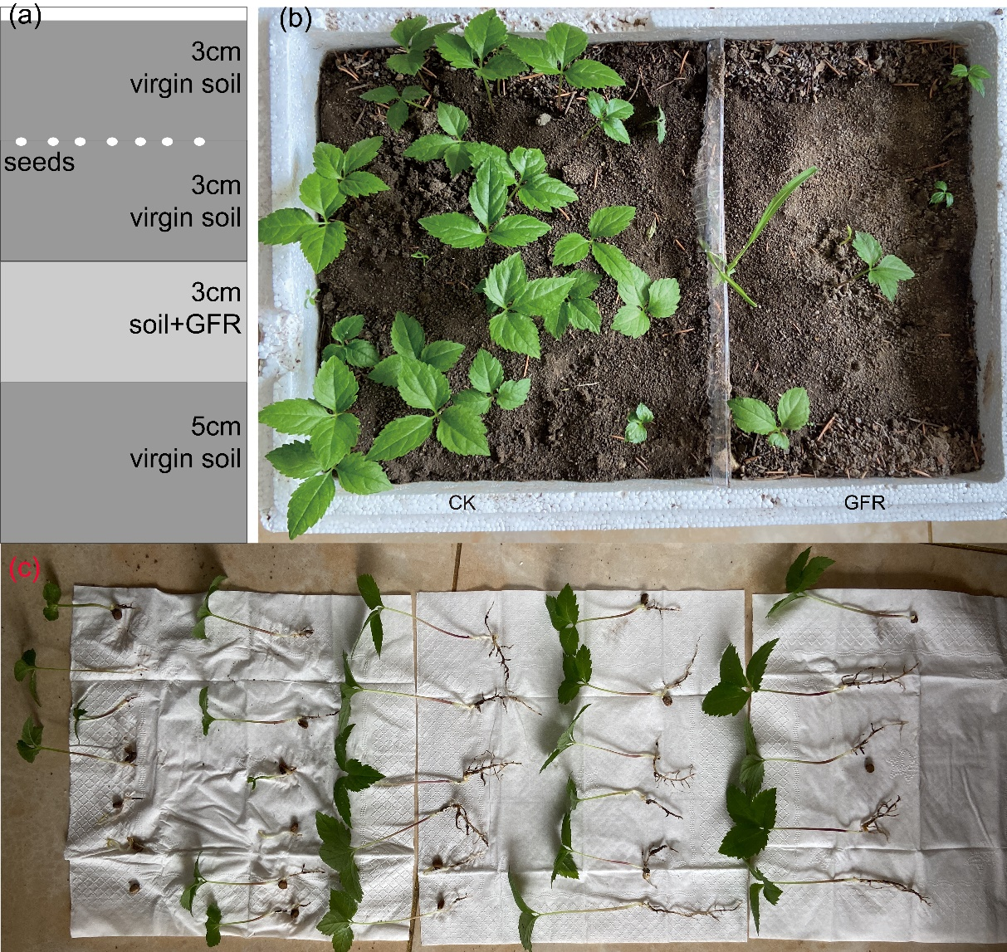
To reduce the toxicity of fibrous ginseng root biomass (GFR) to the seeds and successively grow seedlings resulting from direct contact, we planted the stratified ginseng seeds in the soils, as illustrated in (a). The seeds were separated from GFR using a 3 cm layer of virgin soil. Virgin soils were filled on the other side of the box for control (CK). A 300 × 10 cm plastic plate separated the virgin soils from GFR-added soils (b). The seedlings were analyzed in 30 days post planting (b). (c) displays all the seeds and dead seeds in the virgin soils.

Fig. S2. Fungal community in biomass-treated sands
I, Species accumulation curve; II, Chao1 index; III, Observed species index; IV, PD whole tree index; V, Shanno index; VI, Simpson index; VII, sample scores of a Principal coordinate analysis on weighted Unifrac Distances; VIII, weighted Unifrac Distances heatmap; IX, Top species in different fungal communities. Biomass of alfalfa (B), fibrous ginseng root (GFR) biomass (C), and heat-denatured GFR (D) were added to virgin sands and incubated for 28 days. Virgin sands were incubated under the same conditions for control. The fungi in the sands were tested using ITS rDNA sequencing. All treatments were triplicated.

Fig. S3. Fungal community diversity analyses of fibrous ginseng root and alfalfa biomass-amended soils from the lands where maize and soybean have previously growing
The soils were treated using the same method as Fig. S2. Cor and Soy are the soils collected from the lands with maize and soybean previously growing. CorG and SoyG represent the soils with fibrous ginseng root biomass added. CorA and SoyA are the soils with alfalfa biomass added. Each treatment was triplicate.

Fig. S4. Selective fungal filtrating by the biomasses in the soils from the lands with maize and soybean previously growing
(a) Fungi in the soils collected from the land with maize previously growing (Cor) and those with GFR (CorG) or alfalfa (CorA). (b) plots the fungi in the soils from the land, which was previously grown soybean (Soy) and the soils after GFR (SoyG) and alfalfa (SoyA) biomass-adding. All the soils were incubated for 28 days, and the fungi were tested using ITS rDNA sequencing.

Fig. S5. Ginseng root growth and scars and stubs forming process
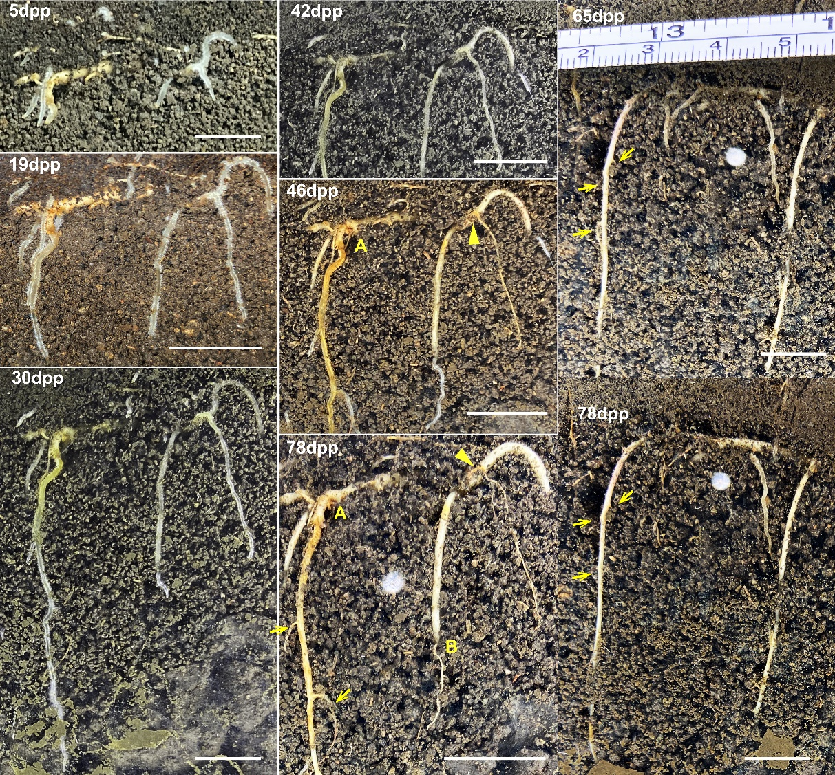
The number in each penal indicates the day after planting (dpp). Fine roots are generated five days after planting. A decomposed root was observed on the 30th day with its cortex left on its parent root. A denotes a scar located at the base of a fine root. B indicates a stub formed precisely at the root base. The solid arrows indicate that the scars are not located precisely at the base of the root bases. Open arrows indicate the process of stub development. A fine root generally does not die from its base (open arrows) and finally leaves a stub on its parent root. Scales in all panels represent 10 mm.

Fig. S6. Co-cultures of Fusarium oxysporum and the antagonists
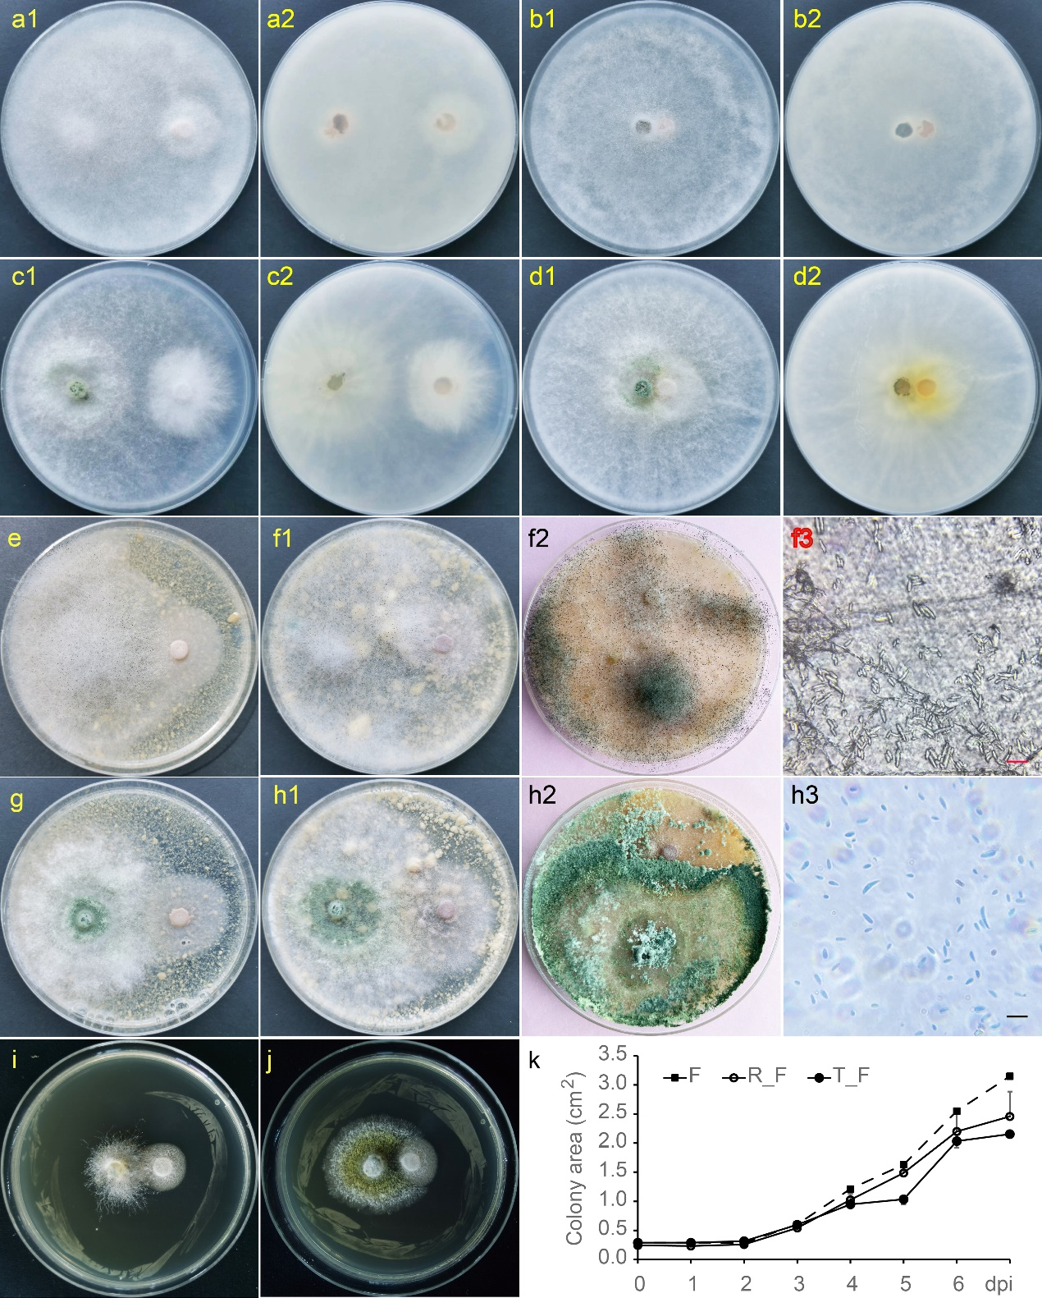
(a) and (b) display the coculture of Rhizopus arrhizus (RA, Left) against Fusarium oxysporum (FO, Right) in PDA (a1 and b1, top view, and a2and b2, bottom view) (c) and (d) display the coculture of Trichoderma harzianum (TH, Left) against FO (Right) in PDA media similarly. (e), Coculture of RA (Left) and FO (Right) in a modified Komada medium with fibrous ginseng root biomass as the sole carbon source. (f1), Coculture of RA (Left) and FO (Right) in a modified Komada medium with the ethanol-insoluble residue fibrous ginseng root as the sole carbon source. (f2) is the latter stage of a coculture of RA (Left) and FO (Right) in the residue-modified Komada medium. (f3) Conidia of FO observed under the colonies of RA in the culture. (g), Coculture of TH (Left) and FO (Right) in a modified Komada medium with fibrous ginseng root biomass as the sole carbon source. (h1), Coculture of TH (Left) and FO (Right) in a modified Komada medium with the ethanol-insoluble residue fibrous ginseng root as the sole carbon source. (h2) is the latter stage of a coculture of TH (Left) and FO (Right) in the residue-modified Komada medium. (h3) displayed the conidia of FO observed in the lysate located on the surface of the medium. (i) and (j) are the cocultures of RA and TH with FO in Komada media. (k) plots the growth curves of FO in its cocultures with RA and TH before their colonies are closely contacted. The scale bars denote 10 μm in (f3) and (h3).

Fig. S7. Fusarium Colony-forming Unit resting
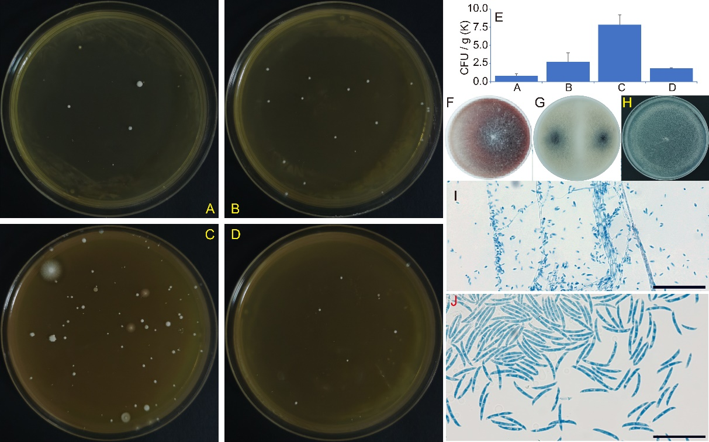
The abundance of Fusarium in the sands was tested using conventional colony formation units (CFU) to validate the results from ITS rDNA sequencing. Soil suspensions were incubated in Fusarium selective Komada media. The photos display the colonies grown on the 7-day post-incubation of 100 times diluted soil suspensions of virgin sand (A), alfalfa mixed sand (B), fibrous ginseng root biomass-mixed sand (C), and heat-denatured fibrous ginseng root biomass-amended sand (D). The average Fusarium CFUs in different sand is presented as ‾x ± SD (E, n=2). The results are consistent with the relative abundance from ITS rDNA sequencing. The dominant fungus in the Komada media cultivated colonies are identified as F. oxysporum according to its colony (F to H), micro- (I), macroconidia (J), and ITS rDNA sequence. F to H displays the colonies of F. oxysporum grown in potato dextrose (PDA), carboxymethyl cellulose (CMC), and Vitamin BC (VBC) agar media. The bars in panels I and J represent 10 μm.

Fig. S8. Fusarium oxysporum grown in low concentration of ginsenoside-spiked Komada media
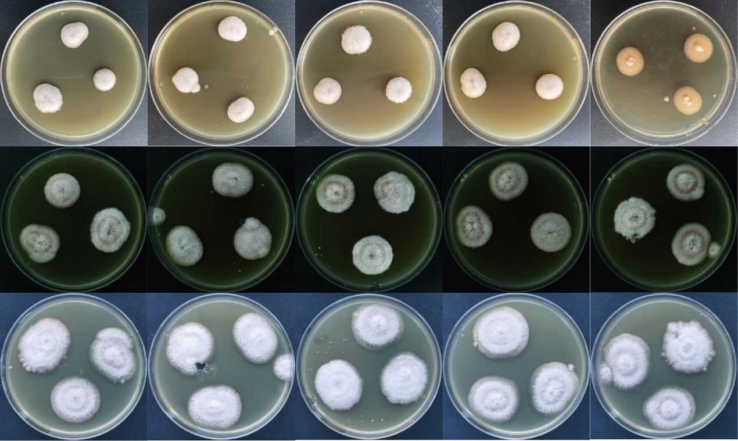
The cultures from left to right are Komada medium, Ginsenoside Rb1, Rb3, Re, and Ro spiked Komada (20 μg/ml), respectively. Photos from up to down display the colonies of F. oxysporum grown 6-, 11-, and 17 days post-inoculation.

Fig. S9. Fusarium oxysporum grown in high concentration of ginsenoside-spiked Komada media
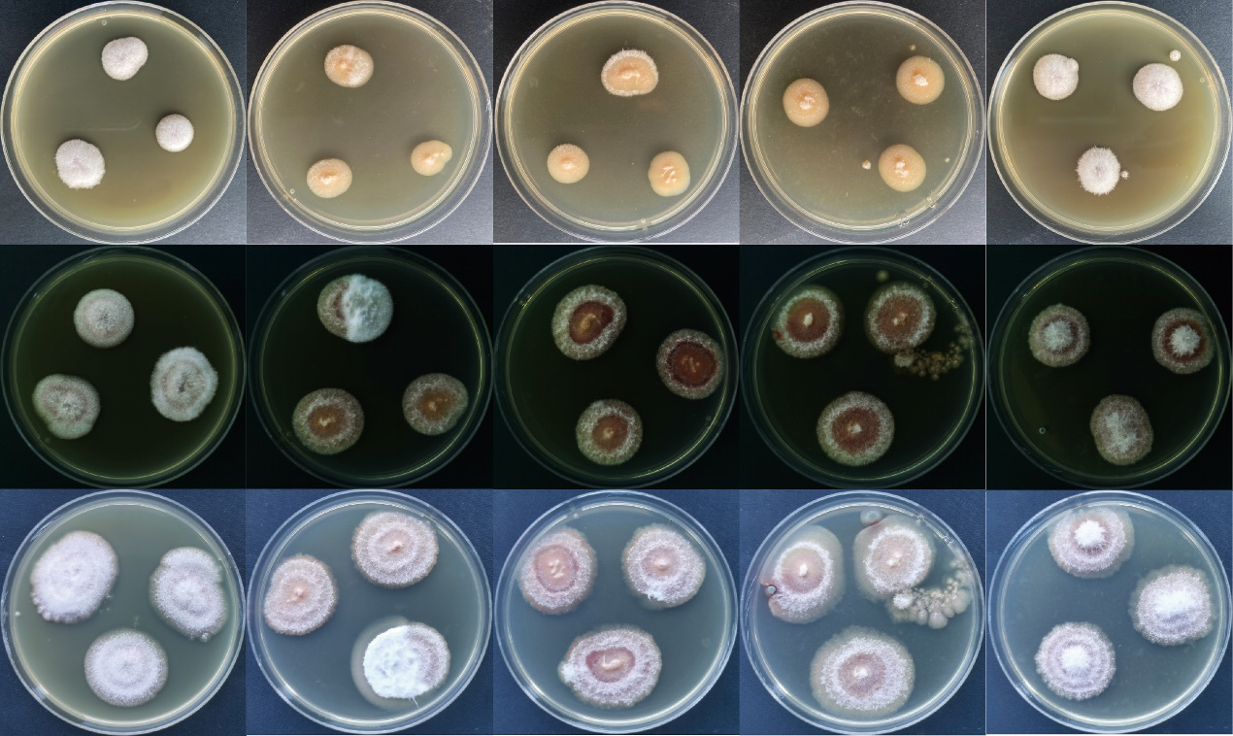
The cultures from left to right are Komada medium, Ginsenoside Rb1, Rb3, Re, and Ro spiked Komada (200 μg/ml), respectively. From up to down displayed the colonies of F. oxysporum on the 6-, 11-, and 17-days post-inoculation.

Fig. S10. Fusarium oxysporum grown in fibrous ginseng root extract-spiked PDA media
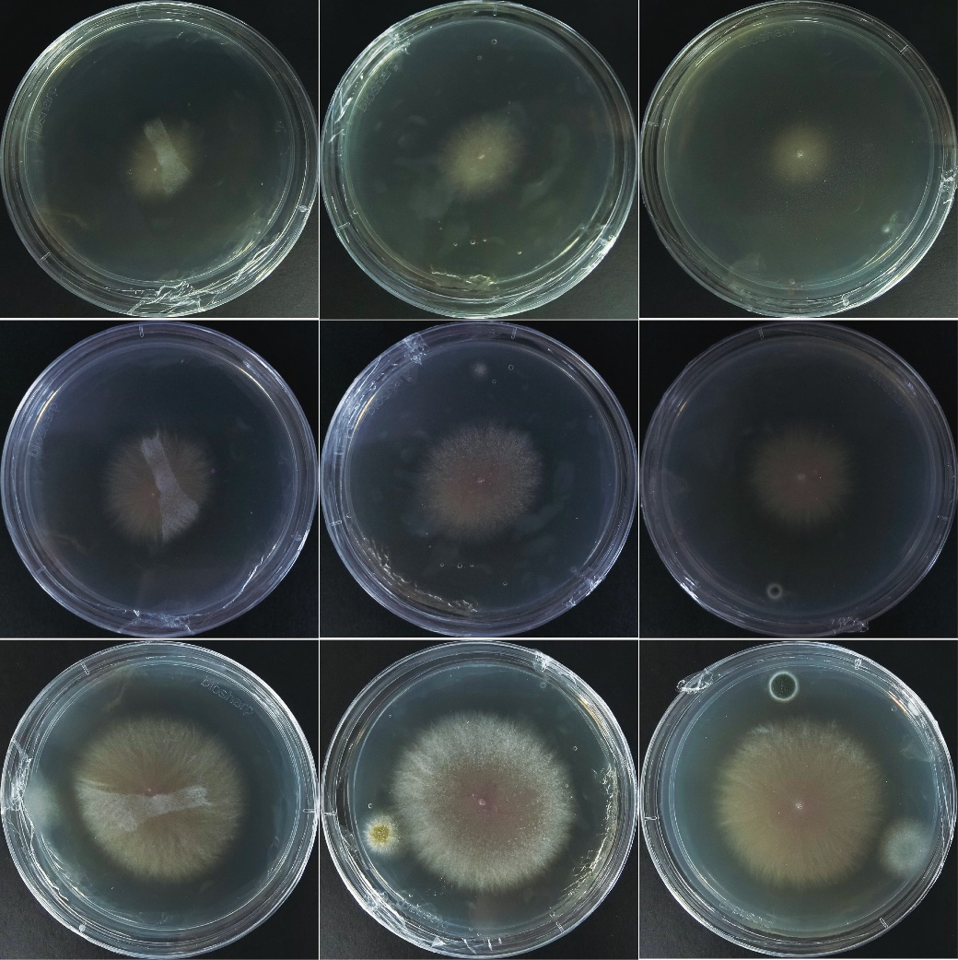
Fusarium oxysporum colonies in PDA (left), hydrophilic (middle), and hydrophobic (right) fibrous ginseng root extracts spiked PDA media on 3-, 4-, and 5-days post inoculation (up to down).

Fig. S11. Cultivations of soilborne fungi in different ingredients of fibrous ginseng roots
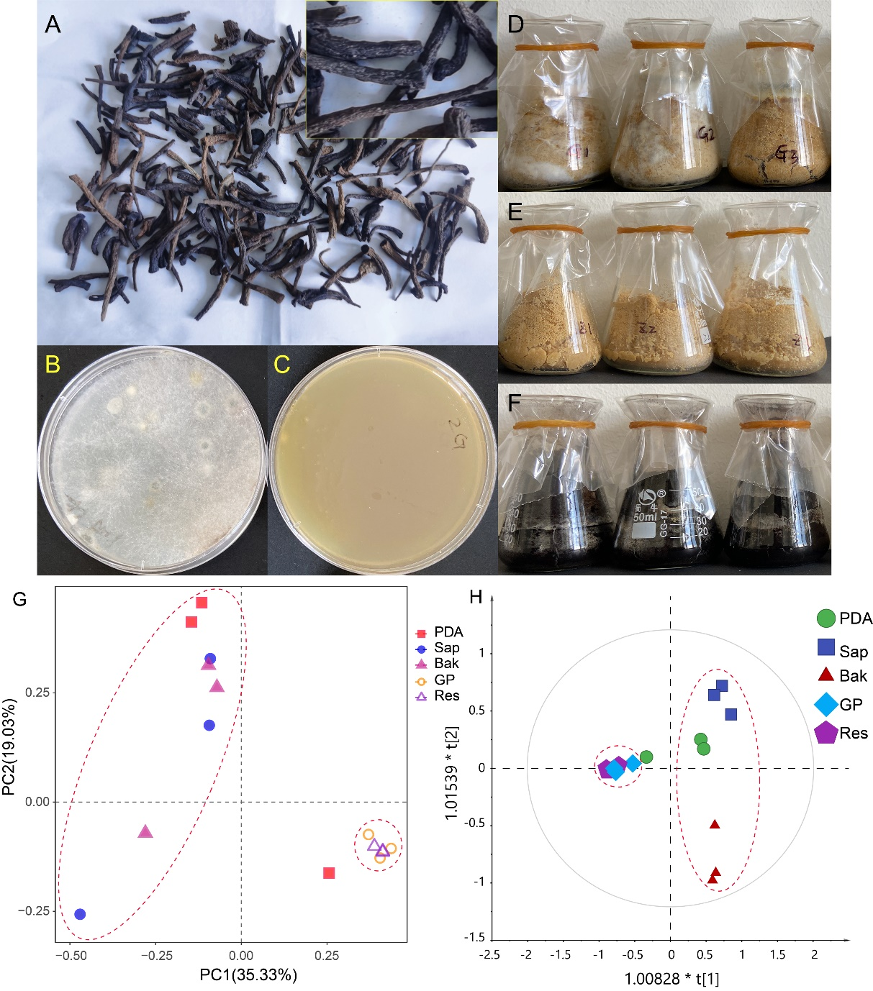
A, Heat-denatured fibrous ginseng roots; B, Culture of soil suspension in PDA agar medium; C, Culture of soil suspension in ginsenoside extract spiked PDA agar medium (Sap, equal to 1g root/ml medium); C, D, and E display the cultures of soil suspension in solid media of fibrous ginseng root (GP), its ethanol-insoluble residue (Res), and denatured biomass (Bak). G, Sample scores of a principal coordinate analysis of the fungal communities in different media. H, Sample scores of an orthogonal partial least square discriminate analysis of the fungal communities in different media.

