Supplementary material

Semaphorin-4D Signaling in Recruiting Dental Stem Cells for Vascular Stabilization

Lili Zhang^{1,2}, Dineshi Sewvandi Thalakiriyawa¹, Jiawei Liu¹, Shengyan Yang¹, Yan Wang², Waruna Lakmal Dissanayaka¹*

¹ Applied Oral Sciences and Community Dental Care, Faculty of Dentistry, The University of Hong Kong, Hong Kong
² Hospital of Stomatology, Guanghua School of Stomatology, Guangdong Provincial Key Laboratory of Stomatology, Sun Yat-sen University, Guangzhou, Guangdong, 510055, China.

* Corresponding author: Waruna Lakmal Dissanayaka, Assistant Professor, Faculty of Dentistry, Prince Philip Dental Hospital, 34 Hospital Road, Sai Ying Pun, Hong Kong, Email: warunad@hku.hk, Phone: 85228590484

Table of contents
Figure S1. The supplement IF photos for Figure 1C&D.
Figure S2. Isotype control for immunofluorescence staining.
Figure S3. The supplement IF photos for Figure 3C&D
Figure S4. A: qRT-PCR results for Sema4D treated HUVECs at different time points. B: The METTL3 knockdown was confirmed by western blotting and qRT-PCR.
Figure S5. Schematic diagram of the vasculature-on-a-chip microfluidic assay.
Figure S6: Schematic diagram of the proposed role of M2c macrophage-Sema4D-Plexin-B1-METTL3-PDGF signaling axis in vascular stabilization.
Table S1. The allocation of mice for in vivo Matrigel plug angiogenesis assay
Table S2. The sequences of relative primers

Figure S1. The supplement IF photos for Figure 1C&D. A&B: Representative images of IF stained sections for CD31 and SM22α at day 7 and day 14. The arrows show that SM22α⁺SHED is lining the abluminal surface of endothelial vessels formed by CD31⁺HUVECs. Scale bar = 50 μm.

Figure S2. Isotype control for immunofluorescence staining. M mAb isotype control for mouse monoclonal anti-CD31; Rb pAb isotype control for rabbit anti-SM22α; Rb mAb isotype control for rabbit anti-NG2; rabbit anti-PDGFR-β. M mAb: Mouse IgG, monoclonal, Rb pAb: Rabbit IgG, polyclonal, Rb mAb: Rabbit IgG, monoclonal. Scale bar = 50 μm

Figure S3. The supplement IF photos for Figure 3C&D. A&B: Representative images of IF stained sections for CD31 and SM22α at day 7 and day 14. The arrows show that SM22α⁺SHED is lining the abluminal surface of endothelial vessels formed by CD31⁺HUVECs. Scale bar = 50 μm.

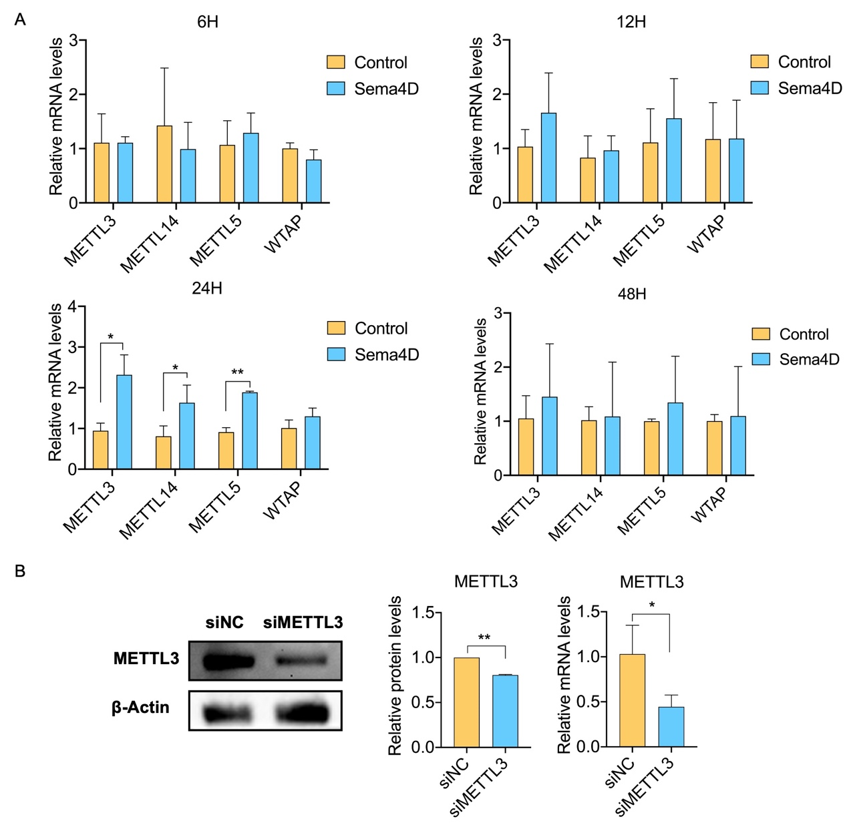
Figure S4. A: qRT-PCR results for Sema4D treated HUVECs at different time points. B: The METTL3 knockdown was confirmed by western blotting and qRT-PCR. Full-length blots are presented in appendix file 2: Appendix Figure 4B.

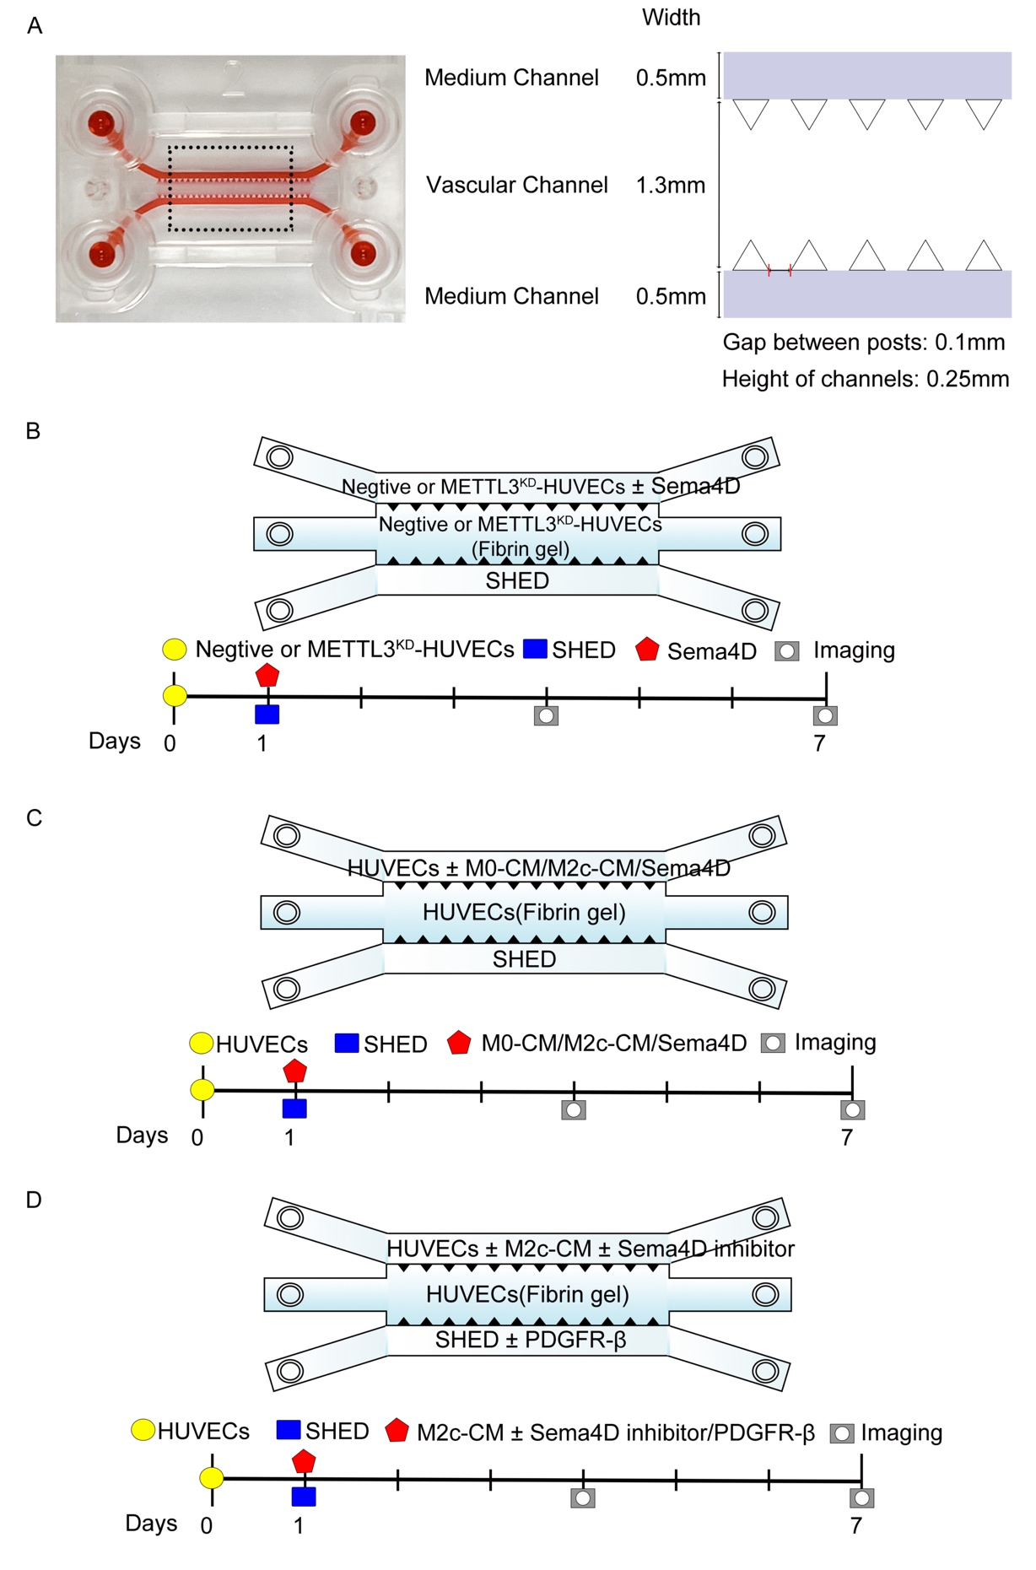
Figure S5. Schematic diagram of the vasculature-on-a-chip microfluidic assay. A: Image of microfluidic model and related parameters. B: Schematic diagram of the microfluidic assay for results shown in Figure 4F. C: Schematic diagram of the microfluidic assay for results shown in Figure 5D. D: Schematic diagram of the microfluidic assay for results shown in Figure 5E.

Figure S6: Schematic diagram of the proposed role of M2c macrophage-Sema4D-Plexin-B1-METTL3-PDGF signaling axis in vascular stabilization.

Table S1. The allocation of mice for in vivo Matrigel plug angiogenesis assay
 | Experiment groups | Number of plugs  (7 days) |  | Number of plugs  (14 days) |  | Total number of mice (2 plugs per mouse)
1 | HUVECs+SHED |  | 4 |  | 4 | 4
2 | HUVECs+SHED+Sema4D |  | 4 |  | 4 | 4
3 | HUVECs+SHED+Sema4+PDGFR-β inhibitor |  | 4 |  | 4 | 4
4 | Vector-HUVECs+SHED |  | 4 |  | 4 | 4
5 | Vector-HUVECs+SHED+Sema4D |  | 4 |  | 4 | 4
6 | Plexin-B1^{KD}-HUVECs+SHED |  | 4 |  | 4 | 4
7 | Plexin-B1^{KD}-HUVECs+SHED+Sema4D |  | 4 |  | 4 | 4
 |  |  |  |  |  | 28

Table S2. The sequences of relative primers
Gene | Forward Primer (5′-3′) | Reverse Primer (5′-3′)
METTL3 | ATCCCCAAGGCTTCAACCAG | GCGAGTGCCAGGAGATAGTC
METTL14 | AGAGAACAAAGGAACACTGCCT | AATGAAGTCCCCGTCTGTGC
METTL5 | CTTTGGAAATGGCAAGAACAGCAG | ATTAGGTCCACTTCAATGTCCACTG
WTAP | TTCCCAAGAAGGTTCGATTG | TGCAGACTCCTGCTGTTGTT
β-Actin | CATTGCTGACAGGATGCAGA | CTGCTGGAAGGTGGACAGTGA

