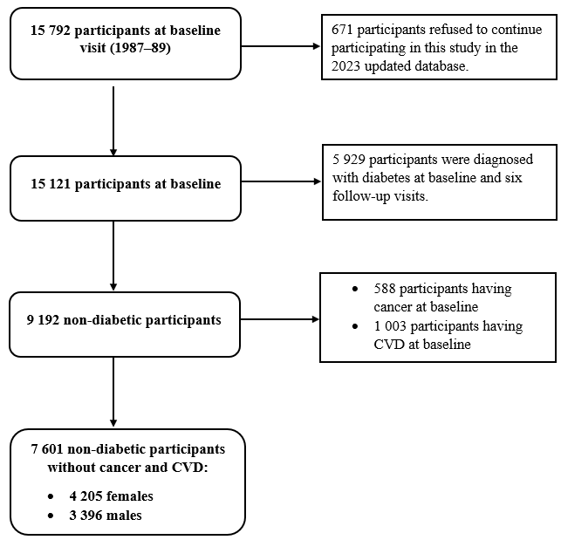
Supplemental Figure 1. The flowchart for the inclusion and exclusion of study participants.

Trajectory patterns |  | Median ± IQR (years) | p-value | Mean ± SE (years) | p-value
BMI
Females | Low level | 77±14 | 0.846 | 75.9±0.42 | 0.955
 | Moderate level | 77±14 |  | 75.9±0.44
 | Low level | 75±16 | 0.919 | 73.9±0.84 | 0.977
 | High level | 76±13 |  | 73.9±0.76
Males | Low level | 75±14 | 0.177 | 74.2±0.38 | 0.187
 | Moderate level | 76±14 |  | 74.9±0.39
 | Low level | 75±14 | 0.044 | 74.0±0.77 | 0.100
 | High level | 73±12 |  | 72.3±0.66
Waist circumference
Females | Low level | 77±14 | 0.201 | 75.4±0.43 | 0.244
 | Moderate level | 77±13 |  | 76.1±0.44
 | Low level | 76.3±15 | 0.261 | 75.3±0.58 | 0.277
 | High level | 76.8±13 |  | 76.1±0.56
Males | Low level | 75±14 | 0.980 | 74.3±0.41 | 0.841
 | Moderate level | 75±12 |  | 74.2±0.40
 | Low level | 76±13 | 0.001 | 75.3±0.58 | 0.003
 | High level | 73±12 |  | 73.0±0.50
Waist-to-hip ratio
Females | Low level | 77±14 | 0.397 | 75.0±0.58 | 0.582
 | Moderate level | 76±13 |  | 74.6±0.50
 | Low level | 78±14 | 0.889 | 76.0±0.68 | 0.851
 | High level | 77±13 |  | 75.8±0.63
Males | Low level | 74±14 | 0.986 | 73.1±0.57 | 0.955
 | Moderate level | 75±14 |  | 73.2±0.54
 | Low level | 74±14 | 0.793 | 73.9±0.68 | 0.647
 | High level | 75±14 |  | 73.4±0.63
Supplemental Table 1 Lifespan by BMI, waist circumference, and waist-to-hip trajectory patterns among the ARIC deceased nondiabetic people.

Note: The bold values are statistically significant. BMI= body mass index.

Supplemental Table 2. Hazard ratios for the association of BMI, waist circumference, waist-to-hip trajectory patterns with all-cause, CVD, and cancer mortality among the ARIC nondiabetic people before dealing with missing covariates values.
 | Trajectory pattern | All-cause mortality | CVD mortality | Cancer mortality
 | Trajectory pattern | HR (95% CI) | HR (95% CI) | HR (95% CI)
 | BMI
Female | Low level | 1.00 | 1.00 | 1.00
 | Moderate level | 1.00(0.89-1.14) | 1.07(0.85-1.35) | 1.12(0.90-1.39)
 | High level | 1.12(0.89-1.43) | 0.96(0.63-1.47) | 1.43(1.03-2.18)
Male | Low level | 1.00 | 1.00 | 1.00
 | Moderate level | 0.98(0.88-1.10) | 1.09(0.87-1.36) | 0.94(0.79-1.14)
 | High level | 1.15(0.93-1.42) | 1.20(0.83-1.73) | 1.06(0.74-1.50)
 | Waist circumference
Female | Low level | 1.00 | 1.00 | 1.00
 | Moderate level | 1.03(0.90-1.17) | 0.90(0.70-1.15) | 1.15(0.92-1.44)
 | High level | 1.12(0.94-1.34) | 1.14(0.83-1.58) | 1.34(0.98-1.84)
Male | Low level | 1.00 | 1.00 | 1.00
 | Moderate level | 1.05(0.95-1.19) | 1.07(0.85-1.35) | 1.02(0.84-1.25)
 | High level | 1.37(1.16-1.62) | 1.39(1.01-1.91) | 1.35(1.03-1.77)
 | Waist-to-hip ratio
Female | Low level | 1.00 | 1.00 | 1.00
 | Moderate level | 1.20(1.02-1.41) | 1.45(1.03-2.03) | 1.26(0.96-1.66)
 | High level | 1.22(1.00-1.48) | 1.52(1.05-2.22) | 1.31(0.92-1.86)
Male | Low level | 1.00 | 1.00 | 1.00
 | Moderate level | 0.96(0.81-1.13) | 0.94(0.69-1.28) | 1.05(0.81-1.36)
 | High level | 1.21(1.00-1.46) | 1.32(0.91-1.91) | 0.83(0.60-1.15)

Note: The bold values are statistically significant. BMI= body mass index; CVD=cardiovascular disease; HR=hazard ratio; CI=confidence interval.

