Extended data Figures and Tables
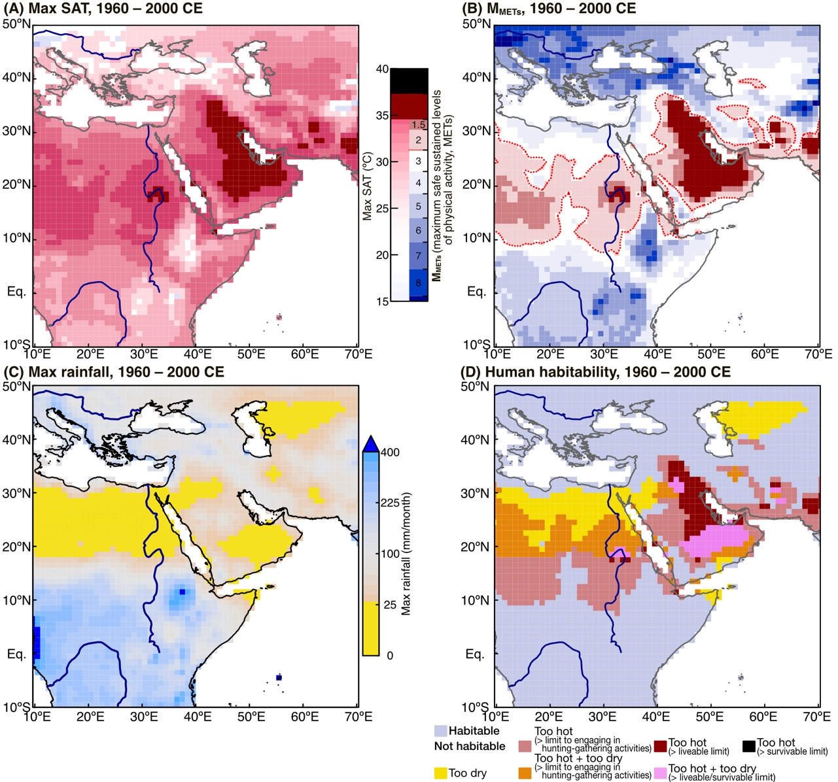
Extended data Figure 1 Present-day climate and habitability. (A) Contour map of max SAT averaged over 1960 to 2000 CE. SAT is derived from the CRU TS 4.07 dataset⁴² Regions where max SAT is beyond the habitability of modern hunter-gatherers (M_{METs} < 3.0 METs, Figure 2), are shown in dark-red colours. (B) Contour map of M_{METs} for modern hunter-gatherers, estimated from the human physiological model of Vanos et al.¹⁷. Blue shading indicates regions where modern hunter-gatherers can safely engage in hunting-gathering activities without being affected by heat. The dashed red line indicates the limit to engaging in hunting-gathering activities (M_{METs} = 3.0 METs). The warm colour shading (M_{METs} < 3.0 METs) indicates regions that are beyond the limit to engaging in hunting-gathering activities due to summer heat. Dark red colours show regions where summer heat is beyond the liveability of modern hunter-gatherers (M_{METs} < 1.5 METs). (C) Contour map of max rainfall averaged over 1960 to 2000 CE. Rainfall is derived from the CRU TS 4.07 dataset⁴². Hyper-arid regions that were not habitable due to extremely low rainfall are masked in yellow. (D) Synthesis map showing habitable (light blue) and not habitable (warm colours) regions for modern hunter-gatherers. Dark red or magenta shades mark regions that are beyond the liveability or survivability of modern hunter-gatherers.

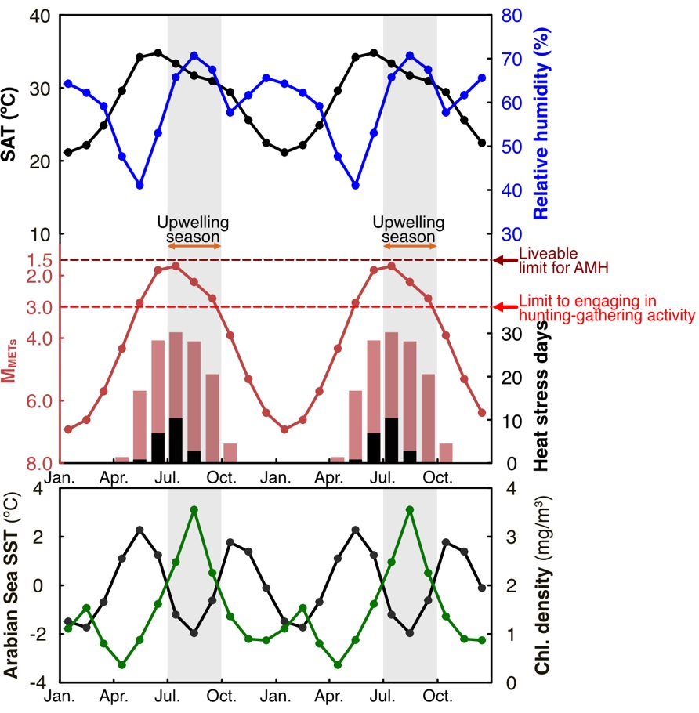
Extended data Figure 2. Mean seasonal cycle of present-day climate in the eastern Arabian Peninsula. Upper panel: Mean seasonal cycles of monthly SAT (black) and relative humidity (blue) measured at Seeb Airport, Oman²⁷. Middle panel: The red line indicates the M_{METs} for modern hunter-gatherers estimated from monthly SAT and relative humidity, using the human physiological model of Vanos et al.¹⁷. Red and black dashed horizontal lines are the limits to engaging in hunting-gathering activities (M_{METS} = 3.0 METs) and liveable limit (M_{METS} = 1.5 METs), respectively. The red bar is the number of days per month with heat exceeding the limit to engaging in hunting-gathering activity. The black bar is the number of days per month with heat exceeding the liveability. Lower panel: The black and green lines are the seasonal variations of SST and chlorophyll-a density in the Arabian Sea. SST and chlorophyll-a density are from OISSTv2p1⁵² and SeaWiFS satellite data, respectively. The Arabian Sea upwelling season continues from July to September (grey shading).

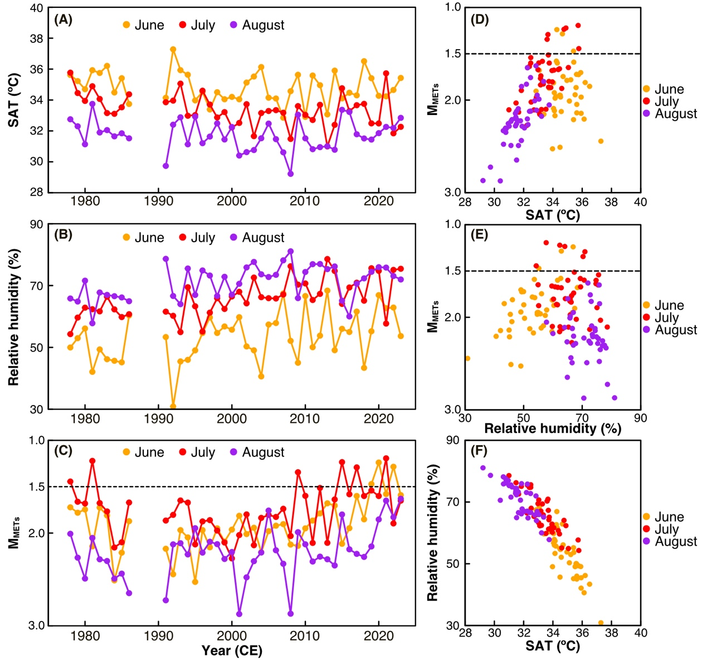
Extended data Figure 3. Time series of SAT, relative humidity and M_{METs} in summer (June to August) in the eastern Arabian Peninsula. (A) SAT measured at Seeb Airport, Oman²⁷ in June (orange), July (red) and August (purple). (B) Same as (A) but for relative humidity. (C) Same as (A) but for the M_{METs} for modern hunter-gatherers, estimated from SAT and relative humidity. We only considered years with over 2000 observations/year for statistical analyses. (D) XY plot of SAT and M_{METs}. (E) XY plot of relative humidity and M_{METs}. (F) XY plot of SAT and relative humidity. The dashed black line shown in panels (C), (D) and (E) marks the liveable limit for modern hunter-gatherers (M_{METs} = 1.5 METs).

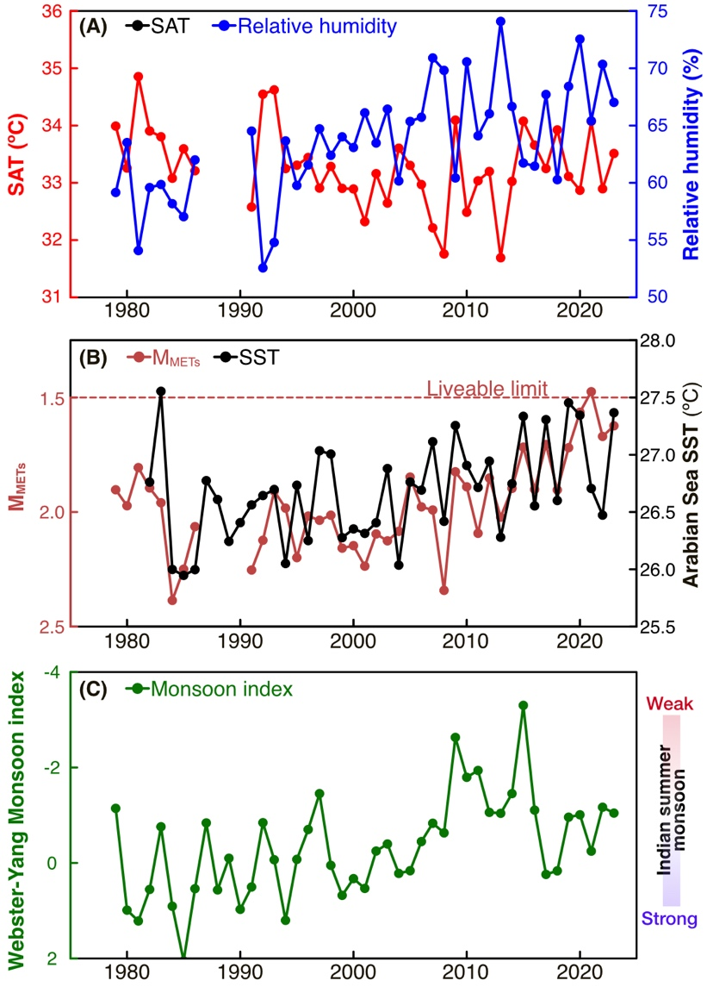
Extended data Figure 4. Time series of summer mean (June to August) of SAT, relative humidity and M_{METs} in the eastern Arabian Peninsula. (A) SAT (black) and relative humidity (blue) measured at Seeb Airport, Oman. (B) M_{METs} (red) and Arabian Sea SST (0 to 20ºN, 50ºE to 60ºE, data from OISSTv2.1, black). The red dashed line marks the liveable limit (M_{METs} = 1.5 METs) (C) Webster-Yang monsoon index. All time series are shown in summer mean (June to August).

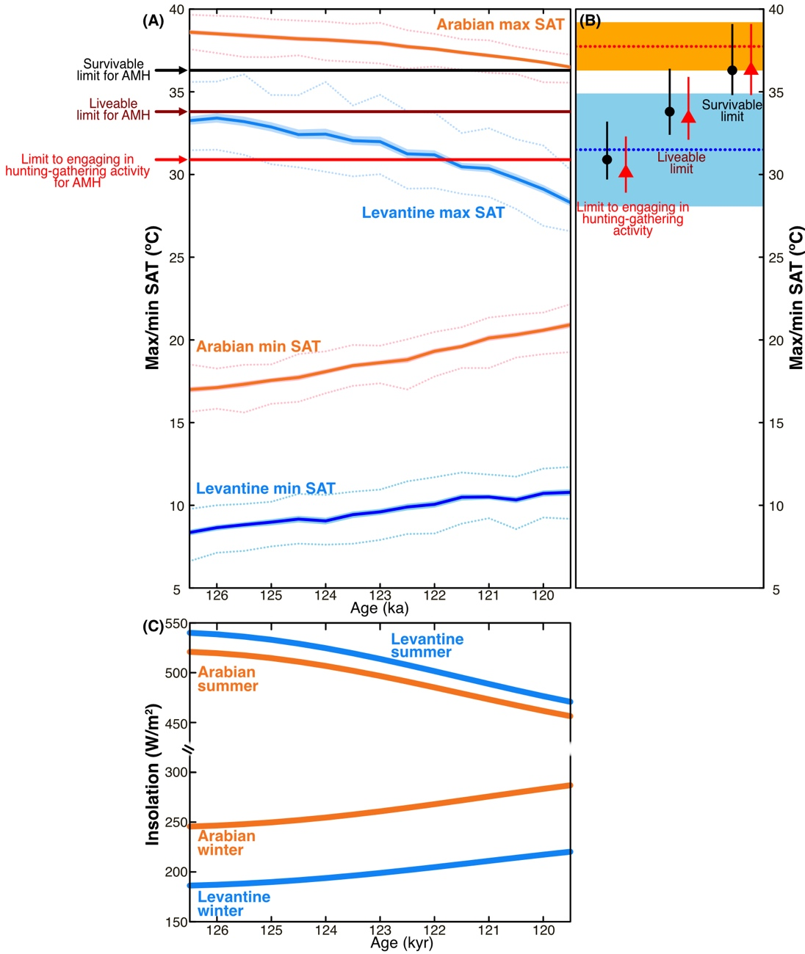
Extended data Figure 5. LIG evolution of max and min SAT inferred from the CESM2. (A) LIG averages of max and min SAT in the eastern Arabian Peninsula (orange lines) and the Levant (blue lines) at 0.5 ka intervals. Orange or blue dotted lines are the 90%tiles of max/min SAT in each time window. Red, dark-red and black horizontal lines mark the SAT limits for AMH to engaging in hunting-gathering activities, liveability and survivability, respectively (Figure 2-B). (B) The SAT limit to engaging in hunting-gathering activities, liveability, and survivability of AMH (black circles, corresponding to panel A and Figure 2-B) and Neanderthals (red triangles, Figure 2-C). The mean values of max SAT and 90%iles of max SAT during the LIG are shown with horizontal lines and shades (red lines: eastern Arabian Peninsula; blue lines: Levant) (C) Insolation changes in the eastern Arabian Peninsula (orange lines, latitude: 23 ºN) and the Levant (blue line, latitude: 32 ºN) during the summer (June) and winter (December). Insolation changes are estimated following Laskar et al.⁵⁰.
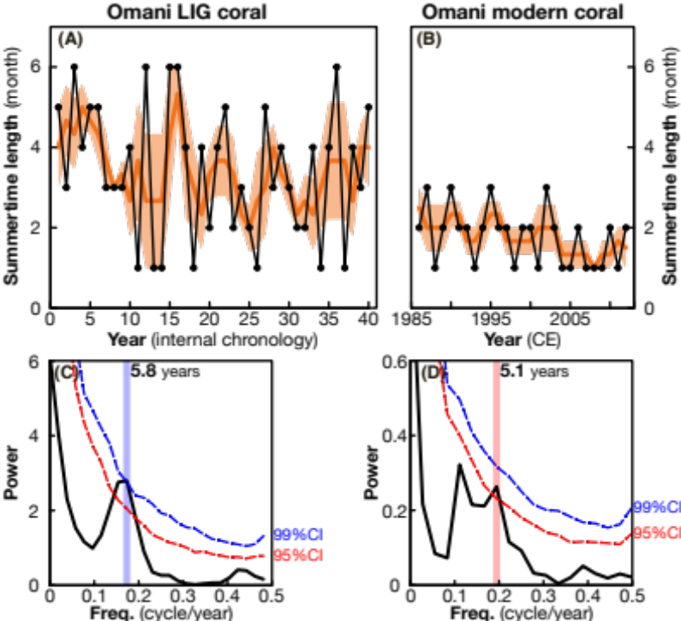
Extended data Figure 6. Persistence of summer temperature maxima estimated from SAT reconstructed from Omani corals (Eastern Arabian Peninsula). (A) and (B) summer length estimated from SAT in Omani fossil and modern corals (SAT_{coral}, black lines). Orange lines and shades are three-year moving averages and their standard errors (1σ). (C) and (D) Frequency analysis of three-year moving averages of summer length estimated with the Redfit test⁵⁴. Blue and red dashed lines indicate the 99% and 95% confidence levels based on the Monte Carlo technique (20,000 times loop). Modern SAT_{coral} reveals that summer today lasts 1.77 months (99% confidence interval: 1.42, 2.12 months). The fossil Omani coral shows that the LIG summer lasted 3.43 months (99% confidence interval: 2.78, 4.08 months), i.e., 1.94 times (99% confidence interval: 1.47, 2.54) longer than today. We note that LIG summer length varied with a frequency of 5.8 years/cycle (significant at 99% confidence level) (shown in panel C). A similar frequency is seen in the modern coral (5.1 years/cycle, significant at the 95% confidence level) (shown in panel D). At present, summer length varies between 1 and 3 months (shown in panel B). In the LIG, summer lasted up to 6 months (shown in panel A). This is observed in five years of the 40-year record. The shortest LIG summer season lasted one month (this occurred in seven years of the 40-year-long record). The LIG coral record revealed that the period of highest summer temperatures experienced by AMH in their habitat on the southern dispersal route lasted on average twice as long as at present, and that extreme years with anomalously prolonged summer seasons occurred every 5.8 years.

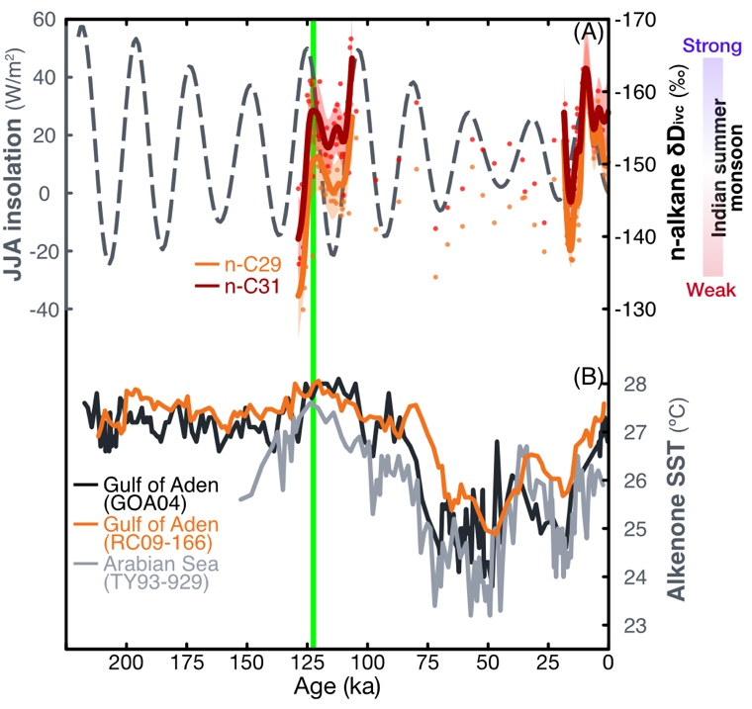
Extended data Figure 7. Long-term climatic changes relevant for the early dispersal of AMH. (A) Indian summer monsoon intensity reconstructions based on n-alkane hydrogen isotopes³⁴ (orange: n-C29; red: n-C31). The data is smoothed following Wang et al.³⁴ (solid lines). The shades are their 95% confidence intervals. The grey dashed line shows insolation changes in summer (from June to August, at 15ºN). The green vertical line indicates the age of Omani fossil coral. (B) Alkenone SST reconstructions in the Gulf of Aden: GOA04⁵⁷ (black) and RC09-166⁵ (orange) and in the Arabian Sea: TY93-929 (grey)⁵⁸. All alkenone datasets are converted to SST⁵⁹.

Extended data Table 1. The definition of human habitable limits
Term | Definition | SAT* or max rainfall limits of habitability
Term | Definition | Modern  Hunter-gatherers | AMH | Neanderthals
Habitable | M_{METs >} 3.0 METs; max rainfall > 28.1 mm/month  Available sufficient food resources  Safe hunting-gathering activity without heat exposure
Not habitable (too hot)
-Beyond the limit to engaging in hunting-gathering activities | M_{METs}: from 1.5 to 3.0 METs  Unable to engage in hunting-gathering activities outdoors for 3-hours due to heat stress | 31.2 ºC  [29.8~34.0] | 30.9 ºC  [29.7~33.2] | 30.1 ºC  [29.9~32.3]
-Beyond liveability  (liveable limit) | M_{METs} < 1.5 METs  Unable to engage in any activities outdoors for 3-hours due to heat stress | 34.5 ºC  [32.9~37.6] | 33.8 ºC  [32.4~36.4] | 33.4 ºC  [32.1~35.9]
-Beyond survivability  (survivable limit) | Internal body temperature cannot be maintained when exposed to outside conditions for 3-hours  Causing heat stroke death | 37.3 ºC  [35.5~40.6] | 36.3 ºC  [39.1~34.8] | 36.3 ºC  [34.8~39.1]
Not habitable (too dry) | Max rainfall ≤ 28.1 mm/month  No available to sufficient food resources | 28.1 mm/month
*The SAT limit of habitability is estimated using the median value of present-day relative humidity (59.6%) and its 1σ-level percentiles (40.2~72.2%) in northeastern Africa and the Arabian Peninsula from 1981~2000. Values in brackets indicate the 1σ-level percentiles of the estimated SAT limit, inferred from the 1σ-level percentiles of relative humidity.

