Supplement information for
Last Interglacial summer heat restricted human migration.
Authors: Takaaki K. Watanabe^{1,2,3*}, Miriam Pfeiffer¹, Atsuko Yamazaki^{2,3}, Dieter Garbe-Schönberg¹, Hsun-Ming Hu^{4,5}, Chuan-Chou Shen^{4,6}, Saori Ito¹, and Tsuyoshi Watanabe^{2,3,7}
Affiliations:
¹Institute of Geosciences, Kiel University, Kiel 24118, Germany.
²KIKAI Institute for Coral Reef Sciences, Kikai Town, Kagoshima 891-6151, Japan.
³Department of Natural History Sciences, Faculty of Science, Hokkaido University, Sapporo, Hokkaido 060-0810, Japan.
⁴High-Precision Mass Spectrometry and Environment Change Laboratory (HISPEC), Department of Geosciences, National Taiwan University, Taipei 10617, Taiwan, ROC.
⁵Atmosphere and Ocean Research Institute, The University of Tokyo, Kashiwa, Chiba 277- 8564, Japan
⁶Research Center for Future Earth, National Taiwan University, Taipei 10617, Taiwan, ROC.
⁷Research Institute for Humanity and Nature, Kyoto, Kyoto 603-8047, Japan.
*Corresponding author: Takaaki K. Watanabe (takaaki.watanabe@ifg.uni-kiel.de)

Supplemental text
Heat waves in the eastern Arabian Peninsula
We investigate the humidity and temperature dataset measured at Seeb Airport, Oman, at monthly resolution (HadISD dataset) ¹. First, we estimate the mean seasonal cycles of SAT, relative humidity, and the maximum safe sustained levels of physical activity (M_{METs}) (Extended data Figure 2). Although SAT and M_{METs} have similar seasonal cycles, the warmest and smallest months differ between them. The warmest SAT was recorded in June, while the smallest M_{METs} was recorded in July. The one-month lag in the M_{METs} relative to temperature is due to high relative humidity during the onset of upwelling. During the onset of upwelling, both SAT and relative humidity are high. Days beyond the survival limit for modern hunter-gatherers are mostly observed in before and during the onset of the upwelling season. The high SAT in June and July has a more important role in enhancing heat stress than the increased relative humidity. The SAT shows a significant negative correlation with the M_{METs}, although relative humidity is positively and weakly correlated with the M_{METs}. Most of the days (86%) with heat beyond the survival limit were observed before the upwelling season or during the transition season to upwelling. This suggested that the high SAT before upwelling season increase the risk of thresholding the SAT beyond the survival limit for modern hunter-gatherers. The cooling SAT in the upwelling season significantly declines the risk of heat stress in the eastern Arabian Peninsula.
Next, we examine the time series of the M_{METs} from June to August calculated in the eastern Arabian Peninsula. The M_{METs} and relative humidity from June to August show an increasing trend (p-value = 0.01, n = 43, Mann-Kendall test, Extended data Figure 3). The M_{METs} are correlated with the summer average of SAT (R = -0.43, p-value < 0.01, n = 43) but not with relative humidity. Although relative humidity does not correlate with the M_{METs}, the recent decrease in M_{METs} clearly shows that the increase in relative humidity has a significant role in the heat stress on the eastern Arabian Peninsula. As a result of the recent weakening trend of the Indian Ocean monsoon and upwelling, SST in the Arabian Sea shows an increasing trend. This increasing trend of SST raises the heat stress over the eastern Arabian Peninsula (R: -0.60, n = 42, between M_{METs} and SST). This suggested that the weakening of upwelling and its related rise of SST in the Arabian Sea is also critical to inflate the heat stress due to transporting humid to eastern Arabian Peninsula.

Table S1 Uranium and Thorium isotopic compositions and U-Th ages by MC-ICP-MS, Thermo Neptune, at National Taiwan University.
Sample | Weight | ²³⁸U |  | ²³²Th |  | d²³⁴U |  | [²³⁰Th/²³⁸U] |  | ²³⁰Th/²³²Th |  | Age (yr ago) |  | Age (yr ago) |  | d²³⁴U_{initial}
ID | g | ppbª |  | ppt |  | measuredª |  | activity^{c} |  | atomic (x 10⁻⁶) |  | uncorrected |  | corrected ^{c,d} |  | corrected ^{b}
S10C02 | 0.1855 | 1407.7 | ± 1.2 | 155 | ± 3 | 113.3 | ± 1.5 | 0.76474 | ± 0.00086 | 114736 | ± 1861 | 122,930 | ± 425 | 122,927 | ± 425 | 160.2 | ± 2.2
Analytical errors are 2σ of the mean.
ª [²³⁸U] = [²³⁵U] × 137.818 (±0.65‰); δ²³⁴U = ([²³⁴U/²³⁸U]_{activity} - 1) × 1000.
^{b} δ²³⁴U^{initial} corrected was calculated based on ²³⁰Th age (T), i.e., δ²³⁴U_{initial} = δ²³⁴U_{measured} × e^{λ234×T}, and T is corrected age.
^{c}[²³⁰Th/²³⁸U]_{activity} = 1 - e^{-λ230T} + (δ²³⁴U_{measured}/1000)[λ₂₃₀/(λ₂₃₀ - λ₂₃₄)](1 - e^{-(λ230 - λ234) T}), where T is the age.
Decay constants are 9.1705 × 10⁻⁶ yr⁻¹ for ²³⁰Th, 2.8221 x 10⁻⁶ yr⁻¹ for ²³⁴U, and 1.55125 × 10⁻¹⁰ yr⁻¹ for ²³⁸U.
^{d} The degree of detrital ²³⁰Th contamination is indicated by the [²³⁰Th/²³²Th] atomic ratio instead of the activity ratio.
^{e} Age corrections for samples were calculated using an estimated atomic ²³⁰Th/²³²Th ratio of 4 ± 2 ppm.

Table S2 Summary of monthly SAT during LIG from the CESM2 model and during the present-day from CRU TS data.
 | Age | Max SAT (ºC) ª  [95%CI] | Min SAT (ºC)ª  [95%CI] | Seasonality^{b} (ºC)  [95%CI] | Difference in  seasonality^{c}  [99%CI]
East Arabian Peninsula | LIG | 37.75 [37.72, 37.79] | 18.76 [18.68, 18.83] | 18.7 [18.6, 18.8] | 4.09 [3.72, 4.40]
East Arabian Peninsula | Present | 33.30 [33.18, 33.42] | 18.40 [18.07, 18.64] | 14.9 [14.6, 15.3] | 4.09 [3.72, 4.40]
Levant | LIG | 31.47 [31.37, 31.57] | 9.66 [9.59, 9.72] | 21.8 [21.7, 22.0] | 6.71 [6.40, 7.02]
Levant | Present | 22.74 [22.51, 22.99] | 7.64 [7.34, 7.90] | 15.1 [14.8, 15.4] | 6.71 [6.40, 7.02]
ª Maxima and minima of SAT is derived from the average of annual maxima and minima in LIG. Values in square brackets indicate 95% confidence intervals (CI) of mean values.
^{b} Seasonality is estimated from the difference between annual maxima and minima of SAT.
^{c} Difference in seasonality is estimated by seasonality in LIG SAT minus modern SAT. Values in square brackets indicate 99% confidence intervals (CI) of difference.

Table S3 Summary of SATs inferred from the modern and LIG corals.
 | Age | Max SAT (ºC)ª  [95%CI] | Min SAT (ºC)ª  [95%CI] | Seasonality^{b} (ºC)  [95%CI] | Difference in  seasonality^{c}  [99%CI] | Skewness^{d}  [99%CI]
Oman  (Eastern Arabian Peninsula) | LIG | 5.4 [4.7, 6.1] | -9.6 [-10.9, -8.5] | 17.0 [16.3, 17.7] | 2.9 [1.3, 4.5] | -0.63 [-0.84, -0.43]
Oman  (Eastern Arabian Peninsula) | Present | 5.6 [4.6, 6.7] | -6.4 [-7.5, -5.5] | 14.1 [13.2, 15.1] | 2.9 [1.3, 4.5] | -0.08 [-0.29, 0.14]
Eilat  (Levant) | LIG | 13.6 [9.4, 16.9] | -12.0 [-13.9, -10.2] | 29.0 [25.6, 31.1] | 13.2 [8.5, 16.2] | 0.30 [-0.13, 0.76]
Eilat  (Levant) | Present | 6.6 [5.9, 7.5] | -7.6 [-8.5, -6.8] | 15.8 [14.9, 16.6] | 13.2 [8.5, 16.2] | -0.17 [-0.35, -0.01]
ª Maxima and minima are derived from the mean seasonal cycle shown in Figures 4 and 5. Values in square brackets indicate 95% confidence intervals (CI) of mean values.
^{b} Seasonality is estimated from the difference between annual maxima and minima of SAT.
^{c} Difference in seasonality is estimated by seasonality in LIG SAT_{coral} minus modern SAT_{coral}. Values in square brackets indicate 99% confidence intervals (CI) of difference.
^{d} Skewness and their confidence interval are estimated using a bootstrap method. Values in square brackets indicate 99% confidence intervals (CI) of skewness.

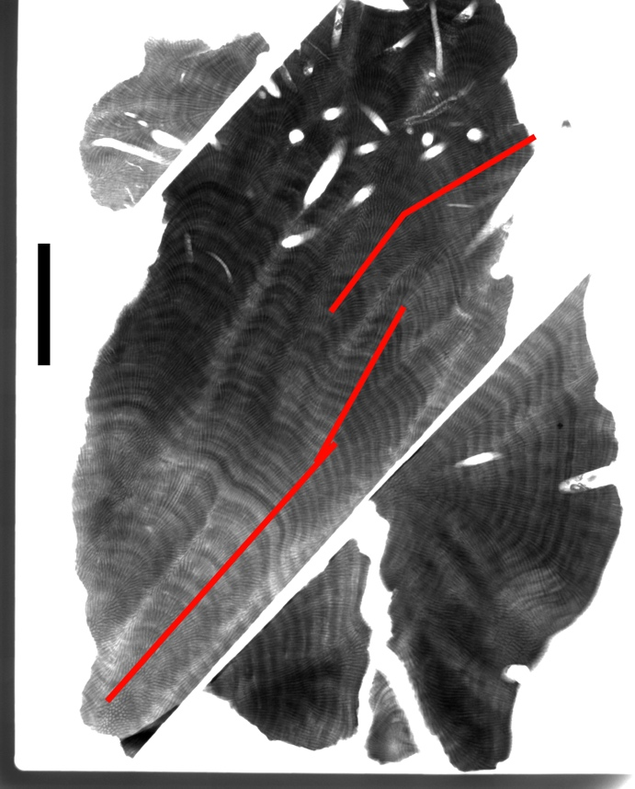
Figure S1 The X-ray image of Omani fossil coral dated to the LIG.
The black scale bar indicates 5 cm. Red lines are sampling transects for geochemical analyses.

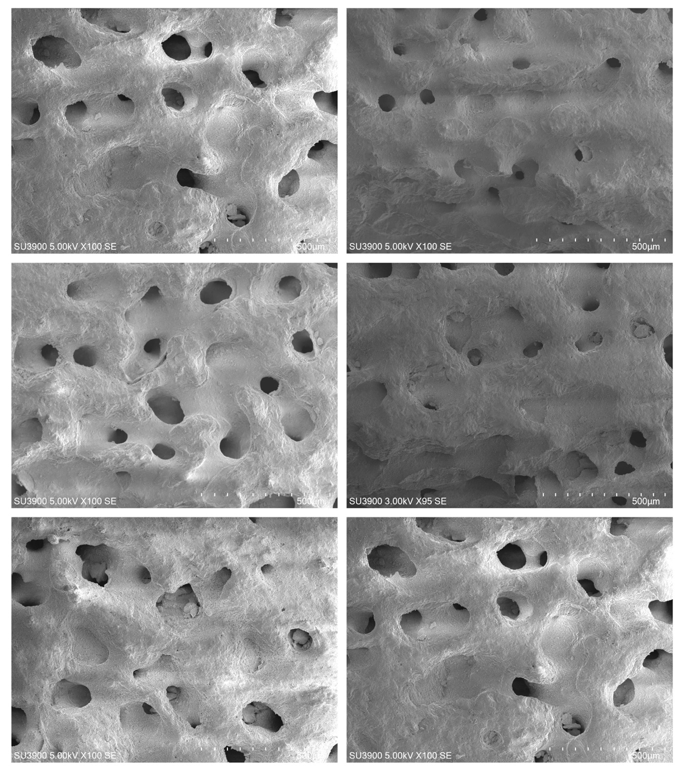
Figure S2 SEM images of the Omani fossil coral dated to the LIG.
These images confirm excellent preservation.

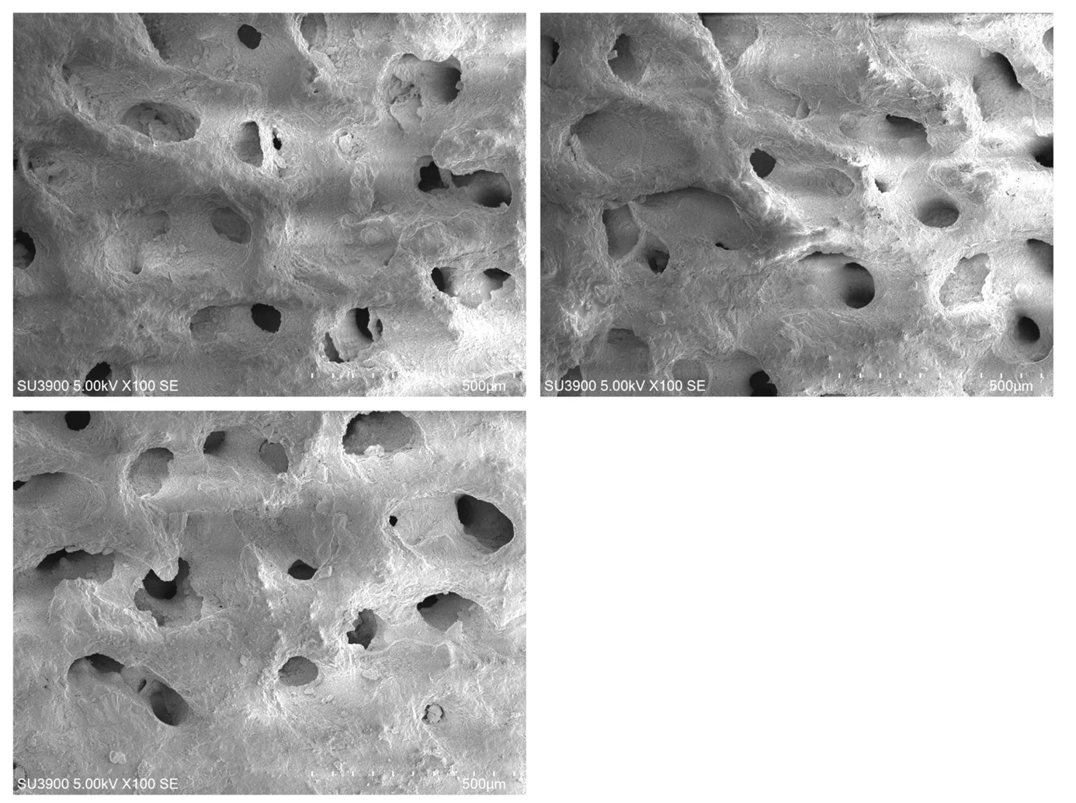
Figure S2 (continued) SEM images of the Omani fossil coral dated to the LIG.
These images confirm excellent preservation.

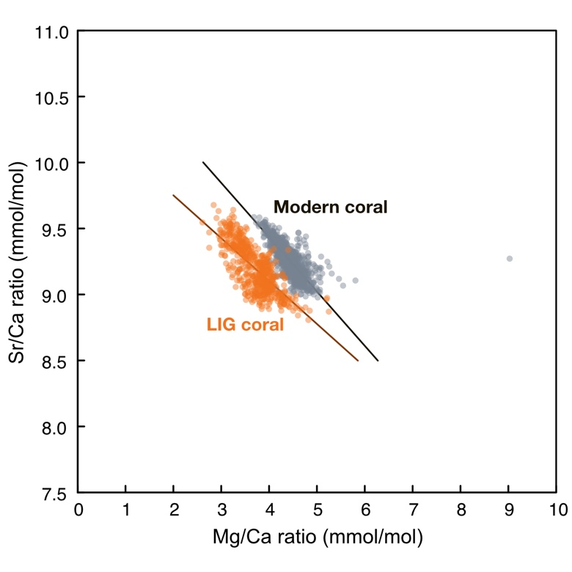
Figure S3 X-Y plot between Mg/Ca and Sr/Ca in modern Omani (grey) and fossil (orange) corals. Lines indicate the weighed least square regression. The weighted least square regressions are as follows:
Sr/Ca = (-0.32 ± 0.01) × Mg/Ca + (10.40 ± 0.04) [fossil coral]
Sr/Ca = (-0.41 ± 0.01) × Mg/Ca + (11.08 ± 0.04) [modern coral]
Sr/Ca negatively correlates with Mg/Ca in both fossil and modern corals (fossil: R = -0.76; 95% confidence interval: [-0.80, -0.73], n = 564, modern: R = -0.65; 95% confidence interval: [-0.68, -0.61], n = 880). There is no difference in mean values of Sr/Ca between modern and fossil corals. Mg/Ca in the fossil coral is lower than in the modern coral, which may result from the much lower growth rate ⁷ of the fossil coral (6.7 ± 2.0 mm/year) compared to the modern (25.1 ± 2.6 mm/year⁸). Sr/Ca and Mg/Ca are in the reported range of modern corals⁷ (Sr/Ca: 8.5 ~ 9.5 mmol/mol; Mg/Ca: 3 ~ 6 mmol/mol). Hence, we concluded that there is no influence of diagenetic alterations on trace elements.

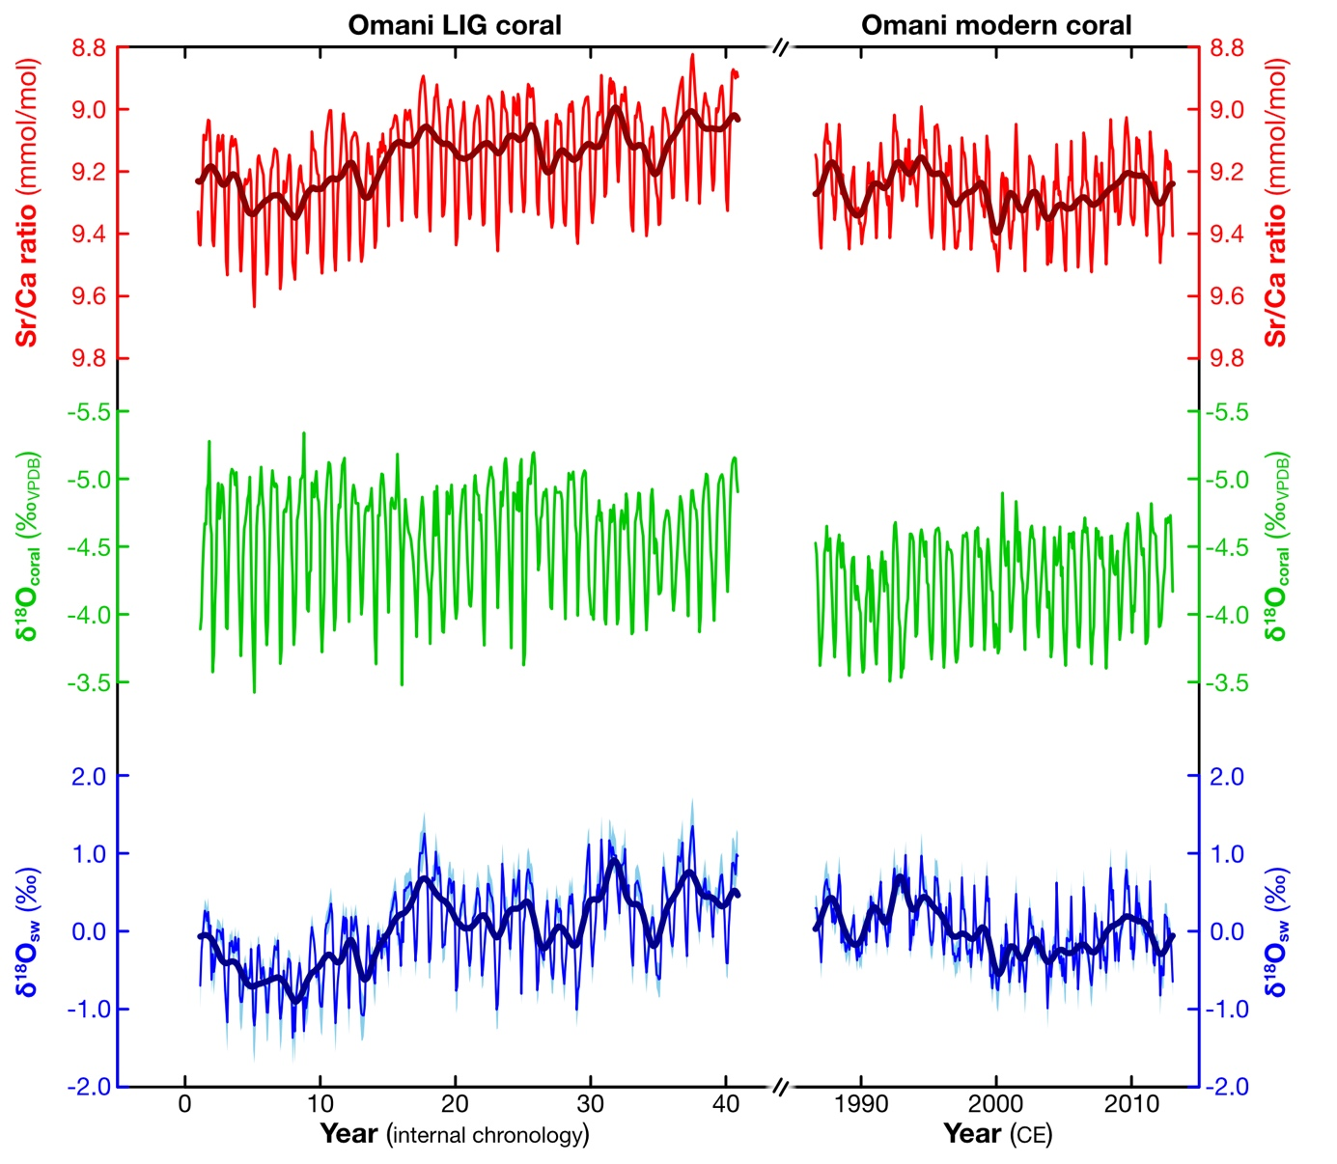
Figure S4 Geochemical data of the LIG and modern Omani corals.
The left panel shows the results of the Omani fossil (LIG) coral. The right panel shows the results of the modern Omani coral. Red lines are the coral skeletal Sr/Ca ratios measured at monthly resolution Green lines are the coral skeletal oxygen isotopes (δ¹⁸O_{c}) measured at monthly resolution. Blue lines are seawater oxygen isotopes (δ¹⁸O_{sw}) derived by subtracting the SST component inferred from Sr/Ca ratio from δ¹⁸O_{c} after centring. Blue shades indicate the uncertainty for δ¹⁸O_{sw} (90% confidence level) estimated by the centring method⁹ and the simple Monte Carlo method¹⁰. Thick lines on the Sr/Ca ratio and δ¹⁸O_{sw} records show the low-pass filtered values (see Methods).
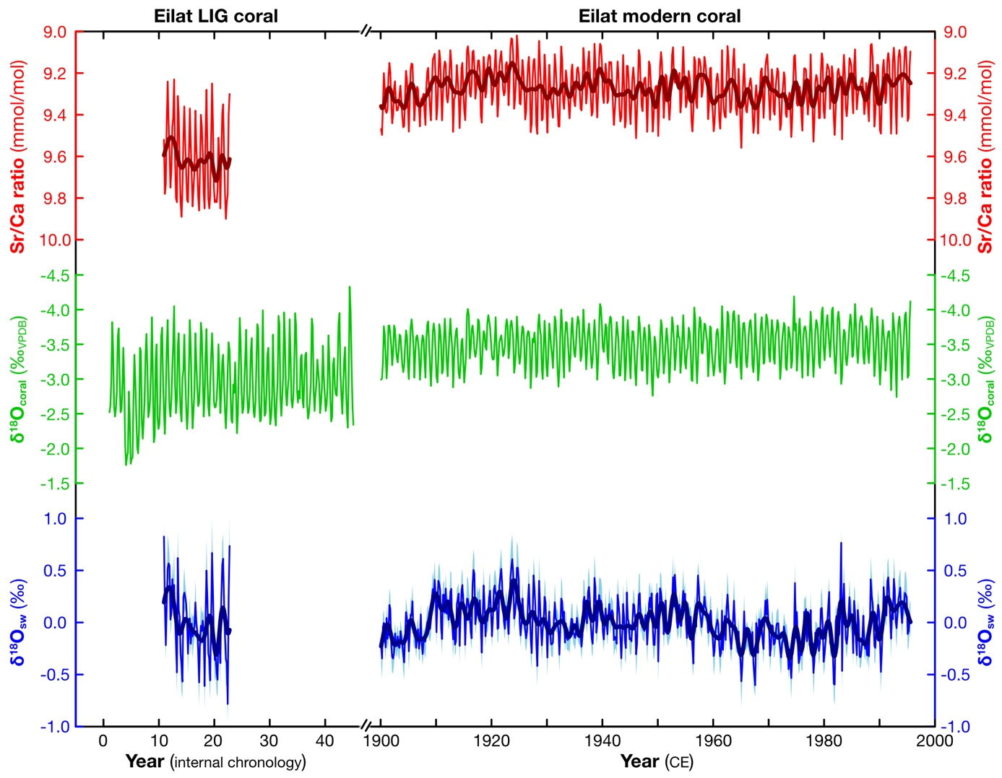
Figure S5 Analytical results of LIG and modern corals from the Red Sea.
Same as Figure S4, but for geochemical data of the Eilat corals^{11,12}.

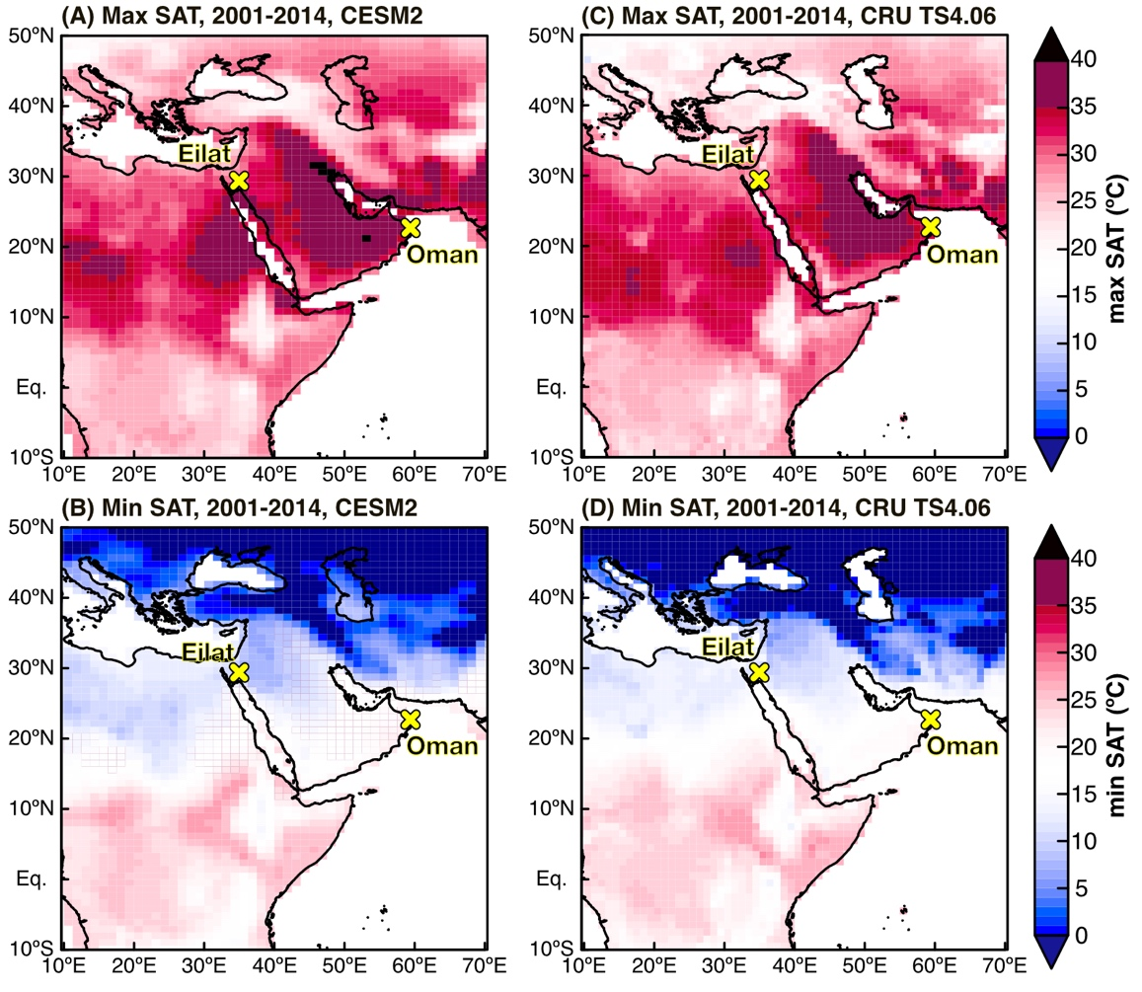
Figure S6 Observed and modelled max and min SAT in present-dat.
(A) and (B) Averages of max and min SAT from 2001 to 2014 derived from the CESM2 result¹³. (C) and (D) Averages of max and min SAT from 2001 to 2014 derived from observations (CRUTS4.06 dataset¹⁴). Note that the spatial distribution of SAT shown by CRU TS4.06 is consistent with the CESM2 result¹³, suggesting that the climate model adequately projects SAT. Yellow crosses indicate the sampling sites for corals from Oman (representing the eastern Arabian Peninsula) and Eilat (representing the Levant).

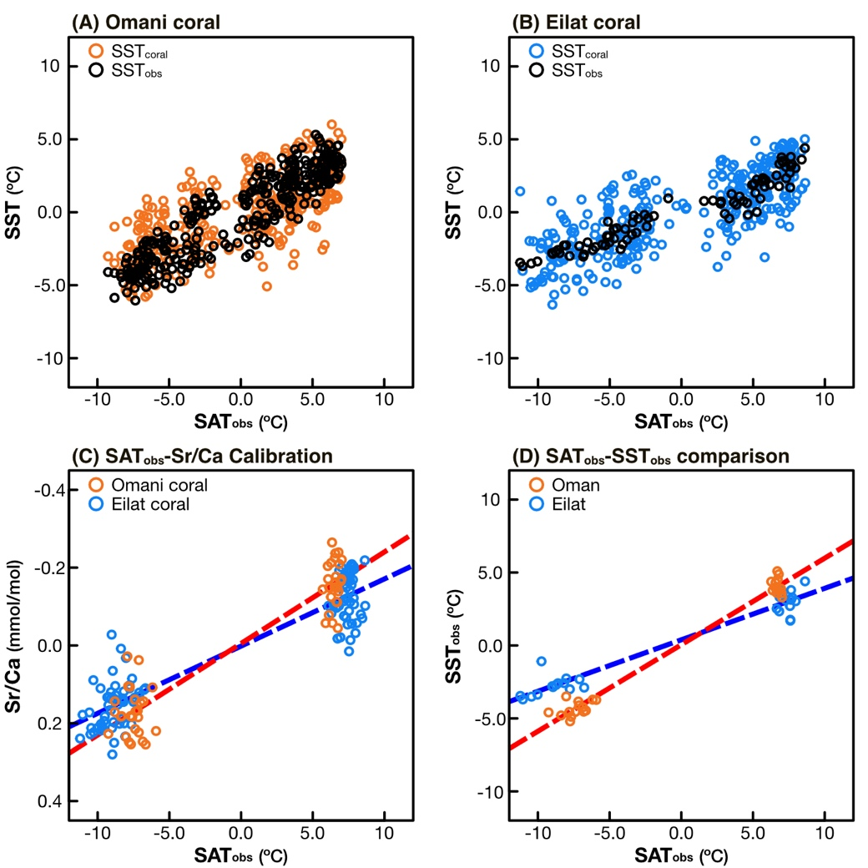
Figure S7 Comparison of SAT with SST and calibration of coral Sr/Ca with SAT.
(A) X-Y plot between observed SAT and SST in Oman (representing the eastern Arabian Peninsula).
Orange circles are SSTs reconstructed from the modern Omani coral Sr/Ca (SST_{coral}). Black circles are SSTs derived from OISSTv2.1¹⁵ (SST_{obs}). (B) same with (A), but for the data in Eilat (representing the Levant). (C) Coral Sr/Ca calibration with SAT (SAT_{obs}) in Oman (orange) and Eilat (blue). Dashed red and blue lines are the linear regressions estimated from the annual maxima/minima of Sr/Ca and annual minima/maxima of observed SAT in Oman and Eilat. SAT_{obs} is derived from the CRUTS 4.06¹⁴. The SAT_{obs}-Sr/Ca slope values are -0.023 mmol×mol⁻¹/ºC (95% confidence interval: [-0.025, -0.021], R: -0.94, n = 52) in Oman and -0.018 mmol×mol⁻¹/ºC (95% confidence interval: [-0.019, -0.017], R: -0.93, n = 104) in Eilat, estimated from bootstrap method (20,000 times loop). The SAT_{obs}-Sr/Ca slope value of the Omani coral is slightly steeper compared to that of the Eilat coral. This is similarly observed in the comparison between SAT_{obs} and SST_{obs} (D). Note that all SST, SAT, and Sr/Ca data are centred (removing each average value).

Reference list in Supplement information
1 Dunn, R. J. H. et al. HadISD: a quality-controlled global synoptic report database for selected variables at long-term stations from 1973–2011. Climate of the Past 8(5), 1649-1679, https://doi.org/10.5194/cp-8-1649-2012 (2012).
2 Webster, P. J. & Yang, S. Monsoon and ENSO: Selectively interactive systems. Quarterly Journal of the Royal Meteorological Society 118(507), 877-926 (1992).
3 Watanabe, T. K. et al. Corals reveal an unprecedented decrease of Arabian Sea upwelling during the current warming era. Geophysical Research Letters 48(10), e2021GL092432, https://doi.org/10.1029/2021GL092432 (2021).
4 Sherwood, S. C. & Huber, M. An adaptability limit to climate change due to heat stress. Proceedings of the National Academy of Sciences 107(21), 9552-9555, https://doi.org/10.1073/pnas.0913352107 (2010).
5 Vecellio, D. J., Cottle, R. M., Wolf, S. T. & Kenney, W. L. Critical Environmental Limits for Human Thermoregulation in the Context of a Changing Climate. Exercise, Sport, and Movement 1(2), e00008, https://doi.org/10.1249/esm.0000000000000008 (2023).
6 Vecellio, D. J., Wolf, S. T., Cottle, R. M. & Kenney, W. L. Evaluating the 35 C wet-bulb temperature adaptability threshold for young, healthy subjects (PSU HEAT Project). Journal of applied physiology 132(2), 340-345, https://doi.org/10.1152/japplphysiol.00738.2021 (2022).
7 Inoue, M., Suzuki, A., Nohara, M., Hibino, K. & Kawahata, H. Empirical assessment of coral Sr/Ca and Mg/Ca ratios as climate proxies using colonies grown at different temperatures. Geophysical Research Letters 34(12), L12611, https://doi.org/10.1029/2007GL029628 (2007).
8 Watanabe, T. K. et al. Past summer upwelling events in the Gulf of Oman derived from a coral geochemical record. Scientific Reports 7(1), 4568, https://doi.org/10.1038/s41598-017-04865-5 (2017).
9 Cahyarini, S. Y., Pfeiffer, M., Timm, O., Dullo, W.-C. & Schönberg, D. G. Reconstructing seawater δ18O from paired coral δ18O and Sr/Ca ratios: Methods, error analysis and problems, with examples from Tahiti (French Polynesia) and Timor (Indonesia). Geochimica et Cosmochimica Acta 72(12), 2841-2853, https://doi.org/10.1016/j.gca.2008.04.005 (2008).
10 Watanabe, T. K. & Pfeiffer, M. A simple Monte Carlo approach to estimate the uncertainties of SST and δ 18 O sw inferred from coral proxies. Geochemistry, Geophysics, Geosystems 23(3), e2021GC009813, https://doi.org/10.1029/2021gc009813 (2022).
11 Felis, T. et al. Increased seasonality in Middle East temperatures during the last interglacial period. Nature 429(6988), 164-168, https://doi.org/10.1038/nature02546 (2004).
12 Felis, T. et al. A coral oxygen isotope record from the northern Red Sea documenting NAO, ENSO, and North Pacific teleconnections on Middle East climate variability since the year 1750. Paleoceanography 15(6), 679-694, https://doi.org/10.1029/1999PA000477 (2000).
13 Otto‐Bliesner, B. L. et al. A Comparison of the CMIP6 <i>midHolocene</i> and <i>lig127k</i> Simulations in CESM2. Paleoceanography and Paleoclimatology 35(11), https://doi.org/10.1029/2020pa003957 (2020).
14 Harris, I., Osborn, T. J., Jones, P. & Lister, D. Version 4 of the CRU TS monthly high-resolution gridded multivariate climate dataset. Scientific Data 7(1), https://doi.org/10.1038/s41597-020-0453-3 (2020).
15 Huang, B. et al. Improvements of the Daily Optimum Interpolation Sea Surface Temperature (DOISST) Version 2.1. Journal of Climate 34(8), 2923-2939, https://doi.org/10.1175/jcli-d-20-0166.1 (2021).

