Carbogels for sustainable and scalable thermoelectric applications
Shoeb ATHAR^{1,2}, Jérémy GUAZZAGALOPPA^{1,2}, Fabrice BOYRIE¹, Cédric HUILLET², Philippe JUND^{1,*}

1. ICGM, Univ Montpellier, CNRS, ENSCM, 34293 Montpellier, France
2. HUTCHINSON SA - Rue Gustave Nourry, 45120 Châlette-sur-Loing, France
* Corresponding author. E-mail address: philippe.jund@umontpellier.fr (Philippe JUND)

Supplementary Material
Table of Contents
- Supplementary methods (Page 1)
- Supplementary results (Page 2)
  - Influence of pyrolysis on the structural properties of the xerogel the RF (Page 2)
  - Vacuum sealing test (Page 6)
  - Creation of the test bench (Page 8)
  - Calculations of the power produced by the Seebeck effect (Page 9)
  - Study of the influence of thickness and surface area of the material (Page 13)
  - Maximum operating point search (Page 15)
  - Repeatability tests (Page 16)
  - Detection of vacuum failure with expected electrical power (Page 17)
- Supplementary figures (Page 20)
References (Page 20)
S1: Supplementary methods
The EDX elemental analysis to determine the chemical composition was performed by coupling the Bruker's XFlash Detector 5030 to a Gemini 300 scanning electron microscopy (SEM) device from ZEISS. Thermogravimetric analysis was done to evaluate the mass losses of our RF materials associated with various pyrolysis processes using TGA/DSC 3+ device from Mettler Toledo. CHNS/O elemental analysis was carried out with FlashSmart™ Elemental Analyzer 1112 from ThermoFisher. To study the influence of synthesis parameters as well as the influence of pyrolysis on our material, we studied the evolution of the porous texture as a function of the pyrolysis temperature by a mercury porosimetry analysis as well as a nitrogen adsorption/ desorption analysis. The measurements were performed in triplicate independently. Before each analysis, the samples are degassed under vacuum at 25°C for 16 h. Subsequently, the mercury intrusion and extrusion curves are recorded on the Autopore IV analyzer. The N2 adsorption/desorption analysis was recorded at 77 K on the Micromeritics TriStar 3000 Adsorption Apparatus Analyzer. The weight loss obtained during pretreatment was recorded and the mass of the dried sample was used in the various calculations. For the mercury porosimetry analysis, initially, a piece of each material (2cm x 2cm x 1 cm) is used to determine the mercury intrusion and extrusion curves. Given that the sample then appears as a parallelepiped of relatively large volume, for a pressure of approximately 0.1 MPa, a first stage of intrusion corresponding to the filling of the void between particles is observed (see figure S1.A). Then, at a pressure of approximately 0.6 MPa, a second intrusion stage occurs, corresponding to the filling of the smaller intra-particle voids. After this stage, a plateau is reached with a pressure of approximately 1 MPa. This suggests that the full porosity of the material has been taken into account. Concerning the nitrogen adsorption/desorption analysis, in the same way, a piece of each of the samples (2cm x 2cm x 1 cm) is used in order to determine the SBET specific surface area precisely.
S2: Supplementary results
S2.1: Influence of pyrolysis on the structural properties of the xerogel the RF
The data obtained from elemental and TGA analysis for non-pyrolyzed and pyrolyzed RF xerogels (carbogels) are summarized in the table S1. It is clear that the TGA and elemental analysis are in agreement with each other: in fact, we see that the carbon content is accompanied by a loss of mass throughout the pyrolysis process. For the non-pyrolyzed xerogel, the mass loss mainly corresponds to the water loss recorded by placing the material under vacuum for 24 hours. We can therefore conclude that the pyrolysis remains incomplete at 650°C, since the maximum carbon content is reached for pyrolysis at 850°C. Finally, we noticed that the mass losses of our material were lower than those generally found in the literature [1]. After drying, the gels are generally monolithic, despite shrinkage which can be significant in the case of samples synthesized at high pH. In our case, at pH = 2, no shrinkage is observed after drying but nevertheless appears accompanied by an increase in material density following pyrolysis affirming that the material undergoes changes in its porosity during pyrolysis.

Materials | Properties
Materials | %C | %H | %O | %S | % loss of mass
RF Xerogel | 61.23 | 6.13 | 31.2 | <1 | 6
RF P_{650°C} | 82.61 | 2.91 | 12.41 | <1 | 25
RF P_{850°C} | 87.12 | 0.79 | 8.34 | <1 | 28

Table S1: Results of elemental analysis and TGA analysis obtained on non-pyrolyzed RF xerogel and on pyrolyzed RF carbogels at three different temperatures
We therefore subsequently studied the evolution of the porous texture as a function of the pyrolysis temperature by a mercury porosimetry analysis as well as a nitrogen adsorption/ desorption analysis. Quantitative information on the distribution and total volume of pores, porosity, density as well as the specific surface area of the different samples are summarized in the table S2 and figure S1.
Materials | Properties
Materials | Loss of mass  (%) | Porous  volume (cm³.g⁻¹) | Porosity  (%) | Skeletal density  (g. cm⁻³) | Apparent density  (g. cm⁻³) | Specific surface area  (m².g⁻¹)
RF Xerogel | 6.2 | 13.91 | 96 | 1.58 | 0.06 | 11.6
RF Xerogel | 7.3 | 14.04 | 97 | 1.36 | 0.04 | 13.6
RF Xerogel | 5.6 | 13.6 | 96 | 1.21 | 0.05 | 12.7
RF P_{850°C} | 3.3 | 7.92 | 92 | 1.38 | 0.11 | 601
RF P_{850°C} | 2.1 | 7.96 | 92 | 1.40 | 0.11 | 632
RF P_{850°C} | 2.7 | 8.26 | 92 | 1.36 | 0.11 | 630

Table S2: Structural properties of non-pyrolyzed RF xerogel and pyrolyzed RF carbogels at 850°C from mercury porosimetry and nitrogen adsorption/desorption analysis

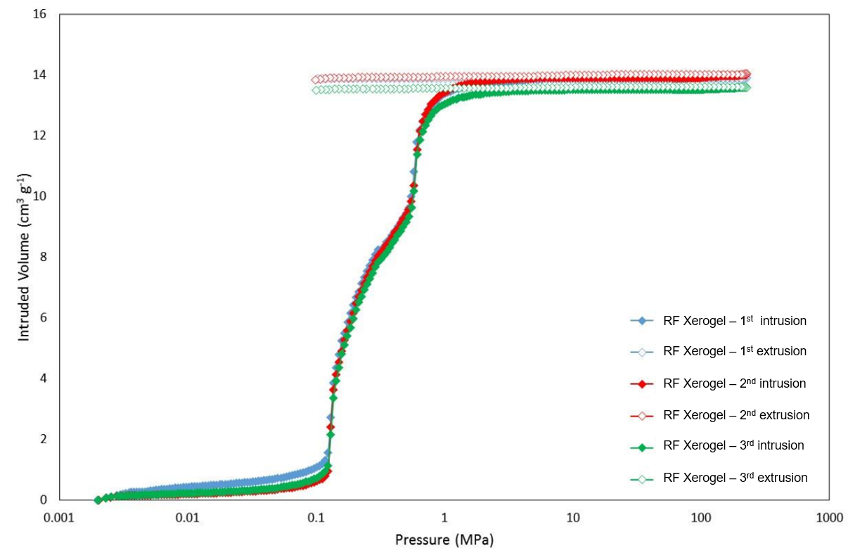
(A)
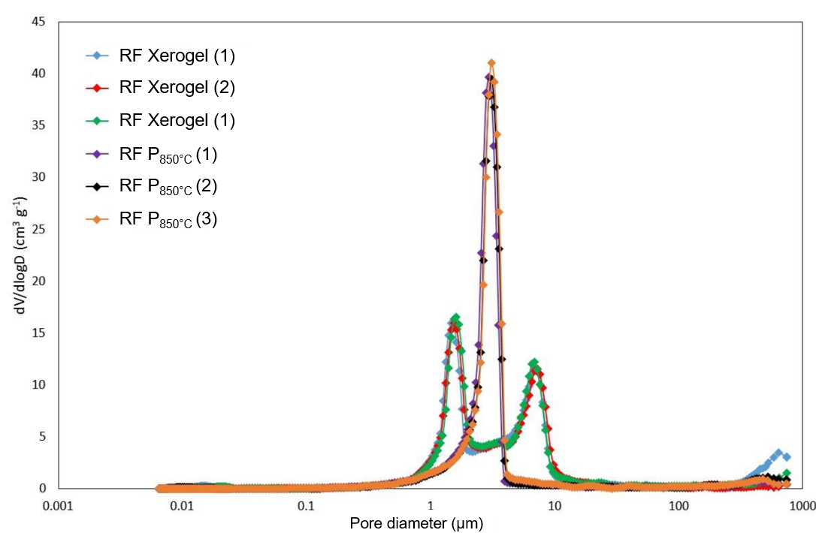
(B)
Figure S1: (A) Mercury intrusion and extrusion curves over the RF xerogel and carbogel samples measured; (B) Pore size distributions of the different samples from mercury porosimetry analysis in triplicates
Foremost, the table S2 shows good repeatability of the measurements between the two samples, with a small relative deviation, thus demonstrating their homogeneity. The same is true according to the pore size distribution curves presented in figure S1. We find that the pore size distribution of the non-pyrolyzed RF xerogel has a first peak at around 10 µm corresponding to the first mercury intrusion, then a second peak at around 2 µm corresponding to the second mercury intrusion. This confirms the fact that porosity is expressed in two types of pores of small size between 1 µm and 20 µm. On the other hand, regarding the pore size distribution of the RF carbogels pyrolyzed at 850°C, only one peak is observed for an average pore size of approximately 5 µm. We conclude that for these pyrolyzed materials, the porosity is expressed in a single type of pore, of a very small size, between 1 µm and 5 µm.
We also compared the structures of these different materials by SEM analysis with the ZEISS Gemini 300 device. A gold/palladium deposit was carried out on each sample before analysis in order to obtain better contrast. The images are presented in figure S2.
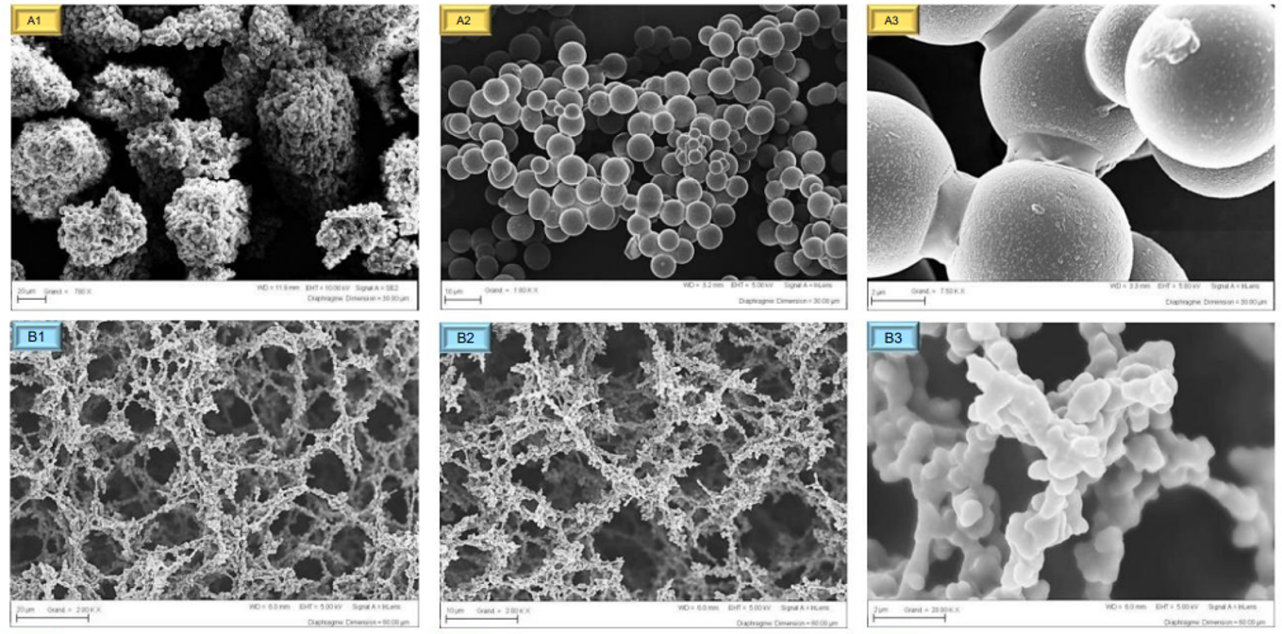
Figure S2: SEM images at scales of 20 µm, 10 µm and 2 µm (from left to right) for the non-pyrolyzed RF xerogel (A1, A2 and A3), for the RF carbogels pyrolyzed at 850°C (B1, B2 and B3)
The results of the impact of pyrolysis on the properties of the RF xerogel are in agreement with the literature. Indeed, the pore size distribution curve of the pyrolyzed material illustrated in figure S1 confirms the appearance of a microporous network within the material. These data are supported by the results obtained in table S1, Table S2 and figure S2. Indeed, we see that pyrolysis leads to a reduction in the pore volume (around 14 cm³.g⁻¹ for the RF Xerogel against ~7 cm³.g⁻¹ for the pyrolyzed carbogel), accompanied by the increase in the specific surface area (from 12 m².g⁻¹ for the RF Xerogel against ~600 m².g⁻¹ for the RF P_{850°C}) as well as the increase in apparent density (from 70 kg.m⁻³ for the RF Xerogel against 110 kg.m⁻³ for the RF P_{850°C}). In the same way, on the SEM images it clearly appears that the pore volume decreases with the increase in the pyrolysis temperature with the appearance of a microporous volume. This is in agreement with the increase in specific surface area observed by nitrogen adsorption/desorption. We also note that two types of pores are initially present (figure S2: A1, A2 and A3), of the order of 2 µm and 10 µm, then finally give way to a single type of pore (around 5 µm) following pyrolysis (figure S2: B1, B2 and B3). This observation, which marks the transition from non-pyrolyzed material to pyrolyzed material at 850°C, is in agreement with the pore size distribution curve obtained by mercury porosimetry as well as the observations from the elementary and TGA analysis presented in Table S1, indicating that the pyrolysis is almost complete.
S2.2: Vacuum sealing test
In order to ensure the proper sealing of the envelope, we carried out a test using a force sensor from the company GO TRONIC [2]. The sensor is supplied with 5 V and connects the mechanical stress to an output voltage. Indeed, a change in pressure in the envelope linked to the loss of vacuum leads to a change in the mechanical stress of the force sensor and therefore a different output signal, according to the following equation, specific to this sensor:
$Force= 15.311 ×e^{5.199\frac{output voltage}{input voltage }}$ Eq. SI
Thus, thanks to knowing the supply voltage of the input force sensor and by reading the output voltage, it is possible to determine the force in Newton exerted on the sensor in the vacuum envelope. Then, by knowing the surface of this sensor, we can determine the corresponding pressure. However, it is important to note that the value of the vacuum pressure is subject to a lot of uncertainty, in particular because of pressure losses. On the other hand, the force sensor used itself has its own uncertainty (of the order of 5%). Consequently, this measurement method is not made to calculate an exact value of pressure but rather to carry out comparative studies in order to evaluate pressure trends and deviations compared to a reference pressure between two different systems. We then carried out a sealing test by comparing the evolution of the pressure in the envelope containing the thermoelectric module using standard electrical cables (leading to a rapid loss of vacuum) and that in the envelope with the thermoelectric module using Cu electrical cables with a thickness of 250 µm from Next Tape. The results are shown in the figure S3 from which we first notice that the two systems experience a sudden rise in pressure from the first hours. This is certainly due to the degassing of the material, due to its high porosity. On the other hand, we note that the pressure tends to stabilize in the case of the use of copper cables with a thickness of 250 µm, while it continues to increase in the case of the use of standard electrical cables. Indeed, the blue curve quickly stabilizes around 0.015 mbar while the red curve has a pressure difference with the blue curve of around 0.07 mbar after 12 hours of acquisition then 0.31 mbar after 4 days acquisition. We can therefore conclude that the tightness of the envelope containing the module using the 250 µm thick copper electrical cables seems to be preserved over time. However, to ensure this, additional analysis, over longer periods with temperature variations, are necessary, but are not the subject of a study in this manuscript.
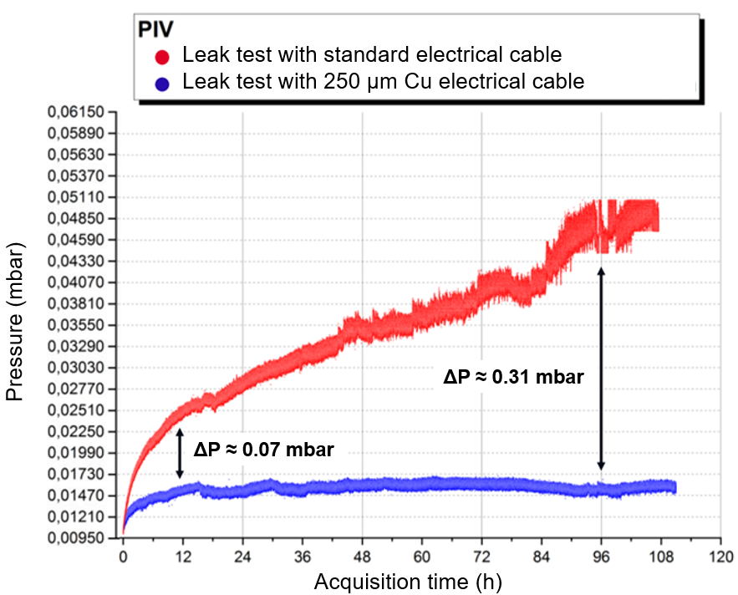
Figure: S3: Leak test with a GO TRONIC force sensor. Comparison of pressure differences between the thermoelectric module using standard electrical cables and that using Next Tape's 250 µm thick copper electrical cables.

Finally, we then produced our thermoelectric module in a vacuum envelope as shown in figure S4. However, before being able to test its performance, it is necessary to create a test bench allowing us to carry out our tests. So, this will be the subject of what follows.
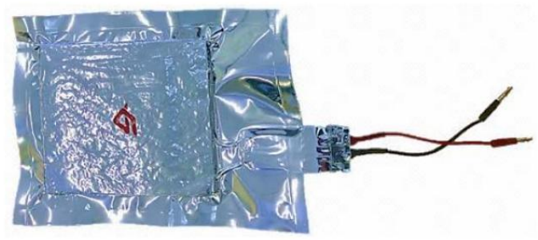
Figure S4: Photo of a vacuum thermoelectric module based on RF carbogel
S2.3: Creation of the test bench
In order to evaluate the performance of the thermoelectric module, we created a test bench that allows it to be characterized both thermally and electrically. Regarding the thermal part, we used a heating plate with different thermostats allowing us to control the maximum temperature to be reached on the hot side. On the hot-side, we would never exceed 75°C, due to the plastic nature of the vacuum envelope; whereas, a cold source, materialized by a tank of water with ice packs, allowed us to maintain the cold side at a temperature below 20°C throughout the duration of the test. Thus, the material placed between the hot source and the cold source undergoes a rise in temperature until reaching a temperature difference of around 50°C. The temperature is controlled using thermocouples placed on either side of the material and connected to a central acquisition unit. Once the desired temperature difference is reached, heating is stopped and the temperature difference begins to decrease until it reaches the ambient temperature on the hot side. Concerning the electrical part measuring the current and voltage is necessary using a multimeter. To determine the optimal operating point, namely the maximum power point (PPM), it is necessary to use a variable resistance device (rheostat) and to adjust the value of the resistance for which the no-load voltage delivered by the thermoelectric module is divided by two. This case occurs when an impedance adaptation is carried out so that the internal resistance of the module is equal to the load resistance [3, 4]. To do this, we used a decade box allowing the load resistance to be varied up to a precision of 0.01 Ω. Such a thermoelectric generator (TEG) of internal resistance R_{int}, associated with a load resistor R_{c} as well as a voltmeter in order to measure the output voltage VS can be modeled by an electrical diagram as shown in figure S5. Finally, the test bench used in this study is presented in the figure S6.
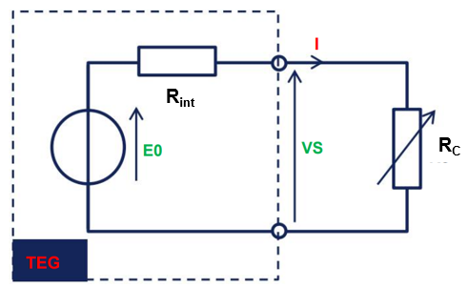
Figure: S5: Electrical diagram of the test bench allowing the characterization of the thermoelectric generator (TEG)
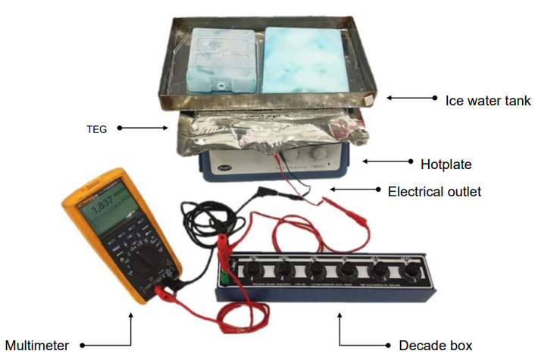
Figure: S6: Photo of the test bench allowing the characterization of the thermoelectric generator (TEG)
S2.4: Calculations of the power produced by the Seebeck effect
After creating an operational test bench as well as several thermoelectric modules based on doped and pyrolyzed RF carbogels, we evaluated their thermoelectric performance and compare these different results with the results of calculations based on the theoretical expressions mentioned in the literature [5, 6, 7] using the values of the experimentally measured TE properties reported in section 2.2. - taking into account the reduction in thermal conductivity due to the evacuation of the material. The mathematical formalism aimed at evaluating the performance of Seebeck effect thermoelectric modules is based on the combination of heat transfer equations and the standard equations of thermoelectricity which take into consideration the Seebeck, Fourier and Joule effects. Here, we will rely on three established models to obtain the electrical power provided by the thermoelectric module. They are as follows:
Model 1
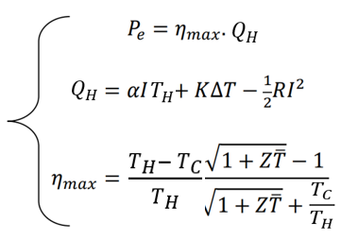
Eq. SIV
Eq. SIII
Eq. SII
Eq. SII
Model 2
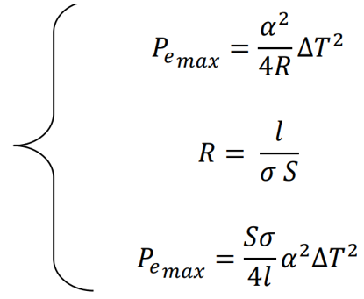
Eq. SVII
Eq. SVI
Eq. SV
Model 3

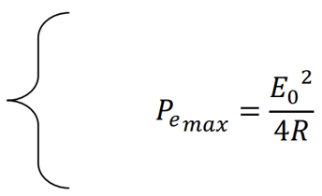
Eq. SVIII
where : ∆𝑇 = 𝑇_{H} – 𝑇_{C}, P_{e} is the electrical power generated, Q_{H} is the thermal power delivered by the hot source, η_{max} is the maximum thermoelectric efficiency, 𝐾 is the total thermal conductivity, 𝑅 is the internal electrical resistance, 𝛼 is the Seebeck coefficient of the material, 𝐼 is the current supplied by the thermoelectric module, 𝑙 is the thickness of the material, 𝑆 is the surface area of the material, 𝜎 is the electrical conductivity of the material, 𝐸₀ represents the no-load voltage delivered by the thermoelectric module.
Eq. SVIII
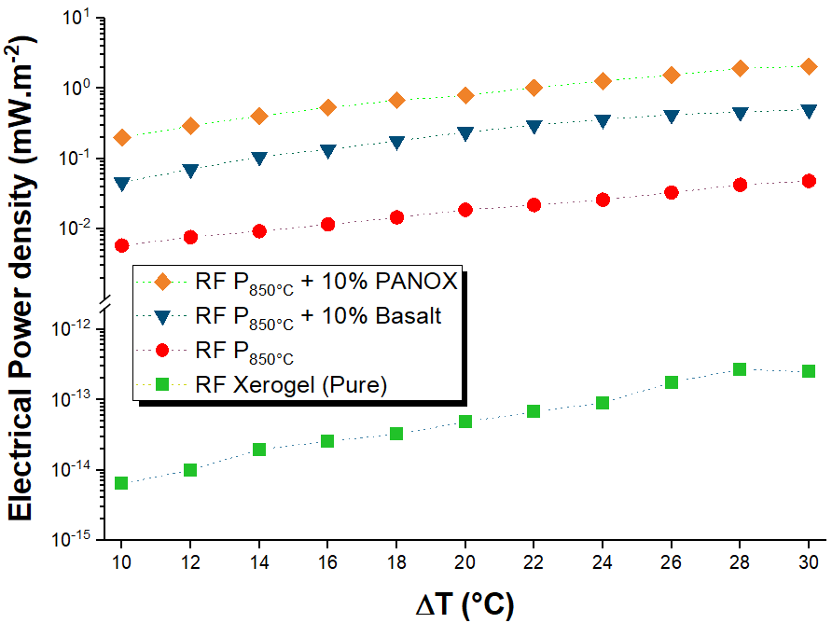
Figure S7: Electric power density of the different materials as a function of the temperature difference, obtained via the test bench using calculation model No. 3
Foremost, in order to evaluate the electrical power produced by the thermoelectric module via measurements on the test bench, we used the equation Eq. (SVIII) (model 3), which represents the measurement of the no-load voltage delivered by the generator divided by four times the value of the internal resistance (value for which the internal resistance of the module is equal to the load resistance). Then, we compared these results to the results of calculations based on the equations Eq. (SII) and Eq. (SVII) (models 1 and 2). For the equation Eq. (SII), we calculated the power produced from maximum thermoelectric efficiency 𝜂_{𝑚𝑎x}, via the equation Eq. (SIV). For this, we used the values ​​of ZT̅ obtained with our materials presented in section 2.2. For the expression for 𝑄_{H} in the equation Eq. (SIII), we neglected the first and last term corresponding respectively to the Peltier effect and the Joule effect. Therefore, only the term corresponding to Fourier's law (several tens of watts) is taken into account in this calculation. Indeed, in the context of this study, the current delivered by the thermoelectric module is very small (of the order of mA) and the Peltier and Joule terms, which depend on this current, become negligible compared to the Fourier term. Furthermore, it should be noted that in the case of materials with low thermoelectric properties (ZT̅ ≪ 1), the power delivered by the generator at its maximum efficiency is very close to its maximum power. This then makes it possible to compare the power values, carried out as part of this study. For the equation Eq. (SVII) we calculated the maximum power produced, using the values of the thermoelectric properties obtained with our materials and presented in section 2.2, taking into account their thickness and their section. The tests were carried out on samples with a thickness of 1 cm and a surface area of 50 cm², with a cold side temperature stabilized at 20°C and a hot side temperature varying from 30°C to 50°C. Thus, the maximum temperature difference reached for these tests is 30°C with an average temperature of 35°C. The results of this study are shown through the two graphs in figure S7 and figure S8 where the former represents the power density results obtained via the test bench using model 3 for all the materials.
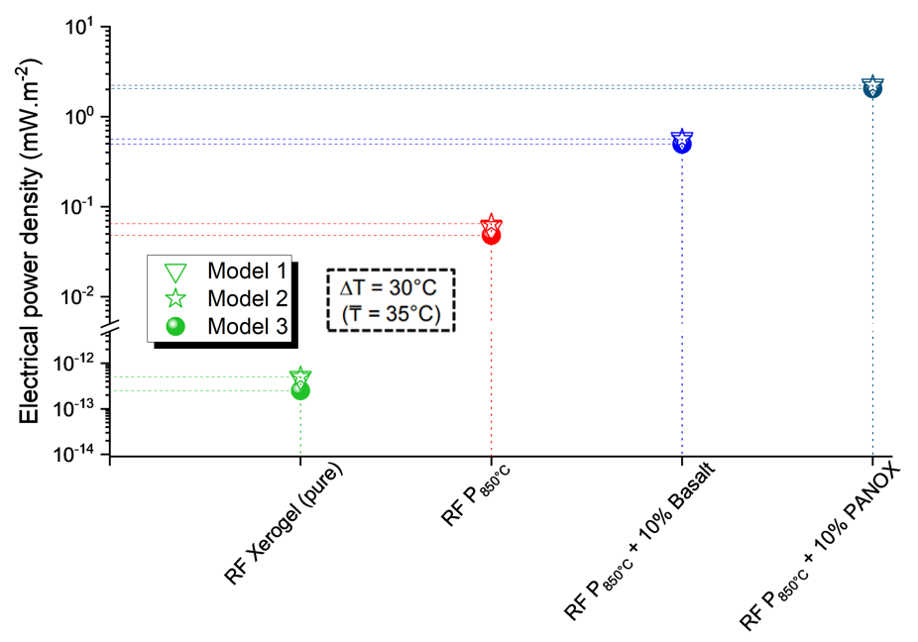
Figure S8: Comparison of the electrical power densities of the different materials, for a temperature difference of 30°C, according to the three calculation models
Figure S7 shows that the classification of materials in terms of power density is the same as that in terms of figure of merit (table 1 and figure 1), which is consistent with what could be expected. Then, we notice an almost linear evolution of the power produced per square meter as a function of temperature, which demonstrates that we could certainly have used our materials at higher temperatures (but always lower than 75°C), in order to achieve, for example, a temperature difference of around 50°C.Then, as an example, we compared these results with the models defined previously (model 1 and model 2), both arising from the same physical principle, for a maximum produced power density ΔT=30°C and shown in figure S8.
Figure S8 allows us first of all to conclude that the results obtained with the test bench via model 3 seem to be rather in agreement with models 1 and 2, which reinforces the reliability of these results. We see that the power densities produced from the test bench with model 3 are, however, still slightly lower than those expected via models 1 and 2. This difference is materialized on the graph by the dotted lines intersecting the ordinate axis. It is explained by the fact that models 1 and 2 consider ideal contact surfaces, while in reality, this is never really the case: the material has its own surface asperities, which no mathematical model can perfectly reproduce. Thus, this roughness will result in a larger contact surface between the material and the copper plates, which causes a slight increase in the electrical resistance of the module and therefore a lower density of electrical power produced. However, it should be noted that the differences recorded during these tests are very low and tend to decrease with the electrically conductive nature of the material (the more resistive the material, the greater the difference).
Finally, the best performing material for a temperature difference of 30°C is the RF carbogel with a doping rate of 10% in PANOX fibers and pyrolyzed at 850°C, with a value of the electrical power density produced of approximately 2 mW.m⁻². This value is greater than that of the initial material (non-doped and non-pyrolyzed) by 12 orders of magnitude. Consequently, the RF P850°C + 10% PANOX carbogel was the material chosen for the TVIP device because it is the one which arouses the most interest in industrial applications as explained in the Discussion section. To conclude this part and before presenting the most relevant applications using this type of material, we wanted to study the influence of parameters such as the thickness or surface area of the material on the value of the electrical power produced at the output. Thus, it will then be possible to determine an optimal surface and thickness depending on the type of application envisaged.
S2.5: Study of the influence of thickness and surface area of the material
We have seen that model 1 and 2 consider ideal contact surfaces, which could lead to certain deviations from reality, in particular with model 3. More generally, these different models show us that in theory, the electrical power increases with the surface area and varies as the inverse of the thickness. However, this consideration alone is not sufficient, we must be aware that modifying these parameters will also modify not only the different thermal flows involved for the electrical conversion but also the different contact resistances. Studies have shown that, for example in the case of conventional (non-thermal insulating) semiconductors, if we adopt an ideal model (in which contact resistances are neglected), we could achieve an output power close to infinity as long as the thickness of the material tends towards zero. However, in reality, by reducing the thickness of the sample below 1 mm, the contact resistances become significant and can no longer be neglected. We then deviate from the ideal model and the surface power increases with the reduction in the thickness of the material until reaching a maximum, before decreasing for an even lower material thickness. We then understand that the choice of the thickness of the material used by an industrialist will have repercussions on the targeted applications, particularly in the case of applications aimed at the conversion of thermal energy into electrical energy at low temperature, where the maximum power in exit is necessary.
As part of this work, the study of the influence of the thickness and surface area of the material on the density of electrical power produced was carried out with the selected material, namely the RF P850°C + 10% PANOX. We varied the thickness from 1 mm to 1 cm as well as the surface area from 50 cm² to 800 cm². The study was carried out with a temperature difference of 30°C and an average temperature of 35°C. We then compared the power values measured via the test bench (model 3) with the values calculated via model 2 which neglects the contact resistances. This study also makes it possible to identify the optimum parameters in terms of thickness and surface to choose, in order to have the greatest possible electrical power produced.
We calculated the percentage difference in power density values between the two models used using the following formula:
Eq. SIX
$\% deviation= \frac{Calculated power \left(model 2\right)-measured power (test bench)}{measured power (test bench)}$ × 100
The graph corresponding to this study appears in figure S9 which allows us to note a general trend, in agreement with the literature, namely that the difference between models 2 and 3 varies with the electrical power produced, shown by the color on the graph (the higher the power, the more the difference is significant). We see that this trend follows two phenomena (represented by the red arrows): the differences noted at a fixed thickness (1 cm), for a variable surface (left half of the graph) are less significant than the differences noted at a fixed surface (0.005 m²), for a variable thickness (right half of the graph). This indicates that the thickness of the material influences the contact resistances more than its surface area. Finally, it should be noted that a difference of 30% was noted for the material having both a large surface area and a low thickness. In addition to the difficulty of using such a material in a given application, this difference suggests moving towards materials with a large surface area but with a thickness of at least 2 mm - which was finalized for the VIP fabrication.
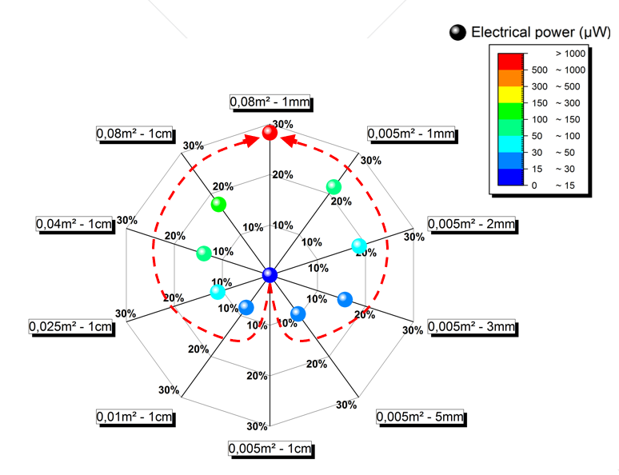
Figure S9: Calculation of the percentage difference between models 2 and 3 for the different materials
S2.6: Maximum operating point search
We identified, the maximum operating point (MOP), specific to our material, by modifying the value of the gain. This consisted of launching the same test several times on our test bench, that is to say, using the same material with the same temperature curves (at a cold side maintained at 20°C and a hot side up to 70°C) and modifying only the value of the gain. The results of this first test are shown in figure S10 which shows that the signal coming from the electronic card is very clean and allows clear readability of the value of the output voltage. Then, we also noticed that the output voltage increases with the gain value, until reaching the value of 12 mV around 10 min of acquisition. This value was obtained for a temperature difference of 50°C with a gain value equal to 20. This is the maximum gain value that this electronic card with our material can withstand, at such temperatures. Consequently, for the rest of the tests carried out, a gain value equal to 20 was used.
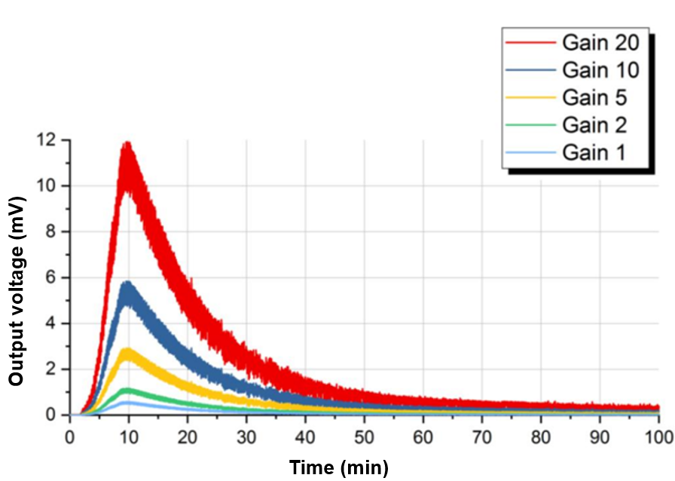
Figure S10: Representation of the TEG output voltage as a function of time during a heating cycle, for different gain values
S2.7: Repeatability tests
The second test consisted of checking the repeatability of the measurements. Thus, we carried out several heating cycles and compared the different voltage curves obtained, with the same material. Each heating cycle consists, via the heating plate, of reaching a temperature of approximately 70°C before allowing to cool to room temperature. The cold side temperature is maintained at around 20°C using a tank of iced water. The results of this test are shown in figure S11.
Figures 11 (A) and (B) show that the measurement is repeatable: they show similar output voltage curves, for almost identical heating cycles. Note that for each test, the voltage peak reached a value of approximately 12 mV around 10 min of acquisition before gradually decreasing with the decrease in the temperature difference. Following the repeatability tests, we were finally able to verify the feasibility of our failure system by evaluating the difference in the value of the output voltage between the case of a compliant material (TVIP) and the case of a failing material (not under vacuum).

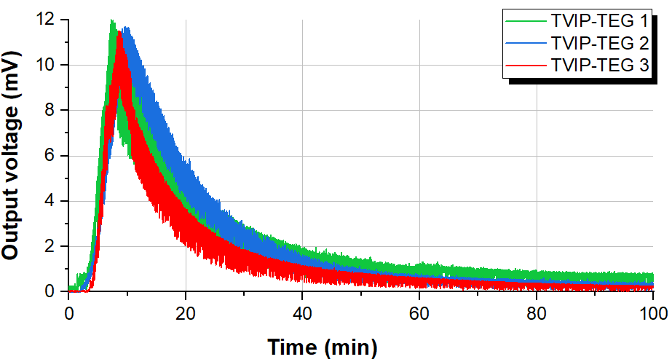
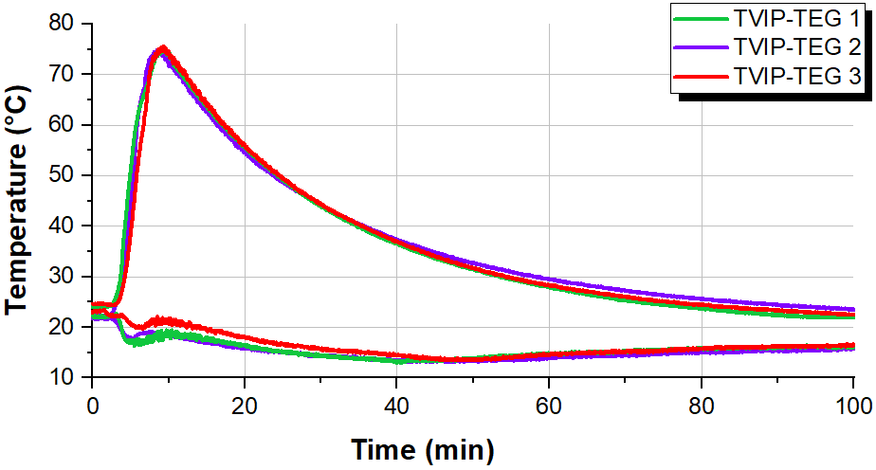
Figure S11: (A) Repeatability tests - Measurement of the output voltage delivered by the RF carbogel pyrolyzed at 850°C and fibered PANOX, as a function of time during a heating cycle; (B) Temperature curves associated with the graph representing the evolution of the output voltage as a function of time in figure S11 (A)
S2.8: Detection of vacuum failure with expected electrical powers
A second method to allow the detection of vacuum failure involves comparing the expected electrical powers (calculated from model 1 established in section S2.4) for 100 cm² of insulation, between a compliant material (TVIP) and a failing material as presented in figure S12. The top graph represents the evolution of the TE electrical power produced for a square meter of insulation under different temperature conditions and with a convection coefficient of 10 Wm⁻².K⁻¹ (representing the natural flow of the air on a wall for temperatures close to ambient temperature) in the case of a compliant material (under vacuum) and in the case of a failing material (with loss of vacuum). The bottom graph represents the evolution of the different temperatures: the hot side temperature curve (T_{H} - red curve) corresponds to the temperature of the environment outside the battery, with an increase (arbitrarily chosen) of 1°C per minute, up to 60°C. Although this does not necessarily reflect a use case, this study covers most situations likely to be encountered in reality. The temperature curves 𝑇_{C} (blue curves) correspond to the temperatures of the cold side (cooling system programmed at 10°C) for which an additional heat intake is observed due to the increase in temperature on the hot side. It will be noted that this contribution of heat is more important in the case of a failing material (light blue curve) than in the case of a compliant material (dark blue curve): the loss of vacuum increases the thermal conductivity, therefore the quantity of heat flow passing through the material is more important and therefore has repercussions on the cooling system which has difficulty maintaining the temperature at 10° C. This explains the greater temperature difference 𝑇_{H} – 𝑇_{C} in the case of a compliant material than in the case of a defective material.
The calculation of the power through model 1 (see section S2.4) corresponds to the product of the maximal efficiency 𝜂_{𝑚𝑎x} (which involves the expression of the figure of merit) and the thermal power delivered by the hot source. The overall thermal conductivity of the TVIP will be greater in the event of loss of vacuum. Thus, for our calculations we considered in the case of a compliant material, a thermal conductivity of the VIP such that 𝜆_{TVIP} = 12 𝑚𝑊.𝑚⁻¹.𝐾 ⁻¹ and in the case of a failing material a thermal conductivity equal to the thermal conductivity of the PANOX fibered RF carbogel, such as 𝜆_{failing} = 37 𝑚𝑊.𝑚⁻¹.𝐾 ⁻¹. The loss of vacuum is manifested by a contribution of additional thermal power which reflects the increase in thermal conductivity. The figure of merit then becomes much lower than in the case of a vacuum material (approximately divided by two) which results in a lower thermoelectric efficiency [14]. Furthermore, the temperature difference being higher in the case of a non-failing material, we logically observe a higher output power: the additional thermal power contribution due to the loss of vacuum is not enough to compensate for the reduction in thermoelectric efficiency as well as less significant temperature difference.
We calculated the electrical power density every 10 minutes for the two scenarios (failing material and compliant material (TVIP)), at a given temperature difference. The TVIP material is considered as a reference material: the indices from 0 to 5 on the graph correspond to the temperature difference recorded between the hot side and the cooling system in the case of a compliant material. Knowledge of the temperature difference associated with knowledge of the TE properties of the compliant material then allows us to draw the green curve as a reference curve. Therefore, if the output power obtained does not correspond to the associated temperature difference, then we will know that the material is deviating from the reference curve, i.e. it is no longer compliant. For all the parts of the figure S12, especially as the hot side temperature rises, the compliant material maintains a higher temperature difference than the failing material and as a result delivers a higher output power (values given in figure S12). This means that the difference in power output indicates the different temperature differences for a compliant and failing material which forms the basic operating principle for our failure detection system. Thus, via the reference curve (green curve), we can define an expected output electrical power range, within which we are certain of the tightness (or conformity) of the material. Therefore, for defined temperature conditions, if the output power is outside the expected values (with a certain pred-defined tolerance), it is possible to detect the loss of vacuum and thus, for example, preserve the battery life.
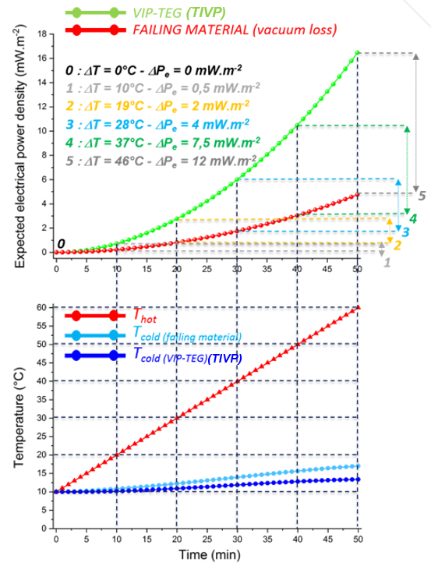
Figure S12: Failure detection in the context of the thermal insulation of a hybrid vehicle battery, with PANOX fibered RF carbogel pyrolyzed at 850°C, with a thickness of 2mm
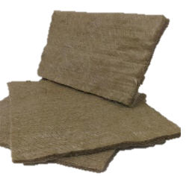
S3: Supplementary figures
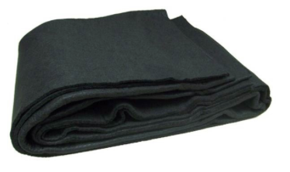
(B)
(A)

Figure S14: (A) Basalt fibers (B) Oxidized polyacrylonitrile fibers (PANOX)
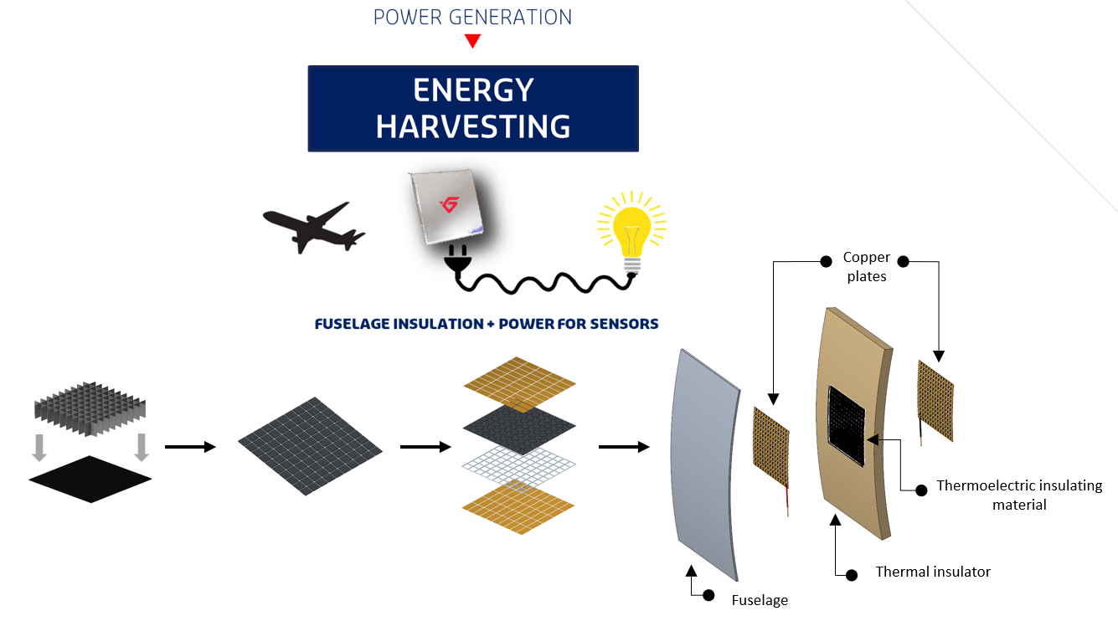
Figure S15: Assembly of a TVIP as part of the insulation of an aircraft cabin for sensor application

References
1. Al-Muhtaseb, S. A. & Ritter, J. A. Preparation and Properties of Resorcinol-Formaldehyde Organic and Carbon Gels. Advanced Materials 15, 101–114 (2003).
2. GoTronic | Robotique et composants électroniques. https://www.gotronic.fr/ (Accessed on 08/07/2024)
3. Montecucco, A., Siviter, J. & Knox, A. R. Simple, fast and accurate maximum power point tracking converter for thermoelectric generators. in: 2012 IEEE Energy Conversion Congress and Exposition (ECCE), IEEE, 2012, 2777-2783. https://ieeexplore.ieee.org/document/6342530
4. Lovatt, H. et al. Comparative study of maximum power point tracking algorithms for thermoelectric generators Comparative Study of Maximum Power Point Tracking Algorithms for Thermoelectric Generators. in: 2008 Australasian Universities Power Engineering Conference, IEEE, 2008, 1-6. https://citeseerx.ist.psu.edu/document?repid=rep1&type=pdf&doi=b4e94302583b7dc0613b9dd81374566fdaaa96d1
5. Rowe, D. M. CRC Handbook of Thermoelectrics. (CRC Press, 2018). https://doi.org/10.1201/9781420049718.
6. Lenoir, B., Michenaud, J.-P. & Dauscher, A. Thermoélectricité : des principes aux applications. Techniques de l’Ingénieur https://www.techniques-ingenieur.fr/base-documentaire/sciences-fondamentales-th8/proprietes-electriques-et-electrochimiques-42336210/thermoelectricite-des-principes-aux-applications-k730/ (2021). (Accessed on 08/07/2024)
7. Lee, H., Attar, A. M. & Weera, S. L. Performance Prediction of Commercial Thermoelectric Cooler Modules using the Effective Material Properties. Journal of Electronic Materials 44, 2157–2165 (2015).
8. Goldsmid, H. Porous Thermoelectric Materials. Materials 2, 903–910 (2009).

