Supplementary data to:

TOLL-LIKE RECEPTOR 3 (TLR3) AGONISTS IN A MULTI-PEPTIDE VACCINE FOR TFDP3 EXPRESSING CANCERS
Genilda Castro de Omena Neta^{1,2,} José Wilson Batista da Silva Junior¹, Rodger Marcel Lima Rocha¹, Ana Kelly da Silva Fernandes Duarte¹, Emisael Stênio Batista Gomes¹, Fernando Berton Zanchi³, Carolinne de Sales Marques⁴, Carlos Alberto de Carvalho Fraga¹*
1Federal University of Alagoas, Arapiraca, Alagoas, Brazil
2Federal Institute of Alagoas, Satuba, Alagoas, Brazil
3 Oswaldo Cruz Foundation of Rondônia (FIOCRUZ/RO), Porto Velho, RO, Brazil
4Institute of Biological and Health Sciences, Federal University of Alagoas, Maceió, Brazil.

*Corresponding author: Carlos Alberto de Carvalho Fraga, Federal University of Alagoas, Arapiraca, Alagoas. E-mail: carlos.fraga@arapiraca.ufal.br

Table S1: Antigenicity prediction of B lymphocyte linear epitopes identified from the ABCPred server by VaxiJen v2.0 server from the TFDP3 amino acid sequence (Uniprot Id.: Q5H9I0).

Nº | Rank | Epitopes | Starting position | Antigenicity
01 | 1 | QVVIGMPQRPAASNIP | 56 | 0.1440 (Probably non-antigenic)
02 | 2 | EQVSQRPLPNSVIHVP | 240 | 0.2557 (Probably non-antigenic)
03 | 3 | TPAVEEEEEEDNNDDD | 382 | -0.3379 (Probably non-antigenic)
04 | 3 | TSSGGSQYSGSRVETP | 368 | 1.0805 (Provável antigênico)
05 | 4 | VGSPNPPSTHFASQNQ | 73 | 0.3871 (Probably non-antigenic)
06 | 5 | YVTEMAQGTFGGVFTT | 328 | 0.2100 (Probably non-antigenic)
07 | 6 | RVERQKRLERIKQKQS | 201 | 1.6392 (Probably antigenic)
08 | 7 | CSISDDKSEYLFKFNS | 269 | 0.7976 (Probably antigenic)
09 | 8 | SSPPWAGQHNRKGEKN | 92 | 0.7683 (Probably antigenic)
10 | 8 | DVKNIKRRTYDALNVL | 156 | 1.0012(Probably antigenic)
11 | 9 | EVLMWMGMTFGLESGS | 293 | 0.3762 (Probably non-antigenic)
12 | 10 | SGSCSAEDLKMARNLV | 306 | 0.7467 (Probably antigenic)
13 | 11 | AGSRSNGTWLSASDLT | 344 | 0.5759 (Probably antigenic)
14 | 11 | PKALEPYVTEMAQGTF | 322 | 0.5497 (Provável antigênico)
15 | 12 | FGGVFTTAGSRSNGTW | 337 | 0.4762 (Probably non-antigenic)
16 | 12 | RRTYDALNVLMAMNII | 162 | 0.3039 (Probably non-antigenic)
17 | 13 | KWIGLTTNSAQNCQNL | 185 | 0.9308 (Probably antigenic)
18 | 14 | LGKQLLPKTFGQSSVN | 37 | -0.2896 (Probably non-antigenic)
19 | 14 | LMDENQTSRPVAVHTS | 17 | 0.5233 (Probably antigenic)
20 | 14 | LSMKVWETVQRKGTTS | 114 | 0.7633 (Probably antigenic)
21 | 15 | HNRKGEKNGMGLCRLS | 100 | 0.6524 (Probably antigenic)
22 | 16 | EDLKMARNLVPKALEP | 312 | 0.5484 (Probably antigenic)

Nº | Rank | Epitopes | Starting position | Antigenicity
23 | 16 | MAMNIISREKKKIKWI | 172 | 0.3109 (Probably non-antigenic)
24 | 17 | EANEELKVLMDENQTS | 9 | 0.8283 (Probably antigenic)
25 | 18 | PQRPAASNIPVVGSPN | 62 | 0.8037 (Probably antigenic))
26 | 18 | PFIIISSSKKTVINCS | 255 | 0.9013 (Probably antigenic)
27 | 18 | TNSAQNCQNLRVERQK | 191 | 0.9420 (Probably antigenic)
28 | 18 | NGMGLCRLSMKVWETV | 107 | 0.0887 (Probably non-antigenic)
29 | 19 | PNESAYDVKNIKRRTY | 150 | 0.6101 (Probably antigenic)
30 | 19 | FRAASNHASPNESAYD | 141 | 0.5059 (Probably antigenic)
31 | 19 | CQEVVGELVAKFRAAS | 130 | 0.2476 (Probably non-antigenic)
32 | 20 | PSTHFASQNQHSYSSP | 79 | 0.0757 (Probably non-antigenic)
33 | 20 | SFEIHDDTEVLMWMGM | 285 | 0.5467 (Probably antigenic)
34 | 20 | PVAVHTSTVNPLGKQL | 26 | 0.3596 (Probably non-antigenic)
35 | 20 | LILQQIAFKNLVLRNQ | 221 | 0.0429 (Probably non-antigenic)
36 | 21 | EEEEDNNDDDLSENDE | 388 | -0.5297 (Probably non-antigenic)
37 | 21 | TWLSASDLTNIAIGML | 351 | -0.1230 (Probably non-antigenic)
38 | 22 | IAIGMLATSSGGSQYS | 361 | 0.3029 (Probably non-antigenic)
39 | 23 | QRKGTTSCQEVVGELV | 123 | 0.4868 (Probably non-antigenic)
40 | 24 | KTFGQSSVNIDQQVVI | 44 | 0.0683 (Probably non-antigenic)

Table S2: Class I MHC epitopes predicted by DTU Health Tech server NetMHCI pan EL version 4.1b, antigenicity by VaxiJen v2.0 server, allergenicity by Vaxijen, AllerTOP v. 2.0, and toxicity by ToxinPred of TFDP3 amino acid sequence (Id. Uniprot: Q5H9I0).
Nº | Epitopes | Position | Alleles | Score_EL | %Rank_EL | Vaxijen Score | AllerTOP | ToxinPred
01 | SLTEANEEL | 06-14 | HLA-A*02:01 | 0.8332 | 0.091 | 1.1362 | Allergenic | Non-toxic
02 | NQTSRPVAV | 21-29 | HLA-B*08:01  HLA-B*39:01 | 0.3514  0.4856 | 0.409  0.235 | 0.7491 | Allergenic | Non-toxic
03 | RPVAVHTST | 25-33 | HLA-B*07:02 | 0.6647 | 0.247 | 0.6800 | Allergenic | Non-toxic
04 | KVWETVQRK | 117-125 | HLA-A*03:01  HLA-A*11:01  HLA-A*30:01  HLA-A*31:01 | 0.9684  0.9484  0.7264  0.6212 | 0.009  0.013  0.034  0.271 | 0.7471 | Non-allergenic | Non-toxic
05 | ELVAKFRAA | 136-144 | HLA-B*08:01 | 0.3110 | 0.482 | 0.7327 | Allergenic | Non-toxic
06 | SAYDVKNIK | 153-161 | HLA-A*03:01  HLA-A*11:01  HLA-A*30:01  HLA-A*68:01 | 0.5224  0.7552  0.5448  0.7907 | 0.412  0.128  0.127  0.273 | 0.6891 | Allergenic | Non-toxic
07 | TYDALNVLM | 164-172 | HLA-A*24:02 | 0.3598 | 0.454 | 0.9859 | Allergenic | Non-toxic
08 | DALNVLMAM | 166-174 | HLA-A*26:01  HLA-B*35:01 | 0.2776  0.6781 | 0.391  0.216 | 0.8599 | Non-allergenic | Non-toxic
09 | KRLERIKQK | 206-214 | HLA-B*27:05 | 0.8870 | 0.081 | 1.5955 | Non-allergenic | Non-toxic
10 | RIKQKQSEL | 210-218 | HLA-B*07:02  HLA-B*08:01  HLA-A*30:01 | 0.6583  0.8827  0.4942 | 0.252  0.022  0.174 | 1.5326 | Non-allergenic | Non-toxic
11 | KQSELQQLI | 214-222 | HLA-A*02:01  HLA-A*02:06 | 0.5099  0.8048 | 0.381  0.085 | 1.2705 | Allergenic | Non-toxic
12 | SISDDKSEY | 270-278 | HLA-A*01:01  HLA-A*26:01  HLA-B*15:01  HLA-B*35:01 | 0.4878  0.4824  0.6114  0.4737 | 0.305  0.181  0.303  0.412 | 0.6114 | Non-allergenic | Non-toxic

Nº | Epitopes | Position | Alleles | Score_EL | %Rank_EL | Vaxijen Score | AllerTOP | ToxinPred
13 | ISDDKSEYL | 271-279 | HLA-A*01:01 | 0.5920 | 0.291 | 0.9410 | Non-allergenic | Non-toxic
14 | YLFKFNSSF | 278-286 | HLA-A*23:01  HLA-B*15:01  HLA-B*35:01 | 0.3216  0.8997  0.4225 | 0.463  0.046  0.471 | 0.5255 | Allergenic | Non-toxic
15 | IHDDTEVLM | 288-296 | HLA-B*39:01 | 0.8435 | 0.041 | 1.1254 | Allergenic | Non-toxic
16 | AGSRSNGTW | 344-352 | HLA-B*58:01 | 0.6239 | 0.352 | 0.5672 | Non-allergenic | Non-toxic
17 | ATSSGGSQY | 367-375 | HLA-A*01:01  HLA-A*11:01  HLA-A*26:01  HLA-B*15:01 | 0.9469  0.4950  0.5364  0.7334 | 0.033  0.384  0.142  0.171 | 1.3318 | Non-allergenic | Non-toxic

Table S3: Class II MHC epitopes predicted by DTU Health Tech server NetMHCIIpan EL version 4.0 method, antigenicity by VaxiJen v2.0 server, allergenicity by Vaxijen, AllerTOP v. 2.0, toxicity by ToxinPred and IFN-gamma induction by IFNepitope of TFDP3 amino acid sequence (Id. Uniprot: Q5H9I0).
Nº | Epitopes | Position | Alleles  (HLA) | Score_EL | %Rank_EL | Vaxijen  Score | AllerTOP | ToxinPred | IFNepitope  Score
01 | EELKVLMDENQTSRP | 90-104 | DRB1*04:03  DRB1*04:04  DRB1*04:08  DRB4*01:01  DRB4*01:03 | 0.7720  0.8830  0.7095  0.3089  0.3089 | 0.63  0.30  0.93  1.07  1.07 | 0.8142 | Allergenic | Non-toxic | 0.2358
02 | ELKVLMDENQTSRPV | 91-105 | DRB1*03:01  DRB1*03:05  DRB1*04:01  DRB1*04:02  DRB1*14:02  DRB3*01:01 | 0.7958  0.3441  0.8463  0.4481  0,2754  0.3527 | 0.59  1.18  0.30  1.98  1.40  1.58 | 0.6150 | Non-allergenic | Non-toxic | 0.1279
03 | SPPWAGQHNRKGEKN | 171-185 | DRB1*01:03  DRB1*04:01  DRB1*04:02  DRB1*04:08 | 0.5155  0.6320  0.5223  0.6226 | 1.49  1.17  1.40  1.47 | 0.8473 | Non-allergenic | Non-toxic | 0.0991
04 | VGELVAKFRAASNHA | 212-226 | DRB1*11:01  DRB1*11:04  DRB1*13:01 | 0.7823  0.8736  0.7578 | 1.06  0.49  0.88 | 0.6633 | Non-allergenic | Non-toxic | 0.3296

Nº | Epitopes | Position | Alleles  (HLA) | Score_EL | %Rank_EL | Vaxijen  Score | AllerTOP | ToxinPred | IFNepitope  Score
05 | VAKFRAASNHASPNE | 216-230 | DRB1*01:01  DRB1*01:02  DRB1*01:03  DRB1*04:01  DRB1*04:02  DRB1*04:03  DRB1*04:04  DRB1*04:05  DRB1*04:08  DRB1*07:01  DRB1*08:01  DRB1*08:03  DRB1*09:01  DRB1*10:01  DRB1*11:01  DRB1*13:02  DRB1*13:03  DRB1*14:02  DRB3*16:01  DRB3*02:02  DRB5*01:01 | 0.8185  0.6749  0.8596  0.9648  0.7936  0.8369  0.8137  0.7747  0.9705  0.5955  0.8039  0.6552  0.7627  0.8818  0.8945  0.5445  0.5673  0.4478  0.9201  0.6220  0.8515 | 0.79  1.63  0.17  0.03  0.26  0.33  0.60  0.58  0.02  1.19  0.60  0.32  0.34  0.19  0.47  0.68  1.79  0.25  0.09  0.38  0.19 | 0.6149 | Non-allergenic | Non-toxic | 0.4843
06 | KWIGLTTNSAQNCQN | 263-277 | DRB3*02:02 | 0.4246 | 0.85 | 0.8402 | Allergenic | Toxic | 0.0223

(A) (B)
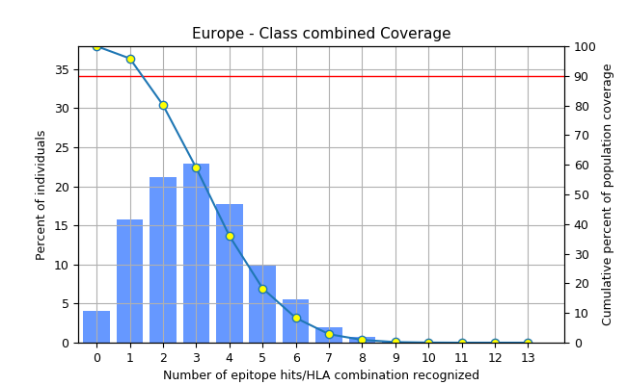Coveragea = 95.88%, Average hitb = 3.02, PC90c = 1.37 | 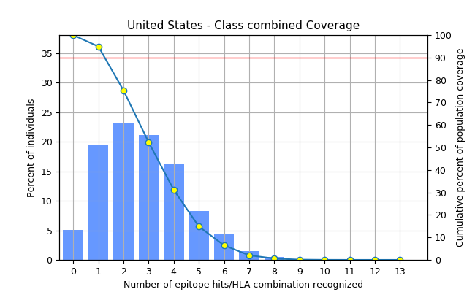Coveragea = 94.93%, Average hitb = 2.78, PC90c = 1.25

(C) (D)
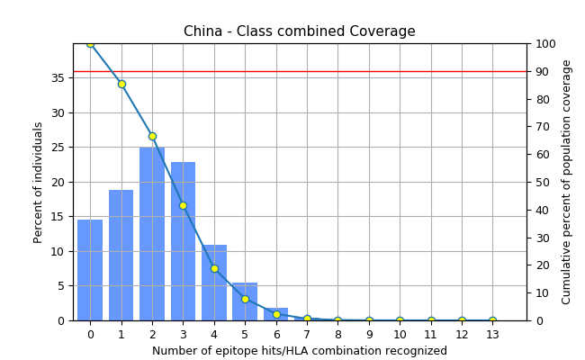Coveragea = 85.48%, Average hitb = 2.24 , PC90c = 0.69 | 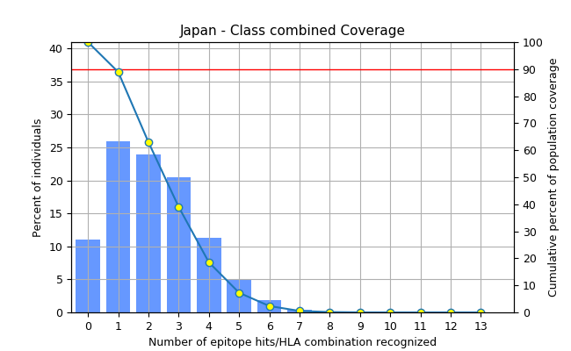Coveragea = 88.94%, Average hitb = 2.2, PC90c = 0.90

(E)  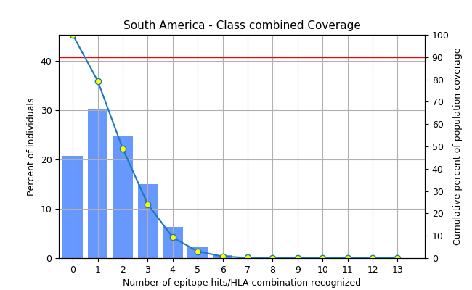Coveragea = 79.29%, Average hitb = 1.66, PC90c = 0.48 | (F)  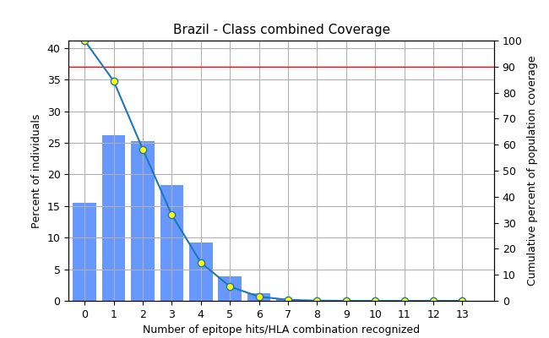Coveragea = 84.45%, Average hitb = 1.98, PC90c = 0.64

(G)
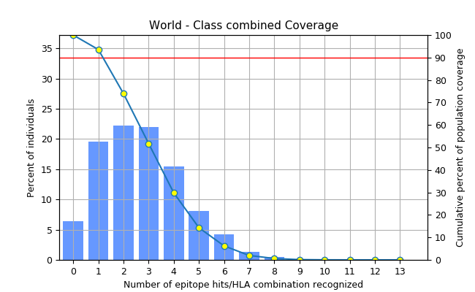
Coveragea = 93.55%, Average hitb = 2.72, PC90c = 1.18

Supplementary Figure 1: Frequency of epitope coverage for class I and class II MHC in Europe (A), United States (B), China (C), Japan (D), South America (E), Brazil (F), and world (G). In the graph, the line (-o-) represents the cumulative percentage of the population covered by epitope information; The bars represent the population cover for each epitope. Legend: aprojected population coverage; baverage number of epitope hits / HLA combinations recognized by the population; and cminimum number of epitope hits / HLA combinations recognized by 90% of the population.

(A) (B)
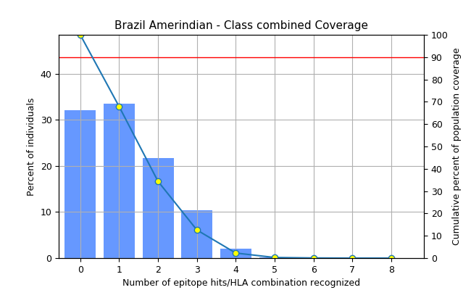Coveragea = 67.87%, Average hitb = 1.17, PC90c = 0.31 | 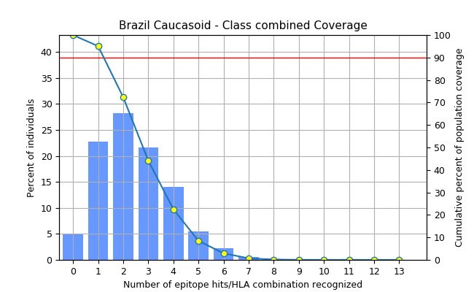Coveragea = 95.06%, Average hitb = 2.46, PC90c = 1.22

(C) (D)
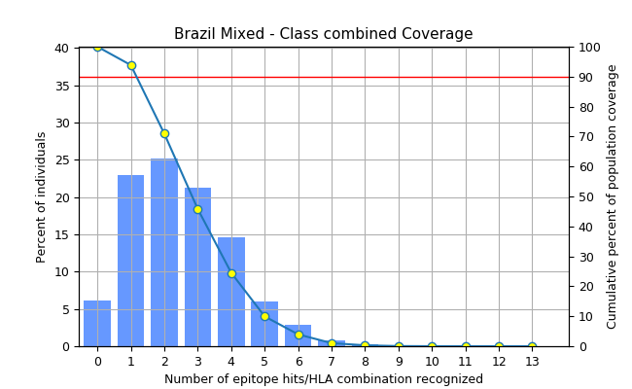Coveragea = 93.85%, Average hitb = 2.5, PC90c = 1.17  (C) | 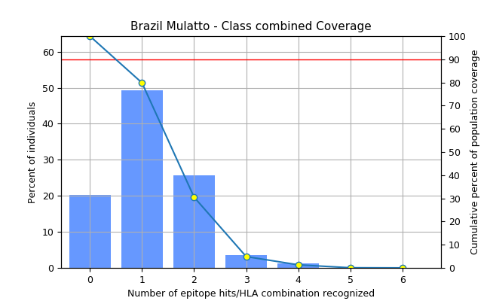Coveragea = 79.84%, Average hitb = 1.17, PC90c = 0.5  (D)

Supplementary Figure 2: Frequency of population coverage of epitopes for class I and class II MHC in Brazil in relation to the following ethnicities: (A) Amerindians (indigenous to the American continent), (B) Caucasoid, (C) Miscegenated and (D) Mulatto. In the graph, the line (-o-) represents the cumulative percentage of the population covered by epitope information; The bars represent the population cover for each epitope. Legend: aprojected population coverage; baverage number of epitope hits / HLA combinations recognized by the population; and cminimum number of epitope hits / HLA combinations recognized by 90% of the population.

Table S4: Regions of cleavage via proteosome in the multi-epitope vaccine determined by NetChop-3.1 server.
Position | Amino acid | Score
6 | M | 0.767197
9 | L | 0.948119
14 | L | 0.772514
15 | L | 0.606073
21 | M | 0.958705
23 | L | 0.814710
24 | L | 0.945871
31 | K | 0.877920
32 | K | 0.894004
33 | F | 0.973249
37 | F | 0.888499
39 | V | 0.944204
47 | V | 0.747797
49 | A | 0.866138
50 | A | 0.597946
59 | V | 0.954352
61 | A | 0.927086
68 | F | 0.520760
72 | L | 0.971231
74 | A | 0.969401
85 | V | 0.893616
87 | R | 0.645251
89 | I | 0.552810
93 | L | 0.935110
95 | L | 0.889264
96 | K | 0.782071

Position | Amino acid | Score
102 | V | 0.877142
109 | L | 0.813520
110 | L | 0.672621
112 | K | 0.941753
113 | V | 0.963759
115 | K | 0.962449
125 | L | 0.971433
132 | V | 0.756099
134 | V | 0.947510
135 | K | 0.798438
136 | K | 0.949445
137 | K | 0.761428
139 | V | 0.813104
141 | R | 0.798186
143 | K | 0.534378
145 | L | 0.964939
148 | I | 0.611520
151 | K | 0.967083
154 | K | 0.822561
155 | K | 0.803758
159 | A | 0.924226
165 | L | 0.605385
167 | V | 0.838117
172 | K | 0.895885
173 | K | 0.948912
186 | R | 0.736181
189 | V | 0.722297

Position | Amino acid | Score
196 | L | 0.968505
198 | V | 0.970855
199 | L | 0.691823
200 | M | 0.968905
207 | R | 0.962489
209 | V | 0.954901
218 | W | 0.976589
222 | H | 0.613734
223 | N | 0.660432
224 | R | 0.970029
225 | K | 0.967816
228 | K | 0.884997
237 | K | 0.769446
238 | F | 0.978322
240 | A | 0.931184
252 | Y | 0.925987
254 | V | 0.942242
255 | W | 0.580737
258 | V | 0.926708
260 | R | 0.562747
261 | K | 0.966924
264 | Y | 0.960613
266 | I | 0.737522
273 | Y | 0.971492
274 | A | 0.708001
275 | A | 0.576302
276 | Y | 0.962084

Position | Amino acid | Score
277 | A | 0.720212
285 | Y | 0.973769
287 | H | 0.613209
289 | H | 0.694461
291 | H | 0.662215

Symbols of amino acids: Alanine (A), Phenylalanine (F), Histidine (H), Isoleucine (I), Lysine (K), Leucine (L), Methionine (M), Asparagine (N), Arginine (R), Valine (V), Tryptophan (W), and Tyrosine (Y).
Table S5: Peptides with high binding affinity to TAP predicted by TAPPred server.
Rank | Position | Sequence | Score
1 | 153 | SKKTNSAQN | 8.645
2 | 245 | ASPNEAAYK | 8.644
3 | 28 | DFVKKFEET | 8.636
4 | 242 | SNHASPNEA | 8.636
5 | 116 | EAADEAKAK | 8.634
6 | 102 | VDGAPKPLL | 8.634
7 | 162 | CQNLRVERQ | 8.633
8 | 269 | DKSEYAAYA | 8.623
9 | 205 | TSRPVGPGP | 8.616
10 | 247 | PNEAAYKVW | 8.612
11 | 138 | RVERQKRLE | 8.593
12 | 115 | KEAADEAKA | 8.590
13 | 60 | EAAEEQSEF | 8.584
14 | 255 | WETVQRKAA | 8.555
15 | 261 | KAAYSISDD | 8.533
16 | 32 | KFEETFEVT | 8.524
Rank | Position | Sequence | Score
17 | 37 | FEVTAAAPV | 8.523
18 | 48 | AAAGAAPAG | 8.516
19 | 188 | LVGPGPGEL | 8.490
20 | 129 | GATVTVKKK | 8.472
21 | 181 | DLKMARNLV | 8.434
22 | 266 | ISDDKSEYA | 8.427
23 | 75 | AGDKKIGVI | 8.413
24 | 122 | KAKLEAAGA | 8.385
25 | 105 | APKPLLEKV | 8.345
26 | 197 | KVLMDENQT | 8.339
27 | 33 | FEETFEVTA | 8.328
28 | 268 | DDKSEYAAY | 8.318
29 | 64 | EQSEFDVIL | 8.311
30 | 81 | GVIKVVREI | 8.291
31 | 270 | KSEYAAYAT | 8.289
32 | 36 | TFEVTAAAP | 8.276
33 | 167 | VERQKKKSG | 8.276
34 | 235 | VAKFRAASN | 8.263
35 | 23 | LLELSDFVK | 8.259
36 | 67 | EFDVILEAA | 8.234
37 | 42 | AAPVAVAAA | 8.144
38 | 100 | DLVDGAPKP | 8.130
39 | 84 | KVVREIVSG | 8.127
40 | 158 | SAQNCQNLR | 8.059
41 | 97 | EAKDLVDGA | 8.056
42 | 200 | MDENQTSRP | 8.048
43 | 155 | KTNSAQNCQ | 8.048
44 | 163 | QNLRVERQK | 8.002

Rank | Position | Sequence | Score
45 | 113 | VAKEAADEA | 7.972
46 | 53 | APAGAAVEA | 7.935
47 | 39 | VTAAAPVAV | 7.888
48 | 21 | MTLLELSDF | 7.865
49 | 259 | QRKAAYSIS | 7.865
50 | 168 | ERQKKKSGS | 7.828
51 | 6 | MAKLSTDEL | 7.807
52 | 22 | TLLELSDFV | 7.762
53 | 123 | AKLEAAGAT | 7.702
54 | 170 | QKKKSGSCS | 7.638
55 | 257 | TVQRKAAYS | 7.634
56 | 180 | EDLKMARNL | 7.562
57 | 175 | AYATSSGGS | 7.560
58 | 9 | LSTDELLDA | 7.552
59 | 128 | AGATVTVKK | 7.544
60 | 125 | LEAAGATVT | 7.527
61 | 25 | ELSDFVKKF | 7.500
62 | 50 | AGAAPAGAA | 7.488
63 | 110 | LEKVAKEAA | 7.480
64 | 126 | EAAGATVTV | 7.469
65 | 150 | QKQSKKTNS | 7.305
66 | 243 | NHASPNEAA | 7.084
67 | 201 | DENQTSRPV | 7.080
68 | 44 | PVAVAAAGA | 7.068
69 | 218 | WAGQHNRKG | 6.957
70 | 149 | KQKQSKKTN | 6.813
71 | 63 | EEQSEFDVI | 6.745

Rank | Position | Sequence | Score
72 | 61 | AAEEQSEFD | 6.709
73 | 104 | GAPKPLLEK | 6.651
74 | 49 | AAGAAPAGA | 6.650
75 | 98 | AKDLVDGAP | 6.627
76 | 154 | KKTNSAQNC | 6.604
77 | 132 | VTVKKKRVE | 6.583
78 | 51 | GAAPAGAAV | 6.583
79 | 57 | AAVEAAEEQ | 6.573
80 | 120 | EAKAKLEAA | 6.555
81 | 237 | KFRAASNHA | 6.550
82 | 121 | AKAKLEAAG | 6.532
83 | 29 | FVKKFEETF | 6.411
84 | 171 | KKKSGSCSA | 6.382
85 | 145 | LERIKQKQS | 6.352
86 | 199 | LMDENQTSR | 6.330
87 | 147 | RIKQKQSKK | 6.281
88 | 18 | KEMTLLELS | 6.279
89 | 114 | AKEAADEAK | 6.254
90 | 151 | KQSKKTNSA | 6.197
91 | 62 | AEEQSEFDV | 6.185
92 | 234 | GVAKFRAAS | 6.157
93 | 176 | SCSAEDLKM | 6.155
94 | 267 | SDDKSEYAA | 6.143
95 | 46 | AVAAAGAAP | 6.118
96 | 77 | DKKIGVIKV | 6.004

Table S6: Phosphorylation sites in the multi-epitope vaccine by NetPhos v.3.1 server.
Position | Residue | Sequence | Kinases | Score
10 | S | MAKLSTDEL | Unspecific | 0.972
10 | S | MAKLSTDEL | PKA | 0.639
10 | S | MAKLSTDEL | CKII | 0.579
10 | S | MAKLSTDEL | PKG | 0.526
11 | T | AKLSTDELL | CKII | 0.502
22 | T | FKEMTLLEL | Unspecific | 0.580
22 | T | FKEMTLLEL | CKII | 0.513
36 | T | KFEETFEVT | Unspecific | 0.727
66 | S | AEEQSEFDV | CKII | 0.584
66 | S | AEEQSEFDV | Unspecific | 0.569
66 | S | AEEQSEFDV | CKI | 0.515
131 | T | AAGATVTVK | PKC | 0.821
133 | T | AAGATVTVK | PKC | 0.939
133 | T | AAGATVTVK | Unspecific | 0.814
153 | S | KQKQSKKTN | Unspecific | 0.984
153 | S | KQKQSKKTN | PKC | 0.895
153 | S | KQKQSKKTN | cdc2 | 0.512
156 | T | QSKKTNSAQ | PKC | 0.600
158 | S | KKTNSAQNC | PKA | 0.531
174 | S | QKKKSGSCS | Unspecific | 0.995
174 | S | QKKKSGSCS | PKA | 0.526
174 | S | QKKKSGSCS | RSK | 0.502
176 | S | KKSGSCSAE | Unspecific | 0.982
176 | S | KKSGSCSAE | PKA | 0.647

Position | Residue | Sequence | Kinases | Score
178 | S | SGSCSAEDL | Unspecific | 0.996
205 | T | DENQTSRPV | Unspecific | 0.986
205 | T | DENQTSRPV | PKC | 0.647
215 | S | PGPGSPPWA | cdk5 | 0.694
215 | S | PGPGSPPWA | Unspecific | 0.693
215 | S | PGPGSPPWA | GSK3 | 0.536
215 | S | PGPGSPPWA | p38MAPK | 0.519
242 | S | FRAASNHAS | Unspecific | 0.964
242 | S | FRAASNHAS | PKC | 0.656
242 | S | FRAASNHAS | RSK | 0.563
242 | S | FRAASNHAS | PKA | 0.556
246 | S | SNHASPNEA | Unspecific | 0.938
246 | S | SNHASPNEA | GSK3 | 0.501
252 | Y | NEAAYKVWE | Unspecific | 0.606
257 | T | KVWETVQRK | PKC | 0.700
264 | Y | RKAAYSISD | Unspecific | 0.741
265 | S | KAAYSISDD | Unspecific | 0.997
267 | S | KAAYSISDD | CKII | 0.615
271 | S | SDDKSEYAA | Unspecific | 0.990
271 | S | SDDKSEYAA | CKII | 0.508
273 | Y | DKSEYAAYA | Unspecific | 0.952
273 | Y | DKSEYAAYA | SRC | 0.533
273 | Y | DKSEYAAYA | EGFR | 0.506
273 | Y | DKSEYAAYA | INSR | 0.503
280 | S | YATSSGGSQ | PKC | 0.663
280 | S | YATSSGGSQ | Unspecific | 0.515
283 | S | SSGGSQYHH | Unspecific | 0.971
283 | S | SSGGSQYHH | DNAPK | 0.636
283 | S | SSGGSQYHH | ATM | 0.540
283 | S | SSGGSQYHH | PKC | 0.540
Kinase abbreviations: PKA (protein kinase A), CKII (casein kinase 2), PKG (cGMP-dependent protein kinase), CKI (casein kinase 1), PKC (protein kinase C), cdc2 (cyclin-dependent kinase 2), RSK (ribosomal S6 kinase), cdk5 (cyclin-dependent kinase 5), GSK3 (glycogen synthase kinase 3), p38MAPK (p38 mitogen-activated protein kinases), SRC (tyrosine kinase receptor), EGFR (epidermal growth factor receptor), INSR (insulin receptor), DNAPK (DNA-dependent protein kinase), and ATM (serine/threonine protein kinase).

- Model 1 | - Model 2 | - Model 3
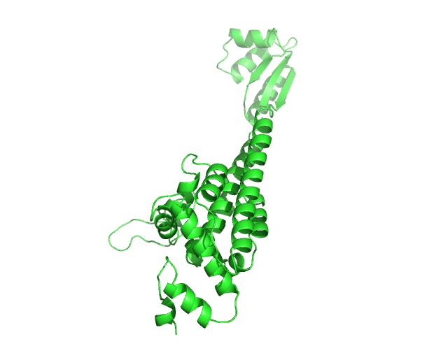 | 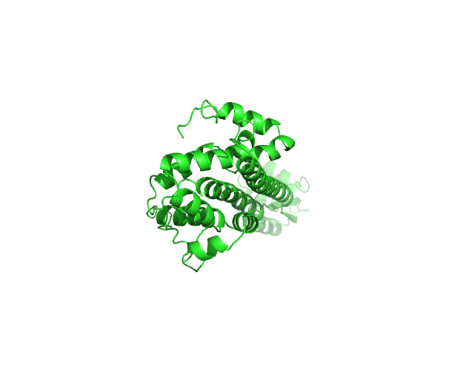 | 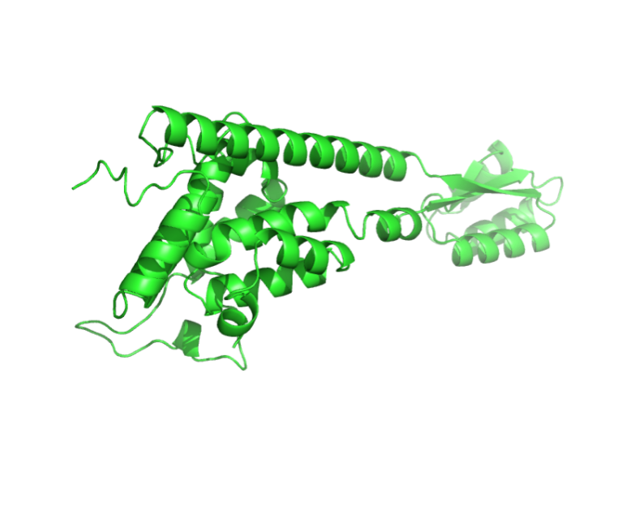
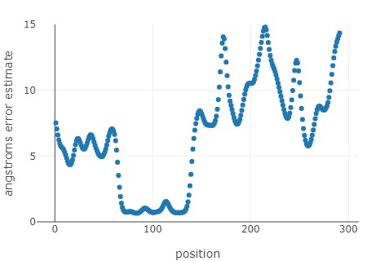 | 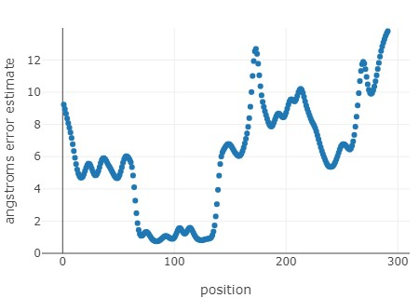 | 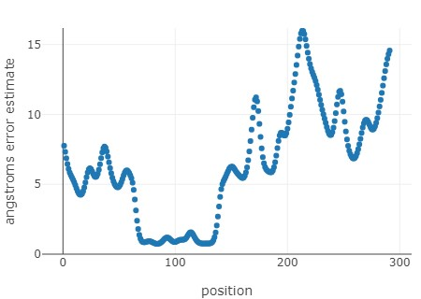

(D) Model 4 | (E) Model 5
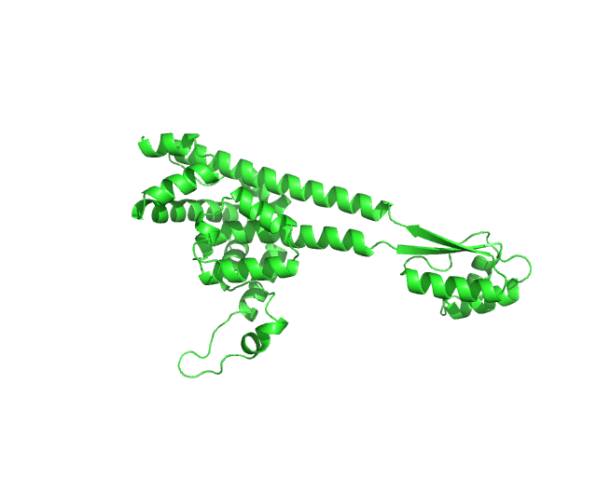 | 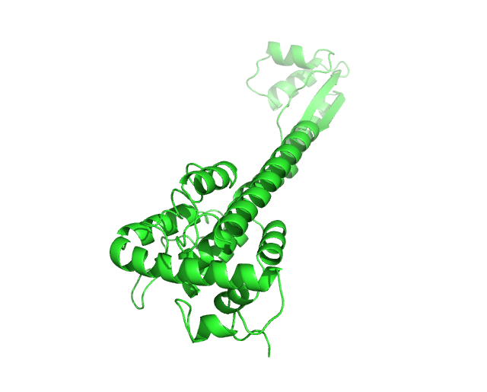
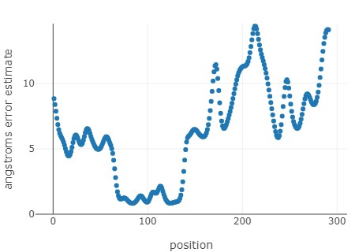 | 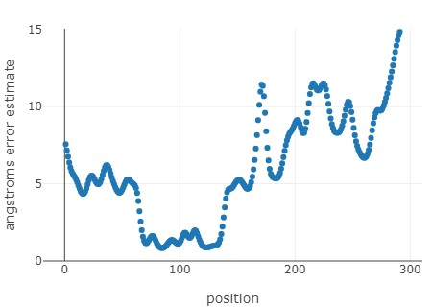
Supplementary Figure 3: Tertiary structure models predicted by ROBETTA server (RoseTTAFold method) and their estimates of error in relation to amino acid position (A-E).

- Model 1
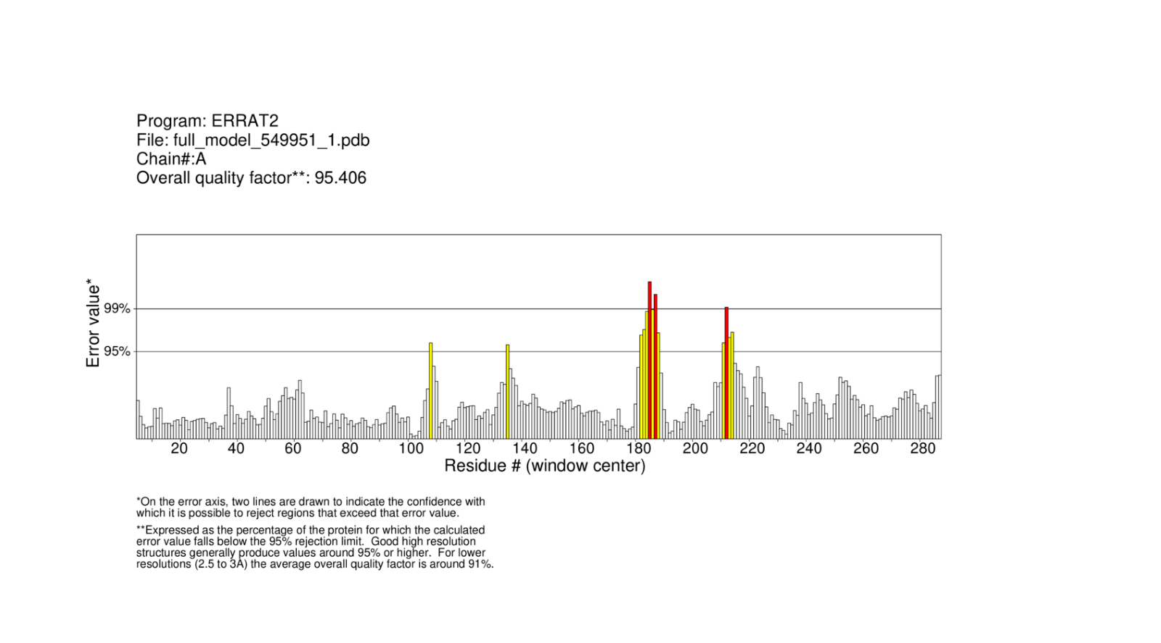

(B) Model 2
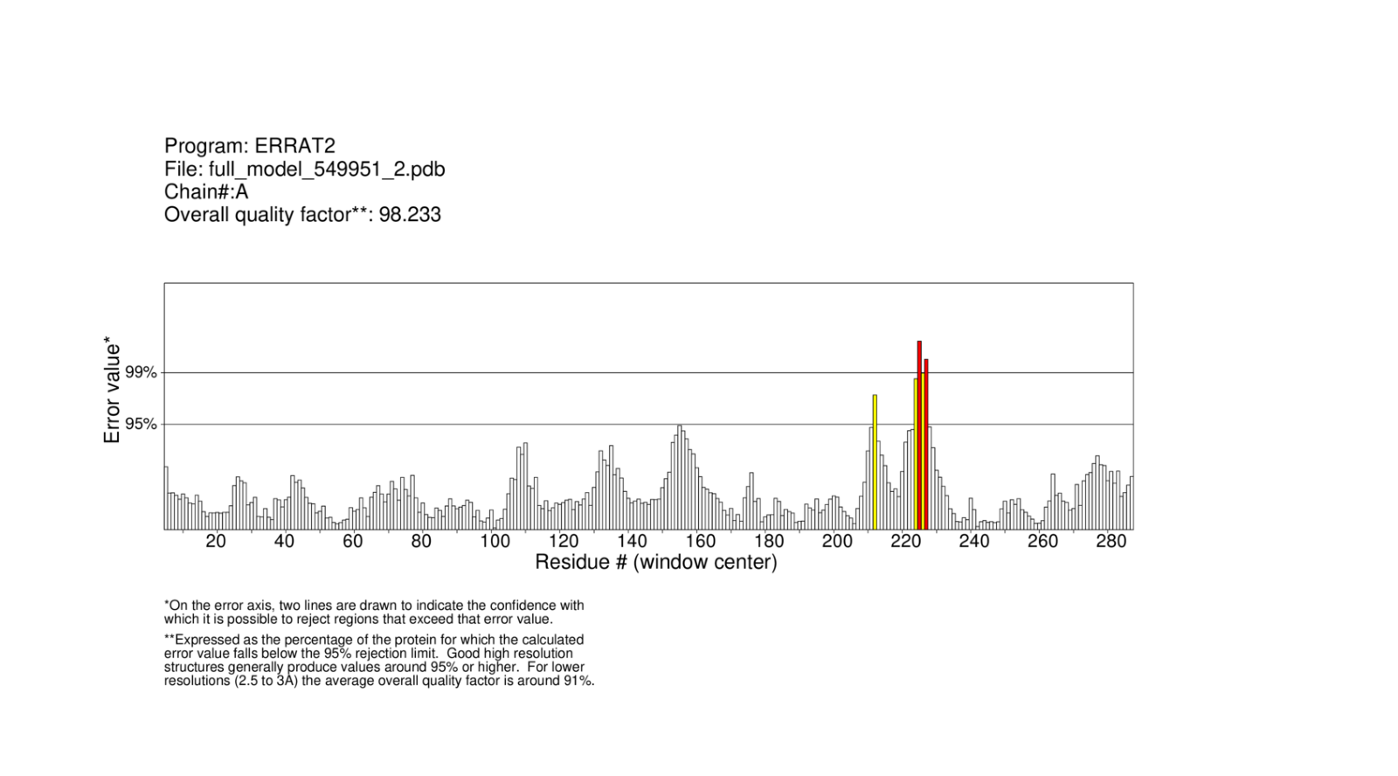

- Model 3
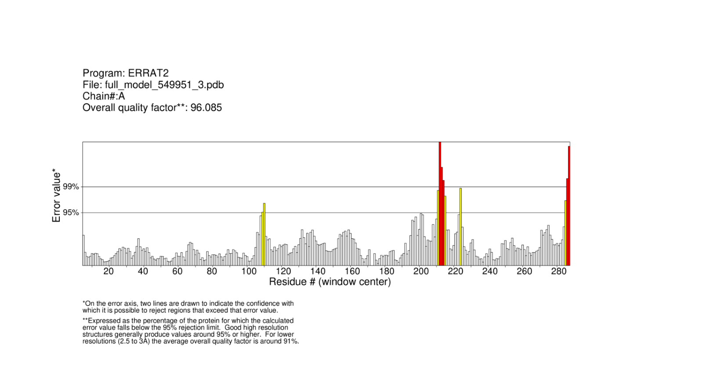

- Model 4
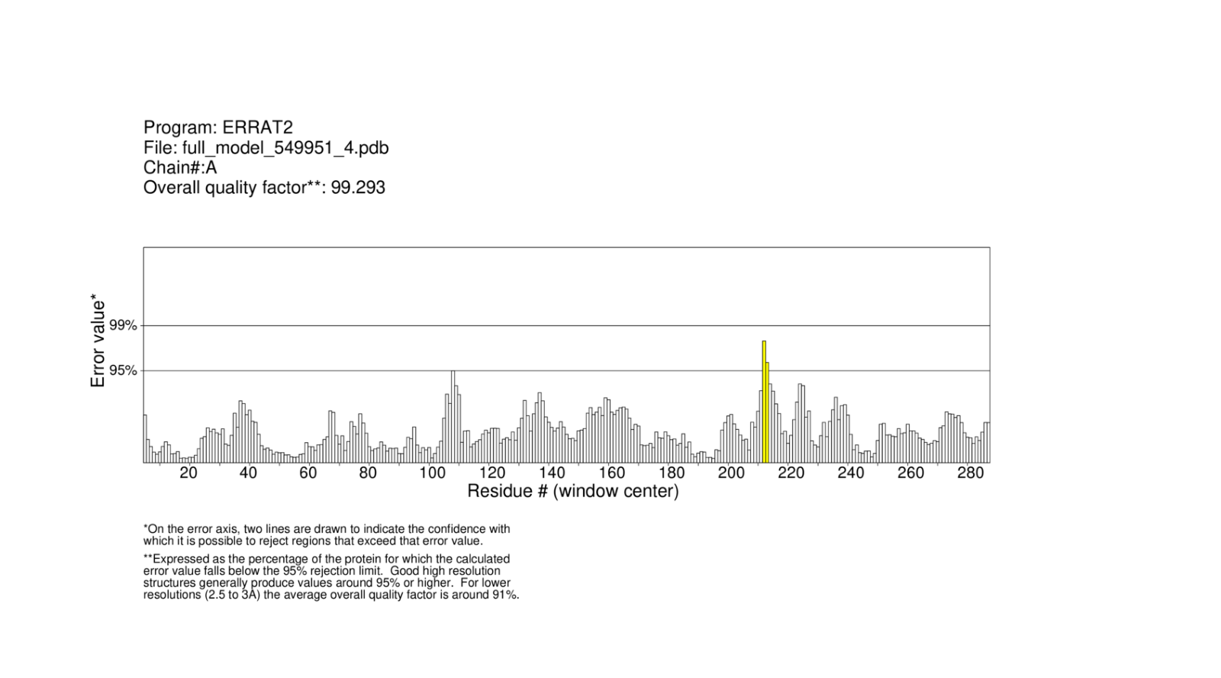

- Model 5
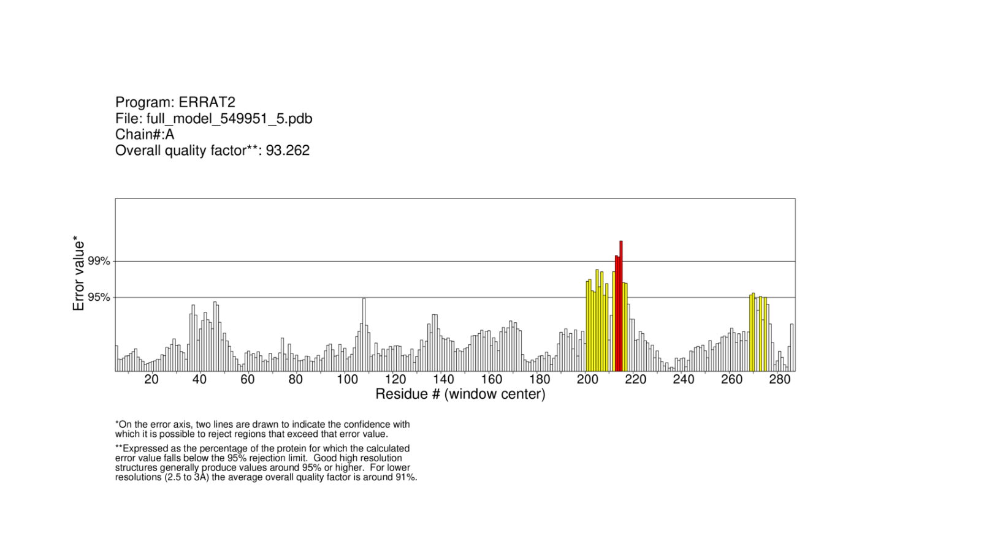
Supplementary Figure 4: Graph representing the value of the residuals errors determined by ERRAT server of each model (A-E).

Table S7: Model parameters obtained after refinement of the model 4 structure by GalaxyRefine server.
Model | GDT-HA | RMSD | MolProbity | Clash score | Poor rotamers | Rama favored
Initial | 1.0000 | 0.000 | 1.259 | 1.7 | 0.0 | 95.2
MODEL 1 | 0.9957 | 0.240 | 1.866 | 12.5 | 0.9 | 96.2
MODEL 2 | 0.9880 | 0.256 | 1.848 | 14.3 | 0.4 | 96.9
MODEL 3 | 0.9923 | 0.241 | 1.873 | 13.8 | 0.0 | 96.5
MODEL 4 | 0.9828 | 0.291 | 1.788 | 11.2 | 0.4 | 96.5
MODEL 5 | 0.9905 | 0.263 | 1.919 | 14.3 | 0.4 | 96.2

