ONLINE SUPPLEMENTAL DATA

Association of urinary dipeptidyl peptidase 4 activity with clinical outcomes in people with chronic kidney disease

Acaris Benetti¹, Joao Carlos Ribeiro-Silva², Luz M. Gómez³, Caio A. M. Tavares^{4,5}, Isabela J. Bensenor⁶, Paulo A. Lotufo⁶, Silvia M. O. Titan^{7,8}, Adriana C. C. Girardi¹

¹Laboratorio de Genetica e Cardiologia Molecular, Instituto do Coracao (InCor), Hospital das Clinicas HCFMUSP, Faculdade de Medicina, Universidade de Sao Paulo, Sao Paulo, SP, Brazil; ²State University of New York (SUNY) Upstate Medical University, Syracuse, NY, USA; ³Departamento de Estatistica, Universidade Federal de Pernambuco, Recife, PE, Brazil; ⁴Unidade de Geriatria, Instituto do Coraçao (InCor), Hospital das Clinicas HCFMUSP, Faculdade de Medicina, Universidade de Sao Paulo, Sao Paulo, SP, Brazil; ⁵Hospital Israelita Albert Einstein, Sao Paulo, Sao Paulo, Brazil; ⁶Hospital Universitario, Universidade de Sao Paulo, Sao Paulo, Brazil. ⁷Divisao de Nefrologia, Hospital das Clinicas HCFMUSP, Faculdade de Medicina, Universidade de Sao Paulo, Sao Paulo, SP, Brazil; ⁸Nephrology and Hypertension Division, Mayo Clinic, Rochester, MN, USA.
Table S1 – Indices for evaluating goodness of fit for structural equation modeling

p-value (Chi-square) | 0.07
CFI | 0.98
RMSEA | 0.04
SRMR | 0.03
TLI | 1.0

Table S2 - Association between uDPP4 activity and initiation KRT while accounting for the competing risk of death.
 | Unadjusted |  |  | Model 1 |  |  | Model 2 |  |  | Model 3
 | Cause-specific HR (95% CI) | p-value |  | Adjusted cause-specific HR (95% CI) | p-value |  | Adjusted cause-specific HR (95% CI) | p-value |  | Adjusted cause-specific HR (95% CI) | p-value
uDPP4 categorical
Tertile 2 x Tertile 1 | 1.14 (0.58 - 2.23) | 0.712 |  | 1.09 (0.55 - 2.15) | 0.802 |  | 0.83 (0.41 - 1.68) | 0.600 |  | 1.02 (0.50 - 2.07) | 0.963
Tertile 3 x Tertile 1 | 2.48 (1.67 - 3.67) | 0.34 |  | 1.29 (0.67 - 2.50) | 0.446 |  | 0.64 (0.31 - 1.30) | 0.219 |  | 1.07 (0.54 - 2.12) | 0.854

Model 1: Adjusted for age, sex, type 2 diabetes (T2D), systolic blood pressure (SBP), and body mass index (BMI). Data available for 418 participants
Model 2: Adjusted for age, sex, T2D, SBP, BMI, eGFR, and albuminuria. Data available for 418 participants
Model 3: Adjusted for age, sex, T2D, SBP, BMI, eGFR, use of RAS blockers, and urinary retinol-binding protein 4 (uRBP4). Data available for 407 participants.
Shown are cause-specific hazard ratios, estimated from the cause-specific hazard model treating death as competing risk.

Table S3 - Association between uDPP4 activity and the composite outcome of initiation KRT or death

 | Unadjusted |  |  | Model 1 |  |  | Model 2 |  |  | Model 3
 | HR (95% CI) | p-value |  | aHR (95% CI) | p-value |  | aHR (95% CI) | p-value |  | aHR (95% CI) | p-value
uDPP4 categorical
Tertile 2 x Tertile 1 | 1.83 (1.26 - 2.66) | 0.001 |  | 1.76 (1.21 - 2.56) | 0.003 |  | 1.61 (1.10 - 2.35) | 0.014 |  | 1.97 (1.35 - 2.89) | <0.001
Tertile 3 x Tertile 1 | 2.29 (1.59 - 3.29) | <0.001 |  | 2.05 (1.42 - 2.97) | 0.001 |  | 1.66 (1.13 – 2.43) | 0.01 |  | 2.05 (1.40 – 3.01) | <0.001

Model 1: Adjusted for age, sex, type 2 diabetes (T2D), systolic blood pressure (SBP), and body mass index (BMI). Data available for 418 participants
Model 2: Adjusted for age, sex, T2D, SBP, BMI, eGFR, and albuminuria. Data available for 418 participants
Model 3: Adjusted for age, sex, T2D, SBP, BMI, eGFR, use of RAS blockers, and urinary retinol-binding protein 4 (uRBP4). Data available for 407 participants.

Figure S1

Figure S1 – Frequency distribution of (A) uDPP4 activity and (B) sDPP4 activity among the PROGREDIR cohort participants.

Figure S2
p-Values
 | log uDPP4 | sDPP4 | Age | SBP | LV mass | BMI | eGFR | ACR | RBP4 | FE PO₄
log uDPP4 |  | 0.007 | 0.05 | <0.0001 | <0.0001 | 0.002 | 0.004 | <0.0001 | <0.0001 | 0.33
sDPP4 | 0.007 |  | <0.0001 | 0.02 | 0.01 | 0.49 | 0.02 | 0.003 | 0.009 | 0.17
Age | 0.05 | <0.0001 |  | <0.0001 | <0.0001 | <0.0001 | 0.004 | 0.03 | 0.08 | 0.45
SBP | <0.0001 | 0.02 | <0.0001 |  | <0.001 | 0.25 | 0.02 | <0.0001 | <0.0001 | 0.15
DBP | 0.43 | 0.003 | <0.0001 | <0.0001 | 0.48 | 0.01 | 0.03 | <0.0001 | 0.01 | 0.28
LV mass | <0.0001 | 0.01 | <0.0001 | <0.001 |  | 0.43 | 0.27 | 0.01 | 0.10 | 0.24
BMI | 0.002 | 0.49 | <0.0001 | 0.25 | 0.43 |  | 0.02 | 0.47 | 0.19 | 0.48
eGFR | 0.004 | 0.02 | 0.004 | 0.02 | 0.27 | 0.02 |  | <0.0001 | <0.0001 | <0.0001
ACR | <0.0001 | 0.003 | 0.02 | <0.0001 | 0.01 | 0.47 | <0.0001 |  | <0.0001 | <0.0001
RBP4 | <0.0001 | 0.009 | 0.08 | <0.0001 | 0.10 | 0.19 | <0.0001 | <0.0001 |  | <0.0001
FE PO₄ | 0.33 | 0.17 | 0.45 | 0.15 | 0.24 | 0.48 | <0.0001 | <0.0001 | <0.0001

Figure S2 – Spearman correlation coefficients a p-values for log-transformed uDPP4 activity, sDPP4 activity, and continuous variables related to demographics and renal function.

Figure S3

A
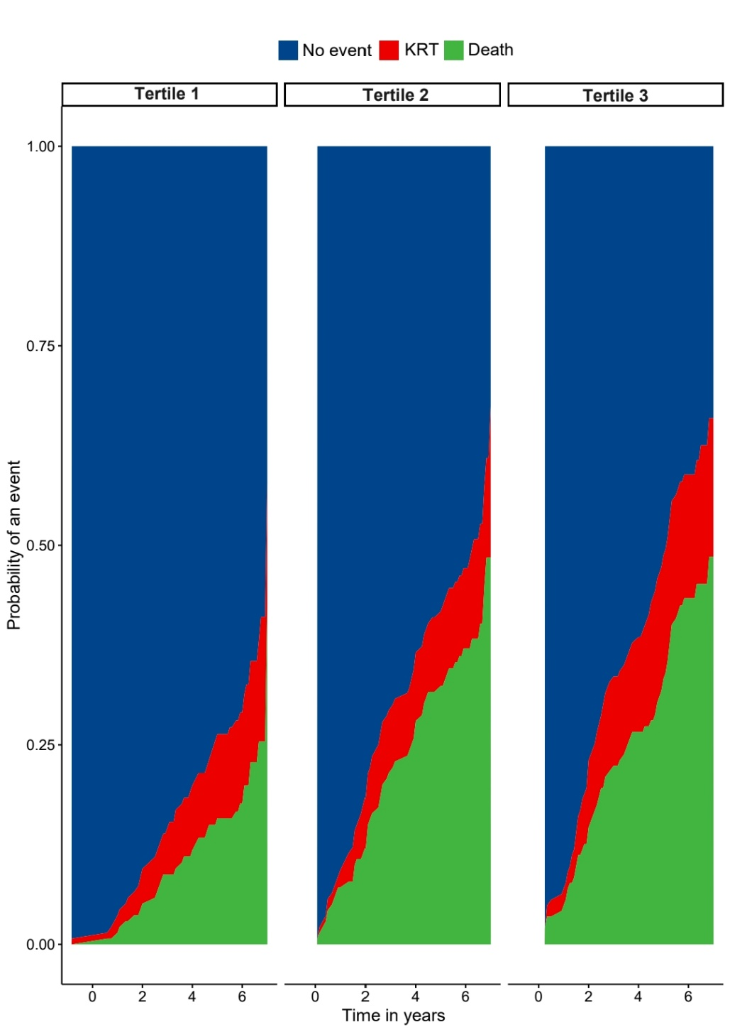
B
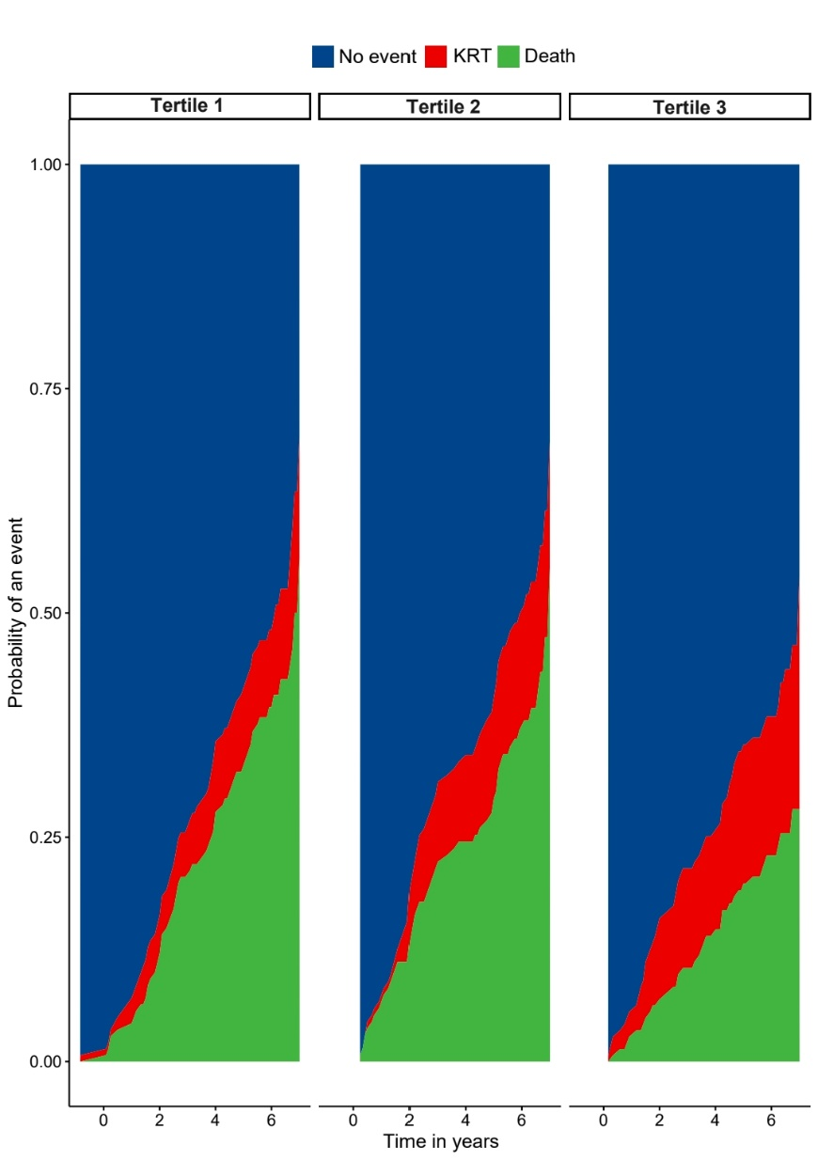

Figure S3 – Cumulative incidence functions of mortality and KRT events according to the tertiles of uDPP4 (A) and (B) sDPP4 activities.

Figure S4

Figure S4 – Kaplan-Meier survival curves for all-cause mortality according to the tertiles of sDPP4 activity.
Figure S5

Figure S5 – Activities of uDPP4 and sDPP4 in participants (A-B) with and without T2D and (C-D) under treatment with or without RAS inhibitors.

