Supplementary Material
Pb²⁺ boost peroxidase-like activity of Cu,Fe-TA nanozyme coupled with dispersive liquid–liquid microextraction for selective detection of zearalenone in food samples

Xiaorong Zhaoª, Jitao Liª, Zitao Zhongª, Dezhi Yang ª, Yaling Yang^{a,*}

ª Faculty of Life Science and Technology, Kunming University of Science and Technology, Yunnan Province 650500, China.
*Corresponding authors. Email: yilil8@163.com (Yaling Yang).

2. Experimental
2.6.2 Pretreatment of ZEN detection
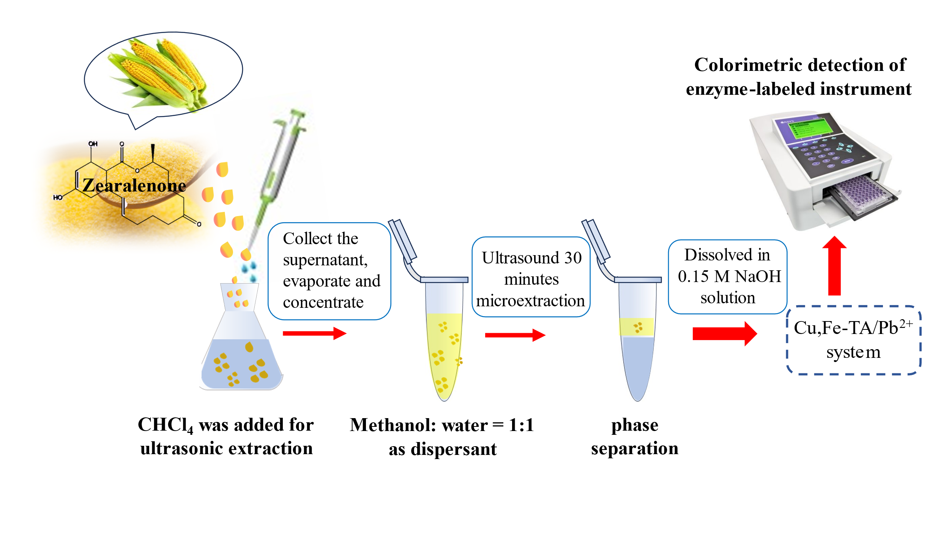
Scheme S1. Pretreatment of corn flour.

