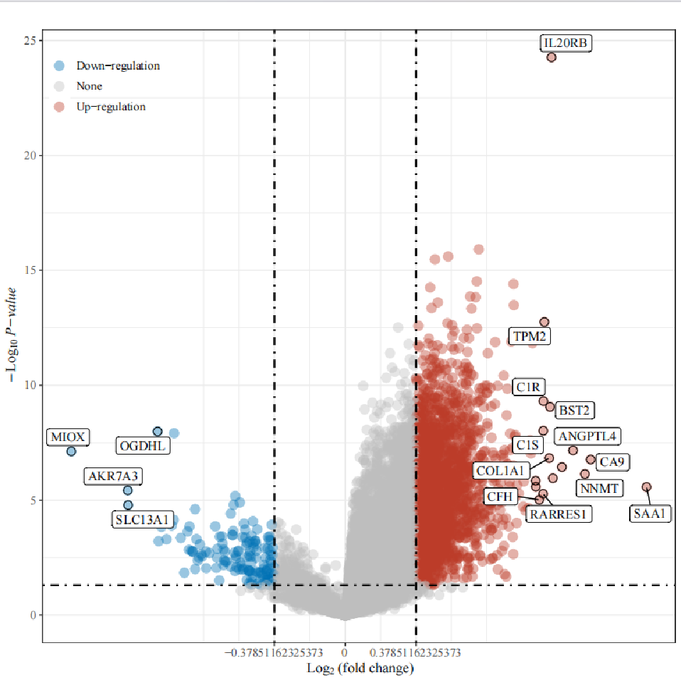+
Supplementary Figure 1. Heatmap of IL20RB-related differential genes in pRCC based on TCGA. Genes labeled in red are up-regulated differential genes and genes labeled in blue are down-regulated differential genes.

Supplementary Table 1. The clinical baseline characteristics of patients with pRCC in our center.

Characteristics | Over all
Age, median (IQR) | 53 (33, 83)
Gender, n (%)
male | 34 (81%)
female | 8 (19%)
Pathological type, n (%)
type 1 | 13 (31%)
type 2 | 23 (54.8%)
Unspecified type | 6 (14.3%)
Laterality, n (%)
Right | 19 (45.2%)
Left | 23 (54.8%)
T stage, n (%)
T1 | 23 (54.8%)
T2 | 8 (19%)
T3 | 10 (23.8%)
T4 | 1 (2.4%)
Clinical stage, n (%)
Stage I | 5 (11.9%)
Stage II | 16 (38.1%)
Stage III | 17 (40.5%)
Stage IV | 4 (9.5%)
Surgical methods, n (%)
Radical nephrectomy | 16 (38.1%)
Partial nephrectomy | 26 (61.9%)
Smoking history, n (%)
No | 25 (59.5%)
Yes | 17 (40.5%)
Hypertensive disease, n (%)
No | 16 (38.1%)
Yes | 26 (61.9%)
Diabetes, n (%)
No | 35 (83.3%)
Yes | 7 (16.7%)

Supplementary Table 2. The clinical baseline characteristics of patients with pRCC in TCGA databse.

Characteristics | Over all
Age, mean ± sd | 60.57 ± 12.767
Gender, n (%)
Male | 64 (74.4%)
Female | 22 (25.6%)
Race, n (%)
White | 61 (70.9%)
Black | 21 (24.4%)
Other | 4 (4.7%)
BMI, mean ± sd | 27.437 ± 5.126
Tumor type, n (%)
Type 1 | 34 (39.5%)
Type 2 | 52 (60.5%)
Laterality, n (%)
Right | 38 (44.2%)
Left | 46 (53.5%)
Bilateral | 2 (2.3%)
pT, n (%)
T0
T1 | 62 (72.1%)
T2 | 8 (9.3%)
T3 | 15 (17.4%)
T4 | 1 (1.2%)
pN, n (%)
N0 | 12 (14%)
N1 | 9 (10.5%)
N2 | 2 (2.3%)
NX | 63 (73.3%)
pM, n (%)
M0 | 30 (34.9%)
M1 | 2 (2.3%)
MX | 54 (62.8%)
Clinical stage, n (%)
Stage I | 64 (74.4%)
Stage II | 6 (7%)
Stage III | 12 (14%)
Stage IV | 4 (4.7%)
Smoking history, n (%)
1 | 50 (58.1%)
0 | 36 (41.9%)

