SUPPLEMENTARY INFORMATION

Unlocking precision oncology by establishing a nationwide comprehensive genomic profiling and molecular tumor board platform for patients with advanced cancer: the BALLETT study

Pieter-Jan Volders, Philippe Aftimos, Franceska Dedeurwaerdere, Geert Martens, Jean-Luc Canon, Gabriela Beniuga, Guy Froyen, Jacques Van Huysse, Rebecca De Pauw, Hans Prenen, Suzan Lambin, Lore Decoster, Freya Vaeyens, Sylvie Rottey, Pieter-Jan Van Dam, Lynn Decoster, Annemie Rutten, Max Schreuer, Siebe Loontiens, Joni Van der Meulen, Jeroen Mebis, Kristof Cuppens, Sabine Tejpar, Isabelle Vanden Bempt, Jacques De Grève, David Schröder, Cédric van Marcke, Marc Van Den Bulcke, Evandro de Azambuja, Kevin Punie, Brigitte Maes

Table of Contents
Figure S1: Distribution of histological subtypes across the tumor types included in the BALLETT study. | 2
Figure S2: CGP success rates across different tumor types in the BALLETT study. | 3
Figure S3: Frequency of genomic alterations in the top mutated genes across all tumor types in the BALLETT study. | 4
Figure S4: Distribution of genomic alterations by tumor type in the BALLETT study. | 5
Figure S5: Distribution of the number of genomic alterations per patient in the BALLETT study. | 6
Figure S6: Distribution of actionable markers across tiers with strong clinical significance (IA, IB) and potential clinical significance (IIC and IID) by tumor type. | 7
Figure S7: Distribution of the number of different recommendations by the nMTB per patient. | 8
Figure S8: Reasons for deviating from treatment recommendations across participating hospitals in the BALLETT study. | 9
Figure S9: Distribution of cancer susceptibility gene (CSG) variants detected through CGP on tumor biopsies in the BALLETT study. | 10
Figure S10: Screenshot of the custom-designed BALLETT app for data visualization during national Molecular Tumor Board (nMTB) discussions. | 11
Table S1: Actionable drivers that did not lead to treatment recommendation. | 12

Figure S1: Distribution of histological subtypes across the tumor types included in the BALLETT study.

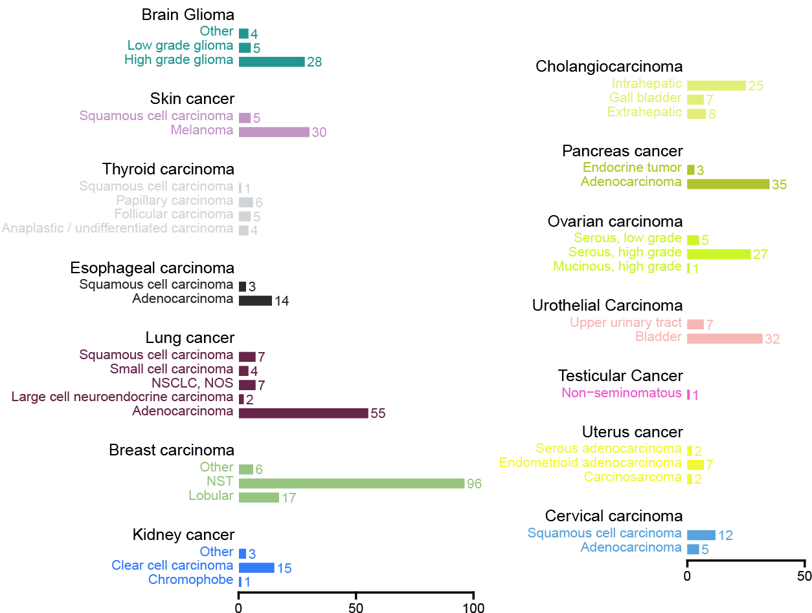
Figure S2: CGP success rates across different tumor types in the BALLETT study. The success rate ranges from 71% for uveal melanoma to 100% for thymoma and neuroendocrine tumor with an overall success rate of 89%.

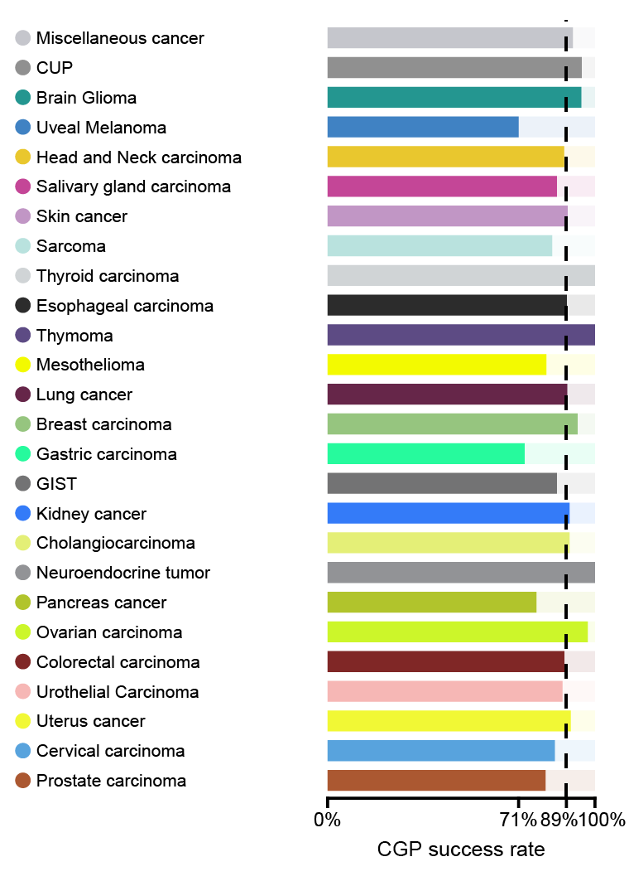
Figure S3: Frequency of genomic alterations in the top mutated genes across all tumor types in the BALLETT study.

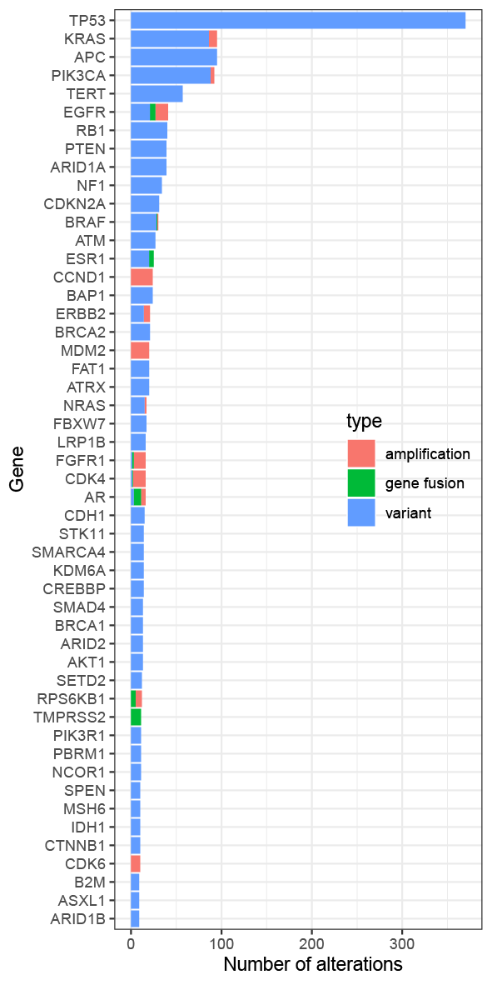
Figure S4: Distribution of the most-frequently observed genomic alterations by tumor type in the BALLETT study.
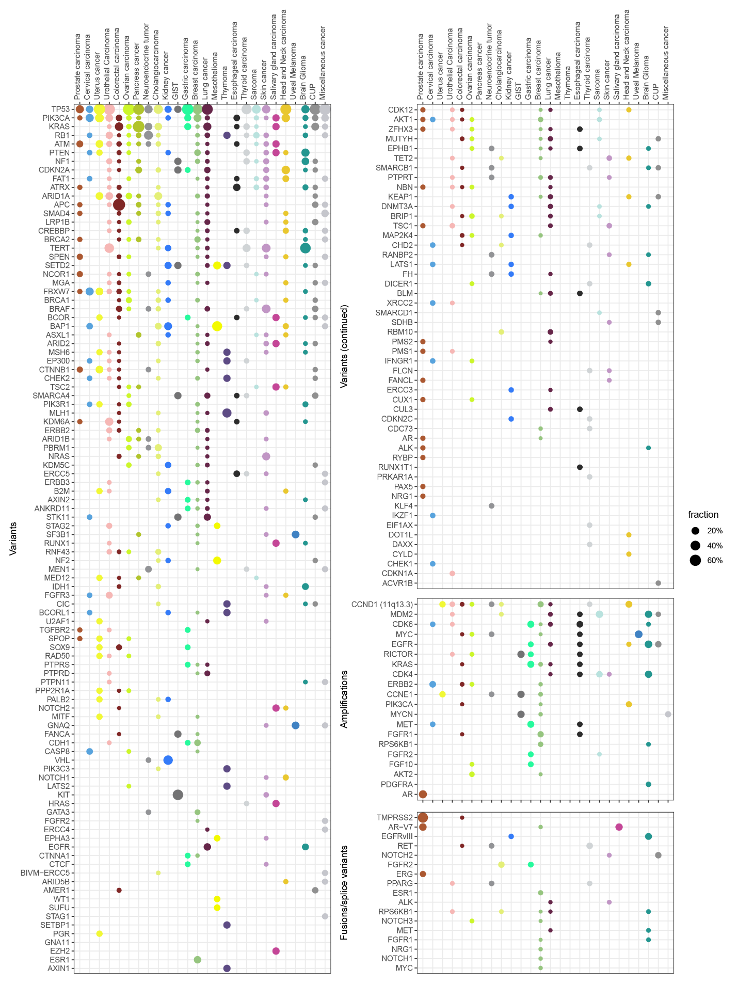
Figure S5: Distribution of the number of genomic alterations per patient in the BALLETT study.

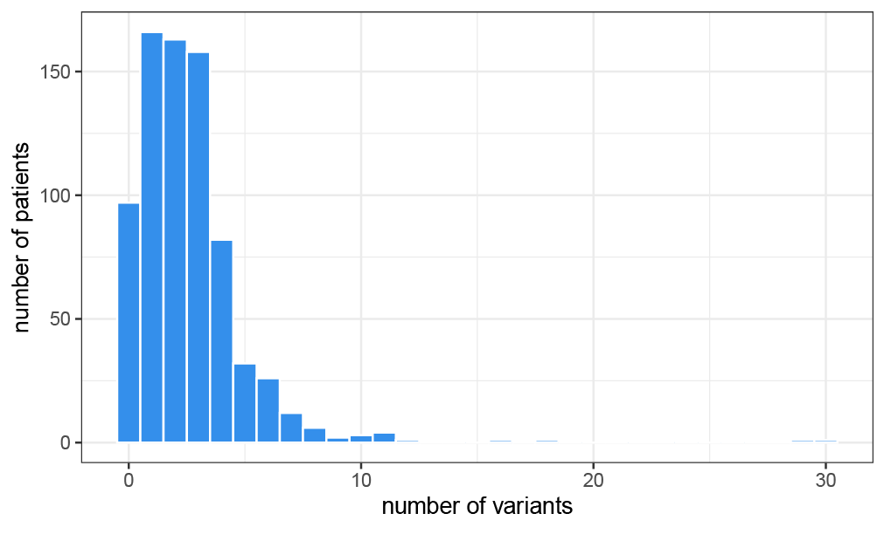
Figure S6: Distribution of actionable markers across tiers with strong clinical significance (IA, IB), potential clinical significance (IIC and IID), and uncertain clinical significance (IIIA) by tumor type.
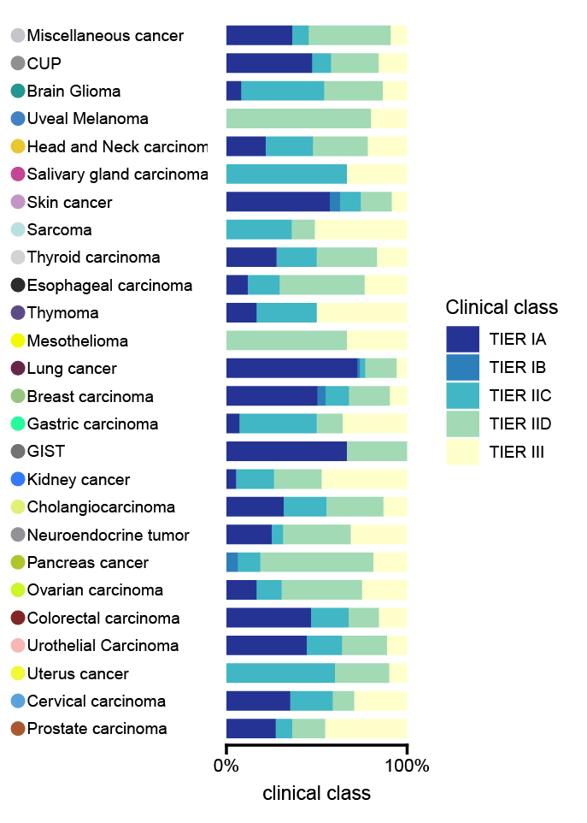

Figure S7: Distribution of the number of different recommendations by the nMTB per patient.
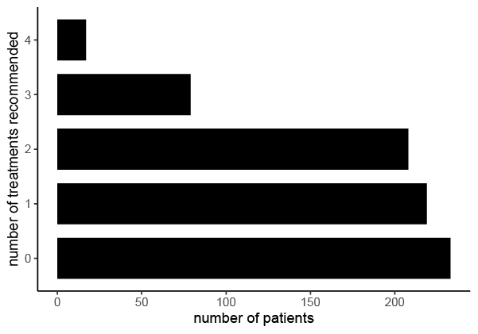
Figure S8: Reasons for deviating from treatment recommendations across participating hospitals in the BALLETT study.
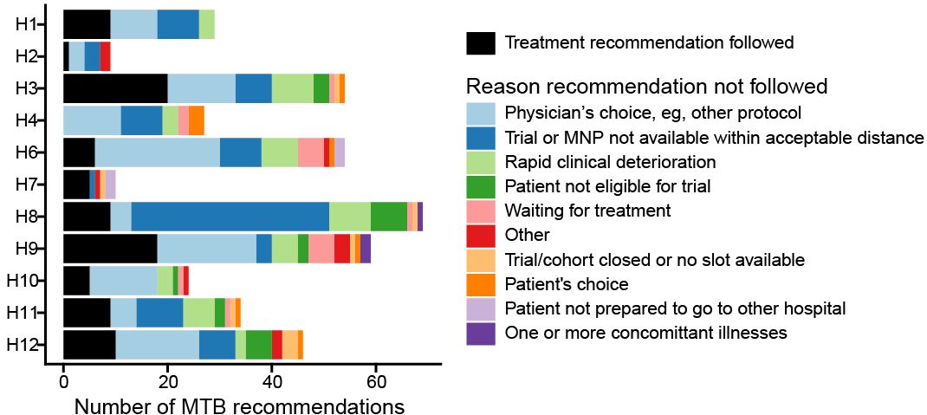
Figure S9: Distribution of cancer susceptibility gene (CSG) variants detected through CGP on tumor biopsies in the BALLETT study. Only genes from the ESMO Precision Medicine Working Group 2023 recommendations are shown (Kuzbari et al).
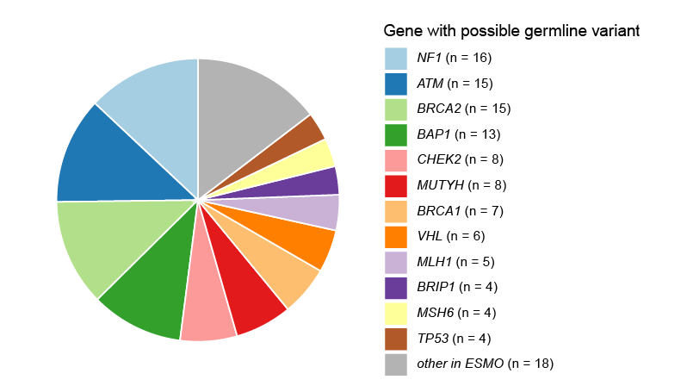
Figure S10: Screenshot of the custom-designed BALLETT app for data visualization during national Molecular Tumor Board (nMTB) discussions.

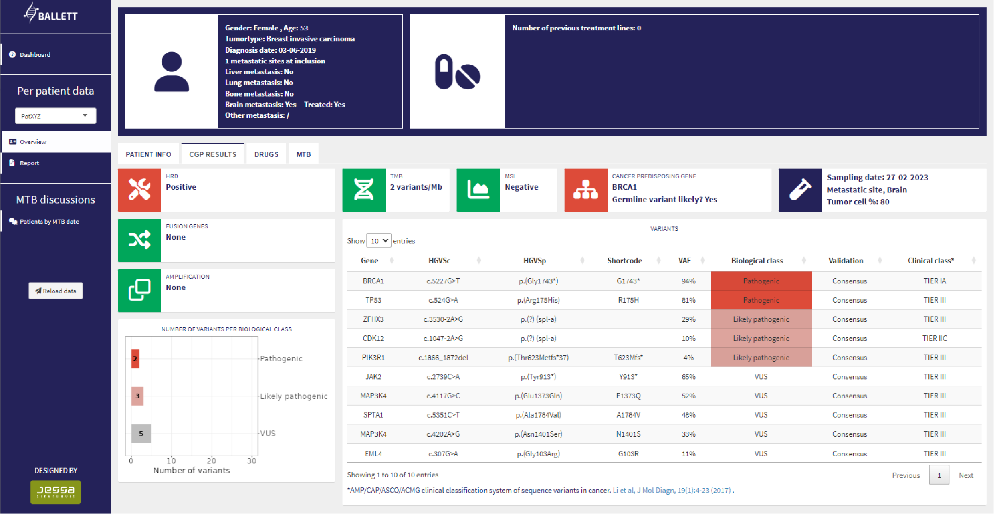

Table S1: Actionable drivers that did not lead to treatment recommendation.
 | Cancer type | Gene | Marker | Clinical class | Number of cases
 | Breast carcinoma | CCND1 (11q13.3) | amplification | TIER IID | 7
 | Breast carcinoma | MYC | amplification | TIER IID | 5
 | Breast carcinoma | ESR1 | variant | TIER IA | 3
 | Breast carcinoma | PIK3CA | variant | TIER IB | 3
 | Colorectal carcinoma | MYC | amplification | TIER IID | 3
 | Head and Neck carcinoma | CDKN2A | variant | TIER IID | 3
 | Urothelial Carcinoma | KDM6A | variant | TIER IID | 3
 | Brain Glioma | EGFR | amplification | TIER IID | 2
 | Brain Glioma | IDH1 | variant | TIER IIC | 2
 | Breast carcinoma | BRCA2 | variant | TIER IIC | 2
 | Breast carcinoma | FGFR1 | amplification | TIER IIC | 2
 | Breast carcinoma | PIK3CA | variant | TIER IA | 2
 | Cholangiocarcinoma | KRAS | variant | TIER IID | 2
 | Colorectal carcinoma | FGFR1 | amplification | TIER IIC | 2
 | Colorectal carcinoma | NRAS | variant | TIER IA | 2
 | Head and Neck carcinoma | CCND1 (11q13.3) | amplification | TIER IID | 2
 | Head and Neck carcinoma | MYC | amplification | TIER IID | 2
 | Head and Neck carcinoma | PIK3CA | variant | TIER IIC | 2
 | Lung cancer | EGFR | amplification | TIER IID | 2
 | Ovarian carcinoma | CCND1 (11q13.3) | amplification | TIER IID | 2
 | Ovarian carcinoma | CCNE1 | amplification | TIER IID | 2
 | Ovarian carcinoma | MYC | amplification | TIER IID | 2
 | Urothelial Carcinoma | ATM | variant | TIER IIC | 2
 | Brain Glioma | CDK4 | amplification | TIER IID | 1
 | Brain Glioma | EGFR | variant | TIER IID | 1
 | Brain Glioma | KDM6A | variant | TIER IID | 1
 | Brain Glioma | PIK3CA | variant | TIER IIC | 1
 | Brain Glioma | PTEN | variant | TIER IIC | 1
 | Breast carcinoma | ARID1A | variant | TIER IID | 1
 | Breast carcinoma | BRCA1 | variant | TIER IA | 1
 | Breast carcinoma | CCNE1 | amplification | TIER IID | 1
 | Breast carcinoma | CDH1 | variant | TIER IID | 1
 | Breast carcinoma | ERBB2 | amplification | TIER IA | 1
 | Breast carcinoma | ESR1 | amplification | TIER IIC | 1
 | Breast carcinoma | ESR1 | gene fusions | TIER IID | 1
 | Breast carcinoma | FGFR2 | variant | TIER IID | 1
 | Breast carcinoma | TP53 | variant | TIER IID | 1
 | Cervical carcinoma | FBXW7 | variant | TIER IID | 1
 | Cervical carcinoma | PIK3CA | variant | TIER IIC | 1
Table S1 continued
Cancer type |  | Gene | Marker | Clinical class | Number of cases
 | Cholangiocarcinoma | ARID1A | variant | TIER IIC | 1
 | Cholangiocarcinoma | FBXW7 | variant | TIER IID | 1
 | Colorectal carcinoma | ATM | variant | TIER IIC | 1
 | Colorectal carcinoma | CCND1 (11q13.3) | amplification | TIER IID | 1
 | Colorectal carcinoma | CDKN2A | variant | TIER IID | 1
 | Colorectal carcinoma | EGFR | amplification | TIER IID | 1
 | Esophageal carcinoma | CCND1 (11q13.3) | amplification | TIER IID | 1
 | Esophageal carcinoma | EGFR | amplification | TIER IID | 1
 | Esophageal carcinoma | FGFR1 | amplification | TIER IIC | 1
 | Esophageal carcinoma | KRAS | variant | TIER IID | 1
 | Esophageal carcinoma | MYC | amplification | TIER IID | 1
 | Esophageal carcinoma | SMARCA4 | variant | TIER IID | 1
 | Gastric carcinoma | CCND1 (11q13.3) | amplification | TIER IID | 1
 | Gastric carcinoma | MYC | amplification | TIER IID | 1
 | Head and Neck carcinoma | IDH2 | variant | TIER IIC | 1
 | Kidney cancer | VHL | variant | TIER IID | 1
 | Lung cancer | CCNE1 | amplification | TIER IID | 1
 | Lung cancer | EGFR | variant | TIER IA | 1
 | Lung cancer | KIT | amplification | TIER IID | 1
 | Lung cancer | PDGFRA | amplification | TIER IID | 1
 | Lung cancer | PIK3CA | variant | TIER IIC | 1
 | Mesothelioma | NF2 | variant | TIER IID | 1
 | Miscellaneous cancer | CCND1 (11q13.3) | amplification | TIER IID | 1
 | Ovarian carcinoma | BRCA1 | variant | TIER IA | 1
 | Pancreas cancer | CCND1 (11q13.3) | amplification | TIER IID | 1
 | Pancreas cancer | KRAS | variant | TIER IID | 1
 | Pancreas cancer | SRC | variant | TIER IID | 1
 | Penile cancer | CCND1 (11q13.3) | amplification | TIER IID | 1
 | Prostate carcinoma | AR | amplification | TIER IID | 1
 | Prostate carcinoma | FGFR1 | amplification | TIER IIC | 1
 | Prostate carcinoma | MYC | amplification | TIER IID | 1
 | Prostate carcinoma | PMS2 | variant | TIER IID | 1
 | Salivary gland carcinoma | HRAS | variant | TIER IIC | 1
 | Salivary gland carcinoma | NOTCH2 | variant | TIER IID | 1
 | Salivary gland carcinoma | PIK3CA | variant | TIER IIC | 1
 | Sarcoma | CDK4 | amplification | TIER IID | 1
 | Sarcoma | FGFR1 | amplification | TIER IIC | 1
 | Sarcoma | FGFR3 | amplification | TIER IIC | 1
 | Sarcoma | MDM2 | amplification | TIER IIC | 1
 | Sarcoma | PDGFRA | amplification | TIER IID | 1
 | Table S1 continued
 | Cancer type | Gene | Marker | Clinical class | Number of cases
 | Sarcoma | TP53 | variant | TIER IID | 1
 | Sarcoma | TSC2 | variant | TIER IIC | 1
 | Skin cancer | CCND1 (11q13.3) | amplification | TIER IID | 1
 | Skin cancer | CDKN2A | variant | TIER IID | 1
 | Skin cancer | EGFR | amplification | TIER IID | 1
 | Thyroid carcinoma | CCND1 (11q13.3) | amplification | TIER IID | 1
 | Thyroid carcinoma | CREBBP | variant | TIER IID | 1
 | Thyroid carcinoma | EGFR | amplification | TIER IID | 1
 | Thyroid carcinoma | HRAS | variant | TIER IIC | 1
 | Thyroid carcinoma | KRAS | variant | TIER IID | 1
 | Urothelial Carcinoma | ARID1A | variant | TIER IID | 1
 | Urothelial Carcinoma | CCND1 (11q13.3) | amplification | TIER IID | 1
 | Urothelial Carcinoma | MYC | amplification | TIER IID | 1
 | Urothelial Carcinoma | NF1 | variant | TIER IID | 1
 | Urothelial Carcinoma | PIK3CA | variant | TIER IIC | 1
 | Uterus cancer | MYC | amplification | TIER IID | 1
 | Vulva Carcinoma | CDKN2A | variant | TIER IID | 1
 | Vulva Carcinoma | PIK3CA | variant | TIER IIC | 1

