Supplemental Information for:
Differential Excitatory-Inhibitory Balance within Dorsolateral Prefrontal Cortex Shapes Inter-network Interactions in Working Memory
Chunzhi Yi^{1,2,3,#}, Haiqi Zhu^{1,#}, Shaoshi Zhang^{4,5,6,7}, Yangping Li⁸, Zehua Lv², Shijie Zhou², Baichun Wei¹
¹ School of Medicine and Health, Harbin Institute of Technology, Harbin, China;
² Zhengzhou Research Institute, Harbin Institute of Technology, Zheng Zhou, China;
³ Institute for Neural Information Processing, University Medical Center Hamburg- Eppendorf (UKE), 20251 Hamburg, Germany;
⁴ Centre for Sleep & Cognition & Centre for Translational Magnetic Resonance Research, Yong Loo Lin School of Medicine, Singapore;
⁵ Department of Electrical and Computer Engineering, National University of Singapore, Singapore;
⁶ N.1 Institute for Health & Institute for Digital Medicine, National University of Singapore, Singapore;
⁷ Integrative Sciences and Engineering Programme (ISEP), National University of Singapore, Singapore, Singapore;
⁸ School of Foreign Studies, Xi'an Jiaotong University, Xian, China;
# The authors share the same contributions.

Address correspondence to:
Chunzhi Yi, Baichun Wei
School of Medicine and Health
Harbin Institute of Technology
Email: chunzhiyi@hit.edu.cn, bcwei@hit.edu.cn

1. DLPFC accounts for the activation and interactions of the frontoparietal and default-mode networks
We first sought to replicate the difference of functional activity and connection between resting state and working memory, and how the difference of DLPFC correlates with that of the two brain networks. We repeated the analysis on activity, and see whether the same phenomena hold for the Schaefer 100 parcellation. Similarly, we calculated fALFF, averaged across scans and across voxels within a ROI and compared through the permutation test after Bonferroni correction. For working memory, we used the parameter estimation obtained from GLM as the input for fALFF. We also analyzed the relationship between the activation difference of DLPFC areas and the two brain networks. We find that the phenomena on the Schaefer 100 parcellation basically presents a similar pattern. That is, the left DLPFC area and the FP network present an engagement during working memory, while the activation of the DM network decreases significantly (Supplementary Fig. 1 A). DLPFC areas’ activation difference of working memory versus resting state is correlated with that of the frontoparietal and default-mode networks (Supplementary Fig. 1 B).
We also repeated the analysis on functional connection. We used the parameter estimation obtained from GLM to calculate Pearson’s coefficients between brain regions and formed the function connectivity matrix. We averaged the strength of the functional connection within each ROI for each subject. We find the moderately significant difference of the functional connection between frontoparietal and default-mode networks in the comparison of resting state and working memory (Supplementary Fig. 1 C, p = 0.0503, permutation test). The strength of the functional connection between the left DLFPC and both the two networks significantly vary across resting state and working memory (Supplementary Fig. 1 C, p = 0.0498 and 0.0396, permutation test, respectively). In contrast, the right DLPFC does not present significant difference (Supplementary Fig. 1 C, p = 0.3668 and 0.3354, permutation test, respectively). When testing the correlation of the strength difference of the functional connection, significantly correlative results suggest the functional connection between FP and DM vary with the functional connection between DLPFC and the two networks (Supplementary Fig. 1 D).
In assessing the DLPFC areas’ potential modulation of the inter-network interaction under different performance, we find that the strength difference of functional connection under the success-versus-error comparison of both DLPFC areas modulates the functional connection difference of the frontoparietal and default-mode networks (Supplementary Fig. 1 E).
Together, all the presented suggest the different activation pattern of the two networks can be modulated by the activation variation of DLPFC and its functional connection with the two networks. This phenomenon holds for the comparison between resting state and working memory and the comparison between different performance of the 2-back task.

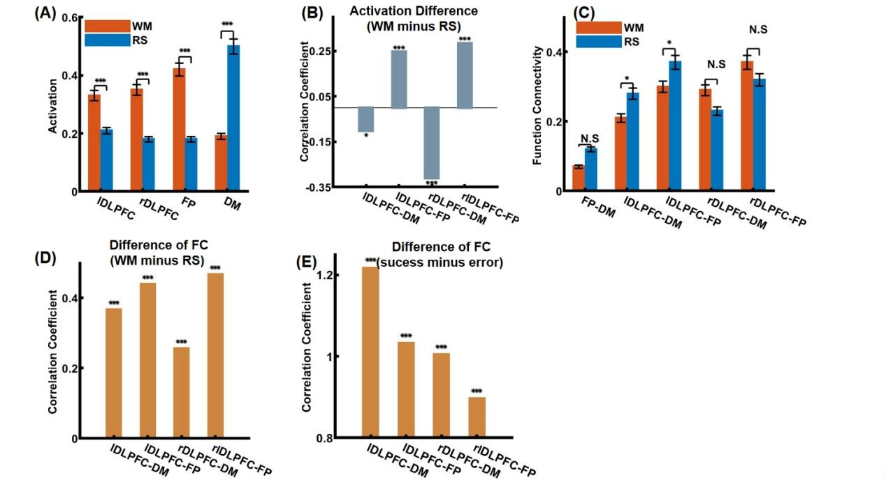

Supplementary Figure 1: Functional variations and associations of DLPFC areas, frontpoparietal and default-mode networks. A The functional activation presents significant difference between resting state (RS) and working memory (WM) for left and right DLPFC, FP and DM. The activation is estimated by fALFF. B The difference of the functional activation between RS and WM for lDLPFC and rDLPFC correlated to that for DM and FP. All the correlations, except for the correlation between rDLPFC and FP, are significant (for right DLPFC and the DM network, linear regression, r = -0.3101, p < 0.0001, for right DLPFC and the FP network, linear regression, r = 0.2832, p < 0.0001, for left DLPFC and the DM network, linear regression, r = -0.1013, p = 0.0304 and for left DLPFC and the FP network, linear regression, r = 0.2456, p < 0.0001). C The strength of functional connections presents significant difference between RS and WM among left and right DLPFC, FP and DM. D The difference (WM minus RS) of the functional connections between DLPFC and the two networks (X axis) correlates with that between FP and DM (for lDLPFC-DM, linear regression, r = 0.3675, p = 0.0003; for lDLPFC-FP, linear regression, r = 0.4385, p < 0.0001; for rDLPFC-DM, linear regression, r = 0.2554, p < 0.0001; for rDLPFC-FP, linear regression, r = 0.4666, p < 0.0001). During the regression, we excluded the DLPFC areas from the FP and DM networks to ensure the avoidance of any potential biases. E The difference (success minus error) of the functional connections between DLPFC and the two networks (X axis) correlates with that between FP and DM during the 2-back tasks (for lDLPFC-DM, linear regression, r = 1.2164, p < 0.0001; for lDLPFC-FP, linear regression, r = 1.0315, p < 0.0001; for rDLPFC-DM, linear regression, r = 1.0040, p < 0.0001; for rDLPFC-FP, linear regression, r = 0.8959, p < 0.0001). All the correlation analyses are performed using robust linear regression. The significance of the difference is evaluated by the permutation test. N.S denotes no significance (i.e. p > 0.05), * denotes p < 0.05, ** denotes p < 0.01, and *** denotes p < 0.001.

- Alternative activation metrics
In the main text, we have employed fALFF as the metric of the functional activation. In order to test whether our findings hold for other activation metrics, we used the amplitude of low frequency fluctuation (ALFF) which has been widely used as the measure of the neuronal activity within a region (Zang et al., 2007; Biswal et al., 1995). ALFF is calculated following the procedures (Zang et al., 2007). Specifically, band-pass filter was performed on the preprocessed BOLD signals of each voxel to remain the low frequency fluctuation between 0.01Hz to 0.08Hz. For working memory task, the filter was performed on the parameter estimation image of GLM. Then, the power density spectrum was calculated, summed across frequencies, squared and divided by the time points of the voxel’s signal. Normalization was applied across the cortex. Finally, the ALFF of each voxel was averaged within ROIs. We performed the same analysis method on the ALFF of each region, also on both parcellations.
The ALFF of the left DLPFC and right DLPFC presents a significantly improved activation on working memory for the Schaefer 100 parcellation (Supplementary Fig.2 A, p < 0.0001) and no significance for the Desikan-Killiary parcellation (Supplementary Fig.3 A, p = 0.350 and 0.4810, respectively). The ALFF of both networks present a activation competition for both parcellations (Supplementary Fig. 2 A and 3 A, p < 0.0001). The activation changes of each DLPFC area is significantly related to the activation changes of each network (Supplementary Fig.2 B and Fig.3 B, p < 0.05). We find the findings remain basically unchanged, no matter for the working memory-aroused activation competition between networks and the correlative relationship between DLPFC and both networks.

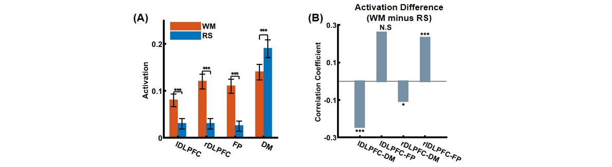
Supplementary Figure 2: Republication of the results on functional variations and associations of DLPFC areas, frontoparietal and default-mode networks (ALFF, Schaefer100). A The functional activation presents significant difference between resting state (RS) and working memory (WM) for left and right DLPFC, FP and DM. B The difference of the functional activation between RS and WM for lDLPFC and rDLPFC correlated to that for DM and FP. All the correlations, except for the correlation between rDLPFC and FP, are significant (for right DLPFC and the DM network, linear regression, r = -0.1044, p = 0.0124, for right DLPFC and the FP network, linear regression, r = 0.2323, p < 0.0001, for left DLPFC and the DM network, linear regression, r = -0.2441, p = 0.0002 and for left DLPFC and the FP network, linear regression, r = 0.2602, p = 0.1429). The significance of the difference is evaluated by the permutation test. N.S denotes no significance (i.e. p > 0.05), * denotes p < 0.05, ** denotes p < 0.01, and *** denotes p < 0.001.
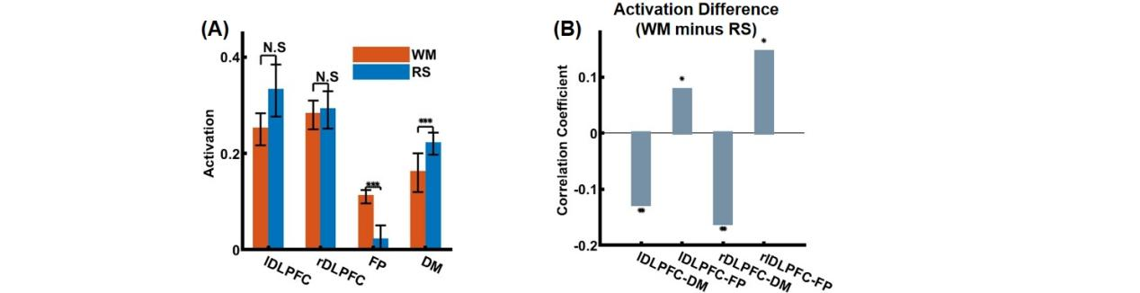
Supplementary Figure 3: Republication of the results on functional variations and associations of DLPFC areas, frontoparietal and default-mode networks (ALFF, Desikan-Killiary). A The functional activation presents significant difference between resting state (RS) and working memory (WM) for FP and DM. The difference is not significant for left and right DLPFC. B The difference of the functional activation between RS and WM for lDLPFC and rDLPFC correlated to that for DM and FP ( for right DLPFC and the DM network, linear regression, r = -0.1605, p = 0.0016, for right DLPFC and the FP network, linear regression, r = 0.21451, p = 0.0175, for left DLPFC and the DM network, linear regression, r = -0.1269, p = 0.0014 and for left DLPFC and the FP network, linear regression, r = 0.0778, p = 0.0404). The significance of the difference is evaluated by the permutation test. N.S denotes no significance (i.e. p > 0.05), * denotes p < 0.05, ** denotes p < 0.01, and *** denotes p < 0.001.
- The structural role of the DLPFC areas
In the following, we sought to assess the structural origin of the DLPFC’s potential modulation of the functional connection on the Schaefer 100 parcellation. Again, we calculated the SC and FC matrices for each subject and analyze how the working memory-aroused FC difference ( i.e., WM minus RS) can correlate with the corresponding SC. We find that the functional connection difference between working memory and resting state of the frontoparietal and default-mode networks is correlated with their structural connection (Supplementary Fig. 4 linear regression, r = 3.8559, p = 0.0374). Similarly, the FC differences between lDLPFC and FP, between lDLPFC and DM and between rDLPFC and FP are correlated with their structural connections (Supplementary Fig. 4, linear regression, r = 3.2978, p < 0.0001, Supplementary Fig. 4, linear regression, r = 2.9246, p < 0.0001, Supplementary Fig. 4, linear regression, r = -0.6695, p < 0.0001, respectively). The correlation in lDLPFC and FP presented by Supplementary Fig. 4 is opposite to the correlation tested on the Desikan-Killiary Atlas. We further find the functional connection difference is negatively correlated with the structural connection difference (Supplementary Fig. 4, linear regression, r = -0.8213, p = 0.0231). These results suggest that the functional connection difference between working memory and resting state may be modulated by the white matter tracts among the regions. That is, the multi-regional functional pattern transformation aroused by working memory may have its structural origin.


Supplementary Figure 4: The structural connections between DLPFC areas and the two brain networks. We use the strength of the structural connections as predictors and the corresponding difference in the functional connections as dependent variables. During the regression, we excluded the DLPFC areas from the FP and DM networks to ensure the avoidance of any potential bias. For FP-DM, linear regression, r = 3.8559 p = 0.0374; for lDLPFC-DM, linear regression, r = 3.2978 p < 0.001; for lDLPFC-FP, linear regression, r = 2.9246, p < 0.001; for rDLPFC-DM, linear regression, r = 0.6228, p = 0.0859; for rDLPFC-FP, linear regression, r = -0.6695 p < 0.001. Through the robust linear regression, we plot the coefficients and the significance. N.S denotes no significance (i.e. p > 0.05), * denotes p < 0.05, ** denotes p < 0.01, and *** denotes p < 0.001.
- Fitting and perturbating EI-MFM on Shaefer 100 parcellation
In the main text, we chose to fit and analyses the EI-MFM model on Desikan-Killiary parcellation. Given that recent studies usually evaluated their models on two parcellations and an optimal brain parcellation is nontrivial, we employed the Schaefer 100 parcellation that is more fine-grained compared with Desikan-Killiary parcellation. We evaluated how robust our in silico findings can be remained under alternative parcellation. The model was fitted, validated and tested using the same procedure presented in the main text. The estimated parameters present a gradient across cortex but with different patterns. The difference can be attributed to the large number of estimated parameters of the Schfaefer 100 parcellation, which induces a potential parameter degradation in $w_{EI}$ (Supplementary Fig. 5B). In line with our findings, the model without inter-regional feedforward inhibitions also presents a better performance than that with inter-regional feedforward inhibitions (Supplementary Fig. 5B).
We also performed the same perturbation strategy on the model. The results of the perturbation experiment present that Left E+0.1 & Right I +0.05 has a significantly improved similarity toward working memory (Supplementary Fig. 5B), no matter for the whole brain functional connection and the inter-network functional connection. Moreover, the significantly improved similarity of Left E+0.1 & Right I +0.05 is robust across parcellations (Fig. 5B), suggesting that the differential excitation-inhibition balance in left and right DLPFC areas may push the brain FC pattern toward working memory. The simulated brain pattern also presents an improved activation of both DLPFC areas and the inter-network competition (Supplementary Fig. 5) aroused by working memory, which further suggests the physiological plausibility of the driving role of DLPFC and differential engagement of excitatory and inhibitory neurons.

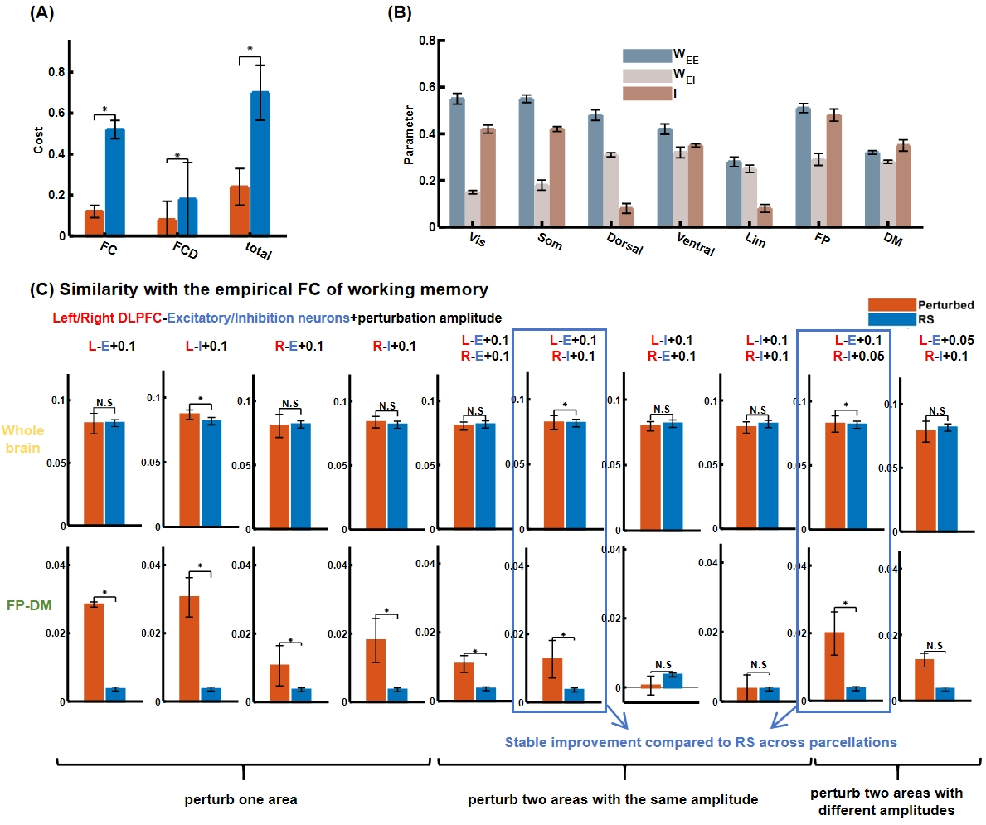
Supplementary Figure 5: Replication of Results on the EI-MFM model fitting and perterbation on Schaefer 100 parcellation. A The disagreement between simulation and functional measures on test set is calculated as 1-r for FC and KS distance for FCD and their summation for the total costs. LR and wLR denote the dynamics of inhibition neuronal populations with and without long-range excitatory inputs. * denotes a significant difference presented by permutation tests (p < 0.05, Bonferroni correction). B The estimated parameters present a gradient across brain networks, suggesting a local heterogeneity across cortex. C The perturbations areas are applied on one side of DLPFC areas, both DLPFC areas with the same amplitude and both DLPFC areas with different amplitudes. The similarity is measured by the Pearson's correlation between the simulated and the empirical FCs of working memory among the whole brain and between the frontoparietal and the default-mode networks, respectively. * denotes p < 0.05 after Bonferroni correction, comparing with RS. A robust improvement across brain parcellations is found for L-E+0.1&R-I+0.1, L-E+0.1&R-E-0.05. * denotes p < 0.05 after Bonferroni correction.

5. The control analyses of the perturbation study on the Anterior Insula
As stated in the main text, we performed the control analyses on the symmetrical areas on both hemispheres by perturbing the neuronal activities of the excitatory/inhibitory neuron populations on the areas with the same amplitudes and then with different amplitudes. We find among all the brain areas except for the DLPFC, only the Anterior Insula presents an improvement after perturbing the neuronal activities of the areas with the same amplitude, which is robust across both parcellations (Supplementary Fig. 6A and B). This meets the phenomenon reported by the work (Cai et al. 2021) that identified the Anterior Insula as the outflow during the 0 and 2-back working memory tasks. When perturbing the excitatory neuronal activities and the inhibitory neuronal activities of the left and right Anterior Insula, respectively, with different amplitudes, there is no perturbation presenting robust improvement across both parcellations (Supplementary Fig. 6A and B).

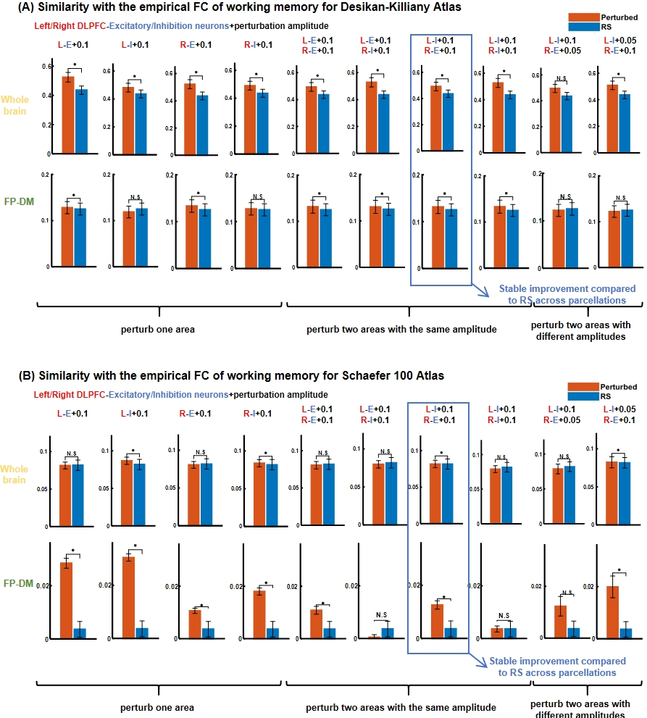
Supplementary Figure 6: The perturbation-induced brain pattern changes of the Anterior Insula. The perturbations areas are applied on one side of DLPFC areas, both DLPFC areas with the same amplitude and both DLPFC areas with different amplitudes using the Desikan-Killiary and the Schaefer 100 atlases. The similarity is measured by the Pearson's correlation between the simulated and the empirical FCs of working memory among the whole brain and between the frontoparietal and the default-mode networks, respectively. * denotes p < 0.05 after Bonferroni correction, comparing with RS. A robust improvement across brain parcellations is found for L-I+0.1&R-E-0.1.
6. The GABA and NMDA receptor-enriched network analysis on Schaefer 100
We tested the robustness of the molecular-enriched analysis on the Schaefer 100 parcellation. Again, the NMDA-enriched activation of the left DLPFC presents a significantly increase when comparing working memory with resting state (Supplementary Fig. 7A, p < 0.0001). The GABA-enriched activation of the right DLPFC presents a significantly increase when comparing working memory with resting state (Supplementary Fig. 7A, p < 0.0001). And the molecular-enriched activation increases present to be different (Supplementary Fig. 7 B, p = 0.058). Collectively, the phenomena combining with the results presented in Fig. 8 support the findings of our in silico experiments, i.e., the differential excitation-inhibition balance of each DLPFC area with the same amplitude.
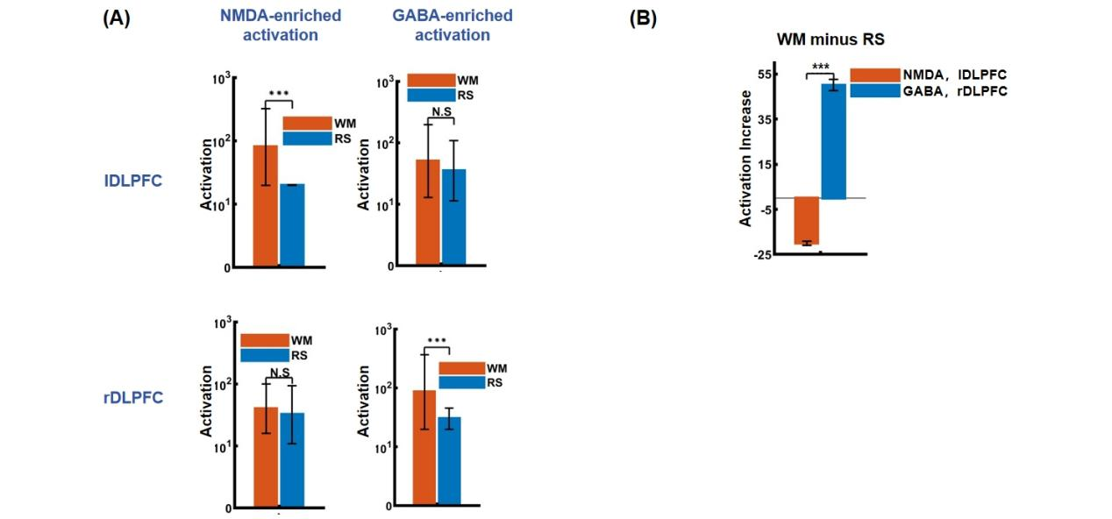
Supplementary Figure 7: Republication of results on GABA and NMDA-enriched analysis on the activation of left and right DLPFC on Shaefer 100 parcellation. We perform the molecular-enriched analysis on how the receptor density if NMDA and GABA would influence the functional activation of the left and right DLPFC areas. A NMDA-enriched and GABA-enriched activation during working memory and resting state for the left DLPFC under the Schaefer 100 parcellation. B The working memory-aroused increase of the NMDA-enriched activation of the left DLPFC versus that of the GABA-enriched activation of the right DLPFC under the Schaefer 100 parcellation.

References
Biswal, Bharat, et al. "Functional connectivity in the motor cortex of resting human brain using echo‐planar MRI." Magnetic resonance in medicine 34.4 (1995): 537-541.
Cai, Weidong, et al. "Dynamic causal brain circuits during working memory and their functional controllability." Nature Communications 12.1 (2021): 3314.
Yu-Feng, Zang, et al. "Altered baseline brain activity in children with ADHD revealed by resting-state functional MRI." Brain and Development 29.2 (2007): 83-91.

