Additional Figures
Figure S1. MR leave-one-out sensitivity analysis for Gut microbiota on Cirrhosis.
Figure S2. Scatter plots for the effect of Gut microbiota on Cirrhosis.
Figure S3. Forest plots for the effect of Gut microbiota on Cirrhosis.
Figure S4. Funnel plots for the effect of Gut microbiota on Cirrhosis.
Figure S5. MR leave-one-out sensitivity analysis for circulating inflammatory proteins on Cirrhosis.
Figure S6. Scatter plots for the effect of circulating inflammatory proteins on Cirrhosis.
Figure S7. Forest plots for the effect of circulating inflammatory proteins on Cirrhosis.
Figure S8. Funnel plots for the effect of circulating inflammatory proteins on Cirrhosis.

Figure S1. MR leave-one-out sensitivity analysis for Gut microbiota on Cirrhosis.
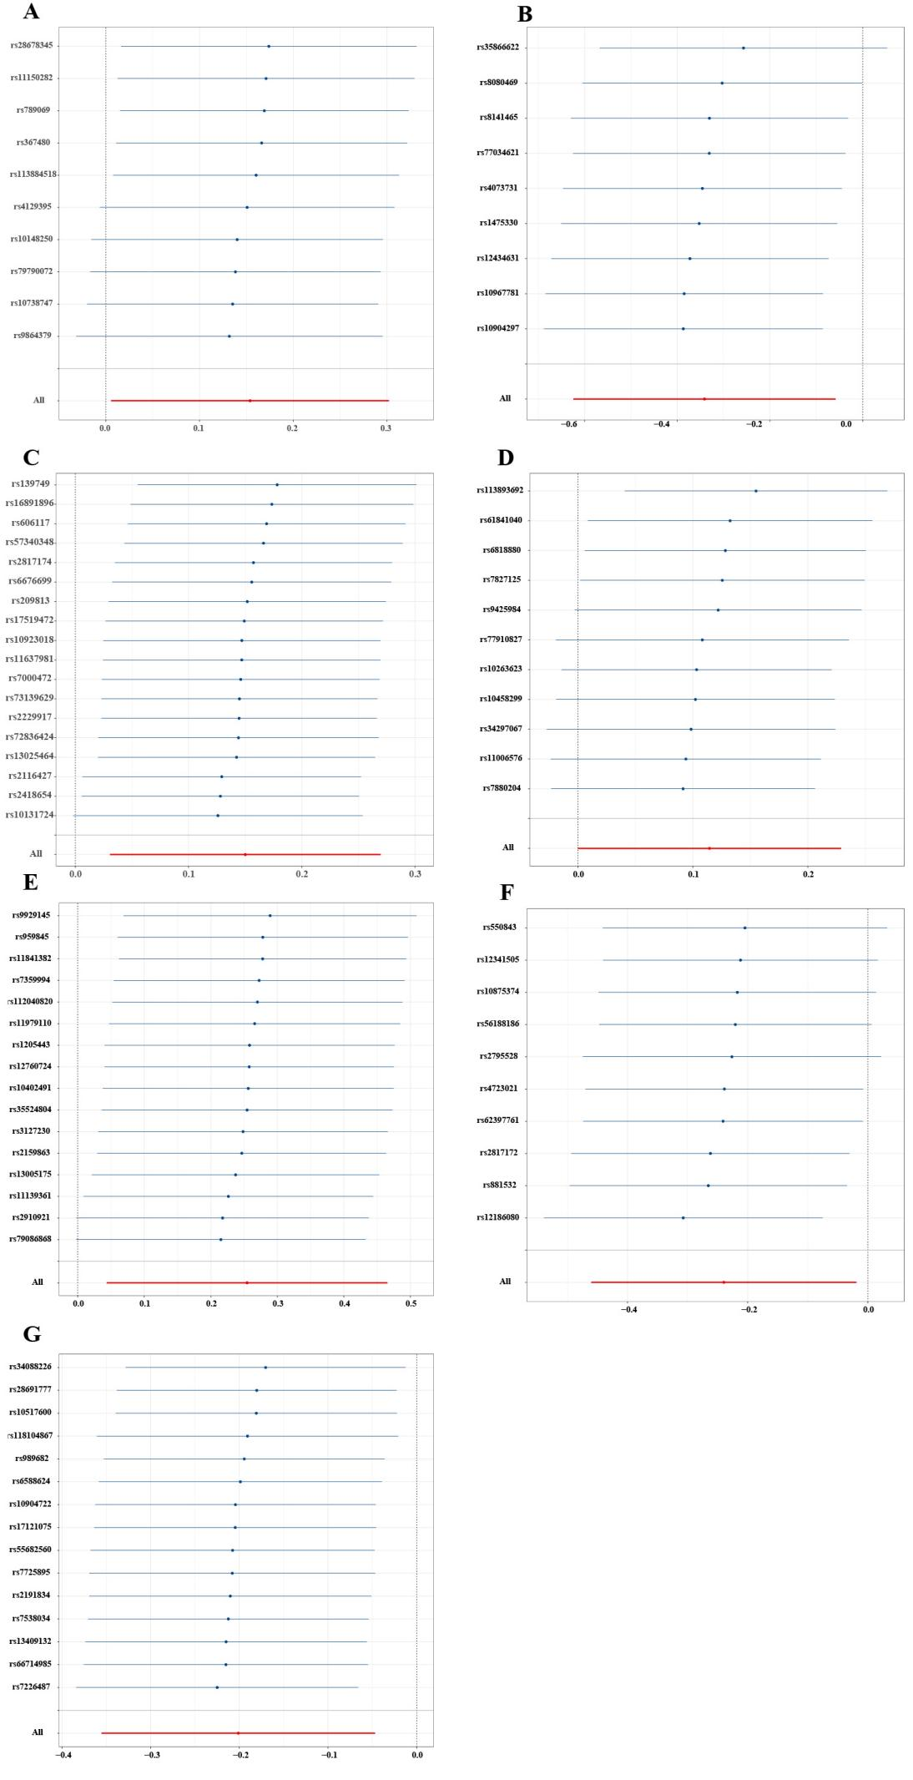

- Analysis for " Class Melainabacteria" on " Cirrhosis "
(B) Analysis for " Genus Ruminococcus torques group " on " Cirrhosis "
(C) Analysis for " Genus Eubacterium ruminantium " on " Cirrhosis"
(D) Analysis for " Genus Eubacterium nodatum " on "Cirrhosis "
(E) Analysis for " Family Lachnospiraceae " on " Cirrhosis "
(F) Analysis for " Family Clostridiaceae1 " on " Cirrhosis "
(G) Analysis for " Family Clostridiales vadin BB60 " on " Cirrhosis"

Figure S2. Scatter plots for the effect of Gut microbiota on Cirrhosis.

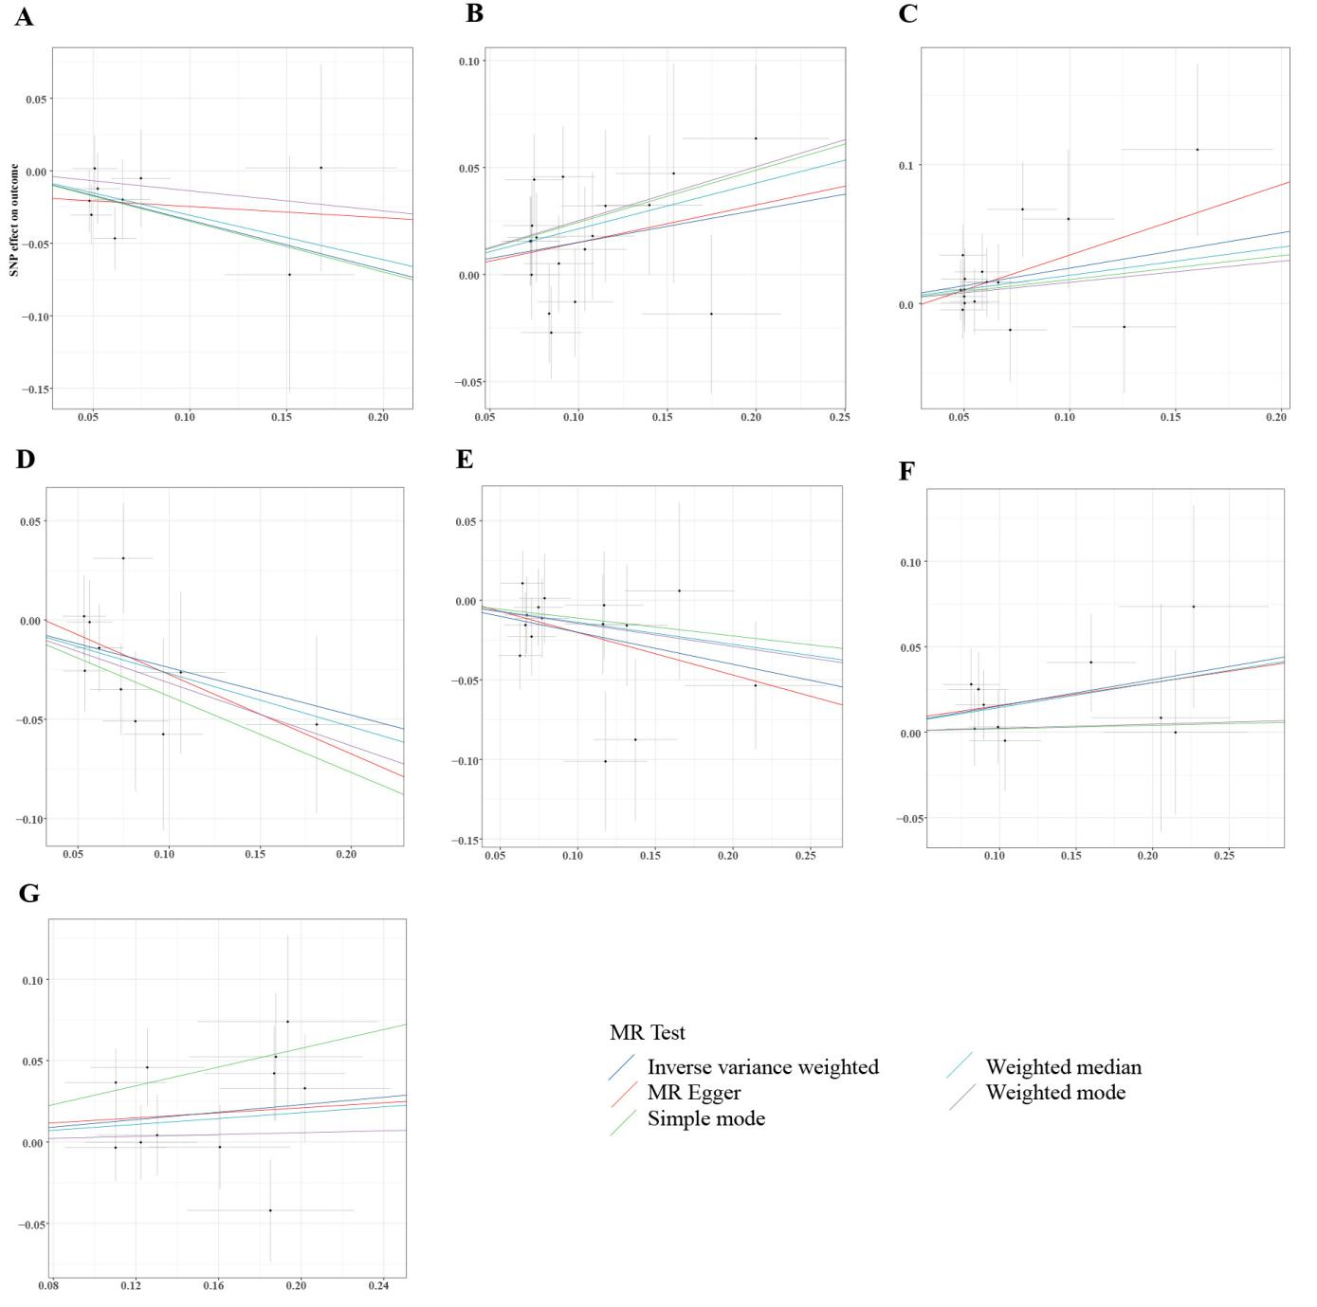

(A)Analysis for " genus Ruminococcus torques " on " Cirrhosis "
(B) Analysis for " genus Eubacterium ruminantium " on " Cirrhosis "
(C) Analysis for " family Lachnospiraceae " on " Cirrhosis "
(D) Analysis for " family Clostridiaceae1 " on " Cirrhosis "
(E) Analysis for " family Clostridiales vadin BB60 " on " Cirrhosis "
(F) Analysis for " class Melainabacteria " on " Cirrhosis "
(G) Analysis for " genus Eubacterium nodatum " on " Cirrhosis"

Figure S3. Forest plots for the effect of Gut microbiota on Cirrhosis.

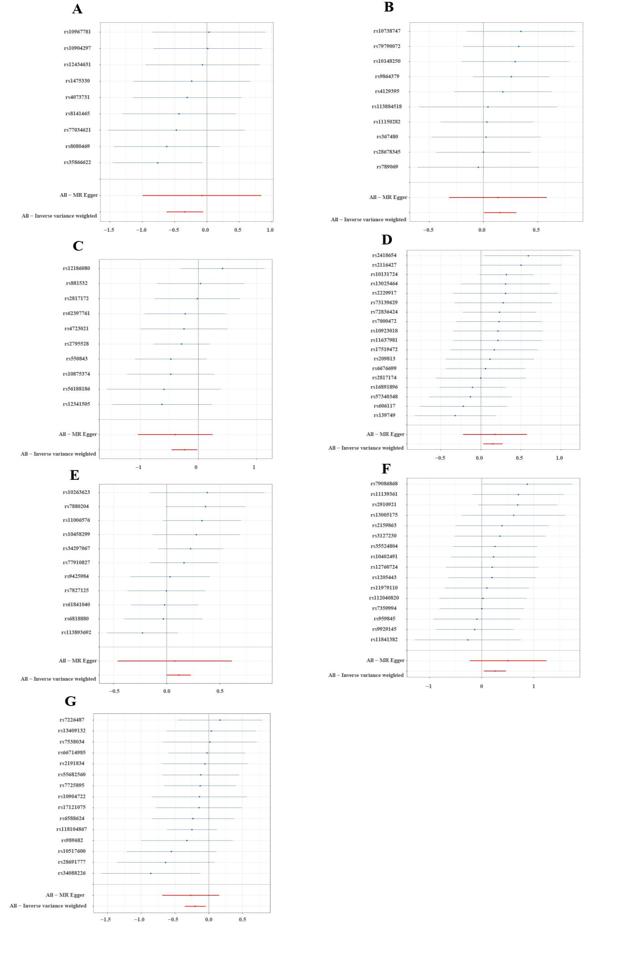
(A)Analysis for " genus Ruminococcus torques " on " Cirrhosis "
(B) Analysis for " class Melainabacteria " on " Cirrhosis "
(C) Analysis for " family Clostridiaceae1 " on " Cirrhosis "
(D) Analysis for " genus Eubacterium ruminantium " on " Cirrhosis "
(E) Analysis for " genus Eubacterium nodatum " on " Cirrhosis "
(F) Analysis for " family Lachnospiraceae" on " Cirrhosis "
(G) Analysis for " family Clostridiales vadin BB60 " on " Cirrhosis"

Figure S4. Funnel plots for the effect of Gut microbiota on Cirrhosis.
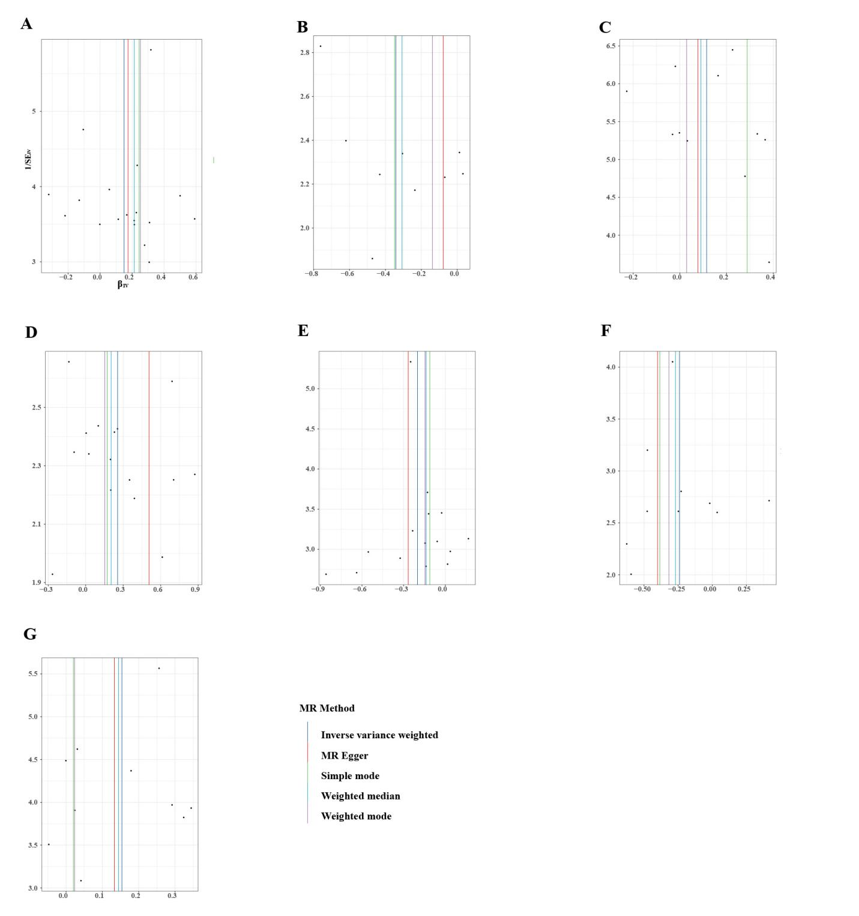
(A)Analysis for " genus Ruminococcus torques " on " Cirrhosis "
(B) Analysis for " genus Ruminococcus torques " on " Cirrhosis "
(C) Analysis for " genus Eubacterium nodatum group " on " Cirrhosis "
(D) Analysis for " family Lachnospiraceae " on " Cirrhosis "
(E) Analysis for " family Clostridiales vadin BB60 " on " Cirrhosis "
(F) Analysis for " family Clostridiaceae1" on " Cirrhosis "
(G) Analysis for " class Melainabacteria" on " Cirrhosis"

Figure S5. MR leave-one-out sensitivity analysis for circulating inflammatory proteins on Cirrhosis.
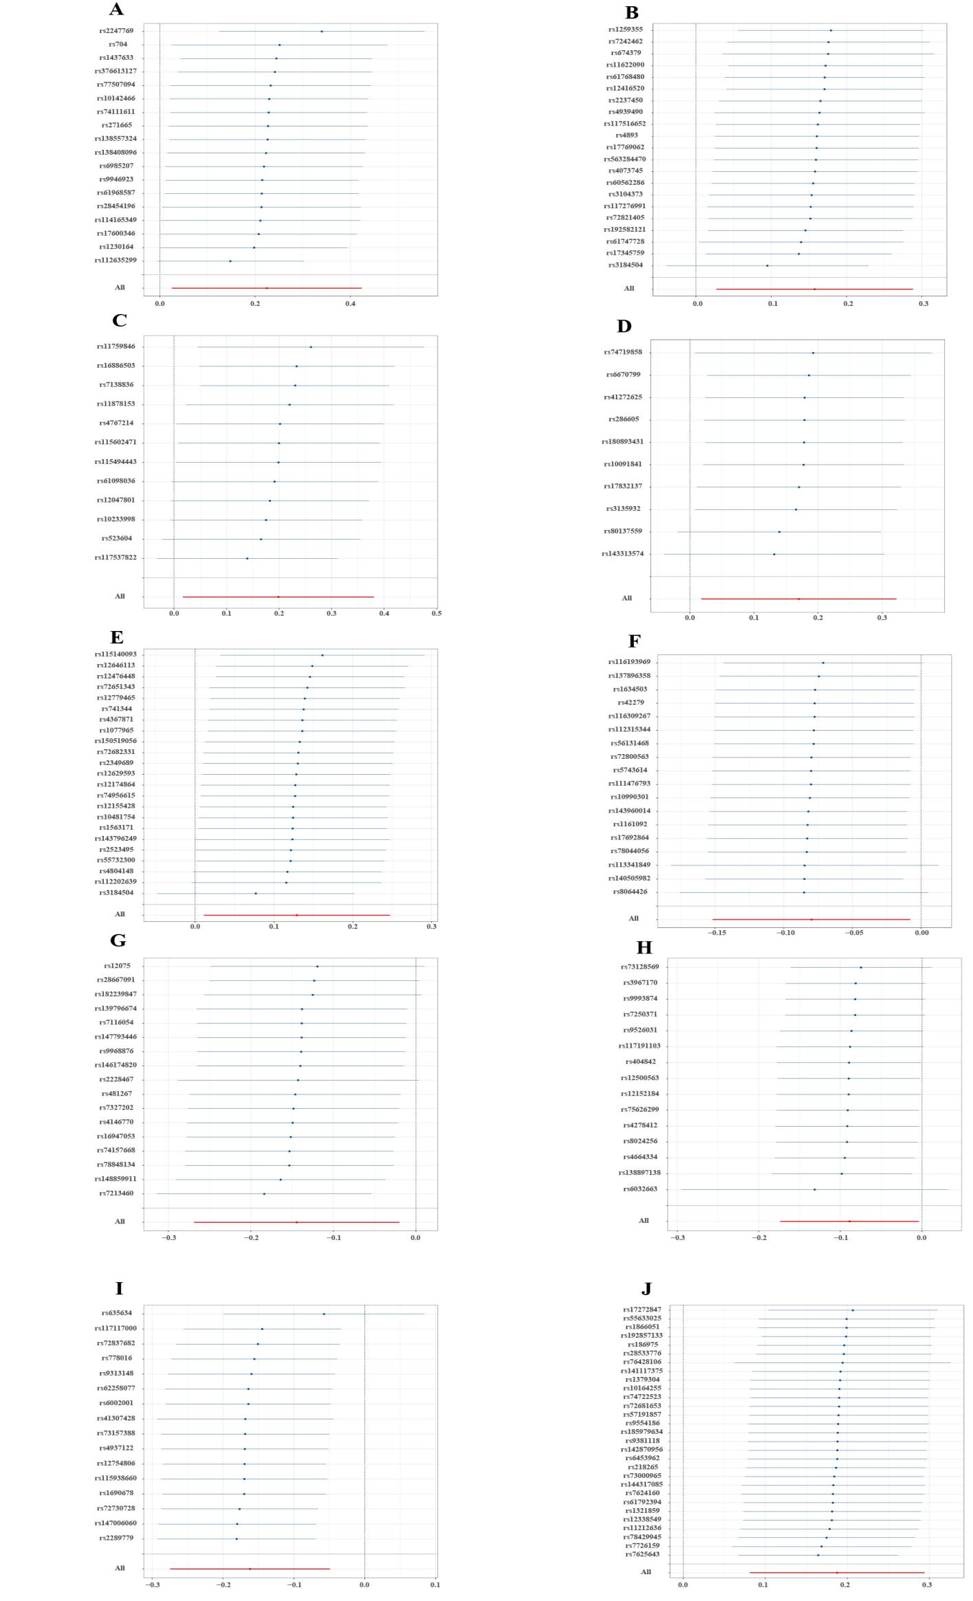
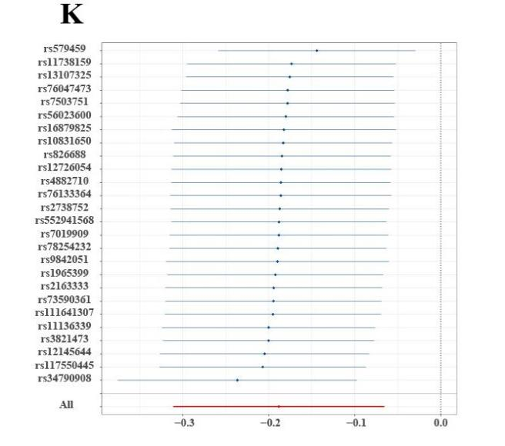
(A) Analysis for " Osteoprotegerin levels" on " Cirrhosis"
(B) Analysis for " T−cell surface glycoprotein CD5 levels" on " Cirrhosis "
(C) Analysis for "Interleukin−1−alpha levels" on " Cirrhosis "
(D) Analysis for "Interleukin−10 receptor subunit alpha levels" on " Cirrhosis "
(E) Analysis for " C−X−C motif chemokine 10 levels" on " Cirrhosis"
(F) Analysis for " C−C motif chemokine 4 levels " on " Cirrhosis "
(G) Analysis for " Monocyte chemoattractant protein−3 levels" on " Cirrhosis"
(H) Analysis for " CD40L receptor levels" on " Cirrhosis"
(I) Analysis for "Leukemia inhibitory factor receptor levels " on " Cirrhosis"
(J) Analysis for " Fms−related tyrosine kinase 3 ligand levels" on " Cirrhosis"
(K) Analysis for "Tumor necrosis factor ligand superfamily member 12 levels" on " Cirrhosis"

Figure S6. Scatter plots for the effect of circulating inflammatory proteins on Cirrhosis.

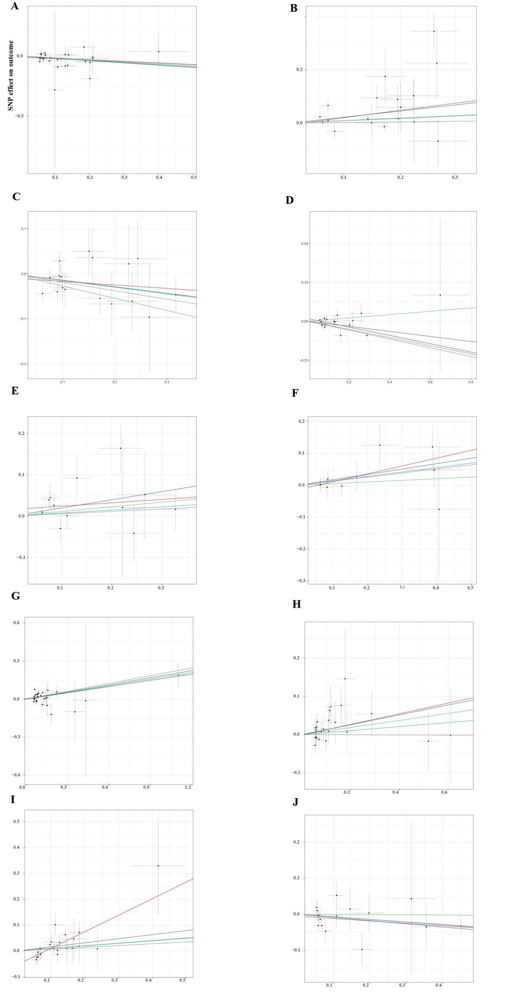

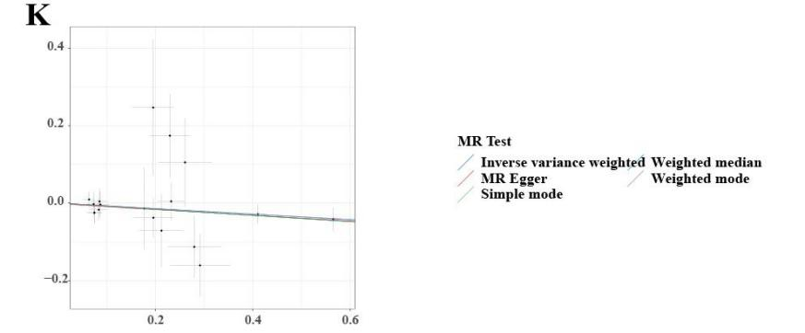
(A) Analysis for " Tumor necrosis factor ligand superfamily member 12 levels" on " Cirrhosis"
(B) Analysis for " Osteoprotegerin levels" on " Cirrhosis "
(C) Analysis for " Monocyte chemoattractant protein−3 levels" on " Cirrhosis "
(D) Analysis for "Leukemia inhibitory factor receptor levelss" on " Cirrhosis "
(E) Analysis for " Interleukin−1−alpha levels" on " Cirrhosis"
(F) Analysis for " Interleukin−10 receptor subunit alpha levels " on " Cirrhosis "
(G) Analysis for " Fms−related tyrosine kinase 3 ligand levels" on " Cirrhosis"
(H) Analysis for " C−X−C motif chemokine 10 levels" on " Cirrhosis"
(I) Analysis for "T−cell surface glycoprotein CD5 levels " on " Cirrhosis"
(J) Analysis for " CD40L receptor levels" on " Cirrhosis"
(K) Analysis for "C−C motif chemokine 4 levels" on " Cirrhosis"

Figure S7. Forest plots for the effect of circulating inflammatory proteins on Cirrhosis.
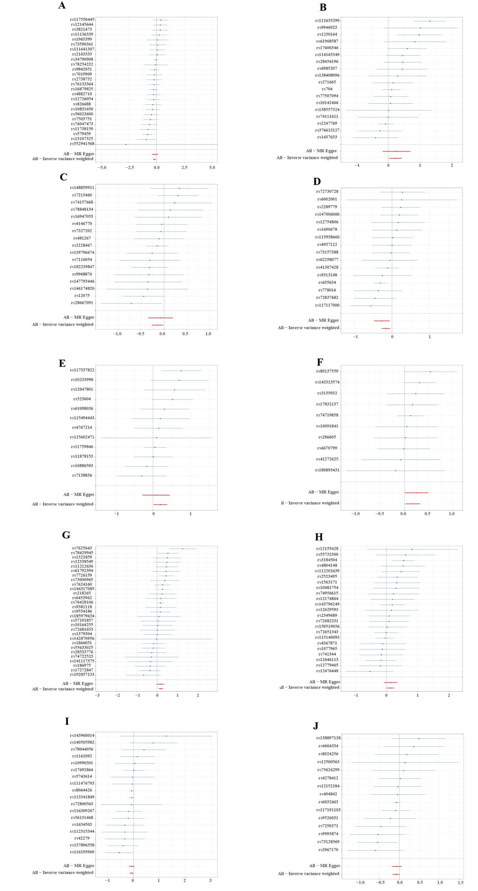
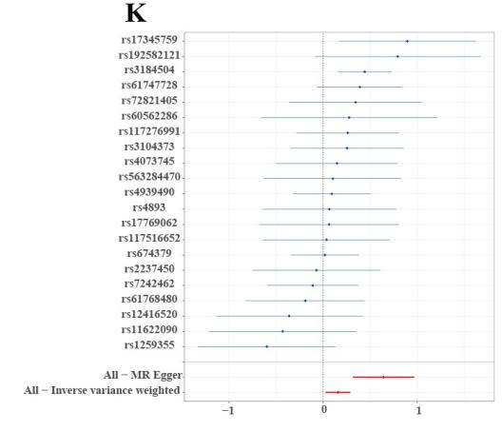
(A) Analysis for " Tumor necrosis factor ligand superfamily member 12 levels" on " Cirrhosis"
(B) Analysis for " Osteoprotegerin levels" on " Cirrhosis "
(C) Analysis for " Monocyte chemoattractant protein−3 levels" on " Cirrhosis "
(D) Analysis for "Leukemia inhibitory factor receptor levelss" on " Cirrhosis "
(E) Analysis for " Interleukin−1−alpha levels" on " Cirrhosis"
(F) Analysis for " Interleukin−10 receptor subunit alpha levels " on " Cirrhosis "
(G) Analysis for " Fms−related tyrosine kinase 3 ligand levels" on " Cirrhosis"
(H) Analysis for " C−X−C motif chemokine 10 levels" on " Cirrhosis"
(I) Analysis for " C−C motif chemokine 4 levels" on " Cirrhosis"
(J) Analysis for " CD40L receptor levels" on " Cirrhosis"
(K) Analysis for "T−cell surface glycoprotein CD5 levels" on " Cirrhosis"

Figure S8. Funnel plots for the effect of circulating inflammatory proteins on Cirrhosis.
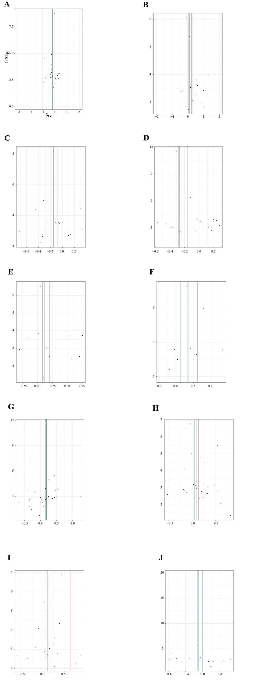
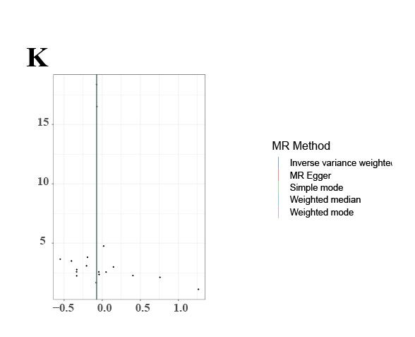
(A) Analysis for " Tumor necrosis factor ligand superfamily member 12 levels" on " Cirrhosis"
(B) Analysis for " Osteoprotegerin levels" on " Cirrhosis "
(C) Analysis for " Monocyte chemoattractant protein−3 levels" on " Cirrhosis "
(D) Analysis for "Leukemia inhibitory factor receptor levelss" on " Cirrhosis "
(E) Analysis for " Interleukin−1−alpha levels" on " Cirrhosis"
(F) Analysis for " Interleukin−10 receptor subunit alpha levels " on " Cirrhosis "
(G) Analysis for " Fms−related tyrosine kinase 3 ligand levels" on " Cirrhosis"
(H) Analysis for " C−X−C motif chemokine 10 levels" on " Cirrhosis"
(I) Analysis for " T−cell surface glycoprotein CD5 levels" on " Cirrhosis"
(J) Analysis for " CD40L receptor levels" on " Cirrhosis"
(K) Analysis for "C−C motif chemokine 4 levels" on " Cirrhosis"

