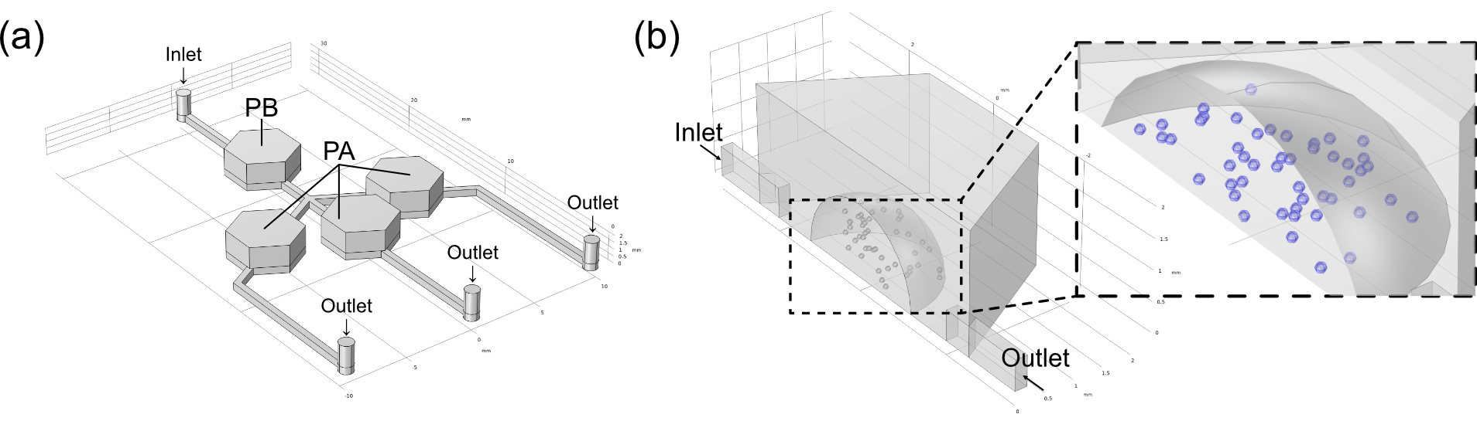
Supplemental Fig. 1. Modeling in COMSOL. (a) The overall model used for numerical analysis. (b) Detailed model of the internal structure of the chambers.

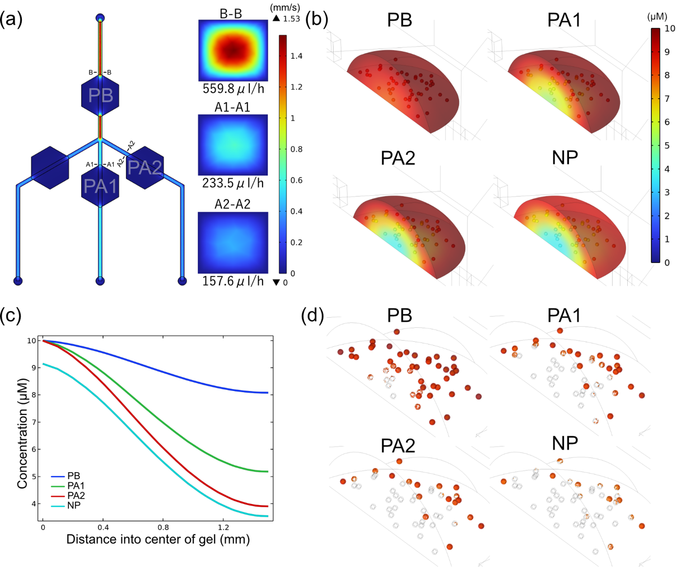
Supplemental Fig. 2. Numerical analysis using COMSOL Multiphysics. (a) Flow rate distribution within the microfluidic device, with right-hand images representing flow rates into each chambers. (b) Concentration gradient profile within the gel in different chambers after 48 h. (c) Concentration distribution from the outer edge to the center of the gel after 48 hours. (d) Proportion of cell death represented by concentrations exceeding the threshold (indicated by red regions) in various chambers following 48 hours of perfusion.

