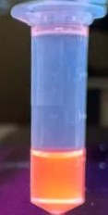
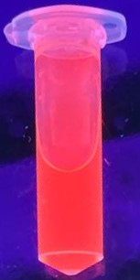
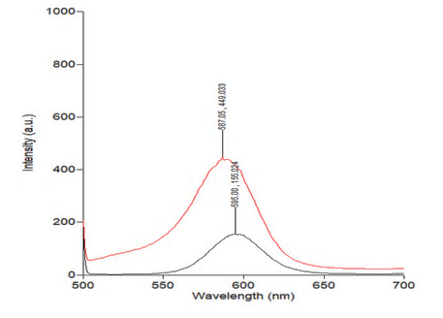
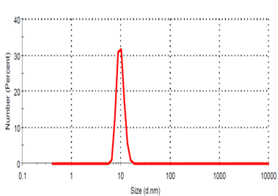
core
shelled
CdSe core
CdSe/CdS/ZnS hydrophillic

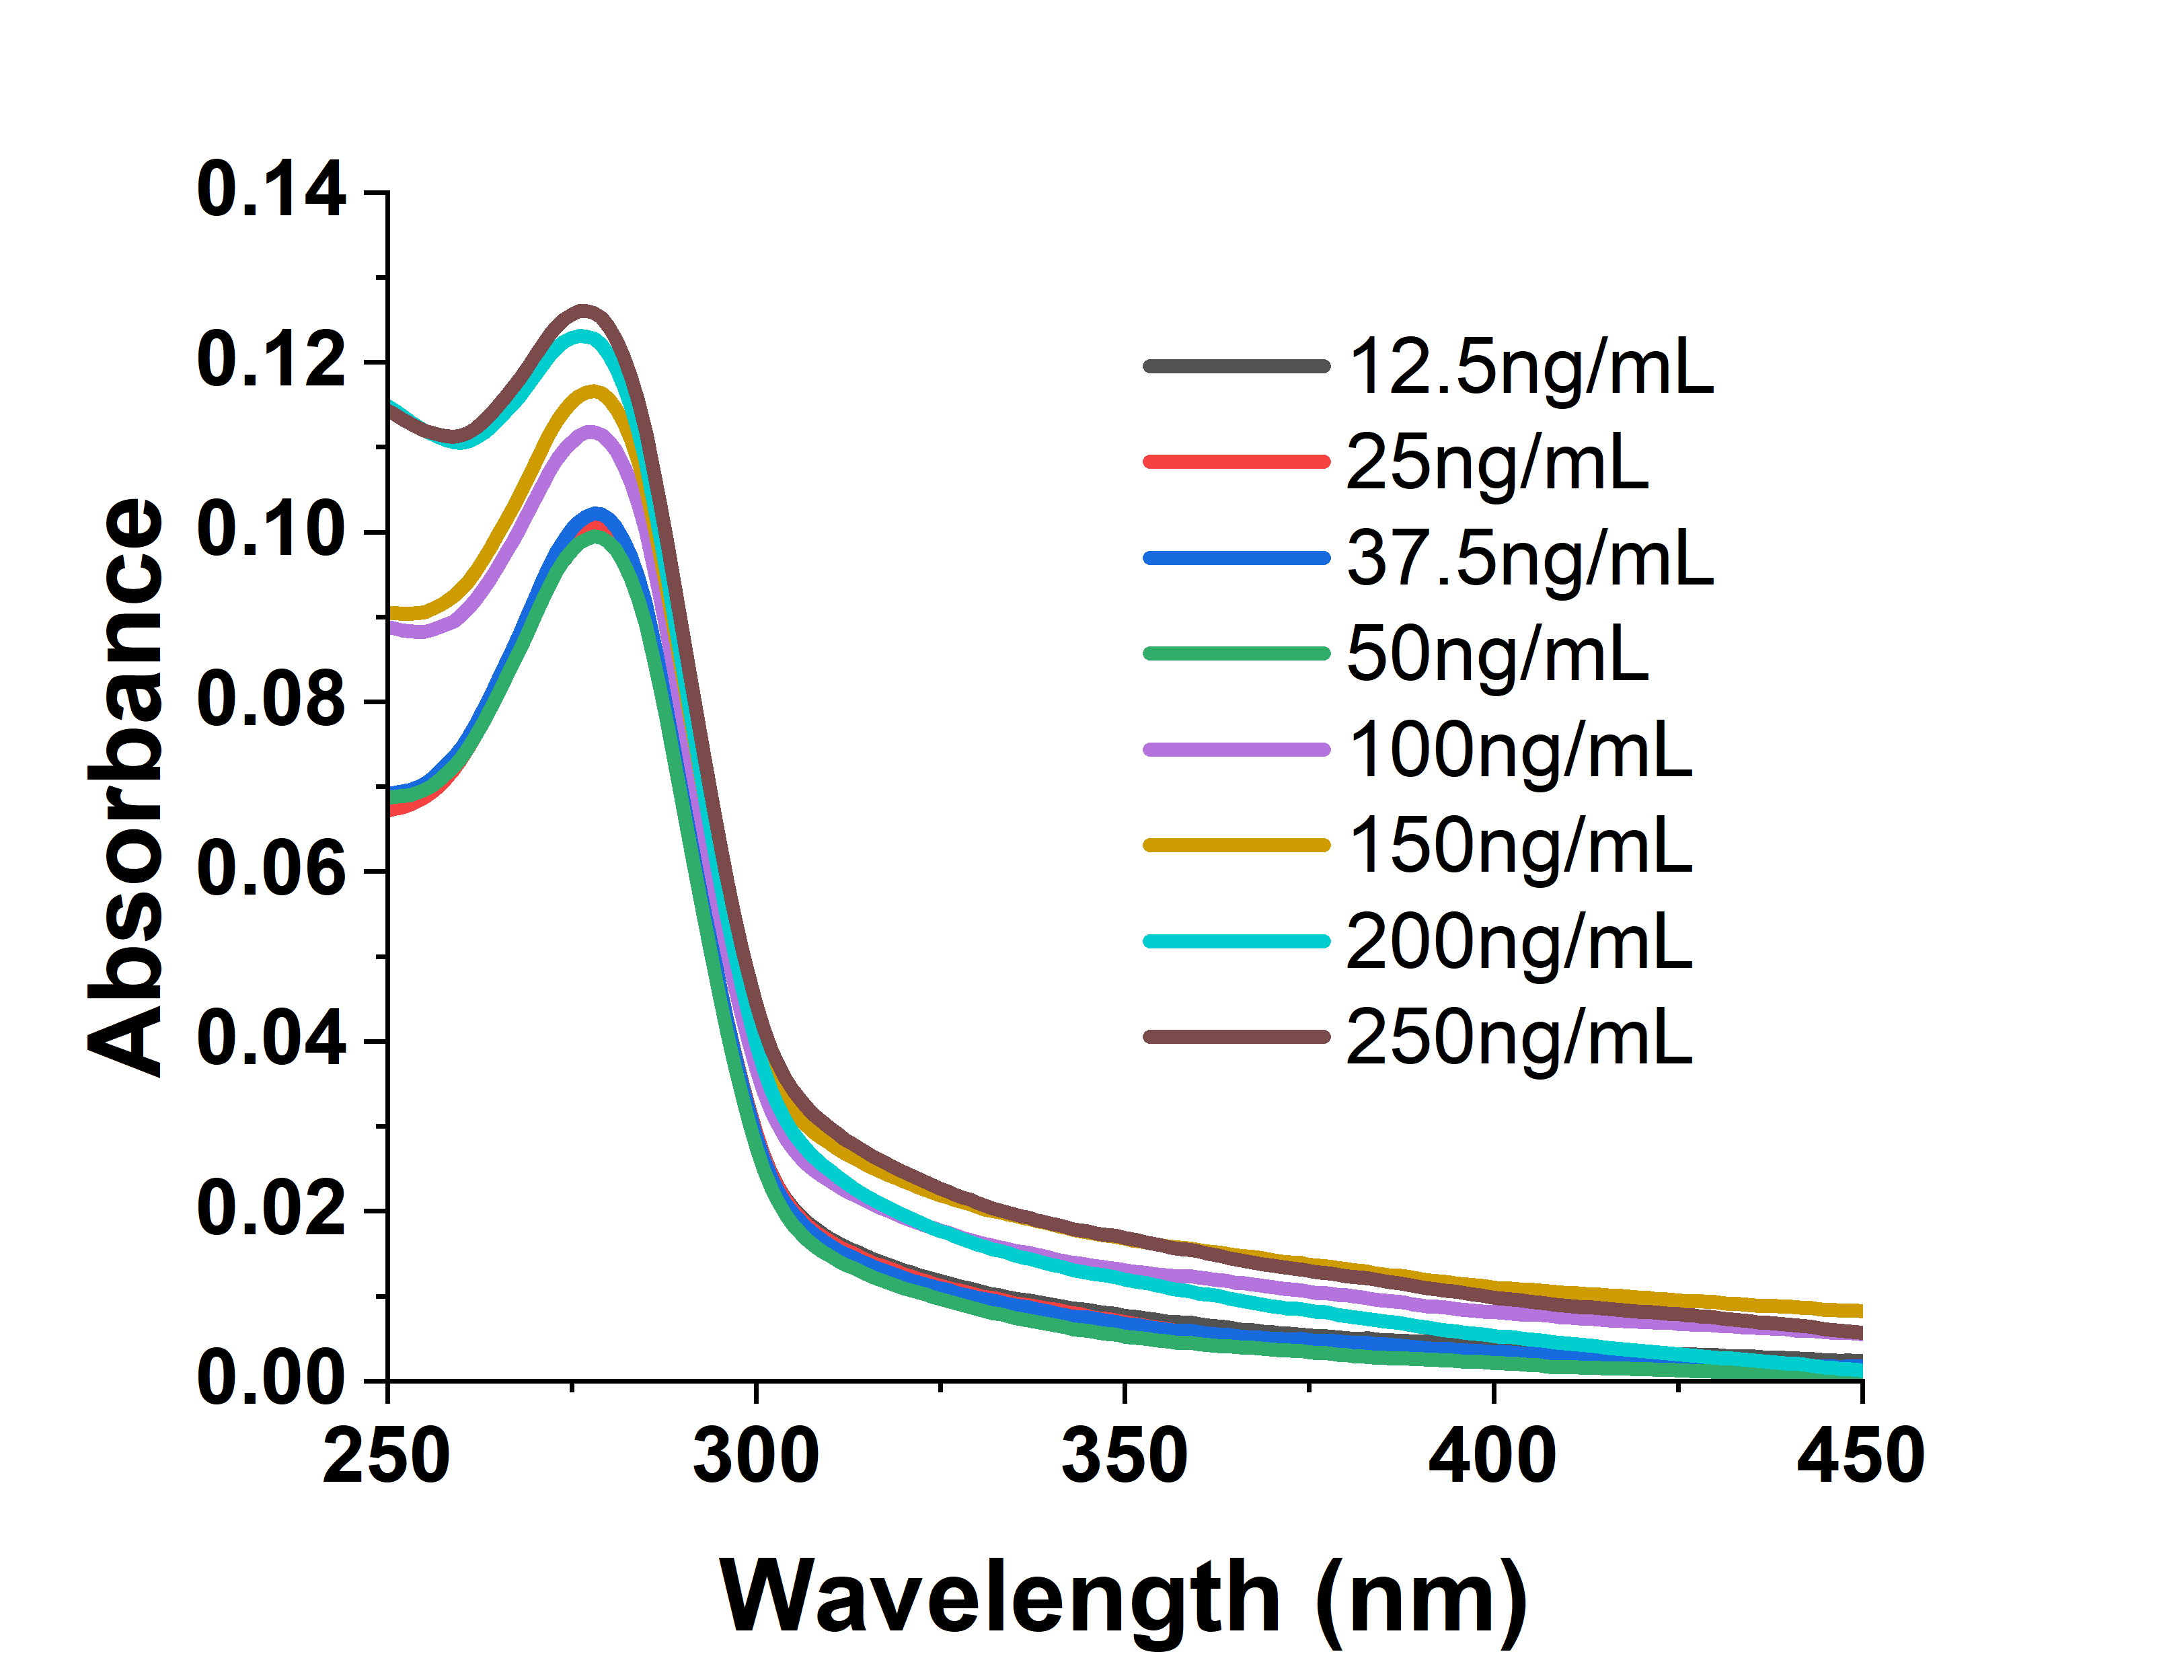
Supplementary Figure 1: Characterization of CdSe:CdS:ZnS core shell quantum dots for DLS (5-8nm), fluorescence emission spectra (Ex 350nm), and visible fluorescence under UV light.

Supplementary Figure 2: Absorbance scan of CdSe:CdS:ZnS quantum dots at various concentrations given in the figure.

Supplementary Figure 3: DLS analysis of apoferritin alone (without quantum dots) showing the size around 10-12nm.

