Table 1. Demographic characteristics and CEBQ subscales of the cohort under study.
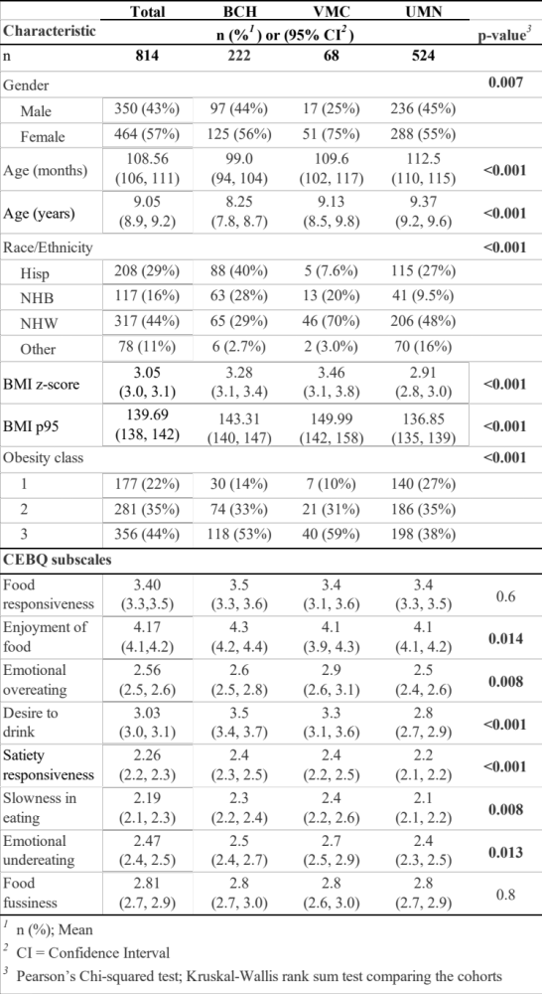
Abbreviations: CEBQ, child eating behavior questionnaire; BCH, Boston Children’s Hospital; VMC, Vanderbilt Medical Center; UMN, University of Minnesota; Hisp, Hispanic; NHB, Non-Hispanic Black; NHW, Non-Hispanic White; BMI p95, Body mass index 95th percentile

