Supplementary Material
Fig. S1 Observed and imputed groundwater level time series for GW2, GW3, GW7, GW8, GW15.
Fig. S2 The periodogram of the first eigenfunction across monitoring wells.
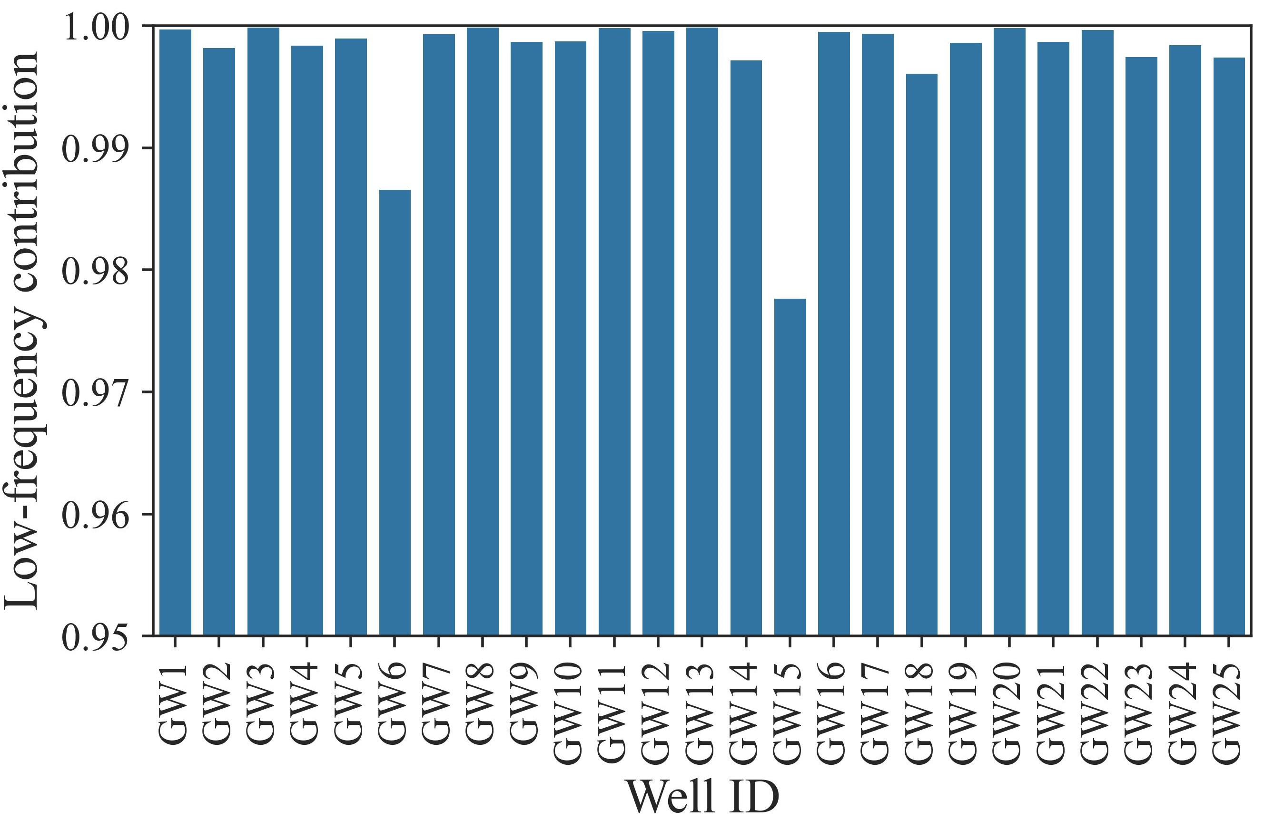
Fig. S3 The low-frequency contribution of the first eigenfunction across monitoring wells.
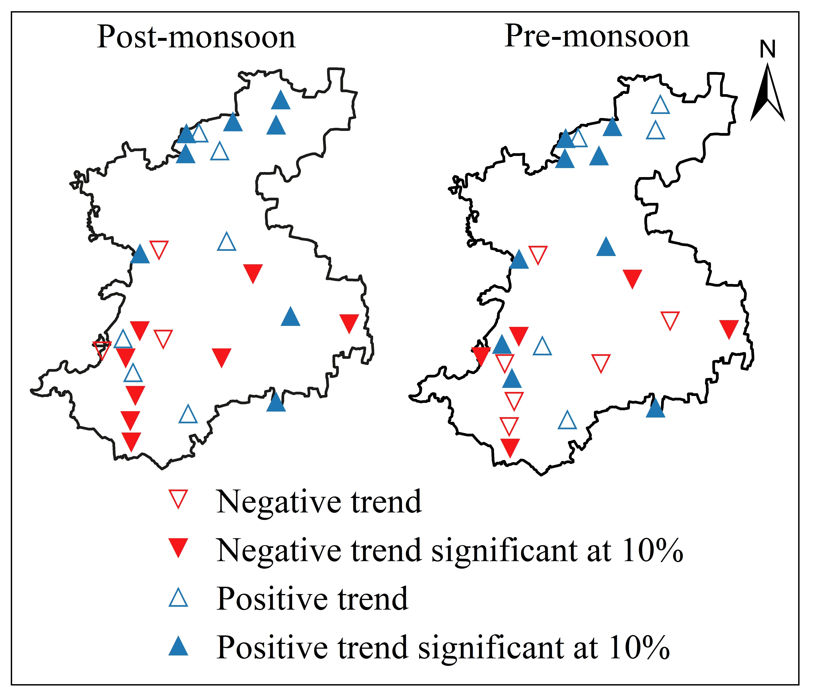
Fig. S4 The spatial representation of the Mann-Kendall linear trends in groundwater levels during the pre-monsoon (May) and post-monsoon (November).
Fig. S5 SSA-extracted nonlinear and linear trends for few monitoring wells.

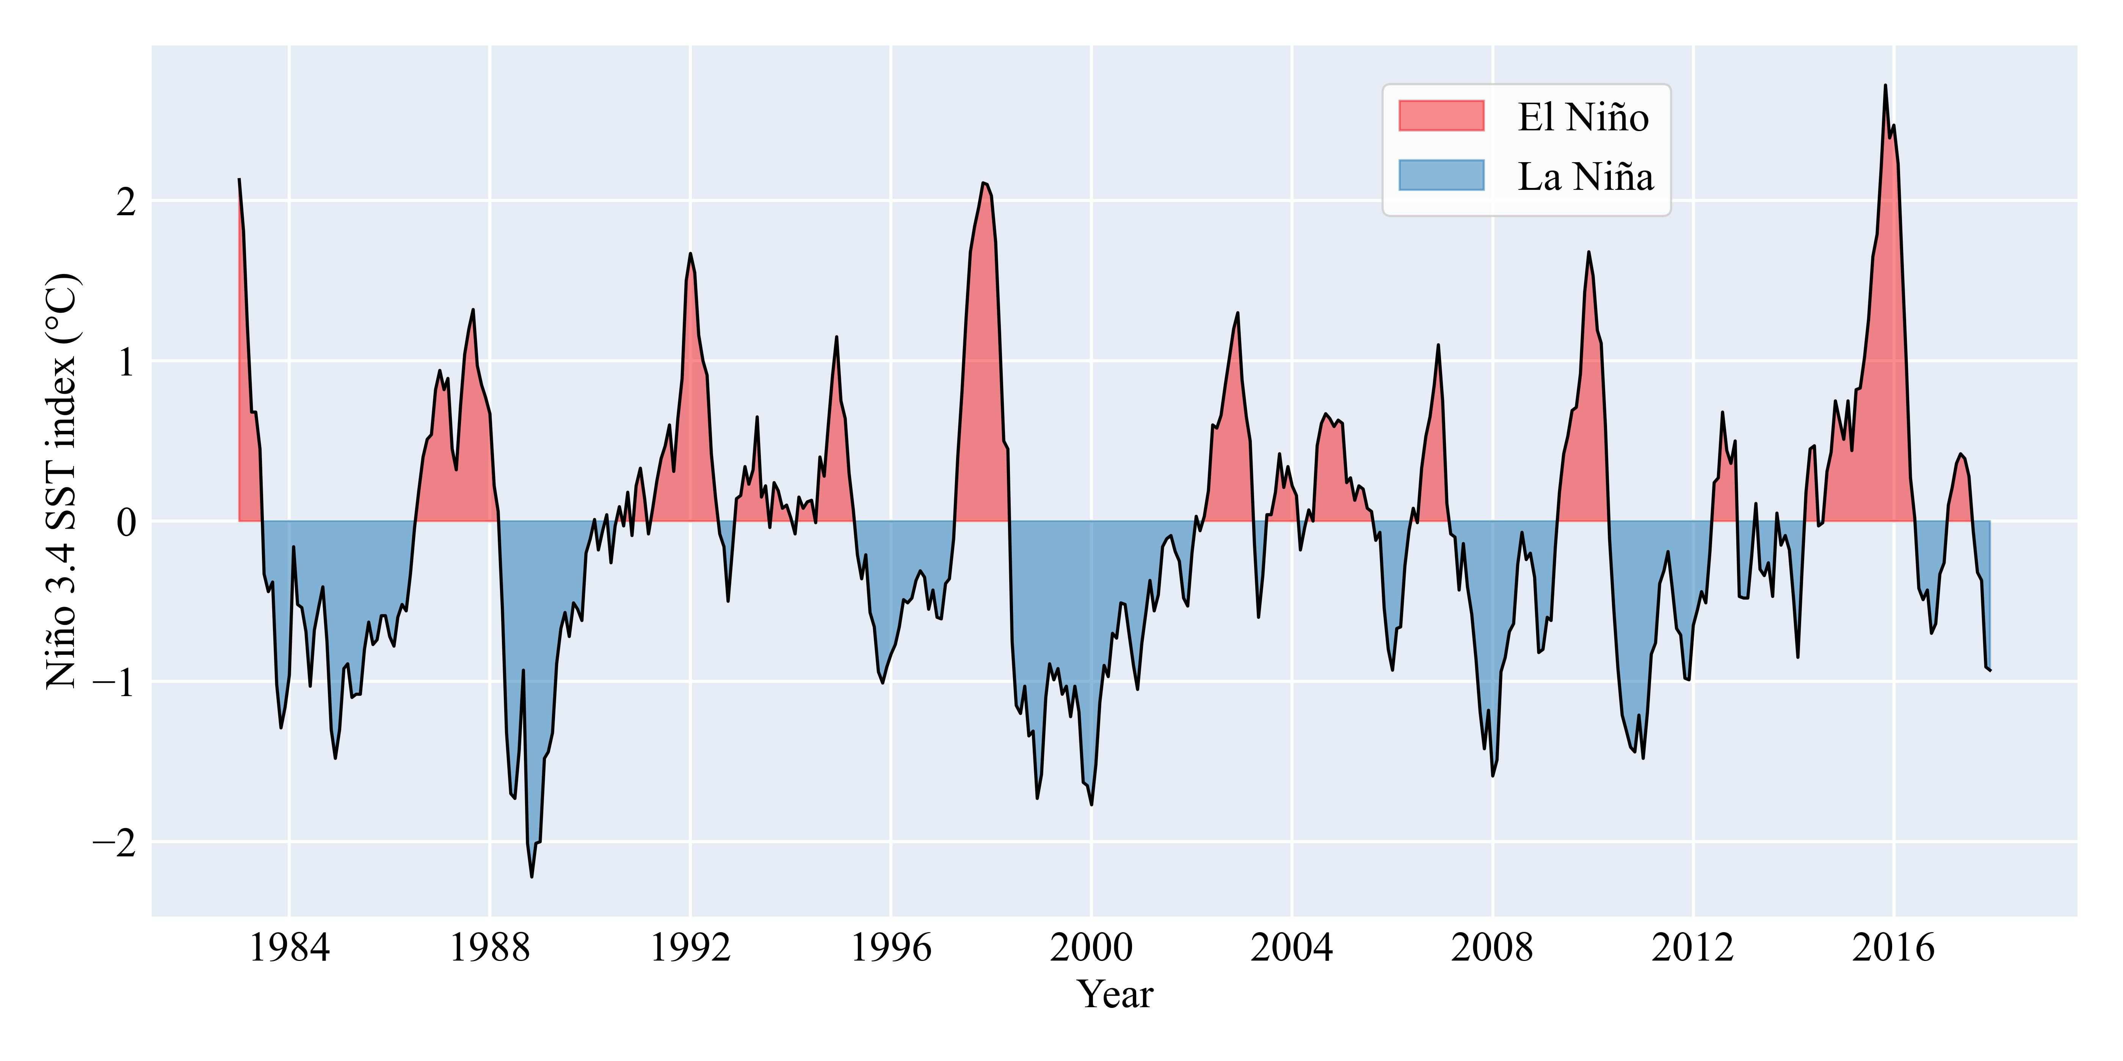
Fig. S6 The monthly time series of the Niño 3.4 SST Index.

