The proportion of free radical scavenging activity revealed by the test compounds 3a-l, 4a-l and 5a-l was quantified using the 1, 1-diphenyl picryl hydrazyl (DPPH) assay technique. Drug stock solutions with concentrations of 1 mg mL-1 in methanol were diluted to produce final concentrations of 2, 4, 6, 8, and 10 mg mL-1. The findings were read after adding a DPPH methanol solution (1 mL, 0.3 M mol) to 2.5 mL of drug solutions with different concentrations and letting the mixture react at room temperature. The proportion of antioxidant activity was determined from the observations made after 30 minutes of observation by measuring the absorbance values at 518 nm. Methanol was applied as the solvent, while ascorbic acid was used as the reference. The estimated percentage of inhibition based on concentration is shown in Figure 4. The outcomes are shown in Table 6. Ascorbic acid was the usual medication.

In the current year, there has been increasing interest in the synthesis of various O-(β -D-Glucopyranosyl)-4-Thiazolidinones due to their extensive pharmacological activities. These are significant class of heterocyclic compounds. The proposed work is extent of the chemistry of O-(β -D-Glucopyranosyl)-4-Thiazolidinones by synthesized in large amount in laboratory via classical as well as microwave analysis. Heterocyclic compounds, often known as heterocyclic, are organic chemical compounds having a ring-like structure that includes one or more heteroatoms. Heterocyclic can be both cyclic and acyclic ¹ ⁻ ¹⁴. The general structure of heterocyclic is similar to that of cyclic organic compounds, which have only carbon atom in their structure, but the substitute of one or more carbon atoms by heteroatoms gives heterocyclic physico-chemical properties that are distinct from those of all carbon ring analogs¹⁵ ⁻ ¹⁷. Heterocyclic involve a wide range of uses, including agrochemical, medicinal, and veterinary¹⁸. Such compounds are also used in sanitizers, antioxidants, copolymers, corrosion inhibitors, dyestuff¹⁹, etc. Heterocyclic are currently employed in the production of a wide range of organic chemical substances²⁰. Several compounds, mostly of natural origin, such as alkaloids, morphine, vinblastine, and reserpine, and a variety of antibiotics, such as cephalosporin, penicillin, and others, include heterocyclic components. Schiff bases are important due to their antimicrobial activity and are remarkable due to their stability and chelating properties ²¹. Schiff bases can be used for the production of novel drugs. Schiff base complexes with metal ions have interested chemists due to applications of imines for their anti-tuberculosis, antibacterial, antifungal, antimalarial, and antiviral activity ²². Schiff bases and their metal complexes contain halogens that display antimicrobial activity ²³.4-thiazolidinones have reported for their antibacterial, antiparkinsonian and anti-convalescent activities²⁴⁻²⁵. 4-thiazolidinones find their application as local anesthetics and also as moderate tuberculosis agent. Thiazolidinones which belong to an important group of heterocyclic compounds have been widely explored for their applications in the field of medicine. Glycosides play important role in variety of biological processes²⁶⁻⁴⁷, such as signaling, cell-cell communication, molecular and cellular targeting and certain glycosides comprise several important classes of compounds such as hormones, sweetener, alkaloids, flavonoids, vitamins, antibiotics, etc.
The reaction sequence leading to the formation of desire heterocyclic compounds are outline in scheme 1. Thiourea and 4-hydroxyacetophenone in ethanol to form starting material 4-(2-amino-1, 3-thiazol-4-yl) Phenol (1) was prepared by stirred for 6 hours with different aldehydes to give 4-(2-schiffs base-1, 3-thiazol-4-yl) Phenol (2) was then undergo cyclisation in presence of glacial acetic acid gives 3-[4-(4-hydroxy phenyl)-1, 3-thiazole-2-yl]-2-phenyl-1, 3-thiazolidin-4-one (3) and α-D-2, 3, 4, 6-tetra-O-acetyl Glucopyranosyl bromide were dissolved in dioxane at 100⁰C and kept at this temperature for 4 hours to give 3-[4-(4- O-(2, 3, 4, 6- tetra- O- acetyl- β- D- Glucopyranosyl)phenyl)-1, 3-thiazol-2-yl]-2-phenyl-1, 3-thiazolidin-4-one (4). To a solution of 3-[4-(4- O-(2, 3, 4, 6- tetra- O- acetyl- β- D- Glucopyranosyl)phenyl)-1, 3-thiazol-2-yl]-2-phenyl-1, 3-thiazolidin-4-one (4) in 25 mL of dry methanol was added freshly prepared 5% sodium methoxide solution and the mixture was kept at room temperature for 24 hour to give3-[4-(4- O-(β -D-Glucopyranosyl) phenyl)-1, 3-thiazol-2-yl]-2-phenyl-1, 3-thiazolidin-4-one (5).
Comparative study of 4-(2-amino-1, 3-thiazol-4-yl) Phenol (1) and compounds 3-[4-(4-hydroxy phenyl)-1, 3-thiazole-2-yl]-2-phenyl-1, 3-thiazolidin-4-one 3(a-l), 3-[4-(4- O-(2, 3, 4, 6- tetra- O- acetyl- β- D- Glucopyranosyl)phenyl)-1, 3-thiazol-2-yl]-2-phenyl-1, 3-thiazolidin-4-one 4(a-l) and 3-[4-(4- O-(β -D-Glucopyranosyl) phenyl)-1, 3-thiazol-2-yl]-2-phenyl-1, 3-thiazolidin-4-one 5(a-l) have been observed by using Norfloxacine and Griseofulvin as standards. The enhancement in biological activity of compound (1) as compared with the newly synthesized 3(a-i), 4(a-l), 5(a-l) has been observed. The synthesized compounds were tested at 100 ug/ml concentrations against Escherichia coli, Pseudomonas aeruginosa, Staphylococcus aureus, Proteus vulgaris and fungal cultures such as Aspergillus niger and Candida albicans for its antibacterial and antifungal screening as shown in Tables 4, 5, and 6.

Table 1-Characterization data of compounds 3(a-l).

Comp | R* | Mol Formula | RF | M. P.  (°C) | Yield  (%) | Analysis fond  (calcd)% (obs)
Comp | R* | Mol Formula | Value Eluentª | M. P.  (°C) | Yield  (%) | C | H | N | S
3a | -H | C₁₇H₁₄ON₂S₂ | 0.81 | 128 | 71 | 62.5  (62.9) | 4.2  (4.7) | 8.5  (8.7) | 19.6  (19.4)
3b | 2-OH | C₁₈H₁₄O₂N₂S₂ | 0.91 | 137 | 67 | 61.01  (61.74) | 3.95  (3.4) | 7.9  (7.2) | 18.0  (18.1)
3c | 3-OH | C₁₈H₁₄O₂N₂S₂ | 0.87 | 131 | 65 | 61.01  (61.74) | 3.95  (3.4) | 7.9  (7.2) | 18.0  (18.1)
3d | 4-OH | C₁₈H₁₄O₂N₂S₂ | 0.65 | 130 | 58 | 61.01  (61.74) | 3.95  (3.4) | 7.9  (7.2) | 18.0  (18.1)
3e | 2-NO₂ | C₁₈H₁₂O₃N₃S₂ | 0.41 | 148 | 68 | 56.8  (56.6) | 3.1  (3.6) | 11.1  (11.2) | 16.8  (16.4)
3f | 3-NO₂ | C₁₈H₁₂O₃N₃S₂ | 0.57 | 144 | 64 | 56.8  (56.6) | 3.1  (3.6) | 11.1  (11.2) | 16.8  (16.4)
3g | 4-NO₂ | C₁₈H₁₂O₃N₃S₂ | 0.74 | 147 | 81 | 56.8  (56.6) | 3.1  (3.6) | 11.1  (11.2) | 16.8  (16.4)
3h | 2-Cl | C₁₈H₁₂ON₂S₂Cl | 0.52 | 153 | 66 | 37.3  (37.6) | 4.7  (4.3) | 11.1  (11.2) | 25.4  (25.3)
3i | 4-Cl | C₁₈H₁₂ON₂S₂Cl | 0.65 | 157 | 74 | 37.3  (37.6) | 4.7  (4.3) | 11.1  (11.2) | 25.4  (25.3)
3j | 2-OCH3 | C₁₈H₁₆O₂N₃S₂ | 0.93 | 158 | 66 | 58.0  (58.6) | 4.3  (4.3) | 7.3  (7.2) | 17.2  (17.8)
3k | 4-OCH3 | C₁₈H₁₆O₂N₃S₂ | 0.80 | 167 | 77 | 58.0  (58.6) | 4.3  (4.3) | 7.3  (7.2) | 17.2  (17.8)
3l | 3, 4, 5 (OCH₃)₃ | C₂₁H₂₀O₅N₂S₂ | 0.45 | 177 | 72 | 56.7  (56.6) | 4.5  (4.3) | 6.5  (6.4) | 14.9  (14.6)

*Solvent for crystallization: aq. Ethanol for 3a-i; methanol for 3j-l.

a Eluents for TLC: ethyl acetate-acetone (6:4) for 3a, 3b, 3c, 3d, 3f ethyl acetate-acetone (7:3) for 3e, 3g, 3h, 3j, 3k, 3l.
Table 2 Characterization data of compounds (4a-l).
Comp | R | Mol Formula | RF | M. P.  (°C) | Yield  (%) | Analysis found  (calcd)% (obs)
Comp | R | Mol Formula | Value Eluentª | M. P.  (°C) | Yield  (%) | C | H |  | N |  | S
4a | -H | C₂₆H₃₀O₇N₂S₂ | 0.72 | 172 | 80 | 57.14  (57.1) | 5.2  (5.3) |  | 5.12  (5.7) |  | 11.2  (11.4)
4b | 2-OH | C₂₆H₃₀O₈N₂S₂ | 0.53 | 177 | 67 | 55.5  (55.7) | 5.3  (5.0) |  | 4.9  (4.2) |  | 11.3  (11.8)
4c | 3-OH | C₂₆H₃₀O₈N₂S₂ | 0.45 | 171 | 65 | 55.5  (55.7) | 5.3  (5.0) |  | 4.9  (4.2) |  | 11.3  (11.8)
4d | 4-OH | C₂₆H₃₀O₈N₂S₂ | 0.92 | 176 | 68 | 55.5  (55.7) | 5.3  (5.0) |  | 4.9  (4.2) |  | 11.3  (11.8)
4e | 2-NO₂ | C₂₆H₂₉O₉N₃S₂ | 0.45 | 185 | 58 | 52.7  (52.6) | 4.4  (4.6) |  | 7.1  (7.2) |  | 10.7  (10.8)
4f | 3-NO₂ | C₂₆H₂₉O₉N₃S₂ | 0.43 | 159 | 78 | 52.7  (52.6) | 4.4  (4.6) |  | 7.1  (7.2) |  | 10.7  (10.8)
4g | 4-NO₂ | C₂₆H₂₉O₉N₃S₂ | 0.65 | 182 | 83 | 52.7  (52.6) | 4.4  (4.6) |  | 7.1  (7.2) |  | 10.7  (10.8)
4h | 2-Cl | C₂₆H₃₀O₇N₂S₂Cl₂ | 0.64 | 173 | 76 | 53.5  (53.6) | 5.3  (5.3) |  | 4.8  (4.4) |  | 11.0  (11.8)
4i | 4-Cl | C₂₆H₃₀O₇N₂S₂Cl₂ | 0.55 | 166 | 75 | 53.5  (53.6) | 5.0  (5.3) |  | 4.8  (4.4) |  | 11.0  (11.8)
4j | 2-OCH₃ | C₂₇H₃₁O₈N₂ S₂ | 0.47 | 143 | 67 | 56.5  (56.6) | 5.3  (5.3) | 4.3  (4.2) |  | 11.7  (11.8)
4k | 4-OCH₃ | C₂₇H₃₁O₇N₂ S₂ | 0.56 | 173 | 87 | 56.5  (56.6) | 5.3  (5.3) |  | 4.3  (4.2) |  | 11.7  (11.8)
4l | 3, 4, 5 (OCH₃)₂ | C₂₉H₃₈O₁₀N₂S₂ | 0.86 | 178 | 78 | 54.5  (54.6) | 5.9  (5.3) |  | 4.3  (4.4) |  | 10.7  (10.8)
*Solvent for crystallization: aq. Ethanol for 4a-i; methanol for 4j-l.
A Eluents for TLC: ethyl acetate-chloroform(8:2) for 4a, 4b, 4c, 4d, 4f ethyl acetate-acetone (6:4) for 4e, 4g, 4h, 4j, 4k, 4l.

Table 3 Characterization data of compounds (5a-l).
Comp | R* | Mol Formula | RF | M. P.  (°C) | Yield  (%) | Analysis found  (calcd)% (obs)
Comp | R* | Mol Formula | Value Eluentª | M. P.  (°C) | Yield  (%) | C | H | N | S
5a | -H | C₁₉H₁₅O₂N₃Cl | 0.44 | 197 | 77 | 64.77  (64.1) | 4.2  (4.3) | 11.9  (11.7) | 9.7  (9.4)
5b | 2-OH | C₁₉H₁₆O₃N₃Cl | 0.54 | 187 | 87 | 65.76  (65.74) | 4.0  (4.0) | 16.1  (16.2) | 9.7  (9.4)
5c | 3-OH | C₁₉H₁₆O₃N₃Cl | 0.57 | 176 | 65 | 65.76  (65.74) | 4.0  (4.0) | 16.1  (16.2) | 9.7  (9.4)
5d | 4-OH | C₁₉H₁₆O₃N₃Cl | 0.66 | 176 | 58 | 65.76  (65.74) | 4.0  (4.0) | 16.1  (16.2) | 9.7  (9.4)
5e | 2-NO₂ | C₁₉H₁₅O₄N₄Cl | 0.74 | 181 | 68 | 60.7  (60.6) | 3.4  (3.6) | 18.1  (18.2) | 9.7  (9.4)
5f | 3-NO₂ | C₁₉H₁₅O₄N₄Cl | 0.73 | 189 | 64 | 60.7  (60.6) | 3.4  (3.6) | 18.1  (18.2) | 9.7  (9.4)
5g | 4-NO₂ | C₁₉H₁₅O₄N₄Cl | 0.44 | 184 | 81 | 67.5  (67.6) | 5.3  (5.1) | 18.7  (18.5) | 9.7  (9.4)
5h | 2-Cl | C₁₈H₁₅O₂N₃Cl₂ | 0.53 | 183 | 66 | 62.5  (62.6) | 5.3  (5.3) | 15.3  (15.2) | 9.7  (9.4)
5i | 4-Cl | C₁₈H₁₅O₂N₃Cl₂ | 0.64 | 168 | 77 | 66.5  (66.6) | 4.3  (4.3) | 15.5  (15.4) | 9.7  (9.4)
5j | 2-OCH3 | C₂₀H₁₈O₃N₃Cl | 0.72 | 183 | 66 | 62.5  (62.6) | 5.3  (5.3) | 15.3  (15.2) | 9.7  (9.4)
5k | 4-OCH3 | C₂₀H₁₈O₃N₃Cl | 0.89 | 187 | 77 | 66.5  (66.6) | 4.3  (4.3) | 15.5  (15.4) | 9.7  (9.4)
5l | 2-N (CH3)2 | C₂₁H₂₁O₂N₄Cl | 0.23 | 170 | 77 | 66.5  (66.6) | 4.3  (4.3) | 15.5  (15.4) | 9.7  (9.4)
*Solvent for crystallization: aq. Ethanol for 5a-i; methanol for 5j-l.
a Eluents for TLC: ethyl acetate-acetone (7:3) for 5a, 5b, 5c, 5d, 5f ethyl acetate-acetone (6:4) for 5e, 5g, 5h, 5j, 5k, 5l.
Table 4- Data for in vitro antibacterial and anti-fungal activities (in mm)
Comp. | Minimum inhibitory concentration’s g/ml
Comp. | E. Coli | S. aurous | Ps. aeruginosa | P. Vulgaris | A. niger | C. albicans
3a | 14 | 15 | 17 | 17 | 14 | 20
3b | 16 | 10 | 12 | 13 | 24 | 15
3c | 18 | 12 | 14 | 16 | 15 | 12
3d | 13 | 9 | 10 | 11 | 17 | -
3e | 14 | 12 | 13 | 20 | 12 | 22
3f | 15 | 11 | 12 | 9 | 11 | 21
3g | 9 | 12 | 10 | 12 | 12 | 13
3h | NA | 10 | 5 | 9 | 8 | 11
3i | 12 | 10 | NA | 10 | 18 | 12
3j | 17 | 7 | 12 | 14 | 12 | NA
3k | 14 | 10 | 7 | 8 | - | 11
3l | 12 | 13 | 12 | 10 | 18 | 16
NA: not active; -: no inhibition of growth.
Table 5- Data for in vitro antibacterial and anti-fungal activities (in mm)
Comp. | Minimum inhibitory concentration’s g/ml
Comp. | E. Coli | S. aurous | Ps. aeruginosa | P. Vulgaris | A. niger | C. albicans
4a | 14 | 17 | 20 | 14 | 17 | 19
4b | 15 | 13 | 14 | 15 | 20 | 14
4c | 17 | 11 | 10 | 12 | 15 | 14
4d | 13 | 9 | 10 | 11 | 17 | 20
4e | 14 | 12 | 15 | 13 | 12 | 22
4f | 15 | 11 | - | 9 | 14 | 21
4g | 13 | NA | 7 | 10 | 13 | 12
4h | 14 | 15 | 12 | 11 | 13 | 14
4i | 12 | 14 | 12 | 15 | 18 | 20
4j | 17 | 14 | 12 | 13 | 16 | 15
4k | 13 | 10 | 11 | 8 | 22 | 11
4l | 12 | NA | 14 | 15 | 18 | 13
NA: not active; -: no inhibition of growth.

Table 5 Data for in vitro antibacterial and anti-fungal activities (in mm).
Comp. | Minimum inhibitory concentration’s g/ml
Comp. | E. Coli | S. aurous | Ps. aeruginosa | P. Vulgaris | A. niger | C. albicans
5a | 15 | 17 | 20 | 25 | 30 | 35
5b | 13 | 12 | 15 | 17 | 24 | 30
5c | 15 | 12 | - | 14 | 19 | 20
5d | 14 | 10 | 11 | 12 | 17 | 18
5e | 14 | 12 | 13 | 14 | 12 | 22
5f | 15 | 11 | 10 | 9 | 20 | 21
5g | 9 | 12 | 7 | 10 | 13 | 12
5h | 14 | 10 | 5 | 8 | 13 | 11
5i | 12 | NA | 13 | 10 | 18 | 17
5j | 17 | 7 | 12 | 14 | 12 | 18
5k | 14 | 10 | 12 | 13 | 11 | 11
5l | 12 | NA | 12 | 10 | 18 | 14
NA: not active; -: no inhibition of growth.
Table 6- Antioxidant activity of new compounds 3(a-l), 4(a-l), 5(a-l).
Compounds | %Inhibition 20ug | %Inhibition 40ug | %Inhibition 60ug | %Inhibition 80ug | %Inhibition 100ug/ml | Compounds | %Inhibition 20ug | %Inhibition 40ug | %Inhibition 60ug | %Inhibition 80ug | %Inhibition 100ug/ml
3a | 23 | 31 | 42 | 53 | 59 | 4g | 12 | 17 | 21 | 25 | 32
3b | 26 | 31 | 42 | 51 | 58 | 4h | 13 | 18 | 22 | 26 | 33
3c | 27 | 32 | 43 | 52 | 57 | 4i | 14 | 17 | 20 | 22 | 25
3d | 25 | 30 | 42 | 53 | 57 | 4j | 22 | 31 | 43 | 52 | 57
3e | 27 | 32 | 46 | 56 | 58 | 4k | 25 | 24 | 22 | 28 | 32
3f | 25 | 24 | 22 | 56 | 32 | 4l | 22 | 25 | 23 | 27 | 33
3g | 22 | 25 | 27 | 54 | 55 | 5a | 23 | 24 | 27 | 30 | 37
3h | 20 | 22 | 25 | 44 | 50 | 5b | 21 | 24 | 26 | 37 | 40
3i | 22 | 24 | 27 | 40 | 46 | 5c | 20 | 23 | 25 | 38 | 45
3j | 21 | 25 | 30 | 37 | 45 | 5d | 21 | 25 | 28 | 37 | 48
3k | 20 | 26 | 31 | 39 | 44 | 5e | 22 | 25 | 32 | 44 | 50
3l | 21 | 25 | 33 | 38 | 43 | 5f | 23 | 26 | 32 | 42 | 51
4a | 23 | 27 | 32 | 39 | 45 | 5g | 24 | 28 | 31 | 41 | 52
4b | 24 | 28 | 34 | 37 | 47 | 5h | 21 | 26 | 34 | 45 | 53
4c | 23 | 29 | 33 | 36 | 42 | 5i | 23 | 25 | 35 | 43 | 54
4d | 20 | 24 | 35 | 38 | 46 | 5j | 22 | 27 | 33 | 47 | 55
4e | 21 | 26 | 34 | 38 | 44 | 5k | 21 | 28 | 36 | 45 | 51
4f | 23 | 24 | 27 | 28 | 34 | 5l | 25 | 32 | 45 | 50 | 55
 | 2ug/ml | 4ug/ml | 6ug/ml | 8ug/ml | 10ug/ml |  | 2ug/ml | 4ug/ml | 6ug/ml | 8ug/ml | 10ug/ml
Ascorbic acid | 10 | 15 | 20 | 33 | 56 | Ascorbic acid | 10 | 15 | 20 | 33 | 56

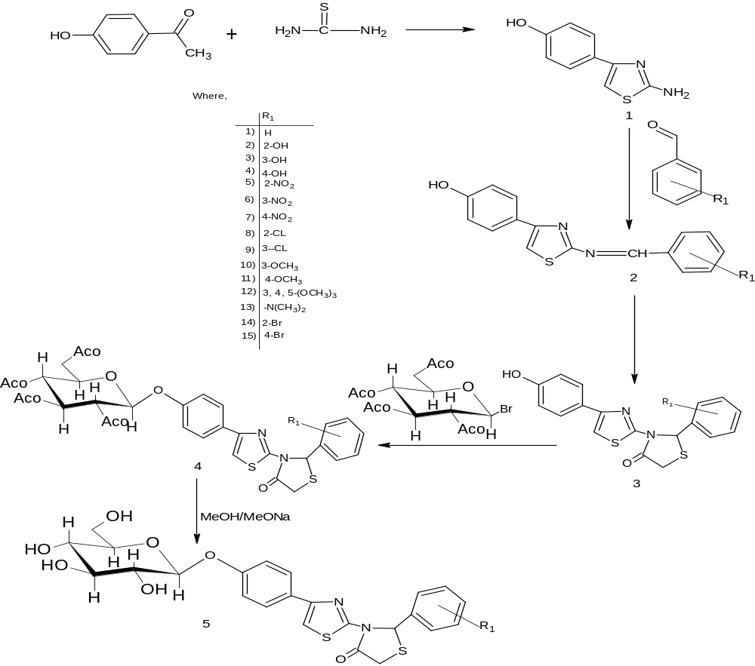

Fig 1- Biological activity of the compounds 3(a-l).

Fig 2- Biological activity of the compounds 4(a-l).

Fig 3- Biological activity of the compounds 5(a-l).
Fig 4- Antioxidant activity of compounds 3(a-l), 4(a-l) and 5(a-I).

