Table 1 Baseline characteristics of the entire cohort of patients
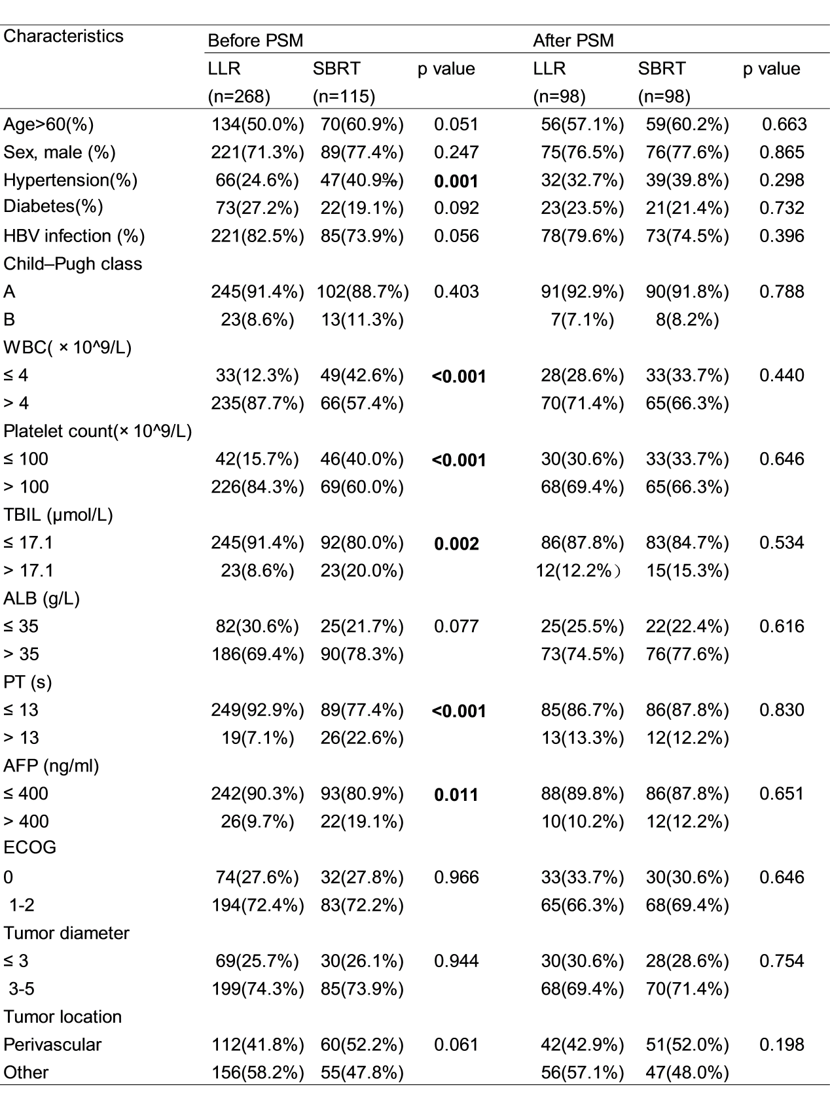
Abbreviations: PSM, propensity score matching; LLR, laparoscopic liver resection; SBRT, stereotactic body radiation therapy; HBV, hepatitis B virus; ECOG, Eastern Cooperative Oncology Group; AFP, alpha-fetoprotein

Table 2 Univariate and multivariate Cox regression analysis on OS and RFS after PSM
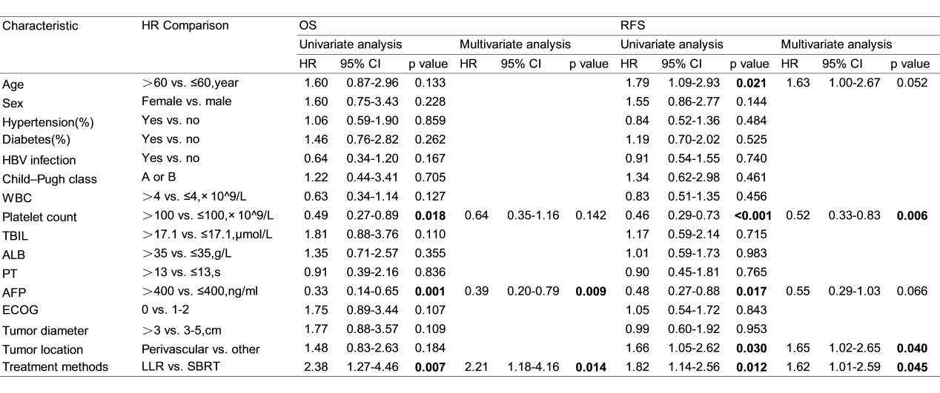
Abbreviations: PSM, propensity score matching; LLR, laparoscopic liver resection; SBRT, stereotactic body radiation therapy; HBV, hepatitis B virus; ECOG, Eastern Cooperative Oncology Group; AFP, alpha-fetoprotein
Table 3 Toxicity and complications
Characteristics | LLR (n=268) | SBRT (n=115)
Total n (%) | 22 (8.2%) | 7 (6.1%)
Grade 1 | fever，n=6  wound infection, n=1 | vomiting, n=5  anorexia, n=2
Grade 2 | ascites, n=9  minor bile leakage, n=6 | abdominal pain, n=1  ALT/AST elevation, n=2
Grade 3 | bile leakage, n=1 | 0
Abbreviations: LLR, laparoscopic liver resection; SBRT, stereotactic body radiation therapy

