Supplemental Information
Fig. S1: Delta area, Consensus matrix, CDF area of cluster result of TCGA-ESCC cohort. (A) Delta area plot of samples. (B) Consensus matrix of samples in four clusters 1-4 (according to the number of samples in each cluster, cluster 1 was termed as Bc1, n = 28; cluster 2 termed as Bc4, n = 11; cluster 3 termed as Bc3, n = 18; cluster 4 termed as Bc2, n = 22). CDF area of cluster numbers 2 to 8 (choosing a curve with less fluctuation). (C) The ConsensusClusterPlus package was utilized to distinguish MPIs-related subclusters of the TCGA ESCC cohort. It was iterated 1000 times for the optimization and stabilization of classification categories. After considering the three cluster indexes comprehensively, ESCC patients were clustered in four subtypes (four clusters: distinct consensus matrix of the cluster with much white and little light blue; CDF curve with less fluctuation).

Fig. S2: Box plot of the remaining significant Mcs proportions in four TCGA ESCC cohort bulk clusters (Dunn’s test, two-sided, unpaired). In the boxplots, the central line represents the median, the bounds of boxes represent the first and third quartiles, and the upper and lower whiskers extend to the highest or the smallest value within the 1.5 interquartile range.

Fig. S3: Box plot of the remaining significant Mcs proportions in four GEO ESCC cohort bulk clusters (Dunn’s test, two-sided, unpaired). In the boxplots, the central line represents the median, the bounds of boxes represent the first and third quartiles, and the upper and lower whiskers extend to the highest or the smallest value within the 1.5 interquartile range.

Fig. S4: The GSEA enrichment result using the Reactome database of the TCGA cohort’s four subtypes (Bc1-4). Pathways related to cell detoxification only downregulated in Bc4. The p.adjust is calculated using the gsePathway function of the ReactomePA package (Benjamini-Hochberg method).

Fig. S5: The GSEA enrichment result using the Reactome database of the GEO cohort’s four subtypes (Bc1-4). Similar to the TCGA cohort, Pathways related to cell detoxification downregulated in Bc4 in the GEO cohort. The p.adjust is calculated using the gsePathway function of the ReactomePA package (Benjamini-Hochberg method).

Fig. S6: The GSEA enrichment result using the hallmark set of the TCGA cohort’s four subtypes (Bc1-4). p.adjust is calculated using the GSEA function of the clusterProfiler package (Benjamini-Hochberg method).
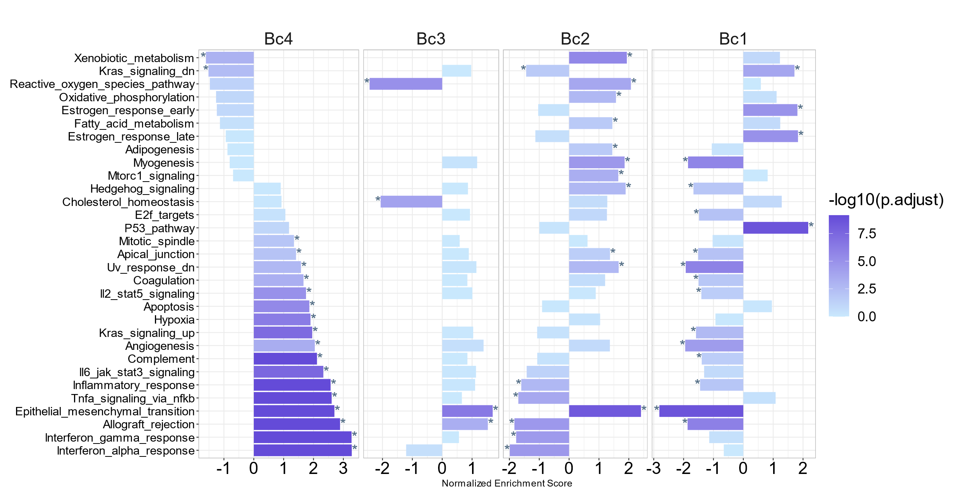

Fig. S7: The GSEA enrichment result using the hallmark set of the GEO cohort’s four subtypes (Bc1-4). p.adjust is calculated using the GSEA function of the clusterProfiler package (Benjamini-Hochberg method).
