SUPPLEMENTARY INFORMATION for:
Molecular dynamics simulation-driven focused virtual screening and experimental validation of Fisetin as an inhibitor of Helicobacter pylori HtrA protease
Li Gao ^{a, #}, Xianqiong Jiang ^{a, #}, Hongtao Duan ^{a, #}, Yan Shen ^{a*}, Kui Gu ª, Kuilong Huang ª, Yuanqiang Wang ª, Mao Shu ª, Rui Zhang^{c}, Zhihua Lin ^{a,b *}
ª School of Pharmacy and Bioengineering, Chongqing University of Technology, 405400 Chongqing, China.
^{b} Chongqing College of Traditional Chinese Medicine, 402760 Chongqing, China.
^{c} Department of pharmacy, Guizhou Provincial People’s Hospital, 550002 Guiyang, China.
* Corresponding author E-mail address: shenbmy@126.com (Yan Shen) and zhlin@cqut.edu.cn (Zhihua Lin).
# These authors contributed equally to this work.

This supplementary file includes results from SDS-PAGE and Coomassie Brilliant Blue staining following the expression, purification, and concentration of HtrA protein, as well as the assessment of HtrA's hydrolytic activity using β-casein.
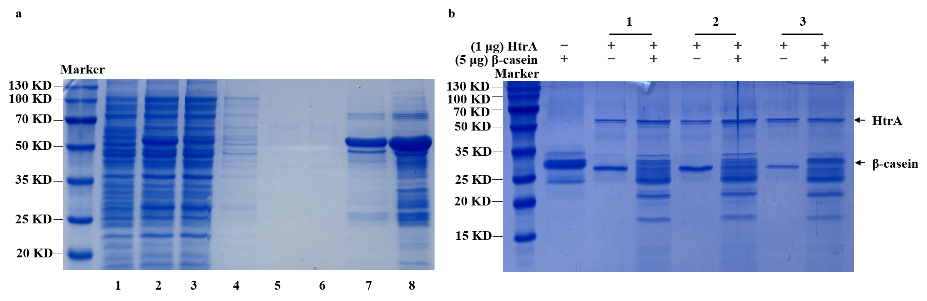
Supplementary Figure 1. Expression, Purification, and Hydrolytic Activity Verification of HtrA Protein. (a) HtrA protein containing His tag was expressed in E.coli BL21(DE3) and concentrated HtrA protein was purified by nickel column and 30 kDa ultrafiltration tubes, then subjected to Caulmers Brilliant Blue staining. Line 1: Blank control group, PET-28(+) empty vector; Line 2: Bacterial lysate supernatant; Line 3: Bacterial lysate precipitate; Line 4: 10 mM imidazole eluent during HtrA purification; Line 5: 30 mM imidazole eluate; Line 6: 50 mM imidazole eluate; Line 7: 250 mM imidazole eluate; Line 8: 30 kDa ultrafiltration tubes to concentrate the purified supernatant. (b) Three different monoclonal were selected for the expression, purification, and concentration of HtrA. Subsequently, β-casein was used as the hydrolytic substrate, and it was co-incubated with HtrA at 37°C for 3 hours to assess the hydrolytic activity of the three distinct HtrA protein samples. 1, 2, and 3 represent the three HtrA protein samples expressed and purified from three distinct monoclonal.

