Supplementary information for:
Chitosan micro/nanobubbles novel chemical structure and characterization
Elsayda Elbana ª, Asmaa M. Elzayat ª, E.M. Abdelrazek ª, Radwa H. Abou-Saleh* ^{b, a.}
ª Physics Department, Faculty of Science, Mansoura University, Mansoura, Egypt, 35516.
^{b} Physics Department, Faculty of Science, Galala University, Egypt, 43511.

Supplementary 1:
Supp. 1: Definitive screening design and experimental data of responses
 | Factor1 | Factor 2 | Factor 3 | Factor 4 | Factor 5 | Factor 6 | Condition | Observation | Response 1 | Response 2
Run | Amount of chitosan  (v/v) % | Amount of glycerol (v/v) % | Amount of NaCl  (v/v) % | Amount of palmitic acid  (v/v) % | Amount of buffer acetate (v/v) % | Amount of NaOH  Or sodium triphosphate(v/v) % |  |  | Bubbles  count | Bubbles diameter
1 | 0.9ml/1ml  (90%) | 0.1 ml/1ml glycerol | - | - | - | - | Flow SF6 gas for 2 min. and shake by amalgamator for 2 min. | The solution appears clear and Low count and appears at 40x low count without dilution | 2.15x10⁶  Bubbles/ml | 1.5:159µm
2 | 0.9ml/1ml  (90%) | 0.1 ml/1ml glycerol  10% | Then try adding a new component NaCl with a different concentration the best 0.1ml/1ml | - | - | - | Flow SF6 gas for 2 min. and shake by amalgamator for 2 min. | The Solution appears milky shape which indicates to high concentration of microbubbles but high diameter | 3.5x10⁶ bubbles/ml | 1.5:109µm
3 | 0.9ml (52.6%) | 0.1ml  (5.8%) | 0.1ml  (5.8%) | 0.2ml  (11.7%) | 0.4ml  (23.4%) | 10um of NaOH  0.58% | Flow SF6 gas for 2 min. and shake by amalgamator for 2min | The solution appears milky,  This sample gives micro/nanobubbles but still, there are high-diameter | concentration 1.5*10⁸ bubble/ml | 0.8:27µm
4 | 0.4ml  (33.05%) | 0.1ml  (8.26%) | 0.1ml  (8.26%) | 0.2ml  (16.52%) | 0.4ml  (33.06%) | 10um  (0.826%) | Flow SF6 gas for 2 min. and shake by amalgamator for only 10 seconds | The best result formed micro/nanobubbles with high concentration and suitable diameter | Count per ml 1.02* 10¹² bubbles/ml | Diameter formed MBs with diameter3.57±0.71µm and nanobubbles with 55 ± 37nm

Chitosan-shelled/ Sulfur hexafluoride-cored MBs/NBs were initially developed. Different types as shown in table 1 were produced starting from MB formulations, comprising only a chitosan shell on the surface and Sulfur hexafluoride in the core. briefly, chitosan microbubbles were synthesized through, SF6 gas used for the core and chitosan medium molecular (100-300 KDa) weight used as a shell. Firstly, a stock solution of A 2.7 wt. % chitosan aqueous solution was prepared by dissolving chitosan with high molecular weight in 2 wt. % glacial acetic acid under magnetic stirring at 400 rpm for at room temperature 25°C for 48h before use 3%palmatic acid prepared by dissolving 3g from solid palmitic acid at 100ml (96% ethanol) at 35 C⁰ and stirred for 5min. We tried to prepare a more stable and high count from micro/nanobubbles. in detail, we used 0.9 ml of chitosan with high molecular weight, and a 0.1 ml glycerol system was homogenized using a vortex mixer. The solution was divided into 1.5-mL Eppendorf tubes (EP tubes), and the air in the tube was replaced with SF6 gas using a tube of SF6 cylinder gas with a long fine needle for 120 s. The Eppendorf tube oscillated for 120 s in a mechanical oscillator (amalgamator, Germany), (SMBs/NBs1), 0.9ml chitosan,0.1glycerol this trier gave MBs with concentration 2.15x10³ bubbles/ml and diameter as 1.5:159um the result. Then try to add a new component to increase the count and decrease the diameter of MBs (sodium chloride ) with different concentrations the best concentration of 0.1 ml per 1ml of the sample (SMBs/NBs) gives MBs with a concentration of 3.5x10³ bubbles/ ml and diameter 1.5:109 µm, then added anew factors buffer acetate solution PH=5 to diluted the chitosan, palmitic acid with different concentration and find that the best 0.2ml per total volume that react with glycerol and formed ester and this represent the tail of the bubbles and form the other hand chitosan react with glycerol and represent the head of the bubbles and sodium hydroxide to increase the stability of the MBs the sample result as milky shape this indict high concentration of MBs 1.5x10⁵ bubbles/ml and diameter 0.8:27µm. In the end, the best result by using 0.4 ml of 2.7% w/v chitosan solution at pH =5 was added dropwise in 0.4 ml acetate buffer solution (PH=5), then added 0.2 ml of palmitic acid,0.1 ml glycerol, 0.1 ml NaCl and 10um of sodium hydroxide in vial (Eppendorf) then well shake with vortex and saturated the mixture with SF6 gas for 2 min. then shake in a mechanical oscillator ( amalgamator, Germany) at a speed of 5000 rpm for only 10s to prepare the mixture from micro/nanobubbles concentration 1.02x10⁹ bubbles/ml and diameter 3.57±0.71µm

Supplementary 2:

$U=\frac{2gR^{2}∆ρ}{3μ}\frac{μ+μ^{'}}{2μ+3μ'}$ (1)

Where R is the average radius of the MBs, g is the gravitational acceleration (9.8 m / s), µ is the dynamic viscosity of water (8.90 x 10⁻⁴ Pa s), µ’ is the dynamic viscosity of SF₆ (1.5x10⁻⁵ Pa s) and $∆ρ$ is the difference in density between the medium and the core of MBs (1015)kg/m³. Density of glycerol Around 1. 26 g/cm³ at 20°C,the density of a 3% palmitic acid solution in 96% ethanol, consider the densities of the components:Density of Palmitic Acid 0.853 g/cm³ ,Density of 96% Ethanol is 0.805 g/cm³ at 20°C ,Assume you have 100 ml of the solution.3% of the solution is palmitic acid, so 3 ml is palmitic acid and 97 ml is 96% ethanol. Calculate the mass of each component: Mass of Palmitic Acid = 3 ml × 0.853 g/ml = 2.559 g

Mass of 96% Ethanol = 97 ml × 0.805 g/ml = 78.085 g, Total Mass = 2.559 g + 78.085 g = 80.644 g and Total Volume = 100 ml

Density= mass/volum=(80.644/100) =0.80644g/ml,the density of a 3% palmitic acid solution in 96% ethanol is approximately 0.806 g/ml , the density of 0.1 M acetate buffer Approximately 1.01 g/cm³ at 20°c, Density of NaCl: Approximately 1.005 g/cm³ at 20°C .To find the average density of a mixture, assuming equal volumes of each component are mixed, you can take the mean of the densities ,the average density of the mixture is approximately 1.022 g/cm³=1022 kg/m³. and the density of SF₆ gas at 20°C and 1 atm is approximately 6.14g/L.so the difference in density between the medium and core (1015) kg/m³
$U=\frac{2gR^{2}∆ρ}{3μ}\frac{μ+μ^{'}}{2μ+3μ'}$ =$\frac{2*9.8*\left(1*{10}^{-6}\right)2*1015}{3*8.9*10^-4}*\frac{8.9*{10}^{-4}+1.5*10^-5}{2*8.9*{10}^{-4}+3*1.5*10^-5}$=3.697*10^-6m/s
time=distance in m /U so that =0.01/3.697*10⁻⁶=2711.8 s = 45 min.
for 200 nm
t =75.33h

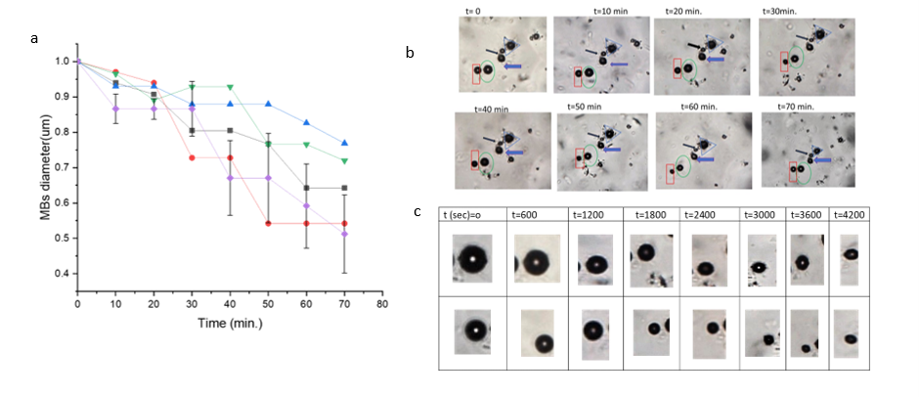
Supplementary 3:

Supp.2: MB gas dissolution. (a) Relative diameter vs time plots presenting different MB dissolution as a function of time at 33%chitosan concentrations (run 4 MB with different diameter) (b) Dissolution curves of the bubbles in supp.2b. The colour of the curve corresponds to the bubble pointed at with a shape of the same colour. These bubbles decreased in size during the time. (c)Selected images in the dissolution time course for MBs showing that circularity is maintained during gas escape. Scale bar=1μm

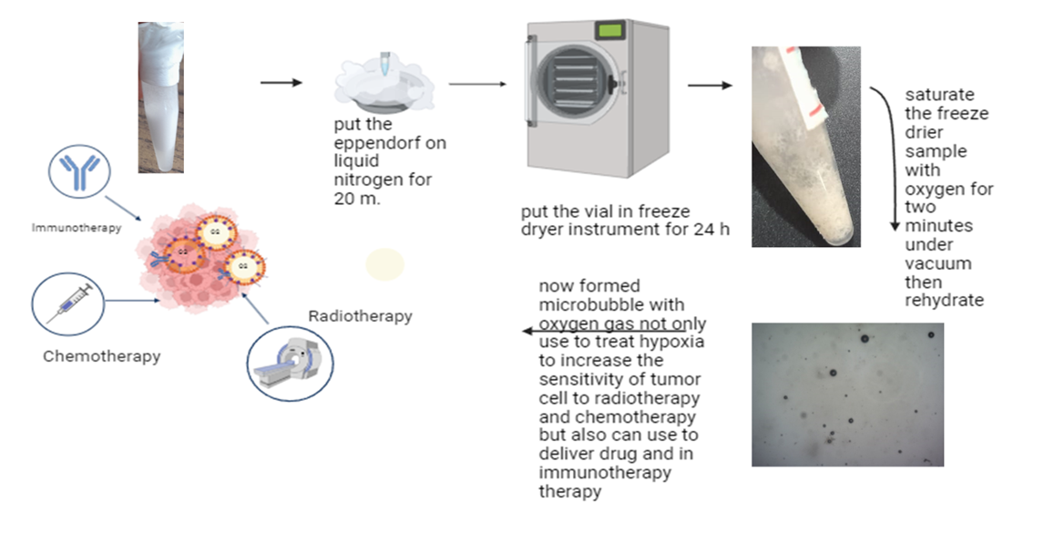
Supplementary 4:

supp.4.shown the method of freeze drying

