Elucidating the Role of Liquid-Liquid Phase Separation (LLPS) in Liver Cancer: From Single-Cell Analysis to Prognostic Biomarkers
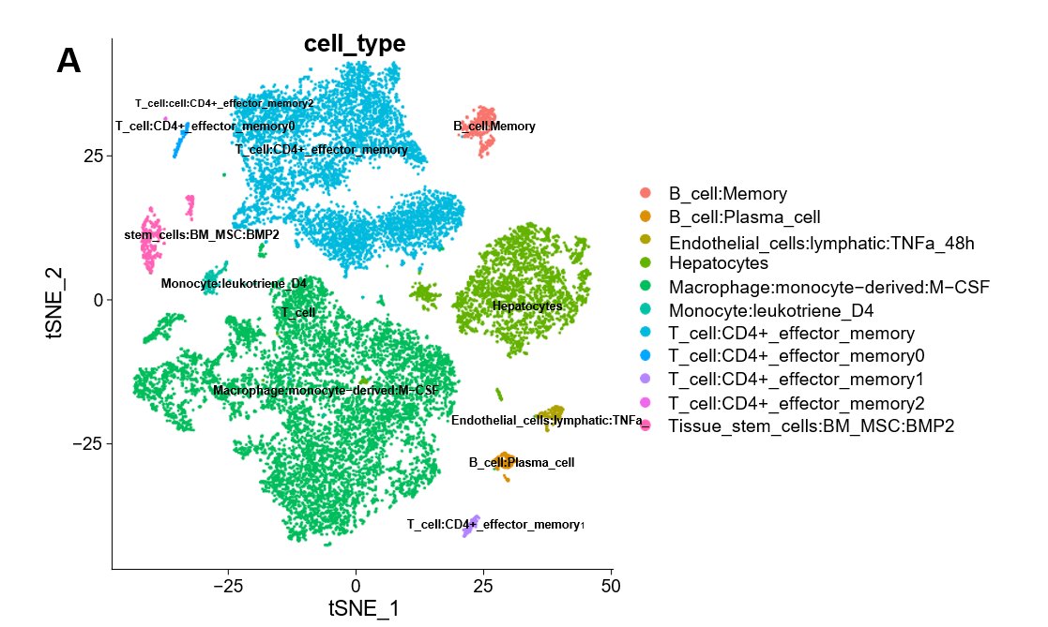
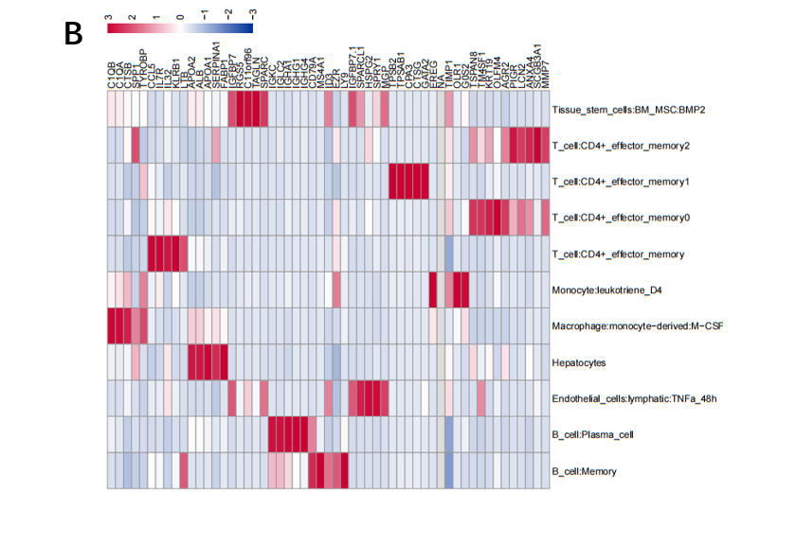
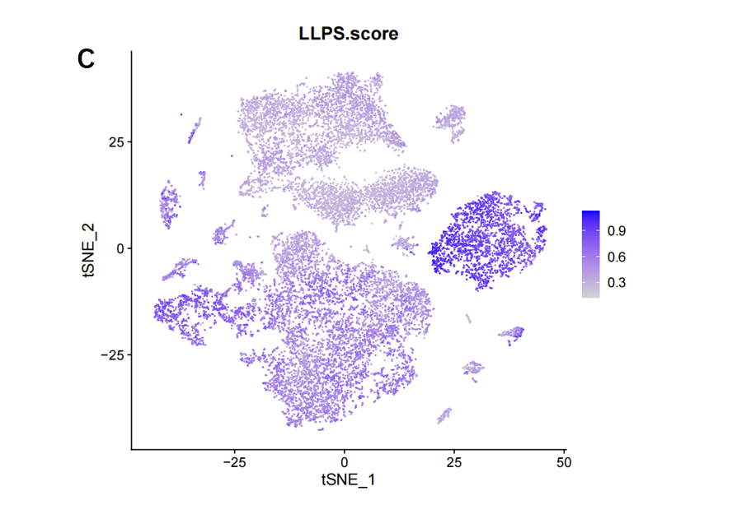
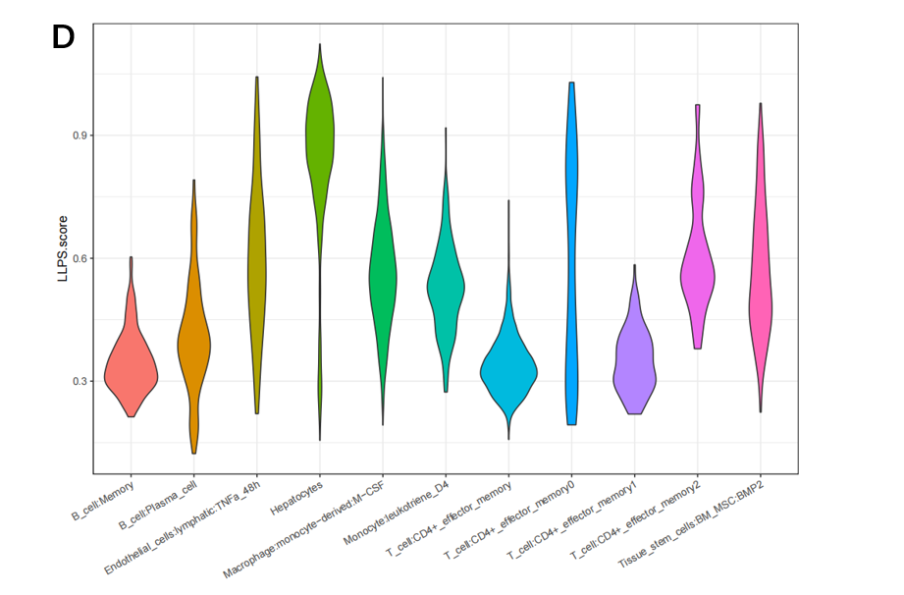
Figure 1:
LLPS characteristic in the Liver cancer. A: t-SNE plot showing the cell types identified by marker genes. B: Heatmap showing the top 4 marker genes in each cell cluster. C: The activity score of LLPS in each cell. D: The distribution of the LLPS-score in different cell types.

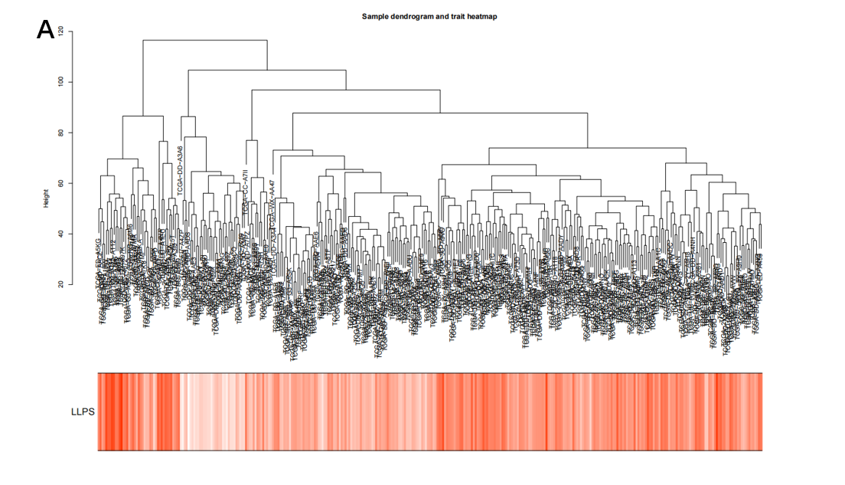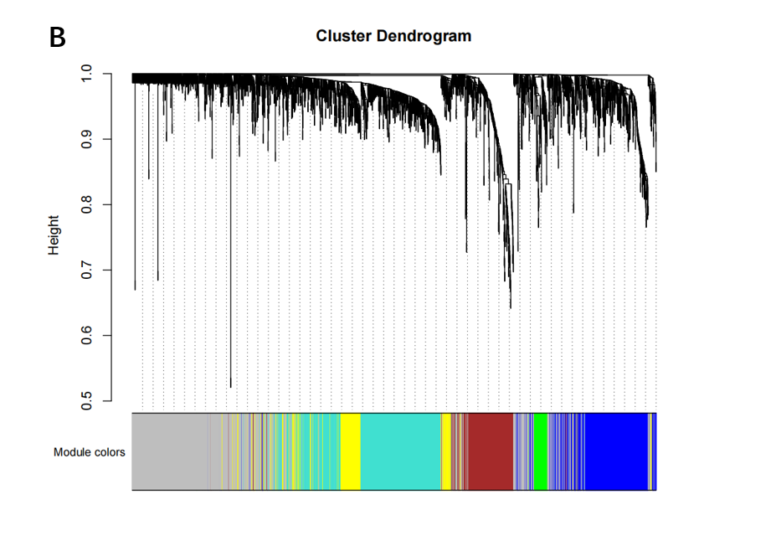
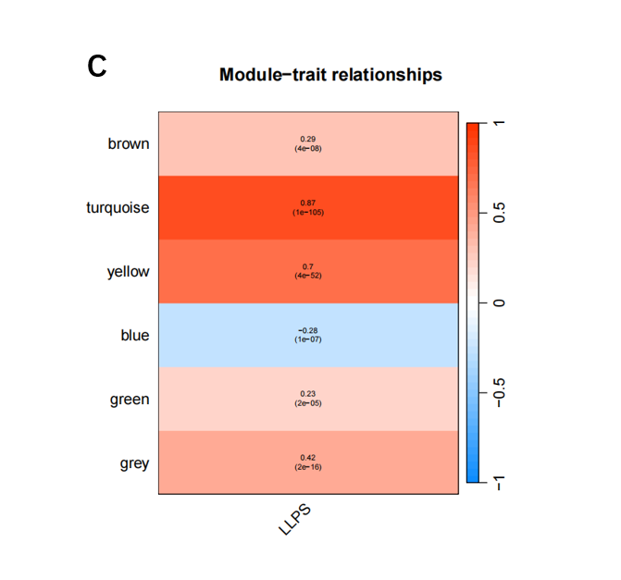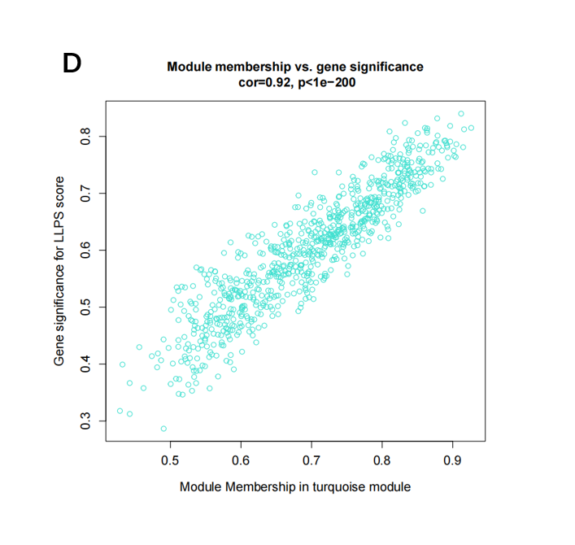
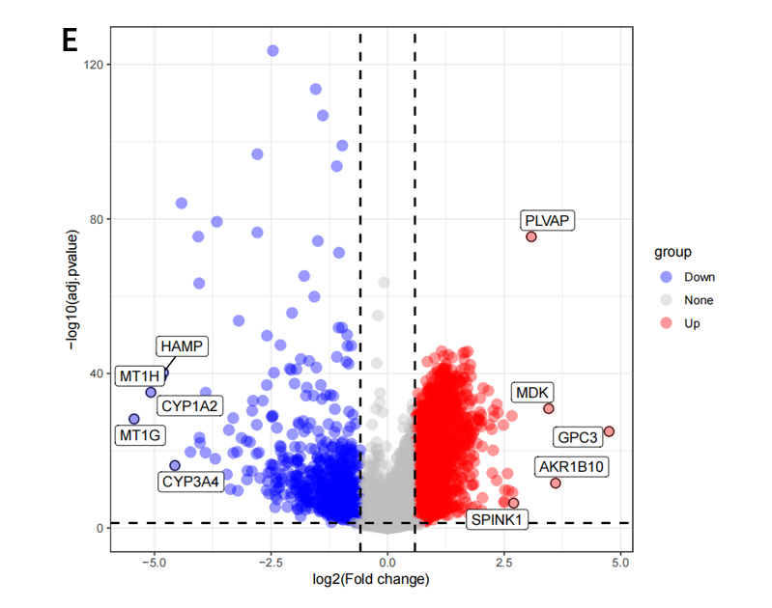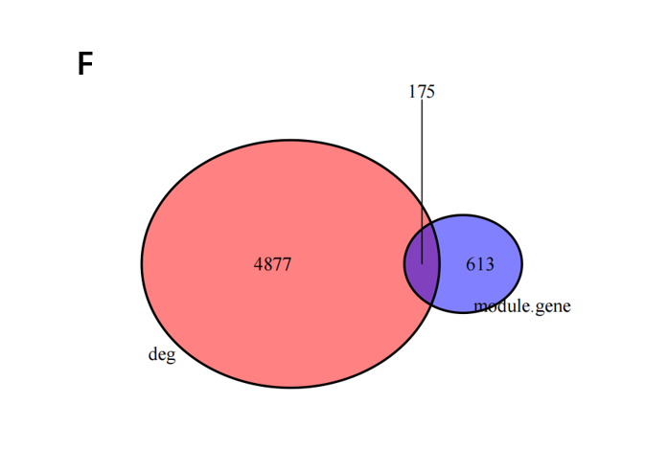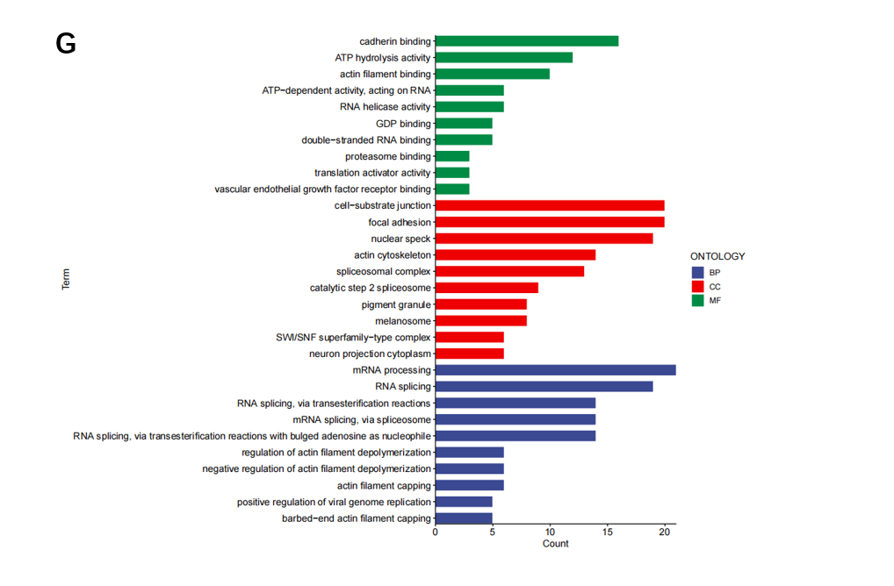
Figure 2:
Identification of the LLPSRGs. A: Dendrogram showing the hierarchical clustering of TCGA-LIHC samples. The bottom heatmap represents each sample's LLPS score, calculated by ssGSEA algorithm. B: Cluster dendrogram of the WGCNA analysis. C: Module-trait heatmap showing that the MEturquoise module was closely related to the LLPS trait. D: Scatter plot showing the relationship between gene significance (GS) and module membership (MM) in the turquoise module. E: Volcano plot showing the results of differential analysis of TCGA-LIHC tumor samples and normal samples, with the top 5 up-regulated or down-regulated genes specially marked. F: Venn plot showing the LLPSRGs between MEturquoise module and DEGs in bulk RNA-seq. G: GO enrichment of the LLPS genes. 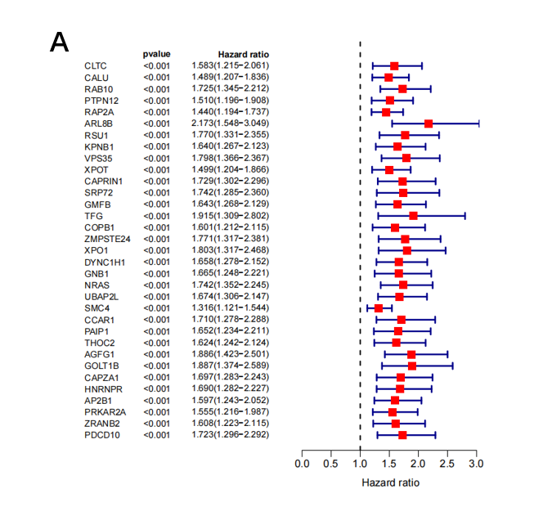 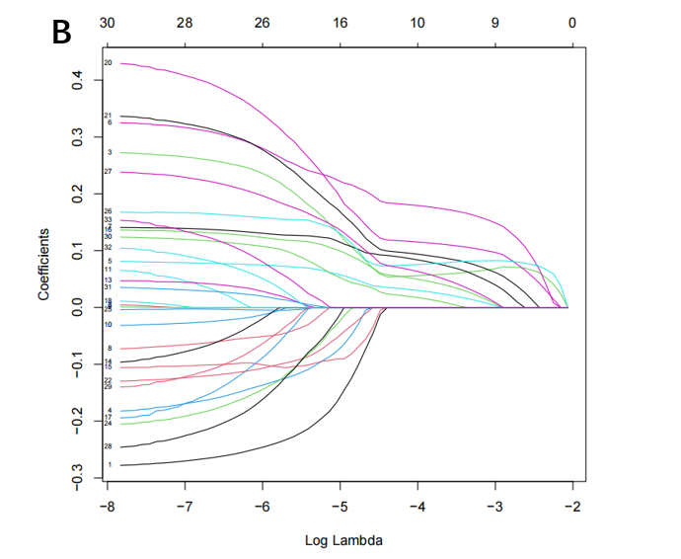 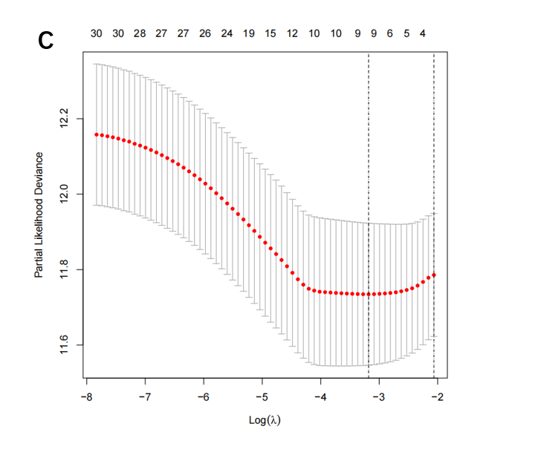 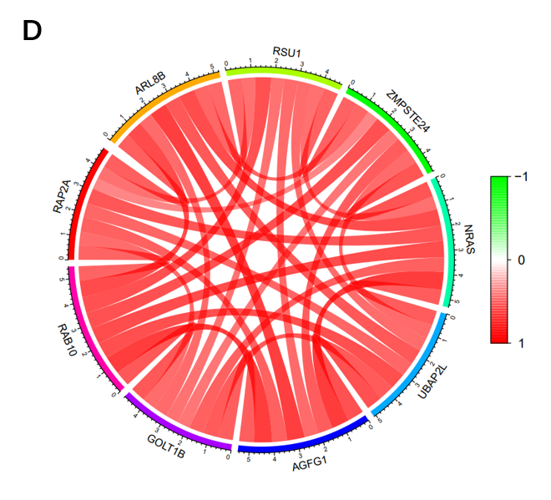 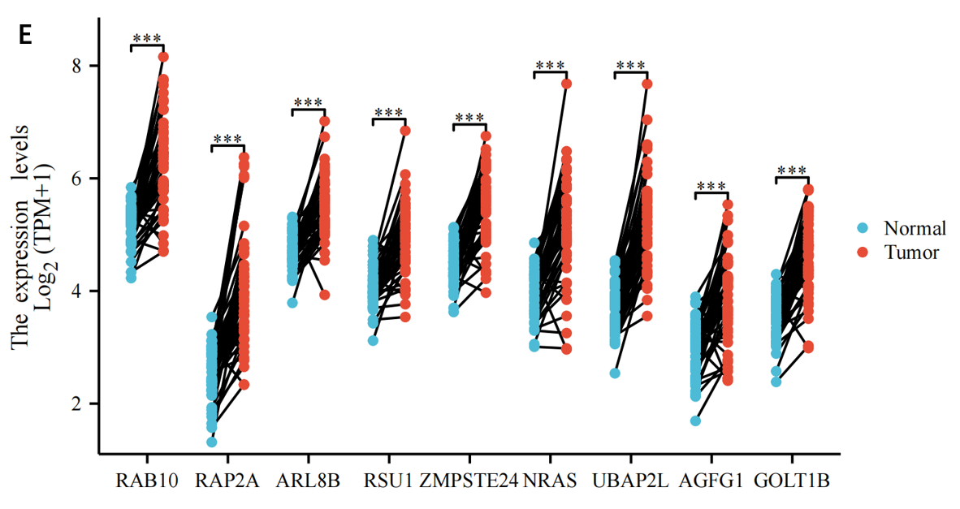

Figure3:
Candidate LLPSRS identification. (A) Univariate Cox regression analysis was utilized to assess the prognosis value of LLPSRGs. (B) Adjusted parameter selection in the Lasso model with tenfold cross-validation. (C) Lasso coefficient curves. (D) Correlation between the LLPSRGs. (E) The Wilcoxon rank-sum test was used to analyze the differential expression of 9 LLPSRGs in LIHC tissues and normal tissues. * p < 0.05; ** p < 0.01; *** p < 0.001.
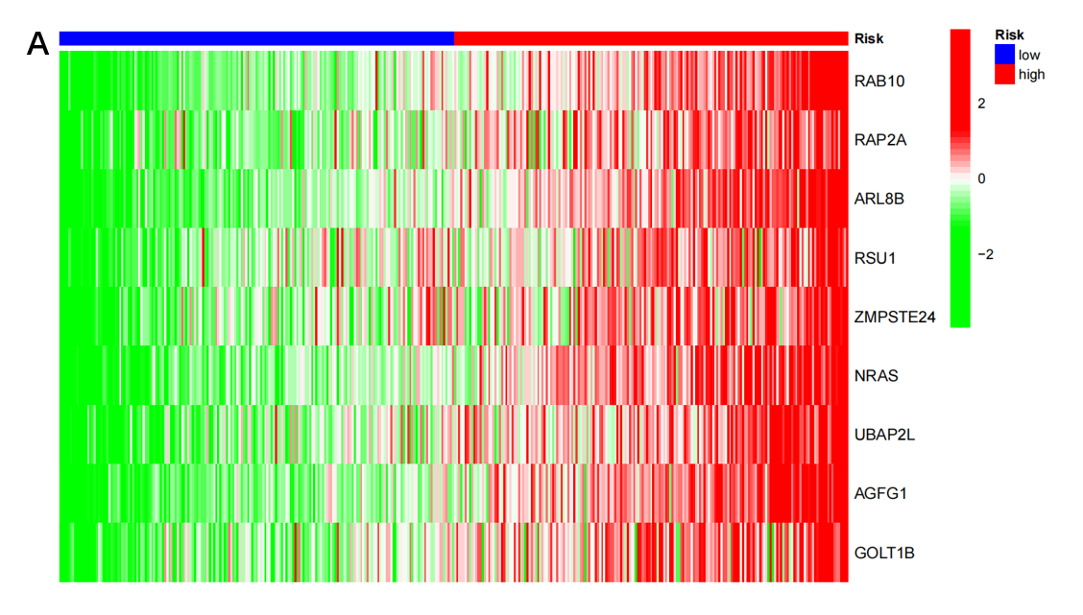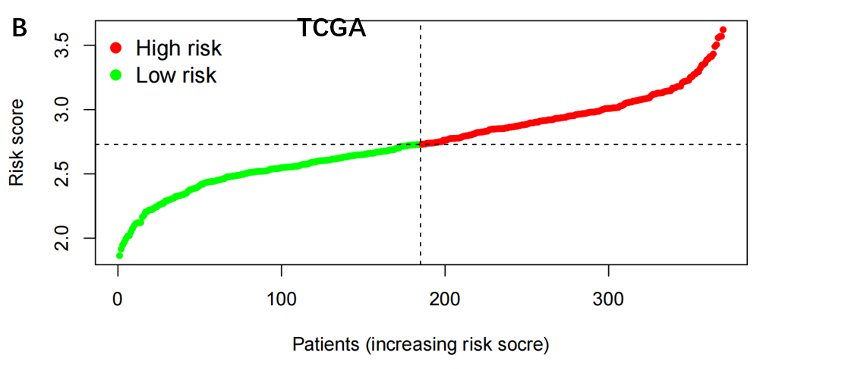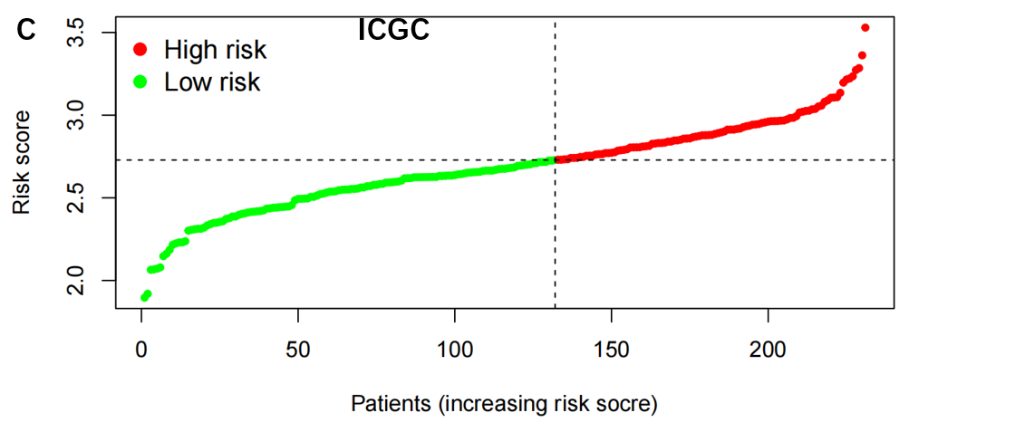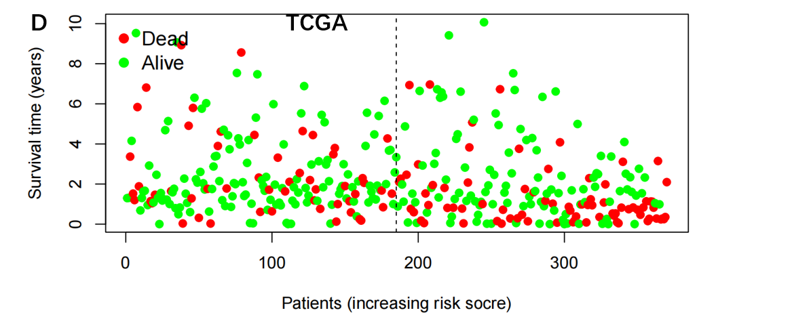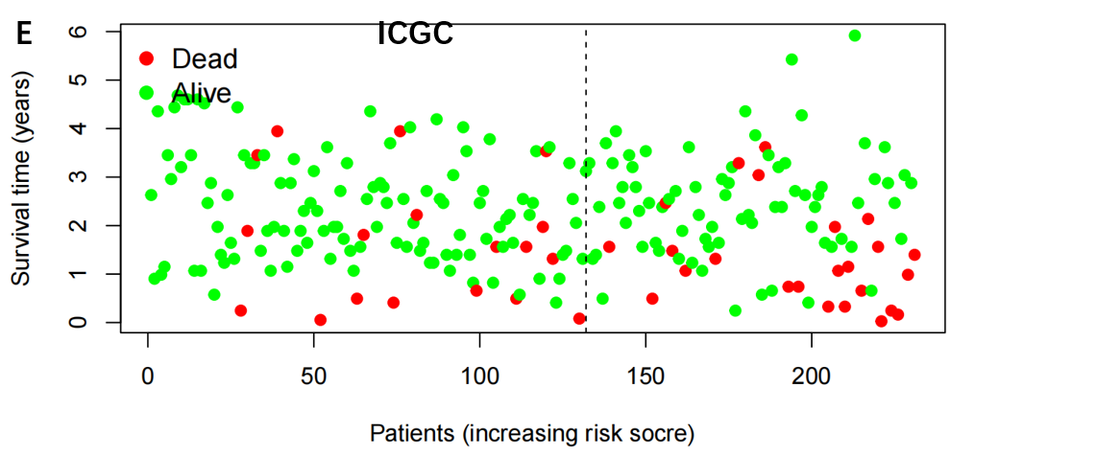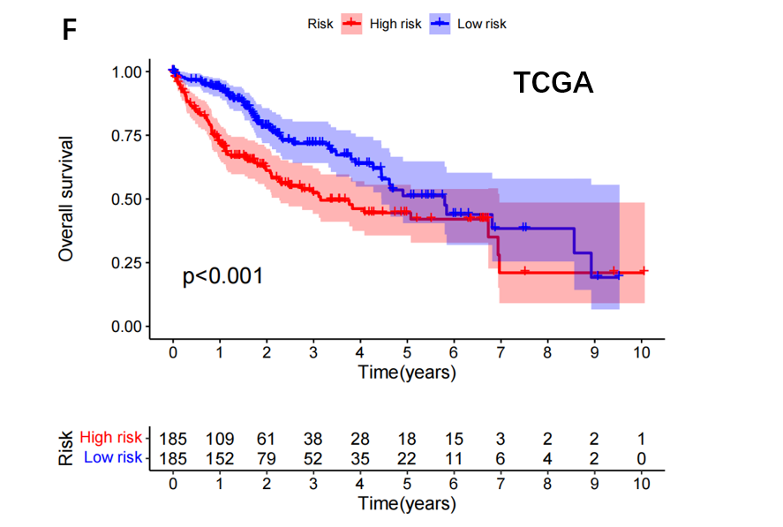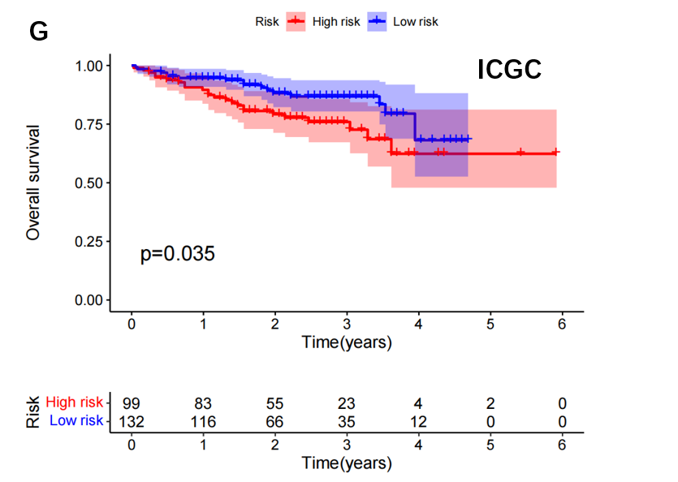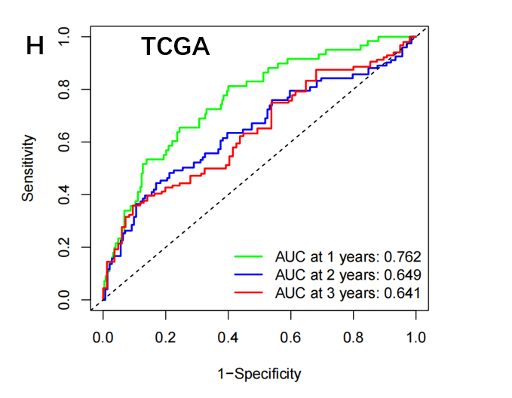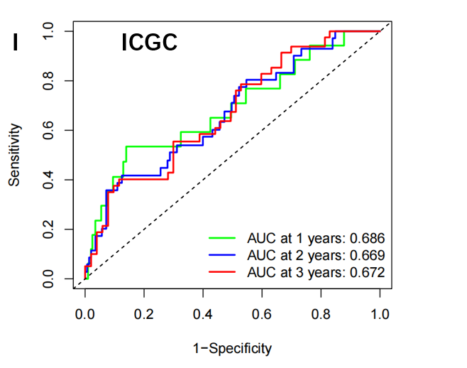
Figure4:
Validation of the accuracy of the LLPSRS models to predict patient prognosis. (A) A heat map showing the differential expression of nine LLPSRDEGs in groups at high and low risk. Scatter plots of LIHC patients’ risk ratings and prognostic LLPSRDEGs that are connected with survival time, TCGA (B, D), ICGC (C, E). (F, G) Survival curves for the TCGA cohorts and ICGC cohorts respectively. Time-dependent ROC curves for TCGA cohorts(H) and (I) for ICGC.
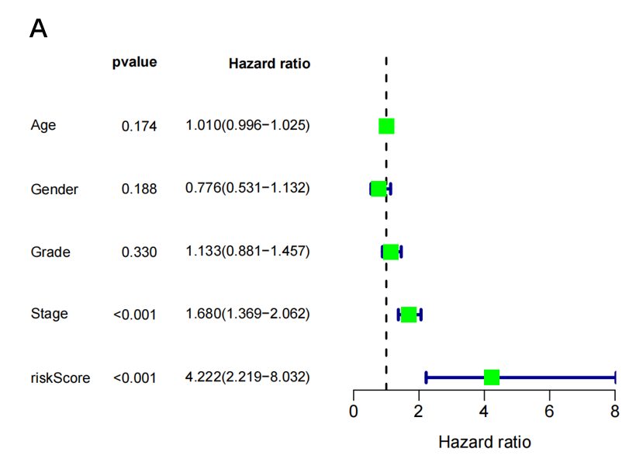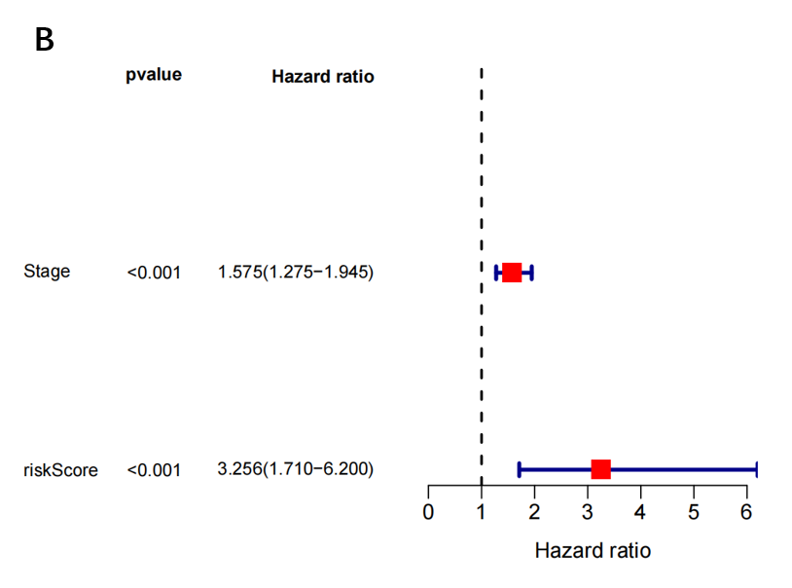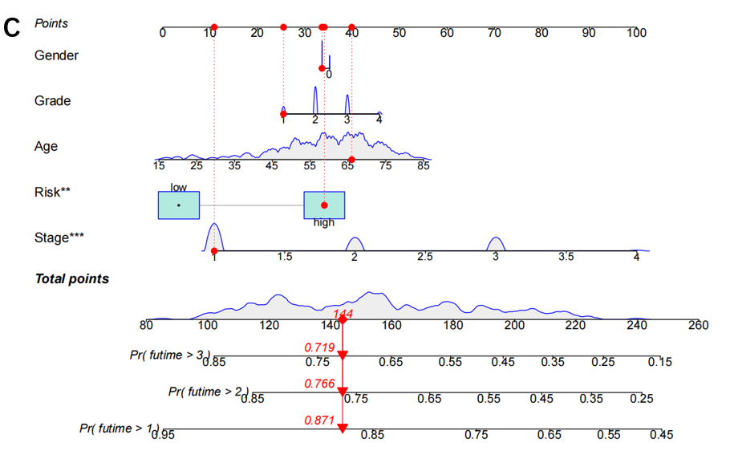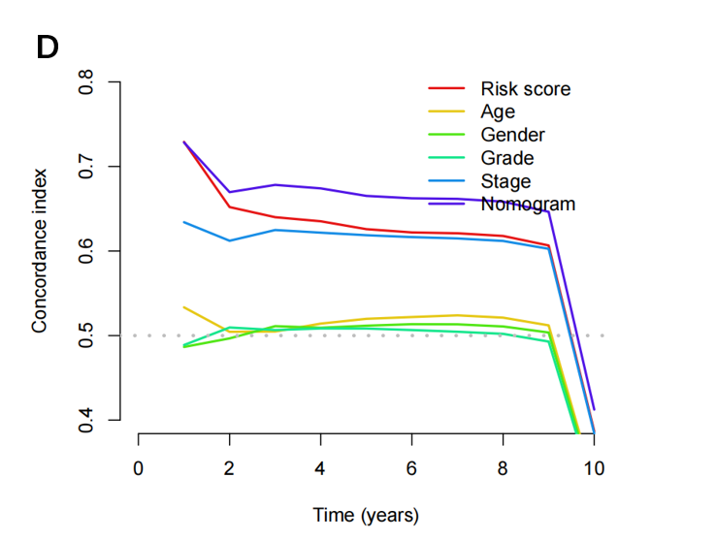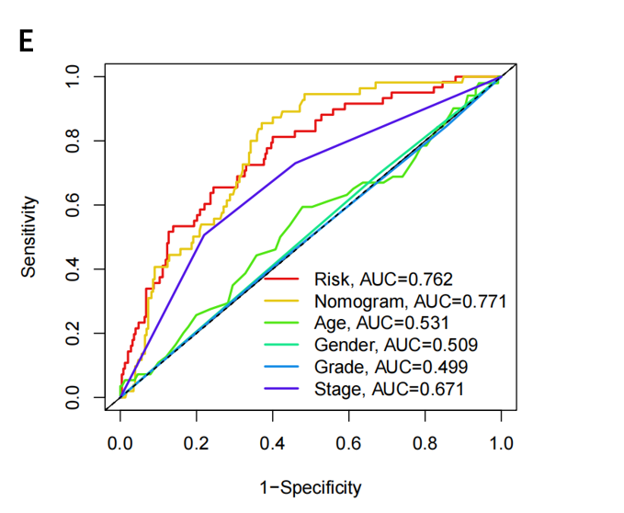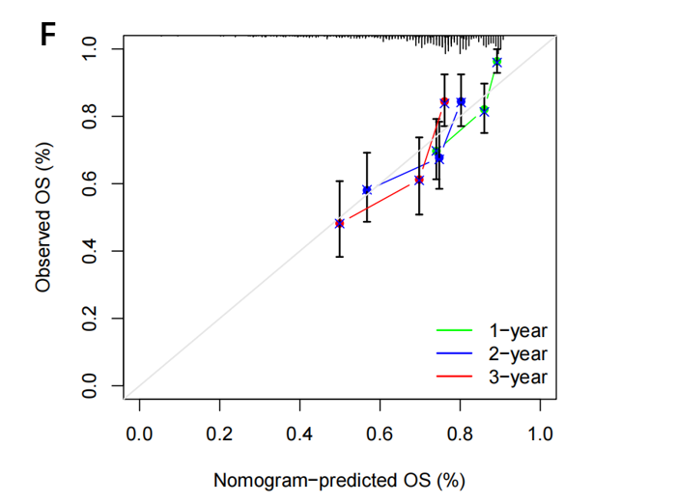

Figure 5：
Independent prognostic analysis of LLPSRDEGs risk scores and clinical parameters. Univariate (A) and multivariate (B) Cox regression analysis of characteristics and different clinical features. (C) Nomogram for predicting 1-year, 2-year, and 3-year OS in LIHC patients. (D) C-index curves for Nomogram, risk scores and clinical parameters. (E) Multi-indicator ROC analysis of the TCGA cohort. (F) The Calibration lots showed the comparison between predicted and actual OS for 1-, 2- and 3-year survival Probabilities.
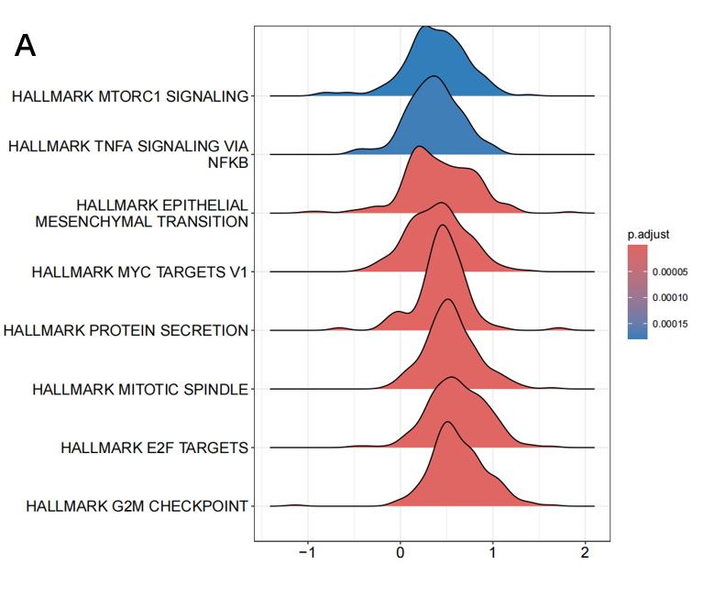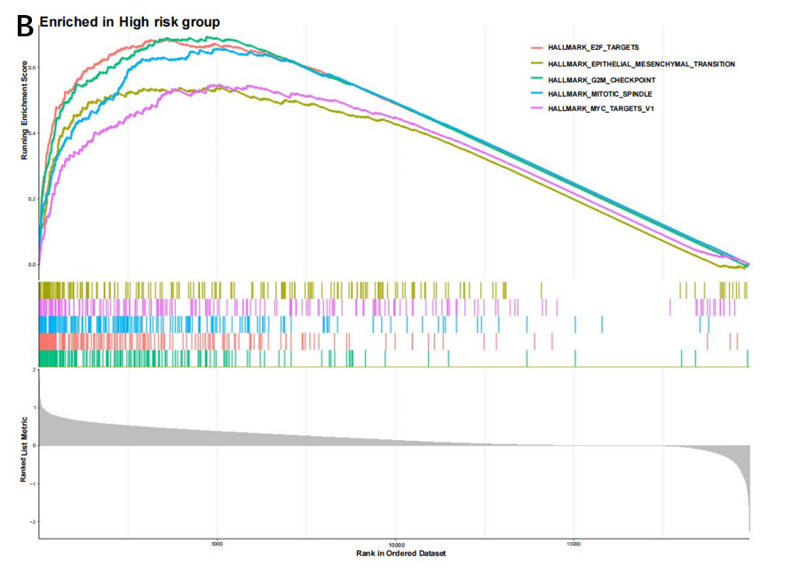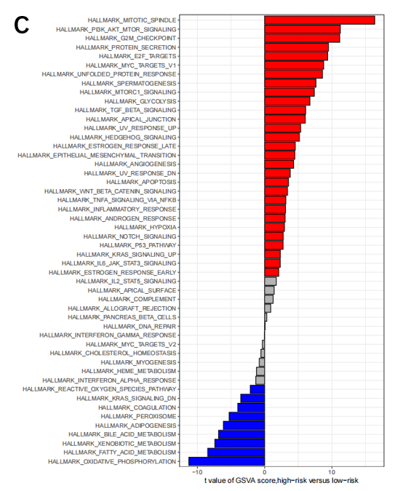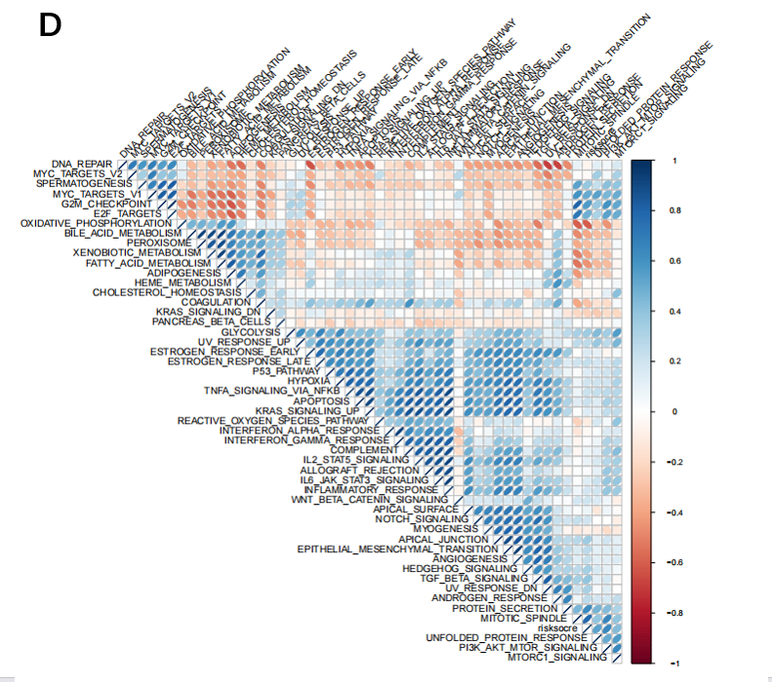
Figure 6：
The transcriptome features of patients with various LLPSRDEGs in HCC. (A) Ridge plot showing the GO terms enriched in the low-risk group. (B) GO terms enriched in the high-risk group by GSEA analysis. (C) Differences in hallmark pathway activities between the high and low-risk groups scored by GSVA. (D) Correlation between the risk score and hallmark pathway activities scored by GSVA.
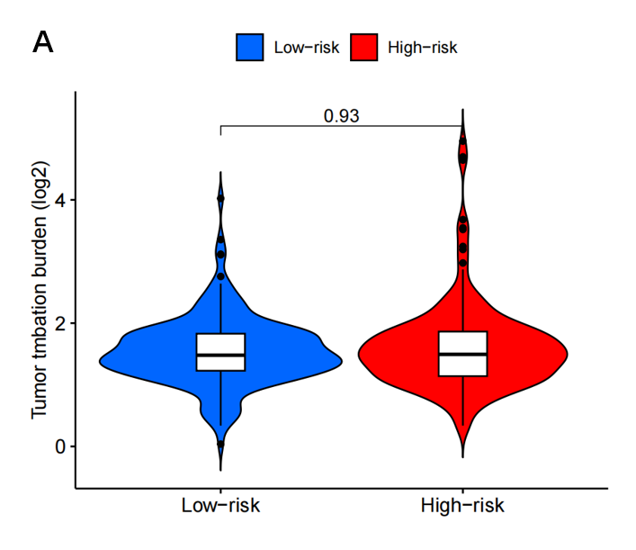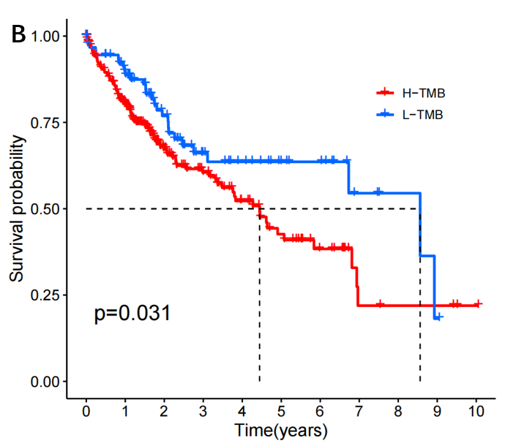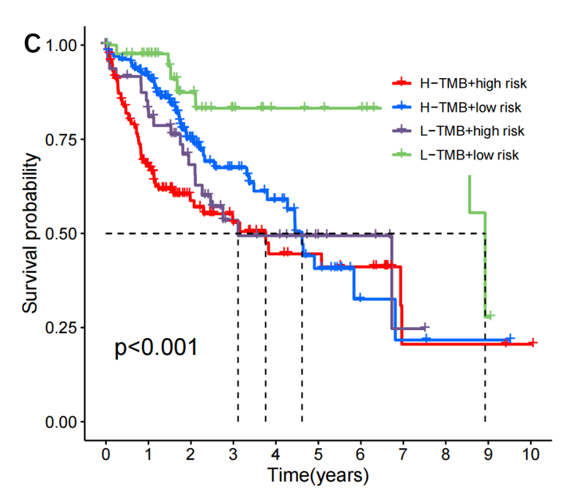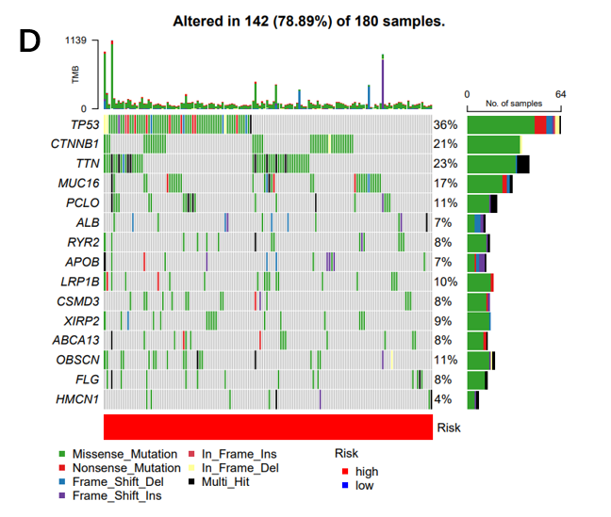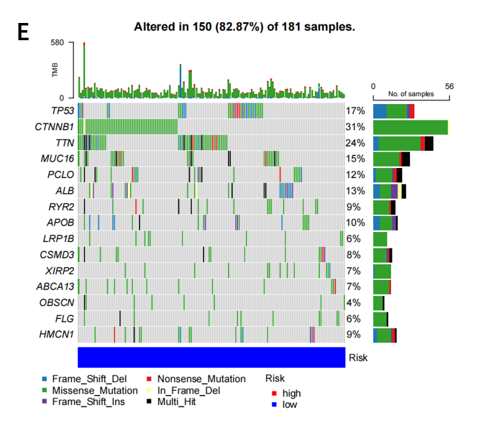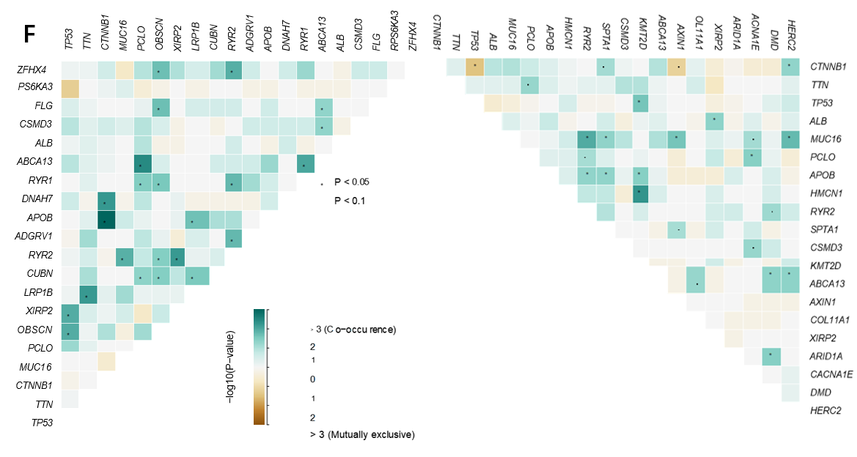

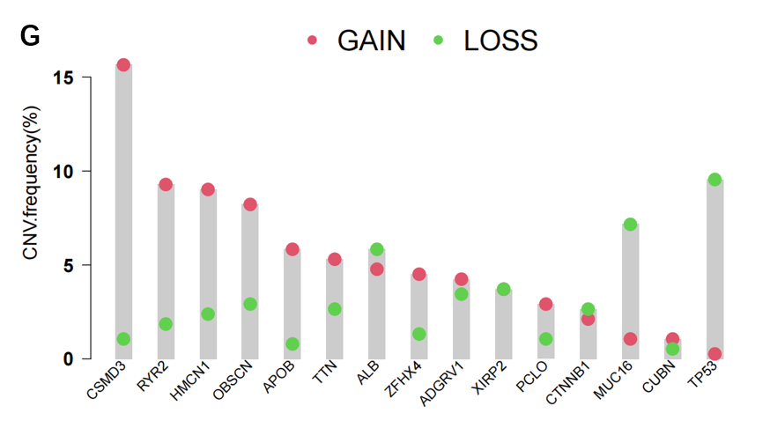
Figure 7：
Genetic alterations associated with LLPSRS between low- and high-risk groups. (A) Violin plot showing the difference in Tumor mutational burden (TMB) score between the high- and low-risk groups. (B) Kaplan–Meier curve shows the difference in OS between high- and low-TMB score groups. (C) Kaplan–Meier curve analysis for OS by combining the TMB score and the LLPSRS risk score. (D, E) The waterfall plot of the somatic mutation landscape in high- (D) and low-risk patients (E) in the TCGA-LIHC cohort. (F) Heatmaps showing the association of co-occurrence and exclusive mutation among the top 20 mutated genes in high- and low-risk groups. (G) Distribution of CNV frequency among DEGs between high- and low-risk groups.
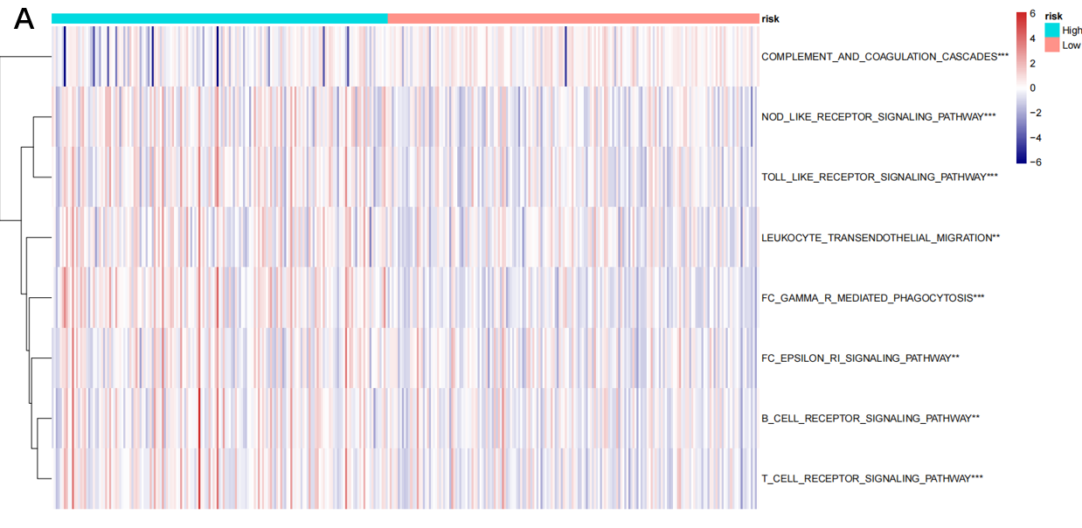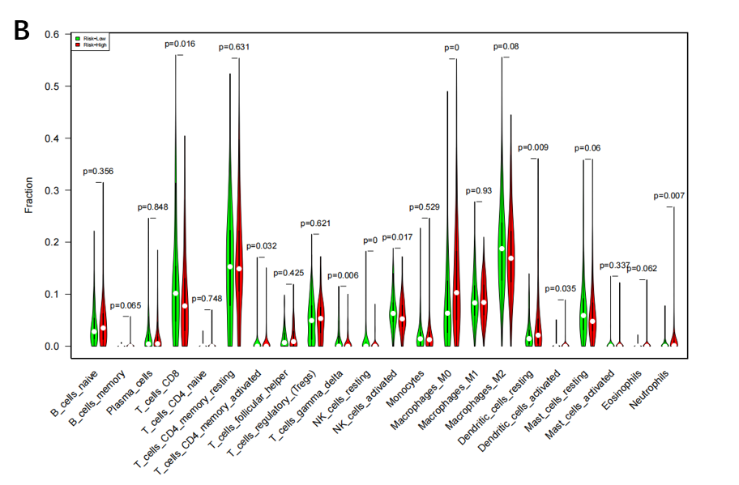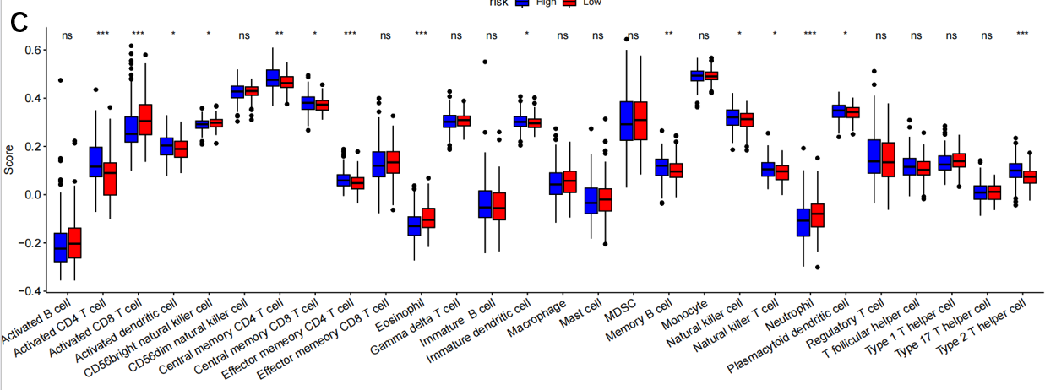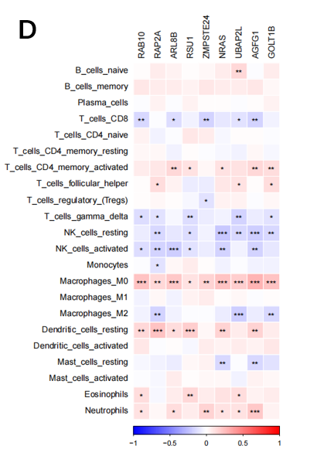

Figure 8：
The immune landscape associated with LLPRGs in HCC. (A) Immune-related pathways’ activity showing a significant difference between high- and low-risk groups. (B, C) The abundance of each TME-infiltrated cell type between high- and low-risk groups, quantified by the CIBESORT algorithm (B) and the ssGSEA algorithm (C). (D) The association between TME-infiltrated cells and genes built-in LLPRGs.
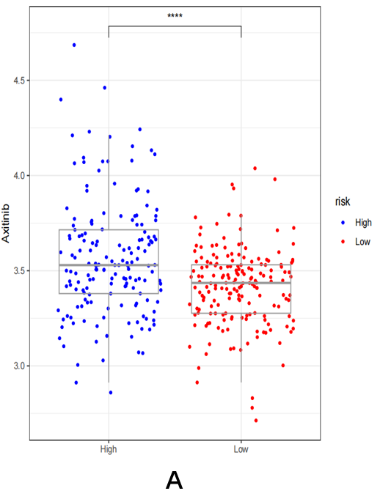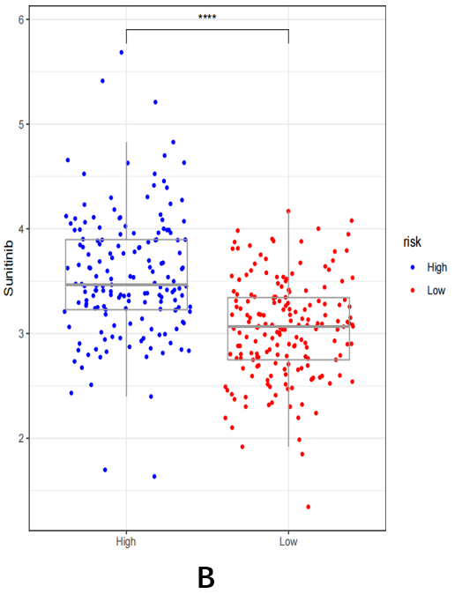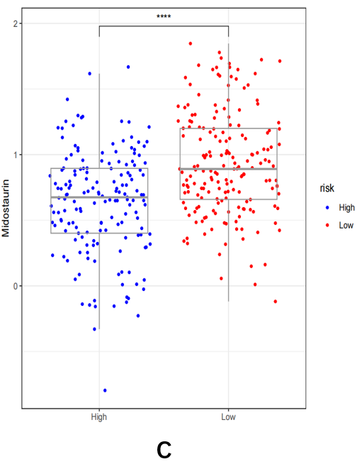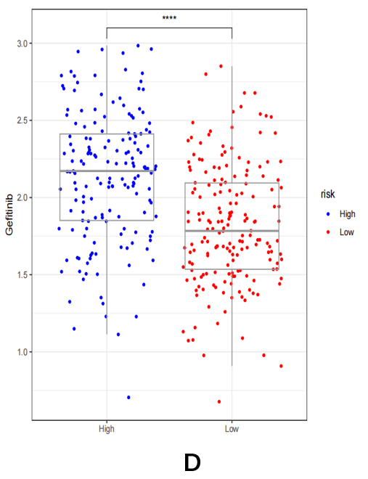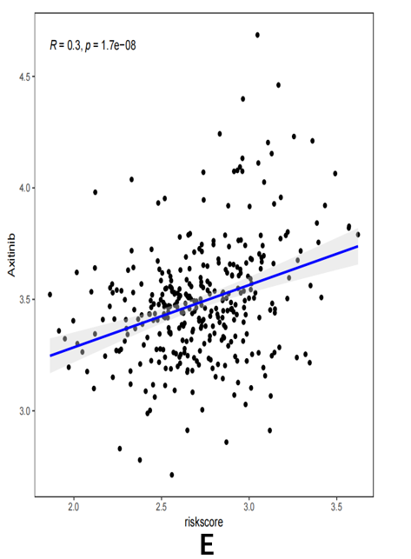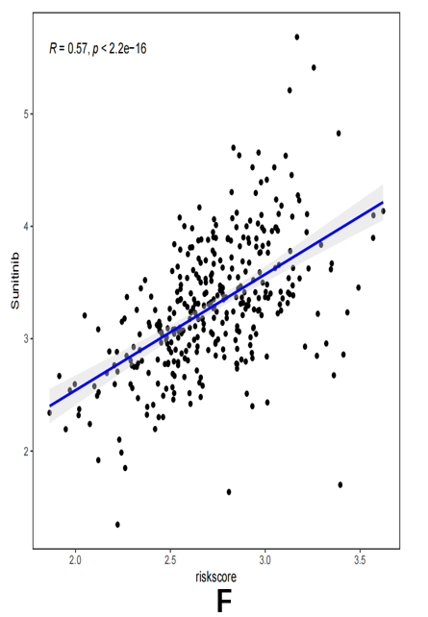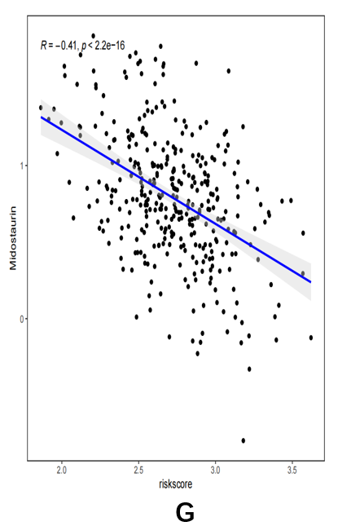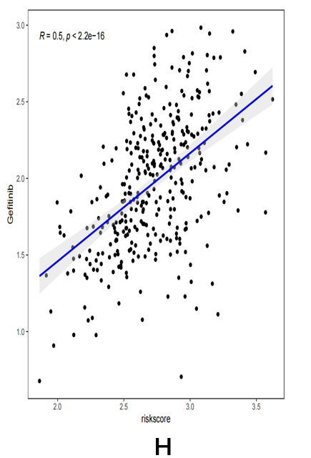
Figure 9：
Association between the ICDRS and drug sensitivity and validation of the genes. (A-D) A comparison of the sensitivity to tyrosine kinase inhibitors (TKIs) and EGFR-TKI inhibitors, including axitinib, sunitinib, Midostaurin, and Gefitinib, between high- and low-risk groups. (E-H) The correlation between the risk score and the half-maximal inhibitory concentration (IC50) of small molecule drugs, including axitinib, sunitinib, Midostaurin, and Gefitinib, in HCC.

