SUPPORTING INFORMATION

Mechanically Interlocked Nanotubes as Recyclable Catalysts for Knoevenagel Condensation
Mariano Vera-Hidalgo,¹ Matías Blanco,² Cristina Navío,¹ Luisa Ruiz-González³, Alejandro López-Moreno¹ and Emilio M. Pérez¹
¹ IMDEA Nanociencia, Campus de Cantoblanco, Calle Faraday 9, 28049 Madrid, Spain. *emilio.perez@imdea.org
² Organic Chemistry Department, Universidad Autónoma de Madrid, Módulo 1, Madrid, 28049 Spain. Institute for Advanced Research in Chemical Sciences (IAdChem), Universidad Autónoma de Madrid, Madrid, 28049 Spain. *matias.blanco@uam.es
³ Departamento de Química Inorgánica and Centro Nacional de Microscopía Electrónica, Universidad Complutense de Madrid, Madrid 28040 Spain

GENERAL METHODS
(6,5)-Enriched single walled nanotubes (6,5-SWNT) were purchased from Sigma-Aldrich (0.7−0.9 nm in diameter, length ≥700 nm, mostly semiconducting, 95% purity). Reagents were used as purchased. All solvents were dried according to standard procedures. All air-sensitive reactions were carried out under N₂ atmosphere.
CHARACTERIZATION METHODS
Analytical thin layer chromatographies (TLC) were performed using aluminium-coated Merck Kieselgel 60 F254 plates. NMR spectra were recorded on a Bruker Avance 400 (1H: 400 MHz; 13C: 100 MHz) spectrometers at 298 K, using partially deuterated solvents as internal standards. Coupling constants (J) are denoted in Hz and chemical shifts (δ) in ppm. Electrospray ionisation mass spectrometry (ESI-MS) and Matrix-assisted Laser desorption ionisation (coupled to a Time-Of-Flight analyser) experiments (MALDITOF) were recorded on a HP1100MSD spectrometer and a Bruker REFLEX. Thermogravimetric analyses (TGA) were performed using a TA Instruments TGAQ500 with a ramp of 10 °C min-1 under air from 100 to 1000 °C. Conventional Transmission electron microscopy (TEM) images were obtained with JEOL-J 6 EM 2100F instrument operating at 200 kV while atomic resolved TEM images were acquired in the image corrected microscope, GRAND ARM300cF, at 60 kV and low current emission density to minimize damage of the samples under the electron beam. Atomic Force Microscopy (AFM) images were acquired using a JPK NanoWizard II AFM working in dynamic mode. NT-MDT NSG01 silicon cantilevers, with typical values of 5.1 N m–1 spring constant and 150 kHz resonant frequency, were employed under ambient conditions in air. Raman spectra were acquired with a Bruker Senterra confocal Raman microscope instrument with 532, 633 and 785 nm excitation wavelengths. UV-vis-NIR spectra were performed using a Shimadzu UV-VIS-NIR Spectrophotometer UV-3600. Photoluminescence excitation intensity maps (PLE) were obtained with NanoLog 4 HORIBA instrument. X-ray Photoelectron Spectroscopy (XPS) were acquired employing the Al Kα line (hν = 1486.7 eV) as exciting photon source and a charge compensation gun was used in order to avoid any charging problem, using a flood gun of SPECS (FG-500) with low energy electrons (3 eV, 40 A). The hemispherical analyzer (SPHERA U7) was set to a pass energy of 20 eV for the high resolution acquisition spectra and all the C 1s centered at 284.4 eV are taken as a binding energy reference.
SYNTHETIC METHODS
NHBoc-U-Shaped molecule preparation:
Synthesis of 5-((tert-butoxycarbonyl)amino)isophthalic acid (2): In an ice bath, 0.5 g (2.76 mmol) of 5-aminoisophtalic acid was dissolved in 6 ml of 1 M NaOH aqueous solution. A solution of Boc anhydride in 1,4-dioxane (0.66 g, 3.04 mmol) was added dropwise for 2 h, and the mixture was stirred additionally for 3 h. Finally, the ice bath was removed and the reaction was stirred overnight at room temperature. Crude mixture was acidified to pH = 5 with 1 M HCl solution. A white solid appeared which was filtrated and dried under vacuum to obtain the pure product in 93 % yield. ¹H NMR (400.16 MHz, DMSO-d₆, δ ppm): 9.73 (s, 2H), 8.28 (s, 2H), 8.10 (s, 1H), 1.50 (s, 9H).
Synthesis of tert-butyl (3,5-bis(hydroxymethyl)phenyl)carbamate (3): A solution of BH₃·THF (0.85 mL, 8.89 mmol) was slowly added to a stirred solution of 0.5 g (1.77 mmol) of 2 in 24 mL of THF. The mixture was allowed to react at room temperature overnight. Crude mixture was poured in water, and extracted 3 times with ethyl acetate. Organic phases were collected and dried over anhydrous MgSO₄, concentrated and dried under vacuum. Crude product was purified by flash chromatography in ethyl acetate to obtain the pure product in 75 % yield. ¹H NMR (400.16 MHz, DMSO-d₆, δ ppm): 7.21 (s, 2H), 6.91 (s, 1H), 4.48 (s, 4H), 1.42 (s, 9H).
Synthesis of tert-butyl (3,5-bis(bromomethyl)phenyl)carbamate (4): 0.5 g (1.98 mmol) of 3 and 2.3 g (6.93 mmol) of CBr₄ were dissolved in 20 ml of dry THF and 1.82 g (6.93 mmol) of PPh₃ were added. Mixture was allowed to react at room temperature for 2 h. Crude was concentrated and purified by column chromatography in 3:1 mixture of hexane - ethyl acetate to obtain the pure product in 65 % yield. ¹H NMR (400.16 MHz, CDCl₃, δ ppm): 7.29 (s, 2H), 7.01 (s, 1H), 6.46 (s, 1H), 4.35 (s, 2H), 1.45 (s, 9H).
Synthesis of tert-butyl (3,5-bis(((7-(undec-10-en-1-yloxy)-1,8-dihydropyren-2-yl)oxy)methyl)phenyl)carbamate (5): 0.11 g (0.8 mmol) of dry K₂CO₃, 0.06 g (0.16 mmol) of 4, and a catalytic amount of potassium iodide were added to a solution of 0.14 g (0.4 mmol) of the monoalkylated hydroxypyrene in 11 mL of dry N,N-dimethylformamide. The solution was heated to 80 ºC for 4 h. The crude reaction was poured into ice-cold 1 M aqueous HCl, and filtrated. The solid was redissolved in CH₂Cl₂ and washed with water (2x), the organic fraction was dried over MgSO₄, the solvent evaporated, and the resulting product subjected to column chromatography (CH₂Cl₂) to obtain the pure product as a light brown solid in 71% yield. ¹H NMR (400.16 MHz, DMSO-d₆, δ ppm): 7.82 (d, J = 1.0 Hz, 8H), 7.65 (s, 4H), 7.60 (s, 4H), 7.46 (d, J = 14.4 Hz, 2H), 7.34 (s, 1H), 7.19 (s, 3H), 6.50 (s, 1H), 5.75 (ddt, J = 16.9, 10.2, 6.7 Hz, 2H), 5.29 (s, 4H), 4.96 – 4.82 (m, 4H), 4.17 (t, J = 6.6 Hz, 4H), 1.98 (dd, J = 14.2, 6.8 Hz, 4H), 1.92 – 1.78 (m, 4H), 1.48 (dd, J = 16.7, 6.5 Hz, 17H), 1.40 – 1.14 (m, 22H). ¹³C NMR (101 MHz, CDCl₃, δ ppm): 156.77 (s), 156.13 (s), 152.74 (s), 139.26 (s), 139.11 (s), 138.70 (s), 131.60 (s), 131.54 (s), 127.50 (s), 127.42 (s), 120.60 (s), 120.28 (s), 119.98 (s), 116.67 (s), 114.18 (s), 111.53 (s), 111.34 (s), 80.73 (s), 70.14 (s), 68.57 (s), 33.85 (s), 29.60 (s), 29.50 (s), 29.18 (s), 28.98 (s), 28.39 (s), 26.20 (s). HRMS-MALDI calculated for C₆₇H₇₅NO₆ [M]⁺: 989.5589; found 989.5619
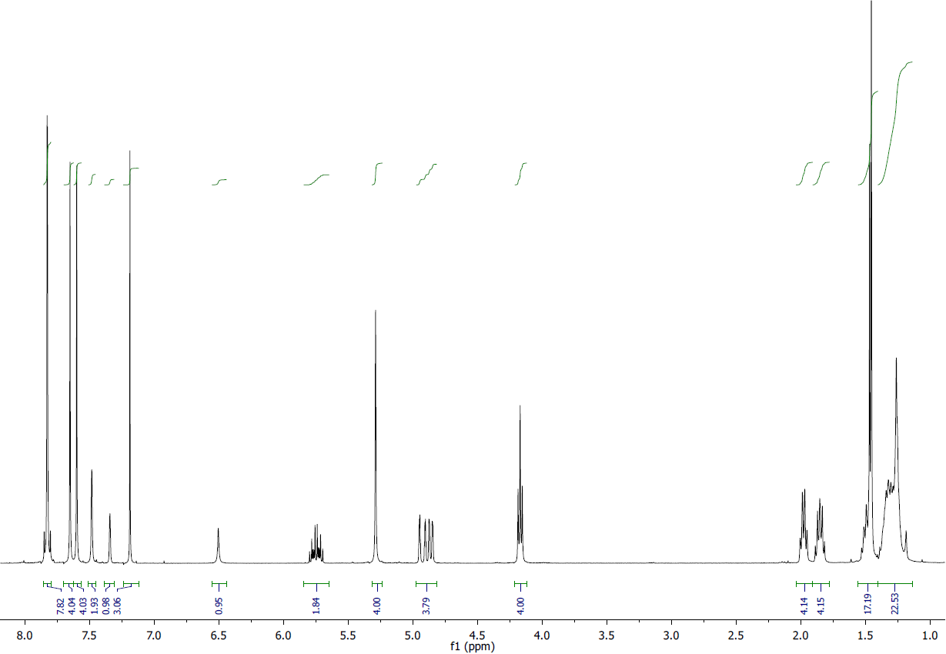
Figure S1: ¹H-NMR spectrum of linear receptor 5.
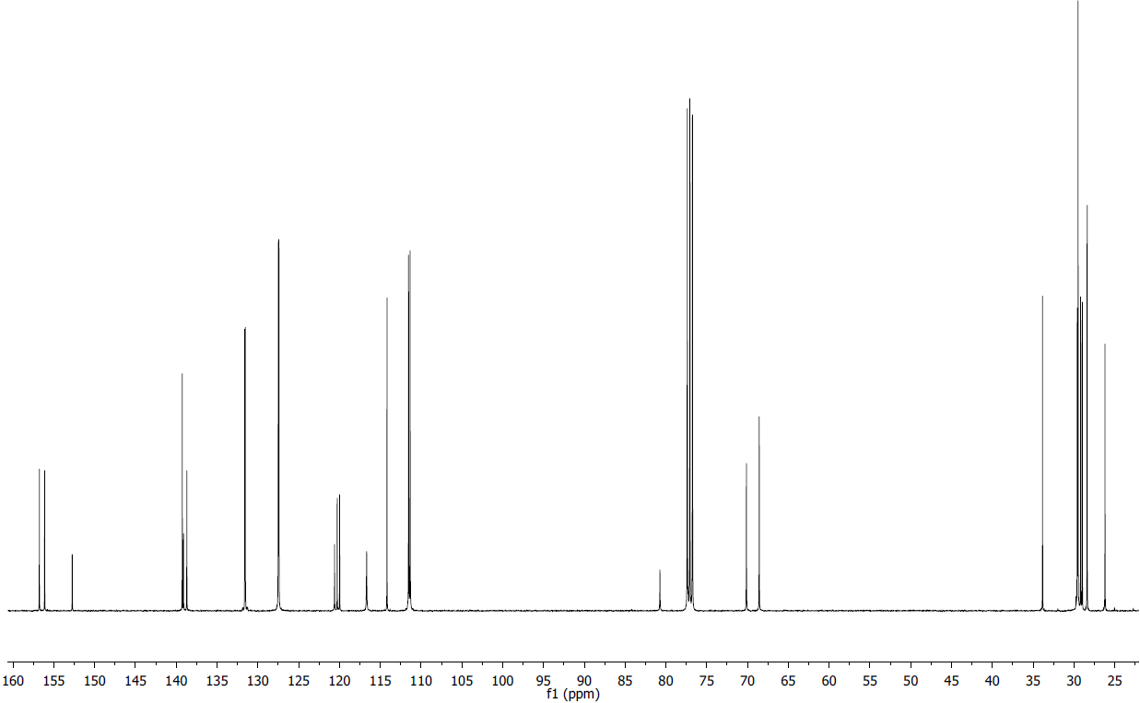
Figure S2: ¹³C-NMR spectrum of linear receptor 5.
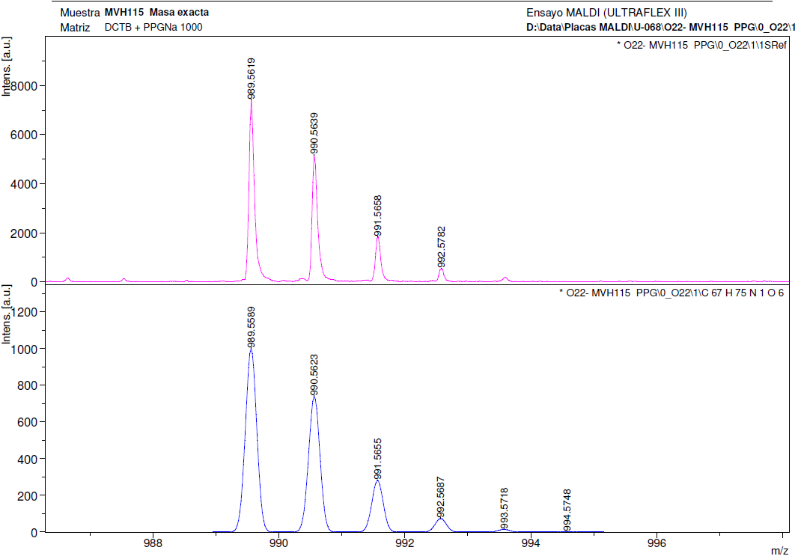
Figure S3: HMRS-MALDI spectra of linear receptor 5.

Synthesis of N-based macrocycles:
Synthesis of Mac-NHBoc: A catalytic amount of Grubb’s 1st generation catalyst was added to a solution of the corresponding linear precursor in dry and degassed DCM, and the mixture was stirred at room temperature. The progress of the reaction was monitored by TLC. When the starting linear precursor was consumed, the reaction was stopped by filtration through a pad of celite. Solvent was evaporated under reduced pressure, and the crude was purified by flash chromatography (Hex:AcOEt 3:1) to obtain the a white solid in 75 % yield. ¹H NMR (400.16 MHz, CDCl₃, δ ppm): 7.42 (s, 3H), 7.39 (s, 1H), 7.34 (s, 4H), 7.26 (dd, J = 8.8, 4.4 Hz, 8H), 6.46 (s, 1H), 5.30 (s, 6H), 4.17 (t, J = 6.6 Hz, 4H), 2.04 – 1.78 (m, 9H), 1.63 – 1.44 (m, 7H), 1.42 (s, 9H), 1.40 – 1.14 (m, 23H). ¹³C NMR (101 MHz, CDCl₃, δ ppm): 156.57 (s), 155.28 (s), 152.67 (s), 139.41 (s), 139.19 (s), 131.42 (s), 131.18 (s), 130.66 (s), 130.11 (s), 127.03 (s, J = 2.7 Hz), 127.00 (s), 119.86 (s), 119.73 (s), 119.41 (s), 115.33 (s), 111.63 (s), 111.03 (s), 80.79 (s), 69.63 (s), 68.62 (s), 32.27 (s), 29.71 (s), 29.66 (s), 29.57 (s), 29.52 (s), 29.46 (s), 29.17 (s), 28.94 (s), 28.53 (s), 28.35 (s), 27.18 – 26.78 (m), 26.35 (s). HRMS-MALDI calculated for C₆₅H₇₁NO₆ [M]⁺: 962.5354; found 962.5361
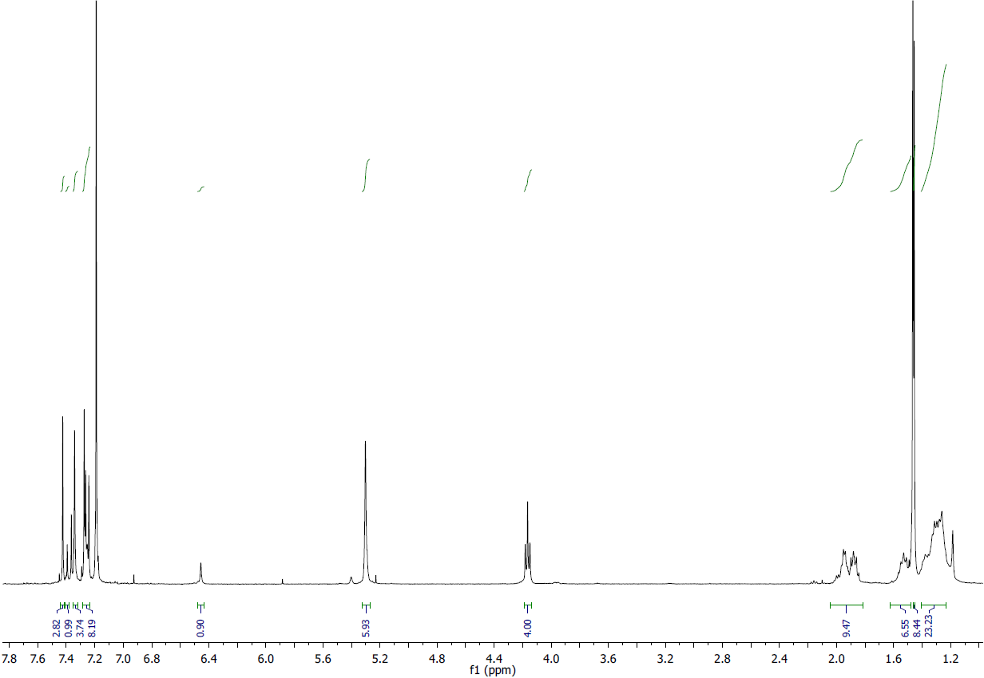
Figure S4: ¹H-NMR spectrum of mac-NHBoc.
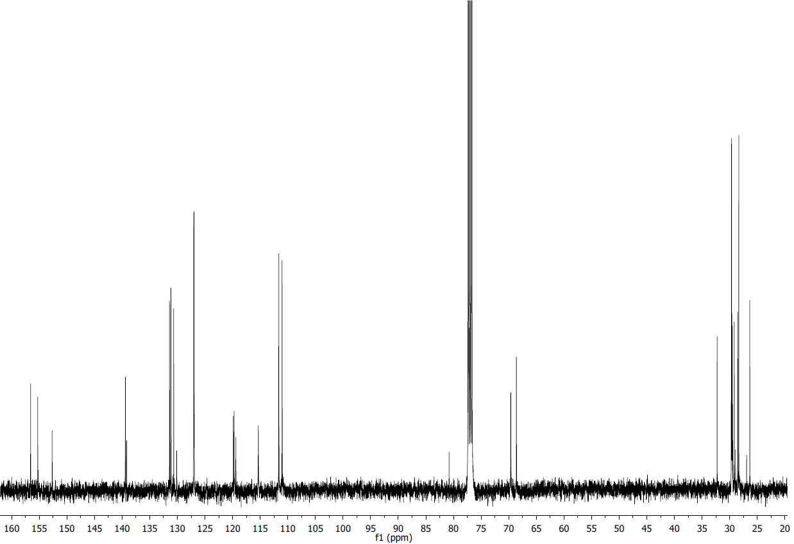
Figure S5: ¹³C-NMR spectrum of mac-NHBoc.
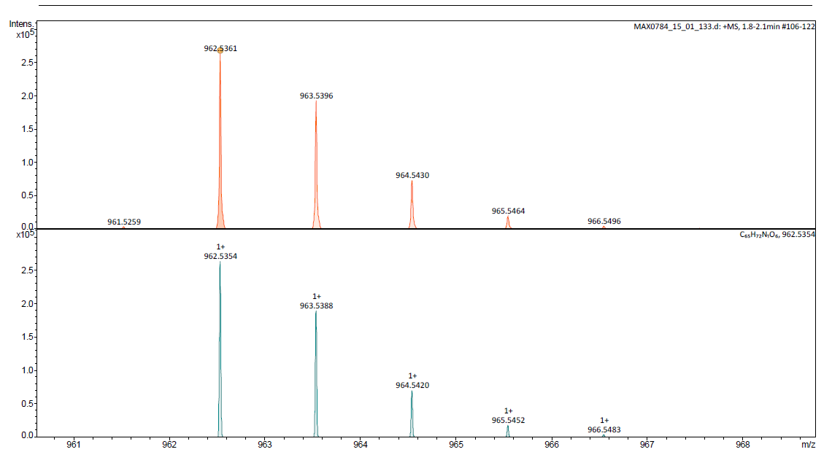
Figure S6: HMRS-MALDI spectra of mac-NHBoc.

Synthesis of Mac-NH₂: 73 mg (0.08 mmol) of Mac-NHBoc was dissolved in 2 mL of DCM and 50 mg (0.4 mmol) of trifluoroacetic acid were added. The mixture was stirred at room temperature overnight. Crude mixture was diluted with additional DCM, and it was washed twice with saturated NaHCO₃ solution. Organic fractions were combined, dried over MgSO₄, solvent evaporated and the crude product dried in vacuum. Purification was carried out by column chromatography (Hexane:Ethyl Acetate 1:1 mixture) to yield a light yellow solid in 56 % yield. ¹H NMR (400.16 MHz, DMF-d₇, δ ppm): 7.74 (m, 3H), 7.71 (s, 1H), 7.66 (m, 7H), 7.58 (m, 4H), 7.50 (d, J = 9.0 Hz, 1H), 7.05 (m, 1H), 6.77 (s, 2H), 5.41 (m, 4H), 5.23 (s, 2H), 4.31 (t, J = 6.5 Hz, 4H), 2.06 (m, 4H), 1.93 (m, 4H), 1.60 (m, 4H), 1.49 – 1.30 (m, 22H). ¹³C NMR (101 MHz, DMF-d₇, δ ppm): 156.92 (s), 156.07 (s) , 155.99 (s), 149.82 (s), 139.11 (s), 131.61 (s), 131.32 (s), 131.29 (s), 130.65 (s), 130.12 (s), 127.27 (s), 127.22 (s), 127.17 (s), 119.63 (s), 113.82 (s), 112.11 (s), 111.93 (s), 111.17 (s), 69.78 (s), 68.25 (s), 31.92 (s), 28.42 (s), 26.70 (s), 26.23 (s). HRMS-MALDI calculated for C₆₀H₆₃NO₄ [M]⁺: 861.4752; found 861.4736.
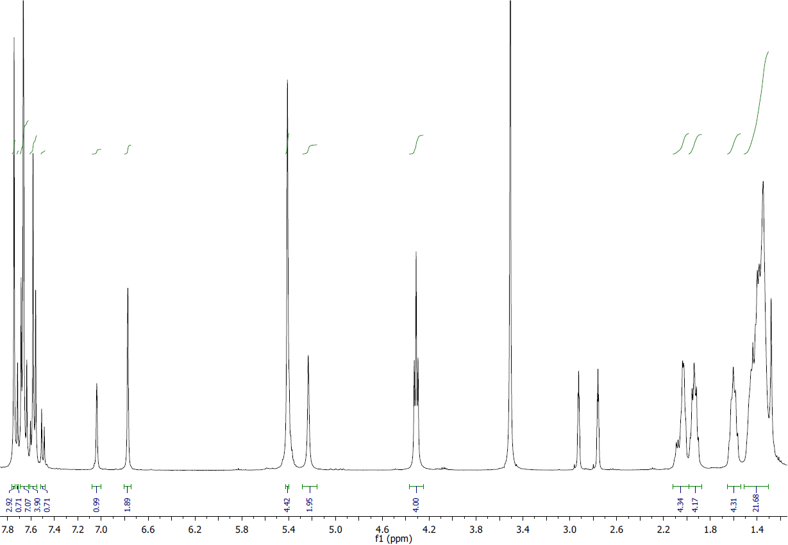
Figure S7: ¹H-NMR spectrum of mac-NH_{2.}

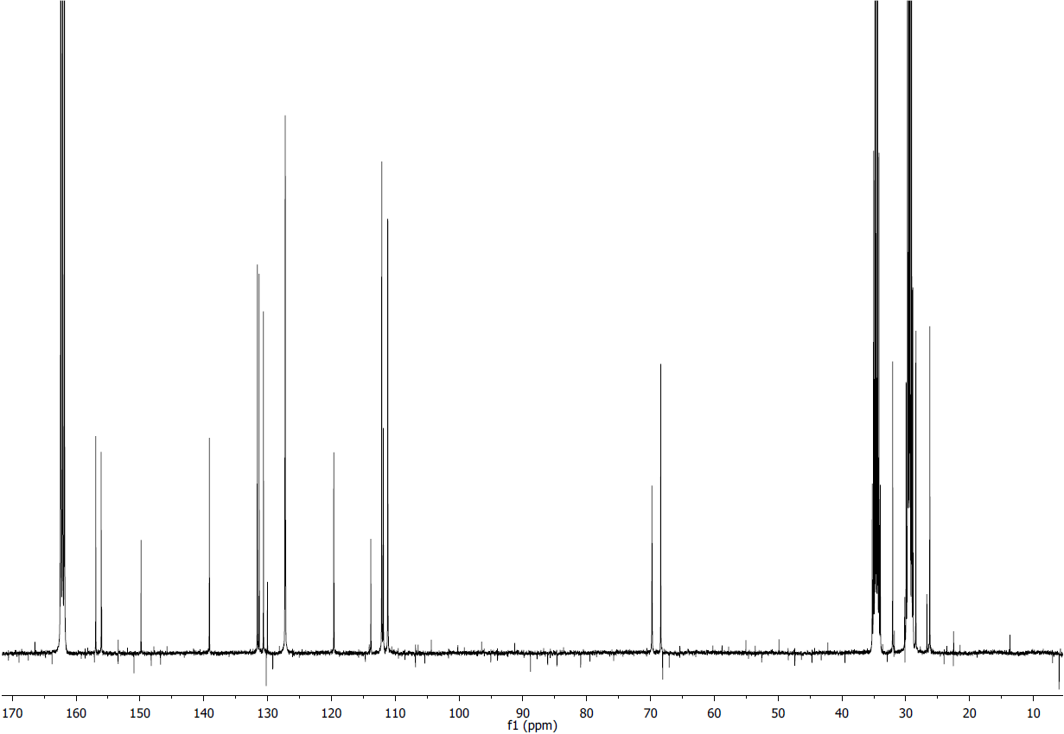
Figure S8: ¹³C-NMR spectrum of mac-NH_{2.}
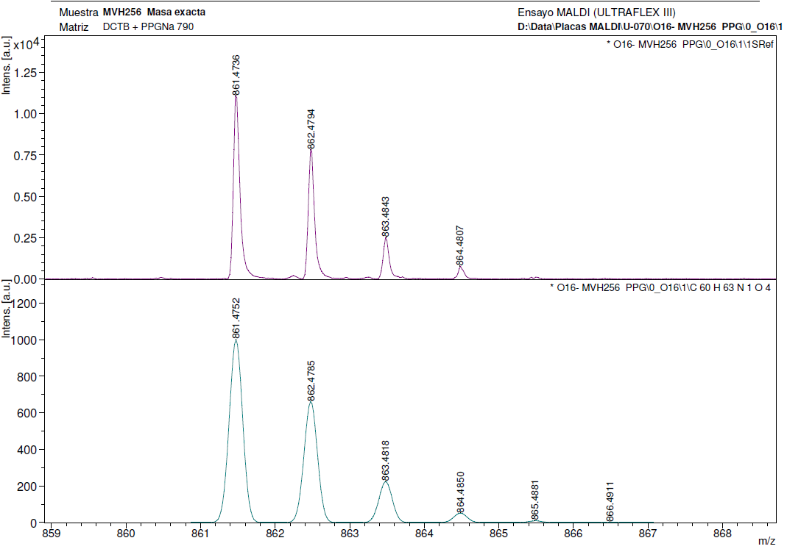
Figure S9: HMRS-MALDI spectra of mac-NH₂.

Synthesis of Mac-NEt₂: 59 mg (0.068 mmol) of mac-NH₂ and 30 mg (0.21 mmol) of K₂CO₃ were dissolved in 2.3 mL of DMF by magnetically stirring. Then, 17 µl (0.21 mmol) of Et2I was added, and the reaction was maintained at 80 ºC for 2 h. After natural cooling, reaction crude was diluted with water and extracted three times with ethyl acetate. The organic phases were combined, washed with brine, dried over MgSO₄ and concentrated under reduced pressure. Purification was performed by column chromatography eluted with a hexane – ethyl acetate mixture of 1:1, to yield a light yellow solid in 78 % yield. ¹H NMR (400.16 MHz, CDCl₃, δ ppm): 7.40 (m, 3H), 7.37 (s, 1H), 7.32 (m, 7H), 7.27 (m, 2H), 7.24 (t, J = 2.4 Hz, 2H), 7.18 (dd, J = 9.0, 2.5 Hz, 2H), 6.86 (d, J = 14.1 Hz, 1H), 5.29 (m, 2H), 5.24 (s, 4H), 4.12 (t, J = 6.6 Hz, 4H), 3.24 (c, J = 6.8 Hz, 4H), 1.92 (m, 4H), 1.84 (m, 4H), 1.48 (m, 5H), 1.20 (m, 22H), 1.04 (t, J = 7.0 Hz, 6H). ¹³C NMR (101 MHz, CDCl₃, δ ppm): 156.57 (s), 155.70 (s), 155.63 (s), 139.39 (s), 139.38 – 139.20 (m), 131.45 (s), 131.43 (s), 131.19 (s), 131.15 (s), 130.67 (s), 130.13 (s), 127.14 (s), 127.08 (s), 126.98 (s), 126.93 (s), 119.88 (s), 119.83 (s), 111.92 (s), 111.85 (s), 111.01 (s), 110.96 (s), 70.53 (s), 70.18 (s), 68.62 (s), 44.40 (s), 32.30 (s), 29.73 (s), 29.67 (s), 29.59 (s), 29.54 (s), 29.49 (s), 29.20 (s), 28.97 (s), 28.57 (s). HRMS-MALDI calculated for C₆₄H₇₁NO₄ [M]⁺: 917.5378; found 917.5382.
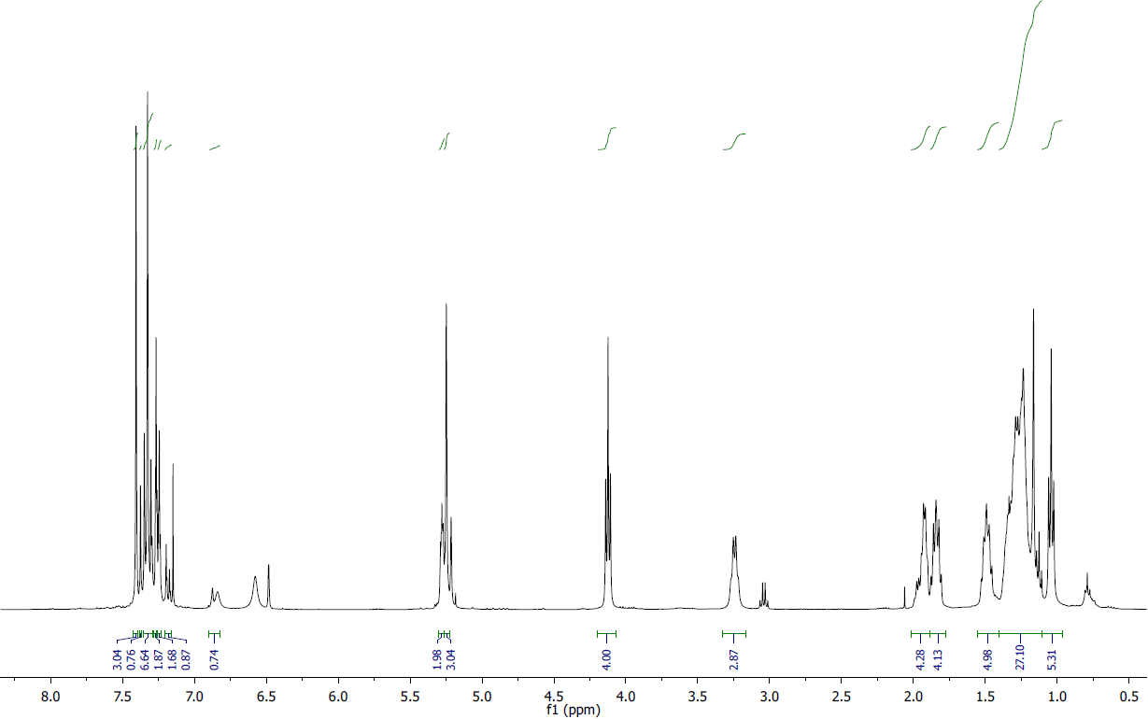
Figure S10: ¹H-NMR spectrum of mac-NEt₂.

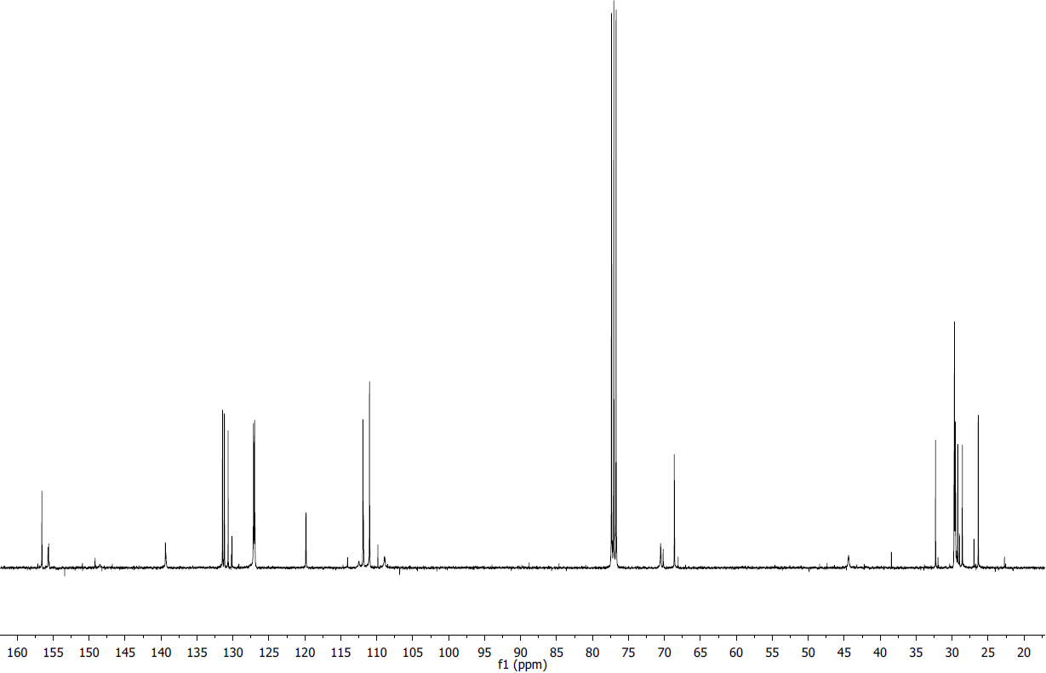
Figure S11: ¹³C-NMR spectrum of mac-NEt₂.

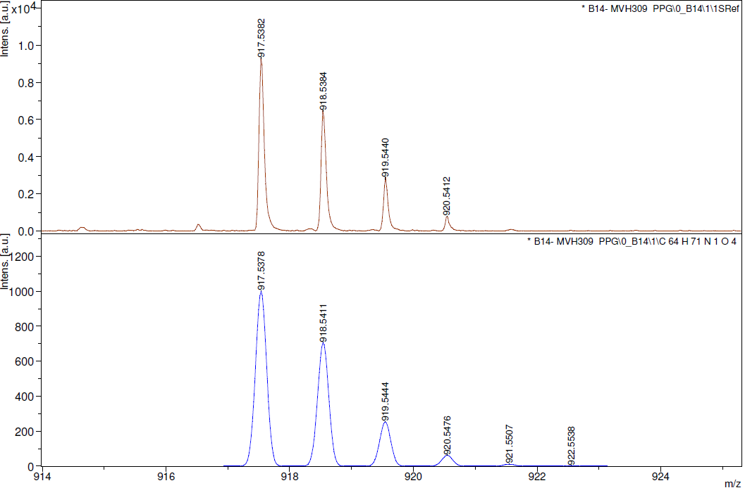
Figure S12: HMRS-MALDI spectra of mac-NEt₂

MINT formation and derivatization
MINT-NHBoc preparation: The general method for the synthesis of MINTs has been reported elsewhere. Brieﬂy, the nanotubes (10 mg) were suspended in 10 mL of tetrachloroethane through sonication (10 min) and mixed with 0.01 mmol of linear bisalkene U-shaped precursor of the macrocycle mac-NHBoc, and Grubb’s second-generation catalyst at room temperature for 72 h. After this time, the suspension was filtered through a polytetrafluoroethylene (PTFE) membrane of 0.2 μm pore size and the solid washed profusely with dichloromethane (DCM). The solid was resuspended in 10 mL of dichloromethane through sonication for 10 min and filtered through a PTFE membrane of 0.2 μm pore size again. This washing procedure was repeated three times. Sample obtained was denoted as MINT-NHBoc.
Synthesis of MINT-NH₂: MINT-NHBoc was suspended in a 4 M aqueous suspension of HCl with a 4 mg mL⁻¹ concentration by 10 min of sonication, and the suspension was magnetically stirred overnight at room temperature. After reaction, the suspension was filtered through polycarbonate (PC) membrane of 0.2 µm pore size, and washed with water till neutral pH was reached. Then, the solid was filtered through a PTFE membrane, washed twice with DCM and finally dried under vacuum. Sample was labeled MINT-NH₂.
Synthesis of MINT-NPy: 5 mg of MINT-NH₂ was suspended in 10 ml of ethanol by 10 min of sonication. To this mixture, 0.7 mmol of 2-picolinealdehyde and a drop of formic acid were added. Reaction was maintained under magnetic stirring and reflux conditions for 48 h. After this time, the suspension was filtered through a 0.2 μm pore size PTFE membrane and the solid washed profusely with dichloromethane. The solid was resuspended in 10 mL of DCM through sonication for 10 min and filtered through a PTFE membrane again, and the washing procedure was repeated three times to yield MINT-NPy.
Synthesis of MINT-NEt₂: 5 mg of MINT-NH₂ and 0.7 mmol of K₂CO₃ were suspended in 25 ml of ethanol by 10 min of sonication. This mixture was stirred for 5 min, and then 0.7 mmol of ethyliodide was added. Reaction was maintained under magnetic stirring and reflux conditions for 48 h. After this time, the suspension was filtered through a 0.2 μm pore size PTFE membrane and the solid washed profusely with DCM. The solid was resuspended in 10 mL of DCM through sonication for 10 min and filtered through a PTFE membrane again, and the washing procedure was repeated three times to yield MINT-NEt₂.
Synthesis of supramolecular complexes: The synthesis of the supramolecular complexes denoted as SWNT-NHBoc, SWNT-NH₂, SWNT-NPy and SWNT-NEt₂ was performed by the direct mixing of the adequate amounts of 6,5-SWNT and the corresponding macrocycle to achieve the same functionalization loading of organic material over the nanotube compared to their respective MINT sample.
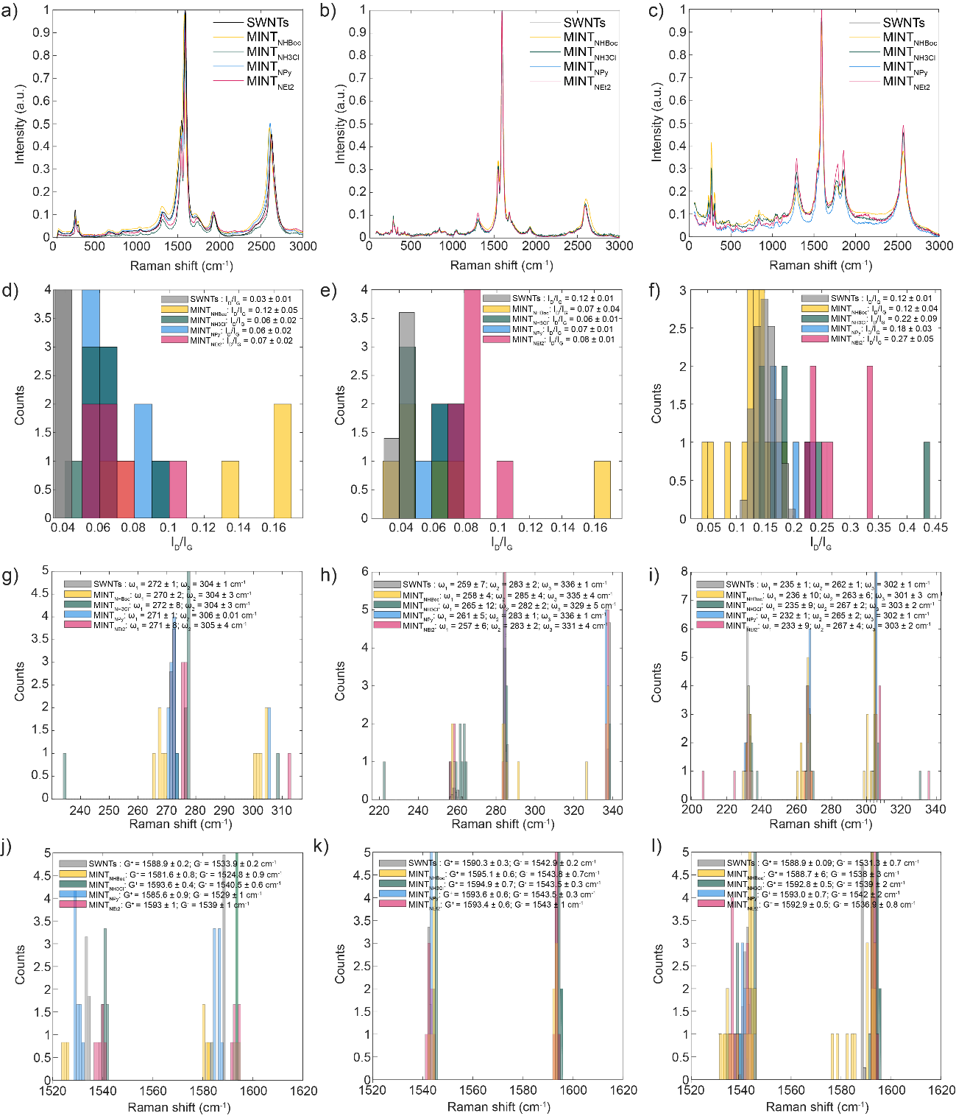
Figure S13 a-c) Average Raman spectrum under λexc=532, 633 and 785 nm respectively; d-f) ID/IG statistic under λexc=532, 633 and 785 nm respectively; g-i) RBM statistic under λexc=532, 633 and 785 nm respectively; and j-l) G band shifts under λexc=532, 633 and 785 nm respectively.

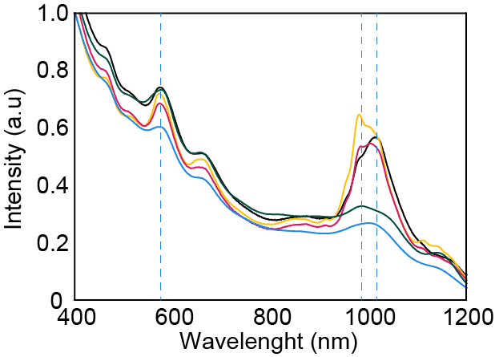
Figure S14. UV-vis-NIR spectra (D₂O, 1% SDS) of (6,5)-SWNT (black), MINT-NHBoc (yellow), MINT-NH₂ (green) MINT-NPy (blue), MINT-NEt₂ (red).

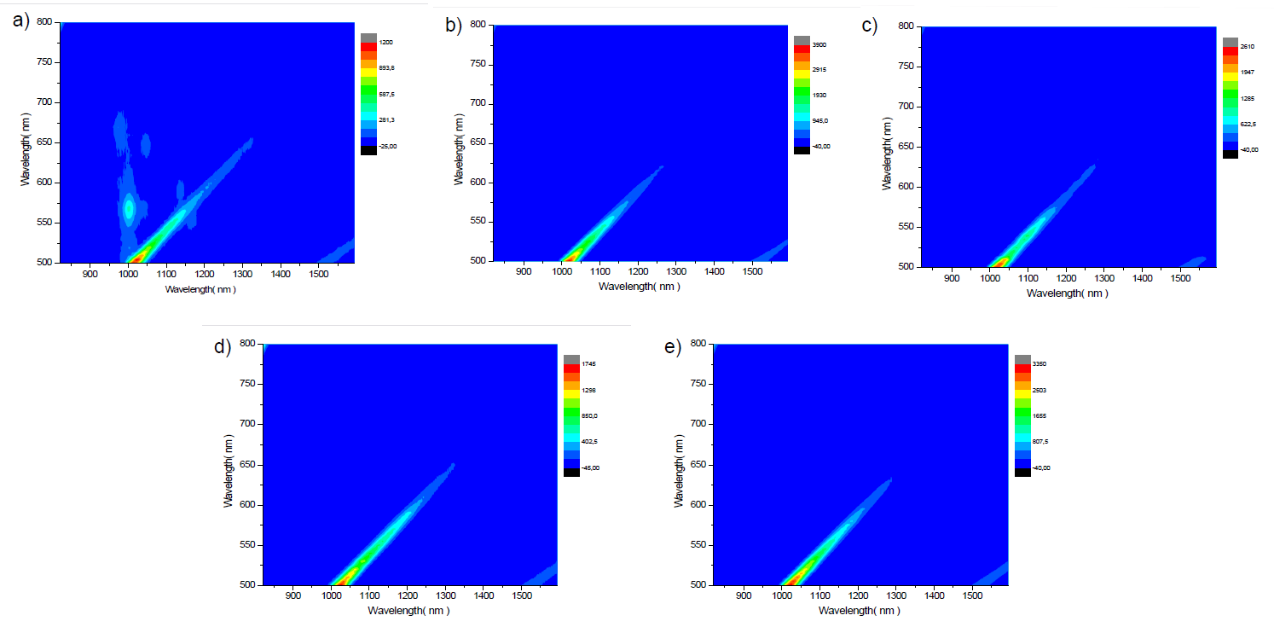
Figure S15. PLE maps of a) SWNT, b) MINT-NHBoc, c) MINT-NH₂, d) MINT-NPy and e) MINT-NEt₂.

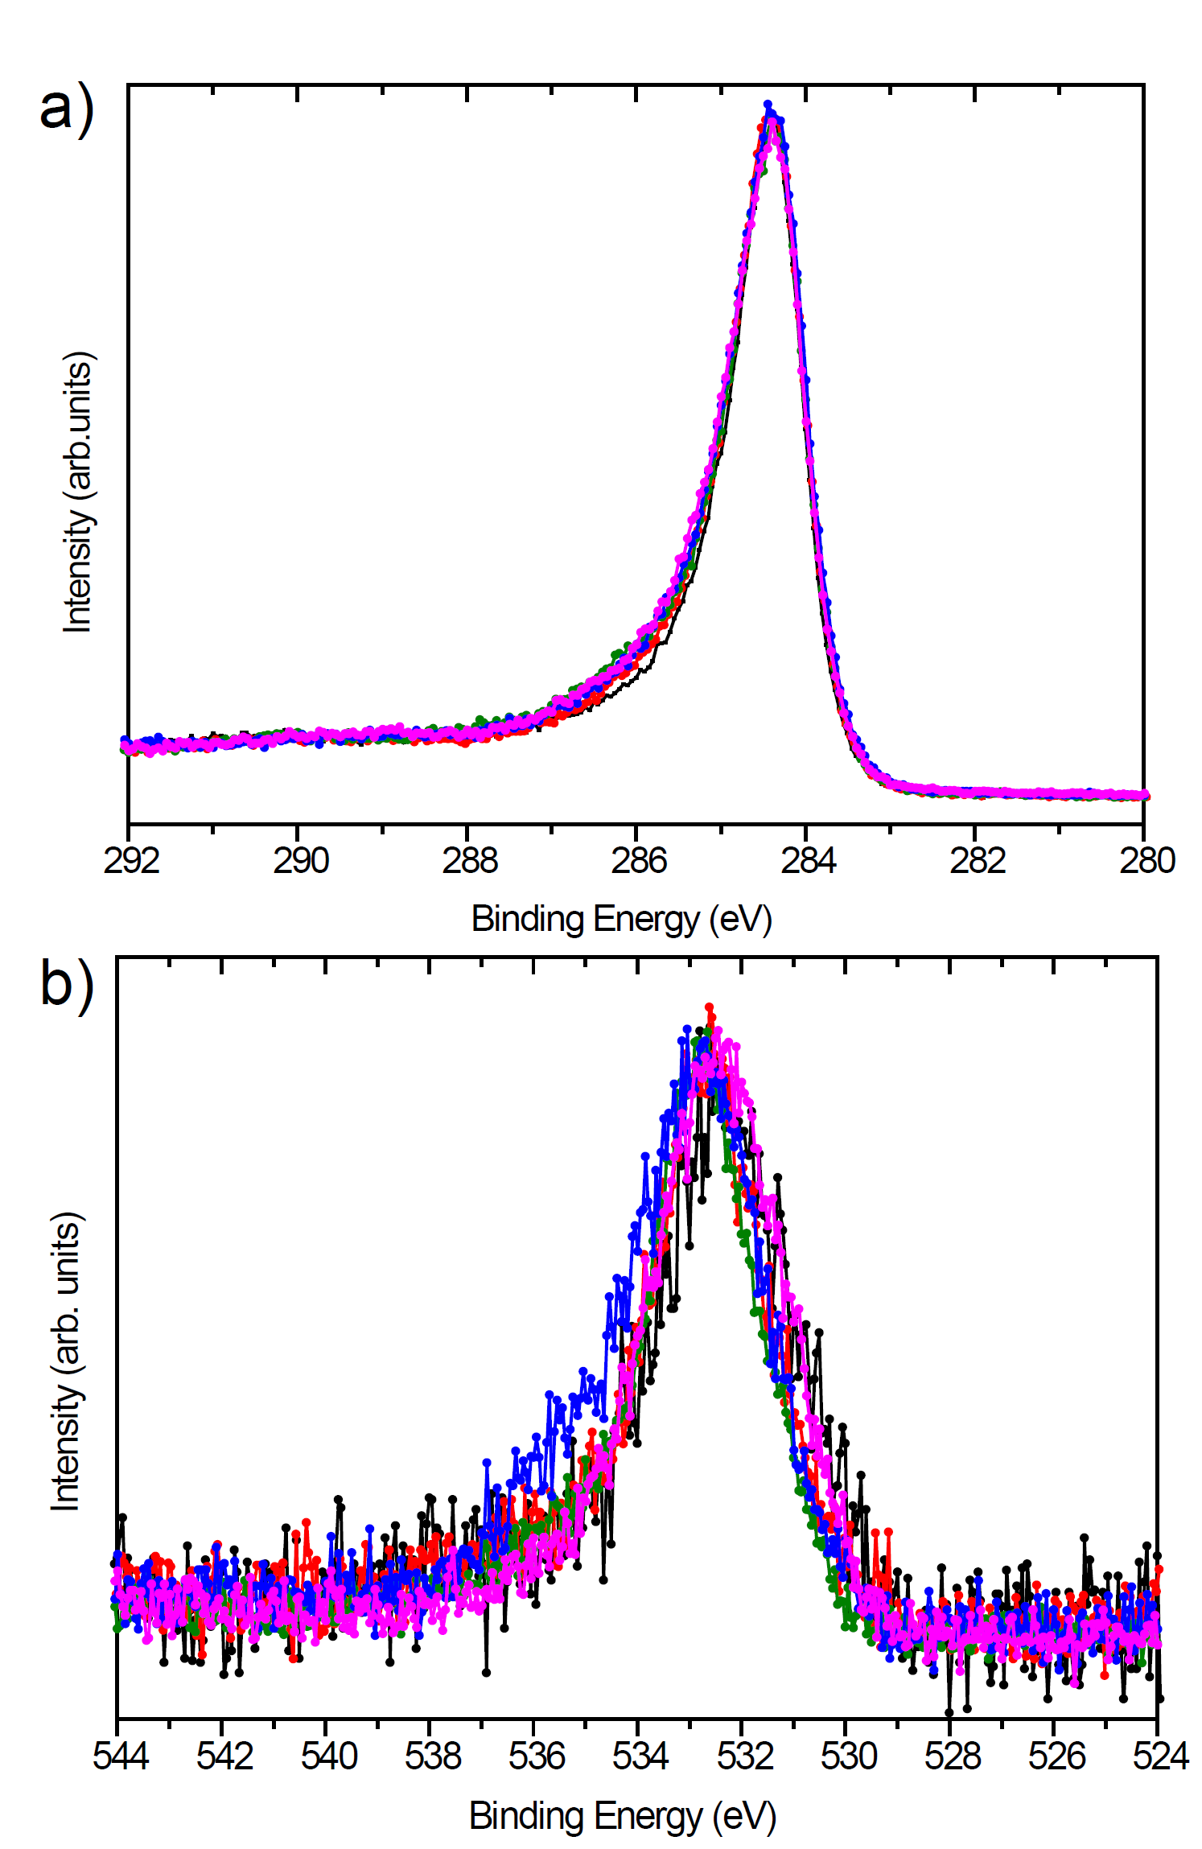
Figure S16: a) XPS C1s and b) O1s core regions of samples 6,5-SWNT (black), MINT-NHBoc (red), MINT-NH₂ (green), MINT-NPy (blue) and MINT-NEt₂ (pink).

Table S1. Binding energy (BE) and full width at half maxima (FWHM) of the XPS N1s core levelregion of samples under study
Sample | BE (eV) | FWHM (eV)
6,5-SWNT | - | -
MINT-NHBoc | 399.9 | 1.8
MINT-NH₂ | 400.2 | 2.2
MINT-NPy | 399.9 | 2.8
MINT-NEt₂ | 399.8 | 2.5

CATALYSIS
General procedure: The typical catalytic experiment was performed as follows: Aldehyde substrate (1 mmol), malononitrile (1 mmol), solvent (3 mL) and catalyst (5 mg) were mixed in a round bottom flask, stirred magnetically and held at determined temperature (room temperature or 75 ºC) for a desired time. At regular intervals, aliquots were withdrawn from the reaction and submitted to NMR spectroscopy analysis to follow the catalytic evolution. Once the reaction was complete, crude mixture concentrated under reduced pressure, yielding the final product. If necessary, attending to the NMR spectra, product was purified by flash chromatography in silica (hexane:ethyl acetate 3:1).
Homogeneous catalysis: Performed according to the general procedure on the benzaldehyde condensation, but adding only as catalyst the corresponding amount of mac-NHBoc, mac-NH₂, mac-NPy and mac-NEt₂ determined from TGA to achieve the same quantity of active sites.
Recycling: the MINT-containing solid catalysts MINT-NHBoc, MINT-NH₂, MINT-NPy and MINT-NEt₂, and their corresponding supramolecular complexes (supra-NHBoc, supra-NH₂, supra-NPy and supra-NEt₂) were recovered by filtration through a PTFE membrane of 0.2 μm pore-size and washed profusely with DCM. The solid was re-suspended in 10 mL of DCM through sonication for 10 min and filtered through a PTFE membrane of 0.2 μm pore size again. This washing procedure was repeated three times. After drying, the material was submitted to another catalytic run without adding in any case new catalyst precursor. MINT-NPy and MINT-NEt₂ were recycled 5 times on the benzaldehyde condensation.
Table S2. Solvent optimization for the Knoevenagel condensation
Solvent | Timeª | Conv^{b} | Select^{c}
EtOH | 28 | 100 | 100
MeCN | 24 | 10 | -
Toluene | 16 | - | -
H₂O | 40 | 75 | -
THF | 24 | - | -
a) Time (h); b) Conversion (%), determined by ¹H-NMR; c) Selectivity to the target benzylidene, determined by ¹H-NMR

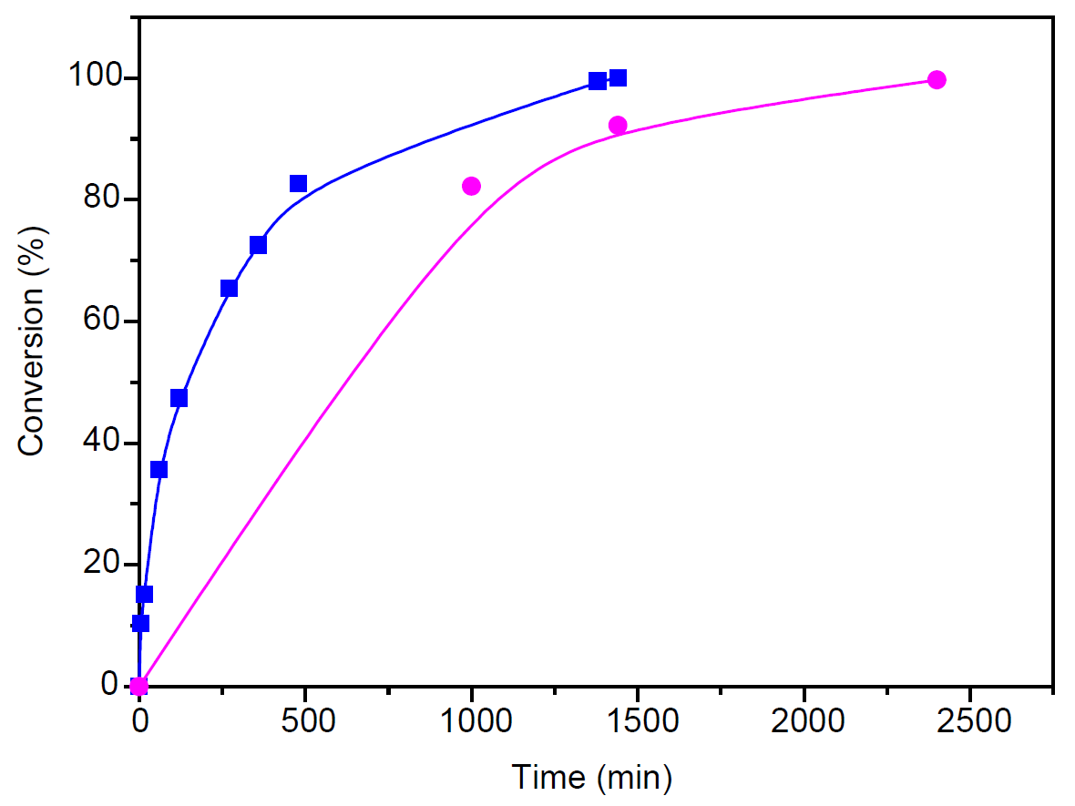
Figure S17. Conversion vs time profiles on the Knoevenagel condensation of benzaldehyde performed at room temperature catalyzed by MINT-NPy (blue) and MINT-NEt₂ (purple).

Table S3. Cycling studies of supramolecular complexes
Catalyst\Cycleª | 1 |  | 2
Catalyst\Cycleª | Conv^{b} | Time^{c} | Conv | Time
Supra-NHBoc | - | 24 | 100 | 24
Supra-NH₂ | - | 24 | 100 | 24
Supra-NPy | - | - | - | -
Supra-NEt₂ | 83 | 6 | 100 | 24
a) Washing with DCM and new catalytic cycle; b) Conversion (%) determined by ¹H-NMR; c) Time (h).

Figure S18. Selected ¹H-NMR spectra (CDCl₃, 400.16 MHz, 298 K) of the cycling studies of a) supra-NHBoc, b) supra-NH₂, c) supra-NPy and d) supra-NEt₂ on the benzaldehyde Knoevenagel condensation
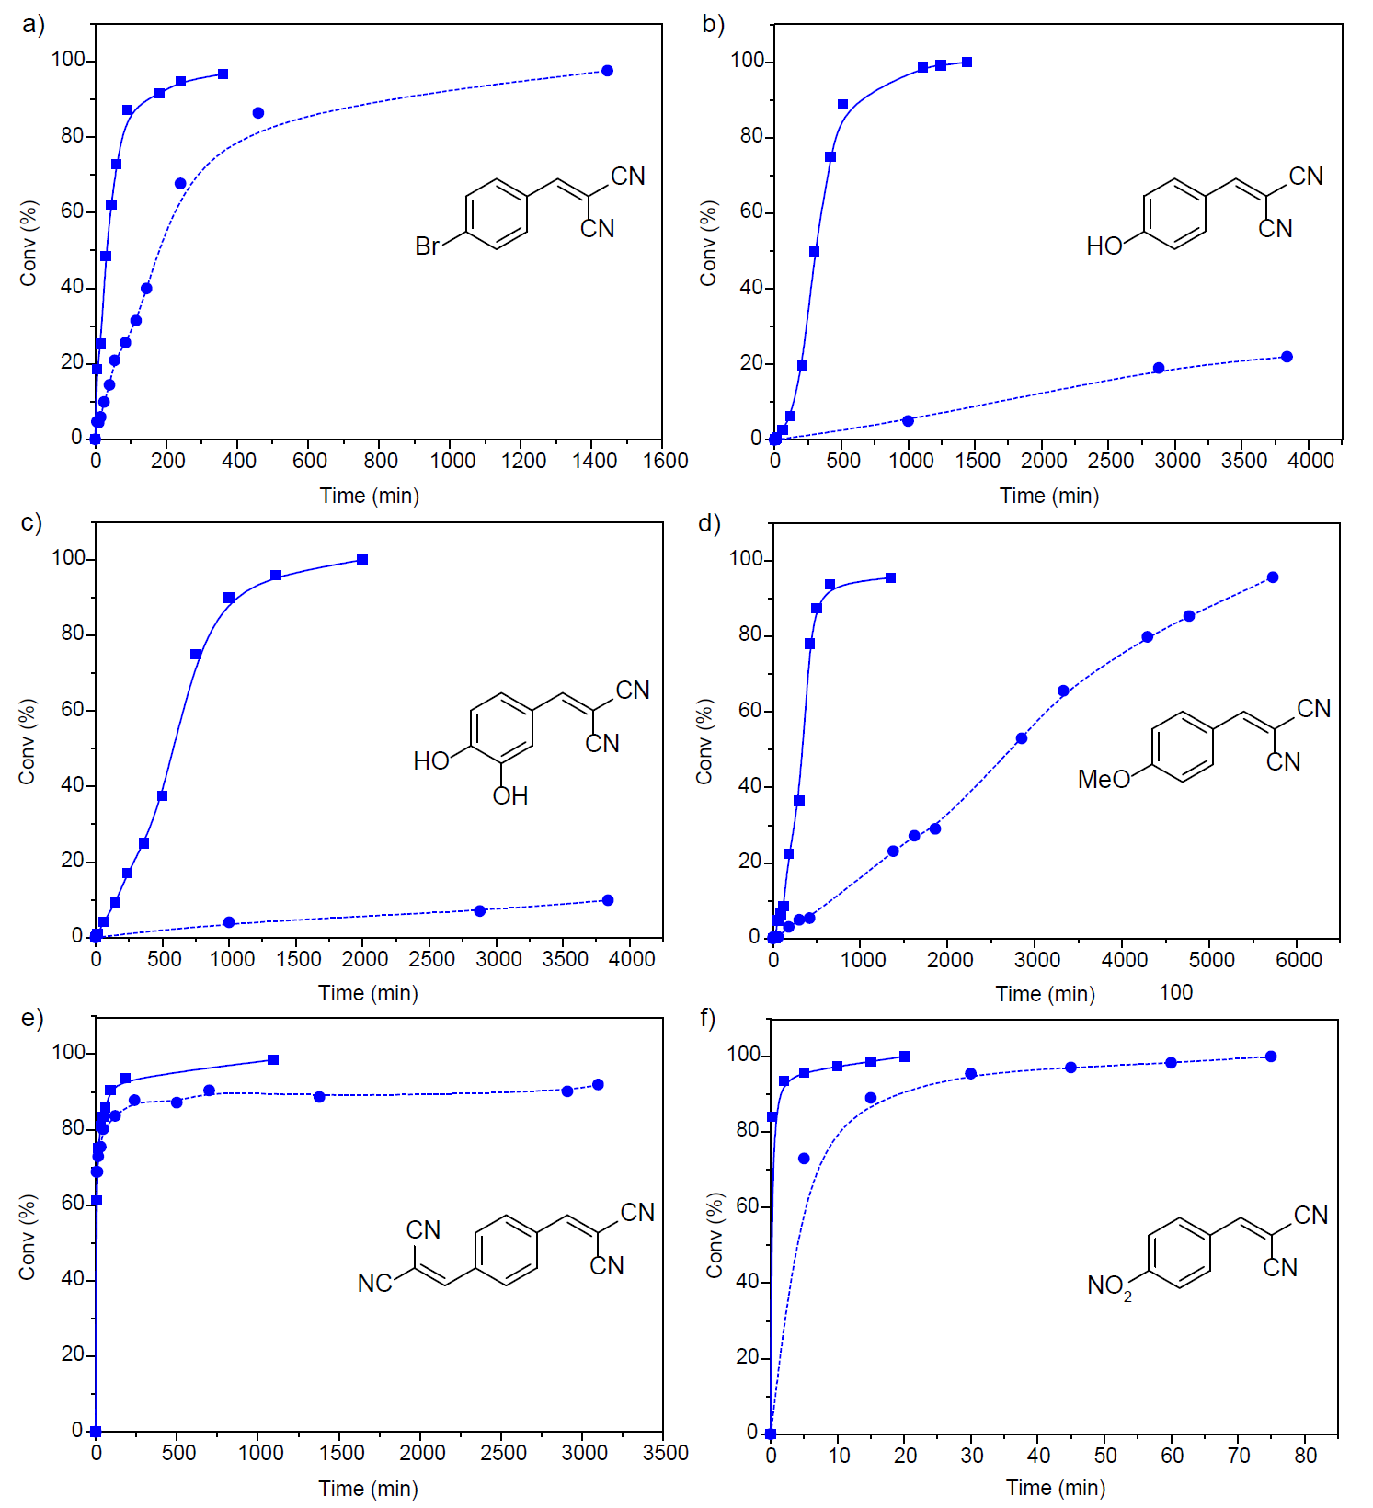
Figure S19. Conversion vs time plots on the reactions catalyzed by MINT-NPy with the substrate a) p-bromobenzaldehyde, b) p-hydroxybenzaldehyde, c) 3,4-dihydroxybenzaldehyde, d) p-anisaldehyde, e) terephthaldehyde and f) p-nitrobenzaldehyde at 75 ºC (solid line) and room temperature (pointed line). Insets: final product obtained.

Table S4. Control experiments in the scope of the catalysts
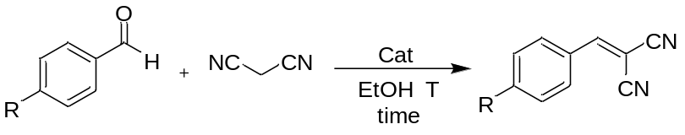
R | Cat^{b} | T ^{c} | Time ^{d} | Conv ^{e} | Select ^{f}
H | No cat | rt | 144 | 100 | 100
H | 6,5-SWNT | rt | 144 | 100 | 100
H | No cat | 75 | 28 | 100 | 100
H | 6,5-SWNT | 75 | 24 | 100 | 100
Br | No cat | rt | 48 | 100 | 100
Br | 6,5-SWNT | rt | 48 | 100 | 100
Br | No cat | 75 | 24 | 97 | 65
Br | 6,5-SWNT | 75 | 24 | 90 | 40
OH | No cat | rt | 48 | 47 | 50
OH | 6,5-SWNT | rt | 48 | 40 | 50
OH | No cat | 75 | 40 | 98 | 100
OH | 6,5-SWNT | 75 | 48 | 95 | 100
OH, OH^{g} | No cat | rt | 48 | 11 | -
OH, OH^{g} | 6,5-SWNT | rt | 48 | 7 | -
OH, OH^{g} | No cat | 75 | 46 | 99 | 100
OH, OH^{g} | 6,5-SWNT | 75 | 40 | 96 | 100
OMe | No cat | rt | 72 | 26 | 100
OMe | 6,5-SWNT | rt | 72 | 4 | -
OMe | No cat | 75 | 24 | 60 | 92
OMe | 6,5-SWNT | 75 | 24 | 53 | 100
CHO^{h} | No cat | rt | 67 | 90 | 100
CHO^{h} | 6,5-SWNT | rt | 67 | 95 | 100
CHO^{h} | No cat | 75 | 16 | 96 | 100
CHO^{h} | 6,5-SWNT | 75 | 16 | 96 | 100
NO₂ | No cat | rt | 3 | 91 | 100
NO₂ | 6,5-SWNT | rt | 3 | 98 | 100
NO₂ | No cat | 75 | 1 | 98.7 | 100
NO₂ | 6,5-SWNT | 75 | 1 | 96.2 | 100
a) Reaction conditions: Substrate (1 mmol), malononitrile (1 mmol), EtOH (3 mL), catalyst (5 mg) for temperature and time; b) Catalyst employed; c) Temperature (ºC); d) time (h); e) Conversion, determined by ¹H-NMR (%); f) Selectivity, determined by ¹H-NMR (%); g) Substrate =3,4-dyhidroxybenzaldehyde; h) 2 eqs. of malononitrile.

Characterization of Knoevenagel products
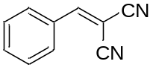
2-Benzilidenemalononitrile: Prepared according to the general procedure. ¹H NMR (400.16 MHz, CDCl₃, δ ppm): 7.83 (d, J = 7.7 Hz, 1H), 7.79 (s, 1H), 7.53 (d, J = 7.2 Hz, 1H), 7.45 (t, J = 7.7 Hz, 1H).
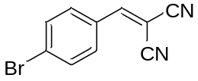
2-(4-bromobenzylidene)malononitrile: Prepared according to the general procedure. ¹H NMR (400.16 MHz, CDCl₃, δ ppm): 7.75 (s, 1H), 7.66 (d, J = 8.6 Hz, 2H), 7.55 (d, J = 8.5 Hz, 2H).
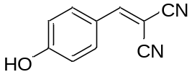
2-(4-hydroxybenzylidene)malononitrile: Prepared according to the general procedure. ¹H NMR (400.16 MHz, DMSO-d₆, δ ppm): 10.53 (bs, 1H), 8.27 (s, 1H), 7.90 (d, J = 8.8 Hz, 2H), 6.97 (d, J = 8.8 Hz, 2H).
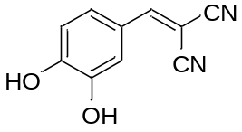
2-(3,4-dihydroxybenzylidene)malononitrile: Prepared according to the general procedure. ¹H NMR (400.16 MHz, DMSO-d₆, δ ppm): 9.48 (bs, 2H), 8.16 (s, 1H), 7.55 (d, J = 2.2 Hz, 1H), 7.33 (dd, J = 8.3, 2.1 Hz, 1H), 6.91 (d, J = 8.3 Hz, 1H).
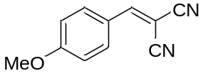
2-(4-methoxybenzylidene)malononitrile: Prepared according to the general procedure. ¹H NMR (400.16 MHz, CDCl₃, δ ppm): 7.85 (d, J = 8.9 Hz, 1H), 7.65 (s, 1H), 6.95 (d, J = 8.9 Hz, 1H), 3.84 (s, 3H).
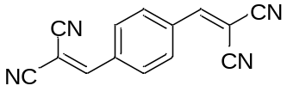
2,2'-(1,4-phenylenebis(methanylylidene))dimalononitrile: Prepared according to the general procedure. ¹H NMR (400.16 MHz, CDCl₃, δ ppm): 8.52 (s, 2H), 8.02 (s, 4H).
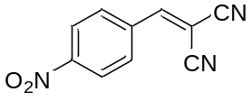
2-(4-nitrobenzylidene)malononitrile: Prepared according to the general procedure. ¹H NMR (400.16 MHz, CDCl₃, δ ppm): 8.31 (d, J = 8.0 Hz, 2H), 8.03 (d, J = 8.1 Hz, 2H), 7.97 (s, 1H).

